FLIGHT DELAY PREDICTION

Project submitted to the
Samskruti College of Engineering & Technology, Hyderabad for the partial fulfilment of the requirements to award the degree of
Bachelor of Technology
In
Computer Science and Engineering
Submitted by
MD ASIF (24U11A6675)
MD AWEZ (24U11A6676)
MD SALMAN(24U11A6678)
SHAIK SHAHID(24U11A66B0)

Under the Guidance of
Ms. V. Veda Sri
Assistant Professor, Department of CSE (AI & ML)
Samskruti College of Engineering & Technology
Kondapur, Ghatkesar, Hyderabad Telangana – 501301
[October , 2026]

Certificate
Date: _________
- This is to certify that the work present in this Project entitled “flight delay prediction” has been carried out by[Asif, Awez, salman, shahid] under my/our supervision. The work is genuine, original, and suitable for submission to the SRM University – AP for the award of Bachelor of Technology/Master of Technology in School of Engineering and Sciences.
Supervisor
Ms. V. Veda Sri
Assistant Professor, Department of CSE (AI & ML)
Samskruti College of Engineering & Technology, Hyderabad

Abstract
AeroPredict is an educational flight-delay project centred on departures from Hyderabad to Bengaluru, Chennai, Vijayawada, Visakhapatnam, Tirupati and Thiruvananthapuram. It combines a reproducible supervised learning experiment with a browser application for scenario exploration and provider-reported flight information. The learning experiment uses 6,000 synthetic records, including schedule, route, weather, congestion and incoming-aircraft attributes. These records are generated educational examples rather than observed airline history.
The classification target identifies synthetic departure delays of at least 15 minutes, while the regression target estimates delay duration. Chronological partitions contain 4,200 training, 900 validation and 900 test records. Preprocessing is fitted on training data only. Logistic regression, Gaussian naive Bayes and K nearest neighbours are compared with a majority-class baseline. Ridge regression and nearest-neighbour regression are compared with a mean-delay baseline. Model selection uses validation data, followed by evaluation on the untouched test partition.
The selected logistic model achieves 82.22% accuracy, 88.81% precision, 83.75% recall, an F1-score of 0.8621 and a ROC-AUC of 0.9123. The selected ridge model produces a mean absolute error of 8.70 minutes and an RMSE of 12.58 minutes. These results measure learning of the synthetic data-generating relationships and do not establish performance on real Indian flight operations.
The main website provides two distinct modes. Simulation calculates transparent rule-based estimates and displays an illustrative route on a 3D globe. Live Flights retrieves schedules and reported delays through a private backend with caching and request accounting. A separate local ML form demonstrates predictions from the trained experimental models. Public QR access can be provided through a temporary tunnel while the local server remains running.
Keywords: Flight delay classification, departure delay regression, synthetic data, logistic regression, ridge regression, Aviationstack, 3D visualization.

Acknowledgement
We thank Ms V Veda Sri, Assistant Professor, Department of CSE with specialization in AI and ML, for her guidance. We also acknowledge Samskruti College of Engineering and Technology for the opportunity to develop and present this project. Published research and software documentation used in this work are listed in the references.

Contents
The report follows the seven-chapter project format. Chapter 6 reports measured results from the accompanying experiment; Chapter 5 documents the application and demonstration interface.
Abstract 3
Contents 4
Chapter 1 Introduction 5
Chapter 2 Literature Survey 6
Chapter 3 Proposed System 8
Chapter 4 Methodology 10
Chapter 5 Implementation 13
Chapter 6 Results and Discussion 16
Chapter 7 Conclusion and Future Scope 20
References 21
Appendix Reproduction and Presentation 22

Reading the evidence
Classification results concern departure delay of 15 minutes or more. Regression results use minutes. Figures labelled as training data are exploratory plots of the training partition. Application screenshots show the existing user interface and are not measurements of ML accuracy.
The evidence folder includes the CSV partitions, experiment and learner code, saved models, row-level test predictions, figures and metrics. The website code remains in AeroPredict_Local_Presentation.

Chapter 1 Introduction

1 1 Background and motivation
A delayed incoming aircraft, severe weather or congested operations can affect the punctuality of a later departure. Published research models these interactions using flight, airport, network and weather information [1–5]. For a classroom project, the challenge is to make the prediction workflow understandable while keeping its evidence separate from a visually attractive flight display.
Hyderabad provides a focused starting point for demonstrating routes across southern India. The project covers six destination airports, including three in Andhra Pradesh. A globe helps users understand the route, while explicit labels distinguish scenario assumptions, learned experimental predictions and provider-reported status.

1 2 Problem statement
Passengers and students need a clear way to understand how operational conditions can relate to flight delay. This project investigates whether pre-departure-style inputs can classify a synthetic departure as delayed by at least 15 minutes and estimate its delay duration. It also presents flight routes and available provider-reported status through a simple interface. The current training records are synthetic, so conclusions are restricted to educational evaluation until suitable real historical data are obtained.

1 3 Objectives
- Prepare and explore a documented synthetic dataset for Hyderabad departures to six South India destinations.
- Implement preprocessing and chronological splitting that prevent target and test-data leakage.
- Train classification and regression models, compare them with simple baselines and evaluate unseen test records.
- Demonstrate new-input predictions through a local ML interface and explain Simulation and Live Flights in the main application.
- Provide reproducible code, documented results, 3D route visualization and QR access for a classroom presentation.

1 4 Scope
The study covers departure delay, not arrival delay, cancellations or missed connections. Live status comes from Aviationstack when available. Neither live provider delay nor the website rule score is presented as the trained model output. The work is an academic prototype and does not provide operational flight-planning advice.

Chapter 2 Literature Survey
Five studies were reviewed from their primary publications or author-hosted records. Their numerical results are reported in their original settings. Differences in delay threshold, geography, prediction horizon and evaluation procedure prevent a direct ranking against this project.
Paper | Method | Dataset | Reported result | Limitation for this project
Rebollo and Balakrishnan 2014 [1] | Random forest classification and regression | US operations from 2007–2008; 100 most-delayed links | 19% classification error at a 60-minute threshold and two-hour horizon | Network-level US setting and different threshold; cannot transfer the score to HYD.
Etani 2019 [2] | Random forest using flight and pressure-pattern information | Peach Aviation flights and Japanese weather | 77% on-time arrival accuracy | Airline and weather setting differs; target concerns arrival.
Patgiri et al 2020 [3] | Logistic regression, naive Bayes, KNN, decision tree and random forest | Historical airline data; train 2000–2007 and evaluate 2008 | Random forest accuracy 82% and recall 99% at a 15-minute threshold | Historical foreign operating context; preprint findings require dataset-specific interpretation.
Hatipoglu and Tosun 2024 [4] | Several classifiers, SMOTE experiments and SHAP | Three years of operations at a Turkish airport | XGBoost accuracy about 80%; adding weather had limited benefit | Single-airport findings; arrival target and input availability differ.
Kim and Park 2024 [5] | Tree, linear, neighbour and neural models | Flight and weather data from ICN, JFK and MDW | Two-hour accuracy 74.9%, 85.2% and 78.5%, respectively | Strong variation across airports; needs location and horizon-specific validation.

Limitations in the final column describe transferability to this educational project; they are not claims that the original studies are invalid.

2 1 Findings from the literature
Operational context matters. Rebollo and Balakrishnan show how temporal and network states support departure-delay forecasts [1]. That motivates recording the incoming-aircraft condition, but it does not justify assigning a real-world coefficient without historical evidence. The present incoming-delay variable is an assumed synthetic input.
Weather can add information, but its usefulness depends on the setting. Etani reports useful associations between flight performance and pressure patterns [2]. Hatipoglu and Tosun find limited incremental weather benefit in their airport dataset [4]. These findings support comparing features empirically rather than treating weather as a universally dominant predictor.
Simple models deserve a baseline role. Patgiri and colleagues compare several classifier families on historical data [3]. Kim and Park report different performance across three airports and prediction horizons [5]. A model selected for one dataset is therefore not automatically the best choice for another.

2 2 Research and project gap
The gap addressed here is a reproducible classroom workflow connecting a documented regional dataset, leakage-aware evaluation and an understandable demonstration. The project does not claim a novel learning algorithm or superior aviation accuracy. Its practical contribution is to keep the source and meaning of each displayed number visible while presenting the complete experiment and application together.
A major unresolved research gap is access to suitable historical Indian flight records with features timestamped before the prediction cutoff. A current API snapshot cannot replace a historical labelled dataset. A future study must also evaluate airport coverage, disruptions, seasonal change, missing observations and prediction calibration.

2 3 Decisions derived from the survey
- Define the target as departure delay of at least 15 minutes throughout the experiment.
- Use earlier dates for training and later dates for validation and testing.
- Compare learned models against majority-class and mean-delay baselines.
- Report recall and false alarms alongside accuracy, and report delay errors in minutes.
- Keep research scores, synthetic experiment scores and provider-reported values in separate contexts.

Chapter 3 Proposed System
AeroPredict contains three coordinated components. The supervised learning experiment trains on the supplied CSVs and saves reusable models. The main application provides Simulation and Live Flights. Each component has its own source of data and a clearly identified output.
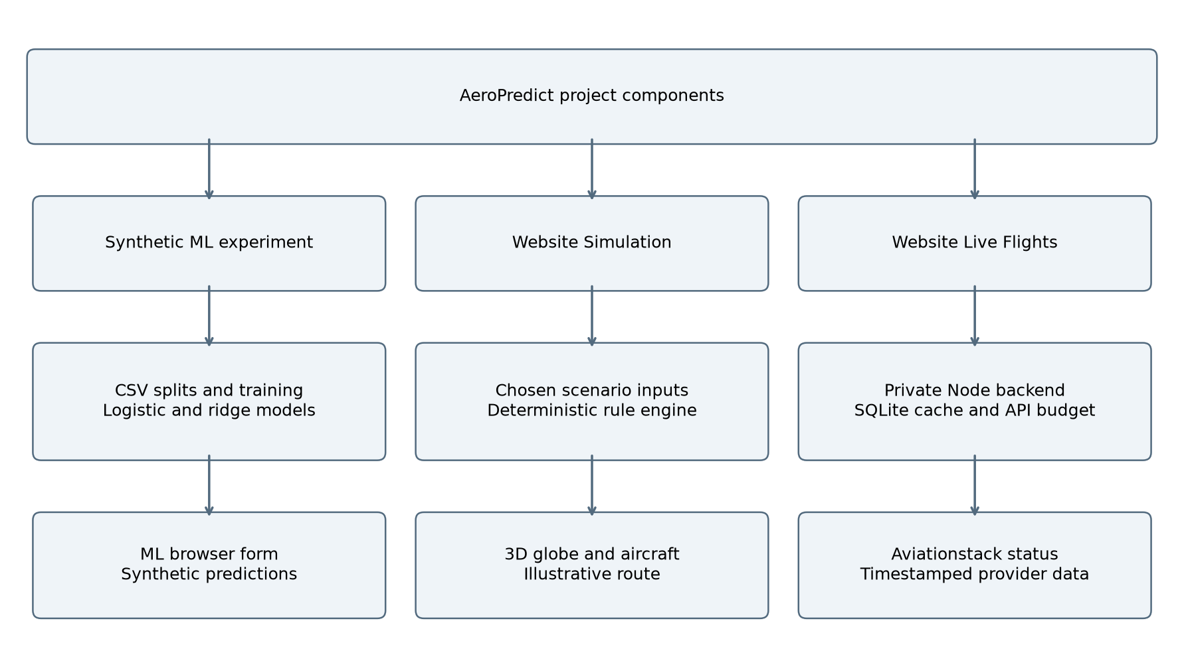
Figure 3.1 System architecture and the three distinct output paths

3 1 Workflow
For ML, records pass through integrity checks, chronological partitions, training-only preprocessing, candidate fitting, validation selection and final test evaluation. A new form submission uses the saved transformations and models. Simulation accepts user assumptions and calculates a deterministic illustrative score. Live Flights calls a local backend, which returns a saved snapshot or makes a budgeted provider request.

3 2 Data flow and boundaries
The browser never needs the private Aviationstack key. The Node server owns provider authentication, caching and request accounting. The standalone ML demonstration has no Aviationstack dependency. A public tunnel forwards web requests to the local application; the laptop continues to execute the server code.

3 3 Dataset and features
The dataset contains 6,000 synthetic records dated 1 January to 27 October 2025, with 20 fictional departures per date. All origins are HYD. The generator seed is 20261019. Dates describe invented schedules; operational inputs and outcomes are not measurements from Aviationstack or an airline.
Field or group | Meaning and use
destination | BLR, MAA, VGA, VTZ, TIR or TRV; one-hot encoded.
weather | Clear, Rain, Fog or Thunderstorm; assumed category.
departure_hour_ist, day_of_week, month | Calendar and schedule inputs; hour 0–23 and weekday Monday 1 to Sunday 7.
congestion_pct | Assumed airport congestion percentage.
incoming_delay_minutes | Assumed delay of the incoming aircraft.
distance_km, scheduled_duration_minutes | Route distance and scheduled duration in the synthetic dataset.
evening_peak | Engineered feature equal to 1 for departure hours 16–22.
departure_delay_minutes | Regression target; excluded from all model inputs.
delayed_15_plus | Classification target, 1 when departure delay is at least 15 minutes.

3 4 Synthetic generation assumptions
delay = round(max(0, -8 + 8*W + 0.12*C + 0.6*I
+ 7*E + noise + disruption))
W is the chosen weather weight, C is congestion as a percentage, I is incoming delay and E is the evening indicator. Noise is centred random variation; a 4% random event adds 20–80 minutes. This equation constructs the labels. It is not a formula estimated from observed aviation operations.
The complete data contain 3,824 delayed records and 2,176 below-threshold records. Mean delay is 30.25 minutes, median delay is 22 minutes and maximum delay is 157 minutes. All values summarize synthetic examples.

Chapter 4 Methodology

4 1 Data preprocessing
The experiment checks record identifiers, missing cells, target consistency and date order before training. The supplied files have zero missing cells and no repeated record identifiers. Every binary label agrees with the 15-minute departure threshold. No rows are dropped during the experiment.
The origin column is removed because it is constant. Record ID, source label, split label, full timestamps and both target columns are excluded from predictors. The hour, weekday and month retain useful schedule information without passing raw identifiers into the model. Only the evening indicator is engineered.
Categorical values are encoded using categories observed in training. Unseen categories map to zero across that feature’s indicator columns. Numeric medians and category modes provide missing-value defaults, although no supplied cells require them. Numeric variables are standardized using training means and population standard deviations. Those fitted values are reused unchanged for validation, testing and new input.

4 2 Chronological dataset division
Partition | Date range in 2025 | Rows | Delayed | Below 15 min
Train | 01-01 to 07-29 | 4200 | 2634 | 1566
Validation | 07-30 to 09-12 | 900 | 593 | 307
Test | 09-13 to 10-27 | 900 | 597 | 303

Training uses 70% of the records; validation and test each use 15%. Entire dates remain in one partition. No date overlaps occur. Candidate parameters and model families are chosen on validation data only; test predictions are produced after those choices are frozen. The selected models are not refitted on the full dataset.

4 3 Leakage prevention
Both delay targets must be excluded, since one reveals the other. No preprocessing statistics are learned from validation or test records. The workflow follows standard separation principles described in the scikit-learn guidance [6], although the experiment implements its learners directly with NumPy. Real data would additionally require a defined prediction time and proof that each feature existed before that time.

4 4 Algorithms and model training
The experiment uses supervised classification and regression. Small NumPy implementations make the equations and stored parameters inspectable. No random forest, XGBoost, SMOTE, grid-search cross-validation or SHAP result is claimed for this run.
Task and model | Fitting method | Candidates
Classification baseline | Always predict the majority training class. | One model
Logistic regression | Regularized binary cross-entropy, Newton updates, maximum 100 iterations. | L2 coefficient 0.001, 0.01, 0.1
Gaussian naive Bayes | Class means, variances and priors; conditional feature independence. | Variance smoothing 0.001, 0.01, 0.1
K nearest neighbours | Euclidean distance after preprocessing; fraction of delayed neighbours. | k = 11, 31, 61
Regression baseline | Always predict the training mean delay. | One model
Ridge regression | Least squares with an L2 penalty; intercept is not penalized. | Alpha 0.1, 1, 10
Neighbour regression | Mean target among nearest training records. | k = 11, 31, 61

4 5 Selected settings
Classification selects the highest validation F1-score using a fixed probability threshold of 0.5. Logistic regression with L2 coefficient 0.01 is selected, with validation F1 of 0.8540. Regression selects the lowest validation MAE. Ridge regression with alpha 10 is selected, with validation MAE of 8.85 minutes. Each family’s best validation candidate is evaluated on the final test set for comparison.
The majority class is delayed in this dataset. Resampling and class weights are not used. Reporting both classes, a baseline and recall exposes the effect of the moderate imbalance. The generator is mostly additive, so the strong performance of linear models is plausible and does not establish that they would outperform ensemble methods on real flights.

4 6 Testing and evaluation metrics
The final test set contains 900 later-dated records: 597 delayed and 303 below the threshold. Predictions are saved per record to test_predictions.csv. The stored models are reloaded and their predictions are compared with all 900 saved rows as a reproducibility check.
Metric | Calculation or interpretation
Accuracy | (TP + TN) / N; fraction of all labels classified correctly.
Precision | TP / (TP + FP); reliability of a predicted delay warning.
Recall | TP / (TP + FN); fraction of actual delays detected.
F1-score | 2TP / (2TP + FP + FN); balances precision and recall.
ROC-AUC | Probability that a delayed example scores above a below-threshold example; tied scores count one half.
Confusion matrix | Rows are actual classes and columns are predicted classes. Class 1 is delayed.
MAE | Mean absolute difference between predicted and actual minutes.
MSE and RMSE | Mean squared error in minutes squared, and its square root in minutes.
R squared | 1 minus squared residual sum divided by total squared variation around the test mean.

4 7 Prediction on new data
New-input prediction uses the same feature order, encoding and scaling as training. The local form accepts weather, congestion, incoming delay and departure hour for an HYD–BLR example. Weekday, month, distance and duration are fixed to documented demonstration values. The classifier returns a class and probability; the regressor returns minutes. There is no known actual outcome for a user-created scenario, so it cannot contribute to test accuracy.
A probability is not automatically calibrated. The report does not claim that a displayed 80% score means an 80% real-flight delay frequency. Ridge outputs are evaluated without clipping, so future inputs can produce negative values or extrapolation errors. A production interface would need a validated nonnegative target treatment and uncertainty estimates.

Chapter 5 Implementation

5 1 Software and hardware requirements
Component | Requirements and role
Main website | Node.js 24 or newer, modern WebGL-capable browser, HTML, CSS and JavaScript.
Data service | Built-in Node SQLite storage, private Aviationstack credential and Internet access for provider requests.
ML experiment | Python 3.12, NumPy, pandas, Matplotlib and joblib. The supplied requirements file records the experiment environment.
3D assets | Blender source model and exported GLB aircraft; globe assets are stored locally.
Public sharing | Cloudflared tunnel while laptop, local server and Internet connection remain active.
Suggested classroom hardware | 64-bit laptop, 8 GB RAM, current browser and sufficient storage for code and assets. This is a practical recommendation, not a measured minimum.

5 2 Important code sections
The following excerpts show the target definition and strict split handling. The full learner equations and preprocessing are available in slap_numpy_models.py.
assert (data.delayed_15_plus ==
(data.departure_delay_minutes >= 15).astype(int)).all()
model = pipe(candidate).fit(X['train'], y_train)
validation_predictions = model.predict(X['validation'])
# Select parameters using validation, then evaluate test.
test_predictions = selected_model.predict(X['test'])
run_experiment.py performs the experiment and exports the evidence. ml_demo.py loads the saved models and serves the local browser form on port 4188. In the main application, engine.mjs calculates simulation outputs, server/flights.mjs normalizes provider fields, and server/budget.mjs controls cache use and request reservations.

5 3 Application screenshots
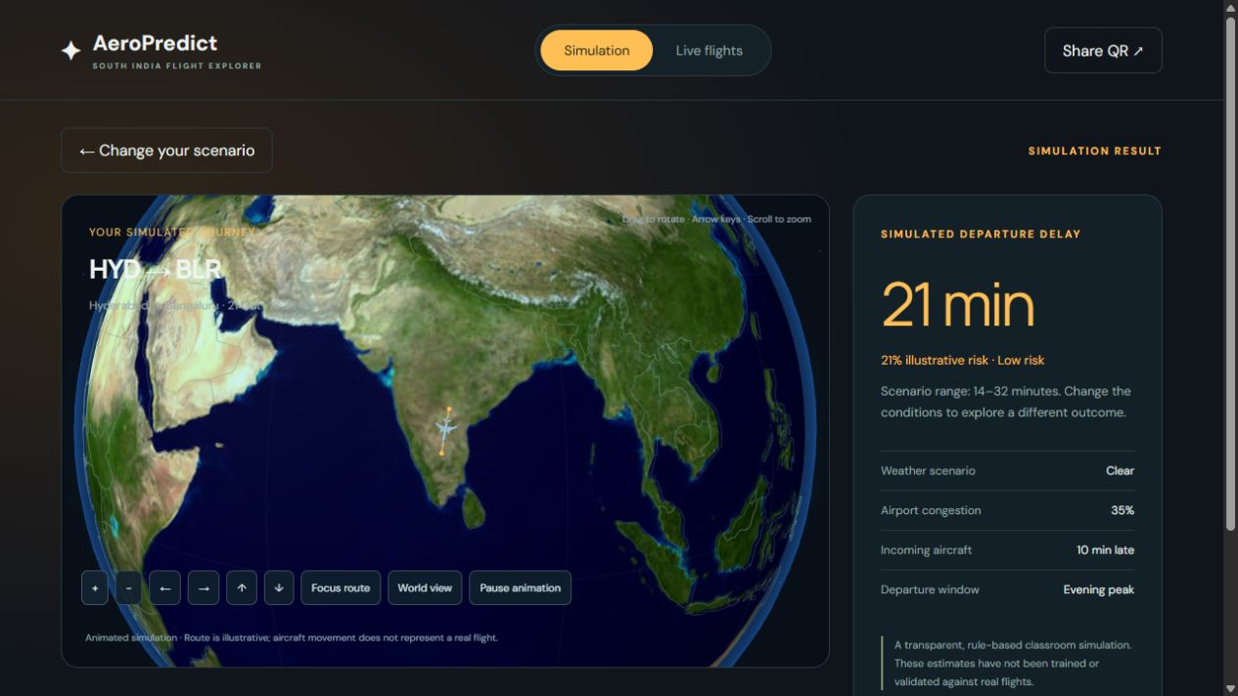
Figure 5.1 Simulation result with a 3D route and explicit illustrative-risk label
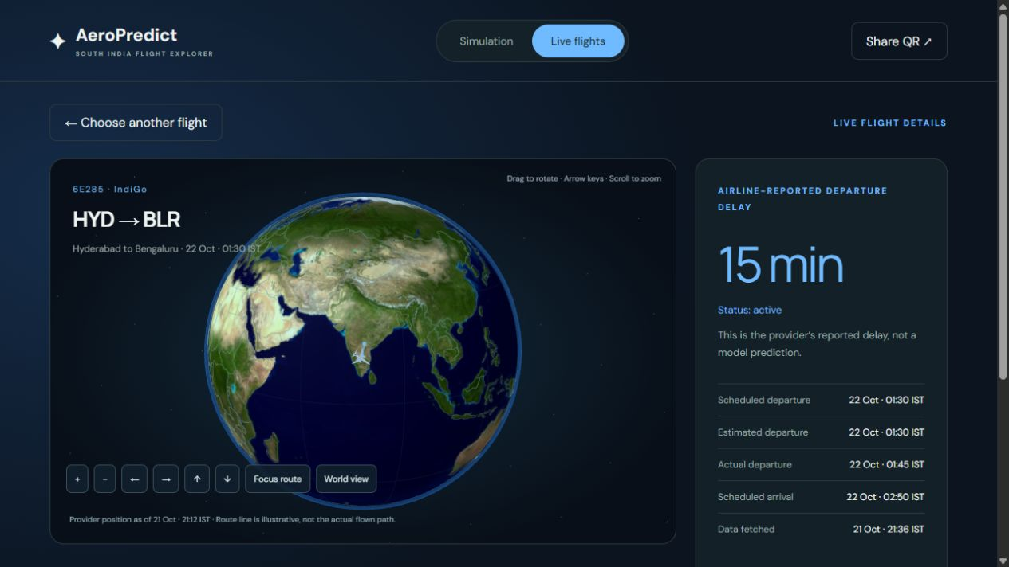
Figure 5.2 Existing Live Flights view showing a timestamped provider-reported delay
These retained project screenshots document the two website modes. They show earlier demonstration states rather than a fresh API observation made for this report. The simulation value comes from the rule engine. The Live value comes from a provider response; neither screenshot represents the separate ML test result.

5 4 Running and sharing the project
START_LOCAL.cmd launches the main application. Its Simulation and Live Flights pages are separate routes. For classmates on other networks, START_PUBLIC.cmd creates a temporary public tunnel and generates public QR files. A new tunnel may produce a new hostname, so the displayed QR should be regenerated and checked before presenting. A LAN or localhost QR cannot be used by classmates on unrelated networks.
The Aviationstack key is an account credential used by the backend. It is stored outside public files and excluded from the hand-in ZIP. The installation tracks a maximum of 100 provider attempts, uses a five-minute cache and cooldown, and counts failed attempts. This local counter is not an authoritative account-wide remaining balance; other uses of the same account may also consume quota.

5 5 Verification performed
Check | Observed result
Dataset integrity | 6,000 unique IDs, zero missing cells and consistent threshold labels.
Split integrity | Strictly ordered date ranges with no overlap.
Metric fixtures | Known confusion matrix, accuracy, precision, recall, F1, tied AUC and regression calculations pass.
Saved model reload | Reloaded classifier and regressor reproduce all 900 stored test predictions.
Website unit checks | Simulation, normalization, cache reuse, cooldown, budget ceiling and error handling pass.
Local HTTP checks | Both modes, private-file protection, model assets and allowed methods pass. SQLite counter survives restart.
New input inference | Thunderstorm example returns delayed class, 97.8% score and 54.2 minutes.

The backend checks use controlled provider responses. No additional Aviationstack request was needed for the report’s experiment or verification. The ML form code loads the saved learners and calls their prediction methods for each submitted scenario.

5 6 Implementation challenges
The most important challenge is maintaining consistent meaning across views. The training dataset predicts departure delay, the main simulation uses chosen coefficients, and live status can be missing or stale. Explicit labels, cached timestamps, preservation of unknown delay values and separate prediction paths prevent those cases from being confused.

Chapter 6 Results and Discussion

6 1 Exploratory data analysis
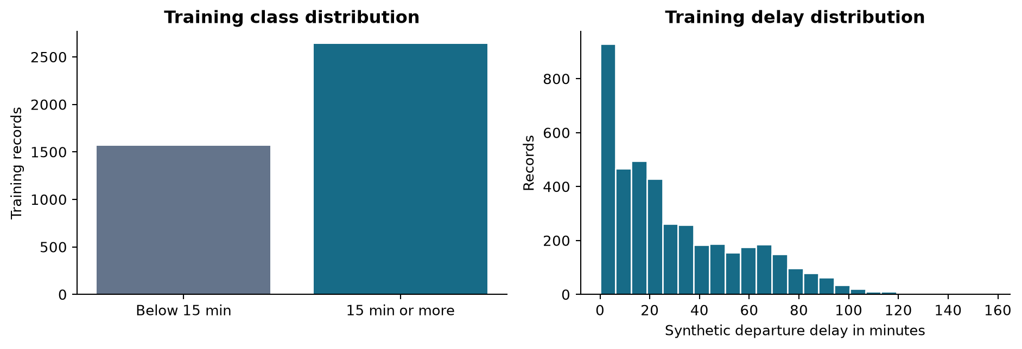
Figure 6.1 Class balance and delay distribution in 4,200 training records
The training set contains 2,634 delayed examples and 1,566 below-threshold examples. Delays are right-skewed, with many moderate outcomes and fewer large disruptions. The majority-class baseline therefore already obtains a high delayed-class recall; accuracy and recall alone would overstate its usefulness.
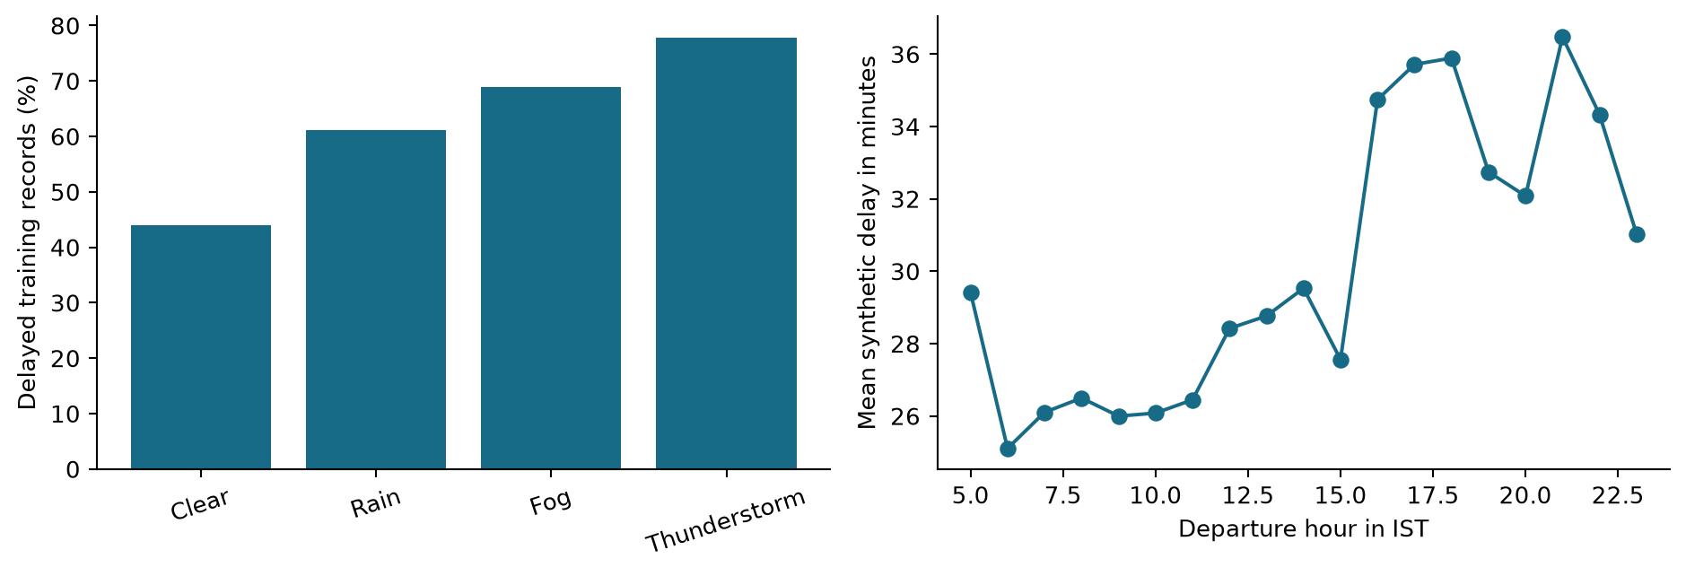
Figure 6.2 Synthetic weather categories and departure-hour patterns in training data
More severe weather categories and the evening window are associated with higher generated delays because these relationships are built into the data generator. These graphs demonstrate exploration of the training data. They do not establish causal effects or measured congestion patterns at Hyderabad airport.

6 2 Classification performance
Model | Accuracy % | Precision % | Recall % | F1 | AUC
Majority baseline | 66.33 | 66.33 | 100.00 | 0.7976 | 0.5000
Logistic regression | 82.22 | 88.81 | 83.75 | 0.8621 | 0.9123
Gaussian naive Bayes | 75.44 | 95.63 | 66.00 | 0.7810 | 0.8956
K nearest neighbours | 75.89 | 84.55 | 77.89 | 0.8108 | 0.8385

Logistic regression, selected using validation F1, also gives the highest test F1 among the evaluated models. Its accuracy exceeds the majority baseline by 15.89 percentage points. The naive Bayes model has higher precision but misses many more delays; its lower recall reduces F1.
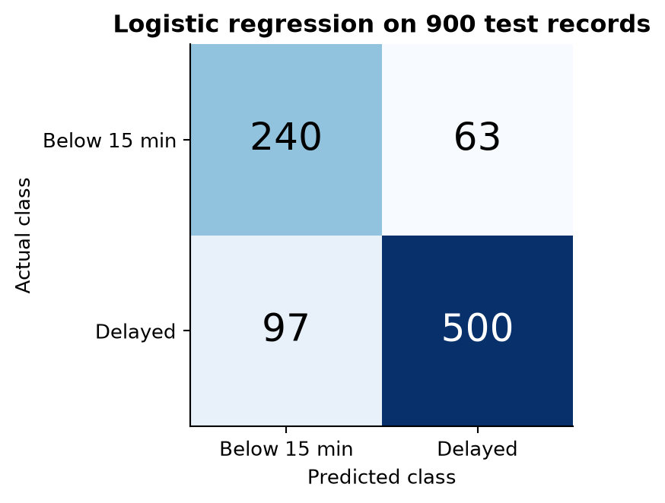
Figure 6.3 Confusion matrix of the selected logistic classifier
The model correctly identifies 500 delayed records and 240 below-threshold records. It produces 63 false warnings and misses 97 delays. The delayed-class F1-score is 0.8621. The majority baseline detects every delay only because it predicts delayed for every record, producing 303 false warnings.
These outcomes describe one synthetic test partition. No confidence interval, repeated-seed stability study or real-world calibration study is included. Reported decimal precision aids reproducibility and should not be mistaken for certainty about future aviation performance.

6 3 Regression performance
Model | MAE min | MSE min squared | RMSE min | R squared
Mean baseline | 21.83 | 713.86 | 26.72 | -0.0007
Ridge regression | 8.70 | 158.24 | 12.58 | 0.7782
K nearest neighbours | 11.02 | 227.86 | 15.10 | 0.6806

Ridge regression is selected using validation MAE and achieves the lowest test MAE of 8.70 minutes. This is a reduction of about 60.1% from the mean-delay baseline error of 21.83 minutes. RMSE is larger than MAE because some test records have large errors. The R-squared value of 0.7782 reflects explained variation in this synthetic holdout.
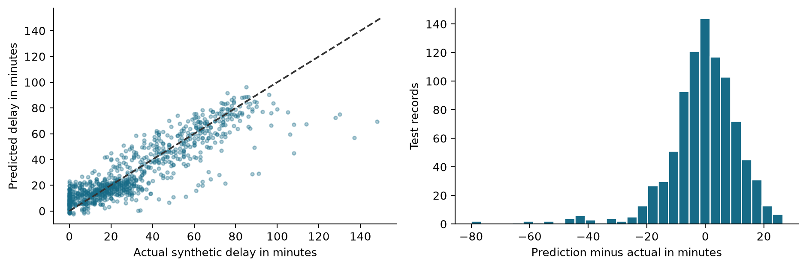
Figure 6.4 Ridge predictions against actual synthetic delays and the residual distribution

6 4 Why substantial errors remain
The label generator includes random noise and occasional disruptions that are not available as model inputs. A learner cannot identify the realization of an independent random event from the displayed features. Large generated delays can consequently be underestimated. Negative residuals in the second plot indicate underprediction.
The generator largely combines weather, traffic, incoming delay and evening effects additively. Ridge regression can learn that structure efficiently. This result does not prove that ridge would be best for real operations with aircraft rotations, runway constraints, unobserved maintenance or airline-specific processes. A licensed historical dataset could favour a different model family.

6 5 Feature analysis and new predictions
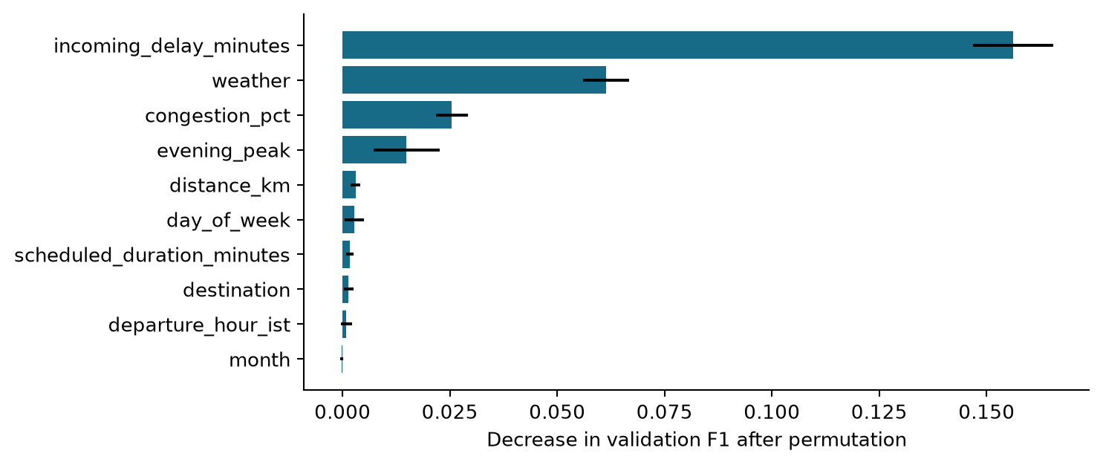
Figure 6.5 Validation F1 decrease after eight permutations of each input feature
Permutation importance measures how much validation F1 changes when a feature is shuffled. Error bars show variation across eight shuffles, not confidence intervals for real-flight effects. Correlated route fields and the relationship between departure hour and evening_peak can distribute or hide importance. The ranking is descriptive rather than causal.
HYD to BLR scenario | Model delay probability | Predicted class | Ridge minutes
Clear, 25% congestion, 0 min incoming | 13.5% | Below 15 min | 0.1
Rain, 60% congestion, 20 min incoming | 77.4% | Delayed | 29.2
Thunderstorm, 85% congestion, 45 min incoming | 97.8% | Delayed | 54.2

The Clear example departs at 10:00 IST; the Rain and Thunderstorm examples use 18:00 IST. All use weekday 5, month 10, a route distance of 456 km and scheduled duration of 72 minutes. These are constructed demonstration inputs with no observed true outcome. They illustrate prediction on new input, not additional evaluation samples.
The saved learners return a 97.8% probability and a 54.2-minute estimate for the Thunderstorm example. A scenario can be below the classification threshold even if the separate regressor estimates a small positive delay; the two models solve different supervised tasks.

Chapter 7 Conclusion and Future Scope

7 1 What was achieved
The project provides a complete educational workflow from dataset understanding to trained models and test evaluation. It checks data integrity, uses chronological partitions, fits transformations on training records only and compares multiple learners against baselines. The saved evidence makes the results traceable to individual test predictions. A local browser form demonstrates new-input inference.
The main AeroPredict application complements that experiment with a 3D globe, editable Blender aircraft, transparent scenario simulation and provider-reported live status. Its private backend protects credentials, caches responses and tracks attempts. Temporary public sharing supports a classroom QR demonstration across different networks.

7 2 Which models performed best
Logistic regression was selected for classification by validation F1 and achieved test accuracy of 82.22% and F1 of 0.8621. Ridge regression was selected by validation MAE and achieved test MAE of 8.70 minutes. These conclusions apply to the candidate set, parameter ranges and synthetic data used in this experiment.

7 3 Limitations
- No model has been trained or validated here on genuine historical Indian airline outcomes.
- One synthetic generation process and one chronological holdout cannot establish generalization to new airports or disruptions.
- The standalone ML demonstration is separate from the main website’s rule engine and Live mode.
- API coverage, stale snapshots and missing coordinates restrict live display; a current flight response is not training history.
- Probability calibration, confidence intervals, repeated-seed evaluation and advanced ensemble comparisons remain future work.

7 4 Future scope
The next research stage is to obtain licensed historical flight records and timestamped weather and operational inputs. A fixed prediction horizon should be defined before feature creation. Rolling chronological validation, per-route error analysis, class weighting, random forest and gradient boosting comparisons can then be evaluated. Only after real-data performance and calibration are measured should a learned predictor be connected to the main website. A stable domain and managed hosting would also improve presentation reliability.

References
[1] J. J. Rebollo and H. Balakrishnan. Characterization and prediction of air traffic delays. Transportation Research Part C, vol. 44, pp. 231–241, 2014. DOI: 10.1016/j.trc.2014.04.007. Author copy: https://web.mit.edu/hamsa/www/pubs/RebolloBalakrishnanTRC2014.pdf
[2] N. Etani. Development of a predictive model for on-time arrival flight of airliner by discovering correlation between flight and weather data. Journal of Big Data, vol. 6, article 85, 2019. https://doi.org/10.1186/s40537-019-0251-y
[3] R. Patgiri, S. Hussain and A. Nongmeikapam. Empirical Study on Airline Delay Analysis and Prediction. arXiv preprint, 2020. https://arxiv.org/abs/2002.10254
[4] I. Hatipoglu and O. Tosun. Predictive Modeling of Flight Delays at an Airport Using Machine Learning Methods. Applied Sciences, vol. 14, article 5472, 2024. https://doi.org/10.3390/app14135472
[5] S. Kim and E. Park. Prediction of flight departure delays caused by weather conditions adopting data-driven approaches. Journal of Big Data, vol. 11, article 11, 2024. https://doi.org/10.1186/s40537-023-00867-5
[6] Scikit-learn developers. Common pitfalls and recommended practices. Guidance on preprocessing consistency, pipelines and data leakage. https://scikit-learn.org/stable/common_pitfalls.html
[7] AeroPredict project files. South India synthetic training data README, metadata.json and build-training-data.mjs; generator seed 20261019. Local project dataset and generation specification, 2026.
[8] AeroPredict project files. engine.mjs, server/flights.mjs, server/budget.mjs, server/http.mjs and local launch/share scripts. Implementation evidence for Simulation and Live Flights, 2026.
[9] AeroPredict machine learning experiment. run_experiment.py, slap_numpy_models.py, metrics.json and test_predictions.csv. Reproducible experiment accompanying this report, 23 October 2026.
Web research sources were checked on 23 October 2026. Numbers quoted from earlier studies describe their own datasets and evaluation settings. Local source files and generated experiment results provide the evidence for this project’s implementation and numerical results.

Appendix Reproduction and Presentation

A 1 Reproduce the ML results
Open the supplied SLAP_Report_Evidence folder. Install the packages listed in requirements.txt in a Python environment, then run the commands below. The script uses the included data folder and regenerates metrics, figures and saved models. No Aviationstack key is required.
python -m pip install -r requirements.txt
python run_experiment.py
python ml_demo.py
The ML form opens at http://127.0.0.1:4188. This is a local demonstration address. Public sharing of the main AeroPredict website is controlled separately through START_PUBLIC.cmd. Stop the ML server with Ctrl+C in its terminal when the demonstration is finished.

A 2 Demonstration sequence
- Explain the 15-minute departure target and identify the synthetic dataset.
- Show the training, validation and test date ranges and why target columns are excluded.
- Present the baseline comparison and the 63 false warnings and 97 missed delays.
- Enter the Thunderstorm example in the trained-model form and explain its prediction.
- Show the main website Simulation and Live Flights views and identify their different sources.
- Demonstrate the 3D controls, explain the private API key and use the current public QR if sharing is active.

A 3 Coverage of the project instructions
Required work | Location in report
Problem and 3–5 objectives | Chapter 1 contains a four-sentence problem statement and five objectives.
Dataset collection, exploration and preprocessing | Chapters 3–4 document provenance and preparation; Chapter 6 contains EDA.
Algorithm, splitting, training and testing | Chapter 4 and the supplied experiment scripts.
Evaluation and new input prediction | Chapter 6 and the local ML form.
Simple UI, implementation and screenshots | Chapter 5 and ml_demo.py.
Literature, gap, conclusions and references | Chapters 2 and 7 and References.

A 4 Repository and live demo
GitHub repository: https://github.com/ASIFMOHAMMAD8386/AeroPredict
Live demo: https://passage-pepper-secrets-walks.trycloudflare.com/simulation/
The live demo is a temporary public link. It works while the presentation laptop, local server and public tunnel are running. Verified on 28 October 2026.

