Customer Segmentation and Churn Pattern Analytics in European Banking
Research paper | Retail banking dataset: France, Germany, Spain | 10,000 customers

Abstract
Customer churn is a hidden cost of retail banking: it reduces lifetime value, raises acquisition costs and destabilises revenue. This paper analyses a customer-level dataset of 10,000 retail clients in France, Germany and Spain to answer three questions: which customer groups churn most, how churn differs across countries, age groups and financial profiles, and whether churn is concentrated among high-value customers.
Key findings. The overall churn rate is 20.4% (2,037 customers). Churn is highly uneven: Germany churns at 32.4% against about 16% in France and Spain; customers aged 46-60 churn at 51.1% and account for 41.3% of all churners while being 16.5% of customers; inactive members churn at 26.9% against 14.3% for active members; and customers with 3 or 4 products churns at 82.7% and 100%. Churn is not concentrated among high-balance customers (23.7%, similar to 24.3% for low-balance customers), but high-balance churners still carry 47.8% of all churned balances. Credit score, tenure, salary and credit card ownership are weak differentiators. These findings support targeted, segment-specific retention rather than generic campaigns.

1. Introduction and objectives
Banks routinely report an aggregate churn rate, but an aggregate figure does not show where to act. Generic retention campaigns are costly and reach many customers who were never at risk. Segmentation-driven analytics breaks the customer base into groups with distinct behaviour so that retention effort can be directed at the groups where it pays off.

Project objectives
- Measure the overall churn rate.
- Identify how churn is distributed across customer segments.
- Compare churn behaviour across European regions (France, Germany, Spain).

Secondary objectives
- Understand churn among high-value customers.
- Evaluate engagement and tenure patterns.
- Support strategic planning and marketing decisions.

2. Data and methodology

2.1 Dataset
The dataset contains one row per customer (10,000 rows) with 14 fields: customer identifier, surname, credit score, country, gender, age, tenure, balance, number of products, credit card ownership, activity status, estimated salary and the churn indicator (Exited: 1 = customer left). It is a single cross-sectional snapshot (all records carry the year 2025). Monetary values are assumed to be in euros.

2.2 Validation and cleaning
- No missing values in any column; no duplicate customer identifiers.
- Binary fields (HasCrCard, Is Active Member, Exited) contain only 0 and 1. Ages range from 18 to 92, tenure from 0 to 10 years, products from 1 to 4, and balances are non-negative.
- Churn labelling is consistent: 2,037 customers have Exited = 1.
- The surname field was removed as non-analytical. Categorical variables were converted into segment fields (below).

2.3 Segmentation design
Customers were grouped along five dimensions. Band thresholds are analyst-defined, documented here and configurable in the accompanying dashboard.
Dimension | Segments | Segment sizes
Geography | France, Spain, Germany | 5,014 / 2,477 / 2,509
Age | <30, 30-45, 46-60, 60+ | 1,641 / 6,248 / 1,647 / 464
Credit score | Low (<600), Medium (600-699), High (700+) | 3,034 / 3,818 / 3,148
Tenure | New (0-2 yrs), Mid-term (3-6), Long-term (7-10) | 2,496 / 3,977 / 3,527
Balance | Zero (=0), Low, High (top 25%, >= 127,644) | 3,617 / 3,883 / 2,500

2.4 Key performance indicators
KPI | Definition used
Overall churn rate | Share of customers with Exited = 1.
Segment churn rate | Churned customers divided by customers in the segment.
High-value churn ratio | Churn rate of high-balance customers (top 25% of balances); also shown relative to the overall rate.
Geographic risk index | Country churn rate divided by the overall churn rate (above 1.0 = riskier than average).
Engagement drop indicator | Churn rate of inactive members minus churn rate of active members, in percentage points.

Method note. The analysis is descriptive: churn rates, contribution to total churn, comparisons of churned and retained profiles, and two-way segment interactions. Because the data is observational, results describe association, not cause.

3. Results

3.1 Overall churn
Of 10,000 customers, 2,037 exited, an overall churn rate of 20.4%: roughly one customer in five. Churned customers are older on average (44.8 vs 37.4 years), hold higher balances (about 91,100 vs 72,700) and are less often active members (about 36% vs 55%). Average credit score, tenure and estimated salary are almost identical between the two groups.

3.2 Geography
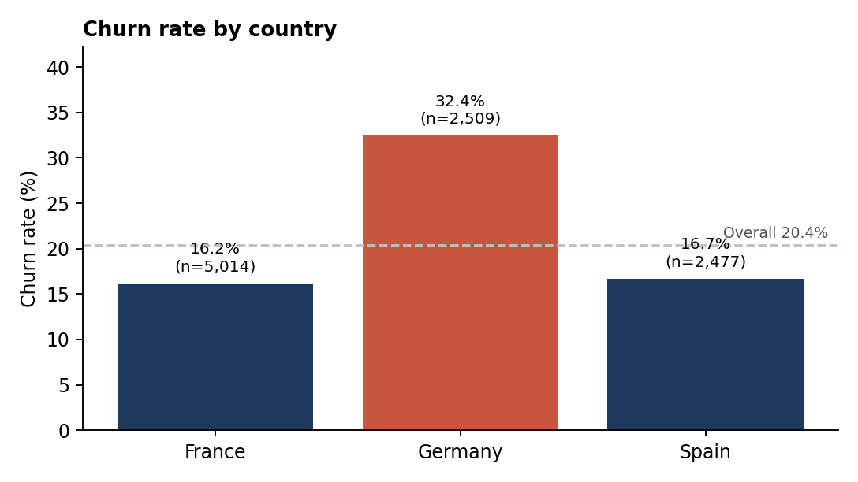
Figure 1. Churn rate by country (dashed line = overall rate)
Germany stands out: its churn rate of 32.4% is about double that of France (16.2%) and Spain (16.7%). Germany holds 25.1% of customers but 40.0% of churners. Its geographic risk index is 1.59, against 0.80 for France and 0.82 for Spain.
One structural feature is worth noting. About 48% of French and Spanish customers hold a zero balance, while no German customer does. Among customers with a non-zero balance, churn is 18.2% in France, 19.6% in Spain and 32.4% in Germany, so the German gap persists after this adjustment and cannot be attributed to the balance mix. Average non-zero balances are almost identical across the three countries (about 120,000).

3.3 Age
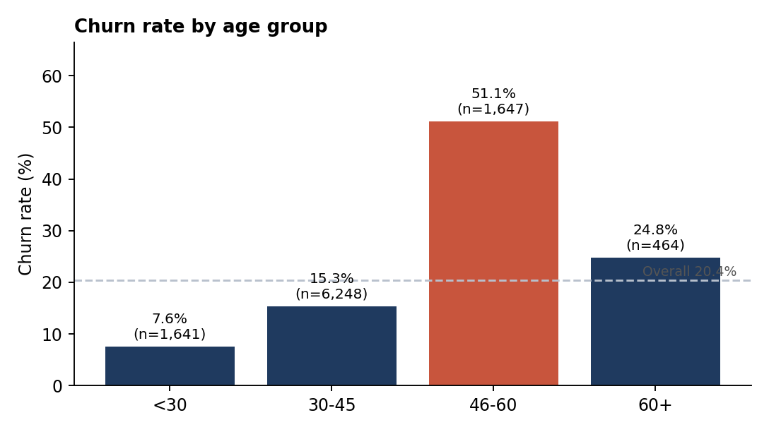
Figure 2. Churn rate by age group
Age is the strongest demographic driver. Churn rises from 7.6% (under 30) to 15.3% (30-45) and 51.1% (46-60), then falls to 24.8% above 60. The 46-60 group is only 16.5% of customers but produces 41.3% of all churners; combined with the 30-45 group (46.9% of churners), these two bands account for about 88% of churn.

3.4 Geography and age interaction; gender
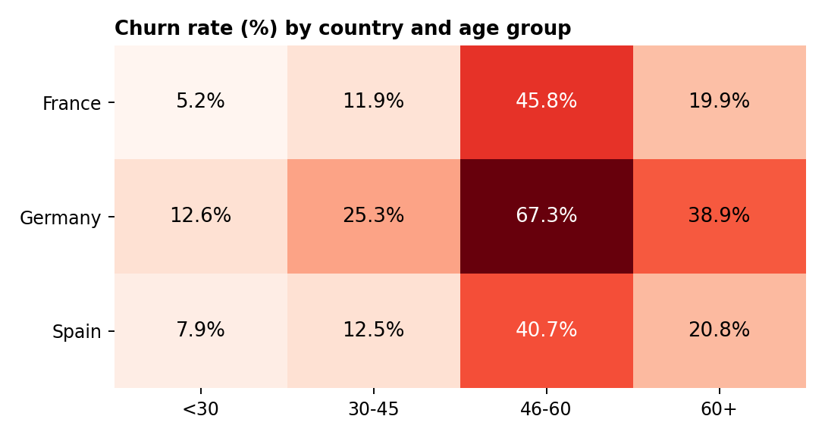
Figure 3. Churn rate by country and age group
The two effects compound. German customers aged 46-60 churn at 67.3%, the highest-risk cell in the base (502 customers), while French customers under 30 churns at only 5.2%. Germany is above France and Spain in every age band, which confirms that the geographic gap is not an age-mix effect.
Women churn more than men overall (25.1% vs 16.5%, an 8.6-point gap), and the gap appears in every country: France 20.3% vs 12.7%, Germany 37.6% vs 27.8%, Spain 21.2% vs 13.1%. Women make up 45.4% of customers but 55.9% of churners.

3.5 Engagement and product holding
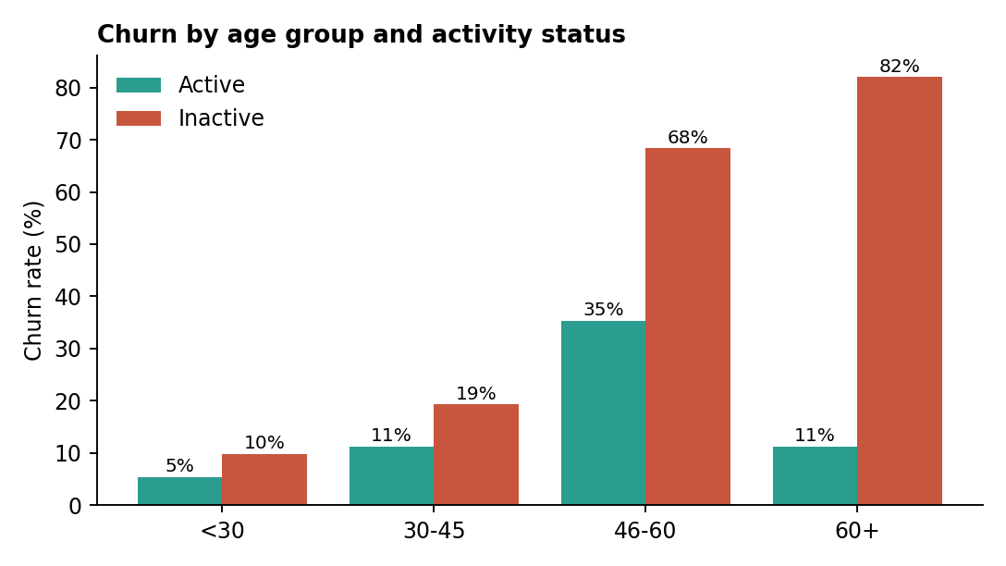
Figure 4. Churn rate by age group and activity status
Inactive members churn at 26.9% against 14.3% for active members, an engagement drop indicator of 12.6 percentage points. Inactive members are 48.5% of customers but 63.9% of churners. Inactivity compounds with age: inactive customers aged 46-60 churn at 68.4%, and inactive customers above 60 at 82.0%.
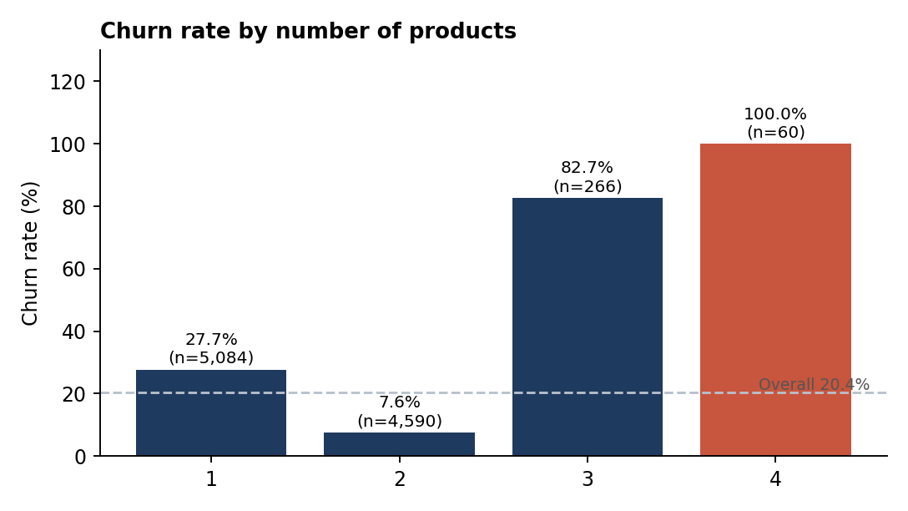
Figure 5. Churn rate by number of products
Product holding has a striking non-linear relationship with churn. Customers with two products are the most loyal (7.6%), those with one product churn at 27.7%, and those with three or four products churns at 82.7% and 100%. The 3-4 product groups are small (326 customers combined) but the pattern holds in all three countries (81-92%), so it is unlikely to be noise. A plausible interpretation is that over-sold or poorly fitting bundles trigger exits, but the data cannot confirm the reason.

3.6 Financial profile: balance, credit score, tenure, salary
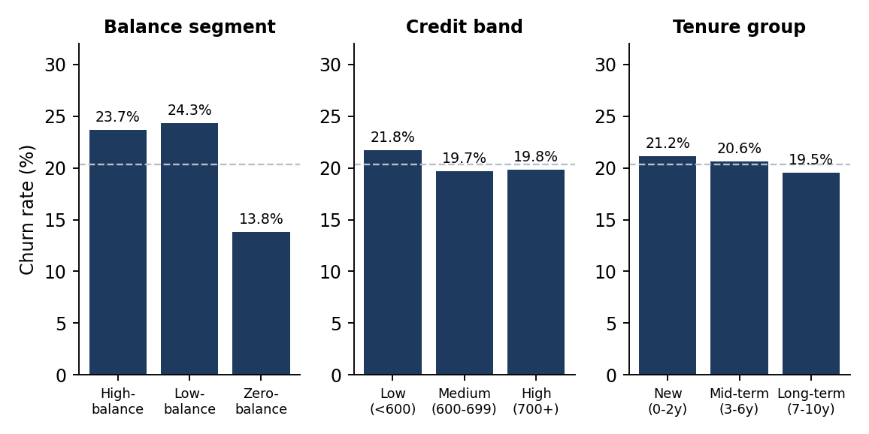
Figure 6. Churn rate by balance segment, credit band and tenure group
- Balance. Zero-balance customers churn least (13.8%); customers holding a balance churn at 23.7-24.3%. Balance carries a modest association with churn (correlation 0.12).
- Credit score. Churn is 21.8% for the Low band and 19.7-19.8% for Medium and High: a small gradient only.
- Tenure. Churn is similar for new (21.2%), mid-term (20.6%) and long-term (19.5%) customers, so length of relationship does not protect against churn.
- Salary and credit card. Estimated salary (correlation 0.01) and credit card ownership (20.2% vs 20.8%) show no meaningful relationship with churn.

3.7 High-value customer churn
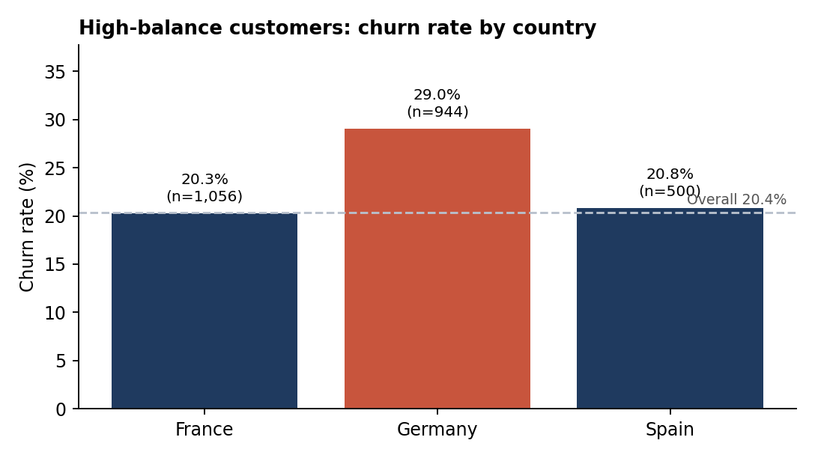
Figure 7. Churn rate among high-balance customers by country
High-balance customers (the top quartile, 2,500 customers) churn at 23.7%, 1.16 times the overall rate but no higher than other customers with a balance (24.3%). Churn is therefore not concentrated among the wealthy. The financial exposure, however, is large: 592 high-balance customers left, and they held 47.8% of all balances lost to churn.
Across the whole base, churned customers took about 185.6 million with them, 24.3% of the 764.9 million total balances. Within the high-value segment, risk follows the general pattern: Germany 29.0% vs about 20-21% in France and Spain, and inactive members 30.5% vs 16.9% for active members. Comparing salary tiers with balance segments shows churn within a balance segment barely changes with salary (about 22-25% in all salary terciles for balance-holders), so salary is not a useful targeting variable.

3.8 KPI summary
KPI | Value | Reading
Overall churn rate | 20.4% | 2,037 of 10,000 customers
High-value churn ratio | 23.7% (1.16x) | Top-quartile balance customers
Geographic risk index | DE 1.59 / ES 0.82 / FR 0.80 | Germany ~60% above average
Engagement drop indicator | 12.6 pp | Inactive 26.9% vs active 14.3%
Highest-risk segment | 67.3% | German customers aged 46-60
Balance at risk | 185.6M (24.3%) | Balances held by churned customers

4. Recommendations
- Prioritise customers aged 46-60. Design a dedicated retention programme (relationship-manager outreach, tailored savings and retirement-planning offers). This band is 16.5% of customers but 41.3% of churners.
- Investigate and act on the German market. Run a diagnostic (pricing, service quality, competitor offers, complaints) because the gap is not explained by age, gender or balance mix. Treat German 46-60 customers as the first pilot group.
- Build an inactivity early-warning trigger. Flag members who become inactive and launch reactivation campaigns before exit, starting with inactive customers over 45 (68-82% churn).
- Review product bundling. Encourage the move from one to two products (7.6% churn) but audit why customers holding 3-4 products almost all leave before pushing further cross-sell.
- Protect high-balance customers selectively. They are not more likely to leave, but each exit costs more; apply premium retention to inactive and German high-balance clients (30.5% and 29.0% churn).
- Do not target on credit score, tenure, salary or card ownership. These show little differentiation, so campaigns built on them would be inefficient.
- Investigate the gender gap. Women churn 8.6 points more in every country; review product fit and service experience for female customers.

5. Limitations
- Single snapshot: there is no time dimension, so churn timing, trends and seasonality cannot be studied, and relationships are associations rather than causes.
- No revenue, margin or cost data. Balance is used as a proxy for customer value, so "revenue at risk" is balance at risk, not lost income.
- The 3-4 product groups are small (326 customers); percentages there are less stable.
- Segment thresholds are analyst-defined, and different cut-offs would shift individual segment figures (not the overall conclusions).
- The dataset has only three countries and no reason-for-leaving field. Findings should be validated on the bank's own data before large-scale action.

6. Conclusion
Churn in this banking sample is not random: it is concentrated in identifiable groups, above all German customers, customers aged 46-60, inactive members and customers with unusual product holdings. Segment-specific analytics converts a single 20.4% churn figure into a prioritised action list. The accompanying Streamlit dashboard lets decision-makers filter by segment, recalculate KPIs and drill into these groups.

Appendix: using the dashboard
- Install Python, then run: pip install streamlit pandas plotly
- Place app.py and European_Bank.csv in the same folder and run: streamlit run app.py
- Use the sidebar to filter by geography, gender, age, credit, tenure, balance and activity; KPIs update automatically. Tabs: Overview, Geography, Age & Tenure, High-Value Explorer.

