**Write a CPU bound C program and a I/O bound C program and observe the effect of their CPU share using the top command and its variants.**



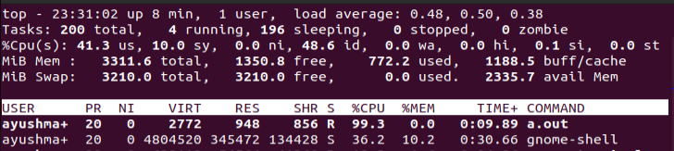

**CPU bound C program**

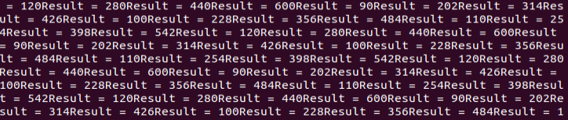

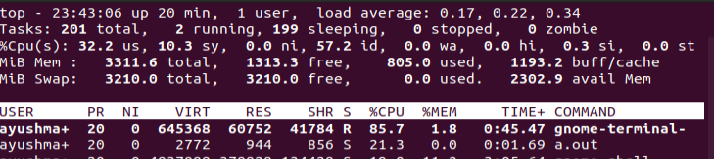

**I/O bound C program**

