Bc:- For using basic calculator.

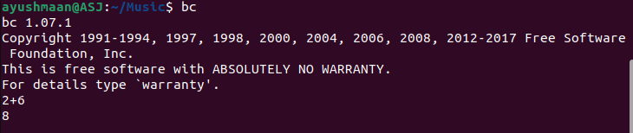

Cat:- open the file.



Cat –e :- Put $ at the end of line.



Cat 1filename>2filename:- To copy paste the file.

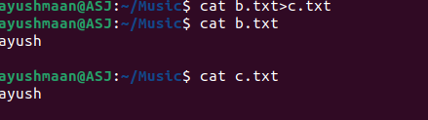

Cat 1filename>>2filename:- Add the content of 1 file in the 2 file.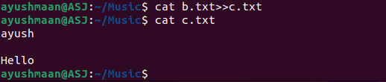

Cat –n:-To show the number of lines.



Cat >> filename:- It helps to write the content and then add that content with the previous content of the file.

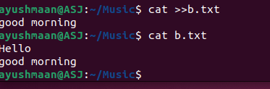

Cd <path>:- open a particular directory using path

Cd:- To go to home directory



Cp:- For copy and paste

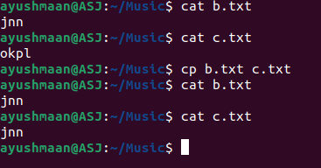

Cp –b 1filename 2filename:- To create a backup file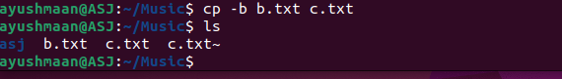

Cp -I :- To ask for the overwrite permission.

Cp –v 1filename 2filename:- To print the path

Grep –B1 “word” “filename”:- To print lower line.

Grep –c word filename:- Display the number of lines in which the given word is found

Grep –v word filename:- Delete the line containing the word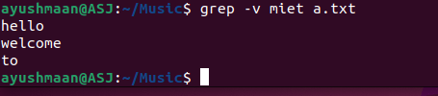

Mkdir –help:- To display the help related information.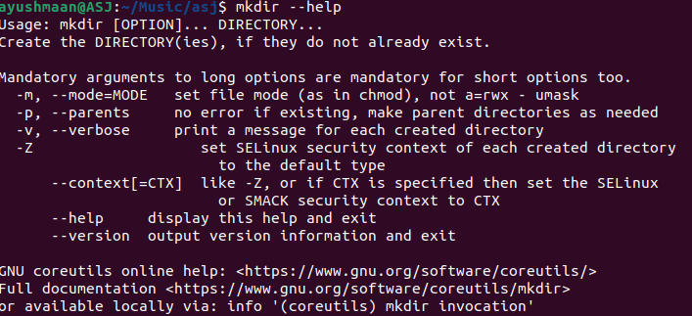

Mv –b :- For creating a backup also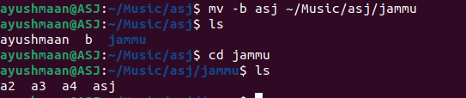

Mv- n:- check changes before running command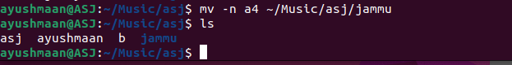

Mv:- to rename a file or directory.

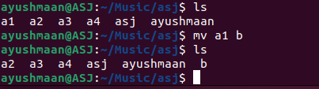

Nano:- To write content in a file.

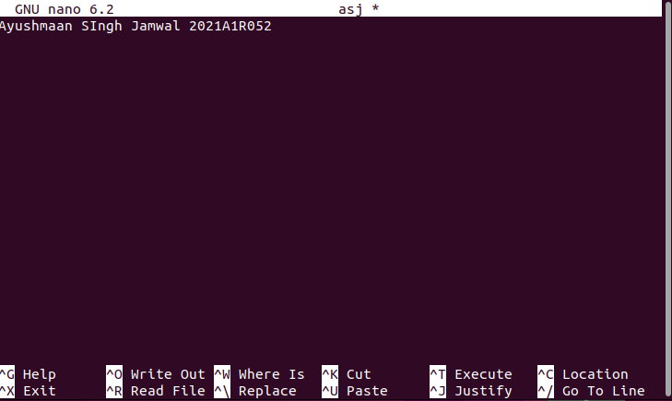

Rm \*.extension:- To delete the files with a particular extension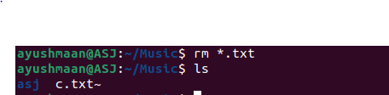

Ls:- To display all the folders

Rm -I \*.extension:- Ask for the permission to delete the files with a particular extension.

Tac 1filename 2filename:- Print the content of both the files in reverse order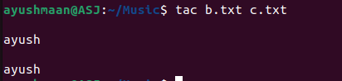

Touch:- To create a file.

Touch filename{from..to}:- To create multiple files.

Whoami:- print the username.



Rm filename:- To delete the file.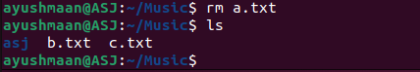

Pwd:- Print the current working directory



Cd..:- To move back to previous directory.



Cd:- To navigate between various directory.



Mkdir:- To create a directory.

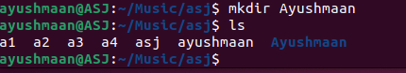

Mv –I:- Ask for the permission to overwrite.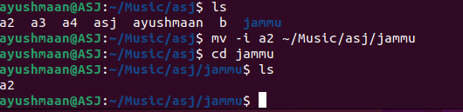

Ls-la:- Show all the files including the hidden files also.

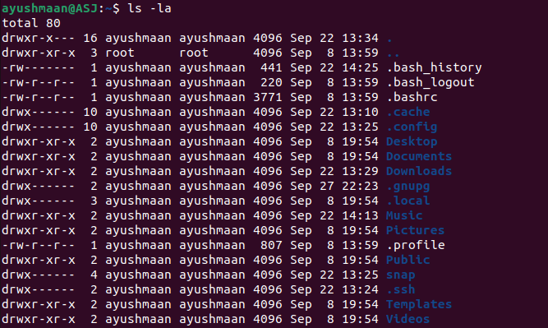

Grep word filename:- To highlight a word in the file.

Hostname:- Print the name of the host.



Rmdir :- To delete the directory

Grep –A1 “word” “filename”:- To Print the upper line

Grep –C1 “word” “filename”:- To print both upper and lower line.



Date:- Display day, date ,month , time and timezone.