PAYTRACK: MODERN FULL-STACK SALARY & PAYROLL MANAGEMENT SYSTEM
A MINI PROJECT REPORT

Submitted by

Name: A SOUJANYA LAKSHMI Regno: RA2411003040056

Name: DEEPAK K Regno: RA2411003040004

in partial fulfillment for the award of the degree
of

BACHELOR OF TECHNOLOGY

B.TECH IN COMPUTER SCIENCE AND ENGINEERING

of

FACULTY OF ENGINEERING AND TECHNOLOGY

Department of Computer Science & Engineering
Vadapalani Campus, Chennai

NOV 26

SRM INSTITUTE OF SCIENCE AND TECHNOLOGY
(Under Section 3 of UGC Act, 1956)

BONAFIDE CERTIFICATE

Certified to be the bonafide of the Project titled “PAYTRACK: MODERN FULL-STACK SALARY & PAYROLL MANAGEMENT SYSTEM” done by Mr/Ms Deepak K, RA2411003040004 and Soujanya Lakshmi, RA24110030040056 of B.Tech – Computer Science and Engineering, III Year / V Sem as a Partial Fulfillment of Degree of Bachelor of Technology in Computer Science and Engineering for the course 21CSE354T – FULL STACK WEB DEVELOPMENT during the academic year 2026 - 2027.

Date:

SUBJECT IN CHARGE SUBJECT IN CHARGE

ABSTRACT
Paytrack is an enterprise-grade, full-stack salary and payroll management web application engineered to automate workforce compensation workflows, minimize human accounting discrepancies, and provide real-time corporate financial visibility. Developed utilizing a modern three-tier architecture comprising an HTML5/CSS3 glassmorphic presentation layer, a resilient Node.js and Express.js RESTful application server, and a high-performance SQLite3 relational database with write-ahead logging, the platform centralizes core human resource operations. Key capabilities include comprehensive employee lifecycle management, automated salary advance and loan ledger reconciliation, attendance-driven unpaid leave deduction computation, single and batch payroll processing, dynamic salary slips with verifiable QR security seals, and export utilities supporting PDF and Excel formats. Furthermore, the system incorporates interactive visual analytics powered by Chart.js, dual-theme dark and light mode persistence, an instant salary arithmetic calculator, and tamper-resistant administrative audit logging to deliver a unified, compliant, and scalable enterprise payroll solution.
Keywords: Full-Stack Development, Payroll Automation, Node.js, Express.js, SQLite3, Salary Ledger, Attendance Deductions, Glassmorphism UI, Payslip Generation, RESTful API.

TABLE OF CONTENTS
CHAPTER / TOPIC TITLE | PAGE NO.
ABSTRACT | iii
1.0 INTRODUCTION | 1
1.1 PROJECT AIM AND OBJECTIVE | 2
1.2 SCOPE | 3
2.0 SYSTEM ANALYSIS | 4
2.1 SOFTWARE REQUIREMENT SPECIFICATION | 4
2.2 SYSTEM DESCRIPTION | 5
2.3 SOFTWARE AND HARDWARE USED | 6
3.0 SYSTEM DESIGN | 8
3.1 UML – USE CASE DIAGRAM OF FUNCTIONALITY | 9
3.2 FLOW CHART | 11
3.3 DATABASE SCHEMA & ENTITY-RELATIONSHIP DESIGN | 13
4.0 SYSTEM IMPLEMENTATION | 15
4.1 LIST OF MODULES | 15
4.2 MODULE DESCRIPTION | 15
4.3 USER INTERFACE | 19
5.0 CONCLUSION  5.1 FUTURE ENHANCEMENT | 24  24
6.0 REFERENCES | 25

1.0 INTRODUCTION
In modern commercial enterprises and institutional organizations, compensation disbursement and human resource accounting represent core operational pillars that directly govern employee satisfaction, organizational morale, and financial audit compliance. Historically, small-to-medium enterprises (SMEs) and growing corporations relied upon manual book-keeping techniques or decoupled desktop spreadsheets to compute monthly salaries, log advance requests, track unpaid absences, and issue compensation vouchers. However, as organizational structures scale and departmental specializations proliferate, manual spreadsheet workflows become inherently prone to mathematical formula errors, unauthorized ledger tampering, accidental data overwrite, lack of concurrency control, and tedious reconciliation delays.
Furthermore, contemporary fiscal management demands agile, transparent, and multi-channel audit trails. Enterprise accounting officers require instantaneous visibility into monthly aggregate payroll liability, departmental resource expenditures, outstanding loan and salary advance balances, and granular per-employee earnings breakdowns. The rapid evolution of full-stack web engineering—characterized by decoupled client-server architectures, RESTful communication protocols, high-concurrency event-driven backends, and lightweight embedded relational databases—offers an ideal technological paradigm to resolve these challenges. The Paytrack system is conceived and realized within this modern web engineering context, delivering a unified digital platform that automates the complete payroll lifecycle from employee onboarding to electronic payslip generation.

1.1 PROJECT AIM AND OBJECTIVE
The primary aim of this project is to architect and deploy a robust, secure, and automated full-stack payroll management system that eliminates manual computational inefficiencies in corporate compensation workflows. Its key objectives comprise developing an intuitive workforce directory, automating dynamic net salary calculations integrating advance loans and leave deductions, providing verifiable digital payslips, and delivering interactive financial analytics to enhance operational transparency and fiscal governance.
To accomplish this comprehensive aim, the project formulates the following tangible technical objectives:
1. Real-Time Full-Stack Architecture: Construct an end-to-end web system utilizing HTML5, modern CSS3 Glassmorphism, vanilla JavaScript ES6+, Express.js, and SQLite3 to guarantee instantaneous responsiveness without heavyweight runtime dependencies.
2. Automated Deduction Engine: Formulate algorithmic services that automatically retrieve outstanding employee advances and calculate pro-rated unpaid leave deductions based on exact per-day rates, seamlessly deducting them during monthly batch generation.
3. Multi-Channel Disbursal & Compliance: Integrate multi-modal disbursement classification (NEFT, IMPS, UPI, Cheque, Cash) alongside verified corporate payslips styled with dynamic dual-column earnings-versus-deductions breakdowns and embedded QR verification seals.
4. Visual Analytics & Reporting: Implement real-time dashboard visualizations featuring Chart.js bar and donut charts, automated audit trail logging, and one-click export utilities to standard Microsoft Excel (.xlsx) and printable PDF documents.

1.2 SCOPE OF THE PROJECT
The functional and technical scope of the Paytrack system spans organizational compensation administration across diverse commercial, educational, and technological enterprises. The system addresses the needs of multiple administrative stakeholders including Human Resources (HR) Executives, Payroll Officers, Finance Directors, and System Administrators. Specifically, the organizational and technical scope encompasses:
• Workforce Lifecycle Management: Comprehensive recording, updating, search-filtering, and soft/hard lifecycle tracking of corporate personnel across distinct corporate departments (Engineering, Product & Design, Marketing, Sales, Human Resources, Finance, and Operations).
• Advance & Loan Ledger Reconciliation: Real-time issuance of short-term employee financial advances, multi-month repayment scheduling, automated remaining balance tracking, and auto-settlement during payroll batch execution.
• Attendance & Absence Compensation Processing: Standardized recording of monthly paid and unpaid leaves, dynamic computation of per-day salary deductibles utilizing normalized 30-day corporate calendar metrics, and automatic ledger adjustments.
• Single & Batch Payroll Generation: Flexible processing engines capable of computing compensation on an individualized single-employee basis or across the entire active workforce simultaneously with transactional atomicity.
• Audit Trails & System Configuration: Persistent logging of every administrative action (sign-ins, profile edits, disbursals, advance deductions), coupled with customizable company profiles, authorized signatory details, and credential management.
• Boundaries and Limitations: In its current implementation, the application assumes a unified base corporate currency (configurable via company settings).

2.0 SYSTEM ANALYSIS
2.1 SOFTWARE REQUIREMENT SPECIFICATION
The Paytrack payroll application software requirement specification outlines the functional, computational, and technical criteria necessary for deployment across modern distributed environments. It mandates a responsive, cross-browser web interface for administrative operations, role-based authentication, and instant salary calculations without client-side latency. Core features encompass persistent employee record storage, advance repayment tracking, automated prorated leave deduction algorithms, and transactional payroll batch generation. The system relies on an event-driven Node.js execution runtime, Express.js middleware for RESTful JSON payloads, and an ACID-compliant SQLite3 database in write-ahead logging mode. Functional requirements govern core operations, starting with secure administrative authentication, session management, and real-time workforce directory CRUD capabilities. It automates financial loan deductions alongside dynamic leave adjustments using the standard formula: $\text{Leave Deduction}=\left(\text{Basic Salary}/30\right)×\text{Unpaid Days}$. Net salary is calculated via the model: $\text{Net}=\text{Basic}+\text{Bonus}-\text{Advance Deduction}-\text{Leave Deduction}-\text{Statutory Deductions}$. Single-click batch payroll generation processes active employees efficiently while avoiding database deadlocks or redundant writes. Document rendering features dual-column payslips with branding, vector PDF generation via jsPDF, browser print styling, and Excel export through SheetJS. Interactive analytics components provide visualizations for expenditure trends, disbursement statuses, and departmental allocations. Non-functional requirements establish performance benchmarks, targeting under 150 ms REST API response times and under 50 ms UI filtering latencies. Data integrity is enforced using foreign key constraints and WAL mode in SQLite3 to guarantee resilience during concurrent operations. Usability standards specify adaptive cross-device layouts with modern glassmorphism UI design and theme switching capabilities. Reliability focuses on persistent storage within a single portable paytrack.db file to enable rapid backups, migrations, and zero-downtime server restarts.

2.2 SYSTEM DESCRIPTION
Paytrack is designed around an enterprise 3-Tier Client-Server Architecture that cleanly decouples presentation, business logic, and data persistence layers. This modular separation of concerns ensures that frontend user interface components can evolve independently of server-side calculation rules, while relational database schemas maintain strict consistency and ACID compliance.
1. Presentation Tier (Client-Side): Implemented entirely in semantic HTML5, modern CSS3 utilizing CSS Custom Properties (CSS variables) and backdrop-blur glassmorphic aesthetics, and vanilla ECMAScript 6+ JavaScript. The client functions as a Single-Page Application (SPA) that manages UI state, coordinates modal views, performs live client-side input validation, renders interactive visual charts via Chart.js, and compiles vector documents via jsPDF and SheetJS without external framework bloat.
2. Application / Business Logic Tier (Server-Side): Engineered on the Node.js V8 JavaScript runtime utilizing the Express.js framework. The server exposes a comprehensive set of RESTful API endpoints exchanging structured JSON payloads. This tier handles administrative authentication, business calculation engines (such as pro-rated leave deduction and advance recovery scheduling), audit logging middleware, and request parameter sanitization.
3. Data Storage Tier (Persistence): Powered by SQLite3 through the high-performance `better-sqlite3` native C++ binding library. Unlike standard asynchronous drivers that incur event-loop queue overhead, `better-sqlite3` executes synchronous, blocking disk queries with sub-millisecond execution speeds. The database operates in Write-Ahead Logging (WAL) mode, permitting concurrent non-blocking reads while atomic writes take place, alongside strict foreign key enforcement.
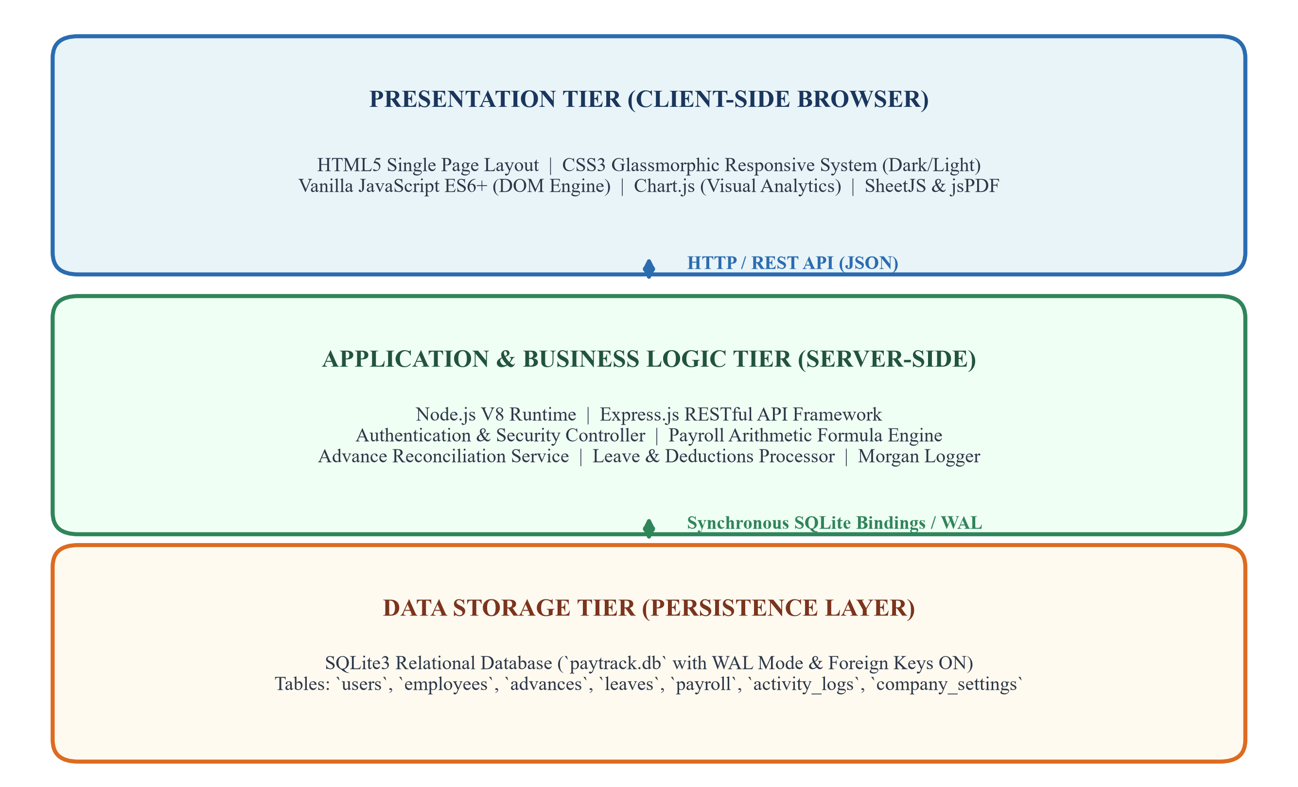
Figure 2.1: Three-Tier Web Application Architecture of Paytrack System
2.3 SOFTWARE AND HARDWARE USED
To ensure seamless execution, continuous integration, and rapid testing across both developer workstations and corporate production environments, the Paytrack platform specifies well-defined hardware and software configurations. The system is intentionally architected to maintain a minimal operational footprint, allowing it to execute smoothly on standard entry-level hardware while scaling effortlessly to multi-core server racks.
Table 2.1: Hardware Environment Specifications
Hardware Component | Minimum Requirement (Client / Host) | Recommended Specification (Server Host)
Processor (CPU) | Intel Core i3 / AMD Ryzen 3 (Dual-Core 2.0 GHz) | Intel Core i5 / AMD Ryzen 5 (Quad-Core 3.0+ GHz)
System Memory (RAM) | 4 GB DDR3 / DDR4 RAM | 8 GB / 16 GB DDR4 RAM
Storage (Disk) | 500 MB Free Space (HDD / SSD) | 10 GB Solid State Drive (NVMe SSD for fast WAL I/O)
Display Resolution | 1280 × 720 HD Resolution | 1920 × 1080 Full HD or Higher Display Monitor
Table 2.2: Software Technology Stack Specifications
Layer / Category | Technology / Software Tool | Version | Functional Role in Project
Operating System | Microsoft Windows / Linux / macOS | Windows 10/11, Ubuntu 22.04+ | Host deployment and execution OS
Backend Runtime | Node.js (V8 Engine) | v18.x to v22.x LTS | Event-driven asynchronous JavaScript runtime
Backend Framework | Express.js | ^4.21.2 | RESTful routing, JSON body-parser, HTTP middleware
Database Engine | SQLite3 (`better-sqlite3`) | ^11.8.1 | Synchronous, relational ACID database with WAL
HTTP Logger | Morgan | ^1.10.0 | Development and production HTTP request logging
Cross-Origin Engine | CORS Middleware | ^2.8.5 | Manages secure Cross-Origin Resource Sharing
Client UI Core | HTML5 & Modern CSS3 | Semantic & CSS3 Vars | Responsive glassmorphism UI, dual themes
Client Scripting | Vanilla JavaScript (ES6+) | Modern ECMAScript | DOM manipulation, API fetch async calls, state
Visual Analytics | Chart.js | v4.4.1 (CDN) | Canvas-based dynamic expenditure and donut charts
Document Generation | jsPDF & SheetJS (XLSX) | v2.5.1 / v0.18.5 | Client-side PDF compilation & Excel spreadsheet export

3.0 SYSTEM DESIGN
System design transforms functional and technical requirements into concrete architectural specifications, behavioral models, and data schemas. This section presents the formal design artifacts of Paytrack, comprising Unified Modeling Language (UML) Use Case diagrams defining operational actors, comprehensive system flowcharts mapping mathematical and transactional execution paths, and complete Entity-Relationship (ER) schemas modeling persistent relational data structures.

The system design of Paytrack is architected around an enterprise Three-Tier Client-Server Architecture comprising a decoupled presentation layer, a business logic application server, and an ACID-compliant persistence database. The Presentation Tier is engineered as a responsive Single-Page Application (SPA) using HTML5, modern CSS3 (featuring glassmorphism and CSS Custom Properties for instant dark/light theme switching), and vanilla ECMAScript 6+, which dynamically renders real-time analytics using Chart.js and generates client-side vector documents via jsPDF and SheetJS. The Application Tier runs on an event-driven Node.js runtime with an Express.js RESTful API framework that coordinates session security, administrative routing, request logging via Morgan, and the core arithmetic processing engine—automating prorated leave deductions $\left(\frac{\text{Basic}}{30}×\text{Unpaid Days}\right)$and reconciling amortized advance salary loans during single or bulk payroll runs. The Data Storage Tier relies on an embedded SQLite3 relational database (paytrack.db) operating via native C++ bindings (better-sqlite3) in Write-Ahead Logging (WAL) mode with strict foreign key constraints (ON DELETE CASCADE), ensuring sub-millisecond query performance, concurrent non-blocking reads, and referential integrity across the interconnected users, employees, advances, leaves, payroll, and activity_logs tables.

3.1 UML – USE CASE DIAGRAM OF FUNCTIONALITY
The UML Use Case model formalizes the functional interaction boundaries between human actors and the Paytrack software system. The primary actor is the **System Administrator / HR Payroll Officer**, who possesses administrative authority to manage employees, record financial advances, input leave balances, compute monthly payroll runs, disburse salary payments, and configure institutional branding settings. A secondary actor is the **Finance Auditor / Executive Management**, who interacts with analytical dashboards, monitors aggregate corporate expenditures, audits security logs, and exports certified financial reports.
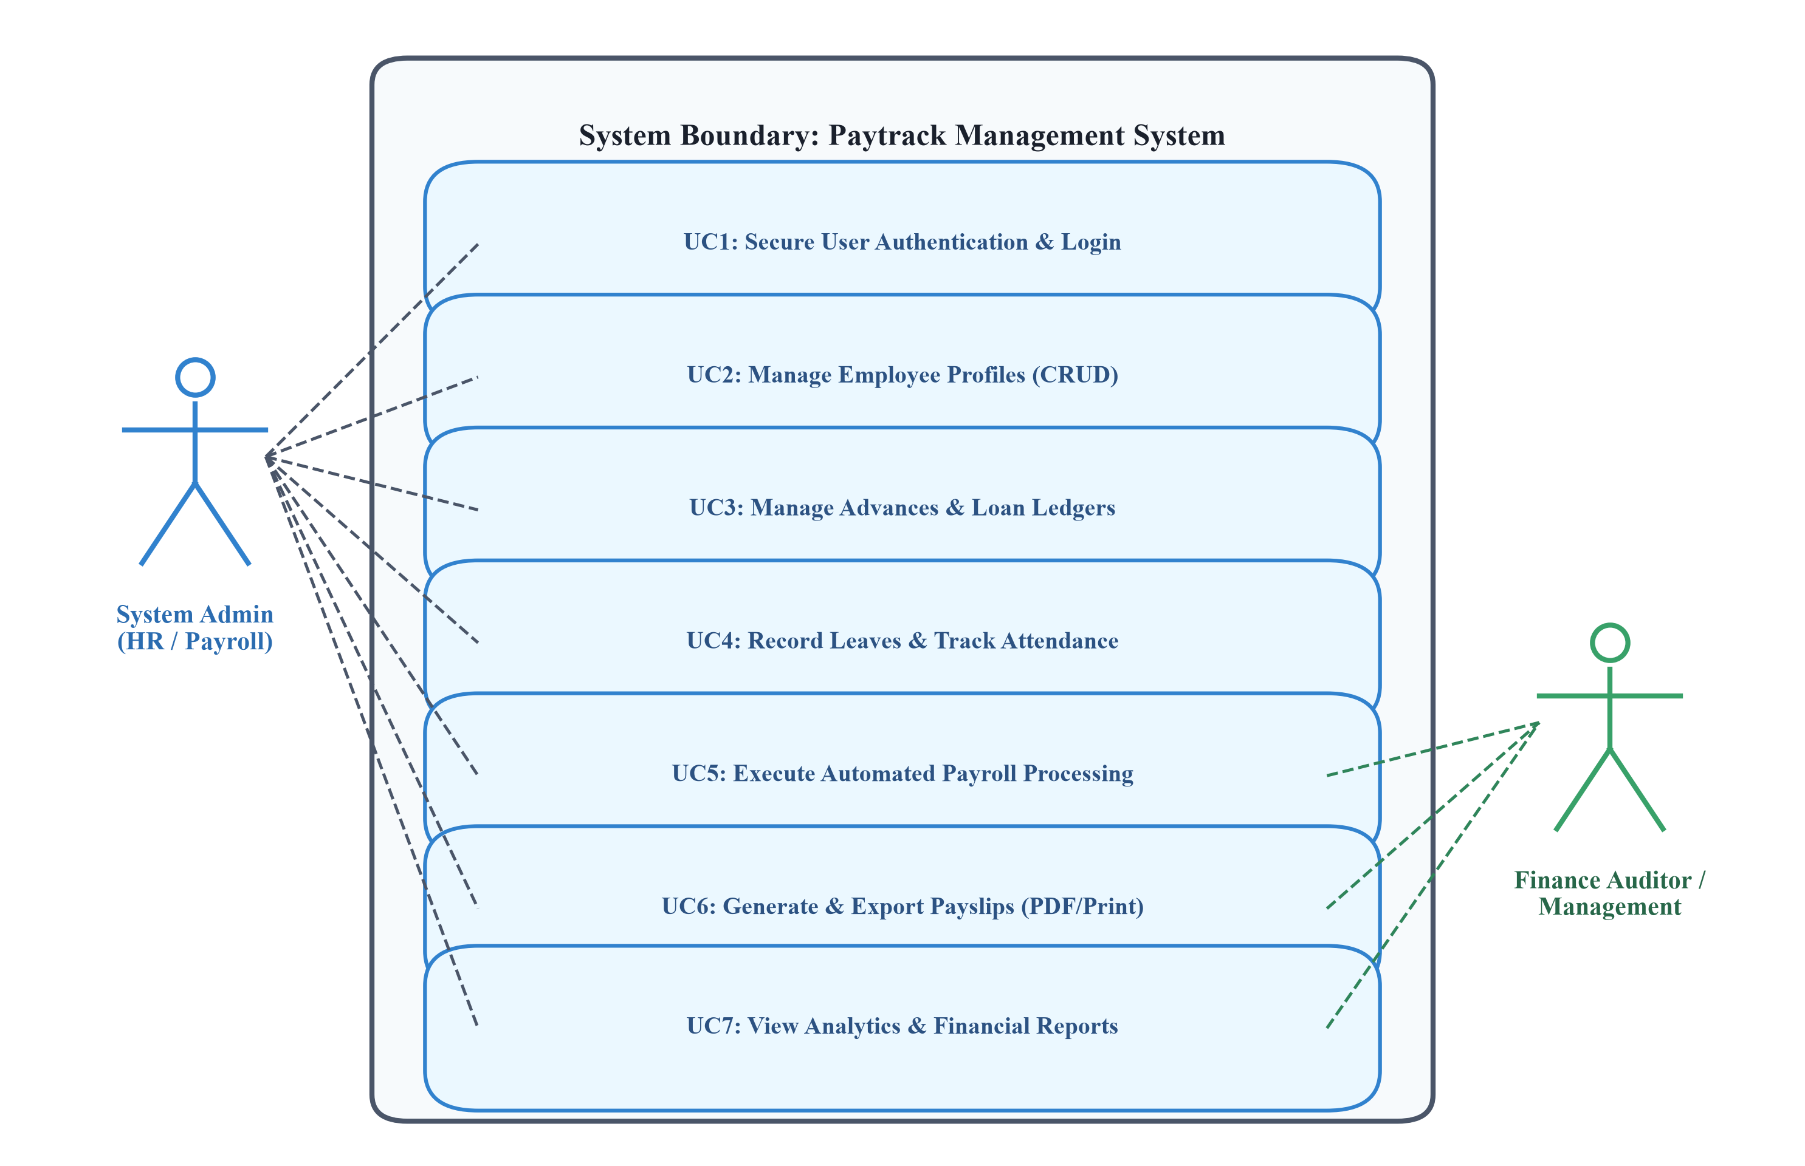
Figure 3.1: UML Use Case Diagram for Paytrack Management System

Table 3.1: Use Case Actor-System Interaction Matrix
Use Case ID | Use Case Title | Primary Actor | Pre-conditions | Main Success Scenario Summary
UC-01 | User Authentication | Admin / HR Officer | Valid credentials in DB | Admin enters username/password; system validates hash, creates session, and redirects to Dashboard.
UC-02 | Manage Employee Profiles | Admin / HR Officer | Authenticated Admin | Admin provisions employee with designation, department, and basic salary; system generates UUID and stores record.
UC-03 | Manage Advance Loans | Admin / HR Officer | Active Employee exists | Admin disburses loan; system initializes remaining balance and binds advance record to employee ID with status 'Open'.
UC-04 | Record Leaves & Deductions | Admin / HR Officer | Active Employee exists | Admin logs monthly unpaid absences; system calculates prorated deduction = (Basic / 30) * Unpaid_Days.
UC-05 | Automated Payroll Batch Run | Admin / HR Officer | Month/Year selected | System queries active workforce, applies advance balance & leave deductions, verifies Net >= 0, and saves run.
UC-06 | Salary Disbursal & Receipting | Admin / Finance Officer | Pending Payroll record | Admin selects payment mode (NEFT/UPI/Cheque) and enters transaction reference; status transitions to 'Disbursed'.
UC-07 | Generate & Export Payslips | Admin / Finance Officer | Payroll record exists | System renders branded payslip document with dual-column ledgers, QR seal, and triggers PDF download / print.

3.2 FLOW CHART
The system flowchart delineates the procedural execution logic governed by the Paytrack calculation engine during a monthly salary run. The algorithm guarantees transactional integrity by verifying that deductions do not exceed statutory limits, reconciling advance ledgers atomically, and preventing duplicate disbursement records for the same employee within the same calendar billing cycle.
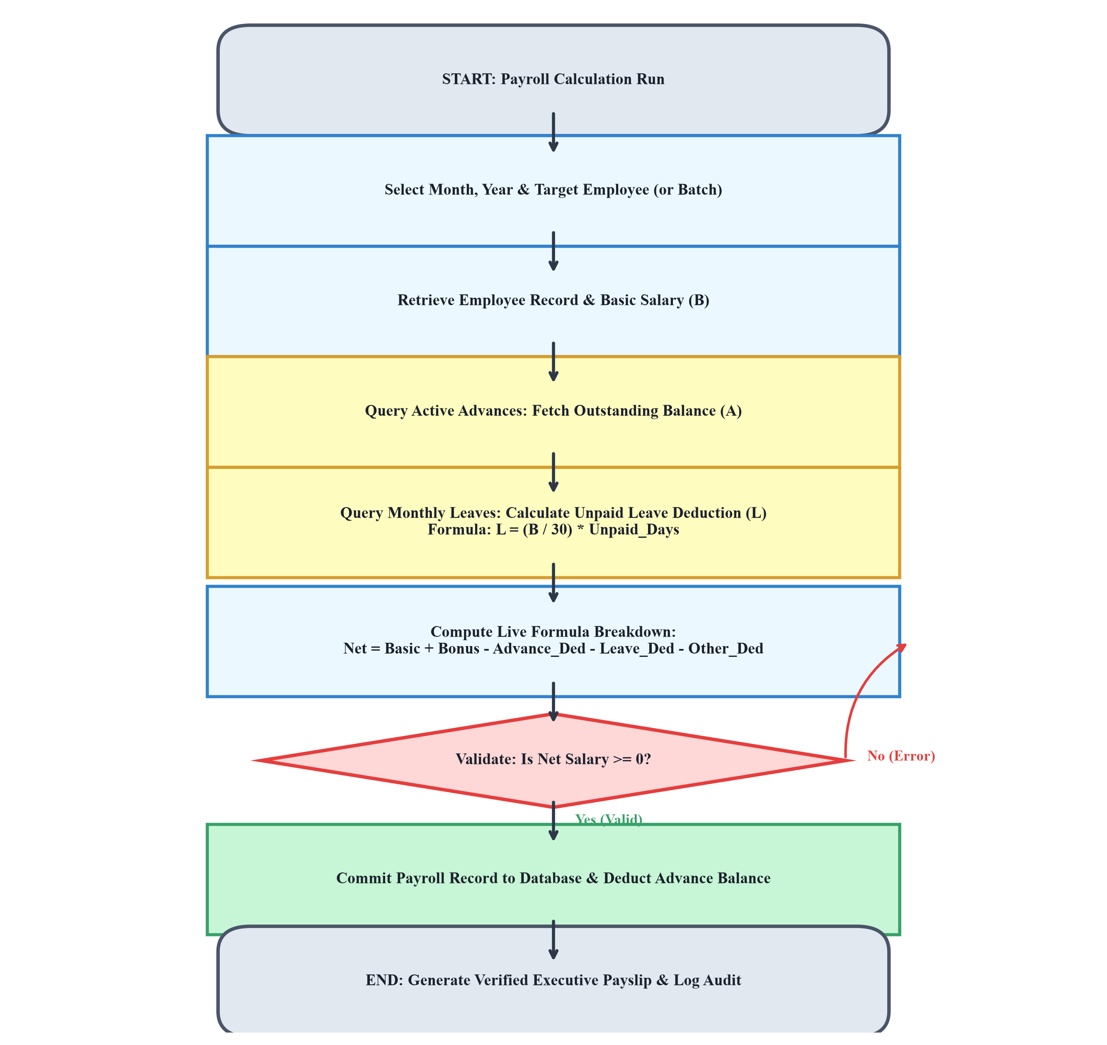
Figure 3.2: System Flowchart of Payroll Calculation and Disbursal Workflow

Algorithmic Execution Pipeline for Payroll Processing:
Step 1: Input Initialization — The administrator specifies the target calendar Month, Year, and employee scope (Individual vs Bulk Workforce).
Step 2: Employee Profile Retrieval — The server queries the `employees` table, validating that the target employee status is 'Active' and retrieving their agreed base compensation (Basic_Salary).
Step 3: Advance Ledger Lookup — The server queries the `advances` table for records matching `employee_id` with `status = 'Open'` and `remaining_balance > 0`. The system retrieves outstanding advance liability.
Step 4: Unpaid Leave Computation — The engine retrieves recorded unpaid absences from the `leaves` table for the specified period and computes the deduction: Leave_Deduction = (Basic_Salary / 30) × Unpaid_Leaves.
Step 5: Formula Evaluation — The system evaluates Net Disbursed Compensation: Net_Salary = Basic_Salary + Bonus - Advance_Deduction - Leave_Deduction - Other_Deduction.
Step 6: Mathematical & Business Validation — The system verifies that Net_Salary is non-negative (>= 0). If negative, the batch operation aborts with a descriptive validation error.
Step 7: Atomic Database Commit — Within a unified database transaction, the engine inserts the record into `payroll`, updates `remaining_balance` in `advances` (updating status to 'Settled' if balance reaches 0), and creates an audit entry in `activity_logs`.
Step 8: Document Compilation — The verified payroll entry becomes immediately available for digital payslip rendering, print media emission, and spreadsheet export.

3.3 DATABASE SCHEMA & ENTITY-RELATIONSHIP DESIGN
The relational database schema is normalized to Third Normal Form (3NF) to eliminate data redundancy, prevent update anomalies, and maintain referential integrity across the system lifecycle. The central parent entity is `employees`, which forms one-to-many (1 : N) relational foreign key associations with `advances`, `leaves`, and `payroll` tables, configured with cascading deletion rules.
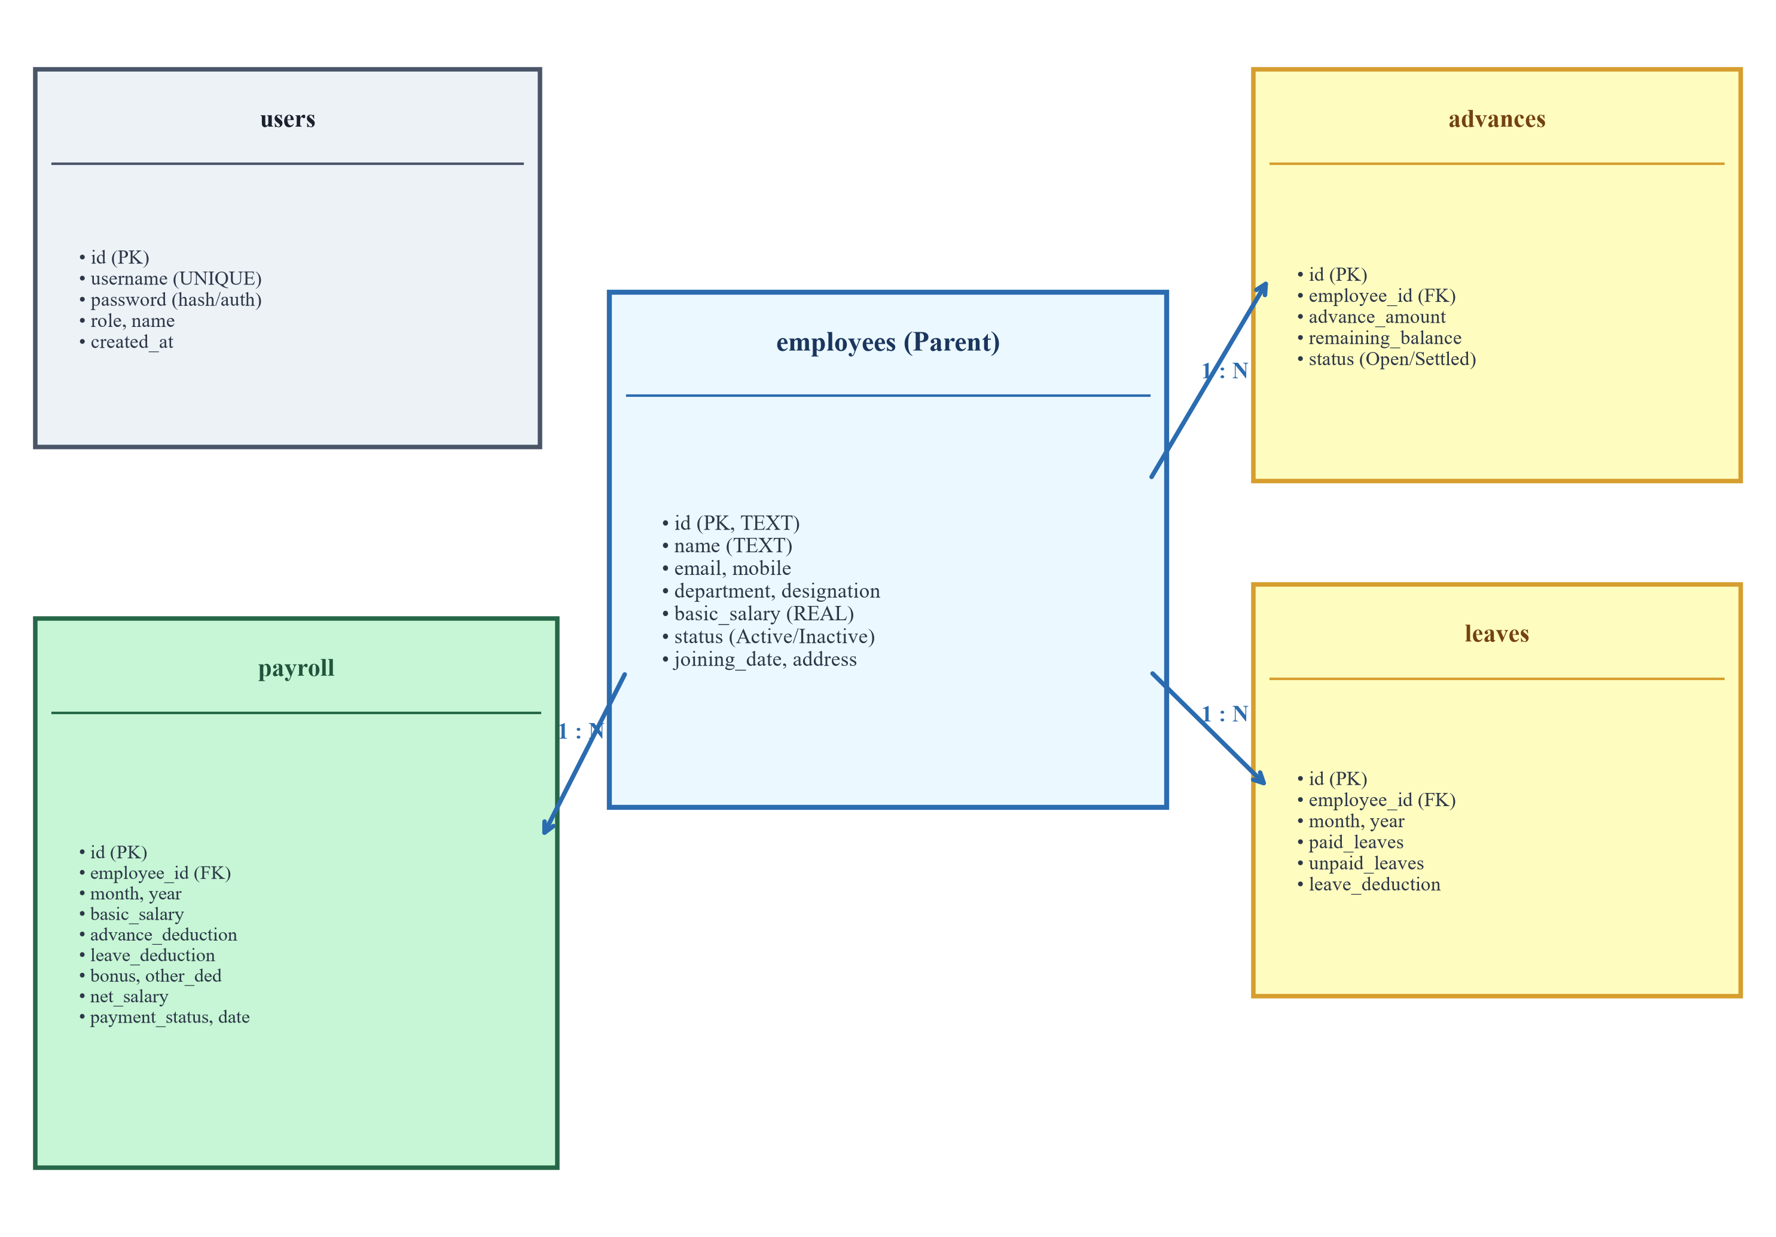
Figure 3.3: Database Entity-Relationship (ER) Diagram of Paytrack Database

Table 3.2: Database Data Dictionary — `employees` Entity
Column Name | Data Type | Constraints | Description
id | TEXT | PRIMARY KEY | Unique alphanumeric employee identifier (e.g. emp_k8j3x)
name | TEXT | NOT NULL | Full legal name of the employee
email | TEXT | NULLABLE | Official corporate email address for correspondence
mobile | TEXT | NULLABLE | Contact mobile telephone number
department | TEXT | NOT NULL | Assigned corporate department (Engineering, Sales, etc.)
designation | TEXT | NOT NULL | Corporate position / job designation title
joining_date | TEXT | NOT NULL | ISO date string representing date of corporate joining
basic_salary | REAL | NOT NULL, DEFAULT 0 | Agreed monthly base salary compensation
status | TEXT | DEFAULT 'Active' | Employment status flag ('Active' or 'Inactive')
address | TEXT | NULLABLE | Residential or official postal address
avatar_color | TEXT | NULLABLE | Hexadecimal theme accent color for UI card display
created_at | DATETIME | DEFAULT CURRENT_TIMESTAMP | Database record creation timestamp

4.0 SYSTEM IMPLEMENTATION
System implementation covers the technical translation of architectural models into executable full-stack software code. Paytrack is implemented using an asynchronous, event-driven Node.js and Express.js backend coupled with a modern, responsive vanilla JavaScript client-side application. This section delineates the core modular breakdown, deep module implementation mechanisms, RESTful endpoint architectures, and user interface implementations.
4.1 LIST OF MODULES
The Paytrack enterprise architecture is decomposed into eight cohesive, independently testable functional modules:
1. Module 1: Authentication & Access Control Subsystem
2. Module 2: Workforce Information & Employee Lifecycle Management Module
3. Module 3: Salary Advance & Loan Ledger Subsystem
4. Module 4: Attendance Tracking & Leave Deduction Engine
5. Module 5: Automated Payroll Computation & Bulk Disbursal Engine
6. Module 6: Executive Digital Payslip & QR Verification Generator
7. Module 7: Interactive Financial Analytics & Executive KPI Dashboard
8. Module 8: Security Audit Logging & System Configuration Subsystem
4.2 MODULE DESCRIPTION
• Module 1: Authentication & Access Control Subsystem — Manages administrator session initialization, credential verification against the SQLite3 database, and security header controls. Upon successful authentication, user identity tokens are maintained within browser storage, gating access to sensitive payroll operations. Password updates are protected through mandatory current-password validation.
• Module 2: Workforce Information & Employee Lifecycle Management — Provides comprehensive CRUD capabilities for corporate personnel. The module supports live dynamic filtering across departmental pills (Engineering, Design, Marketing, Sales, HR, Finance, Operations) and instantaneous full-text search across employee names, email addresses, phone numbers, and designations. It supports dual viewing modes: a compact tabular Data Grid and an interactive Visual Avatar Card Grid.
• Module 3: Salary Advance & Loan Ledger Subsystem — Governs employee advance requests, tracking disbursed capital, reason for advance, and amortized remaining balances. The system renders dynamic CSS progress bars showing debt liquidation percentage and automatically surfaces outstanding advance obligations during payroll calculation, preventing financial write-offs.
• Module 4: Attendance Tracking & Leave Deduction Engine — Normalizes monthly attendance into paid allowances and unpaid absences. The calculation engine automatically computes monetary leave deductions based on exact employee daily earnings rates, applying the formulaic standard: Leave Deduction = (Basic Salary / 30) × Unpaid Leave Days.
• Module 5: Automated Payroll Computation & Bulk Disbursal Engine — Serves as the core arithmetic clearinghouse. Administrators can execute real-time calculation previews or generate full batch runs for all active personnel simultaneously. Once processed, salaries transition through lifecycle states ('Pending' to 'Disbursed') upon logging payment modes (NEFT, IMPS, UPI, Cheque, Cash) and transaction reference codes.
• Module 6: Executive Digital Payslip & QR Verification Generator — Dynamically synthesizes high-fidelity compensation statements featuring corporate branding, GSTIN/tax credentials, dual-column earnings-versus-deductions breakdown, and embedded QR verification seals. Leveraging client-side jsPDF and CSS @media print styling, users can print or download vector-perfect PDF documents with a single click.

• Module 7: Interactive Financial Analytics & Executive Dashboard — Renders high-level corporate KPI metric cards (Total Workforce, Monthly Gross Disbursal, Active Advance Liability, and Pending Disbursal Counts) coupled with responsive Chart.js visual charts illustrating expenditure trends over trailing billing cycles and departmental headcount-cost donut distributions.
• Module 8: Security Audit Logging & System Configuration — Maintains an append-only audit trail in the `activity_logs` table, recording the exact timestamp, action type, description, and administrator ID for every critical mutation. Additionally, it permits dynamic customization of corporate metadata (Company Name, Tax ID, Address, Currency Symbol, and Authorized Signatory Title).

Table 4.1: Comprehensive REST API Endpoint Reference
HTTP Method | API Route Endpoint | Request Body / Params | Success Code | Operational Function
POST | /api/auth/login | { username, password } | 200 OK | Authenticates administrator and initializes session
GET | /api/dashboard/stats | None (Query params) | 200 OK | Fetches KPI metrics, monthly trend charts, & activity feed
GET | /api/employees | search, dept, status | 200 OK | Lists employee workforce with real-time query filters
POST | /api/employees | { name, dept, salary... } | 201 Created | Creates new employee profile in database
PUT | /api/employees/:id | { name, dept, salary... } | 200 OK | Updates existing employee information
DELETE | /api/employees/:id | URL id parameter | 200 OK | Cascading deletion of employee and bound records
GET | /api/advances | None | 200 OK | Lists advance loans and debt amortization progress
POST | /api/advances | { employee_id, amount... } | 201 Created | Disburses new salary advance and logs balance
GET | /api/leaves | month, year | 200 OK | Retrieves employee monthly attendance and deductions
POST | /api/leaves | { employee_id, unpaid... } | 201 Created | Records leave entry and applies deduction formula
POST | /api/payroll/calculate-preview | { employee_id, bonus... } | 200 OK | Executes live arithmetic computation preview
POST | /api/payroll/generate | { employee_id, month... } | 201 Created | Generates and commits individualized salary run
POST | /api/payroll/generate-all | { month, year } | 201 Created | Executes bulk batch payroll generation for all active staff
PUT | /api/payroll/:id/pay | { method, ref, date } | 200 OK | Transitions status to 'Disbursed' with payment details
4.3 USER INTERFACE
The Paytrack user interface is built on a responsive modern design system incorporating modern glassmorphism, CSS Custom Properties, and fluid layout grids. The UI provides a high-contrast dark theme by default, with an instant one-click toggle to a clean light theme persisted in local browser storage.
User Interface of Paytrack

The Paytrack user interface is a responsive Single-Page Application (SPA) designed with modern glassmorphism aesthetics, fluid transitions, and a persistent Dark/Light Mode theme switcher. The interface is organized into the following key screens and components:

1. Global Shell & Navigation:
Collapsible Sidebar: Direct access to Dashboard, Workforce Directory, Payroll, Advances, Leaves, Payslips, Reports, Logs, and Settings, along with active employee count badges.
Top Header Bar: Breadcrumb navigation, persistent billing period indicator, theme toggle switch, and a floating Quick Salary Calculator modal.

2. Executive Dashboard:
KPI Metric Cards: Real-time summaries for Total Workforce, Monthly Disbursal, Active Advance Liability, and Pending Approvals.
Interactive Charts (Chart.js): Monthly Expenditure Bar Chart (Paid vs. Pending) and Department Headcount & Cost Donut Chart.

3.Workforce Directory:
Live search filter (name, designation, contact) and department filter pills.
Switchable view: Modern Data Grid Table or Avatar Employee Cards Grid.
Profile management modals for adding, updating, or deleting employee records.

4. Salary Advance & Loan Tracker:
Ledger displaying disbursed advances, loan reasons, and status (Open vs. Settled).
Visual Debt Amortization Progress Bars showing remaining balances with auto- reconciliation during payroll runs.

5.Attendance & Leave Ledger:
Monthly attendance tracker recording paid and unpaid leaves with automated pro-rated absence deductions: $\text{Deduction} = \frac{\text{Basic}}{30} \times \text{Unpaid Days}$.

6. Payroll Calculation & Disbursal Center:
Single-employee and bulk batch processing engines.
Comprehensive breakdown table: Basic + Bonus $-$ Advance Ded $-$ Leave Ded $-$ Other Ded $=$ Net Disbursed Salary.
One-click disbursal modal supporting NEFT, IMPS, UPI, Cheque, and Cash transaction logging.

7. Executive Payslip Document Viewer:
High-fidelity formal payslip with corporate branding, dual-column earnings vs. deductions ledger, net payable callout in words, and embedded QR Verification Seal.
Instant export options via Browser Print (`@media print`)and Vector PDF Download (jsPDF).

8. Financial Reports & Audit Trail:
Period-wise financial summary tables with one-click Excel (`.xlsx` via SheetJS) export.
Tamper-evident Security Audit Logs detailing every administrative action with timestamps.

The following figures present the operational interfaces of the application:
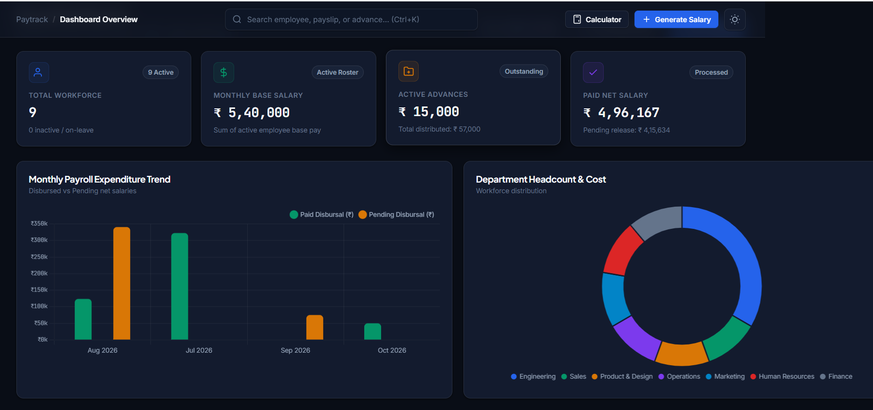
Figure 4.1: Paytrack Interactive Dashboard and Real-Time Financial Analytics UI
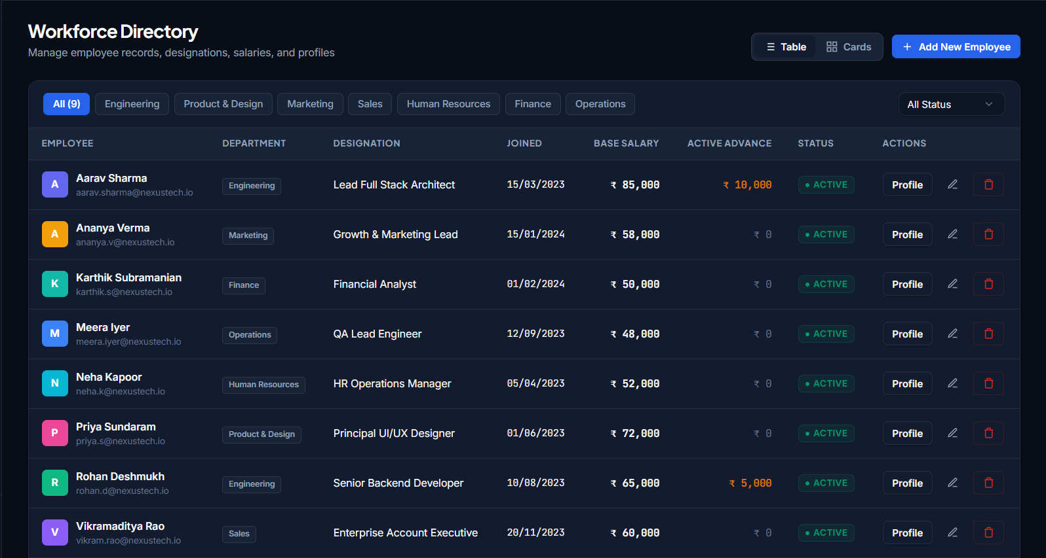
Figure 4.2: Workforce Directory and Employee Lifecycle Management Interface
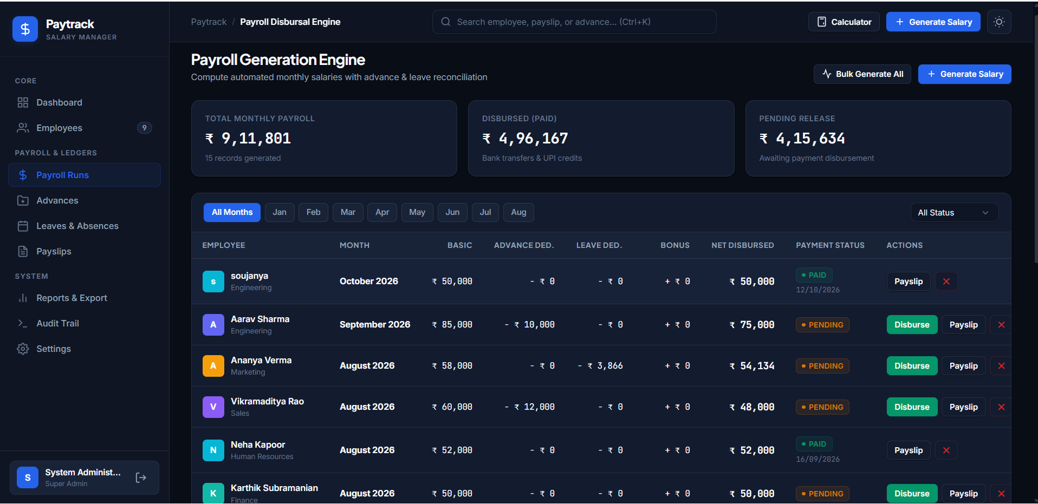
Figure 4.3: Automated Payroll Batch Processing and Disbursal Interface
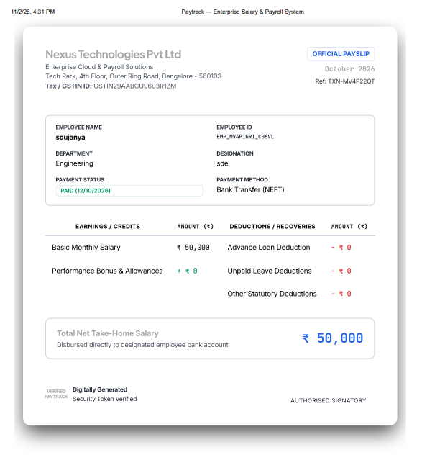
Figure 4.4: Executive Payslip Document with QR Verification Seal and Dual Ledger
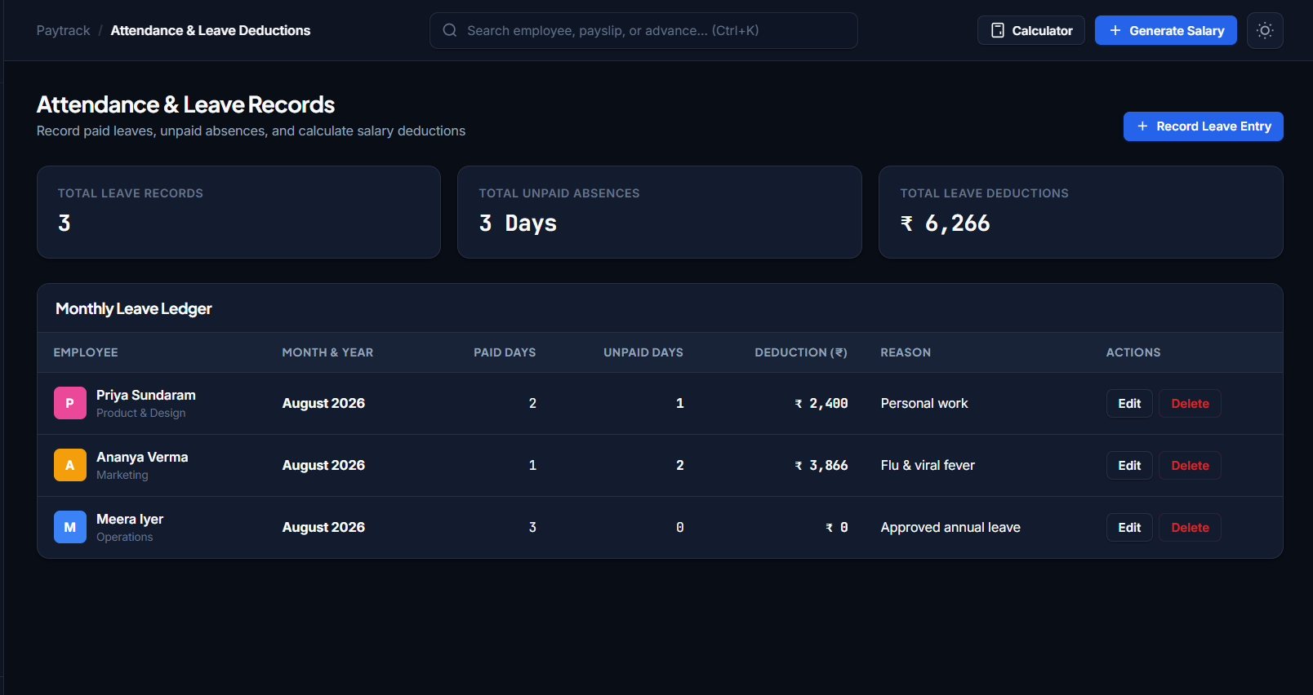
Figure 4.5: Attendance & Leave Records
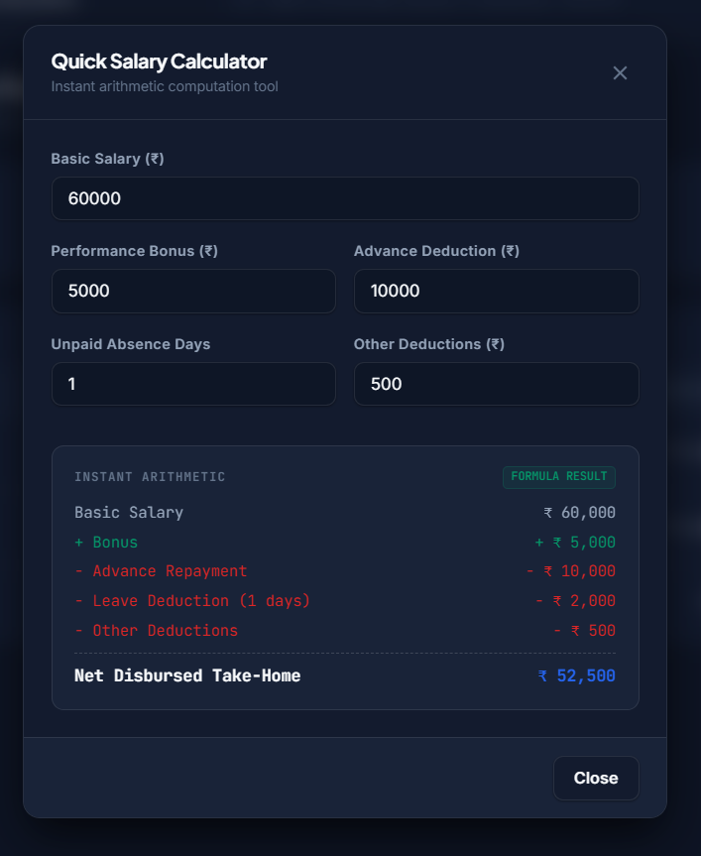
Figure 4.6: Quick Salary Calculator

5.0 CONCLUSION
The Paytrack Full-Stack Salary & Payroll Management System successfully demonstrates how modern web engineering standards can transform traditional, error-prone manual compensation ledgers into a secure, automated, and real-time enterprise workflow. By coupling an agile vanilla JavaScript Single Page Application with an event-driven Node.js and Express.js RESTful backend and a high-concurrency SQLite3 database operating in Write-Ahead Logging mode, the project achieves exceptional operational performance, sub-millisecond data transactions, and robust data integrity.
The platform effectively solves core business bottlenecks by automating complex mathematical calculations—including prorated unpaid leave deductions and multi-month advance debt amortizations—while eliminating human computational mistakes. Furthermore, executive decision-making is strengthened through interactive Chart.js analytics, instantaneous spreadsheet export capabilities via SheetJS, verifiable vector PDF payslip compilations with QR security seals, and non-repudiable audit logging.
5.1 FUTURE ENHANCEMENTS
While the current release of Paytrack provides an exhaustive feature set for small-to-medium enterprise administration, future research and development will focus on the following strategic extensions:
1. Biometric IoT & Attendance Sensor Streaming: Integrating direct hardware telemetry protocols (MQTT / WebSockets) to capture real-time biometric fingerprint and facial recognition time-clock events without manual monthly leave entry.
2. Employee Self-Service Mobile Application: Developing a progressive web app (PWA) or native React Native / Flutter client allowing individual employees to submit leave applications, request salary advances, and download personal payslips securely.
3. Statutory Tax Filing & Regulatory Compliance Engine: Incorporating automated jurisdiction-specific tax computation algorithms.

6.0 REFERENCES
[1] M. Haverbeke, Eloquent JavaScript: A Modern Introduction to Programming, 3rd ed. San Francisco, CA: No Starch Press, 2018.
[2] E. Brown, Web Development with Node and Express: Leveraging the JavaScript Stack, 2nd ed. Sebastopol, CA: O'Reilly Media, 2019.
[3] D. Flanagan, JavaScript: The Definitive Guide: Master the World's Most-Used Programming Language, 7th ed. O'Reilly Media, 2020.
[4] R. Fielding, "Architectural Styles and the Design of Network-based Software Architectures," Ph.D. dissertation, Dept. Inf. Comput. Sci., Univ. California, Irvine, CA, 2000.
[5] D. R. Hipp, "SQLite: Small. Fast. Reliable. Choose any three," SQLite Consortium Documentation, 2024. [Online]. Available: https://www.sqlite.org.
[6] J. Long, better-sqlite3: The fastest and simplest library for SQLite3 in Node.js, GitHub Repository, 2024. [Online]. Available: https://github.com/WiseLibs/better-sqlite3.
[7] Chart.js Documentation, "Simple yet flexible JavaScript charting library for designers & developers," Chart.js Consortium, 2024. [Online]. Available: https://www.chartjs.org.
[8] J. Mrkvicka and J. Owens, jsPDF: Client-side JavaScript PDF generation, Parallax Inc., 2024. [Online]. Available: https://github.com/parallax/jsPDF.
[9] SheetJS LLC, "SheetJS Community Edition: Spreadsheet Data Toolkit," 2024. [Online]. Available: https://sheetjs.com.
[10] W3C, "CSS Flexible Box Layout Module Level 1 & CSS Grid Layout Module Level 2," World Wide Web Consortium (W3C) Recommendations, 2023.

