1. The number of states within the state space depends on the level of detail in the grid employed for plane representation. When we adopt a grid-based approach, that is designating each grid corner as a unique state, the state count corresponds to the grid's cell count. However, given that this problem corresponds to a continuous state space, the number of states are not defined (infinitely many) since (x, y) can take on limitless values.
2. The most efficient path between two points is typically a direct line, but when obstacles or hindrances make a straight route impractical, the next best option involves constructing a path from a series of connected line segments. These segments are strategically chosen to minimize deviation from the ideal straight line. When confronted with obstacles, our goal is to discover a path that minimizes deviations from a straight line, optimizing efficiency and reducing overall travel distance while circumnavigating obstacles.

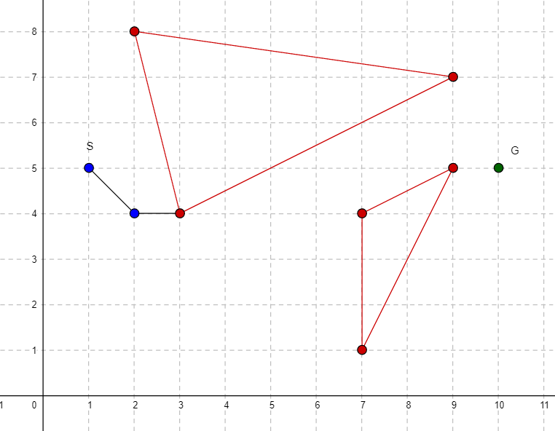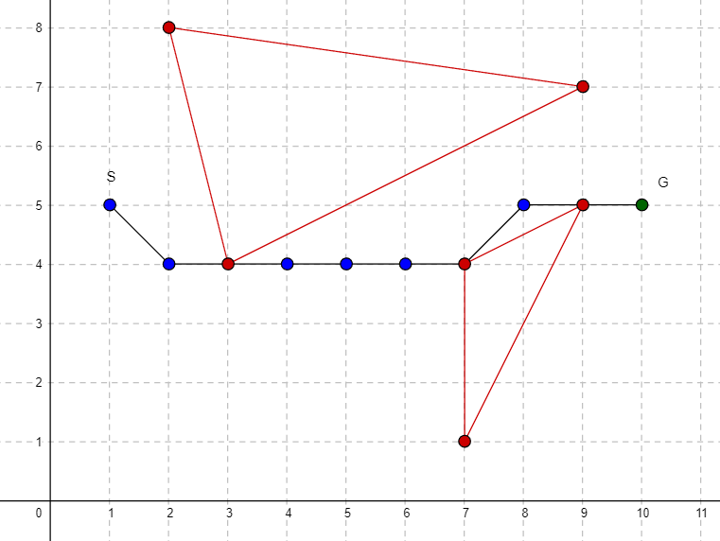

The successor function is given by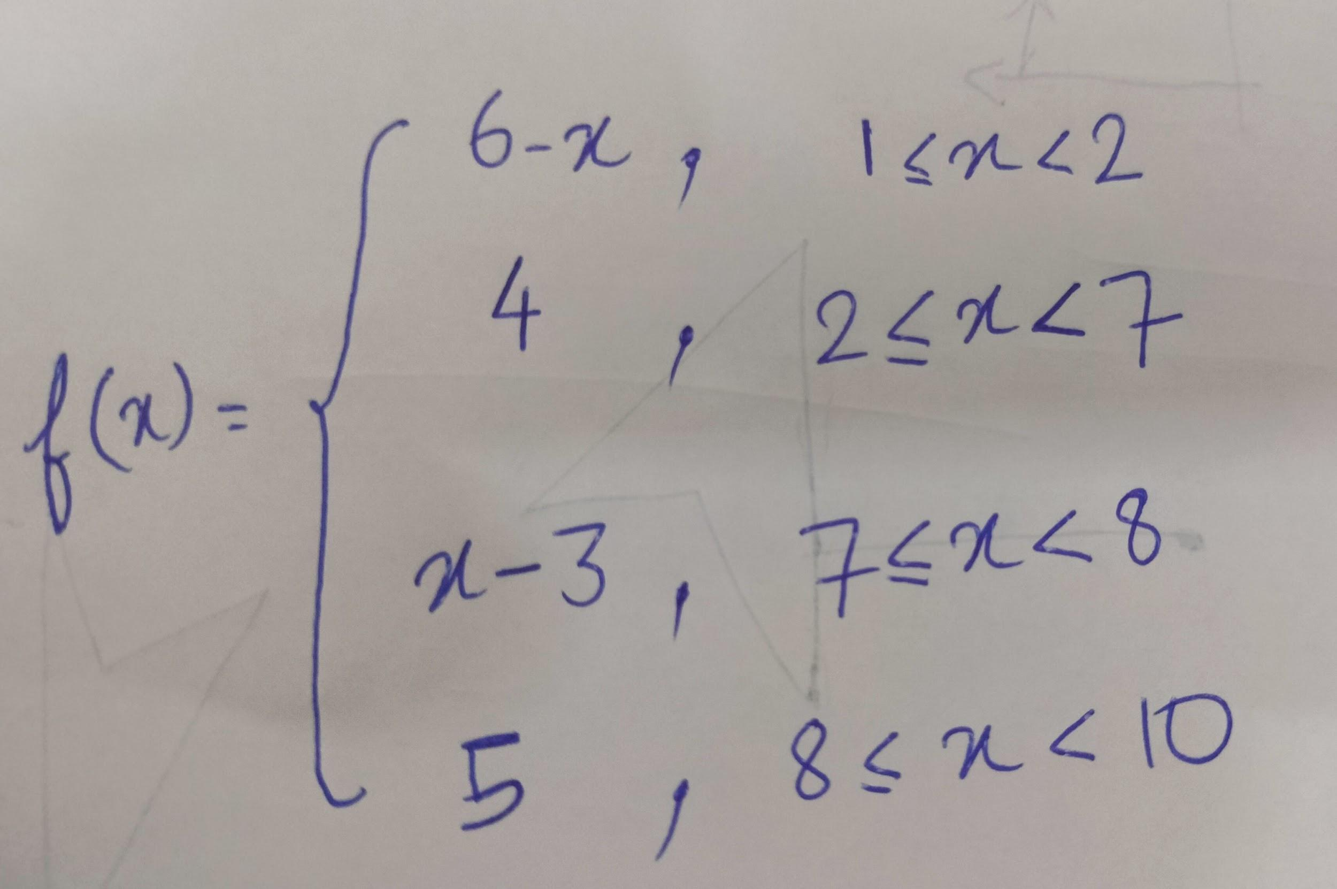

1. Hill-climbing, a basic optimization algorithm, is used to navigate a search space with the objective of reaching a specific goal state. The process initiates from an initial state and progresses iteratively by selecting a neighboring state that minimizes a designated heuristic function, with the ultimate goal of attaining the endpoint characterized by the lowest heuristic value. Nevertheless, the efficiency of hill-climbing depends on the geometry of the search space and the quality of the employed heuristic function. In instances where the search space encompasses multiple local minima, the algorithm may get stuck in one of these minima and fail to attain the global optimum. Furthermore, if the heuristic function lacks precision or fails to accurately depict proximity to the endpoint, it can lead the algorithm astray. To sum up, hill-climbing offers a straightforward approach for reaching an endpoint, but its success cannot be assured in non-convex search spaces, where it may become entrapped in local optima, or when the

reliability of the heuristic function is questionable.

1. Here if we pick euclidean distance as the heuristic function, then when we reach the state (4,4) we have two choices move to (5,5) or (5,4) but as (5,5) is closer to goal than (5,4) the algorithm picks (5,5) as the next state. 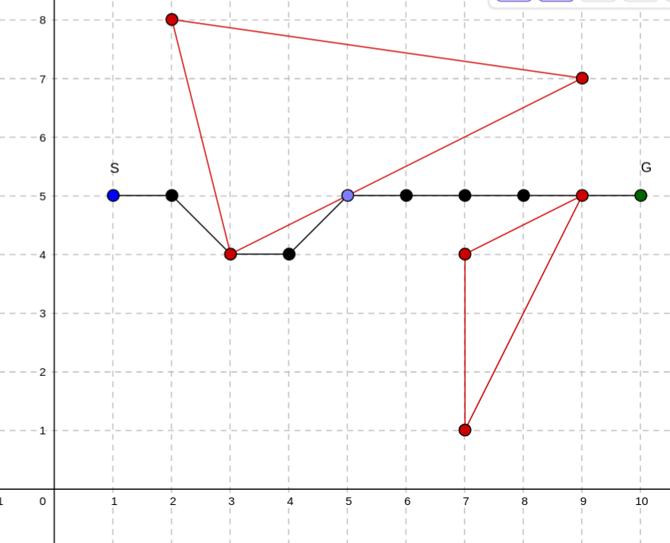
2. Convexity is a characteristic of a set of points in Euclidean space where, in simple terms, any straight line drawn between two points within that set stays entirely within the set itself. In other words, if you have a convex shape, any two points inside it can be connected by a straight line that doesn't leave the shape.

Now, when we encounter non-convex obstacles, it can cause trouble for algorithms like hill-climbing. These obstacles can create situations where the algorithm gets stuck in local high or low points (in this case, typically low points), making it difficult to discover the best paths. Think of it as a scenario where you have narrow passages or grooves. The algorithm might start off well but then become trapped in these tight spaces. It often struggles to realize that there are better paths outside of these immediate surroundings, leading to less-than-optimal solutions.

This limitation arises because hill climbing primarily relies on what's happening nearby, unable to see beyond obstacles that are close by. As a result, non-convex obstacles present significant challenges, illustrating how local high or low points can obstruct the algorithm's ability to find the best overall solutions in problems like path planning. I have made some changes in the given problem to introduce a non-convex obstacle. When the agent encounters this obstacle, it faces a unique situation—it can only explore a fraction of its usual neighborhood. This restriction occurs because some part of the neighborhood is within the obstacle itself.

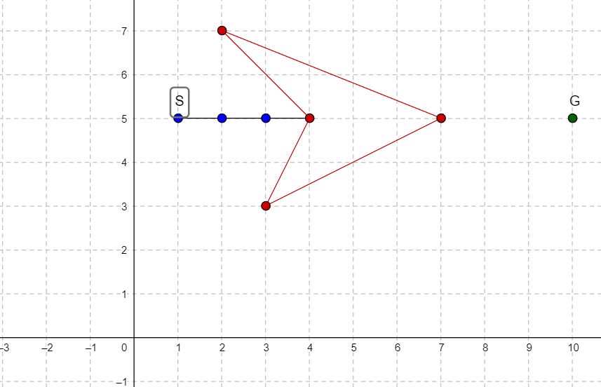

In this constrained state, the agent finds itself in a pinch. Every move it attempts results in an increase in the Euclidean distance to the goal, which goes against its main goal of getting closer to the target. As a result, the agent becomes immobilized and incapable of making any further progress.