TY B.Tech. (CSE) – II [ 2024-25]

6CS371

Advanced Database System Lab.

Assignment No. 8

NAME: PRITI SUNIL DESAI

PRN NO.:22510062

1. Do the installation and configuration of Oracle/MySQL/IBM DB2 distributed databases. [ Take minimum 3 nodes ]

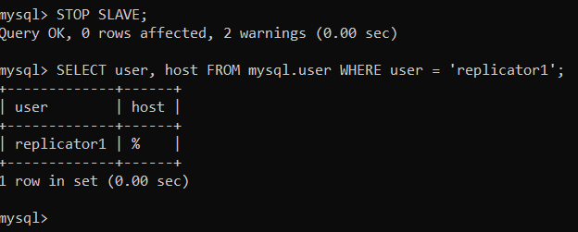

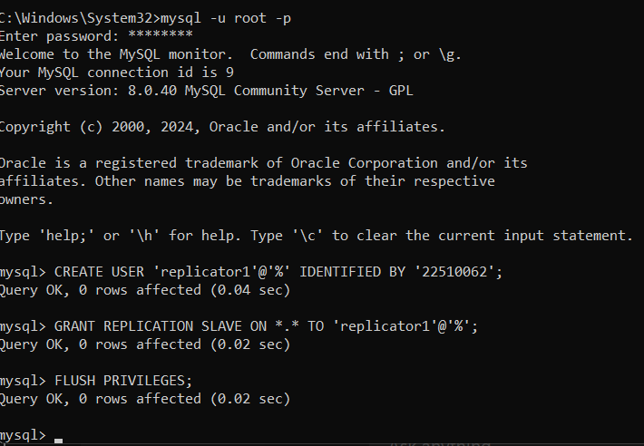

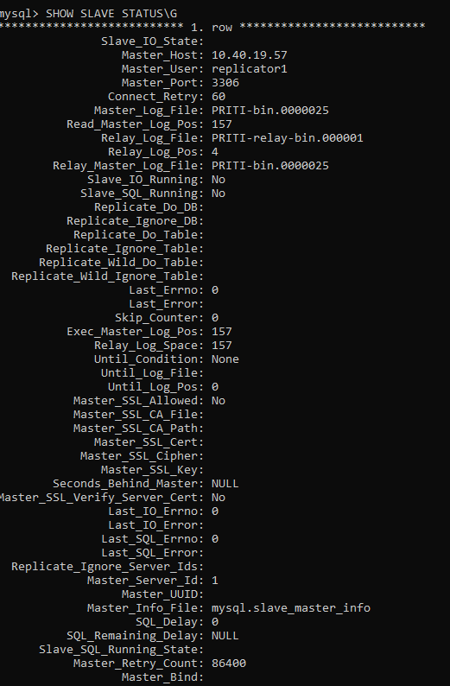

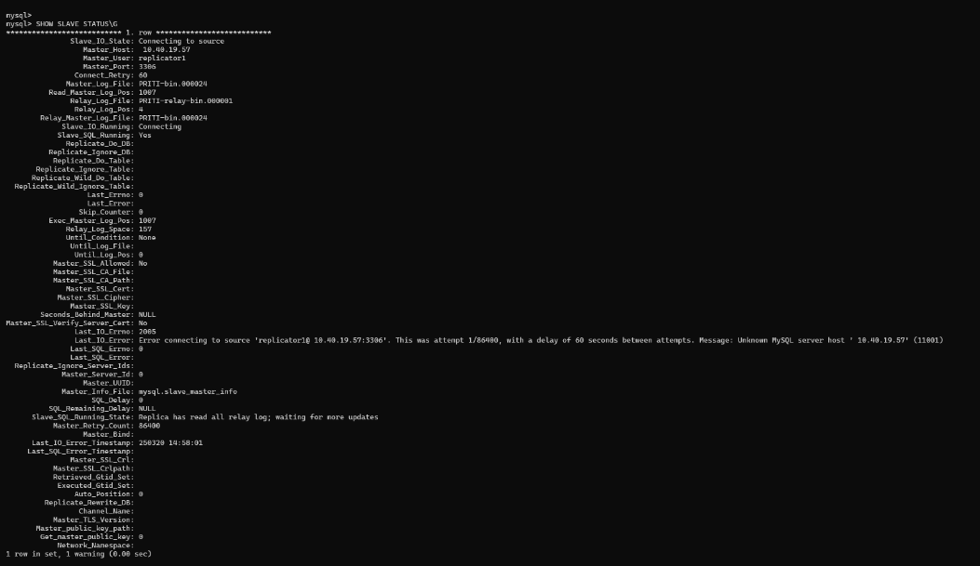

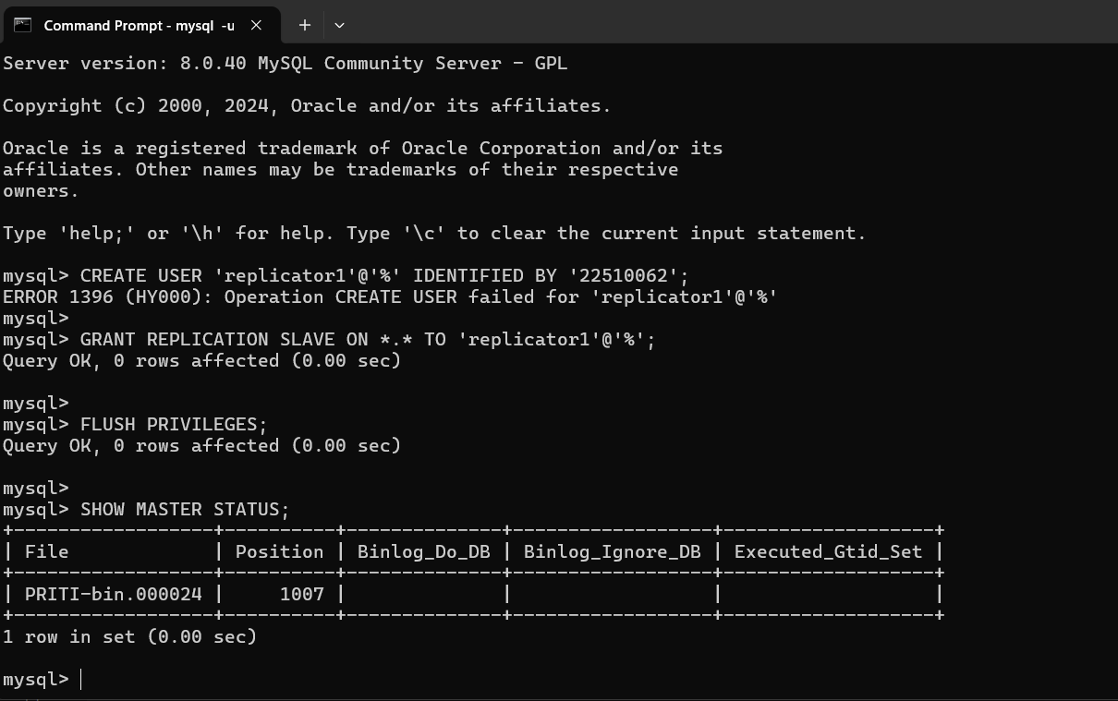

2. Use the above installed distributed database as backend for Assignment No.3 & 4.

3. Demonstrate the working by connecting portals to different nodes, adding data from one node and available / display on portal connected to another node etc.

=>Teammates: Priti Desai [22510062], jasmine Sayyad [22510033], Aadarsh Nandedkar [22510047]

**Designed Architecture**:

So we setup environment of four nodes one is management node, two data nodes and one sql node.

1. Machine 1: Management Node (ndb_mgmd) - IP: 10.40.19.57

- This node manages cluster configurations and coordinates operations.

2. Machine 2 and 3: Data Node (ndbd) - IP: 10.40.3.99

- This node stores the actual data and handles transactions.

3. Machine 4: SQL Node (mysqld) - IP: 10.40.15.92

- This node provides MySQL query access to applications.

So basic steps followed on each PC’s:

1. On all nodes we have installed MySQL NDB Cluster 9.0
2. On all nodes all have created mysql-cluster folder inside C folder and created two main folders one for configuration and one for data.
3. In configuration folders:

On management node we have created config.ini file consisting the basic setup of all data nodes and management node.

On data node we have created my.ini file that defines connection string that defines the IP address of management node in order to connect to the cluster.

1. Through commands prompts we have connected in cluster and MySQL Command Line Client connected to database and performed basic CRUD operations.

Step 1: Installation of NDB Cluster form official MySQL website

Step 2: Configuration on management node

Creation of config file:

1. Open Notepad as administrator and save the file as All files with .ini extension

Content of config.ini

[ndbd default]

NoOfReplicas=2

DataMemory=80M

IndexMemory=18M

[ndb_mgmd]

hostname= 10.40.19.57

datadir=C:\mysql-cluster

[ndbd]

hostname= 10.40.3.99

# Data Node 1

NodeId=2

datadir=C:\mysql-cluster\data

[mysqld]

Hostname=10.40.15.92# SQL Node

1. Start the management node

Open command prompt, run as administrator and run this command:

ndb_mgmd -f C:\mysql-cluster\config.ini

Step 3: Configuration of Data node

1. Creation of config file content: Open notepad create my.ini file and write below

[mysqld]

ndbcluster

[mysql_cluster]

ndb-connectstring=10.40.19.57

1. Starting data node:

ndbd --connect-string="nodeid=2,10.40.2.79:1186"

node id changes per node

Step 4: Configuration of SQL Node

1. Editing my.cnf file

Open terminal and execute below command:

sudo nano /usr/local/etc/my.cnf

Content of file:

[mysqld]

ndbcluster

[mysql_cluster]

ndb-connectstring=10.40.0.94

Step 5: Restarting MySQL service

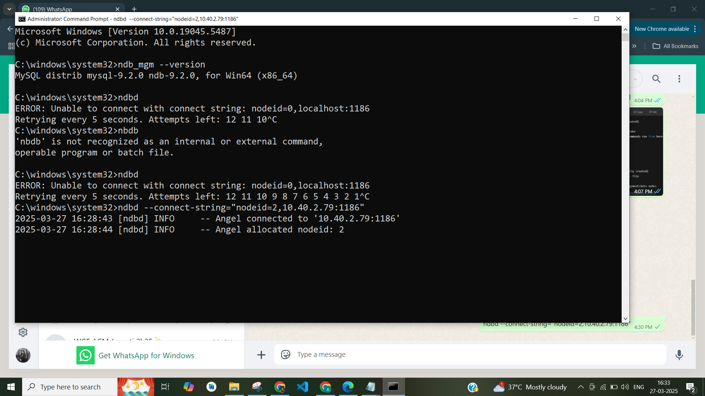

Step 7: So the SQL node will create test database and table

CREATE DATABASE testdb;

USE testdb;

CREATE TABLE users (

id INT PRIMARY KEY AUTO_INCREMENT,

name VARCHAR(100),

email VARCHAR(100)

) ENGINE=NDB;

Step 8: After adding to application

