ABSTRACT

As the internet usage grew rapidly, the number of cyber threats in the digital landscape also increased significantly, and phishing and distributing malware through malicious URLs are quite common cyber threats. This is a lightweight and interpretable machine learning based system to detect malicious URLs and assess the risk level of the URL. We compiled a balanced dataset consisting of 632,508 malicious and benign URLs, from which we trained a Random Forest classifier (50% malignant and 50% benign labels) to categorize URLs according to lexical characteristics, including length, count of special characters, Shannon entropy, and presence of suspicious keywords.
This approach incorporates two risk-scoring mechanisms for better explainability and actionability: probability-based scoring and custom weighted scoring. A model trained in this project will be integrated into a Flask-based web application, which supports real-time URL analysis by making the application user-friendly and allowing users to input any given URL for classification (either as malicious or benign), its risk score, and corresponding risk category. The system attains high accuracy of 98.8% with feature importance analysis while being transparent. This paper presents the practical application of a machine learning technique in solving cybersecurity, offering a strong alternative to deal with URL-based attacks.
Keywords: Machine Learning, URL Classification, Random Forest, Cybersecurity, Malicious URLs, Risk Scoring, Flask Application, Lexical Features, Shannon Entropy, Feature Importance.

Chapter 1: Introduction

1.1 Introduction and Problem Summary

As people increasingly rely on the internet for personal, professional, and financial transactions, this has opened up vulnerabilities that cybercrime can exploit. One of the most common vectors used in malware, phishing attacks, and fraud is malicious URLs. Therefore, the detection of such URLs is very crucial to cybersecurity and protects users and organizations from emerging threats.

The traditional system of detection, like blacklist, works well with known threats but fails to adapt the new and sophisticated attacks, and especially those with dynamically generated URLs. These systems tend to rely on external sources of data and APIs which introduce latency and reduce one's control. Current systems operate without transparency in decision making, which makes it difficult to trust and interpret results among users.

Machine learning (ML) is one dynamic and scalable alternative that learns the patterns and characteristics of malicious URLs. The particular focus of this project will be on lexical features in effective URL classification and risk assessment.

1.2 Aim and Objectives of the Project

Aim
In this research, the objective is to investigate approaches, techniques, and difficulties related to the distinction of malicious URLs through artificial intelligence and machine learning strategies. The project focuses on the investigation and application of lexical features of URLs and incorporates a scoring system based on feature importance and model outputs.

Objectives
- Model Building: Classify benign and malicious based on the URLs with machine learning through lexical features.
- Risk Analysis: Perform scoring systems- one probabilistic scoring, another with a user defined weighting function for URLs, considering two complimentary scoring approaches that may predict the danger in URLs.
- Web App: Construct a real-time, user-interactive, flask-based web interface.
- Risk Transparency: Provide interpretable outputs in terms of risk scores and categories, so that users can decide on the safety of the URLs.
- Research and Evaluation: Study existing researches on malicious URL detection approaches, especially focusing on the techniques of feature extraction and classification and analyse various machine learning algorithms in the effectiveness of classifying URLs as benign or malicious.

1.3 Scope of the Project

Pure Lexical Feature Processing: It is not dependent on any other resources such as DNS or WHOIS-lookups, so it is faster and more efficient.

Holistic Scoring System A flexible scoring system is conceived from the combination of probability-based and custom-weighted scores to measure URL risks. Cybersecurity practitioners could have an actionable way of quantifying and evaluating URL safety based on multi-lexical attributes and model predictions through this mechanism.

Lightweight and Real-Time Solution: Can be used as lightweight real-time solution with instant classification and risk assessment without any external dependency.

comparative Analysis: This comparative study compares various machine learning models which can be applied for detection of malicious URLs. It reveals the best performing methods of classification into good or bad classes for the URLs

Design Methodology: Design and develop a classifier that can classify harmful URLs based on lexical features such as URL length, special characters, entropy, and so on, along with many more useful features discovered in previous work.

Chapter 2: Literature Survey
2.1 Current/Existing System
With increased and sophisticated cyber-attacks in the form of phishing and malware distribution, malicious URL detection has emerged as one of the most critical tasks in cybersecurity. Various approaches, from basic blacklist-based systems to advanced models based on machine learning and deep learning, have been proposed for the detection of malicious URLs.
Wu et al. [1] presented a model optimized by genetic algorithm called CNN to classify malicious URLs. Genetic algorithms decrease the number of features, including both grammatical and structural probabilities and reduces dimensions for these features thereby making the efficiency of the process much higher on this model. The feature sets were further used to classify URLs in a CNN. Such an architecture makes its classification much higher in terms of accuracy from traditional models based on machine learning. The experiment result reveals that the model obtains an accuracy rate of 93.99%, providing an efficient technique for malicious URL detection while minimizing computational overhead.
Dorta et al. [2] tested malicious URL detection using traditional ML algorithms and QML. It evaluated the performance of various ML models like logistic regression, decision trees, and SVM. They have demonstrated their feasibility in fraudulent URL detection. Additionally, it has analysed QML, which promises a lot but is currently under optimization in the space of cybersecurity.
Kumi et al. [3] proposed a scheme in which the malicious URL is being detected using the Classification Based on Association (CBA) algorithm. CBA algorithm discovers association rules by extracting features based on the URL and the webpage contents, namely HTML and JavaScript. This method attained the accuracy of 95.8% in which most of the malicious URL types such as phishing, distribution of malware, and downloading attacks were covered well through this method.
Tariq et al. [4] applied the black-list and white-list methods with ML algorithms. They used filters like Naive Bayes, decision trees, and SVM in their multi-layer model to improve detection accuracy. The multi-stage filtering model outperformed individual models by processing URLs through several layers, eventually improving the accuracy in identifying malicious URLs.
Aljabri et al. [5] examined and evaluated machine learning and deep learning models for the detection of malicious URLs. The authors used 66,506 URLs in the dataset for feature evaluation, including lexical-based, network-based, and content-based features. Utilizing feature selection methods such as ANOVA, chi-square, and correlation analysis, they obtained the maximum detection accuracy of Naive Bayes at 96%.
Yuan et al. [6] proposed a joint neural network model with the help of attention mechanism, Bi-IndRNN and Capsule Networks (CapsNet) for the purpose of malicious URL detection. This model uses word2vec at both the levels of word and character and combines the texture fingerprint feature for in-depth exploration. It resulted in an accuracy of 99.78%, higher than traditional approaches with significantly improved detection efficiency.
Wang [7] evaluated feature extraction techniques as well as their effects on performance in malicious URL detection algorithm performance. The research method involved two extraction techniques that included tokenization/vectorization and lexical feature selection techniques. It used several ensemble machine learning algorithms, among which were Logistic Regression, SVM, Random Forest, Gradient Boosting, as well as Bagging. Results garnered confirmed that tokenization/ vectorization, when combined with ensemble learning algorithms, was of superior predictive performance.
Abad et al. [8] made an evaluation of some machine learning models for the classification of malicious URLs, like decision trees (DTs), random forests (RFs), support vector machines (SVMs), and k-nearest neighbors (KNNs). They also used instance selection methods such as random selection and locality-sensitive hashing-based methods for optimizing training efficiency. Random Forests demonstrated the best performance with respect to SVM that requires much more time for training, emphasizing both model choice and training efficiency.
He et al. [9] proposed a cost-sensitive XGBoost approach with the intention of improving detection accuracy in imbalanced datasets. It has been well proven that CS-XGB reduces classification biases remarkably by improving the detection of minority classes and scores better than traditional methods in AUC, G-mean, and sensitivity metrics.
Patgiri et al. [10] described Random Forest and SVM in malicious URL detection. From the evaluation experiments, Random Forest has better accuracy and consistency performance while SVM performed better concerning specific feature extraction aspects-mainly lexical and host-based.
Sahoo et al. [11] studied the different machine learning techniques for malicious URL detection with a comparison between traditional blacklisting and the machine learning approach. It classified the feature representation methods and discusses various learning algorithms like SVM, logistic regression, and deep learning and shows that they improve the efficiency of detection compared to traditional approaches.
Alsaedi et al. [12] proposed a cyber threat intelligence-based model using ensemble learning techniques, combining Random Forest classifiers with an MLP for decision-making that outperformed the traditional URL-based models with improvements in accuracy of 7.8% and reduced false positives by 6.7%.
2.1.1 Study of Current System
Currently, the detection of malicious URLs mostly consists of the well-known solutions like blacklists or pre-set rules and also the new generation of solutions the machine learning and deep learning models. The implementation of ML algorithms like Naive Bayes, SVM, and Random Forest has led to a huge rise in the detection accuracy, especially in the watching of features like text structure and host-based attributes. However, newer methods have been replacing the old ones. In particular, ensemble techniques and deep learning models have been used to strengthen the capacity of detecting such a factor. At the same time, different innovative methods such as quantum machine learning and cost-sensitive methods have been considered as possible, effective solutions to the problem of high class imbalance such as minority class prediction.

2.1.2 Problem & Weakness of Current System
Even though the URL detection systems have been developed there are still several
Issues
- Static detection: Systems that based on blacklists or pre-defined rules inefficient against the new-generated URL and sophisticated attacks.
- External dependencies: Many of the systems depend on external data sources (e.g., DNS or WHOIS lookups), which introduce latency and the ones that take away the control of the detection process.
- Lack of transparency: Many machine learning models used for URL classification are usually black-box systems, thus making it difficult to understand how the decision is taken or to question the reliability of the results.
Such limitations show that there is a need, for a more dynamic, and real-time URL detection system, which this project aims to develop by concentrating on lexical features and real-time analysis.

2.2 Requirements of New System
Based on the weaknesses identified in current systems, the redesigned system should be:
- Classifying URLS in the real-time mode relying on only lexical features without external data sources.
- Providing back the risk transparency by issuing certain outputs, which for instance, as the risk scores and categories that can be easily interpreted through the use of a clear user interaction design.
- The other system components should be powered by machine learning models capable of not only recognizing the new attacks but also re-establishing their defences
- To be a lightweight, scalable, and easy-to-deploy system, to cater to the real-world application. Also, it should be fast enough to work in parallel with other systems.
2.3 Feasibility Study
2.3.1 Technical Feasibility
The proposed approach for the classification of URLs is based on the already available machine learning methods, namely, Random Forest. They are the tools that libraries like scikit-learn and Flask are supported by and this can provide the means for both model development and web deployment.
2.3.2 Operational Feasibility
In terms of operations, the design of the system is to be light and very easily deployable. The web interface called Flask will provide the interactive mode which will allow users to classify URLs in real-time. As the system only exploits lexical features then it has low latency and zero delay and can be deployed in practical use cases without any data dependencies.

2.4 Tools/Technology Required
The materials and inputs involved in the project are as follows:
- Python: The main programming language that will be used in building both machine learning models and web applications.
- Flask: Web framework is a tool for web interface in real-time.
- scikit-learn: A Python machine learning library, it is mainly exploited for implementing and training the Random Forest classifier.
- Pandas: A library that helps in handling and processing of data for the purpose of feature extraction and data processing.

Hardware Specifications
Laptop: -
- Processor: AMD Ryzen 9
- RAM: 16 GB
- Storage: 1 TB SSD
Software Specifications
Development Tools and Frameworks:
- Google Colab: Training machine learning model along with the support of the GPU/TPU.
- Python: used to build the model in a major way and apply.
- Flask: It was used in making the web application that has the function of URL classifier.
Libraries and Packages:
- scikit-learn: It is used to build feature extractors and perform model training and hyperparameters selection.
- Pandas and NumPy: To data preprocessing and manipulation.
- joblib: This one helps in saving and later retrieval of the trained Random Forest model
- Matplotlib: this will help present the feature importance
Operating System: Windows OS
Browser: Google Chrome or any other web enabled browser to test the application.

Chapter 3: Design: Analysis, Design Methodology, and Implementation Strategy
3.1 Function of the System
The primary function of the system is to classify URLs as benign or malicious using a pre- The major purpose of the system is to classify URLs, whether they are safe ones or infected ones, by applying a previously trained Random Forest model in the URL. It includes the following main points:
Extracting Lexical Features:
The whole range of lexical features is extracted by the system from the URL to supply to the model. These features are:
- URL length: It shows the total number of characters in the URL.
- Number of dots: It shows the subdomain or IP address that can be valid.
- Number of slashes: It represents the level of directories that are in the URL.
- Number of digits: The numbers of numeric characters are analyzed.
- Number of hyphens: URLs in phishing attacks may have dashes.
- Number of special characters: Characters such as -, _, =, ?, & are counted.
- Subdomain count: The approximate number of subdomains in the URL is estimated.
- HTTPS presence: The binary indicator which registers whether the URL begins with "https" is one of the entries.
- Number of tokens: Represents the segments that have been separated by a / in the URL path and then counts them up.
- Digit-to-character ratio: The total number of digits divided by the total length of the URL.
- Suspicious words: A binary indicator for the keywords "login", "account", and "pay", respectively.
- URL entropy: Shannon entropy, calculating the randomness of the URL.
- Shortened URL: It indicates whether the URL has been shortened or not, for instance, through bit.ly.
- Executable extension: A binary indicator for the URLs terminated by file extensions such as .exe, .zip, etc.

Classify URL: This assigns a class to the URL using features extracted as benign or malicious according to the Random Forest model.
Risk Scoring: For every URL, the system will then calculate two types of risk scores:
- Probability-based risk score: This is the probability of its being benign or malicious with the prediction probabilities from the model.
- Custom-weighted risk score: A score defined as a weighted combination of extracted features.
Display Results: After performing the URL, the system results in a classification of whether this is benign or malicious together with the calculated risk score classified into Low, Medium or High Risk.

The system is made lightweight, real-time scalable, and fast, efficient URLs classification without depending on some external data sources.
AI Model and Website Integration:
The AI model is incorporated with the Flask web application to make the overall interaction between the backend and the user interface the most natural.
- Frontend (User Interface): The user types a URL into a web form that is on the website.
- Backend (AI Model): Initially, the interface provides the link to the Random Forest model, and it then produces the risk scores that are gotten from the features.
- Real-Time Classification: The model will also group the URL to one of the classes in real-time and calculate the risk scores correspondingly.
- Displaying Results: The Backend not only provides the frontend with the URL class but also with risk scores, that are in the user's face.
This method, which is resistant to time delay, empowers the users to upload URLs, get the classifications and watch the risk scores in the web interface in a flash.

3.1.1 Use Case Diagram
The Use Case Diagram draws the attention towards the interaction between the operator and the system thereby the URL classification process by the system is illuminated.
Use Cases:
- Submit URL: The user inserts a link into the web form.
- Classify URL: The system treats the URL and makes sure it is either harmless or harmful.
- Display Results: The system guides the user by showing the classification, risk score, and risk category.

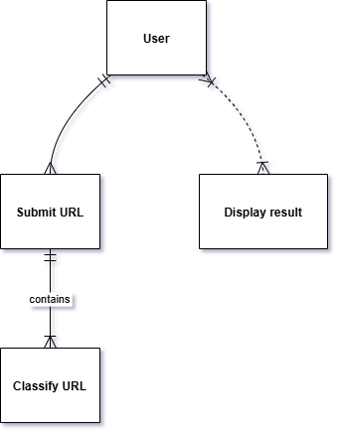

Figure 3.1: Use case diagram

3.1.2 Activity Diagram
The Activity Diagram shows the different ways of entering a URL through a web application from a user's point of view.
Activity Flow:
- User submits URL.
- Extract lexical features from the URL.
- Run model prediction: Using the Random Forest model which classifies the URL.
- Calculate risk scores, both the probability-based and custom-weighted scores, and thus they are then compared.
- Generate visualizations: Show classification, risk scores, and categories to the user.

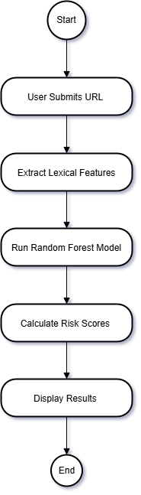
Figure 3.2: Activity diagram

3.1.3 Sequence Diagram
The Sequence Diagram outlines the step-by-step interaction between different components of the system:
- The User Interface (UI) collects the URL input from the user.
- The Feature Extraction module processes the URL and extracts its lexical features.
- The Random Forest Model uses the features to classify the URL.
- The Scoring System computes the risk scores.
- The Output Display presents the results to the user in the web application.

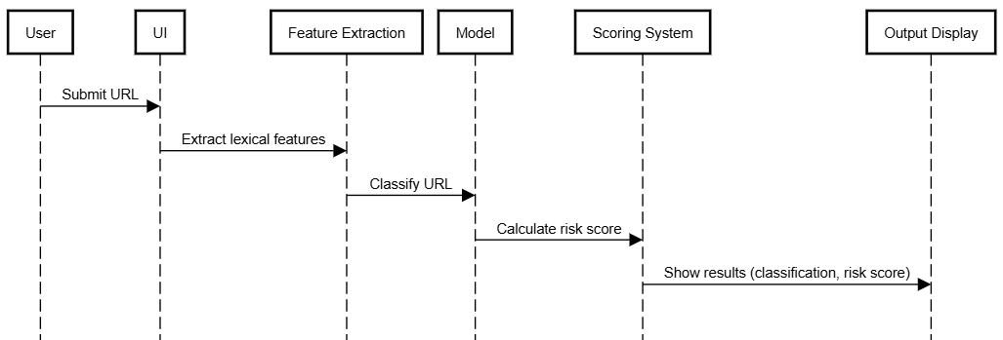

Figure 3.3: Sequence diagram

3.2 Data Modelling.
3.2.1 class Diagram
Class Diagram explains the architecture of the main system components, their relationships, and their interactions:
- URL Processor: It carries out feature extraction and pre-processed URL.
- Random Forest Model: It consists of the model and its techniques to make a prediction
- Risk Scorer: Compute the risk scores and categorize according to the prediction probability and weighted features.
.

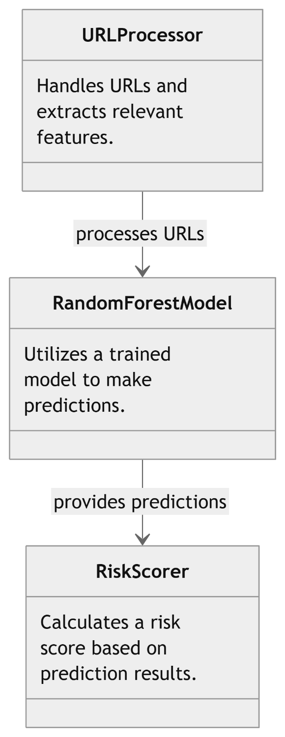
Figure 3.4: Class diagram
Chapter 4: Implementation

This chapter will explain the designing and implementing URL classification with risk assessment using an AI-ML model integrated in a frontend web application, which focuses on the goal of identifying whether or not URLs are benign versus malicious while at the same time generating a risk score based on multiple lexical features extracted from those URLs. The implementation splits into two major parts: the AI-ML model that was developed and trained in Google Colab and the frontend web application was implemented using Flask on a local laptop.

4.1 Implementation Environment
The work of the AI-ML model development was done within Google Colab, that is, a cloud-computer setting that allows the use of GP/TPU for optimized computational efficiency. The models used were in Python with dominant and mostly used libraries such as scikit-learn, Pandas, and NumPy for model training, preprocessing of data, and features selection. Once the model became trained and tuned, serialization was done using joblib and saved as a file in the.pkl format as random_forest_model.pkl for deployment.
The web application was developed locally on a laptop with an AMD Ryzen 9 processor, 16 GB of RAM, and 1 TB SSD storage. Flask was utilized as an application framework in building, making it easy and efficient delivery of the model's predictions. The system is tested to be locally operated using development server of Flask and the execution of the application is made directly since the app.py file itself can run the application in order to make the process of deployments easier without any virtual environments.
4.2 Coding Standards
In accordance with Python's PEP 8 standards, the code was written to ensure that it is maintainable and readable. Each module was well documented; there were comments explaining the key functions and critical code blocks. The system was developed in a modular approach to extract the features, predict the model, and score the risks in separate functions. There was input validation to make sure that the user-submitted URLs were handled correctly. Proper error handling ensured the system could handle invalid or malformed inputs without crashing.

4.3 Laboratory Setup
There were two distinct environments involved with the system implementation: one was for training and developing the AI-ML model and another to run the web application.
Implementation of the AI-ML Model in Google Colab:
The data set consisted of labelled URLs, which was downloaded from Kaggle. It is loaded into Google Colab where features like length of the URL, count of dots, entropy, and count of special characters are derived. Data were split to the training set and to the testing set so the model could be properly assessed. In addition, since the nature of the data was in the form of complex interactions, a Random Forest classifier was used with its default feature importance calculation.
With the model developed and with evaluation, the model file was saved serialized using joblib to deploy it onto the web application.

Data Preprocessing: Training Data- The dataset used for training consisted of 632,508 labelled URLs, half of them belonging to benign and the other half belonging to malicious categories. It involved the extraction of various lexical features from the URLs, including:
Shortened URLs: Identified with a predefined list of common URL shorteners
Suspicious Words: Keywords commonly found in Malicious URLs.
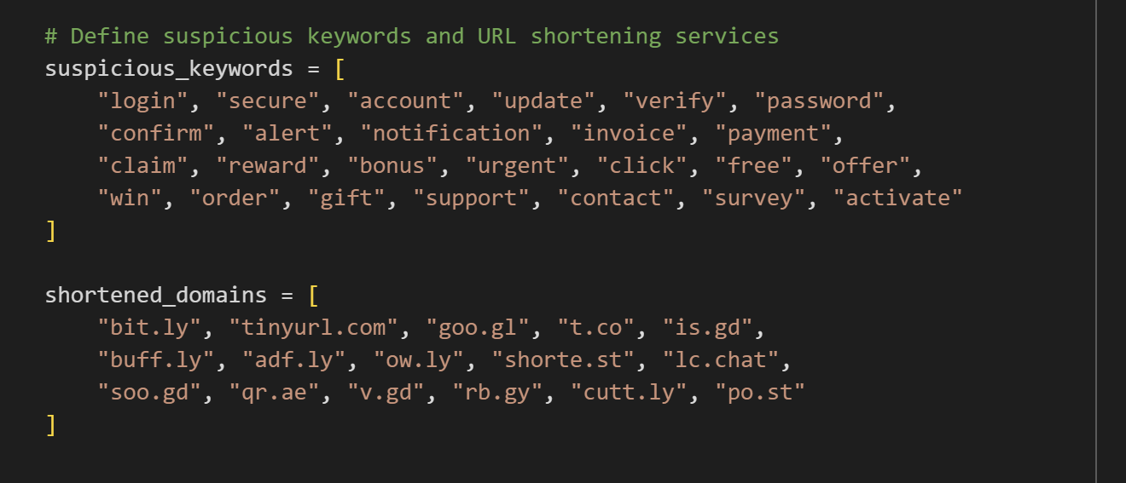
Screenshot 4.1: List of keywords and shortened domains

Shannon Entropy: The entropy of characters in the URL string was calculated using Shannon's entropy formula. Generally, higher entropy values are linked to obfuscated or malicious URLs.
URL entropy is a measure which determines the amount of randomness or unpredictability that exists within a URL string.. Many calculate it using Shannon entropy, that concept in information theory that averages the amount of "surprise" or information resulting from a sequence of characters. For URLs, high entropy values indicate that a structure is complex and looks more random.
Malicious URLs typically lurk behind complicated, seemingly random characters. For instance:
Well-formed URLs, like "example.com/about-us," are more human-readable whereas malicious look more like "abc123x.yz/98FJ8z23.".
High entropy in URLs tends to make links less readable, and therefore more likely to be a combination of numbers, symbols and letters, typical of dynamically generated or obfuscated malicious links.
Shannon entropy calculates the probability of each character in the URL and then uses
these probabilities to determine the average "surprise" per character.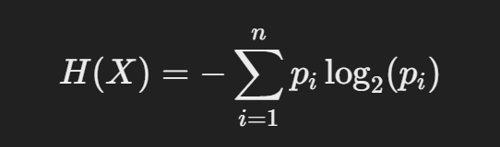
where pi is the probability of the occurrence of each character in the URL.

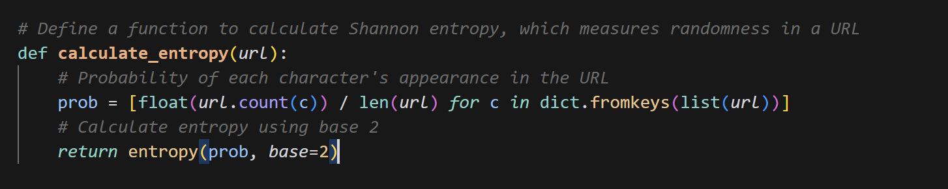
Screenshot 4.2: Shannon Entropy Calculation

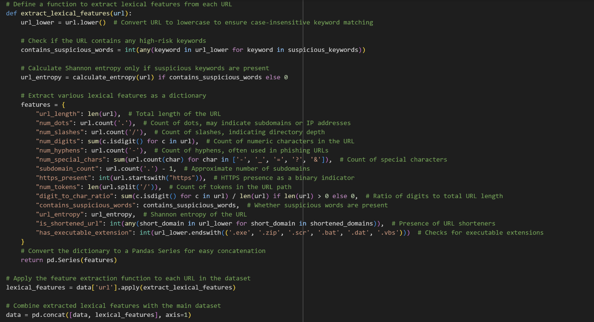
Screenshot 4.3: List of Features Extracted from URL

Feature Engineering: From the analysis, it appeared that the 'https_present' feature was responsible for close to 70% of output influence in the model. As a result, it over emitted and did not holistically evaluate the URLs. That is why this feature is combined with other features (subdomain, number of dots, number of digits) relevant to create a new composite feature. That has equalised the importance of all the separate features and enhanced the final robustness of the model.
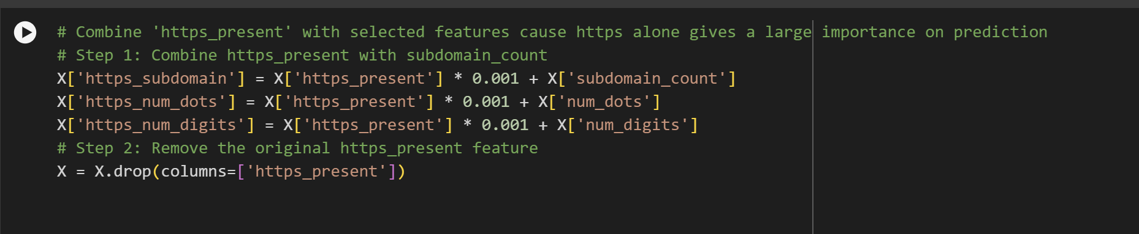
Screenshot 4.4: Combined Features

Data splitting: the reliability of performance evaluation was achieved by splitting the dataset into training and testing sets.

Model Training
The Random Forest classifier was used because of robustness, high-dimensional data handling, and an inbuilt mechanism for importance-feature selection.
in this case, hyper-parameters that will be tuned are max_depth and min_samples_split. GridSearchCV was devised to tune these parameters. A 3-fold cross-validation strategy was used for all combinations of hyper-parameters. The final values chosen as optimal values were max_depth=20 and min_samples_split=10.
The model was trained on the pre-processed data and gave reasonable outputs. The final model was serialized using joblib for easy incorporation into the web app.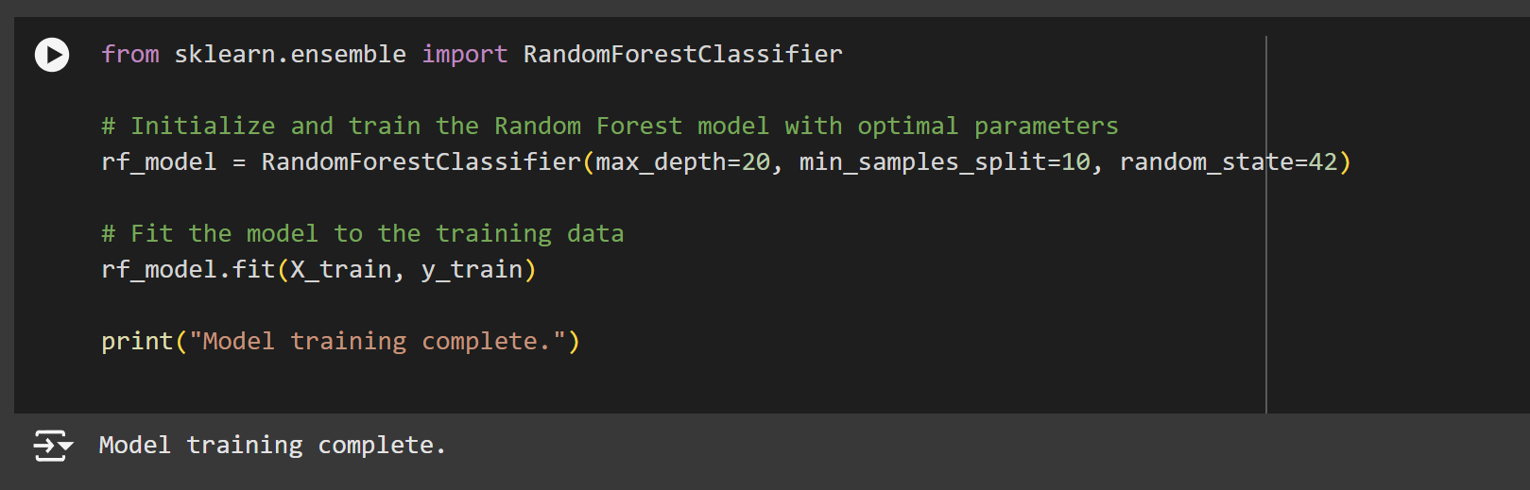
Screenshot 4.5: Model Training

Scoring Systems
A dual mechanism for scoring has been devised to assess the risk levied by the various URLs.
- Scoring According to Probability: Risk Scores were calculated with the predicted probabilities by the model and thresholds predetermined to classify URLs as Low Risk, Medium Risk, or High Risk.
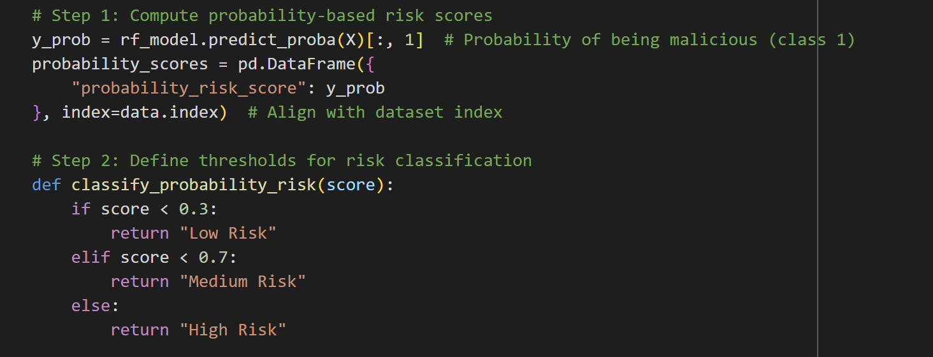
Screenshot 4.6: Probability Based Scoring System

- Custom Weighted Scoring: A custom scoring function was created by combining normalized feature values with predefined weights for each feature. It relied on the relevance of every feature in determining whether or not a URL was malicious, and the resultant scores were classified into risk categories.
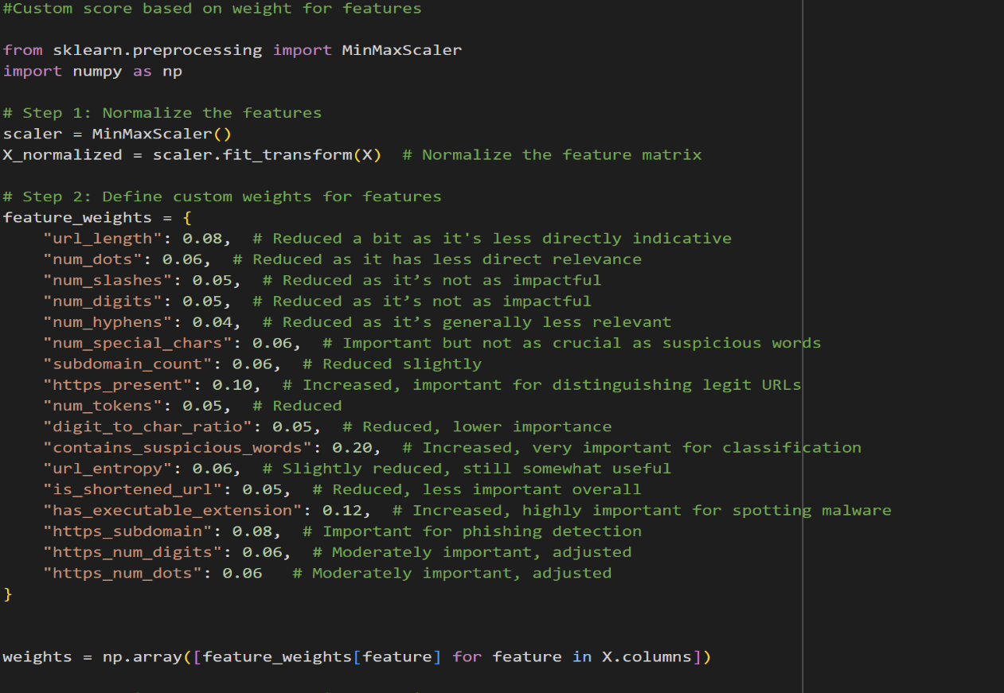
Screenshot 4.7: Custom Weights of Features
Feature Importance Analysis
detailed feature importance analysis was conducted to understand how each feature influenced the model’s predictions. The feature importance scores were derived directly from the Random Forest model and visualized in the bar chart shown in Figure 4.8
The chart illustrates the relative importance of various features, with https_subdomain emerging as the most influential feature in distinguishing malicious URLs. This is subsequently affiliated with features such as https_num_dots and https_num_digits, which were also highly significant for detection of possible threats. These latter features complement the usual patterns associated with phishing and malware; therefore these typically involved malicious URLs with suspicious subdomains or usually ill-structured ones. Their other most important features are subdomain_count, number_of_dots, digit_to_char_ratio, as they further contribute to the classification accuracy. Although not so influential, contains_suspicious_words and is_shortened_url nevertheless contributed to identifying some other categories of malicious URLs.
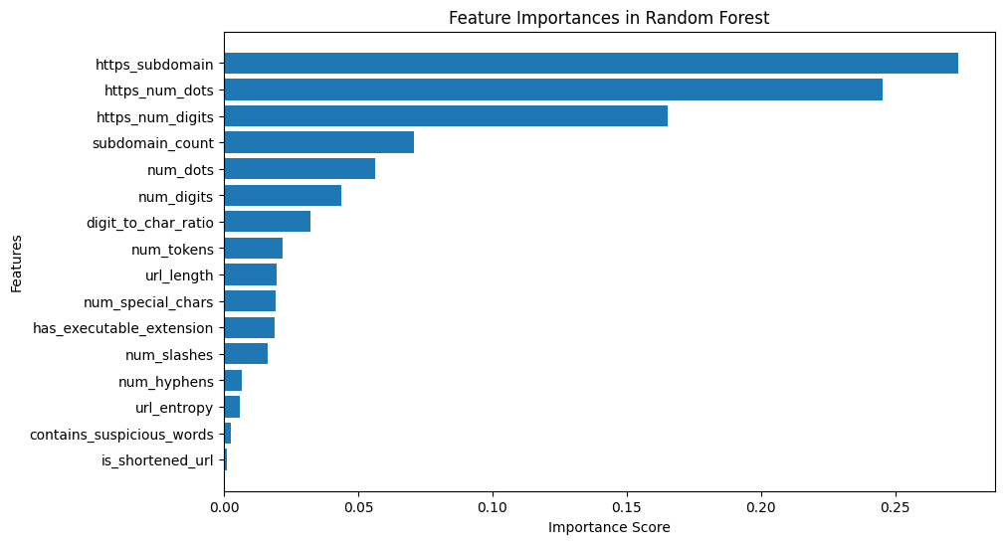Figure 4.8: Feature Importance

Frontend Development: The Flask framework was used to build the web application, which served as the interface for user interactions. The application accepted URLs via a web form, processed the input using the trained model, and displayed the classification results along with a risk score and category. The Flask server was launched locally by running the app.py file in the code editor, making it accessible at http://127.0.0.1:5000.

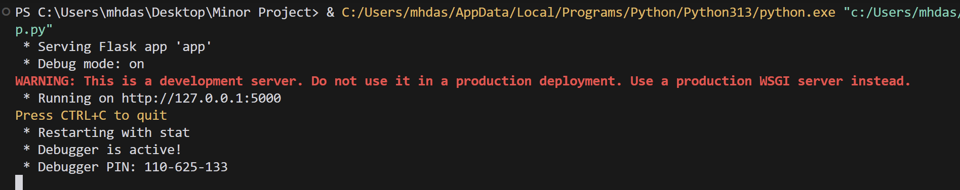
Screenshot 4.9: app.py running

4.4 Tools and Technology Used
Google Colab: Cloud-enabled machine learning model trained in Google Colab, particularly equipped with GPUs/TPUs for high-performance processing.
Python: The programming language through which models and web application code are written.
Scikit-learn: To perform ML techniques such as a Random Forest classifier as well as hyperparameter tuning.
Pandas and NumPy: Used for confining or preprocessing the data.
Joblib: For save and load trained model.
Flask: used to create web applications and to connect machine learning model to user interface.
Matplotlib to plot feature importance.

Chapter 5: Summary of Results and Future Scope
The implementation and evaluation of the AI-driven URL classification and risk scoring system demonstrated its exceptional performance in detecting malicious URLs. This chapter summarizes the project’s unique features, presents the evaluation results, and discusses the future scope for enhancing and expanding the system.

5.1 Advantages and Unique Features
The system emerges with some proprietary features relating to URL-based cyber threat detection
- High Accuracy and Robustness: The system displays high performance metrics hence perfect for malicious URL detection.
- Balanced Dataset Usage: The dataset was trained on 632,508 labelled URLs from Kaggle so that the benign and malicious URLs were in equal proportions for unbiased model training.
- Two Scoring Models: Both a probability-based and custom weighted scoring system enables risk assessment according to particular needs.
- Lexical Feature Specificity: The system contains lexical features only to make it faster and scalable without resorting to external API calls or DNS lookups.
- Real-Time Classification: It is a light-weight interface for real time classification by using a Flask-based web application which produces results on the go after submitting a URL by a user.
- Feature Importance Explanation: Important features give an idea regarding the decision-making processes inside the model and serve as a guide for future refinements.

5.2 Results and Discussions
System performance is measured using key machine learning metrics in order to evaluate the capability of the system in URL classification.

Model Evaluation Metrics:
Metric | Value
Accuracy | 98.84%
Precision | 99.73%
Recall | 97.95%
F1 Score | 98.83%
AUC-ROC Score | 99.72%
Table 5.1
These results indicate that the system performs exceptionally well, balancing between precision and recall to minimize false positives and false negatives. The high AUC-ROC score proves that the model is effective in distinguishing between benign and malicious URLs.
Confusion Matrix Analysis:
There is also a confusion matrix for the model in Figure 5.3, which clearly shows the high number of true positives and true negatives with very few classifications as false.
 | Predicted Malicious | Predicted Benign
Actual Malicious | 62,068 | 1,299
Actual Benign | 170 | 62,965
Table 5.2
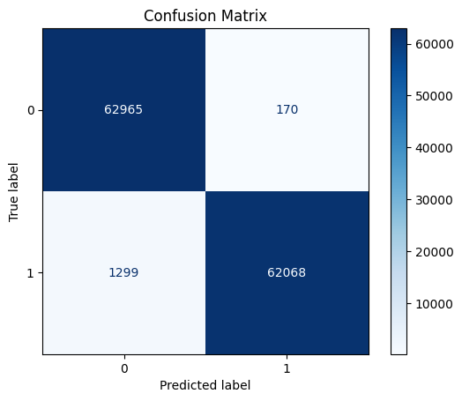

Figure 5.3: Confusion Matrix for Model Performance

Feature Importance:
The feature importance analysis in Figure 4.8 revealed that https_subdomain, https_num_dots, and https_num_digits are the most critical features. These attributes exhibit strong correlation with phishing and malware patterns. Other feature contributors include subdomain_count, num_special_chars, and url_entropy, which added value toward improving the model's performance. Less influential features include contains_suspicious_words, which adds value for specific edge cases.

5.3 Website Demonstration
The web application will take in URLs and provide instant classifications and risk scores. Example outputs are given below to demonstrate how it works: 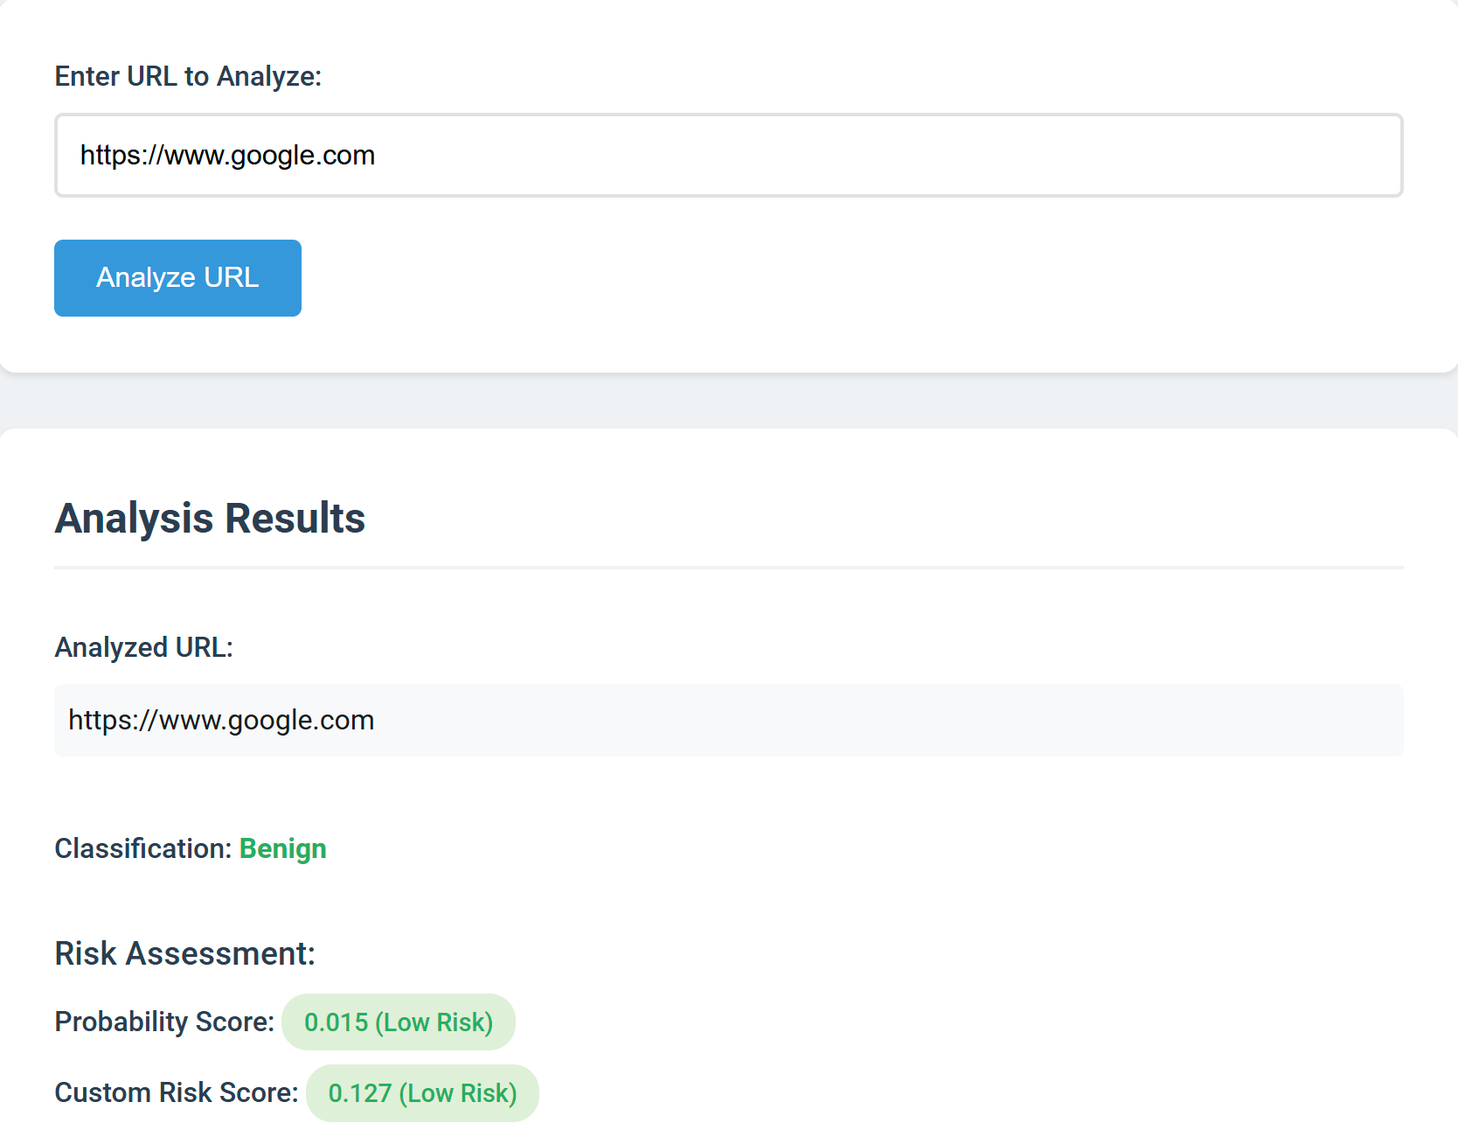

Screenshot 5.2 – Screenshot of website

Chapter – 6
6.1 Future Scope
Although the system scores high marks on accuracy and usability, several ways of improvement and increased applicability still exist:
- Integration with Real-Time Threat Intelligence: In this approach, the incorporation of live feeds would make the system up to date about new URL-based threats.
- Advanced Deep Learning Models: Such networks might help make the system competent enough to analyze even the intricate URL structures with very complex architectures such as LSTM network models.
- Explainability: It might include a tool like SHAP or LIME which makes it totally explainable, hence developing trust and usability.
- Dynamic Feature Expansion: It further engages network-based feature incorporation like DNS lookups and geolocation data to make classification more accurate.
- Browser Plugin Integration: This will take the system further into a browser plug that will be able to scan URLs in real time while surfing the web.
- Cloud Deployment: this type of deployment is accomplished via scalable hosting using the cloud via the deployment on AWS or Azure for reaching a wider audience.

6.2 Conclusion
The successful development and implementation of the AI powered URL classification and risk scoring system really demonstrate the enormous effect it is making against malicious URL-based cyber threats. The project achieved an impressive accuracy rate of 98.84% and the other high-performance metrics like precision, recall, and AUC-ROC with the use of a well-balanced dataset of 632,508 URLs and a Random Forest classifier. The dual scoring mechanism is very flexible and interpretable, so it can provide the risk assessments to be tailored to different cyber security applications.
The system is designed lightweight and scalable only depending upon lexical features. Thus, it does run in quite efficient and real-time conditions without reliance on any extraneous features. Lastly and very important, the interface of the AI model with a user-friendly Flask-based web application facilitated seamless interaction across the world, which gave real-time classifications and actionable insights to the users. Besides, the inclusion of feature importance analysis improved the transparency of the system, laying down grounds for informed future developments.
Although the scope is narrow at present, it holds promise for future integration with real-time threat intelligence, adoption of advanced deep learning methods, and even expansion for browser or cloud-hosted solutions. It marks the transformational potential of AI and machine learning to address real cybersecurity problems and sets a solid groundwork for future innovation in the malicious URL domain.

References
[1] T. Wu, Y. Xi, M. Wang, and Z. Zhao, “Classification of Malicious URLs by CNN Model Based on Genetic Algorithm,” Applied Sciences (Switzerland), vol. 12, no. 23, Dec. 2022, doi: 10.3390/app122312030.
[2] N. Reyes-Dorta, P. Caballero-Gil, and C. Rosa-Remedios, “Detection of malicious URLs using machine learning,” Wireless Networks, 2024, doi: 10.1007/s11276-024-03700-w.
[3] S. Kumi, C. Lim, and S. G. Lee, “Malicious url detection based on associative classification,” Entropy, vol. 23, no. 2, pp. 1–12, Feb. 2021, doi: 10.3390/e23020182.
[4] H. Ahmed Tariq, “USING BLACK-LIST AND WHITE-LIST TECHNIQUE TO DETECT MALICIOUS URLS,” International Journal of Innovative Research in Information Security (IJIRIS) Issue, vol. 12, pp. 1–07, 2017, doi: 10.26562/IJIRIS.2017.DCIS10081.
[5] Aljabri, M., Alhaidari, F., A. Muhammed, R. M., Mirza, S., Alhamed, D. H., & Altamimia, H. S. ., “An Assessment of Lexical, Network, and Content-Based Features for Detecting Malicious URLs Using Machine Learning and Deep Learning Models,” Computational Intelligence and Neuroscience, vol. 2022, 2022, doi: 10.1155/2022/3241216.
[6] J. Yuan, Y. Liu, and L. Yu, “A Novel Approach for Malicious URL Detection Based on the Joint Model,” Security and Communication Networks, vol. 2021, 2021, doi: 10.1155/2021/4917016.
[7] Y. Wang, “Malicious URL Detection An Evaluation of Feature Extraction and Machine Learning Algorithm”, 2022, Highlights in Science, Engineering and Technology, 23. 10.54097/hset.v23i.3209
[8] S. Abad, H. Gholamy, and M. Aslani, “Classification of Malicious URLs Using Machine Learning,” Sensors, vol. 23, no. 18, Sep. 2023, doi: 10.3390/s23187760.
[9] S. He, B. Li, H. Peng, J. Xin, and E. Zhang, “An Effective Cost-Sensitive XGBoost Method for Malicious URLs Detection in Imbalanced Dataset,” IEEE Access, vol. 9, pp. 93089–93096, 2021, doi: 10.1109/ACCESS.2021.3093094
[10] R. Patgiri, H. Katari, R. Kumar, and D. Sharma, “Empirical study on malicious URL detection using machine learning,” in Lecture Notes in Computer Science (including subseries Lecture Notes in Artificial Intelligence and Lecture Notes in Bioinformatics), Springer Verlag, 2019, pp. 380–388. doi: 10.1007/978-3-030-05366-6_31.
[11] Sahoo, D., Liu, C., & Hoi, S. C.H. “Malicious URL Detection using Machine Learning: A Survey”, 2019 , https://doi.org/10.48550/arXiv.1701.07179
[12] F. A. Ghaleb, M. Alsaedi, F. Saeed, J. Ahmad, and M. Alasli, “Cyber Threat Intelligence-Based Malicious URL Detection Model Using Ensemble Learning,” Sensors, vol. 22, no. 9, May 2022, doi: 10.3390/s22093373.

