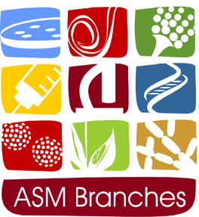

Abstract Information and Submission Form.

American Society for Microbiology

North Central Branch

76th Annual Meeting

October 21-22, 2016

Ames, Iowa

The deadline for the submission of abstracts for oral or poster presentations is **Monday,** **September 19, 2016.** Please fill out the information below and submit your abstract as a Word document electronically to Heather Allen at [asm.ncb.abstracts@gmail.com](mailto:asm.ncb.abstracts@gmail.com). Further instructions are below.

Presenting Author Name:

Email:

Institution:

City, State:

I would like to be considered for (select one):

an oralpresentation, or a poster presentation, or either

The presenting author is (select one):

an undergraduate student, a graduate student, or other

Preferred Track (select one):

(**S1**) Applied, Environmental, and Food Microbiology

(**S2**) Medical, Veterinary, and Cellular Microbiology

**Please use the template on the next page to submit your abstract and the information above as a Word document to** [**asm.ncb.abstracts@gmail.com**](mailto:asm.ncb.abstracts@gmail.com)**.** Please create the file name according to the following example: Track Number-Last Name of presenting author-Oral (**OP**) or Poster Presentation (**PP**) (e.g. **S1-Miller-OP**).

**Abstract Title**

**Author(s)**

Institution(s), City, State

Abstract text not to exceed 300 words