

American International University- Bangladesh

CSC 3222: Web Technologies

CO1.1 and CO2.1 Evaluation

Project Report

Summer 2021-22

**Project Title: Online food ordering**

**Section: H**

**Group No: 02**

|  |  |
| --- | --- |
| Student Name | Student Id |
| MD SAHEBUZZAMAN FAHAD | 20-43229-1 |
| ABID HASAN | 20-41867-1 |
| KAZI ISTIAK AHAMMED | 20-43235-1 |
| MD. MUNTASIR AREFIN | 20-44304-3 |

**Online food ordering**

**Introduction:**

Nowadays people are very busy in their workplace with their work. As a result, they do not have time to go to a hotel or restaurant to eat. Considering them, we have launched an online food ordering system, so that they can order their favorite food online in a very short time. This is the main purpose of our online food ordering system.

**Background Study:**

We are inspired by foodpanda app. Below is a short description of foodpanda app.

foodpanda offers me a long and detailed list of the best restaurants and shops near me to help make me every day easier. Our online food delivery service has it all, whether you fancy a juicy burger from Takeout, fresh sushi from Samdado or peri peri chicken from Nando's, foodpanda Bangladesh has over 2000 restaurants available from Dhaka to Chittagong through to Sylhet.

All the website that we have studied so far are given below to give me idea of our project.

Website Name: foodpanda.

Link: <https://www.foodpanda.com>

Website Name: academia

Link: <https://www.academia.edu>

Website Name: Studypool

Link: <https://www.studypool.com>

**Online food ordering**

**Requirement Analysis:**

1. **User Category:**

There are 4 types of user here. They are:

1. Admin
2. Manager
3. Seller
4. Customer
5. **Feature List:**

In this project the “**Admin**” has have following features:

* Admin registration page.
* Admin login page.
* Admin can save mail & password login time.
* Admin can see he/her profile page with admin user data.

In this project the “**Manager**” has have following features:

* Manager registration page.
* Manager login page.
* Manager can see he/her profile page.
* Manager can logout and destroy session.

**Online food ordering**

In this project the “**Seller**” has have following features:

In this project the “**Customer**” has have following features:

* Registration page.
* Login page.
* Password-recover.
* Profile page.

**ER Design:**

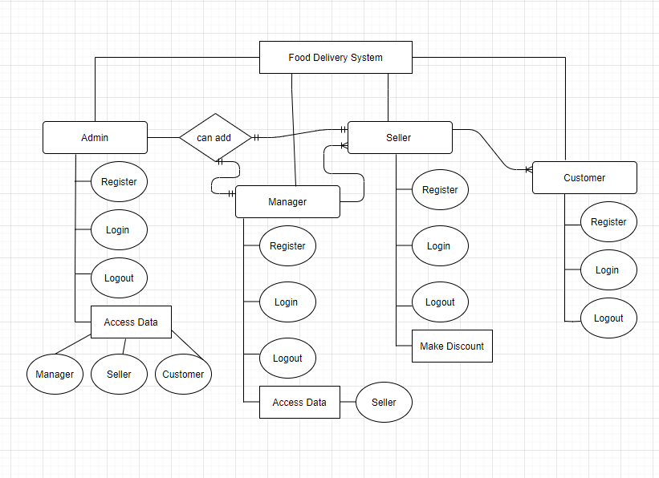

**Online food ordering**

**Tools Used:**

To develop this project, we have used the following:

* Visual studio code.
* XAMPP Control Panel.
* Chrome.
* MS Word.
* Draw.io.

**System Images against the Specification:**

1. **Admin**

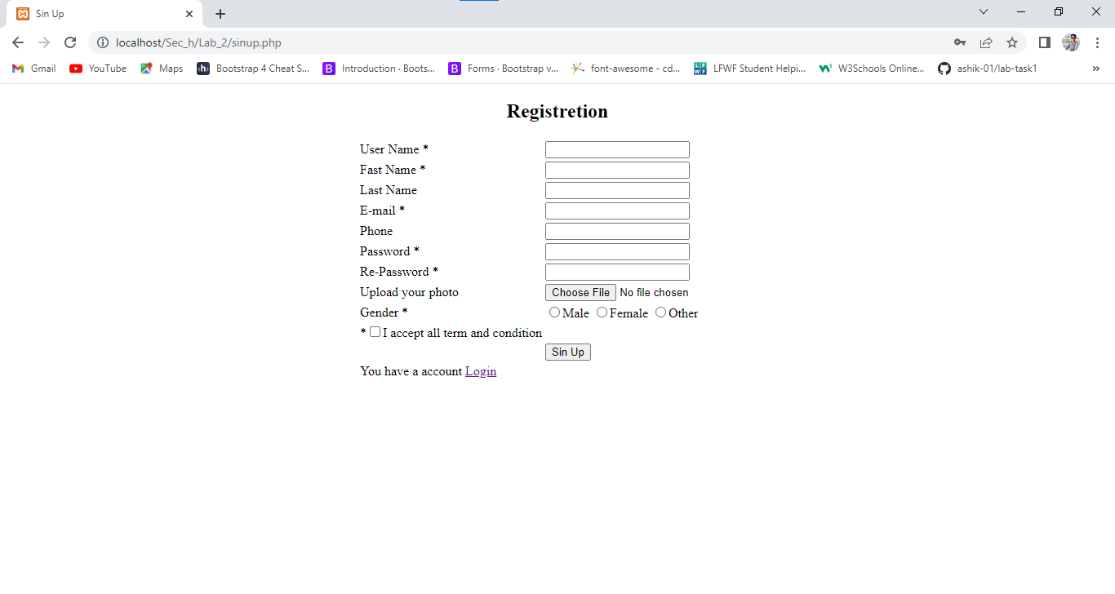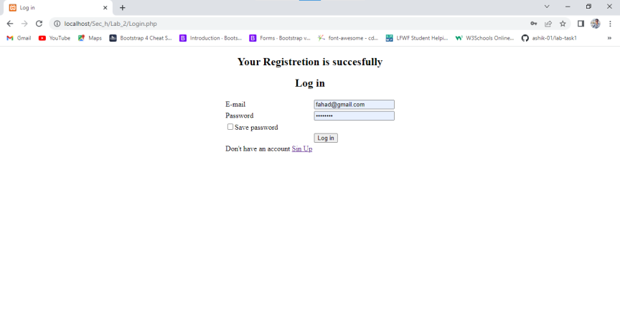

This is Admin part GUIs. This GUIs show Admin registration and login part. Admin can registration or login use this part.

1. **Manager**

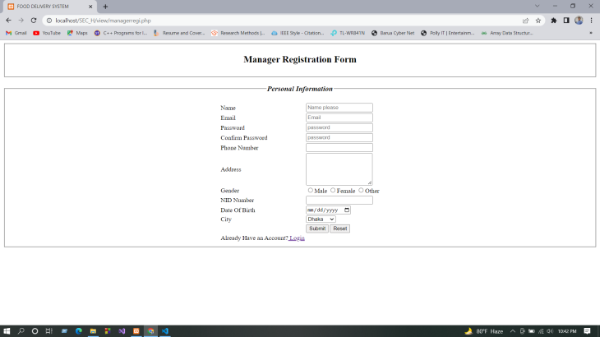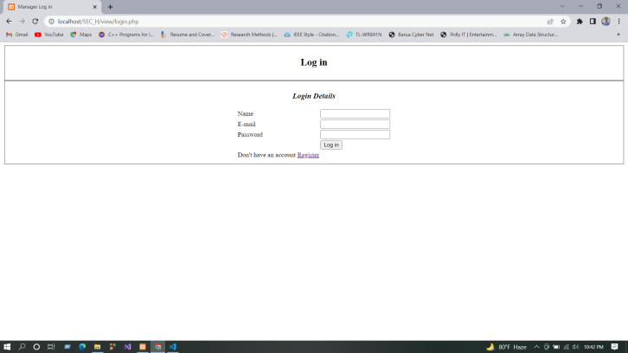

This is manager part GUIs. This GUIs show Admin registration and login part. Manager can registration or login use this part.

1. **Seller**

**Online food ordering**

1. **Customer**

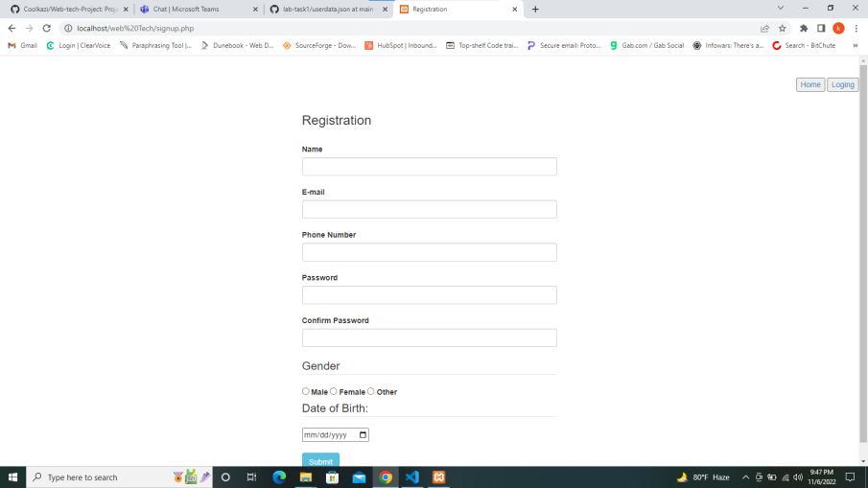

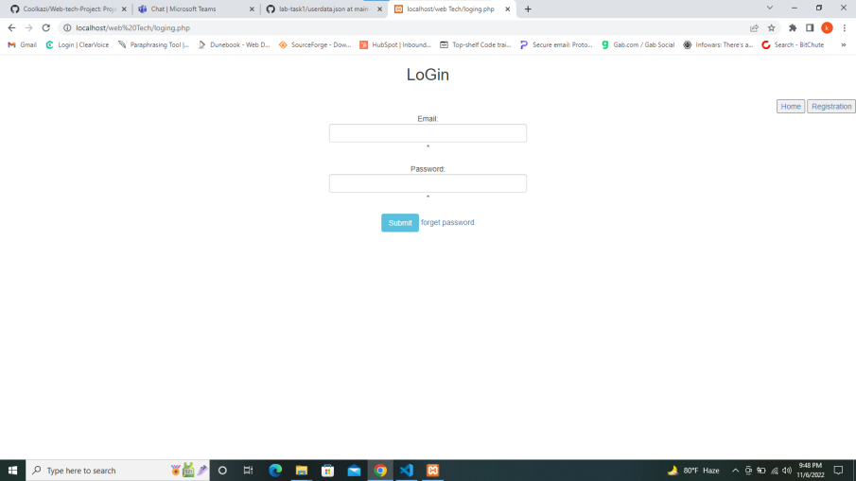

This is customer part GUIs. This GUIs show customer registration and login part. customer can registration or login use this part.

**Impact of this Project:**

The major environmental concerns that can be noted as an outcome of the great development in Online Food Delivery are the massive volumes of plastic waste generated and how to manage it. The efficiency with which different countries deal with the plastic waste

**Online food ordering**

generated by their online food delivery is governed by their recycling infrastructure and the growth of their online Food Delivery.

As a result of the COVID-19 outbreak, disposable food packaging will become increasingly popular in many regions of the world

by 2020, as many customers believe disposable packaging is safer and more hygienic.

**Limitations and Possible Future Improvements:**

1. **Deliverymen Put Themselves in Danger**

Whether it is a heatwave boiling down the city or it is snowing or raining heavily, a Delivery Boy is waiting outside the restaurant to pick and deliver your order. This is one of the disadvantages of ordering food online.

### Revenue Conflicts Between The Restaurants and Delivery Providers

### Not every restaurant owner can afford to employ ten delivery boys and bear all the transport and remuneration expenditure; so, they choose to contract with the delivery service providers through these apps. This brings the disadvantages of food delivery service.