Donor Statement

# ASM-SW

[asm-sw@outlook.com](mailto:asm-sw@outlook.com)

<https://github.com/ASM-SW/DonorStatement/releases>

December 23, 2016

Table of Contents

ASM-SW 1

Background 1

Requirements 1

Installation 2

How the Program Works 2

QuickBooks Sales Report 2

Word Template 4

Running Donor Statement 5

Configuration Step 6

Item Selection 7

Create Documents 8

1FileList.csv 9

# Background

Donor Statement grew out of a need to generate year end Donor statements from QuickBooks™ nonprofit edition. QB doesn’t have a way to generate a letter with the details of the donations. QB can generate a sales report that lists all the donations as items that were sold. This program takes a CSV (comma separated value) version of the report and processes it to generate a custom letter for each member (customer in QB). The custom letter is generated using a Microsoft Word template. This means that Microsoft Word must be installed on the PC where this program is run.

# Requirements

The PC that this program is run on must have Microsoft office installed. I have tested it only with Office 365 2016. Based on the documentation on the Microsoft website I think it should work for version 2013 and later.

Microsoft .Net 4.6 <https://www.microsoft.com/en-us/download/details.aspx?id=48130> .

I have only tested this on Windows 10 but it should work on earlier versions that have .Net installed.

# Installation

I plan on having both a .msi installation package and a .zip package available at:

<https://github.com/ASM-SW/DonorStatement/releases>

The more technically minded can download the .zip package and extract the contents in a directory of your choice.

The .msi package performs the install like any Windows package. It puts a link in the start menu in the Donor Statement folder. It also puts a link on the desktop: .



# How the Program Works

The user first creates a Sales report in Quickbooks. The sales report contains each of the donations made for a particular time period. The report must contain specific columns that has the information needed to generate the report. The report is saved as a CSV file.

The user also creates a word template document that is used to generate the report for each donor. The word template has the wording and formatting of the report. It also has a set of Bookmarks. Each Bookmark is a phrase, paragraph or table that will be replaced by the program with data contained in the Quickbooks report. An example template is included with the program.

More details are given below.

## QuickBooks Sales Report

Each donation or sale in Quickbooks is made as an Item. When you make the sale you can change the memo field as appropriate.

Create a report Reports > Sales > Sales by Customer Detailed

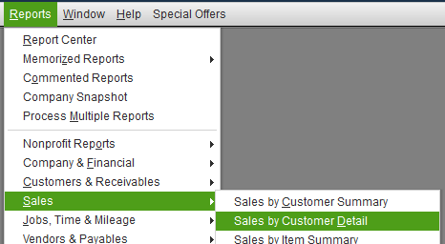

Figure 1 Create Sales Report

Click on “Customize Report”.

Change

* “Reporting Basis” to “Cash”
* “Total by” to “Total Only”
* “Sort by” to “Name”.

Be sure that the following columns are included (checked) in the report. The program will tell you if one of them is missing.

* Date
* Item
* Memo
* Name
* Name City
* Name Contact
* Name E-Mail
* Name State
* Name Street1
* Name Street2
* Name Zip
* Paid Amount

Select a date range for the report based on what you want to include in the donor statements. For a year end statement select Jan1 through Dec 31 of the given year. You could also select a one month range if you wish to generate a monthly report.

After the report is created, select Excel > Create New Worksheet



Figure 2 Create Worksheet

In the send Report To Excel Dialog select

“Create a comma separated values (csv) file.

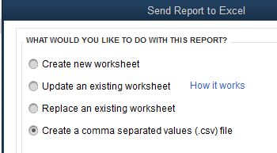

Figure 3 Export CSV file

Click on Export and select a location where you want to file to be saved. Rember the directory and the name of the file.

## Word Template

Each Donor statement created is based on a MS Word template file. The template contains “Bookmarks”. Each of these bookmarks are replaced with text. An example template file is included: YearEndDonnationStatement.dotx

The following bookmarks are used. The bookmarks are not required. The program will warn you if they are not in the template file, but will go on and create the donor statements.

* "Name"
* "StatementDate"
* "ToAddress"
* "YearDateRange"
* "Total"

You can configure word to display the bookmarks. Select “File” from the menu, and then “Options”. Select Advanced. Scroll down to “Show Document Content” and select “Show bookmarks”.

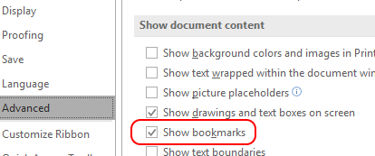

Figure 4 Show bookmarks

The bookmark is shown with square brackets. Here is an example of “Name”: 

To create a bookmark. Select the text that is to be bookmarked. On the menu select Insert, Links,

Bookmark.

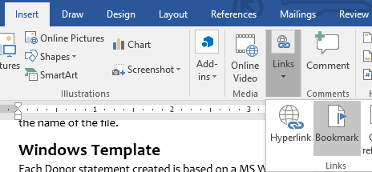

Figure 5 Insert Bookmark

Enter the name of the bookmark and click Add.

Be sure and save your template file as a Word Template.

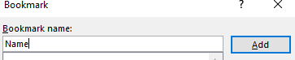

Figure 6 Name Bookmark

In addition to the bookmarks there are two tables that need to be created:

* "TablePayments"
* "TableOtherPayments"

Both tables should look like the following:

|  |  |  |  |
| --- | --- | --- | --- |
| Date | Item | Description | Amount |

After you create or paste the table into your template, right click on the table and select

Auto Fit > Auto Fit To Contents

Select the table again, right click and select Table Properties. The bring sup a tabbed dialog.

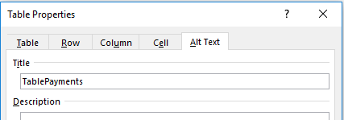

Select the Alt Text tab. Enter the table name in the Title box as shown above. TablePayments will be filled in with the items selected as donations. If you also wish to include in the report other payments create the TableOtherPayments table as a copy of TablePayments with the name TabelOtherPayments.

## Running Donor Statement

Donor Statement has multiple steps. Figure 7 shows the layout of the screen for the program. Each screen has common controls. To exit the program click on the X at the top right of the window.

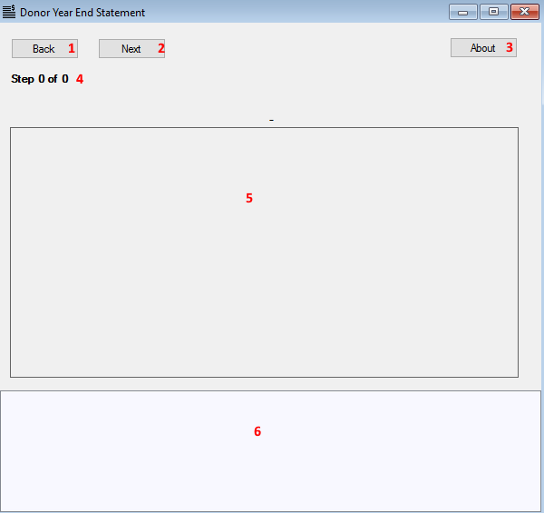

Figure 7 Form layout

The central area of the window, number 5 changes for each step. The other portions of the window stays the same for each step. Number 1 and 2 are navigation keys to book Backward and forward through the various step. Clicking on number 3, about, brings up an about dialog. Number 6 is a log of messages. The latest message is always shown at the top of the list. You can right click on the log area and copy the contents to the clipboard.

## Configuration Step

Step 1 is the configuration step. The central portion of the screen is filled in with the configuration form shown in Figure 8. Each of the items (10-13) have both a button that you press that brings up a dialog to select a value and a text enter that you may type in directly.

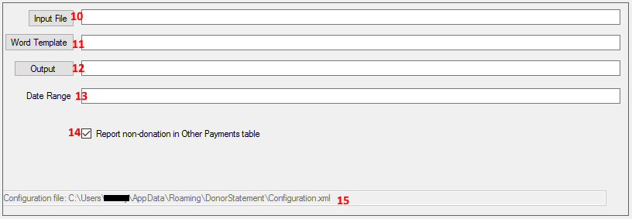

Figure 8 Enter Configuration

Number 10 is the Input file. This is a CSV file that contains the sales report from Quickbooks. See QuickBooks Sales Report for details.

Number 11 is the Word template report. See Word Template.

Number 12 is the Output directory where each of the reports will be placed.

Number 13 is the date range value that will be placed into the report in the YearDateRange bookmark.

Number 14, check this box if you have a TableOtherPayments to fill in.

Number 15 is the location of the configuration file where each of the selected values are stored between programs runs.

## Item Selection

Step 2 is the item selection step. The central portion of the screen is filled in with the item form shown in Figure 9. When this step is entered number 21 shows the Item selections from the previous time the program was run. Click the parse button, number20, to read in the input file and get the list of items in the report. You can then select or deselect the items in the input file to include in each donor statement. Items not selected will not be part of the report. To select a single item, click on it. To select a contiguous range of items, click on the first item, hold down the shift key and click on the last item. To add or remove a single item hold down the shift key and click on the individual item.

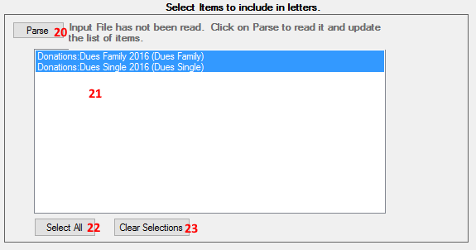

Figure 9 Select Items for report

## Create Documents

Step 3 is the configuration step. The central portion of the screen is filled in with the configuration form shown in Figure 10. Click on number 31 to start creating donor statements. On Donor Statement is created for each name in the input file. The donor statement is saved as a PDF file. Number 34 is a progress bar that provides a visual indication of progress in creating the donor statements. You may click Stop at any time and the program will stop after it completes the current donor statements.

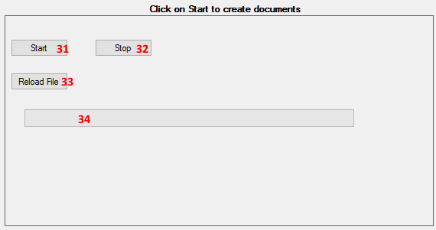

Figure 10 Create Documents

You can watch the program generate donor statements. For each donor statement Word pops-up and you see the program modifying the contents of the file. The file is saved as a PDF and word closes.

If you decide you need to create a new input file in Quickbooks you can click on the number 33, the Reload File button, and the program will reread the input file.

## 1FileList.csv

This file is created in the output directory when either all the donor statements are created or when the user stops statement creation. This file has the following columns:

1. The name of the donor.
2. The name of the PDF file for this donor. The name includes the drive and directory.
3. The email address of the donor, if it is available.