Donor Statement

# ASM-SW

[asm-sw@outlook.com](mailto:asm-sw@outlook.com)

<https://github.com/ASM-SW/EmailWithAttachedFile/releases>

December 21, 2020

Changes:

* Need .Net Framework 4.8 runtime.
* Email address column of input file may contain a semicolon separated list of email addresses.
* Additional Dependencies.

Table of Contents

ASM-SW 1

Background 1

Requirements 1

Additional Libraries 2

Installation 2

How to use the Program 2

First time usage 4

Firewall and AV Software 4

Input File 5

Email template file 5

# Background

I wrote the program DonorStatement that generates tax receipts for multiple people. It reads in a CSV file and then generates separate PDF files for each donor. In addition, DonorStatement creates a file that contains emails, names and the file names of each donor receipt. This program can read in the output file and use it to send emails to each donor.

# Requirements

When you run this program you will need an email account on a mail server that allows you to connect up to a SMTP server. You may have to configure the email account to allow this. You will need to know the SMTP server address and the port.

Microsoft .Net 4.8 Runtime Version available must be installed on the PC. This is a standard component from Microsoft that may already be on your PC. It is available from Microsoft at: [Download .NET Framework 4.8 | Free official downloads (microsoft.com)](https://dotnet.microsoft.com/download/dotnet-framework/net48). Click on the Download button. Note Microsoft is known to change their links from time to time, so you might have to use Google to find it.



I have only tested this on Windows 10 but it should work on earlier versions that have .Net installed.

# Additional Libraries

Several libraries have been used in this program. They are included in the install package. Follow the license link to obtain the license.

|  |  |  |
| --- | --- | --- |
| **Package** | **Website** | **License** |
| MailKit | [NuGet Gallery | MailKit 2.10.0](https://www.nuget.org/packages/MailKit/) | ['MIT' reference (nuget.org)](https://licenses.nuget.org/MIT) |
| MineKit | [MimeKit](http://www.mimekit.net/) | ['MIT' reference (nuget.org)](https://licenses.nuget.org/MIT) |
| Portable.BouncyCastle | [NuGet Gallery | Portable.BouncyCastle 1.8.9](https://www.nuget.org/packages/Portable.BouncyCastle/) | [bouncycastle.org](https://www.bouncycastle.org/csharp/licence.html) |
| System.Buffers | [NuGet Gallery | System.Buffers 4.5.1](https://www.nuget.org/packages/System.Buffers/) | [corefx/LICENSE.TXT at master · dotnet/corefx (github.com)](https://github.com/dotnet/corefx/blob/master/LICENSE.TXT) |

# Installation

The installation file is contained in a ZIP file. After downloading you will need to open up the ZIP file in Windows Explorer and either run from within the ZIP file or copy to a convenient folder on your computer. There is no other installation for this program. Install the .NET framework, if necessary, download this program and run it.

# How to use the Program

Before you use the program you must know how to connect up to your email server. You need the following information:

* SMTP server address and SMPT port.
* Does your email server support SSL, secure socket layer. It is recommended that you use SSL so that the password is encrypted when sent to the server. Typically, the port number is different when you use SSL.
* Username (typically your email address) and password to login to the email server

When you startup the program you see the following window:

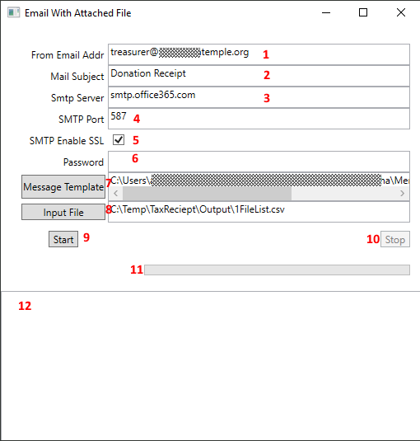

The following explains each of the items on this page. Match the red number in the figure above with the text below

1. Enter the email address that will be put in the from line of the email and that will be the username used to log into the mail server.
2. Enter the text that will be the subject line of the email.
3. Enter the URL or address of the SMTP server that will be used to send the email.
4. Enter the port used to communicate with the email server.
5. If your email server supports SSL, secure socket layer, you should check this box so that the password is encrypted when it is sent to the server.
6. Password to login to the server. Note: for security reasons the password is not saved when you exit the program. While the program is running it is held in memory encrypted.
7. The file name of the email template. More on this later. You can type or paste the path in or click on the button to find the file.
8. Input file that contains the list of email addresses and filenames to send. More on this later.
9. Clicking this Start button starts up the sending of emails.
10. Clicking the Stop button stops the sending of emails. This may take a while because it is has to finish up the email it is trying to send.
11. This is the progress bar. It shows you how many of the emails have been sent.
12. This is the message area for the program. It shows you status and error messages. Messages are also logged to the output file described in a later section.

## First time usage

I suggest that you setup a test before trying to use the program to send out all of the emails.

* Make a copy of the input file and save with a different name.
* Delete all put two people in the file.
* Change the names of these two people.
* Change the email address of these two people. You might one to use an email outside of the domain of your organization so that this test is similar to the real run. One of them give them your email. For the other person use a bogus email.

Now run the program. For input file use the file you made above. You should get an email in the email account for the real email, and you will probably get an email from the server about the bad email address. Depending on your server it may take a while to get the email about the bad email address.

## Firewall and AV Software

When you run this program Windows or your AV software may warn you that you are trying to run a program that does not have a valid signature or that comes from an unknown source. You have to allow the program to run.

On my PC I get the following warning when I click on the start button.

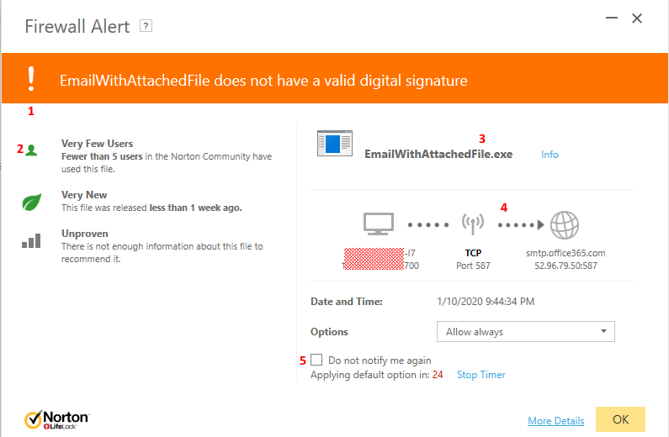

Depending on the security on your computer you may get a warning that looks like this, some other warning or no warning at all.

Here is what this warning is telling you. Match the red number in the figure above with the text below.

1. Because I did not buy a code signing certificate this program does not have a “valid digital signature”.
2. It is saying there are very few users because the only user is me and maybe you.
3. This is the name of the program.
4. This is showing that the program is trying to communicate between your computer and an email server over the TCP which is the internet. Notice that the address under the globe matches what you entered for SMTP server.
5. With Norton I can check this box and the program is only given permission to communicate for the next 24 hours. Once you are comfortable with the warning click OK. Then the program can send emails.

## Input File

This file is used by the program to send the emails. It is a text file of type CSV. The Donor Statement program created it. It can also be made with Excel and saved as a CSV file type. It This file has the following columns:

1. The name of the donor.
2. The name of the PDF file for this donor. The name includes the drive and directory.
3. The email address of the donor, if it is available.

Here is what it looks like:

NameLastFirst, Name,FileName, Email

"Doe, John","John Doe","C:\Temp\TaxReciept\Output\Doe.John.pdf","name@outlook.com"

"Jones, Tom","Tom Jones","C:\Temp\TaxReciept\Output\Jones.Tom.pdf","name@yahoo.com; name2@ya.com"

The first line is the column heading names. Then each line represents one email to send out. The email column may contain multiple email addresses separated by semicolons.

## Email template file

This file forms the basis for the email that is sent along with the attached file. It is a text file that may be created with a program like notepad. Do not use Word to create the file. Here is an example file:

Hi <NAME>,

This is your donation statement for 2019.

Jim Smith

Administrator Congregation….

Street address

Email address

Website URL

The text:

<NAME>

is replaced with the Name column of the input file. This personalizes each email. You can put any additional text into the email that you wish. But as mentioned above this is a text file and the only formatting that you can do is enter blank lines.

**Output File**

An output file is created that the results of sending each of the emails. The name of the out files is : InputFileout.csv, where InputFile is the name of the input file.

The Output file is basically the same as the input file with the addition of a Status column and a message column. The best way to view this file is to open it in Excel and sort on the Sent column.

The Sent column will either say “Sent” if the email was sent successfully or “Error” if the email was not sent. When there is a problem with sending the mail the Message column will contain more information. If an email address is wrong the status will be shown as sent and you will get an email from the mail server it was sent to that there was an error. If there is no email address in the input file the status will be Error and the message will say “Email address is blank”.

If the email address is bad there probably will not be an error shown. The “From Email Address” should get an email that there was a problem. Often this email appears quickly, but in some cases it might take a day or two.