ONES COMPLEMENT
#include <stdio.h>
#define SIZE 8

int main() {
char binary[SIZE + 1], onesComp[SIZE + 1];
int i, error = 0;

printf("Enter %d-bit binary value: ", SIZE);
gets(binary);

// Store all inverted bits of the binary value in onesComp
for (i = 0; i < SIZE; i++) {
if (binary[i] == '1') {
onesComp[i] = '0';
} else if (binary[i] == '0') {
onesComp[i] = '1';
} else {
printf("Invalid Input");
error = 1; // Exits from the loop
break;
}
}

// Mark the end of the onesComp string
onesComp[SIZE] = '\0';

// Check if there are no errors in the binary string
if (error == 0) {
printf("Original binary = %s\n", binary);
printf("Ones complement = %s", onesComp);
}

return 0;
}
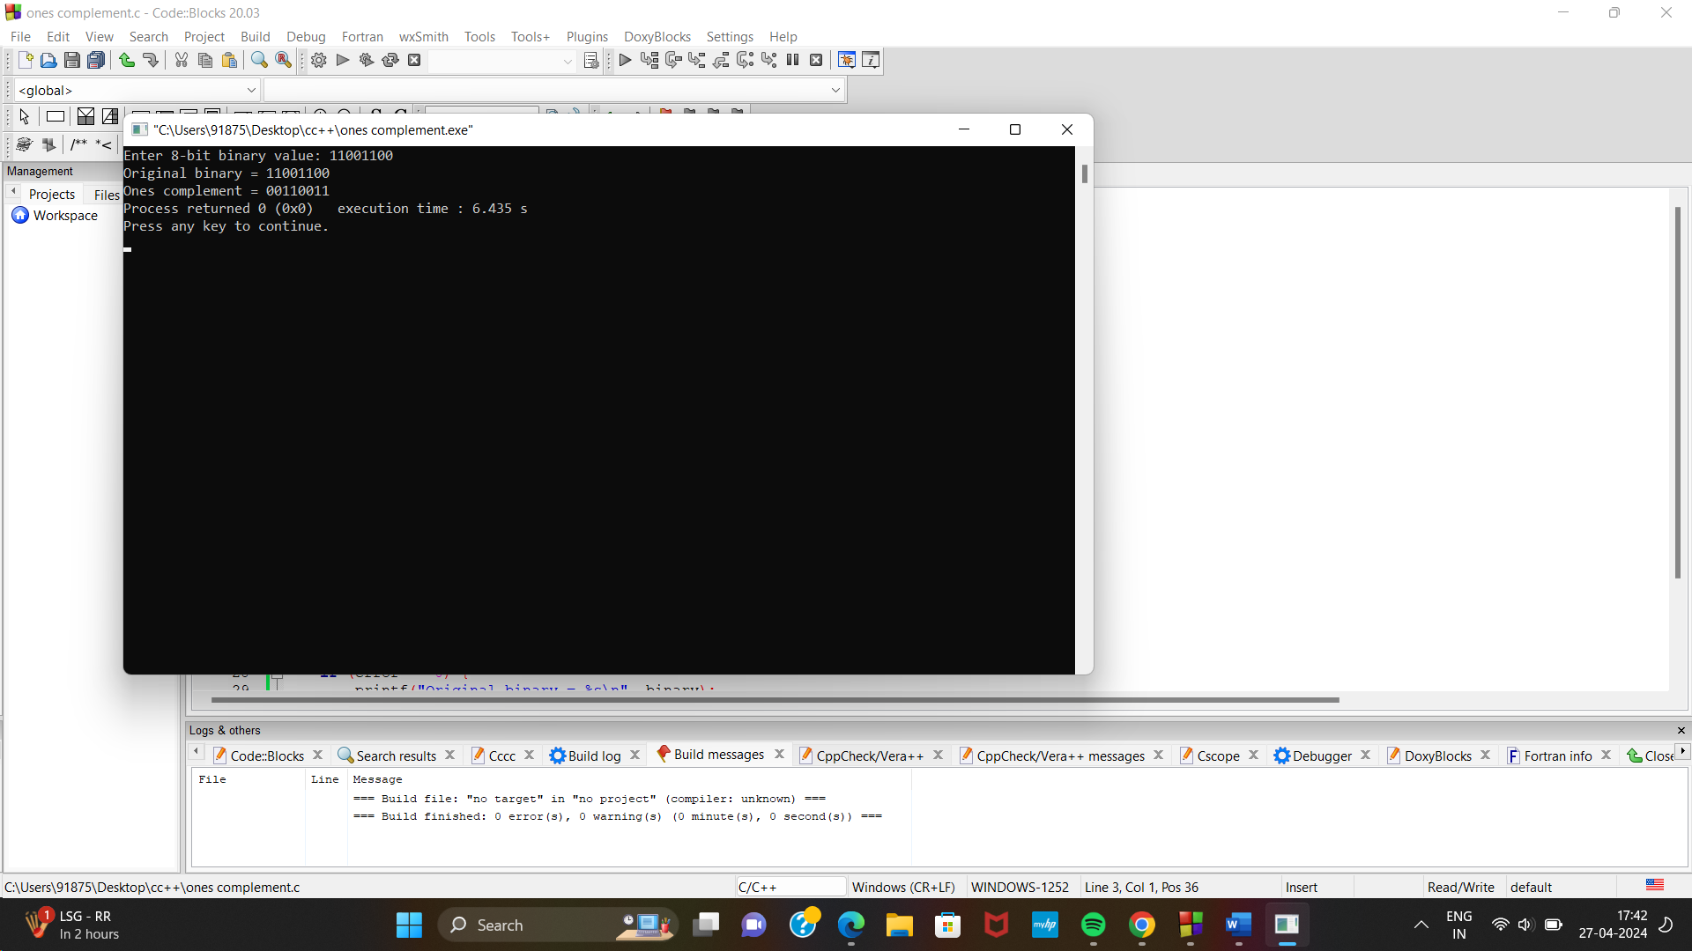

TWOS COMPLEMENT
#include <stdio.h>
#define SIZE 8

int main() {
char binary[SIZE + 1], onesComp[SIZE + 1], twosComp[SIZE + 1];
int i, carry = 1;

printf("Enter %d-bit binary value: ", SIZE);
gets(binary);

// Find ones complement of the binary number
for (i = 0; i < SIZE; i++) {
if (binary[i] == '1') {
onesComp[i] = '0';
} else if (binary[i] == '0') {
onesComp[i] = '1';
}
}
onesComp[SIZE] = '\0';

// Add 1 to the ones complement
for (i = SIZE - 1; i >= 0; i--) {
if (onesComp[i] == '1' && carry == 1) {
twosComp[i] = '0';
} else if (onesComp[i] == '0' && carry == 1) {
twosComp[i] = '1';
carry = 0;
} else {
twosComp[i] = onesComp[i];
}
}
twosComp[SIZE] = '\0';

printf("Original binary = %s\n", binary);
printf("Ones complement = %s\n", onesComp);
printf("Twos complement = %s\n", twosComp);

return 0;
}
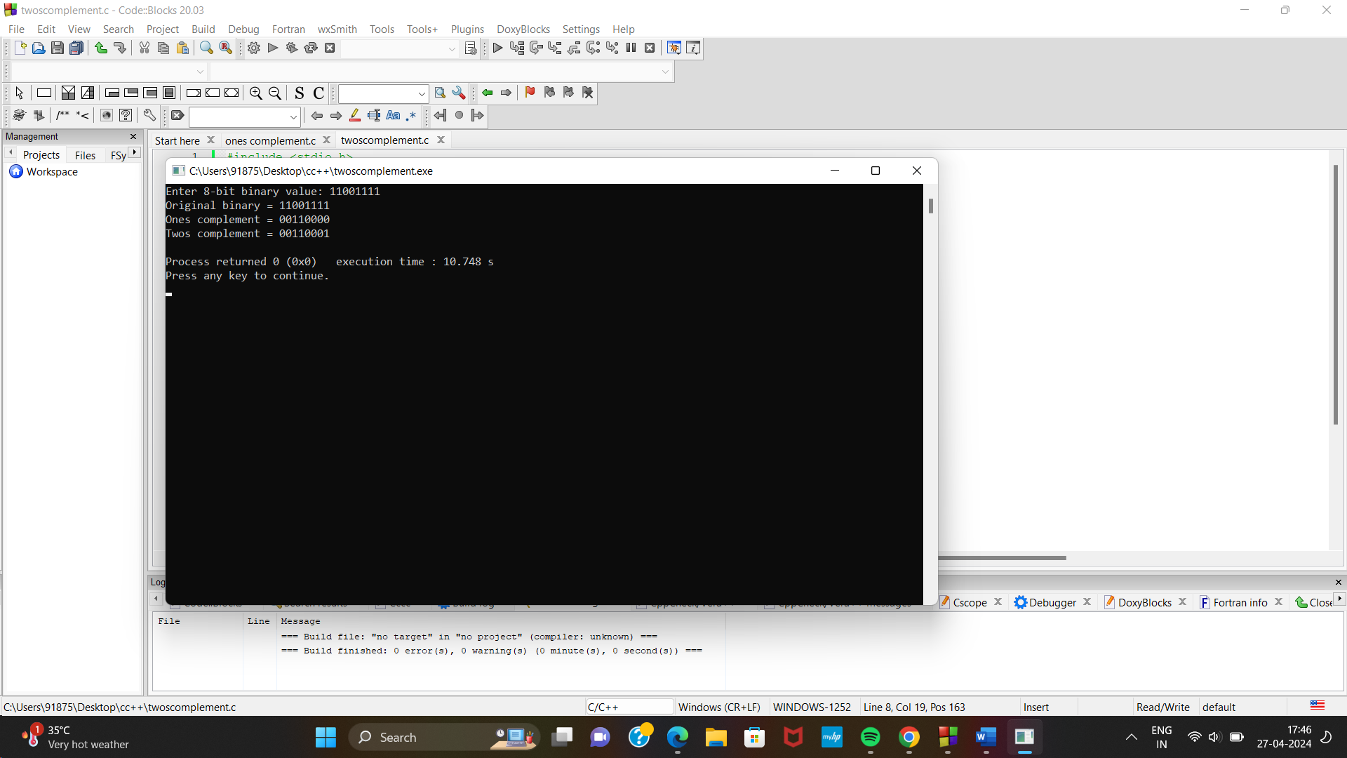

BINARY ADDITON

#include <stdio.h>

int main() {
long int binary1, binary2;
int i = 0, rem = 0, sum[20];

// Asking for input
printf("Enter first binary number: ");
scanf("%ld", &binary1);
printf("Enter second binary number: ");
scanf("%ld", &binary2);

// Add each bits from the two binary numbers
while (binary1 != 0 || binary2 != 0) {
sum[i++] = (binary1 % 10 + binary2 % 10 + rem) % 2;
rem = (binary1 % 10 + binary2 % 10 + rem) / 2;
binary1 = binary1 / 10;
binary2 = binary2 / 10;
}

if (rem != 0) {
sum[i++] = rem;
}

--i;

printf("Sum of two binary numbers is: ");
while (i >= 0) {
printf("%d", sum[i--]);
}

return 0;
}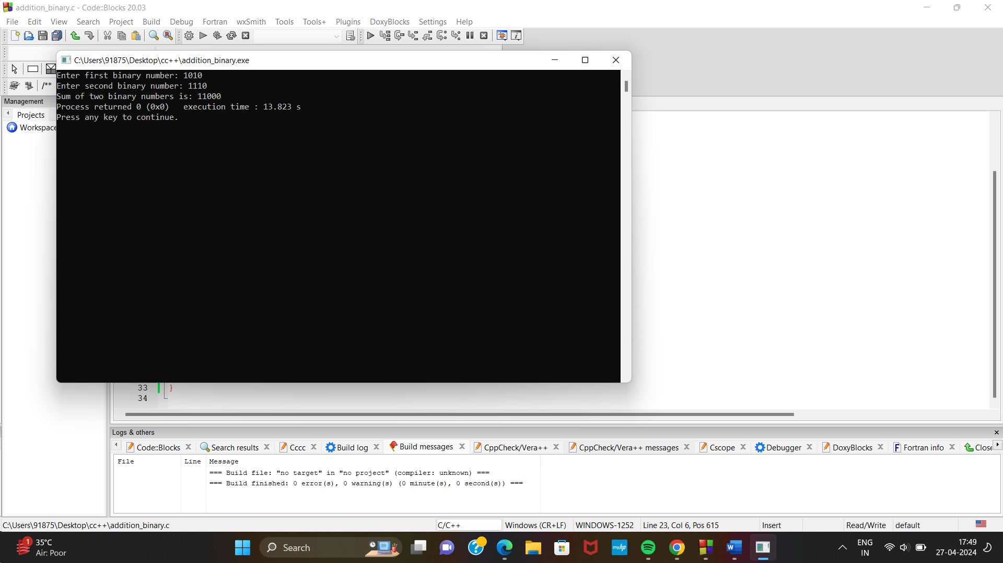

BINARY sub

#include <stdio.h>

// Function to perform binary subtraction
int binarySubtraction(int a, int b) {
int borrow, result = 0, bitPosition = 1;

while (a || b) {
int bitA = a & 1;
int bitB = b & 1;

// Apply borrow if needed
bitA -= borrow;

// Calculate the difference
int diff = bitA - bitB;

// If diff is negative, set borrow for the next iteration
if (diff < 0) {
diff += 2;
borrow = 1;
} else {
borrow = 0;
}

// Update the result
result += diff * bitPosition;

// Move to the next bit position
a >>= 1;
b >>= 1;
bitPosition <<= 1;
}

return result;
}

int main() {
int num1, num2;

printf("Enter two binary numbers: ");
scanf("%d %d", &num1, &num2);

int result = binarySubtraction(num1, num2);

printf("Result of binary subtraction: %d\n", result);

return 0;
}
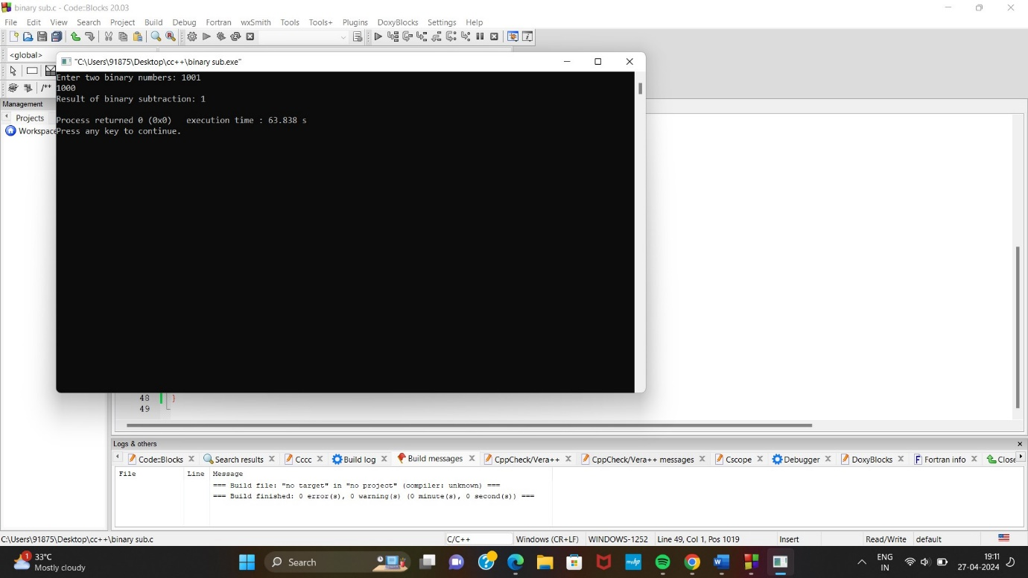
BINARY MULTI

#include <stdio.h>

int binaryproduct(int, int);

int main()
{

long binary1, binary2, multiply = 0;
int digit, factor = 1;

printf("Enter the first binary number: ");
scanf("%ld", &binary1);
printf("Enter the second binary number: ");
scanf("%ld", &binary2);
while (binary2 != 0)
{
digit = binary2 % 10;
if (digit == 1)
{
binary1 = binary1 * factor;
multiply = binaryproduct(binary1, multiply);
}
else
binary1 = binary1 * factor;
binary2 = binary2 / 10;
factor = 10;
}
printf("Product of two binary numbers: %ld", multiply);
return 0;
}

int binaryproduct(int binary1, int binary2)
{
int i = 0, remainder = 0, sum[20];
int binaryprod = 0;

while (binary1 != 0 || binary2 != 0)
{
sum[i++] =(binary1 % 10 + binary2 % 10 + remainder) % 2;
remainder =(binary1 % 10 + binary2 % 10 + remainder) / 2;
binary1 = binary1 / 10;
binary2 = binary2 / 10;
}
if (remainder != 0)
sum[i++] = remainder;
--i;
while (i >= 0)
binaryprod = binaryprod * 10 + sum[i--];
return binaryprod;
}
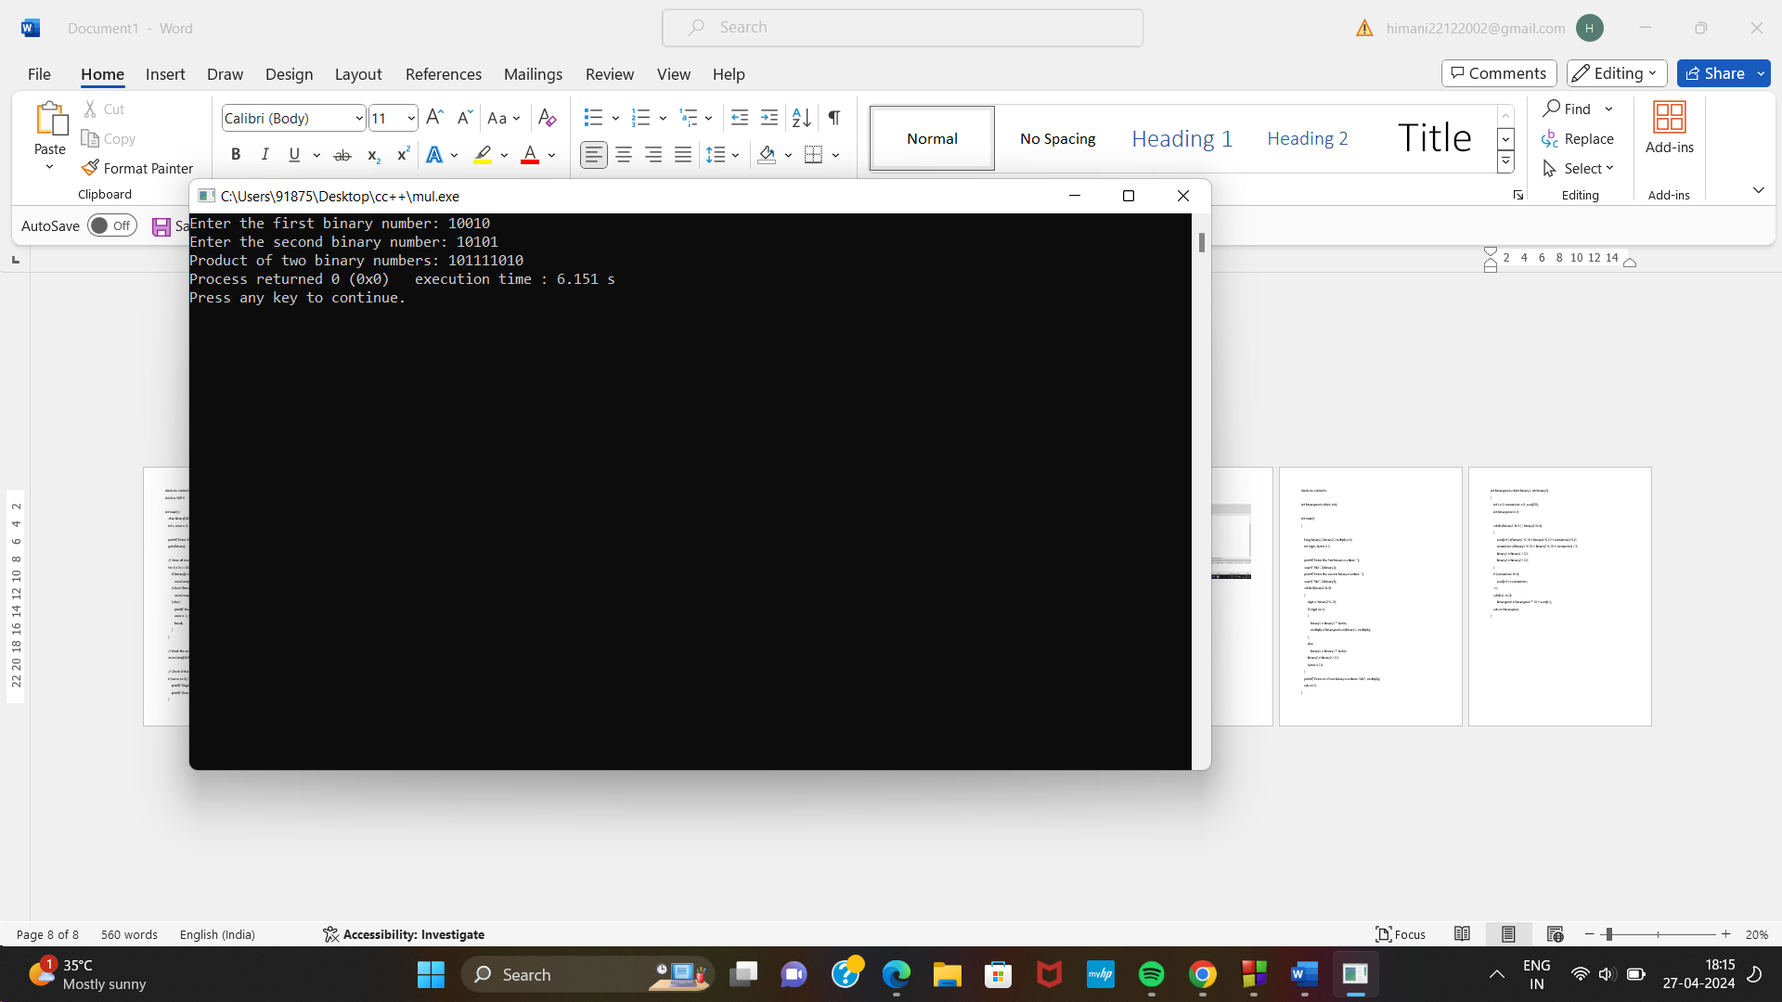

FLOATING POINT ADDITION
#include <stdio.h>

// Structure to represent a floating-point number
struct FloatingPoint {
int sign; // 0 for positive, 1 for negative
int exponent;
float mantissa;
};

// Function to perform binary floating-point addition
struct FloatingPoint addFloatingPoint(struct FloatingPoint a, struct FloatingPoint b) {
struct FloatingPoint result;

// Check if signs are different
if (a.sign != b.sign) {
result.sign = 0; // Return 0 (negative zero)
result.exponent = 0;
result.mantissa = 0.0;
return result;
}

// Determine the larger exponent
int largerExponent = (a.exponent > b.exponent) ? a.exponent : b.exponent;

// Adjust mantissas based on exponent difference
if (a.exponent != b.exponent) {
if (a.exponent < b.exponent) {
a.mantissa /= 2.0; // Right shift a's mantissa
} else {
b.mantissa /= 2.0; // Right shift b's mantissa
}
}

// Add mantissas
result.mantissa = a.mantissa + b.mantissa;

// Normalize the result
while (result.mantissa >= 2.0) {
result.mantissa /= 2.0;
largerExponent++;
}

// Set the result's properties
result.sign = a.sign;
result.exponent = largerExponent;

return result;
}

int main() {
// Example: Adding 1.1 * 10^3 and 50
struct FloatingPoint num1 = {0, 3, 1.1};
struct FloatingPoint num2 = {0, 0, 50.0};

struct FloatingPoint result = addFloatingPoint(num1, num2);

printf("Result: %c%.2f * 10^%d\n", (result.sign == 1) ? '-' : '+', result.mantissa, result.exponent);

return 0;
}
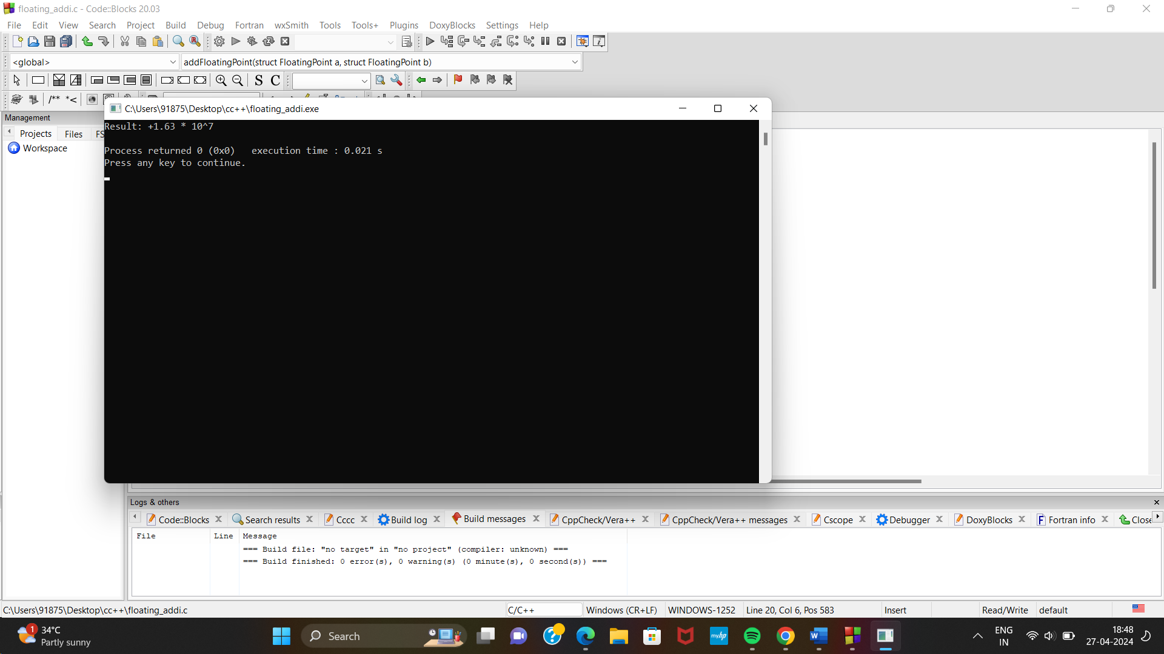

FLOATING POINT SUB

#include <stdio.h>

// Structure to represent a 32-bit floating-point number
struct FloatingPoint {
int sign; // 0 for positive, 1 for negative
int exponent;
float mantissa;
};

// Function to perform binary floating-point subtraction
struct FloatingPoint subtractFloatingPoint(struct FloatingPoint a, struct FloatingPoint b) {
struct FloatingPoint result;

// Calculate the difference in exponents
int exponentDiff = a.exponent - b.exponent;

// Shift the mantissa of the smaller number
if (exponentDiff > 0) {
b.mantissa /= 2.0; // Right shift b's mantissa
} else if (exponentDiff < 0) {
a.mantissa /= 2.0; // Right shift a's mantissa
}

// Subtract the mantissas
result.mantissa = a.mantissa - b.mantissa;

// Normalize the result
while (result.mantissa < 1.0) {
result.mantissa *= 2.0;
a.exponent--; // Decrement the exponent
}

// Set the result's properties
result.sign = a.sign;
result.exponent = a.exponent;

return result;
}

int main() {
// Example: Subtracting 9.75 and 0.5625
struct FloatingPoint num1 = {0, 130, 9.75}; // 9.75 = 1.00111000000000000000000 * 2^3
struct FloatingPoint num2 = {1, 126, 0.5625}; // 0.5625 = 1.00100000000000000000000 * 2^(-2)

struct FloatingPoint result = subtractFloatingPoint(num1, num2);

printf("Result: %c%.2f * 2^%d\n", (result.sign == 1) ? '-' : '+', result.mantissa, result.exponent);

return 0;
}
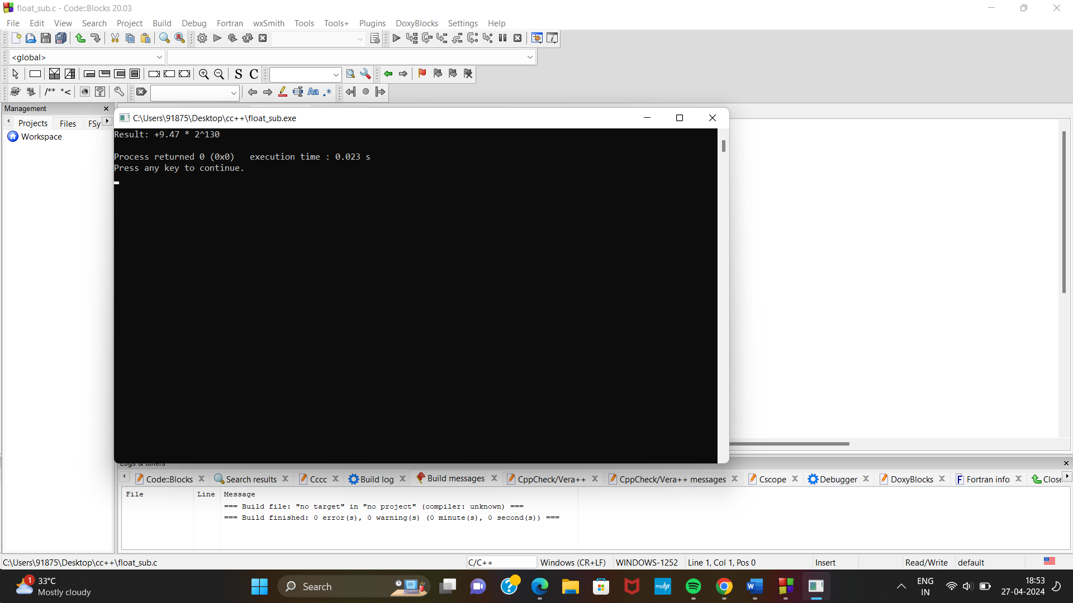

FLOATING POINT MULTI

#include <stdio.h>

// Structure to represent a 32-bit floating-point number
struct FloatingPoint {
int sign; // 0 for positive, 1 for negative
int exponent;
float mantissa;
};

// Function to perform binary floating-point multiplication
struct FloatingPoint multiplyFloatingPoint(struct FloatingPoint a, struct FloatingPoint b) {
struct FloatingPoint result;

// Multiply the mantissas
result.mantissa = a.mantissa * b.mantissa;

// Adjust the radix point if needed
while (result.mantissa >= 2.0) {
result.mantissa /= 2.0;
a.exponent++; // Increment the exponent
}

// Set the result's properties
result.sign = (a.sign ^ b.sign); // XOR of sign bits
result.exponent = a.exponent;

return result;
}

int main() {
// Example: Multiplying 9.75 and -0.5625
struct FloatingPoint num1 = {0, 130, 9.75}; // 9.75 = 1.00111000000000000000000 * 2^3
struct FloatingPoint num2 = {1, 126, 0.5625}; // -0.5625 = -1.00100000000000000000000 * 2^(-2)

struct FloatingPoint result = multiplyFloatingPoint(num1, num2);

printf("Result: %c%.2f * 2^%d\n", (result.sign == 1) ? '-' : '+', result.mantissa, result.exponent);

return 0;
}
