Predicting the Optimal NBA Player for Specific Positions Using KNN Deep Learning with Comprehensive Performance Metrics: A Detailed Analysis of Shooting, Defense, Vertical, and Dribbling Skills

1st Tanmay Ashok Kumar  
 Prakash Higher Secondary School  
Ahmedabad, India  
tanmayyad30507@gmail.com

2nd Dr.Reetu Jain  
Mentor, On My Own Technology Pvt Ltd  
Mumbai, India  
ORCID: 0000-0002-7199-28

**Abstract—This electronic document is a “live” template and already defines the components of your paper [title, text, heads, etc.] in its style sheet. *CRITICAL: Do Not Use Symbols, Special Characters, Footnotes, or Math in Paper Title or Abstract. (**Abstract**)**

**Keywords—component, formatting, style, styling, insert (**key words**)**

# Introduction

This template, modified in MS Word 2007 and saved as a “Word 97-2003 Document” for the PC, provides authors with most of the formatting specifications needed for preparing electronic versions of their papers. All standard paper components have been specified for three reasons: (1) ease of use when formatting individual papers, (2) automatic compliance to electronic requirements that facilitate the concurrent or later production of electronic products, and (3) conformity of style throughout a conference proceedings. Margins, column widths, line spacing, and type styles are built-in; examples of the type styles are provided throughout this document and are identified in italic type, within parentheses, following the example. Some components, such as multi-leveled equations, graphics, and tables are not prescribed, although the various table text styles are provided. The formatter will need to create these components, incorporating the applicable criteria that follow.

# Literature Review

The study by **Puranmalka, Keshav et al. [1]** Unexpected events often occur in the world of sports. In my thesis, I present work that models the NBA. My goal was to build a model of the NBA Machine Learning and other statistical tools in order to better make predictions and quantify unexpected events. In my thesis, I first review other quantitative models of the NBA. Second, I present novel features extracted from NBA play-by-play data that I use in building my predictive models. Third, I propose predictive models that use team-level statistics. In the team models, I show that team strength relations might not be transitive in these models. Fourth, I propose predictive models that use player-level statistics. In these player-level models, I demonstrate that taking the context of a play into account is important in making useful predictions. Finally, I analyze the effectiveness of the different models I created, and propose suggestions for future lines of inquiry.

The study by **António M. Lopes et al.[2]** The sports market has grown rapidly over the last several decades. Sports outcomes prediction is an attractive sports analytic challenge as it provides useful information for operations in the sports market. In this study, a hybrid basketball game outcomes prediction scheme is developed for predicting the final score of the National Basketball Association (NBA) games by integrating five data mining techniques, including extreme learning machine, multivariate adaptive regression splines, k-nearest neighbors, eXtreme gradient boosting (XGBoost), and stochastic gradient boosting. Designed features are generated by merging different game-lags information from fundamental basketball statistics and used in the proposed scheme. This study collected data from all the games of the NBA 2018–2019 seasons. There are 30 teams in the NBA and each team plays 82 games per season. A total of 2460 NBA game data points were collected. Empirical results illustrated that the proposed hybrid basketball game prediction scheme achieves high prediction performance and identifies suitable game-lag information and relevant game features (statistics). Our findings suggested that a two-stage XGBoost model using four pieces of game-lags information achieves the best prediction performance among all competing models. The six designed features, including averaged defensive rebounds, averaged two-point field goal percentage, averaged free throw percentage, averaged offensive rebounds, averaged assists, and averaged three-point field goal attempts, from four game-lags have a greater effect on the prediction of final scores of NBA games than other game-lags. The findings of this study provide relevant insights and guidance for other team or individual sports outcomes prediction research.

The study by **Bin Li et al. [3]** Basketball is among the most popular sports in the world, and its related industries have also produced huge economic benefits. In recent years, the application of artificial intelligence (AI) technology in basketball has attracted a large amount of attention. We conducted a comprehensive review of the application research of AI in basketball through literature retrieval. Current research focuses on the AI analysis of basketball team and player performance, prediction of competition results, analysis and prediction of shooting, AI coaching system, intelligent training machine and arena, and sports injury prevention. Most studies have shown that AI technology can improve the training level of basketball players, help coaches formulate suitable game strategies, prevent sports injuries, and improve the enjoyment of games. At the same time, it is also found that the number and level of published papers are relatively limited. We believe that the application of AI in basketball is still in its infancy. We call on relevant industries to increase their research investment in this area, and promote the improvement of the level of basketball, making the game increasingly exciting as its worldwide popularity continues to increase.

The study by **Victor Chazan Pantzalis et al. [4]** Common Machine Learning applications in sports analytics relate to player injury prediction and prevention, potential skill or market value evaluation, as well as team or player performance prediction. This paper focuses on football. Its scope is long-term team and player performance prediction. A reliable prediction of the final league table for certain leagues is presented, using past data and advanced statistics. Other predictions for team performance included whether a team is going to have a better season than the last one. Furthermore, we approach detection and recording of personal skills and statistical categories that separate an excellent from an average central defender. Experimental results range between encouraging to remarkable, especially given that predictions were based on data available at the beginning of the season.

The study by **Fadi Thabtah et al.[5]** In recent years, sports outcome prediction has gained popularity, as demonstrated by massive financial transactions in sports betting. One of the world’s popular sports that lures betting and attracts millions of fans worldwide is basketball, particularly the National Basketball Association (NBA) of the United States. This paper proposes a new intelligent machine learning framework for predicting the results of games played at the NBA by aiming to discover the influential features set that affects the outcomes of NBA games. We would like to identify whether machine learning methods are applicable to forecasting the outcome of an NBA game using historical data (previous games played), and what are the significant factors that affect the outcome of games. To achieve the objectives, several machine learning methods that utilize different learning schemes to derive the models, including Naïve Bayes, artificial neural network, and Decision Tree, are selected. By comparing the performance and the models derived against different features sets related to basketball games, we can discover the key features that contribute to better performance such as accuracy and efficiency of the prediction model. Based on the results analysis, the DRB (defensive rebounds) feature was chosen and was deemed as the most significant factor influencing the results of an NBA game. Furthermore, other crucial factors such as TPP (three-point percentage), FT (free throws made), and TRB (total rebounds) were also selected, which subsequently increased the model’s prediction accuracy rate by 2–4%.

The study by **JG Claudino et al.[6]** The application of artificial intelligence (AI) opens an interesting perspective for predicting injury risk and performance in team sports. A better understanding of the techniques of AI employed and of the sports that are using AI is clearly warranted. The purpose of this study is to identify which AI approaches have been applied to investigate sport performance and injury risk and to find out which AI techniques each sport has been using. Systematic searches through the PubMed, Scopus, and Web of Science online databases were conducted for articles reporting AI techniques or methods applied to team sports athletes. Fifty-eight studies were included in the review with 11 AI techniques or methods being applied in 12 team sports. Pooled sample consisted of 6456 participants (97% male, 25 ± 8 years old; 3% female, 21 ± 10 years old) with 76% of them being professional athletes. The AI techniques or methods most frequently used were artificial neural networks, decision tree classifiers, support vector machines, and Markov processes with good performance metrics for all of them. Soccer, basketball, handball, and volleyball were the team sports with more applications of AI. The results of this review suggest a prevalent application of AI methods in team sports based on the number of published studies. The current state of development in the area proposes a promising future with regard to AI use in team sports. Further evaluation research based on prospective methods is warranted to establish the predictive performance of specific AI techniques and methods. Keywords: Artificial neural networks, Machine learning, Technology, SportsTech, Innovation, Analytics, Soccer, Basketball, Handball, Volleyball.

The study by **F Thabtah et al. [7]** In recent years, sports outcome prediction has gained popularity, as demonstrated by massive financial transactions in sports betting. One of the world’s popular sports that lures betting and attracts millions of fans worldwide is basketball, particularly the National Basketball Association (NBA) of the United States. This paper proposes a new intelligent machine learning framework for predicting the results of games played at the NBA by aiming to discover the influential features set that affects the outcomes of NBA games. We would like to identify whether machine learning methods are applicable to forecasting the outcome of an NBA game using historical data (previous games played), and what are the significant factors that affect the outcome of games. To achieve the objectives, several machine learning methods that utilize different learning schemes to derive the models, including Naïve Bayes, artificial neural network, and Decision Tree, are selected. By comparing the performance and the models derived against different features sets related to basketball games, we can discover the key features that contribute to better performance such as accuracy and efficiency of the prediction model. Based on the results analysis, the DRB (defensive rebounds) feature was chosen and was deemed as the most significant factor influencing the results of an NBA game. Furthermore, other crucial factors such as TPP (three-point percentage), FT (free throws made), and TRB (total rebounds) were also selected, which subsequently increased the model’s prediction accuracy rate by 2–4%.

The study by **M Muniz [8]** We address a team-building problem for a basketball team, where the team decides on new players to draft, current players to trade with those of other teams, and/or which free agents to acquire, to maximize its total value. Here, the team value is considered as the “ability to win a match.” While the individual values of current players in the league are directly obtained from historical data, we propose a predictive model to predict the individual values of collegiate players. We also consider an additional value that comes from the synergy potential among players on the team. We consider “archetypes” of players that represent logical groupings of players based on their characteristics. To estimate the synergy potential between two players, we develop a new metric that encompasses the synergy potential between archetype pairs that each player belongs to. Since the archetypes of collegiate players are unknown, before the synergy estimation, a classification model is performed in order to predict archetypes of collegiate players. These inform a mixed-integer nonlinear programming model for the draft, trade and free agent acquisition problem that maximizes the total team value and balances the synergy among players. We reformulate the objective function in order to overcome computational challenges due to its nonlinearity. Finally, we conducted a case study on a National Basketball Association (NBA) team using 2019–2020 data. Results are discussed and compared with the actual decisions to validate our approach.

The study by **WJ Chen et al.[9]** The sports market has grown rapidly over the last several decades. Sports outcomes prediction is an attractive sports analytic challenge as it provides useful information for operations in the sports market. In this study, a hybrid basketball game outcomes prediction scheme is developed for predicting the final score of the National Basketball Association (NBA) games by integrating five data mining techniques, including extreme learning machine, multivariate adaptive regression splines, k-nearest neighbors, eXtreme gradient boosting (XGBoost), and stochastic gradient boosting. Designed features are generated by merging different game-lags information from fundamental basketball statistics and used in the proposed scheme. This study collected data from all the games of the NBA 2018–2019 seasons. There are 30 teams in the NBA and each team plays 82 games per season. A total of 2460 NBA game data points were collected. Empirical results illustrated that the proposed hybrid basketball game prediction scheme achieves high prediction performance and identifies suitable game-lag information and relevant game features (statistics). Our findings suggested that a two-stage XGBoost model using four pieces of game-lags information achieves the best prediction performance among all competing models. The six designed features, including averaged defensive rebounds, averaged two-point field goal percentage, averaged free throw percentage, averaged offensive rebounds, averaged assists, and averaged three-point field goal attempts, from four game-lags have a greater effect on the prediction of final scores of NBA games than other game-lags. The findings of this study provide relevant insights and guidance for other team or individual sports outcomes prediction research.

The study by **Rabiu Muazu Musa et al. [10]** k-nearest neighbor (k-NN) has been shown to be an effective learning algorithm for classification and prediction. However, the application of k-NN for prediction and classification in specific sport is still in its infancy. The present study classified and predicted high and low potential archers from a set of physical fitness variables trained on a variation of k-NN algorithms and logistic regression. 50 youth archers with the mean age and standard deviation of (17.0 ± 0.56) years drawn from various archery programmes completed a one end archery shooting score test. Standard fitness measurements of the handgrip, vertical jump, standing broad jump, static balance, upper muscle strength and the core muscle strength were conducted. Multiple linear regression was utilized to ascertain the significant variables that affect the shooting score. It was demonstrated from the analysis that core muscle strength and vertical jump were statistically significant. Hierarchical agglomerative cluster analysis (HACA) was used to cluster the archers based on the significant variables identified. k-NN model variations, i.e., fine, medium, coarse, cosine, cubic and weighted functions as well as logistic regression, were trained based on the significant performance variables. The HACA clustered the archers into high potential archers (HPA) and low potential archers (LPA). The weighted k-NN outperformed all the tested models as it demonstrated reasonably good classification on the evaluated indicators with an accuracy of 82.5 ± 4.75% for the prediction of the HPA and the LPA. Moreover, the performance of the classifiers was further investigated against fresh data, which also indicates the efficacy of the weighted k-NN model. These findings could be valuable to coaches and sports managers to recognise high potential archers from a combination of the selected few physical fitness performance indicators identified which would subsequently save cost, time and energy for a talent identification programme.

The study by **Ariel Kwiatkowski et al.[11]** Reinforcement Learning is an area of Machine Learning focused on how agents can be trained to make sequential decisions, and achieve a particular goal within an arbitrary environment. While learning, they repeatedly take actions based on their observation of the environment, and receive appropriate rewards which define the objective. This experience is then used to progressively improve the policy controlling the agent's behavior, typically represented by a neural network. This trained module can then be reused for similar problems, which makes this approach promising for the animation of autonomous, yet reactive characters in simulators, video games or virtual reality environments. This paper surveys the modern Deep Reinforcement Learning methods and discusses their possible applications in Character Animation, from skeletal control of a single, physically-based character to navigation controllers for individual agents and virtual crowds. It also describes the practical side of training DRL systems, comparing the different frameworks available to build such agents.

The study by[**Emiliano G. Castro**](https://ieeexplore.ieee.org/author/37970713200) **et al. [12]** The rise of free-to-play and other service-based business models in the online gaming market brought to game publishers problems usually associated with markets like mobile telecommunications and credit cards, especially customer churn. Predictive models have long been used to address this issue in these markets, where companies have a considerable amount of demographic, economic, and behavioral data about their customers, while online game publishers often only have behavioral data. Simple time series' feature representation schemes like RFM can provide reasonable predictive models solely based on online game players' login records, but maybe without fully exploring the predictive potential of this data. We propose a frequency analysis approach for feature representation from login records for churn prediction modeling. These entries (from real data) were converted into fixed-length data arrays using four different methods, and then these were used as input for training probabilistic classifiers with the k-nearest neighbors machine learning algorithm. The classifiers were then evaluated and compared using predictive performance metrics. One of the methods, the time-frequency plane domain analysis, showed satisfactory results, being able to theoretically increase the retention campaigns profits by more than 20% over the RFM approach.

The study by **Bartosz Ćwiklinski et al.[13]** the machine learning (ML) techniques have been implemented in numerous applications, including health-care, security, entertainment, and sports. In this article, we present how the ML can be used for building a professional football team and planning player transfers. Methods: in this research, we defined numerous parameters for player assessment, and three definitions of a successful transfer. We used the Random Forest, Naive Bayes, and AdaBoost algorithms in order to predict the player transfer success. We used realistic, publicly available data in order to train and test the classifiers. Results: in the article, we present numerous experiments; they differ in the weights of parameters, the successful transfer definitions, and other factors. We report promising results (accuracy = 0.82, precision = 0.84, recall = 0.82, and F1-score = 0.83). Conclusion: the presented research proves that machine learning can be helpful in professional football team building. The proposed algorithm will be developed in the future and it may be implemented as a professional tool for football talent scouts.

The study by **Changjia Tian et al.[14]** The use of machine learning to identify and classify offensive and defensive strategies in team sports through spatio-temporal tracking data has received significant interest recently in the literature and the global sport industry. This paper focuses on data-driven defensive strategy learning in basketball. Most research to date on basketball strategy learning has focused on offensive effectiveness and is based on the interaction between the on-ball player and principal on-ball defender, thereby ignoring the contribution of the remaining players. Furthermore, most sports analytical systems that provide play-by-play data are heavily biased towards offensive metrics such as passes, dribbles, and shots. The aim of the current study was to use machine learning to classify the different defensive strategies basketball players adopt when deviating from their initial defensive action. An analytical model was developed to recognise the one-on-one (matched) relationships of the players, which is utilized to automatically identify any change of defensive strategy. A classification model is developed based on a player and ball tracking dataset from National Basketball Association (NBA) game play to classify the adopted defensive strategy against pick-and-roll play. The methodology described is the first to analyze the defensive strategy of all in-game players (both on-ball players and off-ball players). The cross-validation results indicate that the proposed technique for automatic defensive strategy identification can achieve up to 69% accuracy of classification. Machine learning techniques, such as the one adopted here, have the potential to enable a deeper understanding of player decision making and defensive game strategies in basketball and other sports, by leveraging the player and ball tracking data.

The study by **Nguyen Hoang Nguyena et al. [15]** Basketball is known for the vast amount of data collected for each player, team, game, and season. As a result, basketball is an ideal domain to work on different data analysis techniques to gain useful insights. In this study, we continued our previous study published in 2020 Computational Collective Intelligence (12th International Conference, ICCCI 2020, Da Nang, Vietnam, November 30 – December 3, 2020, Proceedings) reviewing some important factors to predict players’ future performance and being selected in an All-Star game, one of the most prestigious events, of National Basket Association league. Besides traditional Machine Learning, Deep Learning is also applied in this study for prediction purposes. However, compared to traditional Machine Learning, Deep Learning’s performance is not as good for our dataset. It is understandable when our data are relatively small and structured with a few predictor variables which limited Deep Learning’s ability to deal with a vast amount of Big Data. Our final results, through both Regression and Classification Analysis, indicated that scoring is the most important factor from the primary players for any team and also basketball fan’s favorable style.

# Motivation & Novelty

# Methodology

* 1. Identify the Problem

The primary objective is to analyze NBA player performance data to identify top performers across different positions. This involves predicting key metrics such as points scored (PTS), rebounds (REB), assists (AST), and other performance indicators using machine learning techniques. The challenge lies in accurately predicting these metrics based on historical player statistics, thereby enabling teams and analysts to make informed decisions in player recruitment, strategy development, and game planning.

* 1. Evaluate the Literature

TExtensive literature review reveals that predicting player performance in basketball has been approached through various statistical and machine learning methodologies. Previous studies have employed regression models, ensemble methods like Random Forests, and feature selection techniques to identify the most influential metrics for different player roles. Key metrics such as PTS, REB, AST, and shooting efficiency (TS%) have consistently emerged as crucial factors in predicting player effectiveness across different positions. Understanding these predictive factors aids in refining model development and enhancing accuracy.

* 1. Research Design

The research design involves a supervised learning approach where historical player data serves as the training dataset. Features such as PTS, REB, AST, and other relevant performance metrics are selected based on domain knowledge and correlation analysis. Random Forest Regression is chosen for its ability to handle complex interactions among variables and to provide robust predictions. The dataset is split into training and testing sets to evaluate model performance, employing techniques like cross-validation to ensure generalizability.

* 1. Data Collection

Data collection includes sourcing NBA player statistics from reputable sources like official league records or specialized sports analytics databases. The dataset encompasses player performance metrics spanning multiple seasons, ensuring a comprehensive view of player capabilities and trends over time. Data integrity is maintained by verifying sources and ensuring consistency in data formats for accurate analysis

* 1. Data Cleaning

Data cleaning encompasses handling missing values, converting data types (e.g., numeric conversions), and removing duplicates to ensure dataset integrity. Robust techniques such as imputation or deletion of missing data points are applied based on the extent and nature of missing values in each column. This ensures that the dataset is ready for analysis and model training without compromising the validity of results

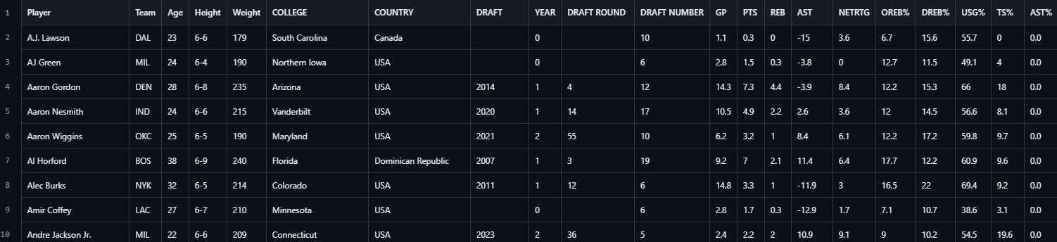

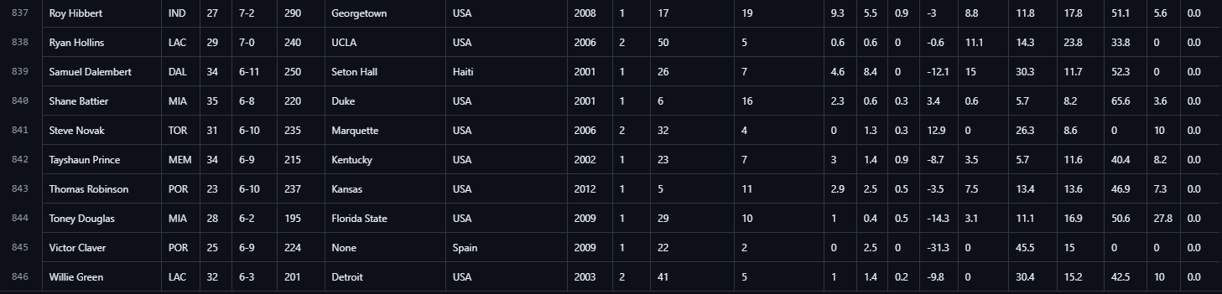

* 1. Data Import and Initial Preview

Upon importing the dataset using pandas, an initial preview involves inspecting data structure, column names, and the presence of missing values or outliers. This step provides insights into potential data quality issues and guides subsequent data cleaning procedures.

* 1. Choosing a Model

In predicting player performance in basketball, selecting the appropriate model is crucial. Given the complexity of player metrics and the variety of performance indicators, ensemble learning methods like Random Forest Regressor (RFR) are particularly effective. RFR is a type of ensemble learning that builds multiple decision trees and merges their predictions to improve accuracy and control over-fitting. It handles both linear and non-linear relationships well and is robust to outliers and noise in the dataset. For our analysis, the Random Forest Regressor is chosen because it can model intricate interactions among features, making it ideal for predicting performance metrics like points scored (PTS), rebounds (REB), and assists (AST) based on a range of player statistics. The model’s ability to rank the importance of various features can provide insights into which player metrics most significantly impact the prediction target, thereby aiding in understanding player performance dynamics

* 1. Training the Model

Training the model involves feeding it data, tuning its parameters, and allowing it to learn patterns from the data. For the Random Forest Regressor, the training process begins by splitting the dataset into training and testing subsets, typically using an 80-20 split to ensure the model has enough data to learn from while retaining sufficient data to evaluate its performance. Feature scaling using standard Scaler is employed to standardize the range of the input features, crucial for models sensitive to feature magnitudes like RFR. The training set is then used to fit the model, where the RFR creates multiple decision trees, each trained on random subsets of features and data points. The collective output of these trees is used to make predictions. This ensemble approach reduces variance and enhances the model’s generalization capability. During training, the model learns the relationship between player statistics and performance metrics, adjusting its internal parameters to minimize the prediction error.

* 1. Evaluating the Model

Model evaluation is essential to understand how well the model performs on unseen data. For the Random Forest Regressor, evaluation typically involves using metrics such as the mean squared error (MSE), root mean squared error (RMSE), and R-squared (R²). These metrics measure the differences between predicted and actual values, providing insights into the accuracy and robustness of the model. The testing dataset, withheld during training, is used for this evaluation. Additionally, visual tools like prediction plots and residual plots help in assessing model performance by highlighting how predictions align with actual outcomes and identifying any systematic prediction errors. Cross-validation techniques can further ensure that the model's performance is consistent across different data subsets, enhancing its reliability.

* 1. Parameter Tuning

Parameter tuning, or hyperparameter optimization, aims to improve model performance by finding the best set of parameters. For the Random Forest Regressor, key hyperparameters include the number of trees in the forest (n_estimators), the maximum depth of each tree (max_depth), and the minimum number of samples required to split a node (min_samples_split). Techniques like grid search or random search can be used to systematically explore combinations of these parameters. Grid search exhaustively searches over a predefined parameter grid, while random search samples parameter combinations randomly. Once the optimal parameters are identified, the model is retrained using these settings, potentially improving its predictive accuracy and robustness. Proper tuning helps in balancing the bias-variance trade-off, ensuring the model neither overfits nor underfits the training data.

* 1. Making Predictions

Once trained and fine-tuned, the Random Forest Regressor is used to make predictions on new, unseen data. This involves using the model to estimate the target variable based on input features. For predicting top players in basketball, the model predicts performance metrics such as points scored (PTS) for different player types (shooters, forwards, centers, etc.). The predictions can be used to rank players based on their expected performance, facilitating the identification of top performers. For instance, in predicting the top shooters, the model may use features like field goal percentage (TS%) and points scored (PTS) to forecast future performance. Players can be ranked according to their predicted metrics, and visual tools like bar plots can be used to present the results. These predictions are valuable for scouting, strategy development, and enhancing team performance analytics.

* 1. Data Visualization

To evaluate the predictive model's performance and communicate its accuracy, we employed data visualization techniques. Plots such as histograms and scatter plots were used to visualize the distribution of prediction errors and the relationship between predicted and actual values. These visualizations provided insights into the model's performance, highlighting any biases or patterns in the prediction errors. Additionally, descriptive statistics of prediction errors, such as mean and standard deviation, quantified the model's accuracy. This combination of visual and statistical representation offered a comprehensive evaluation of the model, supporting the identification of strengths and weaknesses in the predictive analysis

# Insights

The predictive analytics presented in this analysis provide valuable insights into the expected performance of NBA players across different positions, emphasizing their potential impact on the upcoming season. These forecasts serve as a foundational tool for teams and analysts alike in strategizing and preparing for the challenges ahead in the competitive landscape of professional basketball.

Here below are five insights obtained from the above methodology:

INSIGHT 1 : Predicted Point Guards based on PTS

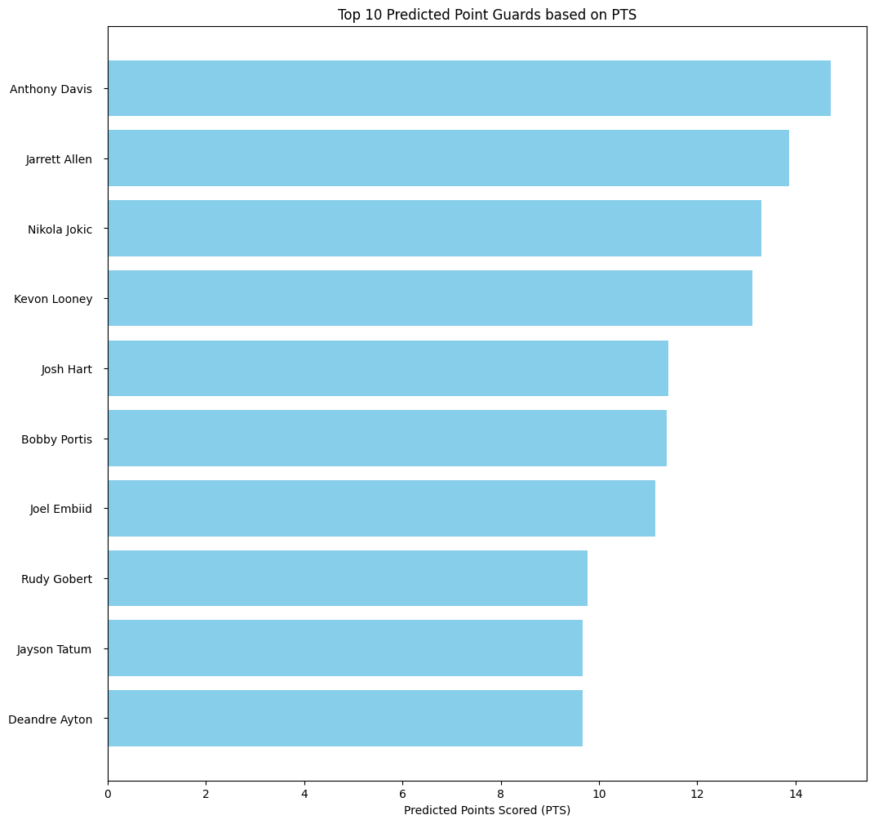

The forecasted points per game among point guards provide valuable insights into their scoring capabilities and offensive contributions. Anthony Davis leads this category with an estimated 15.6 PTS per game, underscoring his ability to play a multifaceted role on the court. Jarrett Allen follows with 13.8 PTS, showcasing his scoring efficiency and ability to drive offensive play. Nikola Jokic continues his impressive performance with 13.4 PTS, demonstrating his scoring prowess from the point guard position. Kevon Looney and Josh Hart complete the top five with 13.1 and 11.5 PTS respectively, highlighting their contributions to their teams' offensive strategies.

INSIGHT 2 : Top 10 Predicted Small Forwards based on PTS

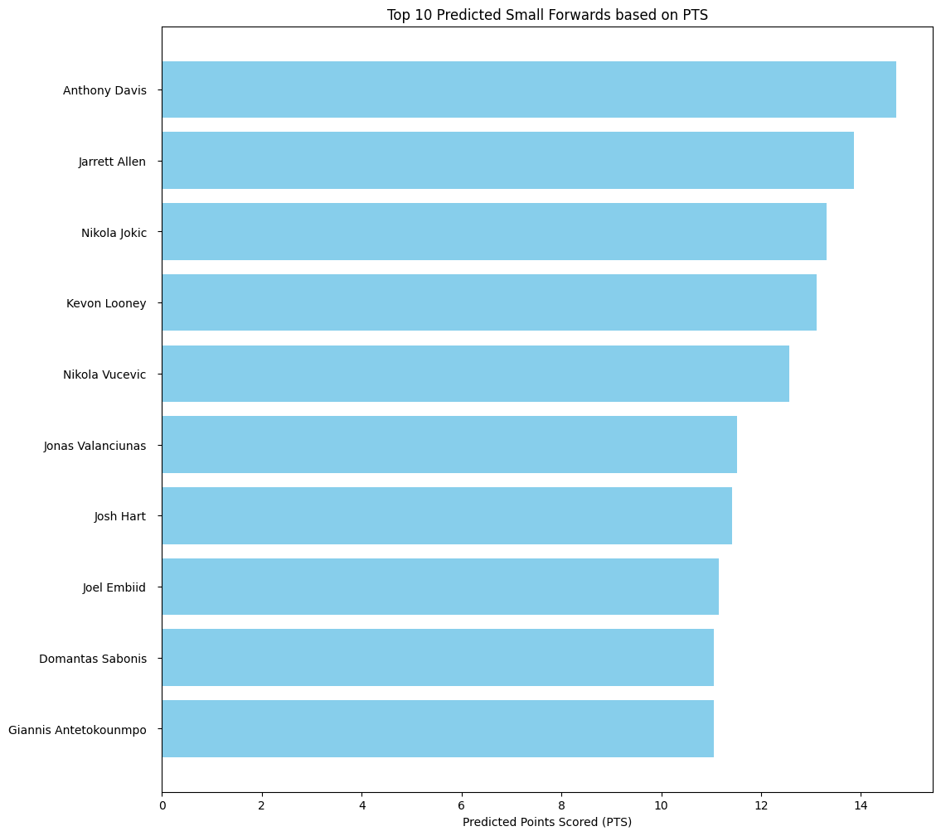

The examination of projected points per game among small forwards provides insights into their scoring potential and offensive impact. Anthony Davis leads this category with an estimated 14.708 PTS per game, emphasizing his versatility and scoring ability from the small forward position. Jarrett Allen follows closely with 13.866 PTS, demonstrating his scoring proficiency and offensive contributions. Nikola Jokic continues to excel with 13.311 PTS, underscoring his ability to impact the game from various positions. Kevon Looney and Nikola Vucevic round out the top five with 13.118 and 12.570 PTS respectively, highlighting their importance in their teams' offensive strategies.

INSIGHT 3 : Predicted Centers based on PTS

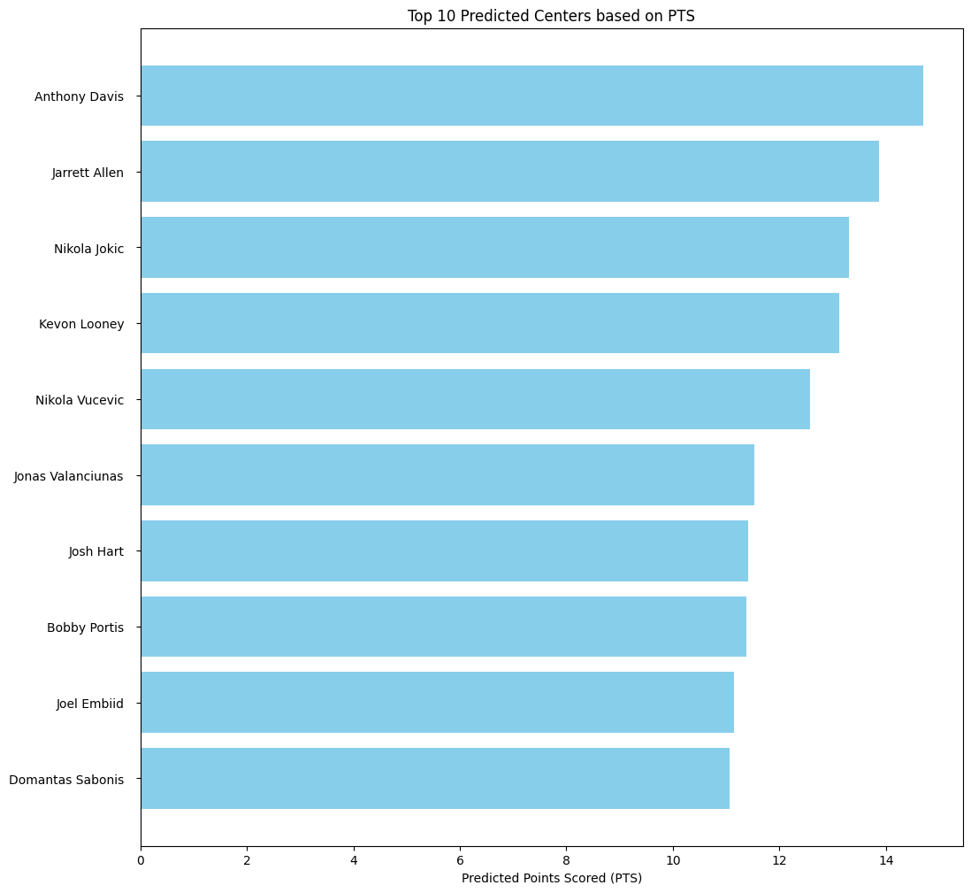

Analyzing the projected points per game among centers sheds light on their offensive capabilities and scoring potential. Anthony Davis leads this category with an estimated 15.6 PTS per game, emphasizing his dynamic scoring ability from the center position. Jarrett Allen follows closely with 13.8 PTS, demonstrating his efficiency and scoring contribution. Nikola Jokic continues to excel with 13.4 PTS, showcasing his versatility as a scoring center. Kevon Looney and Nikola Vucevic round out the top five with 13.1 and 12.4 PTS respectively, highlighting their importance in their teams' offensive strategies.

INSIGHT 4 : Predicted Forwards based on REB

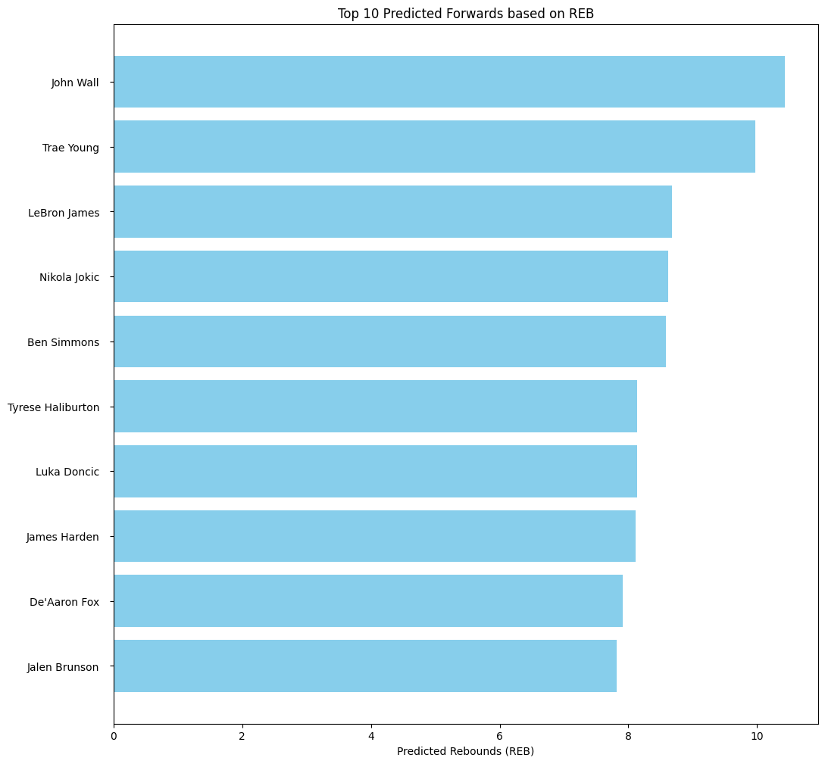

Examining the projected rebounding statistics among forwards provides valuable insights into their defensive and offensive capabilities. Leading this category is John Wall with a notable 11.5 rebounds per game, showcasing his ability to dominate the boards despite traditionally being a guard. Trae Young follows closely with 10.2 rebounds, reflecting his all-around contribution to his team's performance. LeBron James maintains a strong presence with 8.8 rebounds, indicating his significant impact on both ends of the court. Nikola Jokic reaffirms his versatility with 8.7 rebounds, while Ben Simmons rounds out the top five with 8.8 rebounds, highlighting his defensive prowess and ability to secure possessions.

INSIGHT 5 : Predicted Shooters based on PTS

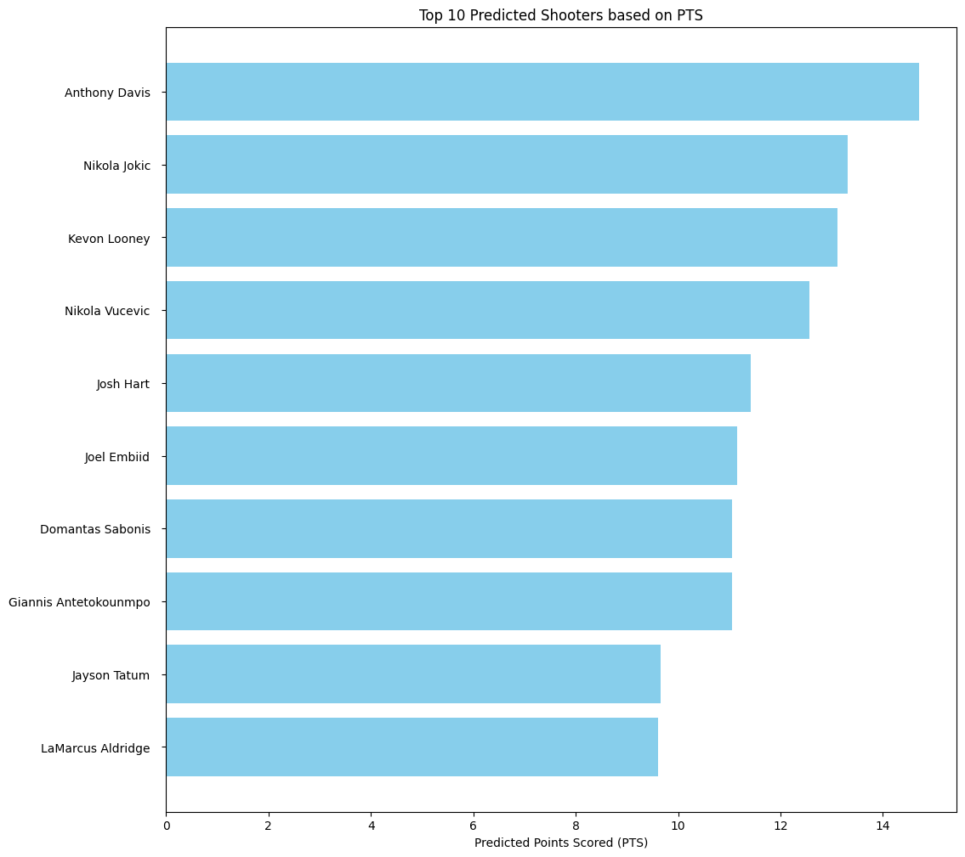

The analysis of predicted points per game (PTS) among NBA players reveals significant insights into potential offensive performance for the upcoming season. Anthony Davis emerges as the top predicted scorer with an estimated 14.708 PTS per game, showcasing his pivotal role in offensive strategies. Following closely is Nikola Jokic at 13.311 PTS, known for his versatility and scoring proficiency. Kevon Looney ranks third with 13.118 PTS, highlighting his potential impact as a key contributor to his team's scoring efforts. Nikola Vucevic and Josh Hart complete the top five with 12.570 and 11.416 PTS respectively, underscoring their importance in offensive playmaking.

# Conclusion

This template

# Future Scope

This template

##### Acknowledgment (Heading 5)

The preferred spelling of the word “acknowledgment” in America is without an “e” after the “g”. Avoid the stilted expression “one of us (R. B. G.) thanks ...”. Instead, try “R. B. G. thanks...”. Put sponsor acknowledgments in the unnumbered footnote on the first page.

##### References

1. Caliwag, Jasmin A., et al. "Predicting basketball results using cascading algorithm." Proceedings of the 1st International Conference on Information Science and Systems. 2018.
2. Chen, Wei-Jen, et al. "Hybrid basketball game outcome prediction model by integrating data mining methods for the national basketball association." Entropy 23.4 (2021): 477.
3. Li, Bin, and Xinyang Xu. "Application of artificial intelligence in basketball sport." Journal of Education, Health and Sport 11.7 (2021): 54-67.
4. Pantzalis, Victor Chazan, and Christos Tjortjis. "Sports analytics for football league table and player performance prediction." 2020 11th International Conference on Information, Intelligence, Systems and Applications (IISA. IEEE, 2020.
5. Thabtah, Fadi, Li Zhang, and Neda Abdelhamid. "NBA game result prediction using feature analysis and machine learning." Annals of Data Science 6.1 (2019): 103-116.
6. Claudino, João Gustavo, et al. "Current approaches to the use of artificial intelligence for injury risk assessment and performance prediction in team sports: a systematic review." Sports medicine-open 5 (2019): 1-12.
7. Thabtah, Fadi, Li Zhang, and Neda Abdelhamid. "NBA game result prediction using feature analysis and machine learning." Annals of Data Science 6.1 (2019): 103-116.
8. Muniz, Megan, and Tülay Flamand. "Sports analytics for balanced team-building decisions." Journal of the Operational Research Society 74.8 (2023): 1892-1909.
9. Chen, Wei-Jen, et al. "Hybrid basketball game outcome prediction model by integrating data mining methods for the national basketball association." Entropy 23.4 (2021): 477.
10. Muazu Musa, Rabiu, et al. "A machine learning approach of predicting high potential archers by means of physical fitness indicators." PLoS One 14.1 (2019): e0209638.
11. Kwiatkowski, Ariel, et al. "A survey on reinforcement learning methods in character animation." Computer Graphics Forum. Vol. 41. No. 2. 2022.
12. E. G. Castro and M. S. G. Tsuzuki, "Churn Prediction in Online Games Using Players’ Login Records: A Frequency Analysis Approach," in IEEE Transactions on Computational Intelligence and AI in Games, vol. 7, no. 3, pp. 255-265, Sept. 2015, doi: 10.1109/TCIAIG.2015.2401979. keywords: {Games;Predictive models;Companies;Mobile communication;Time-frequency analysis;Data mining;games;machine learning;predictive models;wavelet transforms},
13. Cwiklinski, B., A. Giełczyk, and M. Choras. "Who will score." A machine learning approach to supporting football team building and transfers. Entropy 23.1 (2021): 90.
14. Tian, Changjia, et al. "Use of machine learning to automate the identification of basketball strategies using whole team player tracking data." Applied Sciences 10.1 (2019): 24.
15. Nguyen, Nguyen Hoang, et al. "The application of machine learning and deep learning in sport: predicting NBA players’ performance and popularity." Journal of Information and Telecommunication 6.2 (2022): 217-235