EXPERIMENT:5
- CIRCUIT DIAGRAM:
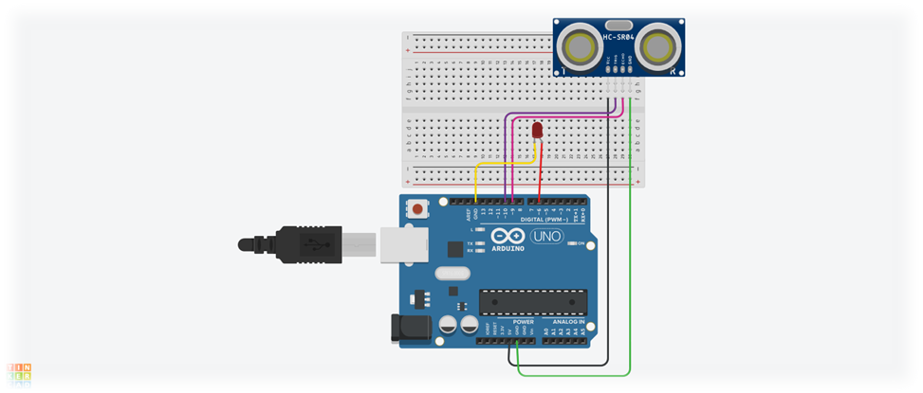
2.CONCEPT USED:
- There are various concepts used in the experiment as listed below:
- Use of Ultrasonic Sensor.
- Concept used for coding Arduino UNO for the Ultrasonic Sensor.
- Combination of ultrasonic sensor with LED.
- Dual behavior of digital pins of Arduino UNO.
3.LEARNINGS AND OUTCOMES:
- IN THIS EXPERIMENT WE LEARNT ABOUT THE FOLLOWING:
- We learnt about Ultrasonic Sensor.
- We learnt how to use the pulseIn command Ffor coding on Arduion.
- We learnt about the transmitter and receiver pins of the Ultrasonic Sensor.

- Observations :
- The delay time is given in microseconds.
- If the distance of the object is less than 20cm than the LED will glow with a noticeable effect.
- While using the Analogue commands for OUTPUT and INPUT we use numeric values instead of HIGH and LOW.
5.PROBLEMS AND TROUBLESHOOTING:
- Problems faced while performing the experiment:
- The cables were not connected to the Ultrasonic Sensor and also to Arduion UNO at times.
- The LED glowed without a noticeable effect.
- Troubleshooting while performing the experiment:
- Changed the connecting cables of Arduino UNO and Ultrasonic Sensor.
- Tightened the cable connections.
- Altered the delay time in microseconds.

6.PRECAUTIONS:
- Some precautions to keep in mind while performing the experiment:
- pinMode should be declared for each pin in the void setup.
- The loop should not be an infinite loop.
- LED should be connected to the analogue pin.
7.LEARNING AND OUTCOMES:
- We have learnt the following from this experiment:
- Writing the basic code for glowing of an LED with the help of an Ultrasonic Sensor.
- Application of the analogue pins.
- Applications of Ultrasonic Sensor.
- Glowing effect of the LED.

