EXPERIMENT:6
- CIRCUIT DIAGRAM:
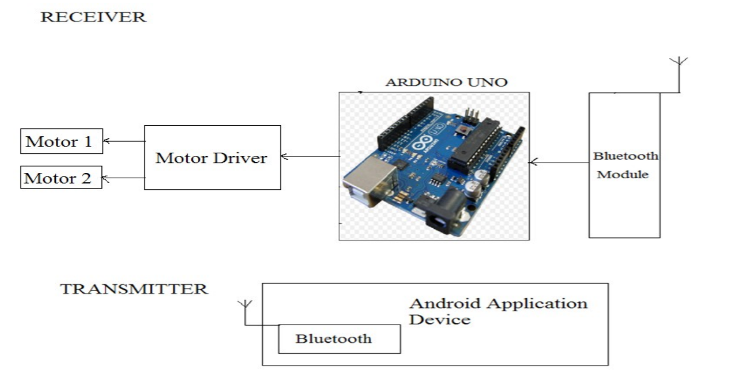
2.CONCEPT USED:
- There are various concepts used in the experiment as listed below:
- Use of HC-05 Bluetooth .
- Concept used for coding Arduino UNO for the HC-05 Bluetooth.
- Concept of Grounding.
3.LEARNINGS AND OUTCOMES:
- IN THIS EXPERIMENT WE LEARNT ABOUT THE FOLLOWING:
- We learnt about smart phone to Bluetooth transmitting and receiving module.
- We learnt how to use basic algorithms for using HC-05 Bluetooth.
- We learnt about the output current for our Bluetooth module which we generally use in our circuit is 600mA per channel.
- We learnt that the peak output current for our Bluetooth module is 1.2mA per channel.

- Observations :
- The data received from the smart phone is either 1 or 0 i.e. binary.
- If we change the value of Serial.begin(9600), then we are also changing the data rate transmitted or received from or to the Bluetooth module.
- We use Serial.available in our code so that the electromagnetic radiations in our surroundings does not hinder the working of our module . Bluetooth continuously receive some sort of E.M signals.
5.PROBLEMS AND TROUBLESHOOTING:
- Problems faced while performing the experiment:
- Uploading the code while the Tx and Rx pin of the HC-05 Bluetooth is connected to the Tx and Rx pin fo Arduion UNO .
- Bluetooth unable to connect to the smart phone.
- Troubleshooting while performing the experiment:
- The hardware was correctly connected to the respective pins .
6.PRECAUTIONS:
- Some precautions to keep in mind while performing the experiment:
- Bluetooth module should be connected to your smart phone only.
- No loose connections. Connections should be proper.
- The code should only be uploaded when the Tx and Rx pin of Bluetooth and Arduino UNO are disconnected .
7.LEARNING AND OUTCOMES:
- We have learnt the following from this experiment:
- Writing the basic algorithms which are used while handling a Bluetooth Module.
- Application Bluetooth Module.
- The transfer rate of Bluetooth Module.

