
FinGuard-AI
A Rules-First, Explainable Framework for Narrative-Based Financial Fraud and Consumer-Harm Triage in U.S. Financial Services
Design-science artifact and synthetic demonstration study

Research Snapshot
30  Synthetic cases | 11  Output categories | 4  Auditable scores | 30/30  Complete outputs
A S M FAHIM
UNIVERSITY OF NEW HAVEN, MS FINANCE & FINANCIAL ANALYTICS
Correspondence: asmfahim987@gmail.com
RESEARCH PROTOTYPE | NOT PRODUCTION-READY
This paper reports on a transparent software artifact and a synthetic demonstration. It does not claim real-world predictive validation, legal determinations, or production deployment outcomes.

Abstract
Financial fraud is often visible first in a transaction record, but the complaint narrative usually explains what the ledger cannot: who contacted the consumer, what story was used, how quickly money moved, and what happened when the consumer asked for help. This paper introduces FinGuard-AI, a Python and Streamlit research prototype that converts those narrative details and a small set of structured case facts into transparent fraud, harm, dispute, and recovery indicators. The system uses explicit weighted phrase rules not opaque embeddings to classify narratives into ten substantive fraud, anti-money-laundering, consumer-stress, and disclosure-integrity categories plus another category. It then produces four bounded measures: Fraud Risk, Consumer Harm, Dispute Friction, and Recovery Urgency. Every output can be traced back to matched phrases and visible point adjustments. Following a design-science methodology, the prototype was exercised on 30 realistic but synthetic cases spanning all requested categories. All cases produced complete classifications, scores, explanations, and recommendations. Mean scores were 74.2, 53.5, 23.6, and 54.7, respectively, and 17 cases met the prototype’s high-risk queue criterion. Because the cases were constructed for coverage, these results demonstrate functional behavior rather than predictive validity. The study contributes an auditable complaint-triage architecture, a multidimensional view of consumer harm, a governance mapping to the NIST AI Risk Management Framework, and a preregistration-ready plan for future evaluation using independently annotated public complaint narratives.
Keywords: financial fraud; consumer complaints; authorized push payment scams; anti-money laundering; explainable artificial intelligence; rules-based systems; consumer harm; dispute resolution; design science; FinTech governance
Scope of evidence: The synthetic demonstration verifies software behavior, category coverage, score bounds, and audit-trail generation. It cannot establish accuracy, calibration, fairness, or effectiveness for real consumers.

Highlights
- A transparent, rules-first engine analyzes complaint narratives without opaque embeddings or black-box predictions.
- The framework separates fraud indicators from consumer harm, dispute friction, and recovery time sensitivity.
- Every score is auditable through visible matched phrases and factor-level point additions or deductions.
- A 30-case synthetic demonstration confirms functional coverage across eleven output categories.
- A future validation protocol is specified for public complaint narratives, independent annotation, baselines, robustness, and human-review studies.

Abbreviations
Abbreviation | Meaning
AML | Anti-money laundering
APP | Authorized push payment
BEC | Business email compromise
CFPB | Consumer Financial Protection Bureau
DSR | Design-science research
IC3 | Internet Crime Complaint Center
NIST AI RMF | National Institute of Standards and Technology AI Risk Management Framework
PII | Personally identifiable information
SAR | Suspicious Activity Report
XAI | Explainable artificial intelligence

1. Introduction
Financial fraud is not a single operational problem. It may begin with a spoofed bank call, a changed invoice, a fake investment platform, or a relationship built over months. By the time a consumer reports the event, the transaction record shows only part of the story. The narrative may reveal the deception method, the pressure applied, the payment rail used, the consumer’s vulnerability, and the barriers encountered during the dispute. That broader context matters to fraud teams, AML investigators, complaint managers, and consumer-protection specialists. The scale of reported harm reinforces the need for better triage. The Federal Trade Commission reported more than $12.5 billion in consumer-described fraud losses for 2024, while the FBI Internet Crime Complaint Center reported 1,008,597 complaints and $20.877 billion in losses for 2025 (FTC, 2025a; FBI, 2026). The two systems differ in scope and should not be combined, but both show why institutions need methods that can move from a consumer’s account of events to a timely, reviewable response.
Complaint narratives add the human and operational details that transaction data usually omit. A consumer may describe a caller who claimed to represent a bank, a vendor whose payment instructions suddenly changed, a one-time passcode that was disclosed under pressure, an investment platform that demanded another fee, or a dispute that stalled after repeated submissions. These details can change how a case should be routed, what evidence should be preserved, and whether recovery steps are time-sensitive. The CFPB’s public complaint database makes such narratives available for research under defined consent and publication conditions, while appropriately cautioning that complaints are consumer allegations rather than verified findings (CFPB, 2025a, 2025b).
Contemporary fraud research increasingly uses machine learning, deep learning, graph analytics, and natural-language processing. These methods can improve pattern discovery, but real-world deployment remains constrained by class imbalance, concept drift, limited labeled data, privacy restrictions, and the tension between predictive performance and auditability (Hilal et al., 2022; Pourhabibi et al., 2020; Yang et al., 2026). In high-stakes contexts, explanations must permit meaningful review rather than merely provide a persuasive visualization. Rudin (2019) argues that inherently interpretable models should be preferred where feasible, while Doshi-Velez and Kim (2017) and Sokol and Flach (2020) emphasize that explanation quality itself requires systematic evaluation.
FinGuard-AI addresses a deliberately narrower problem than general transaction monitoring. It is a complaint-level triage artifact designed to translate narrative and structured case data into transparent risk indicators and practical next-step recommendations. The current version is a research prototype, not a production control. Its purpose is to make assumptions, indicators, thresholds, and limitations visible enough for analysts, researchers, and governance reviewers to inspect and challenge.
This paper makes five contributions:
- An auditable taxonomy for complaint-level fraud, scam, AML/mule-account, consumer-stress, and disclosure-integrity triage.
- Four separate indicators for fraud evidence, consumer harm, dispute friction, and recovery time sensitivity.
- A rules-first Python implementation that exposes matched phrases, category rule scores, and factor-level score adjustments.
- A synthetic demonstration establishing functional completeness across the intended workflow without overstating predictive validity.
- A governance and evaluation protocol for extending the artifact to independently annotated public or institutional complaint data.
The remainder of the paper reviews the relevant fraud, complaint-analytics, and explainability literature; describes the design-science method; presents the artifact and synthetic demonstration; maps the system to governance, privacy, security, and accessibility requirements; and defines the empirical work necessary before any operational claims could be justified.

2. Background and Related Work

2.1 Scam typologies, payment speed, and financial-system risk
Scam-related losses arise through heterogeneous mechanisms. Bank impersonation schemes may use spoofed caller identification, urgent security narratives, and requests to disclose authentication codes or transfer funds to a purported “safe account.” Business email compromise can redirect invoice or closing payments by substituting fraudulent beneficiary instructions. Romance and investment schemes may involve extended grooming, fabricated returns, and escalating payments. Marketplace scams exploit trust between counterparties, while money-mule schemes recruit people to receive and forward proceeds. These patterns can overlap: a romance victim may also become an unwitting mule, or an investment scam may use bank impersonation during recovery fraud.
FinCEN advisories describe imposter scams, money-mule schemes, business email compromise, elder financial exploitation, and virtual-currency investment fraud as typologies that financial institutions should evaluate in context (FinCEN, 2019, 2020, 2022, 2023). The advisories treat red flags as indicators rather than conclusive proof. This distinction is central to FinGuard-AI: the system identifies narrative consistency with a typology but does not determine criminal liability, suspicious-activity reporting obligations, reimbursement rights, or the status of a receiving account.
Payment speed changes the operational value of early triage. Wires, instant payments, peer-to-peer transfers, gift cards, cash, and cryptocurrency differ in reversibility, dispute mechanisms, and the information needed for tracing. A narrative-triage system can therefore contribute by separating the probability-like question “does this resemble fraud?” from the operational question “how quickly should recovery or preservation actions be considered?” FinGuard-AI implements this separation through distinct Fraud Risk and Recovery Urgency scores.

2.2 Consumer complaints as risk-intelligence data
Complaint data occupy an intermediate position between customer-service records, regulatory intelligence, and research data. They capture consumer-reported experiences and may reveal recurrent operational failures, communication barriers, and dispute patterns. The CFPB’s public database supports analysis of complaint products, issues, company responses, and narratives, but the Bureau cautions that the data are not a representative statistical sample and that narratives reflect consumer accounts rather than adjudicated facts (CFPB, 2025a, 2025b). Accordingly, a responsible system should describe outputs as indicators derived from reported information.
Recent work has applied NLP and machine learning to complaint classification and outcomes. Jain et al. (2026) compared TF-IDF-based models with a multilingual transformer for bilingual financial complaint classification, while Wang et al. (2026) combined narrative features, topic representations, and structured attributes to predict monetary-relief outcomes in CFPB complaints. These studies demonstrate the analytic value of complaint narratives but also reinforce the need to separate predictive labels from legal or normative judgments. FinGuard-AI differs by focusing on a transparent multidimensional triage output rather than a single product, issue, or relief label.

2.3 Explainability, interpretability, and auditability
Explainability is not a single technical property. LIME approximates a complex model locally around a prediction (Ribeiro et al., 2016), while SHAP assigns additive feature-attribution values (Lundberg & Lee, 2017). Such methods are useful when a complex model is necessary, but post-hoc explanations can be unstable or misunderstood. In contrast, a rules-first system is interpretable by construction when the decision logic, matched evidence, weights, and thresholds are visible.
Interpretability alone does not guarantee validity. A transparent rule can still be poorly specified, biased, incomplete, or overconfident. A proper evaluation must test at least four properties: predictive agreement with independently labeled cases; robustness to linguistic variation and missing information; human ability to understand and challenge the output; and governance controls that record changes, overrides, and outcomes. Sokol and Flach’s (2020) explainability fact-sheet approach and the NIST AI Risk Management Framework provide useful structures for documenting these properties.

2.4 Research gap
The literature contains substantial work on transaction fraud, graph-based anomaly detection, accounting fraud, and complaint classification. Less attention has been given to integrated, complaint-level tools that simultaneously identify scam typologies, measure consumer harm, quantify dispute friction, prioritize recovery urgency, and expose an auditable policy recommendation. FinGuard-AI is designed as a testable response to that gap. The claimed contribution is the artifact and its evaluation framework, not a claim that heuristic rules outperform mature institutional fraud systems.

3. Research Method

3.1 Design-science approach
Design-science research is appropriate when the research objective includes creating and evaluating an artifact that addresses an identified practical problem. Hevner et al. (2004) describe design science as the construction and evaluation of purposeful artifacts, while Peffers et al. (2007) operationalize the process through problem identification, objectives, design and development, demonstration, evaluation, and communication. FinGuard-AI follows this sequence.
DSR stage | Application in this study
Problem identification | Narrative complaints contain fraud, harm, dispute, and recovery information that is difficult to triage consistently and transparently.
Objectives | Provide auditable typology classification, four separate scores, evidence explanations, practical recommendations, and portfolio oversight.
Design and development | Implement weighted phrase rules, structured factor adjustments, bounded scores, recommendations, and a Streamlit dashboard in Python.
Demonstration | Run the complete workflow on 30 realistic but synthetic complaint narratives covering all output categories.
Evaluation | Assess functional completeness, score bounds, category coverage, explanation generation, and known failure risks; define a future empirical protocol.
Communication | Document the architecture, methodology, limitations, reproducibility requirements, and public-service deployment controls.

3.2 Design objectives
- Transparency: each output must be reconstructable from visible rules and case attributes.
- Separation of dimensions: fraud evidence, consumer harm, dispute friction, and recovery urgency must not be collapsed into one score.
- Actionability: the system should translate analysis into a short, reviewable recommendation.
- Abstention readiness: weak or conflicting evidence should be capable of triggering “other,” “insufficient evidence,” or human review in future versions.
- Governance: rules, thresholds, explanations, and overrides should be versioned and auditable.
- Non-adversarial use: the system should support human triage and consumer assistance, not automated adverse decisions.

3.3 Research questions
- RQ1: Can an explicit rules-first artifact operationalize a coherent complaint-level taxonomy across fraud, scam, AML/mule, consumer-stress, and disclosure-integrity cases?
- RQ2: Can fraud evidence, consumer harm, dispute friction, and recovery urgency be represented as separate and auditable indicators?
- RQ3: Does the prototype generate complete, inspectable explanations and recommendations for a diverse synthetic case set?
- RQ4: What governance, privacy, security, and accessibility controls are necessary before the artifact could support real consumers or institutional reviewers?
- RQ5: What empirical design is required to test classification performance, score validity, robustness, and explanation utility on real complaint narratives?

4. FinGuard-AI Artifact Design
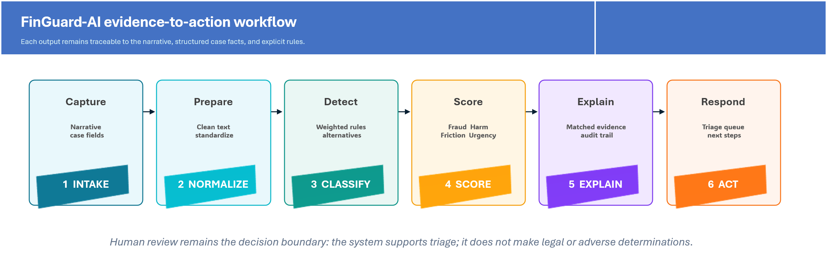
FinGuard-AI rules-first analysis pipeline.

4.1 Inputs and preprocessing
The application accepts either a single narrative or a CSV portfolio with eight fields: case identifier, date, state, narrative, amount lost, payment channel, institution type, and outcome. Text is lowercased, punctuation is normalized, and repeated whitespace is removed. Matching is deterministic: multiword phrases use substring matching, while single terms use word boundaries. The prototype does not currently use stemming, embeddings, fuzzy matching, named-entity recognition, or contextual negation detection.

4.2 Typology classification
The current rule inventory contains 103 weighted phrases across ten substantive categories. For a narrative x and typology t, the rule score is the sum of the weights for matched indicators: S(t,x) = Σ w(i,t) I(i,x), where I equals one when indicator i is matched and zero otherwise. The category with the highest score is selected; if no category-specific phrase matches, the output is “other.” A rule-confidence indicator reflects the top score, number of matched indicators, and separation from the second-ranked category. It is explicitly not a calibrated probability.
Output category | Operational definition | Illustrative indicators
APP scam | The consumer reports authorizing a transfer after deception or manipulation. | “sent the money myself,” “instant payment,” “transfer was authorized”
Bank impersonation scam | A scammer claims to represent a bank or fraud/security team. | “claimed to be from the bank,” “safe account,” “one-time passcode”
Invoice redirection / BEC | Fraudulent or compromised communications redirect a business or closing payment. | “payment instructions changed,” “vendor email,” “new bank details”
Marketplace scam | A listing, seller, buyer, rental, or off-platform payment is fraudulent. | “online marketplace,” “item never arrived,” “payment outside the platform”
Romance scam | Relationship-building or emotional grooming induces payments. | “dating app,” “said they loved me,” “travel emergency”
Investment scam | A purported investment, trading platform, or withdrawal process is deceptive. | “guaranteed return,” “profits shown,” “withdrawal fee”
AML / mule-account risk | An account receives and forwards funds or exhibits pass-through behavior. | “forward the money,” “keep a commission,” “multiple incoming transfers”
Medical debt / credit stress | The narrative concerns medical billing, collection, or credit-reporting harm. | “medical debt,” “hospital bill,” “credit score dropped”
Mortgage or insurance stress | The narrative concerns servicing, foreclosure, escrow, or insurance claims. | “mortgage servicer,” “foreclosure,” “force-placed insurance”
Financial reporting/ disclosure integrity | The narrative alleges material misstatement, omission, valuation, or control concerns. | “misstated revenue,” “material omission,” “internal controls”
Other | No category-specific phrase reaches a positive score. | Fallback; manual review is appropriate
FinGuard-AI typology taxonomy. Indicators are illustrative, not exhaustive or determinative.

4.3 Four score dimensions
Each score is clamped to an integer from 0 to 100. The point systems are heuristics intended for transparent demonstration. They have not been calibrated to observed probabilities or validated against expert ratings. The separation of score dimensions is a core design decision: a low-dollar case can have high fraud evidence but moderate consumer harm, while a non-fraud servicing case can have low fraud risk but high dispute friction or housing-related harm.
Dimension | Primary inputs | Interpretation
Fraud Risk Score | Typology base value; credential compromise; spoofing; urgency; false safe-account instruction; payment channel; amount; confirmed-fraud outcome. | Strength of narrative and transaction indicators associated with fraud.
Consumer Harm Score | Loss magnitude; age/fixed-income vulnerability; disability; language barriers; medical or housing stress; essential funds; repeat victimization; recovery outcome. | Severity and persistence of reported financial and personal harm.
Dispute Friction Score | Denial; case closure; no response; repeated contacts; transfers; duplicate evidence requests; appeal; provisional-credit reversal; delay; resolution. | Reported procedural burden in obtaining review or remediation.
Recovery Urgency Score | Payment-channel reversibility; typology; fraud score; recency; pending status; loss amount; unresolved outcome; reported recovery. | Time sensitivity of freeze, recall, tracing, stop-payment, or evidence-preservation action.
Score construction and intended interpretation.

4.4 Explanation and recommendation generation
For each case, the interface displays the selected typology, matched category indicators, alternative categories with nonzero evidence, and the complete factor list for all four scores. Recommendations are generated from visible branches. For example, APP and bank-impersonation cases can trigger escalation and reimbursement-review language; BEC cases can trigger beneficiary-bank outreach and wire-recall review; mule-account cases can trigger receiving-side risk review and transaction-record preservation; high dispute-friction scores can trigger senior-level case review; and cryptocurrency channels can trigger preservation of wallet addresses and transaction hashes. The application uses cautious language and does not represent these actions as legal entitlements.

4.5 Portfolio dashboard
The portfolio view summarizes total cases, cases meeting the high-risk queue criterion, mean Fraud Risk and Dispute Friction scores, total reported loss, typology distribution, severity distribution, and high-risk case details. Users may download an analyzed CSV containing case inputs, classifications, scores, indicators, and recommendations. This feature demonstrates how a narrative-level engine can support operational oversight in addition to single-case assistance.

5. Synthetic Demonstration Study

5.1 Dataset and procedure
The demonstration dataset contains 30 realistic but fictional narratives dated in July 2026. The cases cover bank impersonation, APP scams, BEC, marketplace fraud, romance and investment scams, money-mule risk, medical-debt and credit stress, mortgage or insurance stress, financial-reporting concerns, and an “other” case. The narratives include payment channels, loss amounts, institution types, dispute outcomes, and harm indicators. No narrative describes an actual person or event.
The dataset was processed through the same analyze_dataframe() pipeline used by the Streamlit application. Functional checks confirmed the required schema, unique identifiers, valid dates, bounded scores, populated recommendations, and category coverage. The high-risk queue criterion was defined as Fraud Risk ≥70, Consumer Harm ≥75, or Recovery Urgency ≥75.

5.2 Descriptive results
Measure | Demonstration result
Cases processed | 30
Total synthetic reported amount lost | $627,910
Median synthetic amount lost | $8,900
Cases with nonzero loss | 28
High-risk queue cases | 17 (56.7%)
Mean Fraud Risk Score | 74.2
Mean Consumer Harm Score | 53.5
Mean Dispute Friction Score | 23.6
Mean Recovery Urgency Score | 54.7
Descriptive results for the synthetic demonstration set.
Important interpretation: These values show how the rules behave on constructed examples. They are not prevalence estimates, accuracy estimates, calibrated risks, or evidence of real-world effectiveness.
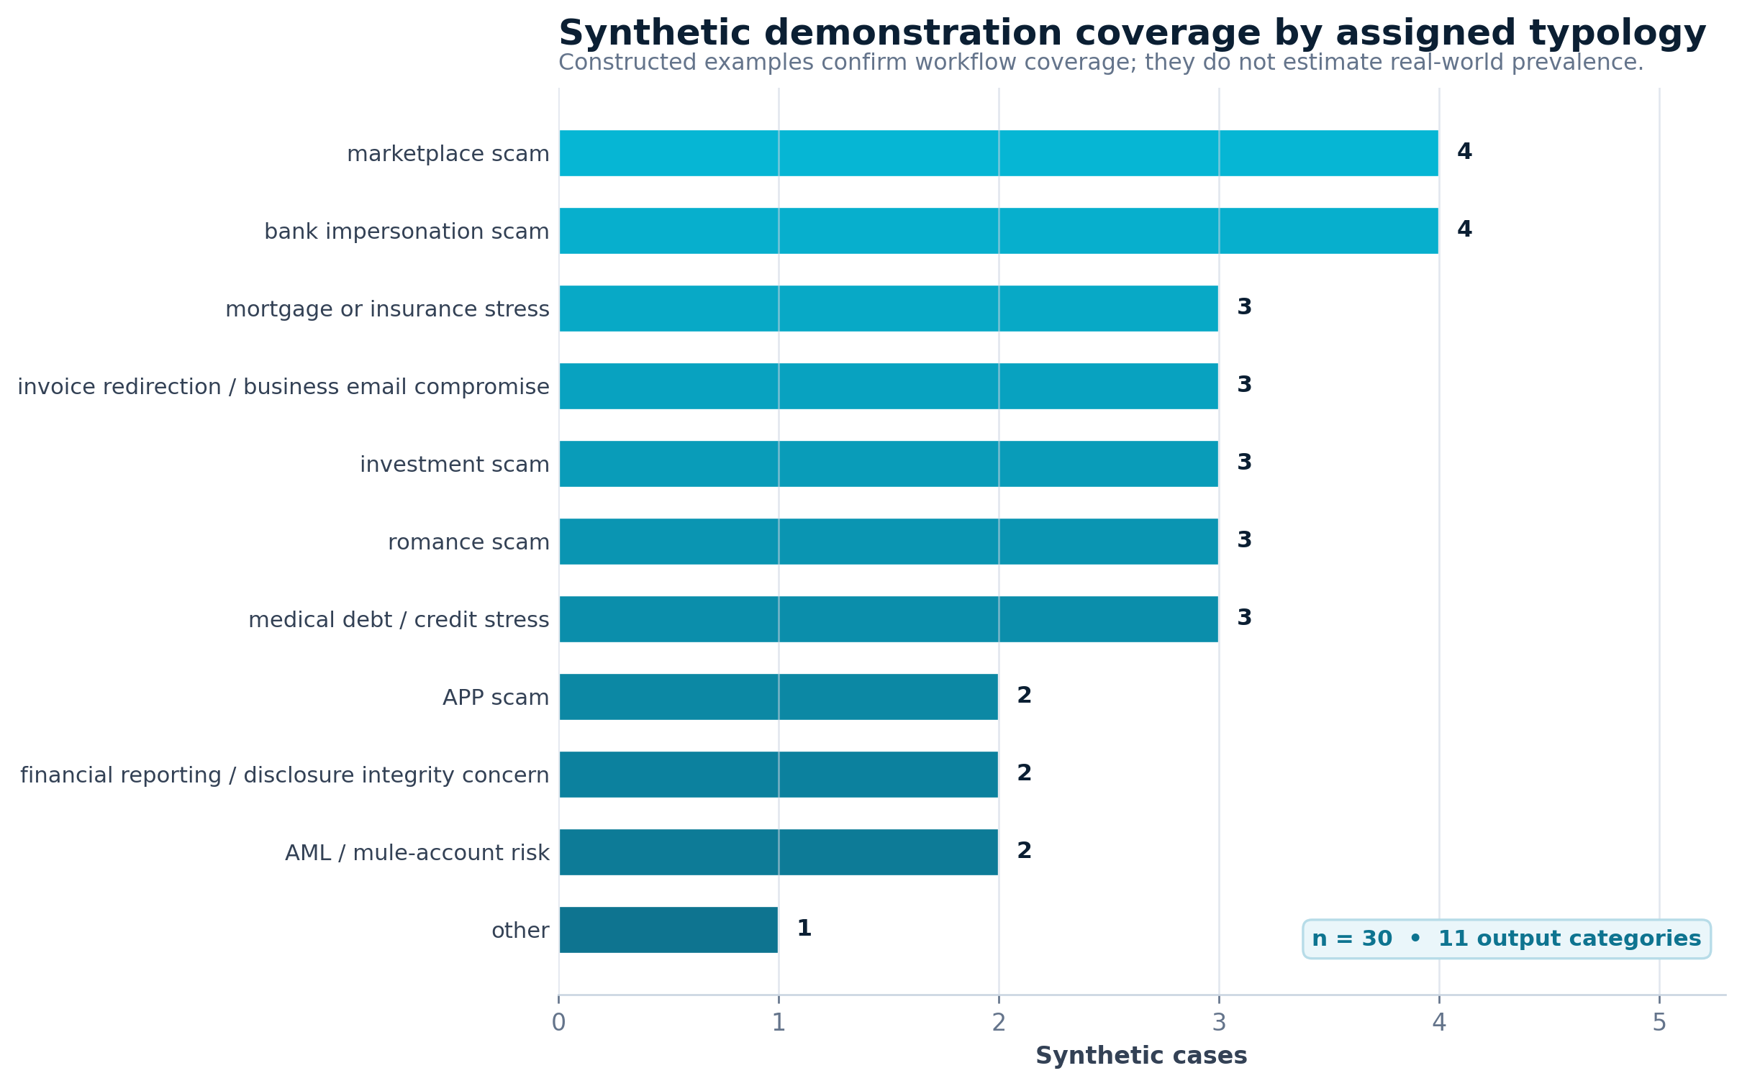
Distribution of synthetic cases by assigned typology.
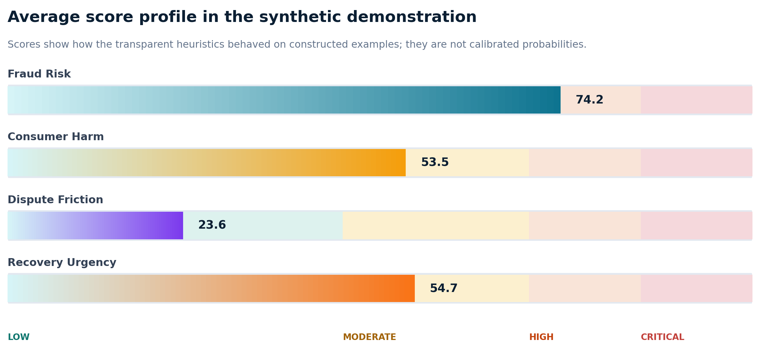
Mean scores in the synthetic demonstration set.
The system assigned 15 cases to the Critical band, 2 to High, 12 to Moderate, and 1 to Low. This distribution is expected to be risk-enriched because the dataset was constructed to demonstrate fraud and harm scenarios rather than reproduce a population distribution.
Case | Assigned typology | F/H/D/U scores | Recommendation excerpt
FG-0001 | bank impersonation scam | 100/44/10/94 | Escalate for bank-impersonation and APP scam review. Initiate freeze, recall, or stop-payment steps where operationally available. Check receiving-side account, device, and beneficiary risk indicators.
FG-0002 | invoice redirection / business email compromise | 99/53/10/93 | Initiate beneficiary-bank outreach and wire recall review. Initiate freeze, recall, or stop-payment steps where operationally available. Check receiving-side account, device, and beneficiary risk indicators.
FG-0007 | medical debt / credit stress | 28/53/22/18 | Validate billing, collection authority, and credit-reporting accuracy.
FG-0022 | APP scam | 92/61/58/78 | Escalate for APP scam review and assess reimbursement eligibility. Initiate freeze, recall, or stop-payment steps where operationally available. Check receiving-side account, device, and beneficiary risk indicators.
FG-0030 | other | 46/60/62/36 | Request additional evidence and route for manual risk review. Assess credential compromise and secure affected access channels.
Illustrative synthetic case outputs. F/H/D/U = Fraud Risk, Consumer Harm, Dispute Friction, and Recovery Urgency.

5.3 Functional findings
- All 30 records were processed without missing score or recommendation outputs.
- All four score dimensions remained within the required 0–100 bounds.
- The output set covered all ten substantive typologies and the “other” fallback.
- The application produced both case-level explanations and a portfolio-level high-risk queue.
- Outcome text affected continuing harm, dispute friction, and recovery urgency as intended.
- The demonstration exposed a design limitation: phrase rules require explicit contextual safeguards for negation, ambiguity, and synonymous wording.

6. Governance and Public-Service Deployment

6.1 NIST AI RMF mapping
The NIST AI RMF describes four core functions Govern, Map, Measure, and Manage and identifies validity, safety, security, accountability, transparency, explainability, privacy, and fairness as characteristics of trustworthy AI systems (NIST, 2023). FinGuard-AI can be mapped to this framework even though the present artifact is rules-based rather than a trained model.
AI RMF function | FinGuard-AI control objectives
Govern | Assign rule owners; approve changes; version rule dictionaries and thresholds; define prohibited uses; maintain override and incident procedures.
Map | Document users, decision context, affected consumers, data flows, foreseeable misuse, legal boundaries, and consequences of false positives and false negatives.
Measure | Evaluate per-class precision/recall, abstention, score agreement, robustness, subgroup performance, explanation usefulness, accessibility, and security.
Manage | Require human review for high-impact outputs; monitor drift and complaints; suspend unsafe rules; preserve audit logs; provide correction and deletion processes.
Governance mapping to the NIST AI Risk Management Framework.

6.2 Consumer-help workflow
A public-facing version should not begin with an unstructured scoring screen. It should first screen for urgent loss, pending transactions, credential compromise, remote access, and immediate account-security needs. It should then warn users not to submit passwords, PINs, Social Security numbers, full account or card numbers, or one-time codes. Structured questions should capture the incident date, payment channel, authorization status, contact method, impersonated entity, evidence available, dispute status, and hardship indicators. Results should present an action plan, evidence checklist, official reporting resources, and a clear statement that the assessment is informational.

6.3 Privacy, security, and accessibility
Real complaint narratives may contain highly sensitive financial, identity, health, and contact information. The NIST Privacy Framework provides an enterprise approach to identifying and managing privacy risk (NIST, 2020). A public implementation should support data minimization, automatic redaction, explicit consent, short retention periods, encryption in transit and at rest, role-based access, multi-factor authentication for reviewers, secure file scanning, rate limiting, audit logging, and deletion requests. The current local prototype does not provide these controls.
Application-security requirements should be verified against a recognized standard such as the OWASP Application Security Verification Standard, and customer security should be treated as a core product requirement consistent with CISA Secure by Design principles (CISA, 2023; OWASP Foundation, 2025). The public interface should target WCAG 2.2 Level AA through keyboard navigation, clear labels and errors, sufficient contrast, readable language, responsive design, and screen-reader compatibility (World Wide Web Consortium [W3C], 2023).
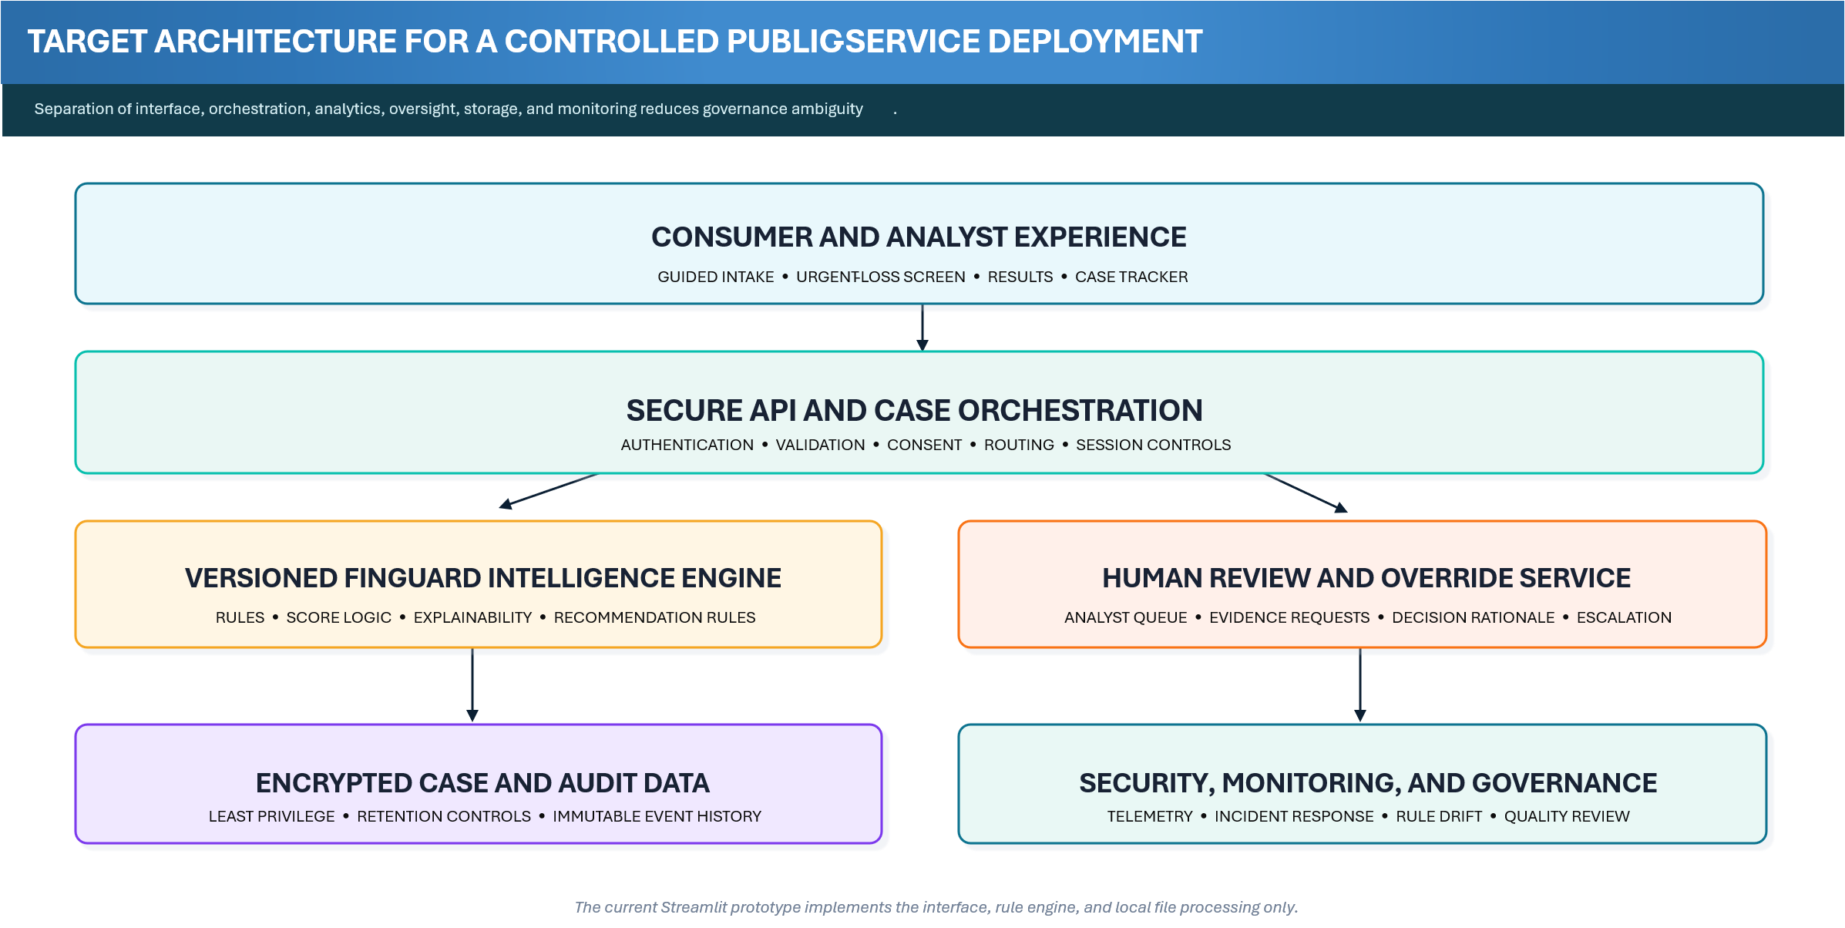
Target architecture for controlled public-service deployment.

6.4 Human review and decision boundaries
FinGuard-AI outputs should support, not replace, professional review. The system should never state that a bank must reimburse a consumer, that a person committed fraud, that an account is definitively a money-mule account, or that a SAR must be filed. Safer language includes “indicators are consistent with,” “the case may warrant,” and “request review of eligibility.” High-risk, conflicting, or low-evidence cases should be routed to human review, and reviewers should record whether they accepted, modified, or rejected the automated recommendation and why.

7. Empirical Validation Protocol

7.1 Data source and sampling
The next study should use a documented sample of public complaint narratives, initially from the CFPB Consumer Complaint Database. The database permits CSV and JSON downloads and includes narratives only under the Bureau’s publication process (CFPB, 2025a, 2025b). Because the data are not a representative survey and allegations are not verified, the study should evaluate agreement with expert annotation of reported narrative characteristics, not “ground-truth fraud.” A first study could target approximately 1,000–1,500 English-language narratives, stratified by relevant products and issues while preserving natural prevalence in a final test set.

7.2 Annotation and adjudication
- Prepare a codebook with definitions, inclusions, exclusions, positive examples, neighboring categories, multi-label rules, and insufficient-evidence criteria.
- Use at least two independent reviewers who do not see the prototype output during initial labeling.
- Train reviewers on a separate calibration set and freeze the codebook before formal annotation.
- Record one primary typology, an optional secondary typology, four ordinal score ratings, missing evidence, and reviewer confidence.
- Calculate Cohen’s kappa, weighted kappa, or Krippendorff’s alpha as appropriate, and preserve original labels after adjudication.

7.3 Evaluation metrics and baselines
Evaluation domain | Recommended measures
Typology classification | Macro and weighted precision, recall, F1; per-class metrics; confusion matrix; abstention coverage and selective accuracy.
Four scores | Spearman correlation with reviewer ratings; mean absolute error; weighted kappa after score banding; threshold sensitivity and specificity.
Robustness | Performance under synonyms, misspellings, negation, shortened narratives, reordered sentences, missing fields, and conflicting statements.
Explainability | Reviewer ability to identify relevant evidence, detect incorrect rules, understand score contributions, and complete review efficiently.
Fairness and access | Performance by available language, state, product, narrative length, payment channel, age-related indicators, and other ethically justified groups.
Table 6. Recommended empirical evaluation measures.
Baselines should include a majority-class predictor, a simple keyword-count method, TF-IDF with logistic regression, and TF-IDF with a linear support-vector classifier. A transformer model may be included as a higher-capacity comparator. The rules should be developed on a development set, thresholds selected on a validation set, and the final test set evaluated once after the artifact is frozen. The most informative result may be a trade-off rather than outright superiority: a rules-first method could provide lower predictive performance than a transformer while offering stronger traceability and easier governance.

7.4 Explainability and reviewer-utility study
A human-grounded study should compare review with and without FinGuard-AI assistance. Reviewers can rate whether the explanation identifies relevant evidence, whether the score rationale is understandable, whether the recommendation follows from the evidence, and whether the system helps them identify missing information. Outcomes should include review time, agreement, error-detection rate, explanation usefulness, and the proportion of recommendations accepted, modified, or rejected. This design follows calls for application-grounded interpretability evaluation rather than assuming that visible features are automatically useful (Doshi-Velez & Kim, 2017; Sokol & Flach, 2020).

8. Discussion

8.1 What the artifact contributes
The central lesson from the prototype is practical: complaint triage becomes easier to govern when it is broken into separate questions. What reported mechanism best fits the narrative? How strong are the fraud indicators? How severe is the consumer harm? How difficult has the dispute process become? How quickly might recovery opportunities close? FinGuard-AI answers those questions separately, then shows the evidence and point adjustments behind each answer. That separation makes disagreements visible. An analyst can accept the typology but challenge the urgency score, or agree that harm is severe while requesting more evidence before treating the receiving account as suspicious.
The artifact also connects consumer protection and AML perspectives. A person may be both a victim and an unwitting mule; a receiving account may present risk indicators even when the sending consumer authorized the payment; and repeated disputes may reveal consumer harm even where fraud cannot be established. The system therefore encourages cross-functional review among fraud operations, AML, complaints, conduct risk, cybersecurity, and consumer-assistance teams.
“ | Design principle: A useful explanation should help a reviewer question the system—not simply make the system sound confident.

8.2 Interpretability versus adaptability
Rules-first systems are easy to audit but can be brittle. Exact phrases may miss synonyms and indirect descriptions, and weights can encode untested judgments. Machine-learning models can generalize across language but introduce data dependency, drift, and explanation challenges. A sensible future architecture is hybrid: explicit rules for high-confidence red flags and safety constraints; an interpretable statistical classifier for broader language coverage; disagreement detection; and mandatory human review when components conflict.

8.3 Policy and operational implications
For financial institutions, the prototype illustrates how narrative intelligence might improve complaint routing, escalation, receiving-side review, recovery coordination, and management reporting. For consumer-assistance organizations, it illustrates how a guided intake can convert a distressing narrative into a prioritized checklist without making legal promises. For regulators and researchers, the artifact offers a reproducible object for testing explainability, complaint taxonomies, consumer-harm measures, and cross-functional governance.
The work should not be framed as a replacement for transaction monitoring, identity verification, sanctions controls, suspicious activity reporting, legal analysis, or case-management platforms. Its value lies in a specific layer: transparent narrative triage and decision support.

9. Limitations
- Synthetic evidence: the 30 cases were constructed to exercise the software and cannot establish predictive validity or prevalence.
- Rule brittleness: exact matching is sensitive to synonyms, misspellings, narrative structure, and implicit meaning.
- Negation and context: the current matcher can misinterpret phrases such as “the caller did not claim to be from my bank.”
- Forced single-label output: overlapping scam mechanisms are common, but the current interface selects one primary typology.
- Heuristic weights: category weights and score adjustments reflect design judgment rather than statistical calibration or expert consensus.
- Data limitations: public complaints are self-reported, selectively published, nonrepresentative, and not verified adjudications.
- Language limitation: the current rule dictionary is English-only and has not been tested for dialect, literacy, or language-access effects.
- Security limitation: the Streamlit prototype lacks the privacy, identity, storage, and monitoring controls required for sensitive public submissions.
- No legal determination: the artifact does not determine reimbursement eligibility, regulatory violations, SAR obligations, or criminal conduct.
- No outcome study: there is no evidence yet that using the tool improves recovery, reduces harm, or improves reviewer decisions.

10. Future Development Roadmap
Phase | Primary deliverables
Phase 1: Reproducible research release | Publish versioned code, synthetic data, rule inventory, methodology, tests, and a stable demonstration deployment with no real-data storage.
Phase 2: Public-data validation | Retrieve and annotate CFPB narratives; implement abstention, multi-label outputs, negation handling, baselines, and robustness tests.
Phase 3: Expert utility study | Evaluate review time, agreement, explanation usefulness, override patterns, and recommendation quality with qualified reviewers.
Phase 4: Controlled pilot | Deploy a secure API, encrypted database, role-based analyst portal, PII redaction, consent and deletion controls, monitoring, and incident response.
Phase 5:Continuous governance | Monitor drift, false positives, false negatives, consumer feedback, subgroup performance, security events, and rule/version changes.
Recommended research and deployment roadmap.

11. Conclusion
FinGuard-AI shows what a transparent complaint-triage tool can look like before predictive ambition is allowed to outrun governance. The prototype does not attempt to replace transaction monitoring, legal analysis, reimbursement review, or human judgment. Its contribution is more focused: it organizes narrative evidence into an auditable workflow that keeps fraud indicators, consumer harm, dispute friction, and recovery urgency distinct. The 30-case synthetic study confirms that the software functions across the intended categories and produces complete explanations, but it does not establish accuracy on real complaints. The next stage is therefore empirical rather than cosmetic: independently annotated public narratives, frozen rules, transparent baselines, robustness tests, and human-review studies. With those safeguards, FinGuard-AI can mature from a credible research prototype into a well-evaluated contribution to financial-fraud intelligence and consumer-protection governance.

Declarations
Funding: No external funding is reported for the current prototype and manuscript draft.
Conflicts of interest: The author is the developer of the FinGuard-AI research prototype. No other conflicts are declared.
Ethics statement: The demonstration dataset is entirely synthetic and contains no real consumer records. Any future study involving nonpublic institutional data or human participants should obtain the required institutional, legal, privacy, and ethics approvals before data collection.
Data availability: The synthetic demonstration CSV, source code, methodology, and requirements files are available in the accompanying reproducibility package. Public complaint data should be retrieved from the originating agency using a documented query rather than redistributed unnecessarily.
Code availability: The prototype is implemented in Python using Streamlit, pandas, and Plotly. A versioned repository and archived release should be created before journal submission.
Author contributions: Conceptualization, methodology, software, validation, visualization, writing original draft and writing review and editing: A S M FAHIM.

References
Bao, Y., Ke, B., Li, B., Yu, Y. J., & Zhang, J. (2020). Detecting accounting fraud in publicly traded U.S. firms using a machine learning approach. Journal of Accounting Research, 58(1), 199–235. https://doi.org/10.1111/1475-679X.12292
Consumer Financial Protection Bureau. (2025a). Consumer Complaint Database. https://www.consumerfinance.gov/data-research/consumer-complaints/
Consumer Financial Protection Bureau. (2025b). How we share complaint data. https://www.consumerfinance.gov/complaint/data-use/
Cybersecurity and Infrastructure Security Agency. (2023). Secure by Design. https://www.cisa.gov/securebydesign
Doshi-Velez, F., & Kim, B. (2017). Towards a rigorous science of interpretable machine learning. arXiv:1702.08608. https://arxiv.org/abs/1702.08608
Federal Bureau of Investigation. (2026). 2025 IC3 Annual Report. Internet Crime Complaint Center. https://www.ic3.gov/AnnualReport/Reports/2025_IC3Report.pdf
Federal Bureau of Investigation. (2024). Business email compromise: The $55 billion scam. Internet Crime Complaint Center. https://www.ic3.gov/PSA/2024/PSA240911
Federal Trade Commission. (2025a). New FTC data show a big jump in reported losses to fraud to $12.5 billion in 2024. https://www.ftc.gov/news-events/news/press-releases/2025/03/new-ftc-data-show-big-jump-reported-losses-fraud-125-billion-2024
Federal Trade Commission. (2025b). Consumer Sentinel Network Data Book 2024. https://www.ftc.gov/reports/consumer-sentinel-network-data-book-2024
Financial Crimes Enforcement Network. (2019). Updated advisory on email compromise fraud schemes targeting vulnerable business processes (FIN-2019-A005). https://www.fincen.gov/system/files/advisory/2019-07-16/Updated%20BEC%20Advisory%20FINAL%20508.pdf
Financial Crimes Enforcement Network. (2020). Advisory on imposter scams and money mule schemes related to Coronavirus Disease 2019 (FIN-2020-A003). https://www.fincen.gov/system/files/advisory/2020-07-07/Advisory_%20Imposter_and_Money_Mule_COVID_19_508_FINAL.pdf
Financial Crimes Enforcement Network. (2022). Advisory on elder financial exploitation (FIN-2022-A002). https://www.fincen.gov/system/files/advisory/2022-06-15/FinCEN%20Advisory%20Elder%20Financial%20Exploitation%20FINAL%20508.pdf
Financial Crimes Enforcement Network. (2023). FinCEN alert on prevalent virtual currency investment scam commonly known as “pig butchering” (FIN-2023-Alert005). https://www.fincen.gov/system/files/shared/FinCEN_Alert_Pig_Butchering_FINAL_508c.pdf
Hevner, A. R., March, S. T., Park, J., & Ram, S. (2004). Design science in information systems research. MIS Quarterly, 28(1), 75–105. https://www.jstor.org/stable/25148625
Hilal, W., Gadsden, S. A., & Yawney, J. (2022). Financial fraud: A review of anomaly detection techniques and recent advances. Expert Systems with Applications, 193, 116429. https://doi.org/10.1016/j.eswa.2021.116429
Jain, P., Tripathi, S., Garg, T., Sadashiv, N., Kundur, N. C., Phadke, M., Gaikwad, M., et al. (2026). An intelligent transformer based framework for bilingual financial complaint classification. Scientific Reports, 16, 20594. https://doi.org/10.1038/s41598-026-51771-w
Lundberg, S. M., & Lee, S.-I. (2017). A unified approach to interpreting model predictions. Advances in Neural Information Processing Systems, 30. https://arxiv.org/abs/1705.07874
National Institute of Standards and Technology. (2020). NIST Privacy Framework: A tool for improving privacy through enterprise risk management, Version 1.0. https://www.nist.gov/privacy-framework
National Institute of Standards and Technology. (2023). Artificial Intelligence Risk Management Framework (AI RMF 1.0) (NIST AI 100-1). https://doi.org/10.6028/NIST.AI.100-1
OWASP Foundation. (2025). OWASP Application Security Verification Standard. https://owasp.org/www-project-application-security-verification-standard/
Peffers, K., Tuunanen, T., Rothenberger, M. A., & Chatterjee, S. (2007). A design science research methodology for information systems research. Journal of Management Information Systems, 24(3), 45–77. https://doi.org/10.2753/MIS0742-1222240302
Pourhabibi, T., Ong, K.-L., Kam, B. H., & Boo, Y. L. (2020). Fraud detection: A systematic literature review of graph-based anomaly detection approaches. Decision Support Systems, 133, 113303. https://doi.org/10.1016/j.dss.2020.113303
Ribeiro, M. T., Singh, S., & Guestrin, C. (2016). “Why should I trust you?”: Explaining the predictions of any classifier. Proceedings of the 22nd ACM SIGKDD International Conference on Knowledge Discovery and Data Mining, 1135–1144. https://doi.org/10.1145/2939672.2939778
Rudin, C. (2019). Stop explaining black box machine learning models for high stakes decisions and use interpretable models instead. Nature Machine Intelligence, 1, 206–215. https://doi.org/10.1038/s42256-019-0048-x
Sokol, K., & Flach, P. (2020). Explainability fact sheets: A framework for systematic assessment of explainable approaches. Proceedings of the 2020 Conference on Fairness, Accountability, and Transparency, 56–67. https://doi.org/10.1145/3351095.3372870
Wang, Z., Zhu, S., & Chen, X. (2026). From complaint narratives to monetary relief: A hybrid machine learning framework for CFPB consumer complaints. arXiv:2606.22664. https://arxiv.org/abs/2606.22664
World Wide Web Consortium. (2023). Web Content Accessibility Guidelines (WCAG) 2.2. https://www.w3.org/TR/WCAG22/
Yang, H., Shukur, Z., & Sahran, S. (2026). A review of artificial intelligence for financial fraud detection. Applied Sciences, 16(4), 1931. https://doi.org/10.3390/app16041931

Appendix A. Rule Inventory Summary
Category | Rule count | Example phrases
APP scam | 10 | authorized push payment; authorized the transfer; sent the money myself; peer to peer; …
bank impersonation scam | 11 | pretended to be my bank; claimed to be from the bank; bank fraud department; spoofed bank number; …
invoice redirection / business email compromise | 11 | invoice; vendor email; supplier email; business email compromise; …
marketplace scam | 10 | online marketplace; marketplace seller; marketplace buyer; item never arrived; …
romance scam | 10 | dating app; romantic relationship; online relationship; said they loved me; …
investment scam | 10 | investment platform; guaranteed return; crypto investment; trading coach; …
AML / mule-account risk | 11 | received funds for someone else; forward the money; keep a commission; money mule; …
medical debt / credit stress | 10 | medical debt; hospital bill; medical collection; credit report; …
mortgage or insurance stress | 10 | mortgage servicer; foreclosure; escrow; loan modification; …
financial reporting / disclosure integrity concern | 10 | financial statements; misstated revenue; undisclosed related party; material omission; …
Other | 0 | Fallback when no category-specific phrase is matched
Summary of the version 1.0 typology rule dictionary.
The complete rule dictionary is stored in app.py. A research release should move this dictionary into a versioned configuration file with a rule identifier, source, rationale, effective date, owner, change history, and test cases for each indicator.

Appendix B. Scoring Audit Requirements
Audit element | Minimum record
Case provenance | Case ID, source, consent/publication status, ingestion timestamp, and data-retention status.
Input snapshot | Narrative and structured values exactly as analyzed, with PII redaction status.
Rule metadata | Application version, rule-set version, score version, and recommendation version.
Classification evidence | Matched indicators, weights, category scores, alternative categories, and abstention reason.
Score evidence | Base value and every positive or negative adjustment for all four dimensions.
Human review | Reviewer, status, accepted/modified/rejected output, override reason, and final disposition.
Monitoring outcome | Recovery result, dispute outcome, confirmed error, complaint, incident, or feedback tied to the output.
Minimum audit record for controlled deployment.

Appendix C. Reproducibility Checklist
- Source code and dependency file are version controlled.
- Synthetic data are clearly labeled and included.
- Rule dictionary and score weights are frozen for each reported experiment.
- Data retrieval query, date, filters, exclusions, and deduplication are documented.
- Annotation codebook and reviewer instructions are archived.
- Development, validation, and test assignments are reproducible.
- All metrics can be regenerated from scripts without manual spreadsheet edits.
- Figures and tables are generated from analysis outputs.
- Random seeds are fixed for machine-learning baselines.
- Software environment and hardware are documented.
- Limitations, data statement, ethics statement, and governance statement are included.
- A DOI-backed release is archived before final publication.

Appendix D. Prototype Artifact
The accompanying artifact consists of app.py, sample_data.csv, requirements.txt, README.md, and methodology.md. The current implementation uses Python, Streamlit, pandas, and Plotly. The synthetic dataset contains 30 cases with the columns case_id, date, state, narrative, amount lost, payment channel, institution type, and outcome.

