

24 ways to communicaTE

Luca Bulles – Advanced Smart Mobile S7



February 14, 2023

Fontys

Tube prototype (Group)

|  |  |  |  |  |
| --- | --- | --- | --- | --- |
| Version | Date | Author | Workshop name | Description |
| 0.1 | 14-02-2023 | Luca Bulles | 24 ways to communicate | * First setup of document |
|  |  |  |  |  |

Table 1 - Version table

Table of Contents

1. Introduction 3

2. Brainstorming 4

3. First prototype 5

4. First version of the application 7

# Introduction

The workshop was about different types of communication. In the presentation of the workshop, we learned about the evolution of the communication and how it developed.

The assignment was to come up with ways to communicate (try to have 24 ways of communication). After brainstorming the ways of communication, we needed to think about new ways or new combination of already existing ways of communication.

As a group, we needed to decide what idea we would like to use for the prototype phase and demonstrate it to the class. The first demo was only a quick prototype with pen and paper and coloured sticky notes. After we received feedback on our first prototype, we went on to create a prototype with higher level of detail (an app instead of using phones made from paper and markers).

In this document, you can find how we tackled the case of the workshop.

# Brainstorming

In the beginning we started with brainstorming about ways to communicate and even made sketches of some of the ideas that we’ve came up with. A picture of our whiteboard with our brainstorming session is added here below:

Figure 1 - Whiteboard with our brainstorming session

# First prototype

The first prototype is created with paper, sticky notes, and markers. The tube is made of paper and the interface of the application is drawn on paper. Pictures of the prototype are added here below:

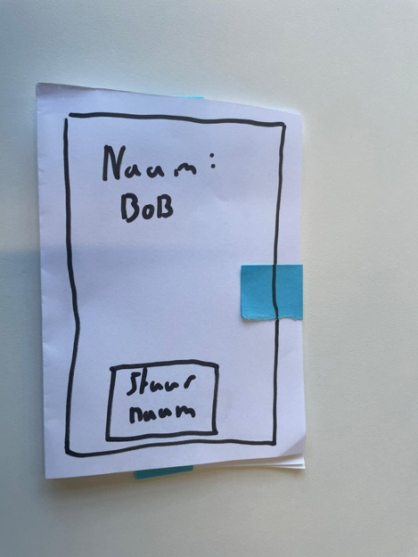

Figure 2 - Screen of sender

Figure 3 - Privacy tube

Figure 4 - Interface of received message

Figure 5 - Interface of receiver

Figure 6 - Demo of prototype

Figure 7 - Colour codes explained

The demo of this prototype is recorded. It is located in the same folder as the images. The name of the file is: Video_Demo.mp4

# First version of the application

The first mobile application is created with SwiftUI and is added in the folder of this workshop. The files are zipped and the folder is called: TubeTransfer.zip