This dataset contains information about electric vehicle (EV) adoption across various States and Union Territories (UTs) in India. Here's a summary of key insights:

1. Proportion of Electric Vehicles:

The percentage of EVs varies significantly, with Delhi having one of the highest at 2.71%, followed by Tripura ( 2.02% ) and Assam ( 2.16% ). In contrast, many regions like Arunachal Pradesh and Nagaland have meager EV adoption rates, around 0.01%.

2. FinTech Hubs :

Major fintech hubs like Bengaluru (447 FinTech companies), Mumbai and Pune (525), Gurugram (128), and Noida (77) are highlighted as key cities where fintech companies are concentrated, suggesting a correlation between these cities' urban infrastructure and higher EV adoption.

3. EV Subsidies and Incentives :

Several states offer incentives to promote EV adoption:

Assam, Meghalaya, Rajasthan, Odisha, and Uttar Pradesh provide direct incentives for E2W, E3W, and E4W (electric two, three, and four wheelers), typically ranging from INR 10,000 to 30,000 per kWh or a percentage of the vehicle's cost.

Delhi, Goa, and Haryana also offer incentives, with some states providing additional subsidies such as scrapping incentives or early bird discounts.

4. Charging Infrastructure :

Charging station availability varies widely. Karnataka leads with 5,130 stations, followed by Maharashtra ( 3,083 ), Delhi ( 1,886 ), and Tamil Nadu ( 643 ). This indicates that states with more urban development and larger populations tend to have more charging infrastructure, which supports EV adoption.

5. Clusters and EV Adoption :

States like Delhi , Tripura , and Assam are identified as having a relatively higher proportion of EV adoption and are grouped in Cluster 2 along with some other states.

Cluster 0 , which contains most of the states, generally shows lower EV adoption, fewer incentives, and less developed charging infrastructure.

6. FinTech & Urban Influence :

There is a noticeable concentration of fintech companies in states with higher EV adoption rates, such as Bengaluru , Mumbai , Pune , Ahmedabad , and Gurugram , possibly highlighting an association between modern infrastructure, economic development, and EV adoption.

7. Variation in Subsidy Policies :

States like Chhattisgarh and Kerala offer additional incentives such as interest subvention, scrapping incentives, or other unique policies, while many states (e.g., Bihar , Jharkhand , and West Bengal ) do not provide specific details on subsidies for EVs.

This data provides a snapshot of how various regions in India are progressing towards EV adoption, influenced by infrastructure development, government policies, and fintech growth.

**New Categories Added:**

* **Charging Station Category:** Classifies the density of charging stations in each state or UT as *Low*, *Medium*, *High*, or *Very High*.
* **EV Adoption Category:** Classifies EV adoption rates as *Low*, *Medium*, *High*, or *Very High*, which provides an easier way to interpret the proportion of electric vehicles.
* **FinTech Category:** Classifies the number of fintech companies into levels like *Low*, *Medium*, and *Very High*. This was missing in the previous dataset.
* **Geographical Segment:** New classification of states/UTs into *Rural*, *SemiUrban*, and *Urban* segments, offering insights into the level of urbanization.

**Interpretation of the New Dataset:**

**1. Charging Stations:**

* **Delhi**, **Karnataka**, and **Maharashtra** maintain their leadership with a *Very High* density of charging stations, which likely correlates with their higher EV adoption rates.
* Several regions like **Andaman & Nicobar Island**, **Ladakh**, **Nagaland**, and **UT of DNH & DD** have very low numbers of charging stations, categorized as *Low*, which aligns with their lower levels of EV adoption.

**2. Proportion of Electric Vehicles (EV Adoption):**

* The dataset highlights states with *Very High* EV adoption, including **Delhi**, **Assam**, **Tripura**, and **Uttar Pradesh**. These regions are progressing well in the transition to electric vehicles.
* Many states, such as **Arunachal Pradesh**, **Nagaland**, and **Sikkim**, show *Low* adoption of EVs, reflecting infrastructure or policy challenges in rural and remote areas.

**3. Number of FinTechs:**

* The presence of fintech companies is concentrated in **Karnataka**, **Maharashtra**, and **Tamil Nadu**, which are categorized as *Very High* fintech hubs, showing the states' strong tech ecosystems.
* Several states like **Andaman & Nicobar**, **Arunachal Pradesh**, **Himachal Pradesh**, and **Manipur** are categorized as having *No* or *Low* fintech presence, suggesting a lack of financial technology infrastructure in these rural or less developed regions.

**4. Geographical Segment:**

* Most of the *Urban* regions, such as **Karnataka**, **Maharashtra**, and **Tamil Nadu**, tend to have high levels of fintech activity and charging infrastructure. These regions also have a medium to high EV adoption rate, indicating that urbanization plays a role in supporting EV growth.
* In contrast, **Rural** regions like **Ladakh**, **Mizoram**, **Nagaland**, and **Sikkim** are categorized as having low fintech activity, fewer charging stations, and lower EV adoption, illustrating the gap in development between urban and rural areas.

**5. Segmentation of EV, FinTech, and Charging Stations:**

* **Urban states** like **Delhi**, **Karnataka**, and **Maharashtra** score high in fintech presence, charging station availability, and EV adoption. These regions benefit from better infrastructure, government policies, and urbanization.
* **Semiurban regions** such as **Bihar**, **Chhattisgarh**, and **Punjab** show medium levels of EV adoption and infrastructure, indicating developing markets.
* **Rural states** like **Manipur**, **Nagaland**, and **Arunachal Pradesh** struggle with low fintech presence, EV adoption, and charging infrastructure, highlighting the challenges these regions face in transitioning to EVs.

**KMeans Clustering Process:**

1. **Encoding Categorical Variables**:  
   Since KMeans clustering works with numerical data, categorical features like "Charging Station Category," "EV Adoption Category," and "FinTech Category" have been label encoded. This means that the categories are converted to numerical representations, which allow them to be used in the KMeans algorithm.
2. **Standardization**:  
   The features, including the numeric ones (charging stations, proportion of EVs, fintech numbers) and the encoded categorical variables, were standardized. This step is essential in clustering algorithms like KMeans because features with different scales can disproportionately affect the clustering result. Standardization ensures that each feature contributes equally to the distance calculations.
3. **PCA for Dimensionality Reduction**:
   * PCA reduces the dimensionality of the dataset by transforming the original feature space into two principal components (PC1 and PC2) while retaining most of the variance. This step is crucial because it simplifies the data and allows us to visualize it in 2D.
   * Although PCA reduces the complexity, it still captures the most significant patterns in the data, making it easier to visualize the clusters.
4. **KMeans Clustering**:
   * After applying PCA, KMeans clustering is used to group the data points into **four clusters** (k=4) based on their similarity.
   * The algorithm assigns each state/UT to one of these clusters by minimizing the withincluster sum of squares (variance) and maximizing the separation between clusters.
   * This plot represents the PCA (Principal Component Analysis) applied to the dataset along with KMeans clustering to segment the states/UTs based on EV adoption, fintech presence, and charging infrastructure. The points represent different states/UTs, and the axes (PC1 and PC2) are the two principal components that capture the maximum variance in the data. The states are grouped into four clusters, with color coding as follows:
   * Cluster 0 (Red): Multiple states are grouped in this cluster.
   * Cluster 1 (Blue): Contains Karnataka and Maharashtra.
   * Cluster 2 (Green): Contains Assam.
   * Cluster 3 (Purple): Includes states such as Uttar Pradesh, Delhi, and Tamil Nadu.
   * Clusterwise Interpretation:
   * Cluster 0 (Red):
   * This cluster includes several states/UTs, such as Madhya Pradesh, Goa, Chhattisgarh, Punjab, Uttarakhand, Puducherry, and others.
   * These states are likely characterized by lowtomoderate levels of EV adoption, moderatetolow fintech presence, and relatively underdeveloped charging infrastructure.
   * These states appear to be more clustered toward the bottomleft of the plot, indicating similarities in their lower levels of development in the key factors considered (fintech, EV, and infrastructure).
   * Cluster 1 (Blue) – Karnataka and Maharashtra:
   * Karnataka and Maharashtra are the only states in this cluster. Both of these states are highly urbanized and technologically advanced, with strong fintech ecosystems.
   * This positioning indicates that these states have high fintech activity, good charging infrastructure, and likely higherthanaverage EV adoption. The separation of these two states from the other clusters suggests they are leading in these areas.
   * Maharashtra and Karnataka are likely more mature in terms of infrastructure and EV ecosystem compared to states in other clusters.
   * Cluster 2 (Green) – Assam:
   * Assam is the sole state in this cluster, and its positioning indicates that it has a unique combination of characteristics compared to other states.
   * Assam has a relatively high EV adoption rate but differs in terms of fintech presence and charging infrastructure from other states, which places it in its own cluster.
   * This uniqueness could stem from the fact that although Assam is making strides in EV adoption, its fintech ecosystem or infrastructure might not be as developed as states in other clusters.
   * Cluster 3 (Purple):
   * This cluster includes states such as Uttar Pradesh, Delhi, West Bengal, Tamil Nadu, Odisha, Kerala, Rajasthan, and Tripura.
   * These states are likely moderatetohigh performers in terms of EV adoption, fintech presence, and charging infrastructure.
   * The states in this cluster are more spread out, with some closer to the highly developed states and others closer to the lowerperforming states. This suggests that while they share certain characteristics, they may differ in specific areas such as the number of charging stations or fintech activity.
   * Delhi, for instance, stands slightly apart from other states in this cluster, indicating that it may have a unique combination of characteristics (possibly high fintech activity and EV adoption but with certain limitations in infrastructure).
   * Insights from the Plot:
   * Highly Developed States (Cluster 1 Blue):
   * Maharashtra and Karnataka lead the way in fintech and EV development. Their separation from other clusters suggests they are significantly more advanced in terms of EV ecosystem readiness, which could be driven by their urbanization and techdriven economies.
   * Isolated High Performer (Cluster 2 Green):
   * Assam stands alone, indicating that it has a distinctive EV adoption rate but likely lacks the same fintech presence or infrastructure development as states like Karnataka or Maharashtra. Its unique characteristics could stem from regional policies or specific market conditions that have encouraged EV adoption independently of other factors.
   * Moderate Performers (Cluster 3 Purple):
   * States like Uttar Pradesh, Tamil Nadu, Delhi, and West Bengal fall into the middle category. They likely have a balanced mix of fintech presence, EV adoption, and infrastructure development, but not as advanced as Maharashtra and Karnataka.
   * Delhi, positioned slightly away from the bulk of Cluster 3, could be seen as progressing faster in fintech and EV adoption, but it may still have limitations in other areas, such as charging infrastructure.
   * LowtoModerate Performers (Cluster 0 Red):
   * States like Madhya Pradesh, Goa, Chhattisgarh, and Uttarakhand fall into this cluster, likely indicating they are in earlier stages of development concerning EV adoption and infrastructure.
   * These states may have less developed fintech ecosystems, fewer charging stations, and lower EV adoption rates compared to the other clusters.
   * Conclusion:
   * Maharashtra and Karnataka (Cluster 1) stand out as the leaders in fintech and EV infrastructure, while Assam (Cluster 2) has a unique position driven by higher EV adoption but lacks in other areas.
   * Cluster 3 consists of a mixture of states that are steadily progressing but have not yet reached the development levels of the leaders.
   * Cluster 0 represents states that are lagging behind in both fintech development and EV adoption.
   * This analysis provides a clear view of the regional differences in EV adoption, fintech presence, and infrastructure readiness across India.

This plot represents the PCA (Principal Component Analysis) applied to the dataset along with KMeans clustering to segment the states/UTs based on EV adoption, fintech presence, and charging infrastructure. The points represent different states/UTs, and the axes (PC1 and PC2) are the two principal components that capture the maximum variance in the data. The states are grouped into **four clusters**, with color coding as follows:

* **Cluster 0 (Red)**: Multiple states are grouped in this cluster.
* **Cluster 1 (Blue)**: Contains **Karnataka** and **Maharashtra**.
* **Cluster 2 (Green)**: Contains **Assam**.
* **Cluster 3 (Purple)**: Includes states such as **Uttar Pradesh**, **Delhi**, and **Tamil Nadu**.

**Clusterwise Interpretation:**

**Cluster 0 (Red):**

* This cluster includes several states/UTs, such as **Madhya Pradesh**, **Goa**, **Chhattisgarh**, **Punjab**, **Uttarakhand**, **Puducherry**, and others.
* These states are likely characterized by **lowtomoderate levels of EV adoption**, **moderatetolow fintech presence**, and relatively underdeveloped charging infrastructure.
* These states appear to be more clustered toward the bottomleft of the plot, indicating similarities in their lower levels of development in the key factors considered (fintech, EV, and infrastructure).

**Cluster 1 (Blue) – Karnataka and Maharashtra:**

* **Karnataka** and **Maharashtra** are the only states in this cluster. Both of these states are highly urbanized and technologically advanced, with strong fintech ecosystems.
* This positioning indicates that these states have **high fintech activity**, **good charging infrastructure**, and likely **higherthanaverage EV adoption**. The separation of these two states from the other clusters suggests they are leading in these areas.
* **Maharashtra** and **Karnataka** are likely more mature in terms of infrastructure and EV ecosystem compared to states in other clusters.

**Cluster 2 (Green) – Assam:**

* **Assam** is the sole state in this cluster, and its positioning indicates that it has a unique combination of characteristics compared to other states.
* Assam has a **relatively high EV adoption rate** but differs in terms of fintech presence and charging infrastructure from other states, which places it in its own cluster.
* This uniqueness could stem from the fact that although Assam is making strides in EV adoption, its fintech ecosystem or infrastructure might not be as developed as states in other clusters.

**Cluster 3 (Purple):**

* This cluster includes states such as **Uttar Pradesh**, **Delhi**, **West Bengal**, **Tamil Nadu**, **Odisha**, **Kerala**, **Rajasthan**, and **Tripura**.
* These states are likely **moderatetohigh performers** in terms of EV adoption, fintech presence, and charging infrastructure.
* The states in this cluster are more spread out, with some closer to the highly developed states and others closer to the lowerperforming states. This suggests that while they share certain characteristics, they may differ in specific areas such as the number of charging stations or fintech activity.
* **Delhi**, for instance, stands slightly apart from other states in this cluster, indicating that it may have a unique combination of characteristics (possibly high fintech activity and EV adoption but with certain limitations in infrastructure).

**Insights from the Plot:**

1. **Highly Developed States (Cluster 1 Blue)**:
   * **Maharashtra** and **Karnataka** lead the way in fintech and EV development. Their separation from other clusters suggests they are significantly more advanced in terms of EV ecosystem readiness, which could be driven by their urbanization and techdriven economies.
2. **Isolated High Performer (Cluster 2 Green)**:
   * **Assam** stands alone, indicating that it has a distinctive EV adoption rate but likely lacks the same fintech presence or infrastructure development as states like Karnataka or Maharashtra. Its unique characteristics could stem from regional policies or specific market conditions that have encouraged EV adoption independently of other factors.
3. **Moderate Performers (Cluster 3 Purple)**:
   * States like **Uttar Pradesh**, **Tamil Nadu**, **Delhi**, and **West Bengal** fall into a middle category. They likely have a balanced mix of fintech presence, EV adoption, and infrastructure development, but not as advanced as **Maharashtra** and **Karnataka**.
   * **Delhi**, positioned slightly away from the bulk of Cluster 3, could be seen as progressing faster in fintech and EV adoption, but it may still have limitations in other areas, such as charging infrastructure.
4. **LowtoModerate Performers (Cluster 0 Red)**:
   * States like **Madhya Pradesh**, **Goa**, **Chhattisgarh**, and **Uttarakhand** fall into this cluster, likely indicating they are in earlier stages of development concerning EV adoption and infrastructure.
   * These states may have less developed fintech ecosystems, fewer charging stations, and lower EV adoption rates compared to the other clusters.

**Conclusion:**

* **Maharashtra** and **Karnataka** (Cluster 1) stand out as the leaders in fintech and EV infrastructure, while **Assam** (Cluster 2) has a unique position driven by higher EV adoption but lacks in other areas.
* **Cluster 3** consists of a mixture of states that are steadily progressing but have not yet reached the development levels of the leaders.
* **Cluster 0** represents states that are lagging in both fintech development and EV adoption.

This analysis provides a clear view of the regional differences in EV adoption, fintech presence, and infrastructure readiness across India.

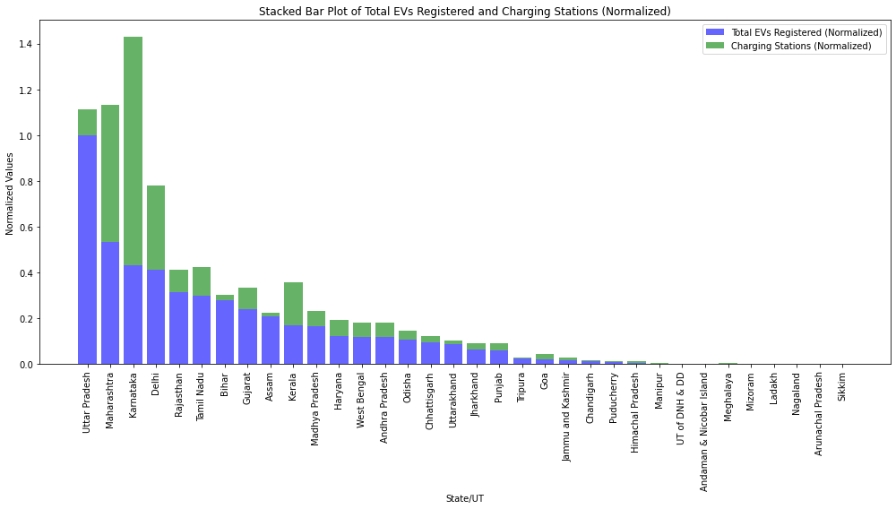

This plot visually represents the comparison between Total EVs Registered and Charging Stations across different states/UTs, with both values normalized. Normalization scales the data between 0 and 1, making it easier to compare states/UTs that may differ significantly in absolute numbers.

1. Xaxis (State/UT):

The xaxis shows different states and union territories (UTs) in India. The data is sorted by the total number of EVs registered, from highest to lowest.

Each bar represents one state or UT.

2. Yaxis (Normalized Values):

The yaxis shows the normalized values for both the total number of EVs registered and the number of charging stations. The values have been normalized so that both EVs registered and charging stations fall between 0 and 1, making them comparable across different states.

3. Stacked Bars:

Blue Segment: Represents the normalized number of total EVs registered in each state/UT. States with taller blue segments have registered a higher proportion of EVs relative to the highest Registered state.

Green Segment: Represents the normalized number of charging stations in each state/UT. States with taller green segments have a greater density of charging stations relative to the state with the most charging stations.

The height of the combined stacked bars represents the sum of both metrics (total EV registrations and charging stations), indicating how developed each state’s EV ecosystem is relative to others.

1. Leading States (High EV Registration and Charging Infrastructure):

Some states, like the first few on the left, have large blue and green sections, indicating they not only have a high number of EV registrations but also a significant number of charging stations.

For example, the first state in the plot has high levels of both EV adoption and charging stations (likely states like Karnataka or Maharashtra).

2. States with Disparity (High EV Registrations but Low Charging Infrastructure):

In certain states, you might observe a large blue section with a much smaller green section. This indicates that while the state has a high number of EV registrations, its charging infrastructure is lagging.

These states might need to invest more in charging infrastructure to support further EV adoption.

3. States with More Charging Stations but Fewer EVs:

In some cases, you might see a larger green section with a smaller blue section, suggesting that the state has developed its charging infrastructure but hasn’t seen a high level of EV adoption yet. These states might be preparing for future EV adoption but haven’t yet caught up in terms of registrations.

4. Less Developed States (Low EV Registrations and Charging Stations):

Toward the right of the plot, the bars are much smaller for both blue and green segments. These states have low EV registration and low charging infrastructure development, meaning they are lagging behind in terms of EV adoption and infrastructure.

#### Overall Summary:

The plot helps to visually identify states that are doing well in both EV adoption and charging infrastructure (with tall bars representing both segments).

It also highlights the disparities in certain states where either EV adoption is outpacing infrastructure development or vice versa.

Finally, it shows which states are falling behind in both EV adoption and charging station deployment, indicating potential areas where policy interventions might be necessary to accelerate growth.

This type of visualization allows policymakers and businesses to focus on areas needing more development and investment in EV infrastructure or promotion of EV adoption.

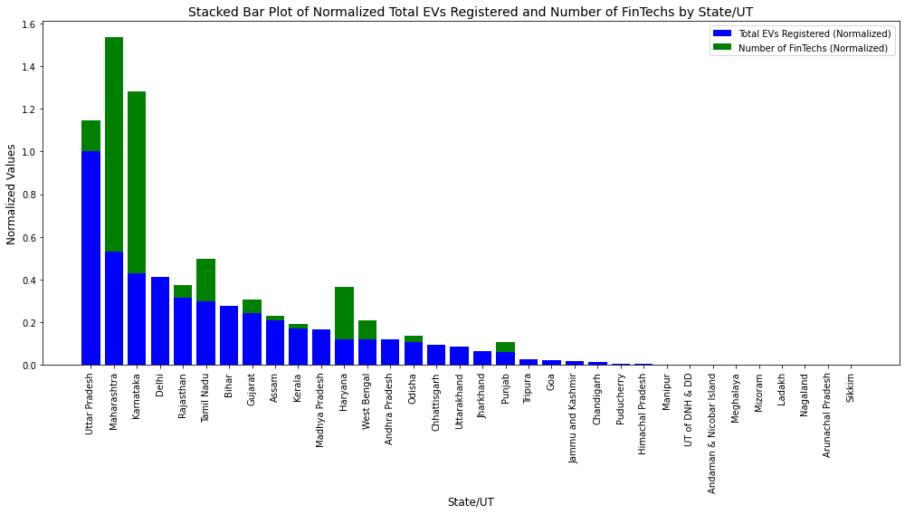

This plot represents the **normalized values** for **Total EVs Registered** and the **Number of FinTechs** across different states and union territories (UTs). Both values have been normalized to make them comparable on the same scale.

**Key Components:**

1. **Xaxis (State/UT)**:
   * The states/UTs are displayed along the x-axis. Each bar represents one state or UT, and the data is sorted based on the total number of EVs registered.
2. **Yaxis (Normalized Values)**:
   * The y-axis shows the **normalized values**, which scale the raw data between 0 and 1. This means that the highest value for EV registrations or fintech presence is represented as 1, and other values are scaled accordingly.
3. **Stacked Bars**:
   * **Blue Segment**: Represents the **normalized number of total EVs registered** for each state/UT. Taller blue sections indicate states with a higher proportion of EV registrations relative to other states.
   * **Green Segment**: Represents the **normalized number of fintech companies** in each state/UT. Taller green sections indicate a higher concentration of fintech companies.
   * Together, the total height of the stacked bars reflects the combined performance of each state in terms of both EV adoption and fintech presence.

**Key Observations:**

1. **States Leading in Both EV Adoption and FinTech Presence**:
   * The states with **large blue and green sections** are likely to be the ones leading in both EV adoption and fintech presence. These states likely have developed ecosystems for both EV infrastructure and financial technology.
   * For example, the first few states on the left have large bars, indicating they have both a significant number of EV registrations and a thriving fintech environment (likely states like **Karnataka** or **Maharashtra**).
2. **States with High FinTech Presence but Lower EV Registrations**:
   * States with **large green segments** but relatively smaller blue segments indicate a strong fintech presence but lower EV adoption. This could imply that these states have financial technology hubs but haven’t yet seen large-scale EV adoption.
   * These states might have strong urban infrastructure that supports fintech, but the EV ecosystem may be in earlier stages of development.
3. **States with High EV Registrations but Lower FinTech Presence**:
   * States with **large blue segments** and **small or absent green segments** indicate regions where EV adoption is growing, but the fintech sector is still underdeveloped. These states may have implemented policies promoting EVs, but they haven’t seen corresponding growth in the fintech sector.
   * This suggests potential areas of improvement for fintech-related initiatives in these states.
4. **States with Low EV Registrations and FinTech Presence**:
   * Toward the right of the plot, the bars are relatively smaller for both blue and green sections, indicating that these states are lagging in both EV adoption and fintech development. These regions may require further investment and support to develop in these sectors.

**Overall Summary:**

* The plot provides a visual comparison of states/UTs in terms of both **EV adoption** and **fintech presence**. It highlights the states that are leaders in both areas and those that excel in one but lag in the other.
* **Leading states** have tall stacked bars (large blue and green segments), representing strong ecosystems for both EVs and fintech.
* **Disparities** between EV adoption and fintech development can be seen in certain states where one is high but the other is low, indicating potential opportunities for growth in the underdeveloped sector.
* Finally, the **less developed states** have small bars, showing they are still in the early stages of both EV and fintech development.

In this scatter plot, the x-axis represents the Government Incentives provided by various states, and the y-axis represents the Total EVs Registered in those states. The labels on the points indicate the respective states/UTs.

1. General Trend:

High Incentives, High EV Registrations: States like Delhi, Tamil Nadu, Rajasthan, and Maharashtra offer relatively higher incentives and correspondingly have high EV registrations. This suggests a positive relationship between government incentives and the adoption of electric vehicles in these regions.

Low Incentives, Low EV Registrations: Several states, such as Meghalaya, Chandigarh, and Ladakh, offer lower incentives, and consequently, the EV registrations are also lower. This again highlights the impact of government support on EV adoption.

2. Outliers:

Delhi stands out with a high level of EV registrations relative to its incentives. This may indicate that factors other than incentives, such as infrastructure or policy support, are also driving EV adoption.

Uttar Pradesh and Karnataka have high EV registrations, but their incentives might not be as significant as those provided by states like Delhi. This could suggest that local demand or other market dynamics are stronger drivers of EV adoption in these regions.

3. Cluster of Low EV Registrations and Low Incentives:

Many states are clustered toward the lower left corner of the plot, such as Madhya Pradesh, Bihar, and Haryana. These regions show lower EV registrations, and their government incentives are also limited or not fully captured. This points to areas where both incentives and adoption may need to be improved.