AY 2019 Nephrology Match—Preliminary Results

## ASN *Data Brief* November 28, 2018

### Kurtis Pivert *ASN Data Science Officer*

### Contents

### I. Moving in Two Directions

### II. ERAS Application Data: A Look at the Candidates

### III. The Match in Context

## I. Moving in Two Directions

***Key Points***

# AY 2019—Turning of the Tide?

July application data provided by [ERAS](https://www.aamc.org/data/facts/eras/) for the appointment year (AY) 2019 nephrology Match show an uptick in total candidates and applications over the same time point in previous recruitment cycles.

### Total candidates in July are up …

Candidate numbers in July have inched up over the past 3 application cycles. AY 2019 candidate totals for July (286) are 6% shy of AY 2014. (In 2014, available nephrology fellowship positions outnumbered candidates for the first time since the specialty rejoined the Match.)

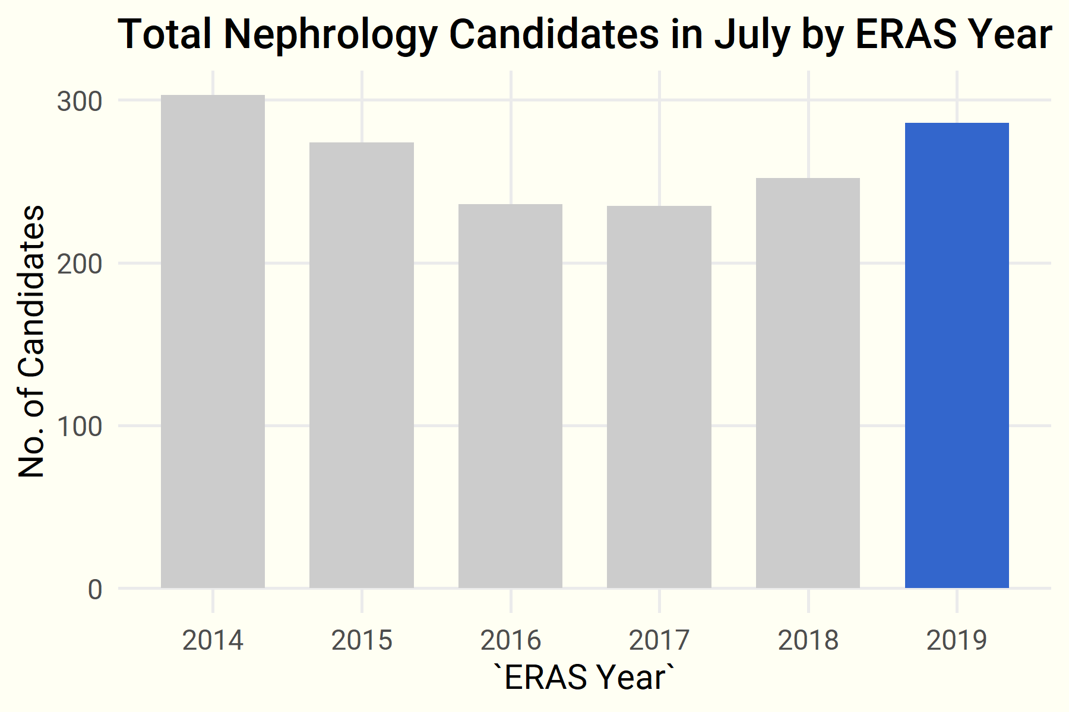

##### **Source**: ERAS, 2014–2018.

### … and candidate trends are reversing.

Starting with last year’s application cycle, the year-over-year trend of declining candidates in July is slowly reversing, building on last year’s increase.

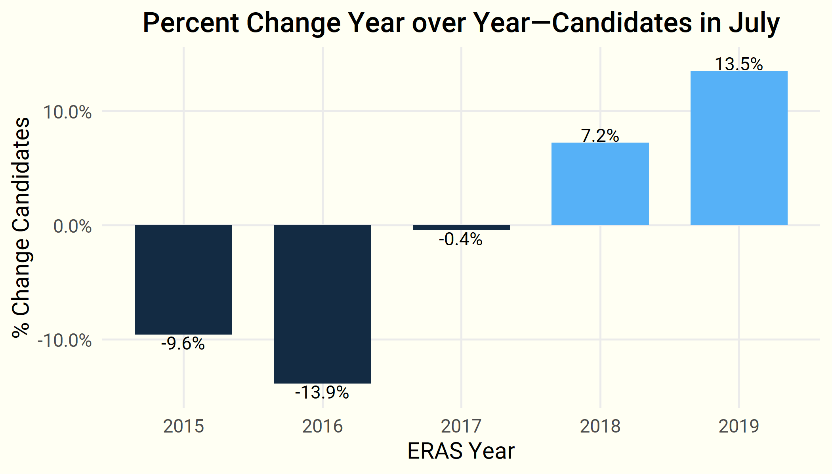

##### **Source**: ERAS, 2014–2018.

### Applications to nephrology fellowships are up slightly …

Total applications in July have rebounded from an apparent nadir in 2017.

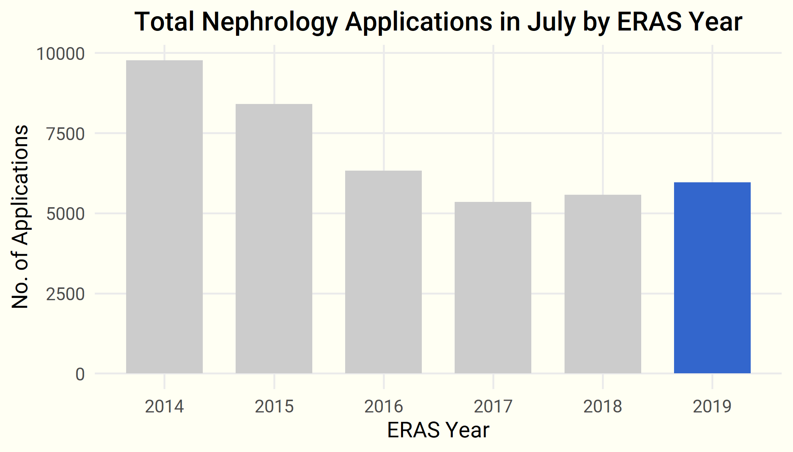

##### **Source**: ERAS, 2014–2018.

### … and growing slowly year over year.

The year over year percentages illustrate the stark decline in total nephrology applications experienced after the inversion in AY 2014.

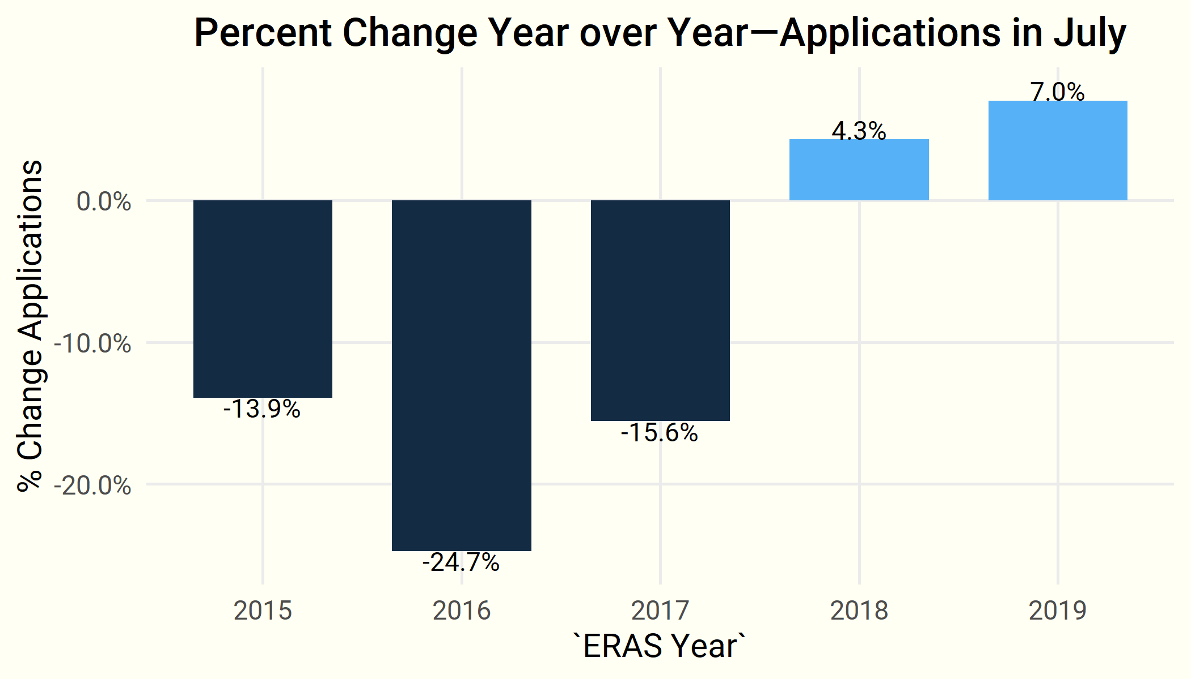

##### **Source**: ERAS, 2014–2018.

### IMG candidates are back …

July numbers show a strong rebound in international medical graduate (IMG) candidates applying to the specialty. While US IMGs and DOs continue to edge up, US MDs declined in July by 6%.

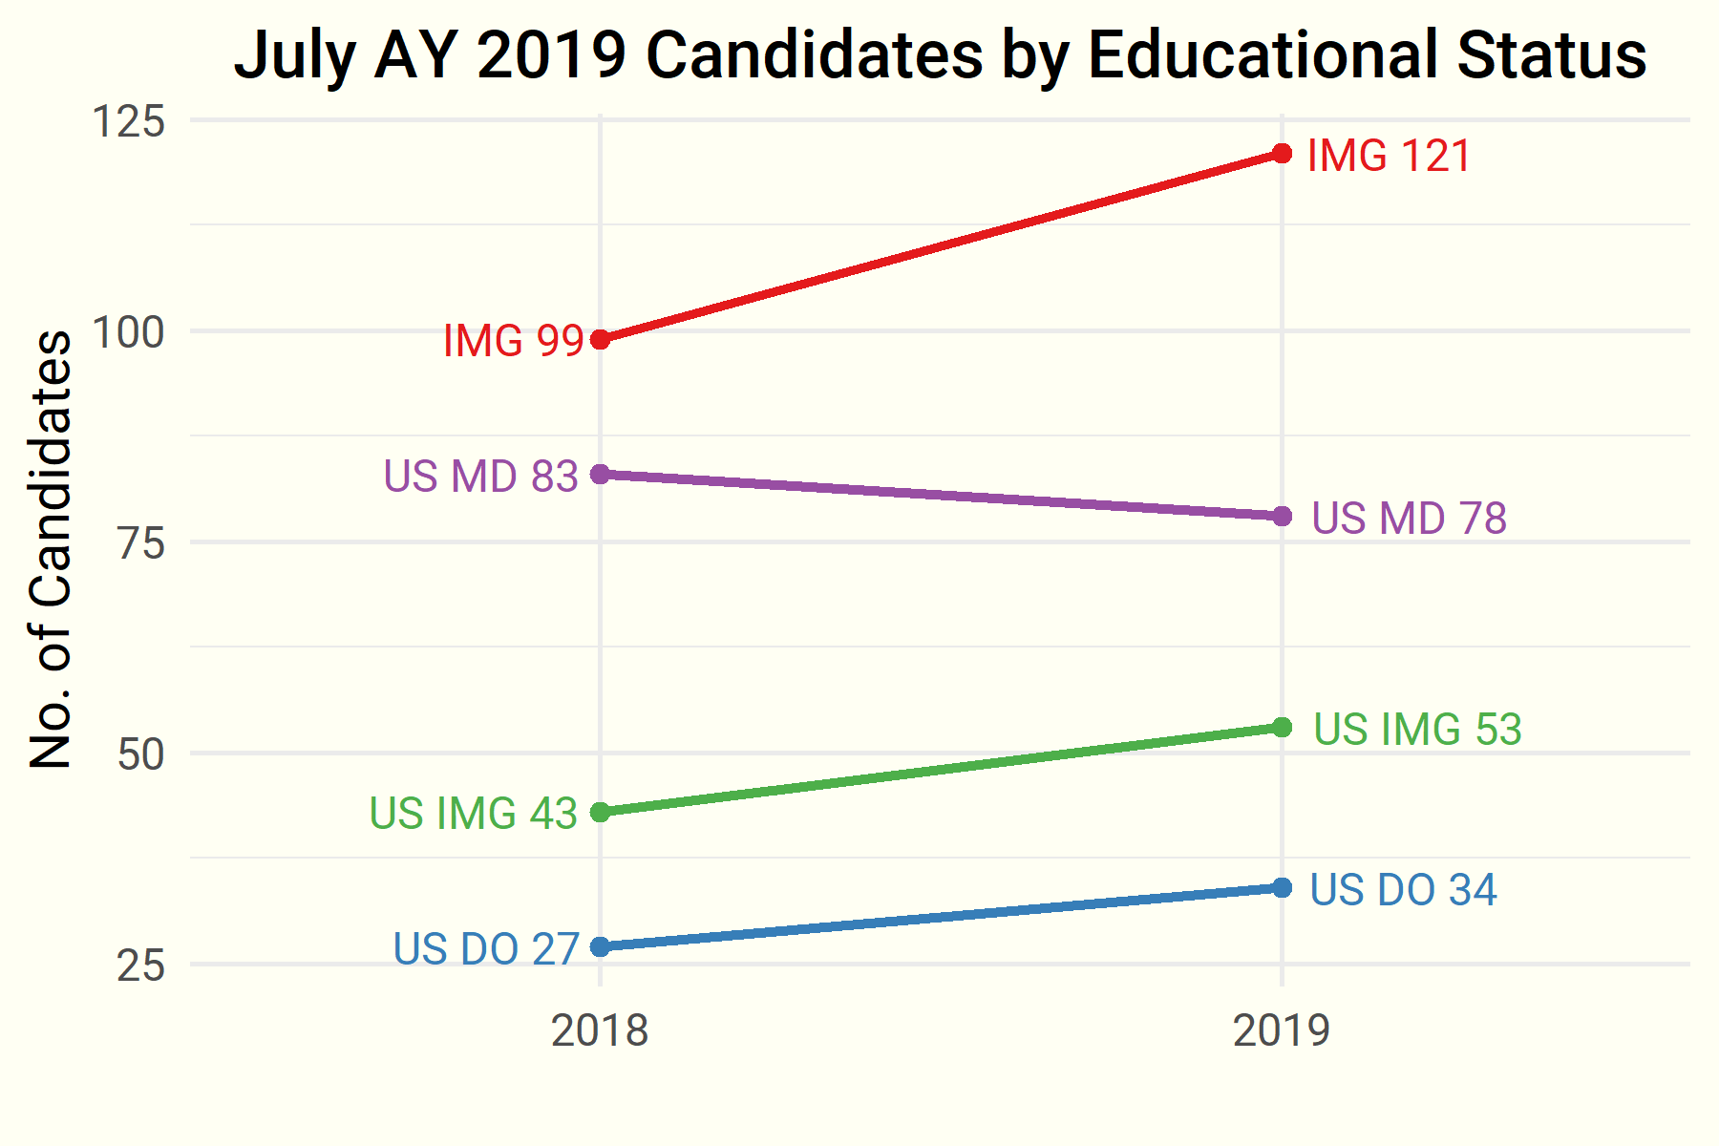

##### **Source**: ERAS, 2014–2018.

### …but total candidates …

Although its early in the application cycle, it’s possible the total candidates for the AY 2019 application cycle may match that of AY 2018.

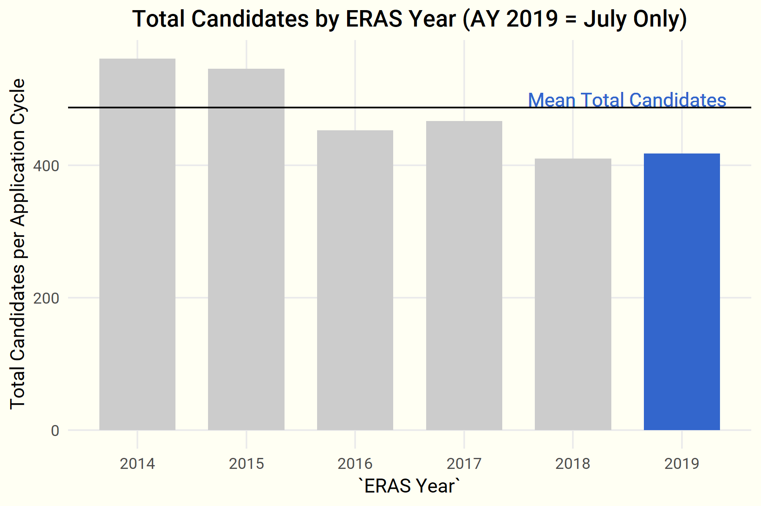

##### **Source**: ERAS, 2014–2018.

### …and applications are still down compared to historic averages.

Despite the upturn in candidates, it’s unknown when or if total applications will ever return to former levels, indicating a continued lack of selectivity.

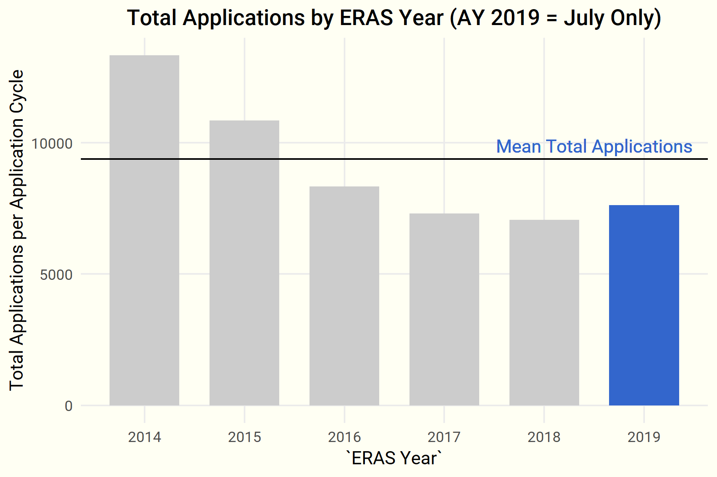

##### **Source**: ERAS, 2014–2018.

### Up Next

Future *Data Briefs* will report ERAS application data as it becomes available.

***Questions? Comments?***

Contact ASN Data Science Officer Kurtis Pivert at 202-699-0238 or [kpivert@asn-online.org](mailto:kpivert@asn-online.org).