August/September ERAS Applications

## ASN *Data Brief*

**Kurtis Pivert** *ASN Data Science Officer*

# AY 2019 Nephrology Match Update: August/September ERAS Applications

August and September [ERAS](https://www.aamc.org/data/facts/eras/) application data for the appointment year (AY) 2019 nephrology Match exhibited diverging trends. While applications declined in August, year-over-year totals are trending above the past 3 Match cycles.

### Fall Rebound in Candidates and Applications

New nephrology candidates applying in August continued their recent decline, but September saw a bump in new candidates (40), an 11% increase over AY 2018. The uptick is expected and likely an artifact of residents changing career plans mid–application cycle. Nephrology candidates have recently had the highest proportion of ERAS cross-specialty registrations (excepting allied subspecialties such as Pulm–CCM) and new data from the *Report on the 2018 Nephrology Fellow Survey*—being released October 15, 2018—found only 35.4% of respondents had considered nephrology as their only career option.

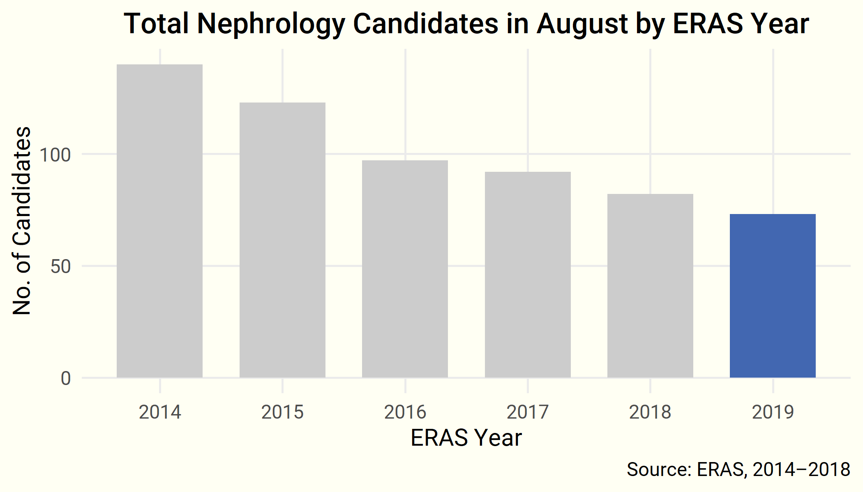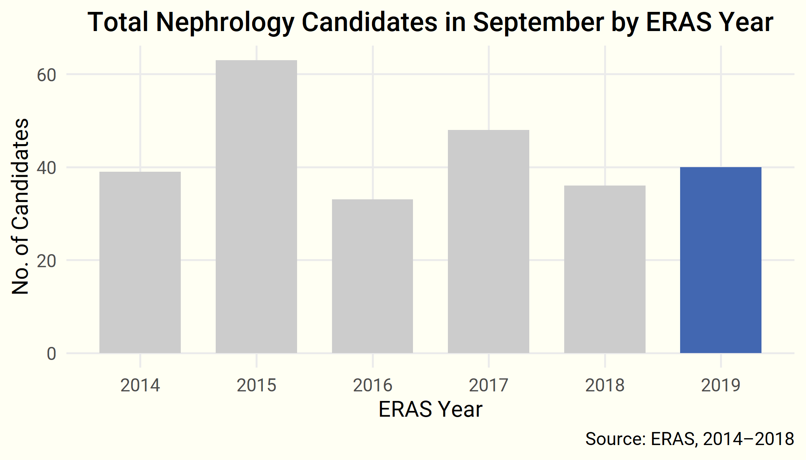

New application numbers mirror those for candidates, but September totals increased  
40% over last application cycle, with each applicant submitting to an average of 12 programs.

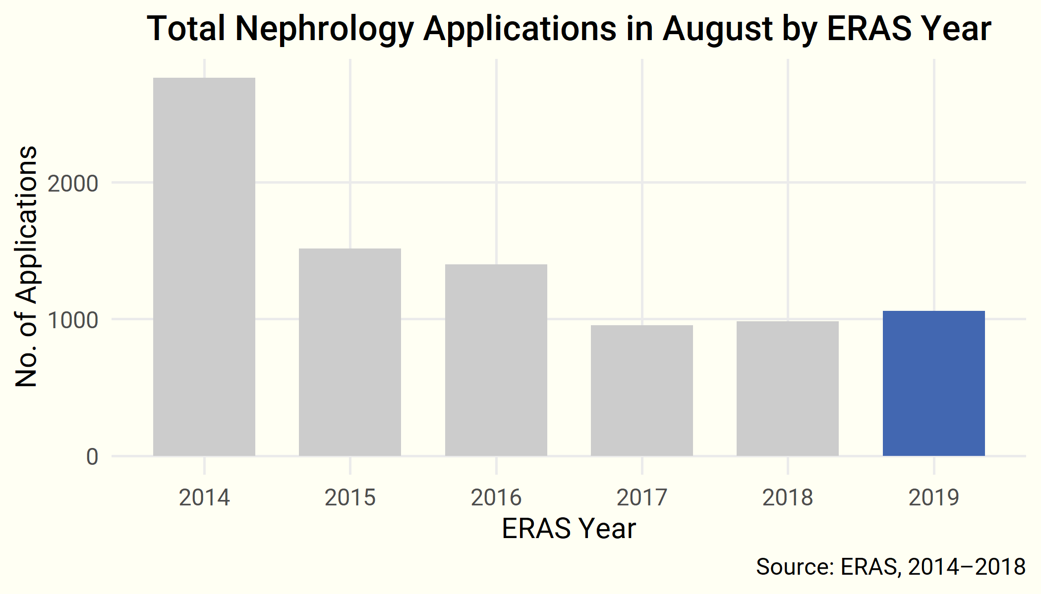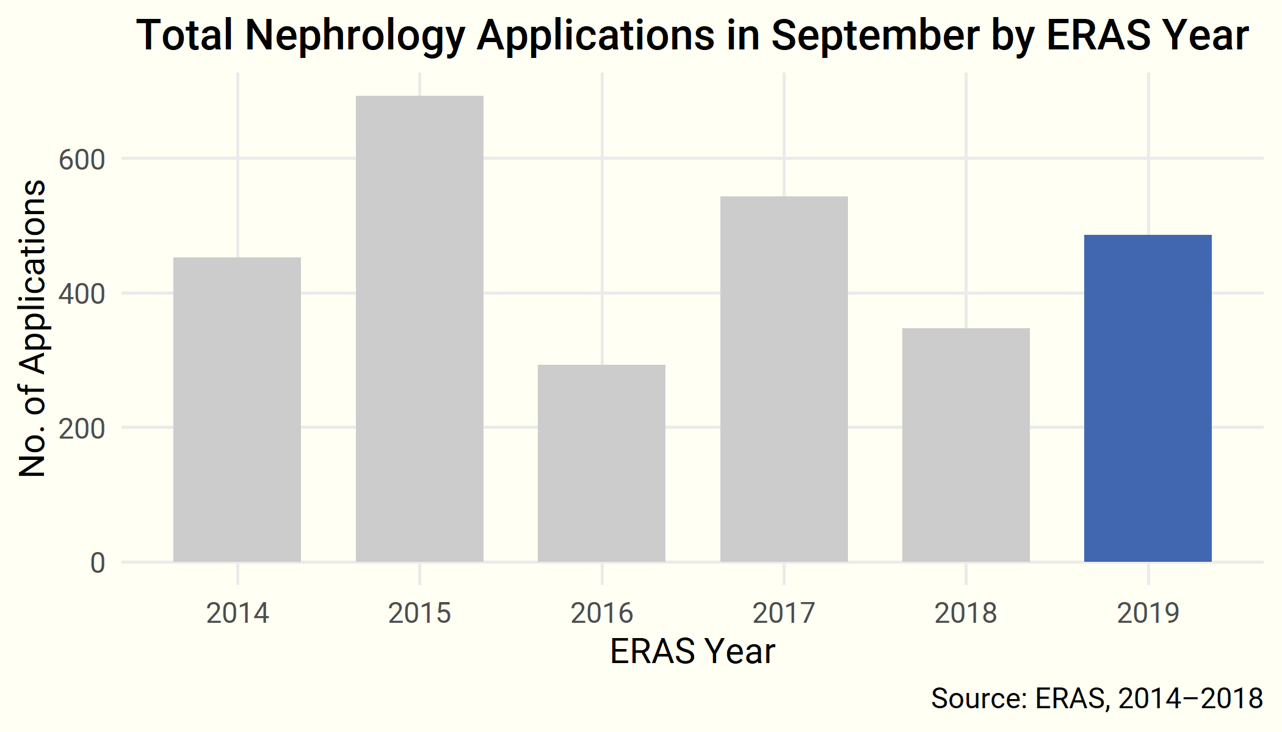

#### Educational Status

Broken down by educational status, US international medical graduates (US IMGs) have offset declines among both USMGs and IMGs over the past 2 months.

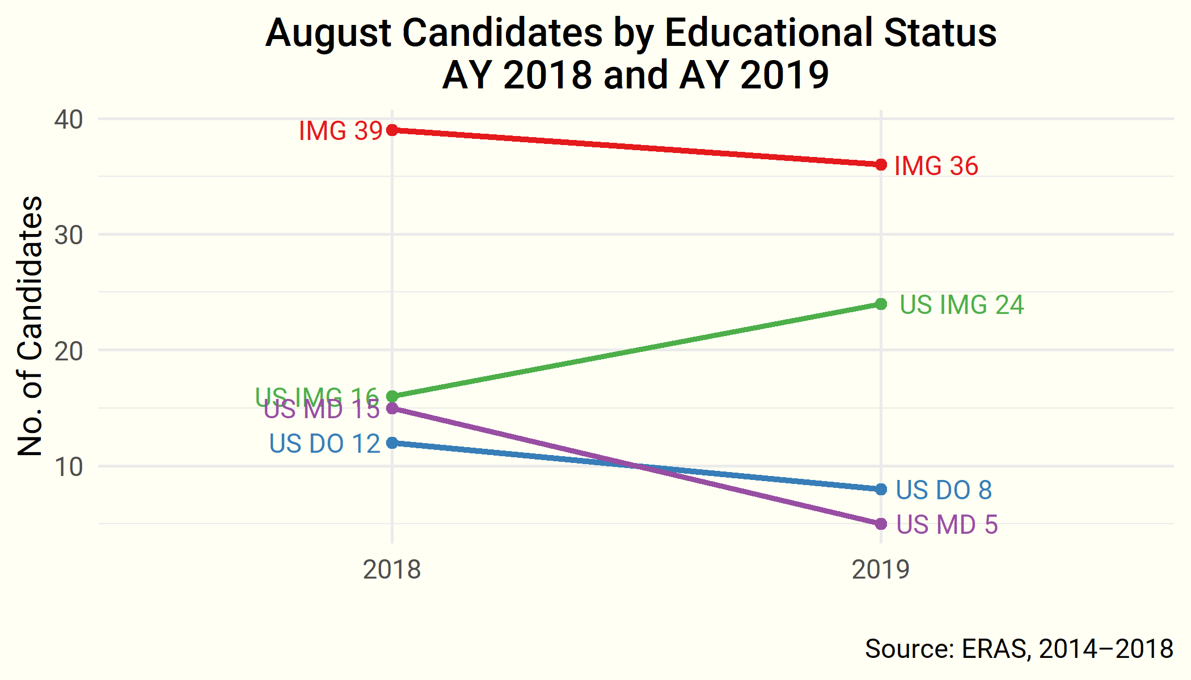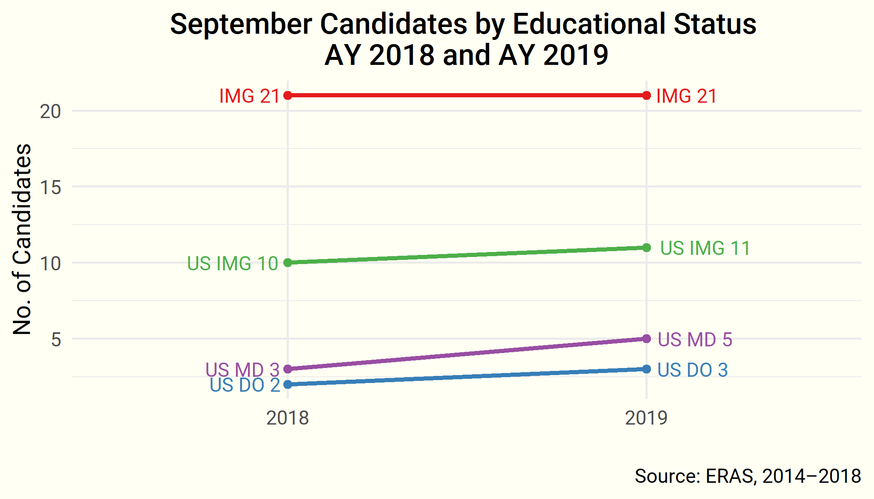

### Year over Year—Candidates and Applications

Total candidates and applications continue to trend higher over AY 2018 application cycle (7.8% and 8.7%, respectively). As of September, candidate totals are trending higher than the past 3 application cycles (AY 2016–AY 2018).

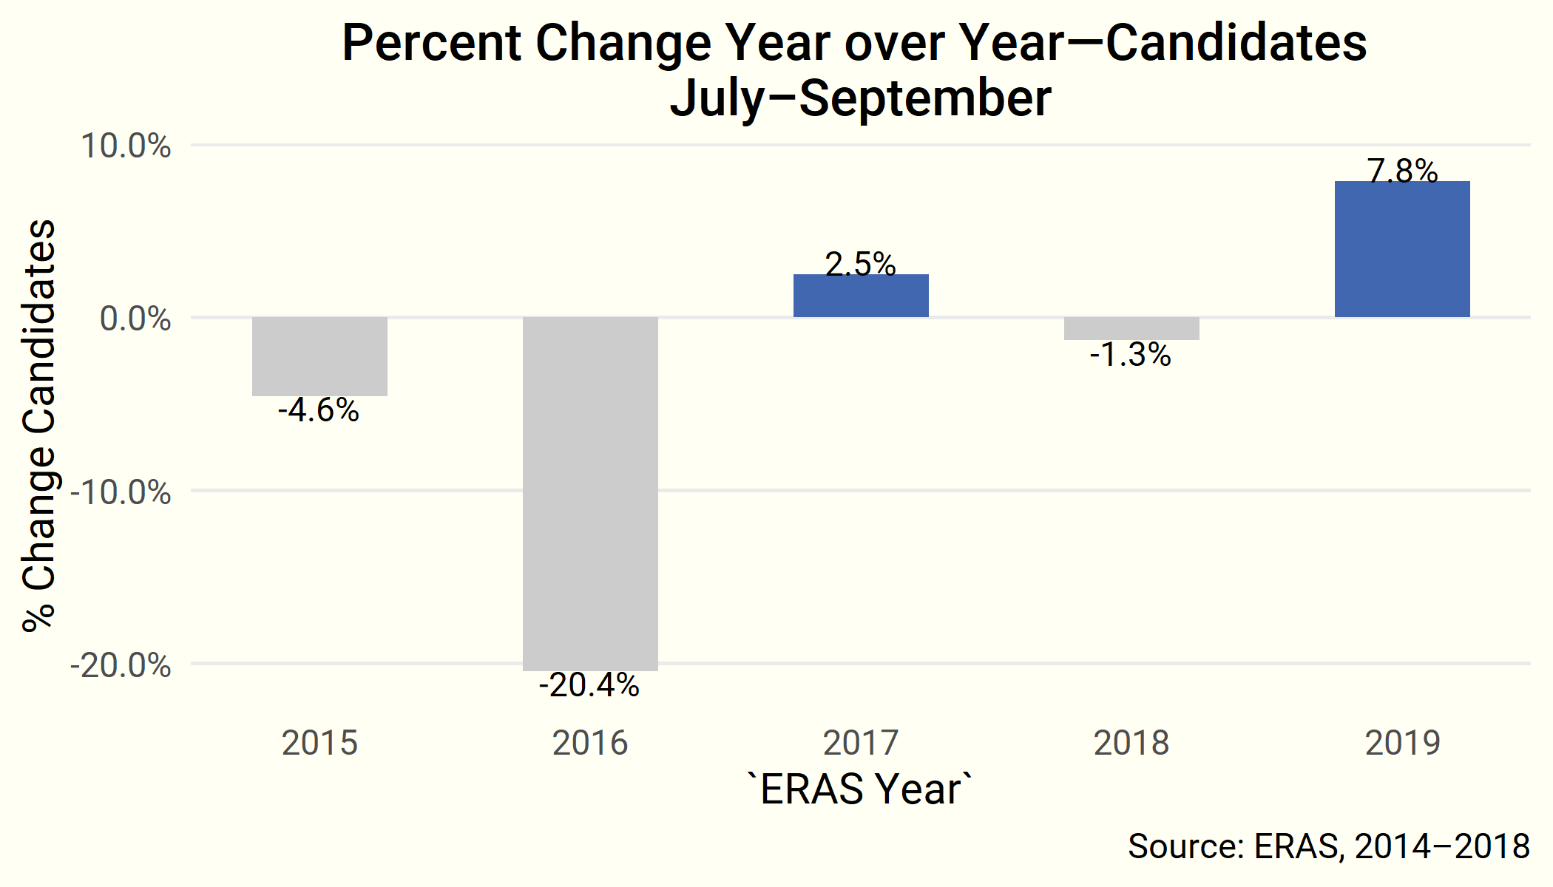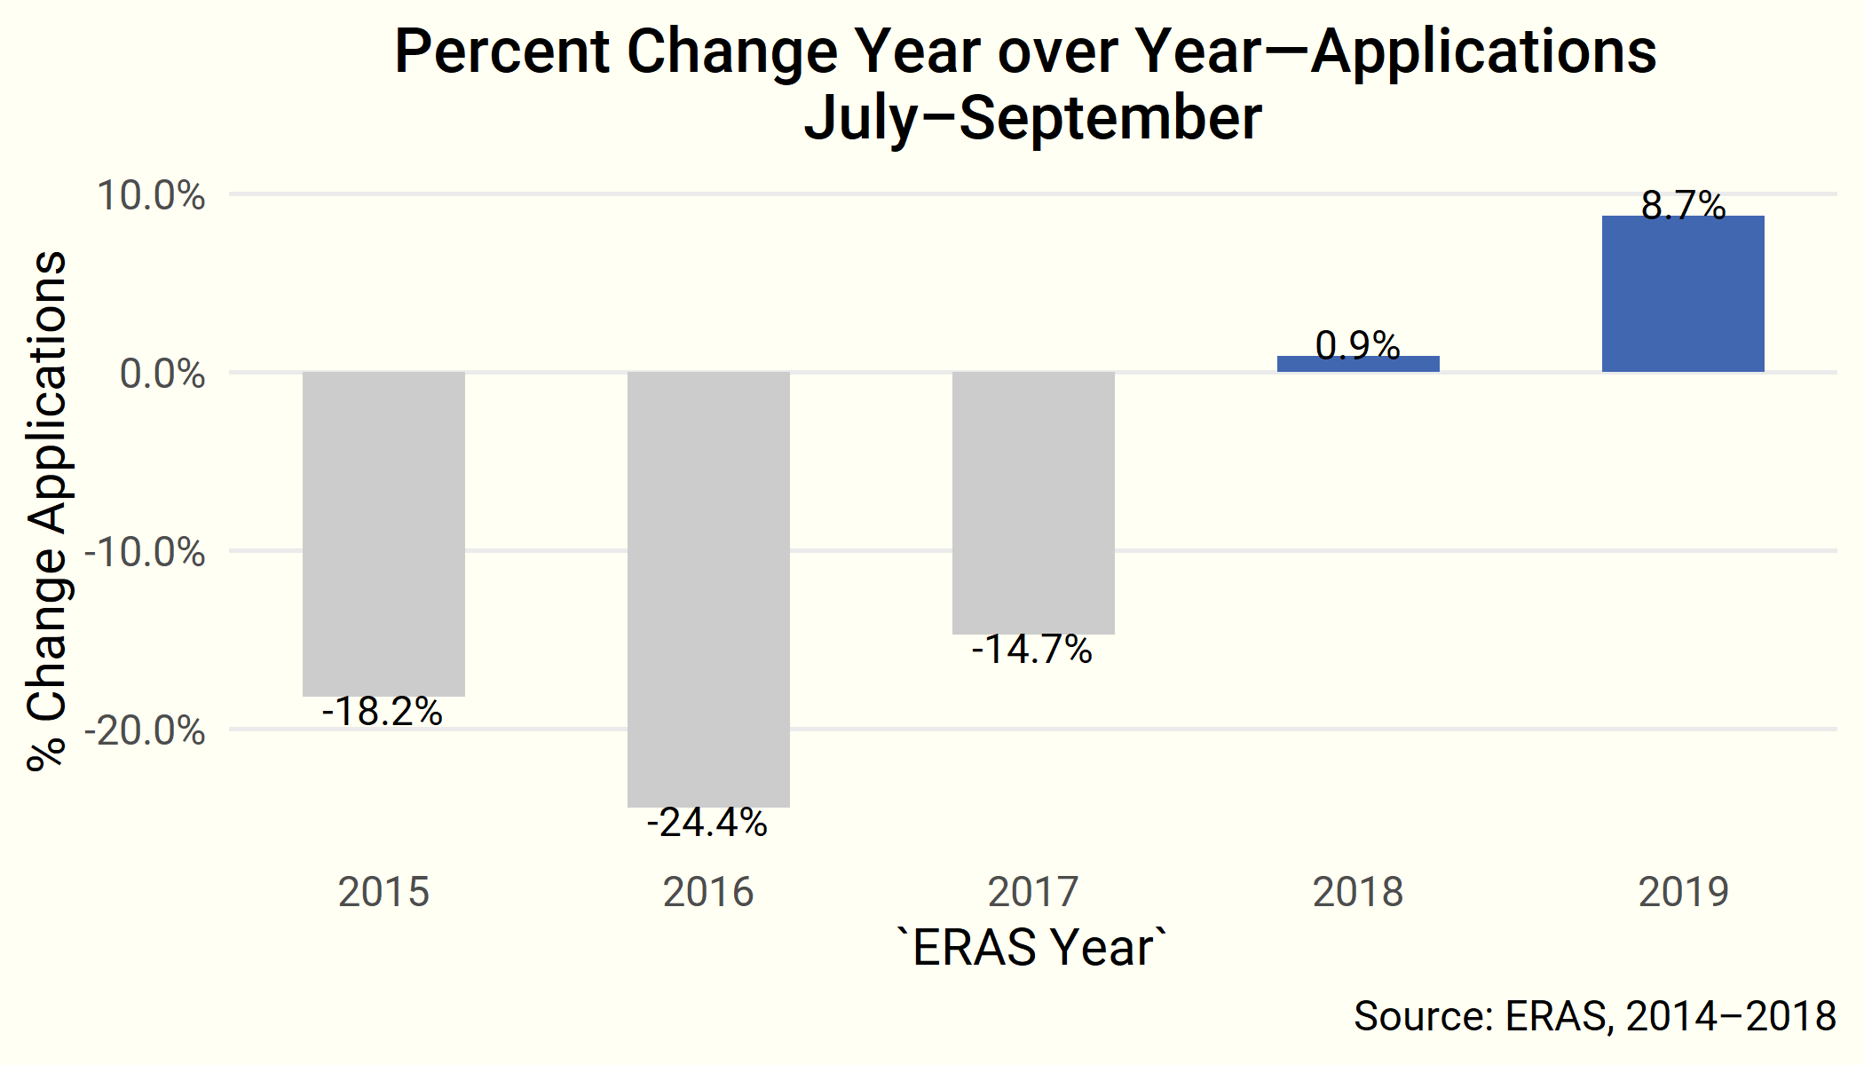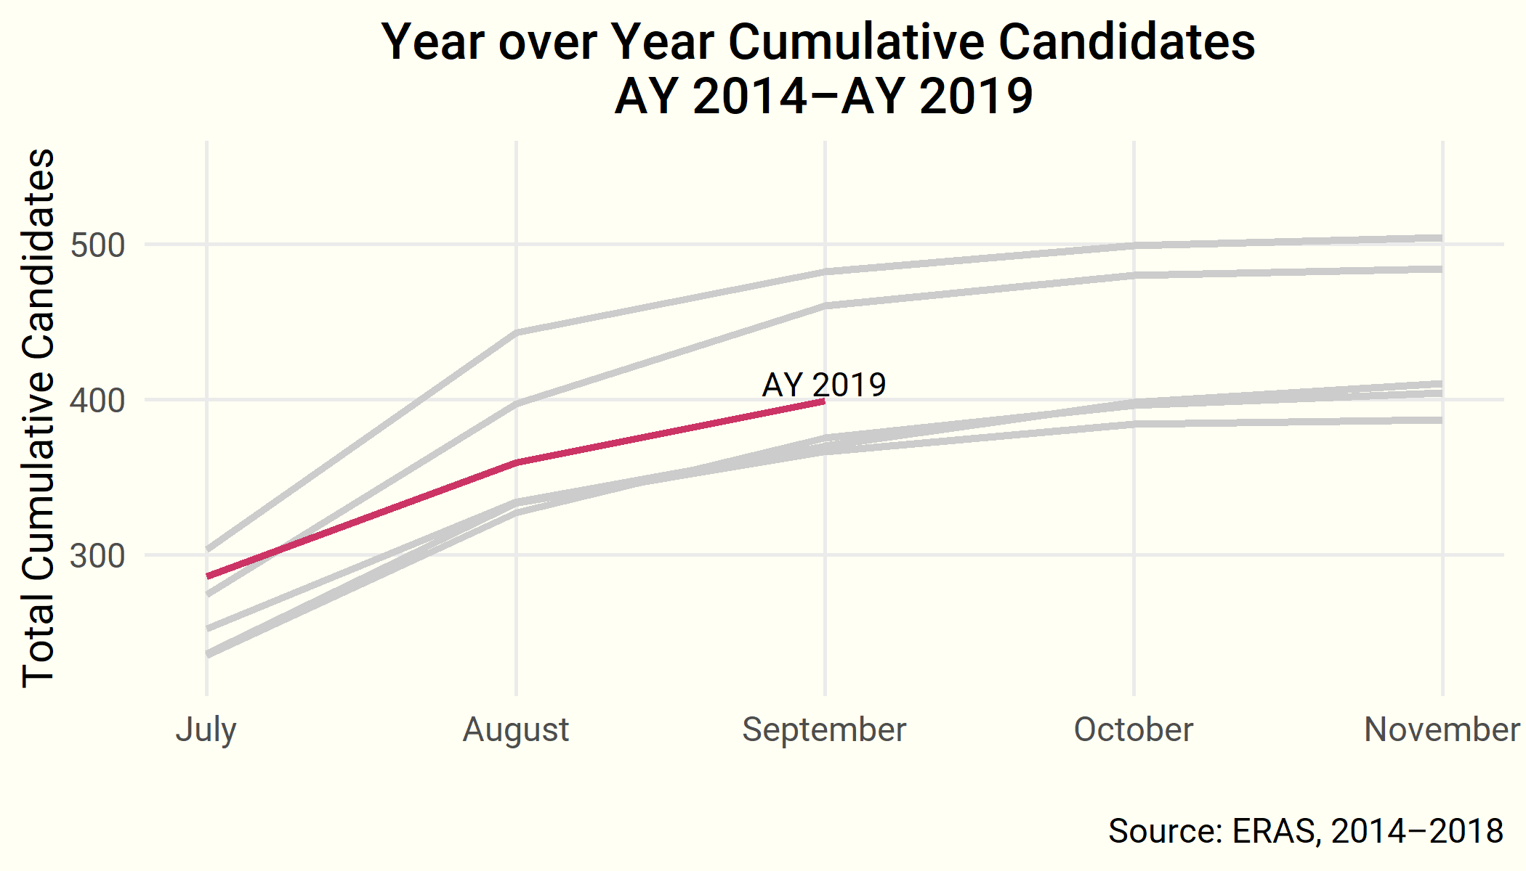

#### Educational Status

To date, IMGs have rebounded over last year by 12% and US IMGs are up 28%. Yet, the number of US MDs dropped 13% over September of last year (when 91 US MDs matched in nephrology), pointing to a lower total for AY 2019 (Figure 9).

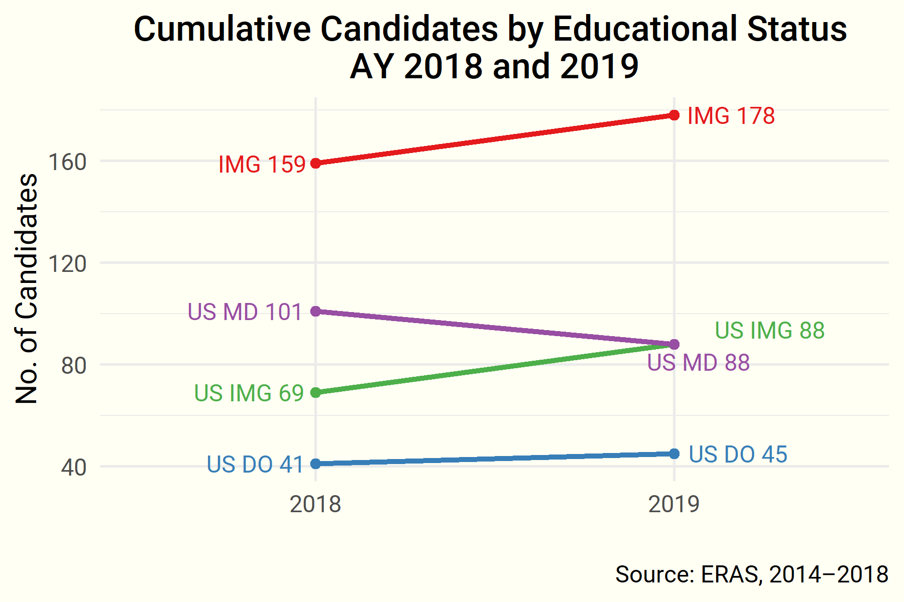

### Up Next

The next *Data Brief* will report preliminary nephrology Match results on *Match Day, Wednesday, November 28*.

***Questions? Comments?***

Contact ASN Data Science Officer Kurtis Pivert at 202-699-0238 or [kpivert@asn-online.org](mailto:kpivert@asn-online.org).