AY 2019 Nephrology Match—Preliminary Results

## ASN *Data Brief* November 28, 2018

### [Kurtis Pivert](mailto:kpivert@asn-online.org) *[ASN Data Science Officer](mailto:kpivert@asn-online.org)*

### Contents

### I. Moving in Two Directions

### II. ERAS Application Data: A Look at the Candidates

### III. The Match in Context

## I. Moving in Two Directions

***Key Points***

* US MDs matching in nephrology declined 12% from last year’s application cycle.
* International medical graduates (IMGs), US IMGs, and DOs matching in the specialty increased 6%–13% over AY 2018.
* Filled fellowship positions and training tracks edged up 2%, with 37.3% of slots and 56.4% going unfilled on Match Day.

Appointment year (AY) 2019 nephrology Match results released by the National Resident Matching Program [(NRMP)](http://www.nrmp.org/) captured a specialty seemingly moving in two directions. While total filled positions and training tracks edged up this year, US MDs matching in nephrology dropped 12%. International medical graduates (IMGs) entering fellowship ticked up 6%, but are still far below historic highs, accounting for just 39.2% of matriculating matched fellows.

The percentage of programs and fellowship positions completely filling on Match Day was up 2%. Yet—despite the closure and/or consolidation of several nephrology training programs since the AY 2018 application cycle—the gap between offered positions and qualified candidates to fill them remains wide. For the first time, the number of candidates preferring nephrology that matched into another subspecialty dropped to 0 (while those applicants preferring nephrology who did not Match were up slightly).

Nearly every candidate preferring nephrology continued to Match into the specialty (95.1% in AY 2019), pointing to a continuing lack of selectivity for nephrology. NRMP data from the AY 2018 Match indicated nephrology applicants had the second highest rate of matching into their first-choice program (68.8%), narrowly behind geriatrics (72.4%).

### Unfilled training tracks…

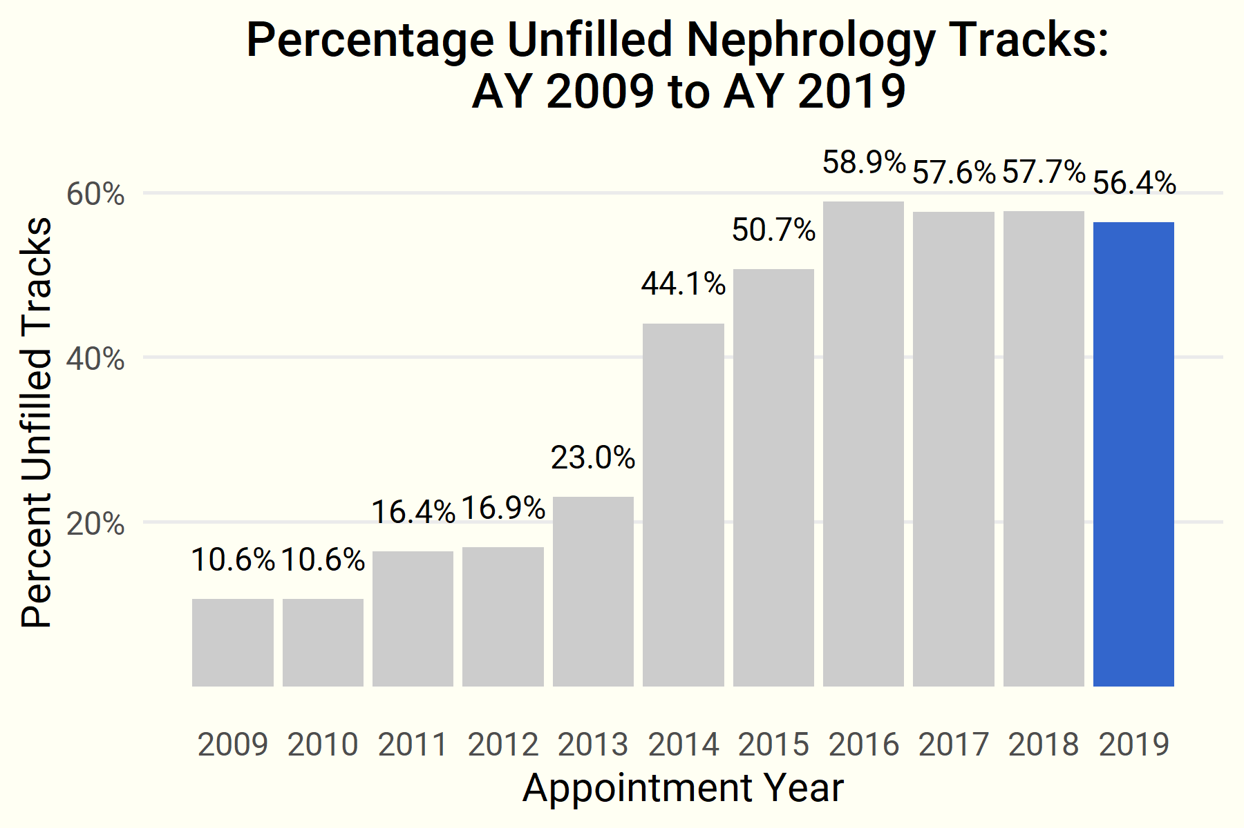

### …and unfilled positions edged down in the AY 2019 Match.

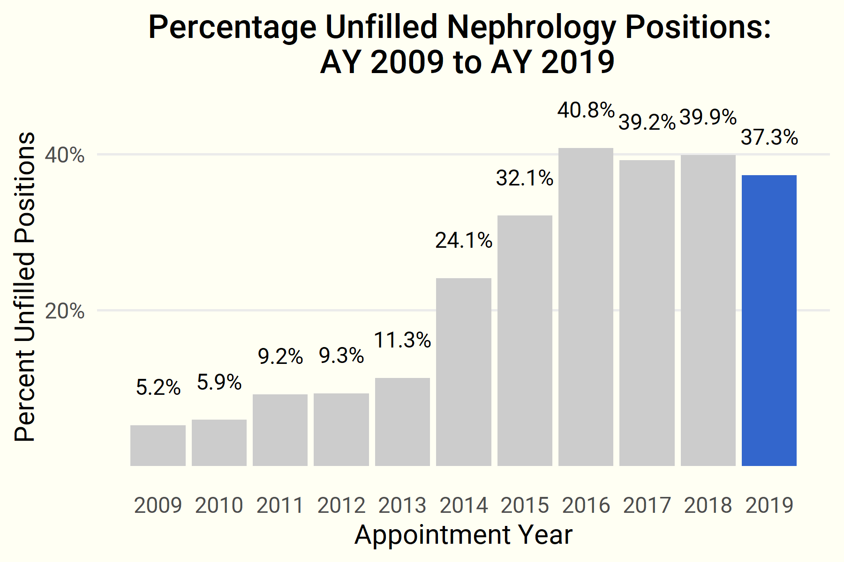

### Yet the gap in offered and filled positions…

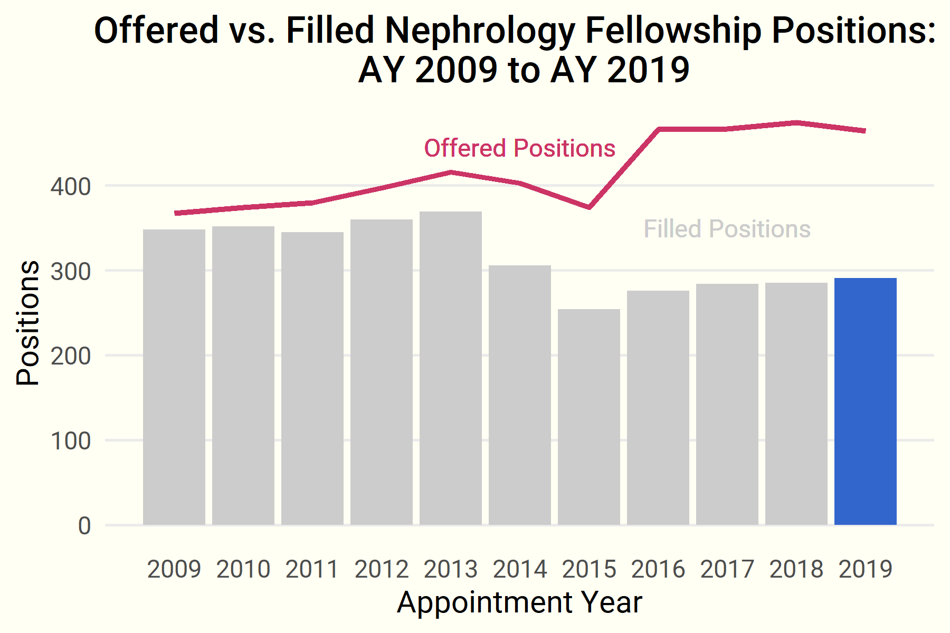

### … and training tracks, while narrowing, remains wide.

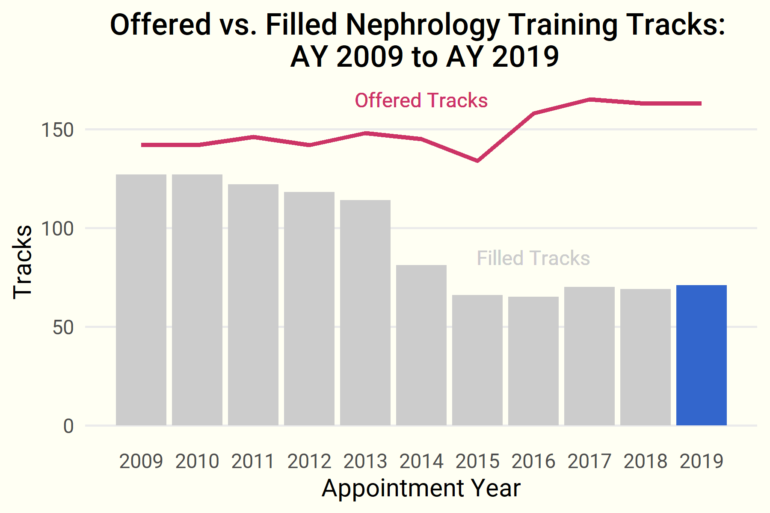

### An increasing number of US-IMGs and DOs are entering nephrology…

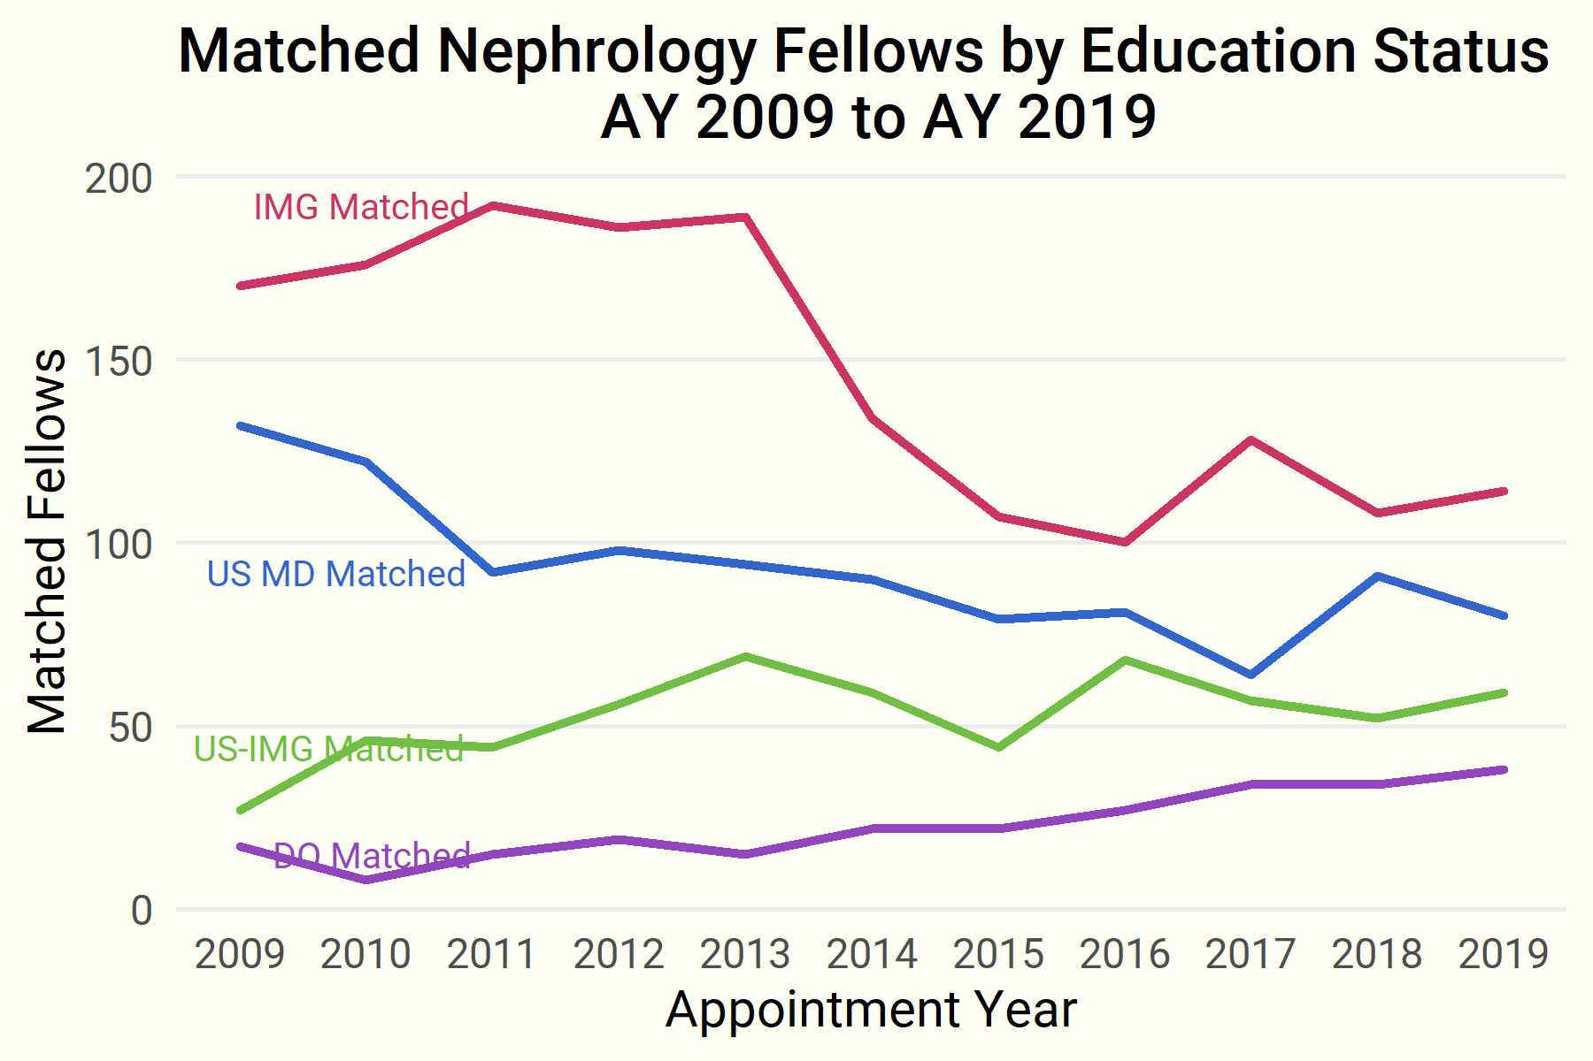

### …and nearly all candidates preferring the specialty obtained fellowships.

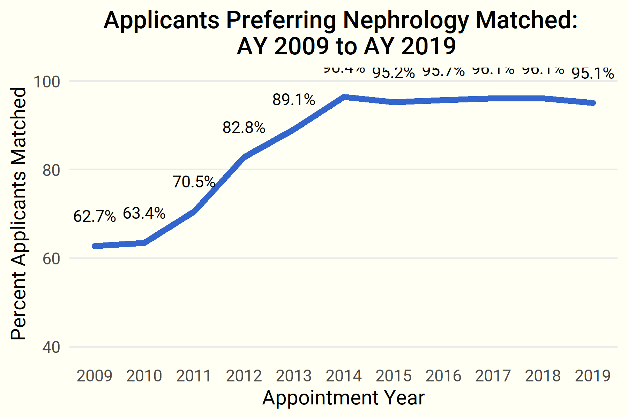

## Nephrology in the Match Era—Complete Results

The past 10 years of Match results can be filtered interactively using the *Search* function and filters.

### Table 1: Nephrology Match Results

|  |  |  |  |  |  |  |  |  |  |  |  |
| --- | --- | --- | --- | --- | --- | --- | --- | --- | --- | --- | --- |
| Variable | AY-2009 | AY-2010 | AY-2011 | AY-2012 | AY-2013 | AY-2014 | AY-2015 | AY-2016 | AY-2017 | AY-2018 | AY-2019 |
| Offered Positions | 367 | 374 | 380 | 397 | 416 | 403 | 374 | 466 | 467 | 474 | 464 |
| Filled Positions | 348 | 352 | 345 | 360 | 369 | 306 | 254 | 276 | 284 | 285 | 291 |
| Unfilled Positions | 19 | 22 | 35 | 37 | 47 | 97 | 120 | 190 | 183 | 189 | 173 |
| Percent Filled Positions | 0.948 | 0.941 | 0.908 | 0.907 | 0.887 | 0.759 | 0.679 | 0.592 | 0.608 | 0.601 | 0.627 |
| Offered Tracks | 142 | 142 | 146 | 142 | 148 | 145 | 134 | 158 | 165 | 163 | 163 |
| Filled Tracks | 127 | 127 | 122 | 118 | 114 | 81 | 66 | 65 | 70 | 69 | 71 |
| Unfilled Tracks | 15 | 15 | 24 | 24 | 34 | 64 | 68 | 93 | 95 | 94 | 92 |
| Percent Filled Tracks | 0.894 | 0.894 | 0.836 | 0.831 | 0.77 | 0.559 | 0.493 | 0.411 | 0.424 | 0.423 | 0.436 |
| Total Applicants | 578 | 576 | 510 | 446 | 421 | 323 | 276 | 298 | 308 | 304 | NA |
| Applicants Prefer Nephrology | 553 | 543 | 481 | 425 | 395 | 306 | 252 | 280 | 280 | 282 | 288 |
| Applicants Prefer Nephrology Matched | 347 | 344 | 339 | 352 | 352 | 295 | 240 | 268 | 269 | 271 | 274 |
| Applicants Matched Other | 12 | 19 | 16 | 10 | 7 | 4 | 7 | 7 | 11 | 7 | 0 |
| Applicants Did Not Match | 218 | 205 | 149 | 76 | 45 | 13 | 15 | 15 | 13 | 12 | 14 |
| Total Matched | 348 | 352 | 345 | 360 | 369 | 306 | 254 | 276 | 284 | 285 | 291 |
| US MD Matched | 132 | 122 | 92 | 98 | 94 | 90 | 79 | 81 | 64 | 91 | 80 |
| DO Matched | 17 | 8 | 15 | 19 | 15 | 22 | 22 | 27 | 34 | 34 | 38 |
| US-IMG Matched | 27 | 46 | 44 | 56 | 69 | 59 | 44 | 68 | 57 | 52 | 59 |
| IMG Matched | 170 | 176 | 192 | 186 | 189 | 134 | 107 | 100 | 128 | 108 | 114 |
| Canadian Matched | 1 | 0 | 1 | 1 | 2 | 1 | 0 | 0 | 1 | 0 | 0 |
| Fifth Pathway Matched | 1 | 0 | 1 | 0 | 0 | 0 | 2 | 0 | 0 | 0 | 0 |

***Source****:* National Resident Matching Program, 2009–2018. Available at <http://www.nrmp.org/fellowship-match-data/>.

## II. ERAS Application Data: A Look at the Candidates

### Year over Year—Candidates and Applications

Total candidates and applications continue to trend higher over the AY 2018 application cycle (5% and 8.7%, respectively). As of the close of October, candidate totals were trending higher than the past 3 application cycles (AY 2016–AY 2018), foreshadowing today’s slightly higher numbers. Reviewing candidates by educational status shows the proportions closely mirror that of the final Match results.

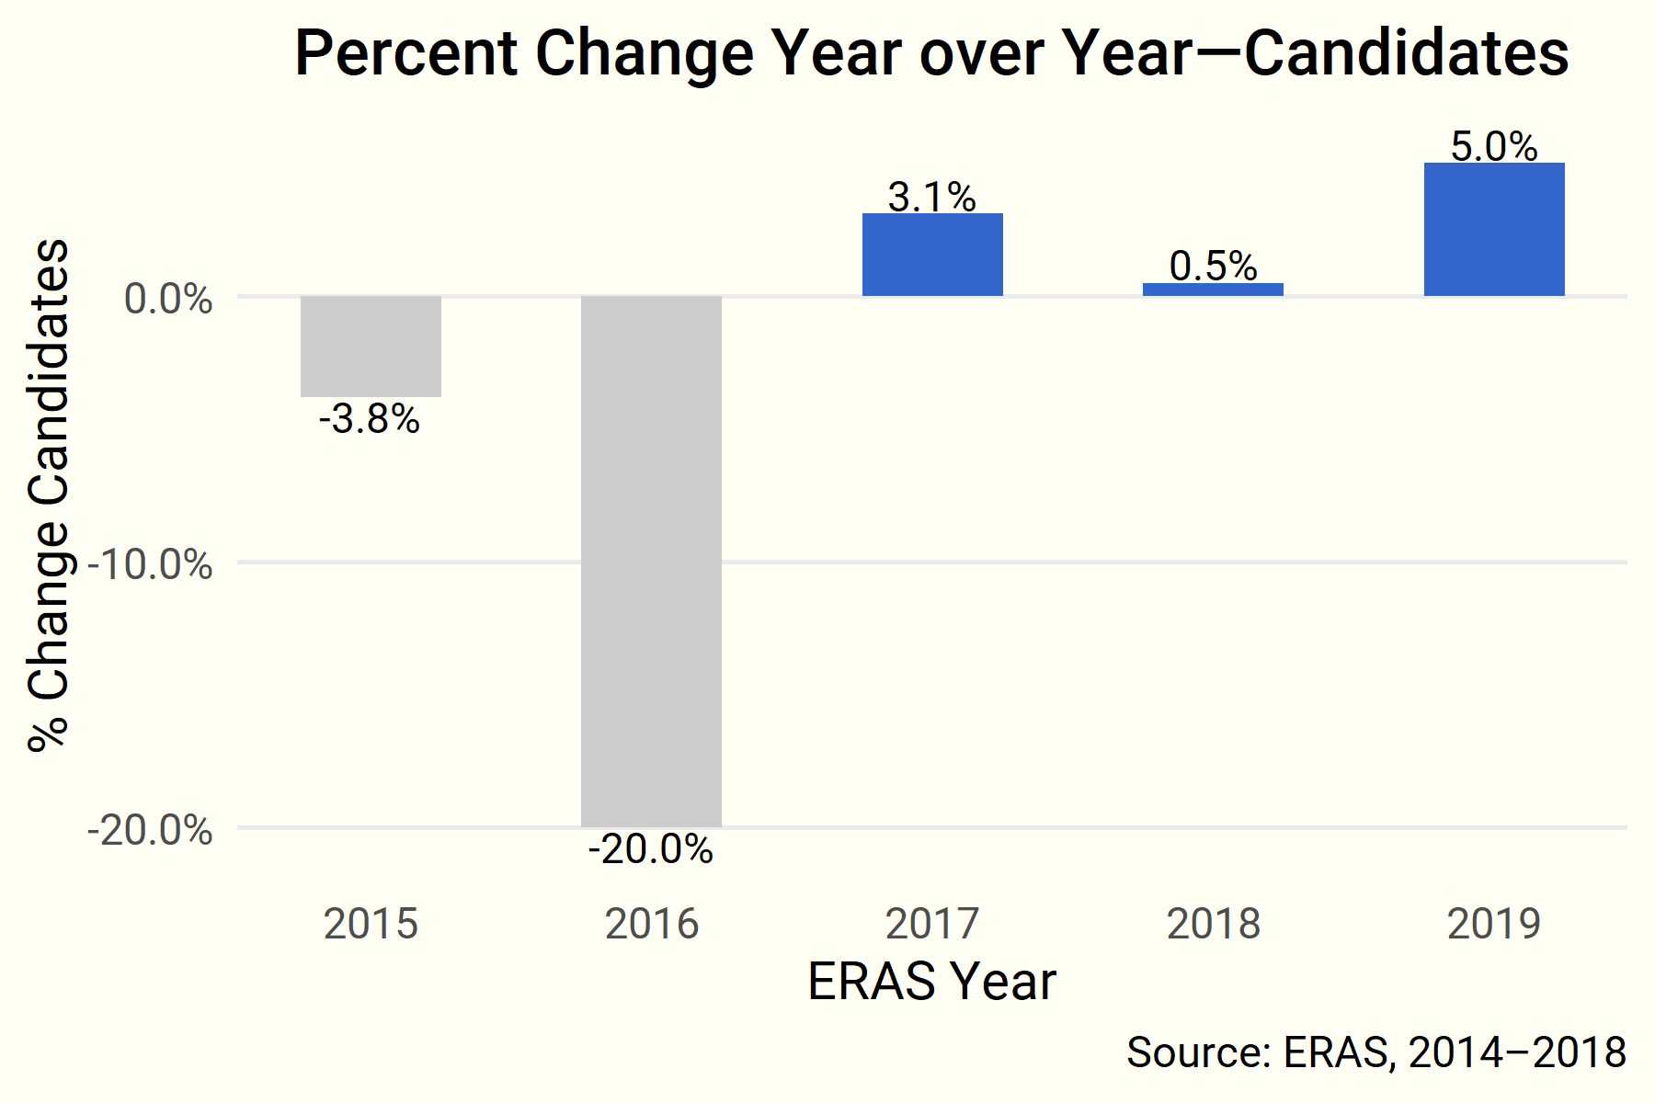

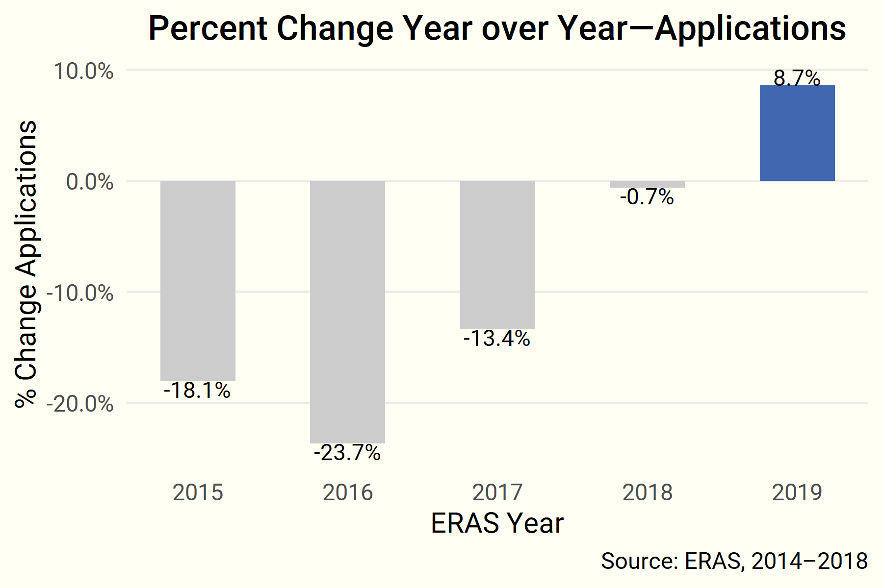

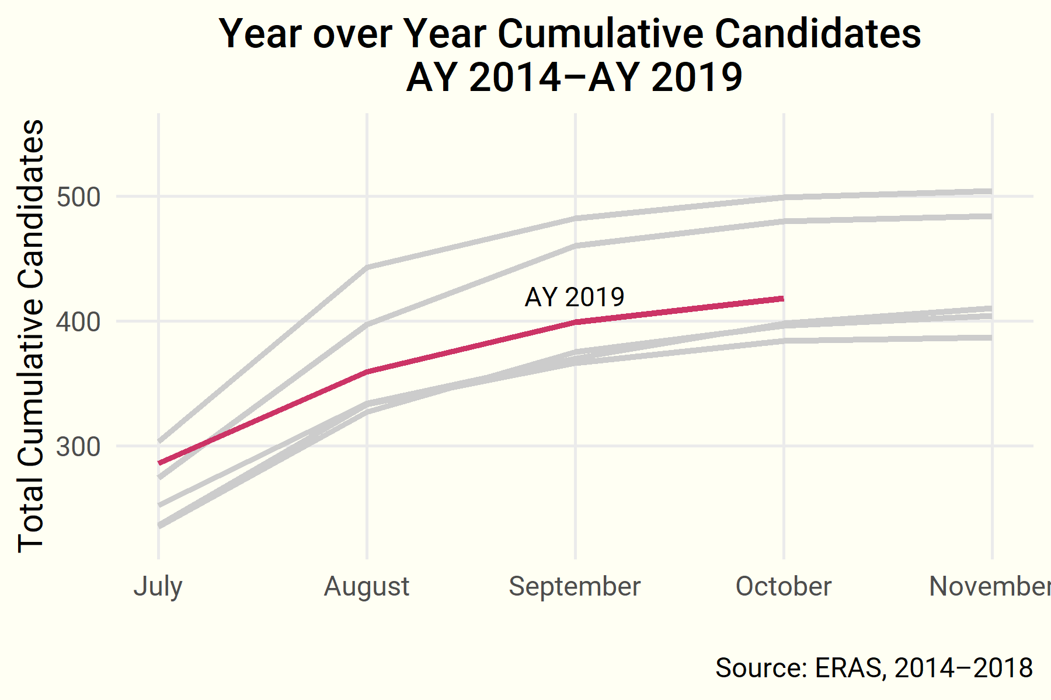

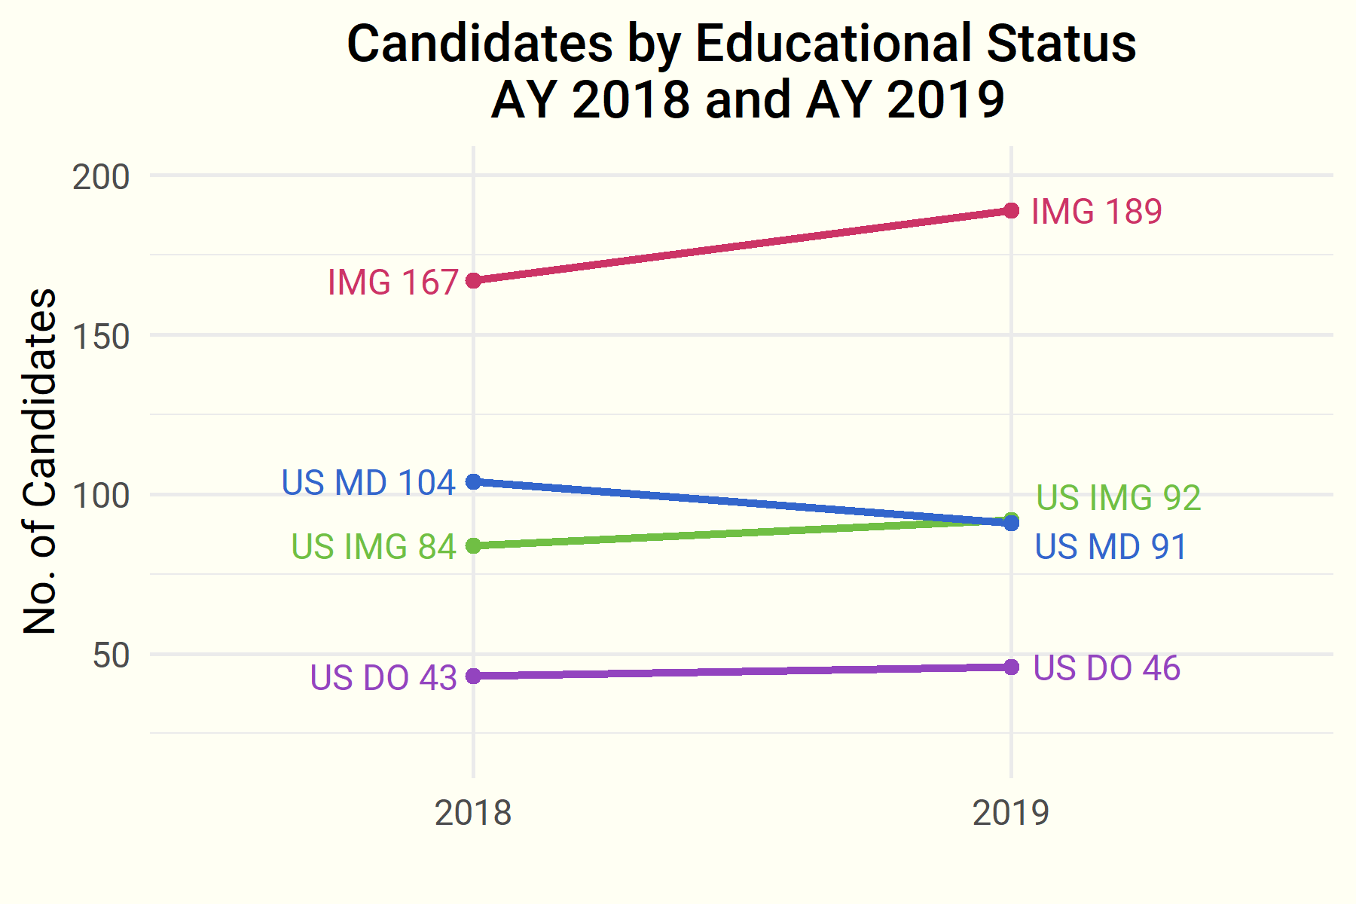

## III. The Match in Context

Results from the ASN Nephrology GME Census provide some context for today’s Match results. Although the trend of unfilled positions on Match Day has slightly improved, the overall number of 1st-year nephrology fellows in training have remained steady, slightly declining over the past 3 years. In the current academic year, nearly 30% (128) of fellows in training filled in the scramble.

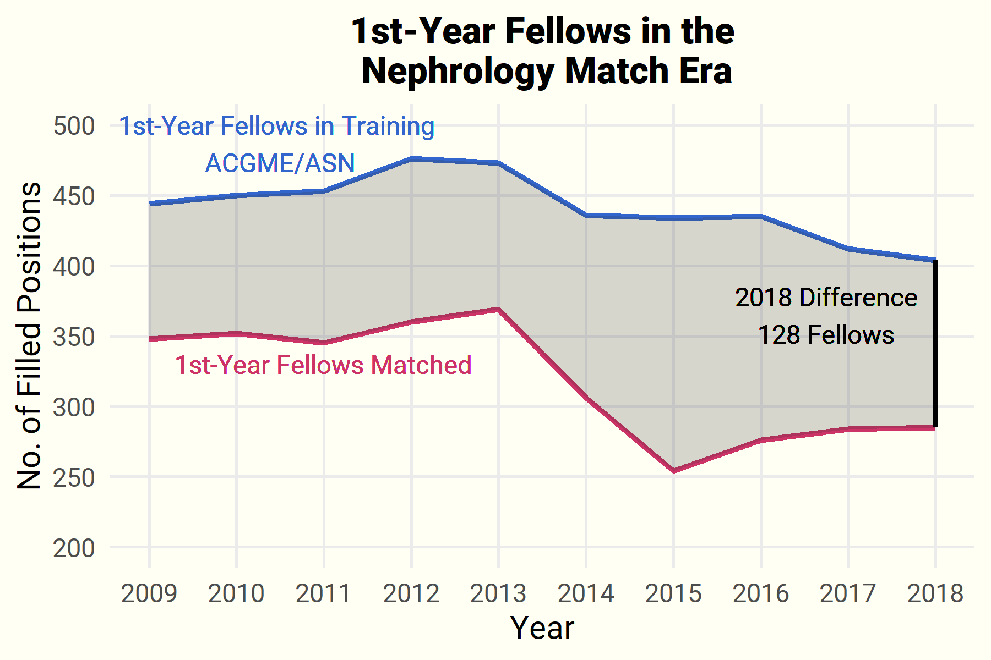

### *Questions? Comments?*

Contact ASN Data Science Officer Kurtis Pivert at 202-699-0238 or [kpivert@asn-online.org](mailto:kpivert@asn-online.org).