1. Login page with invalid credential

1. Successful login

1. User with “Administrator” permissions can manage list of users and change user details

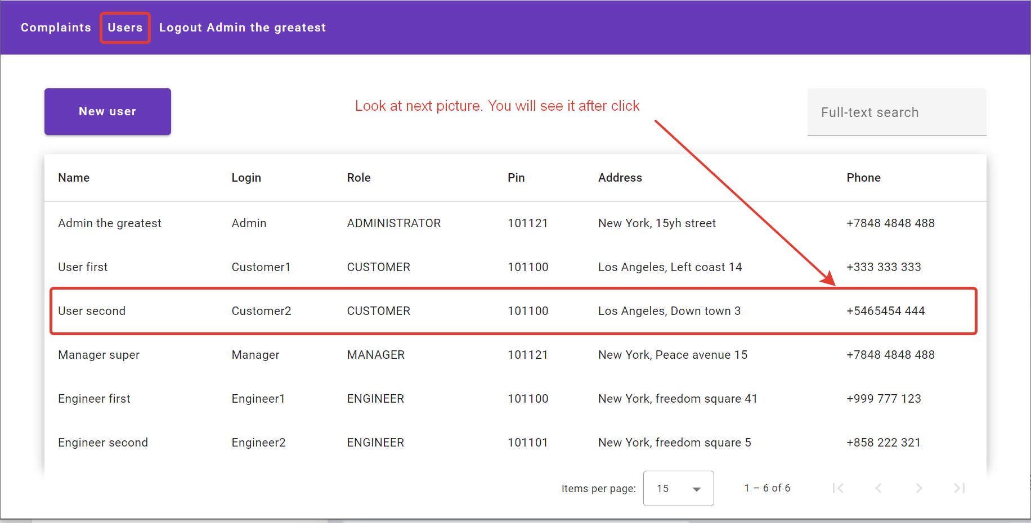

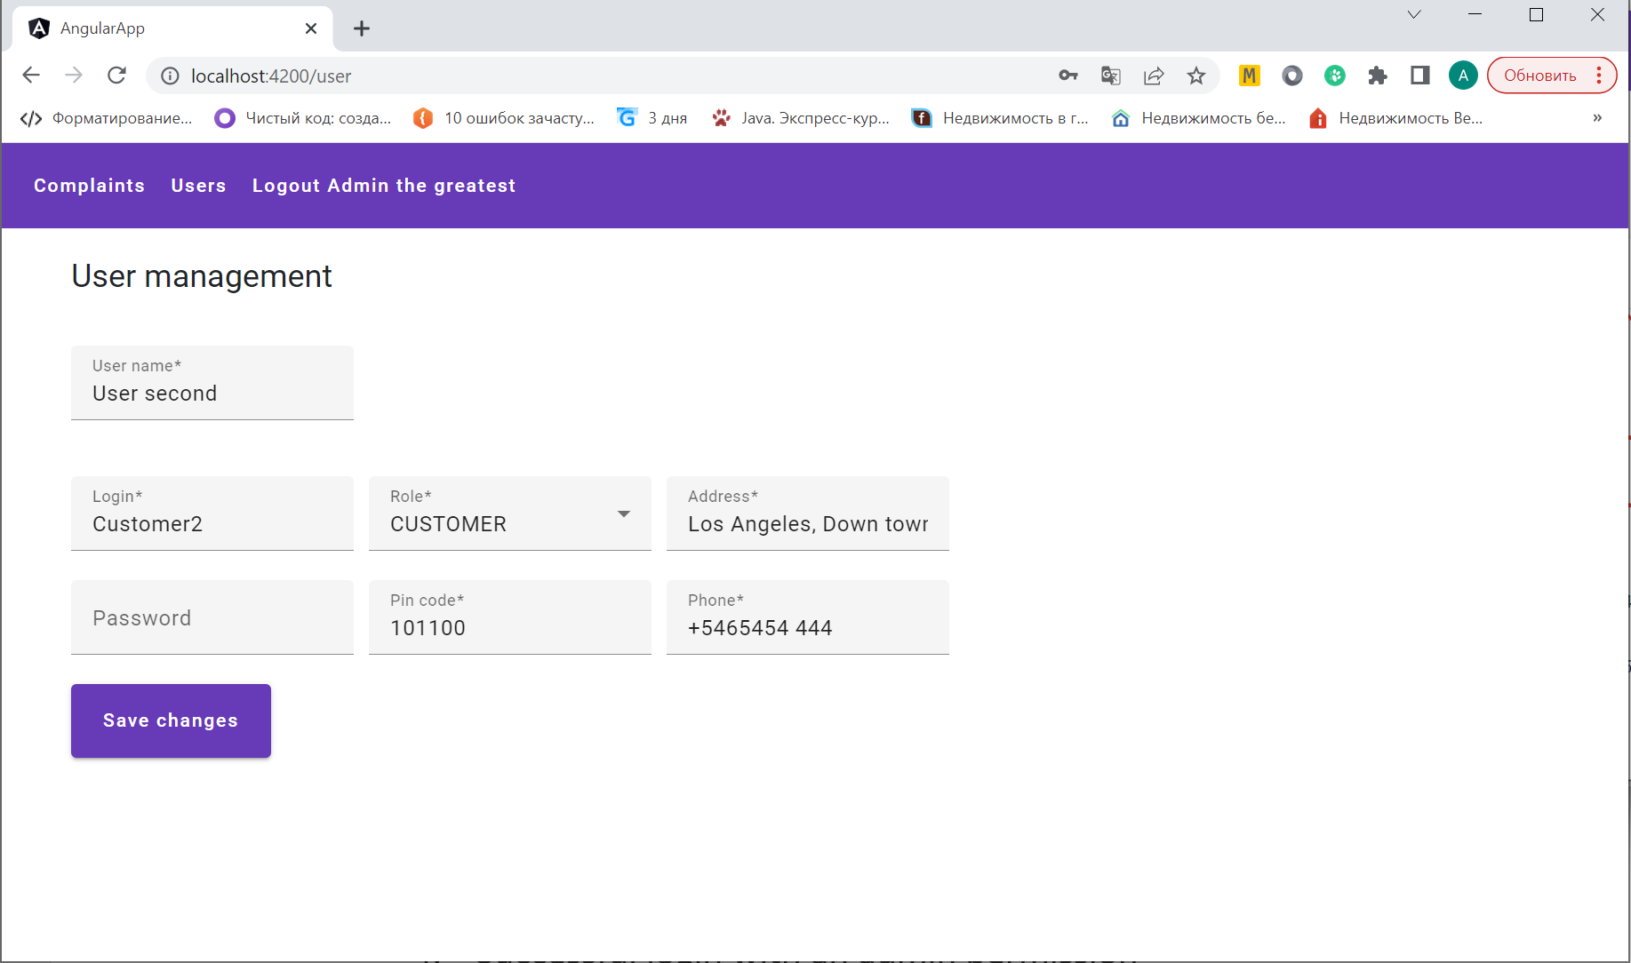

1. User with “Administrator” permissions also be able to create new user by click the button “New user”.

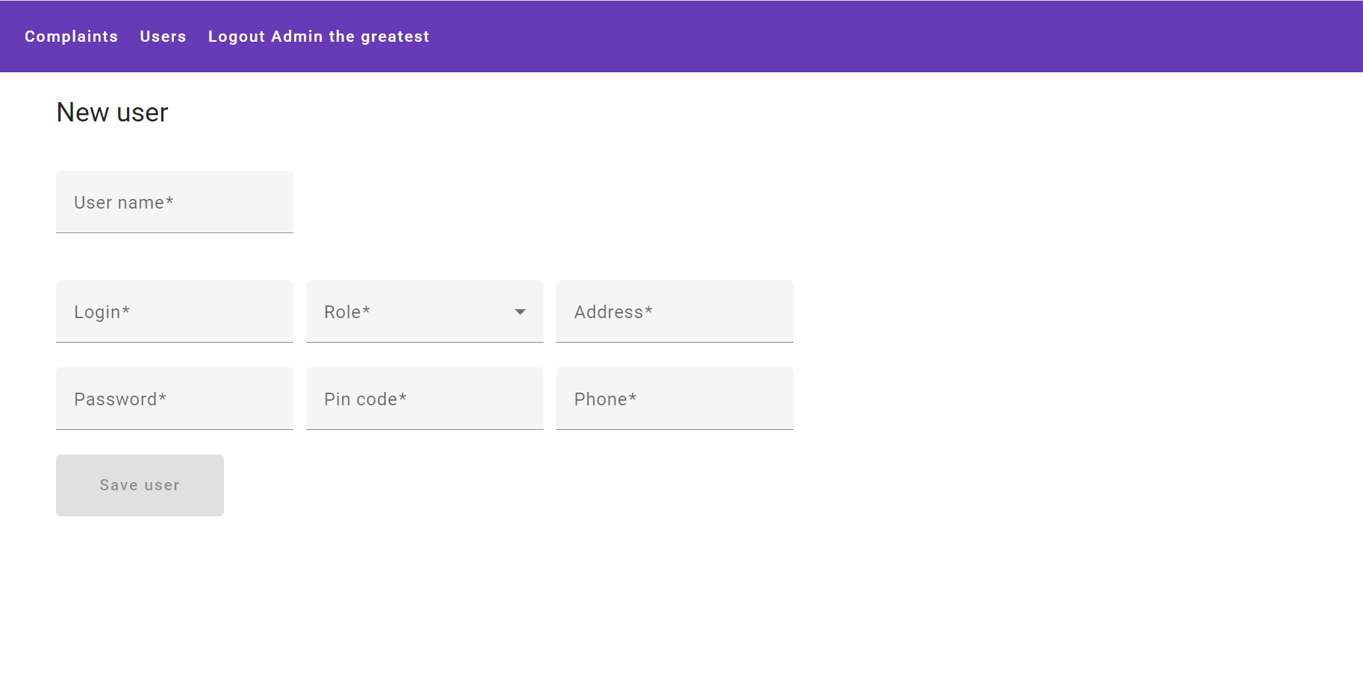

1. Also, users with “Administrator” permissions can see all complaints and change all details in every complaint.

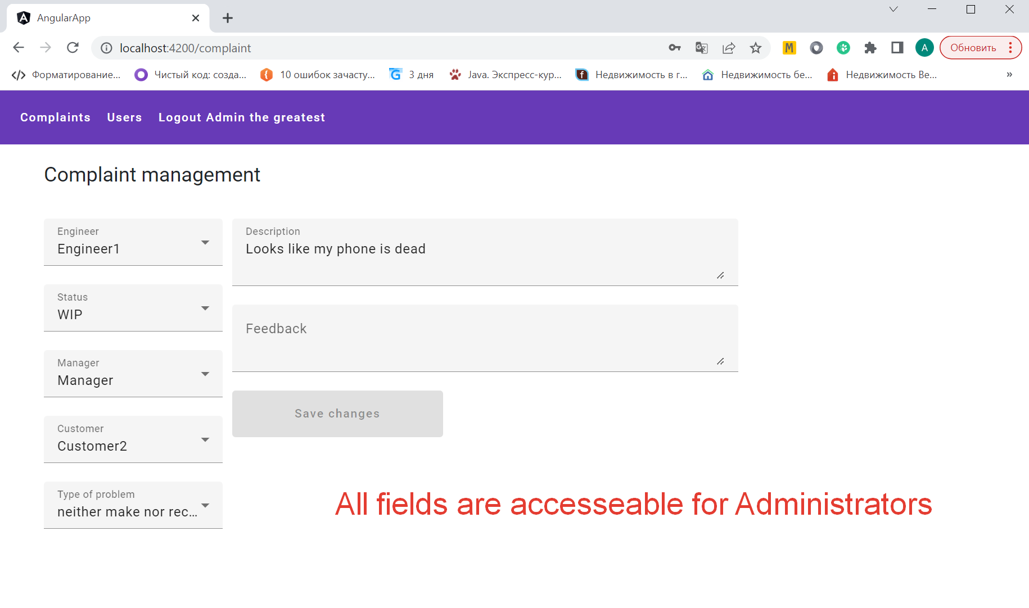

1. Users with permission “Customer” can see only its own complaints

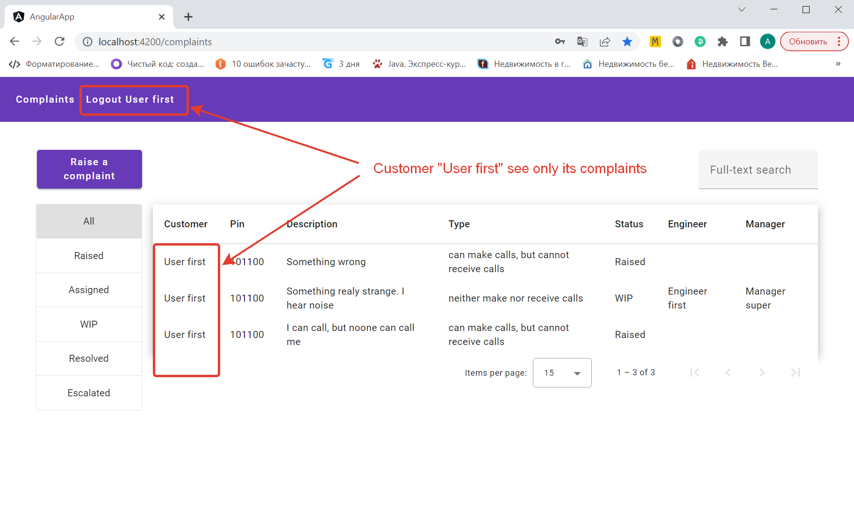

1. Users with permission “Customer” can write feedback into its complaints

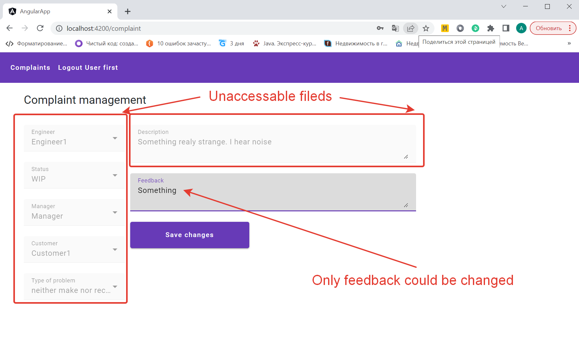

1. All users can raise new complaint.

1. Users with permission “Manager” can see all complaints and assign Engineer based on PinCode certain engineer and users who rise a complaint.

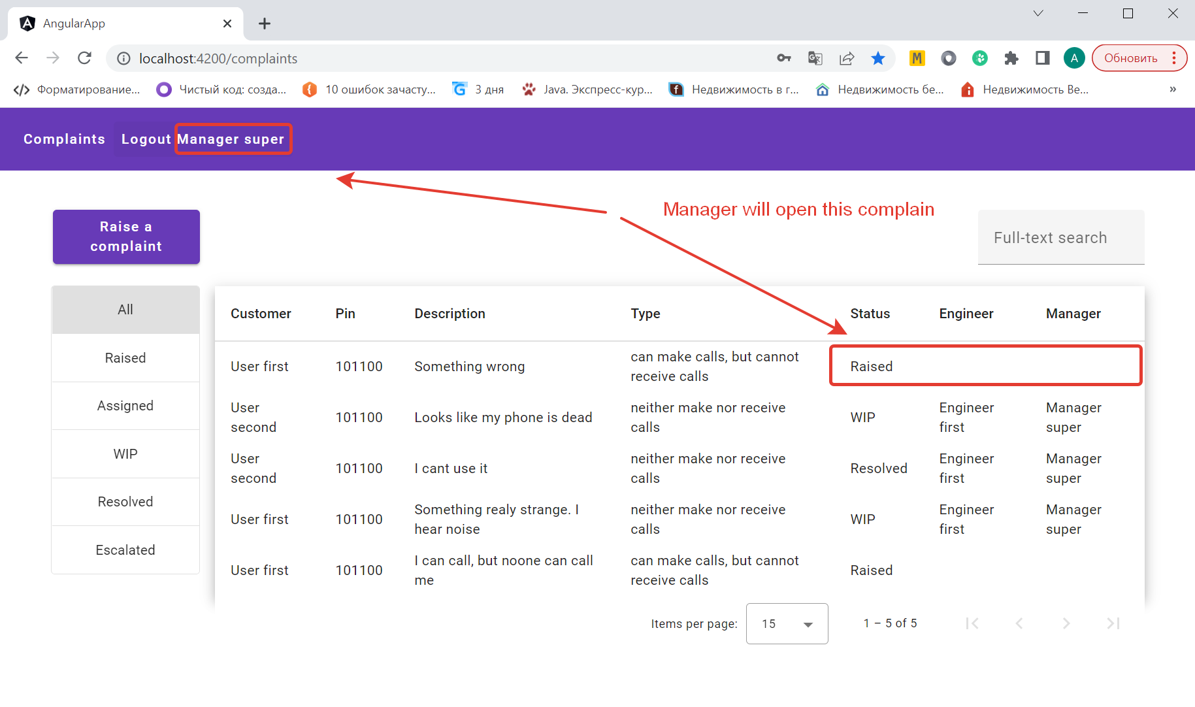

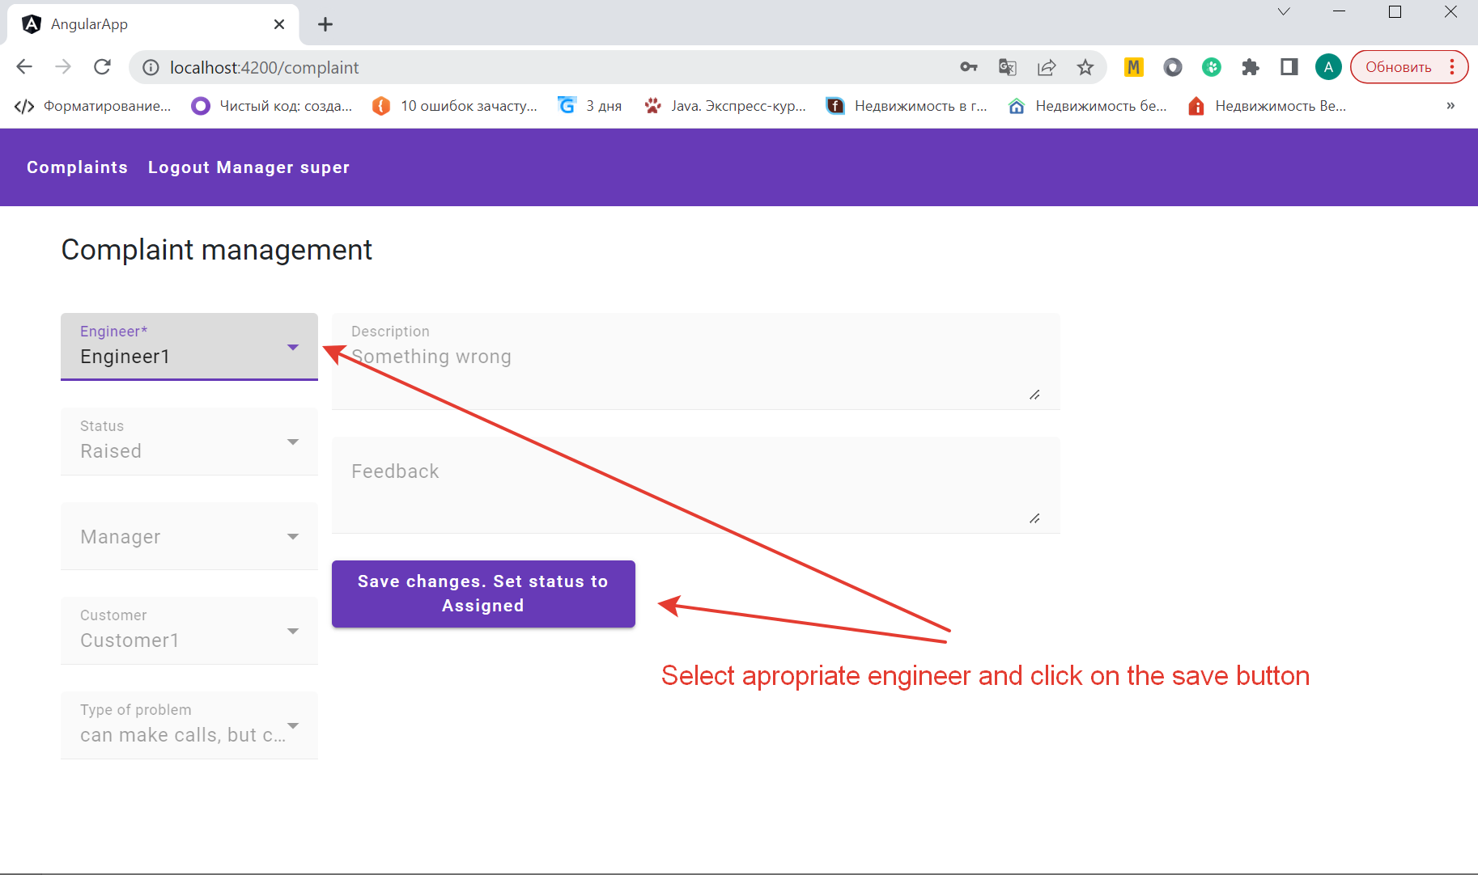

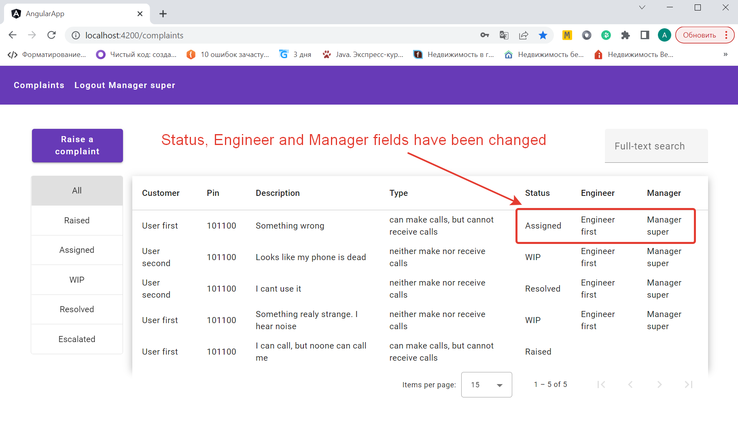

1. User with permission “Engineer” can see only its complaints

