oprating system and system orgogramming

Individual Assignment

Name – Haniya Gebeyehu

ID - 1601700

FreeBSD Operating system

Contents

0

1. Historical development of FreeBSD 2

2. MOTIVATION 3

3. OBJECTIVES 4

4. REQUIERNMENTS 4

a. HARDWARE REQUIRENMENTS 4

b. SOFTWARE REQUIRENMENTS 4

5.INSTALLATION STEPS 4

Step1: downloading and installing VMware workstation pro (the latest version release 17.6.3) 4

Step2:Getting an ISO 5

STEP 3: INSTALLING FREEBSD 14.1 INTO VMWARE WORKSTATION 17.6.3 6

STEP 4: EJECT VIRTUAL DISK 8

STEP 5: FIRST BOOT 9

STEP 6: BECOME ROOT USER 9

STEP 7: INSTALL XORG PACKAGE 10

STEP 8: ADD USER TO VIDEO GROUP 10

STEP 9: INSTALL VMWARE KERNEL MODULE 10

STEP 10: INSTALLING LIGHTDM LOGIN MANAGER 10

STEP 11: FIRST BOOT INTO LIGHTDM AND XFCE 11

STEP 12: DISPLAY RESLUTION CHANGE 12

5. ISSUES(PROBLEM) FACED 13

6. SOLUTIONS 14

7. FILESYSTEM SUPPORT 14

WHY? 15

8. ADVANTAGE AND DISADVANTAGE 15

9. CONCLUSION 16

10. FUTURE OUTLOOK/RECOMMENDATION 16

**Briefly explain the what, why and how virtualization in modern operating system** 17

**IMPLEMENT SYSTEMCALLS** 18

Step 1: 18

Step2: 18

step 3: 18

Step 4: 18

Step 5: 18

Step 6: 18

Step 7: 18

Step 8: 18

step 9: 19

# Historical development of FreeBSD

The UNIX operating system's progress and the academic advancements made at the University of California; Berkeley are linked to the historical development of FreeBSD. In order to standardize operating systems, Berkeley Software Distribution (BSD) offered a number of technologies, including the C shell, job control, and the TCP/IP networking stack. With time, BSD gained popularity as a UNIX substitute, particularly in academic and research institutions.   
  
BSDNet published 4.3BSD-Reno in 1989, followed by 4.4BSD/2 in 1991, which was a highly regarded and accepted version. However, 4.4BSD/2 has some UNIX and AT&T code. It does not have a license because of this problem. BSD started creating an open-source version in order to address this license issue. Following that, William and Lynne Jolitz built 386BSD, which was published in 1992 specifically designed for intel.

FreeBSD was born shortly after, in 1993, when a grouped of developers of 386BSD was come out and developed their own team due to limitations in development and lack of updates. The FreeBSD aimed to create a well-maintained operating system with robust. The very first release was FreeBSD 1.0, which is based on 4.3BSD-lite release from Computer System research Group (CSRG) at Berkely. To get the licensing the developers removed AT&T code which make it very acceptable, constraints-free and distributable.

Throughout the 1990s and early 2000s, FreeBSD had rapid improvement and growth. And each versions introduced new features like SMP (symmetric Multiprocessing) support, improved filesystem and networking capabilities. The release of FreeBSD 5.0 in 2023 marked a major milestone with new threading model and support for more advanced hardware.

Today, FreeBSD continues to be actively developed and supported by global community under effort of FreeBSD Core Team. The FreeBSD operating system is still highly influential in open-source ecosystem. And its code being reused by many other operating systems such as macOS, iOS and many more embedded systems.

The historical evolution of FreeBSD reflects the story of open-source software development upon collaboration, academic research and commitment to innovation and reliability. Its consistency shows its solid foundation on early developers and verity of community.

# MOTIVATION

FreeBSD's BSD license is one of its advantages. Distribution, use, and incorporation into commercial products are all permitted under this license. FreeBSD stands out from the competition thanks to this special feature. Both closed-source and open-source solutions based on FreeBSD have been encouraged by this licensing. Some of famous companies which uses FreeBSD are Netflix and Sony.

FreeBSD known for its performance, scalability and advanced networking capabilities. It has ZFS file system, virtualization, TCP/IP stack, documentation, providing extensive manuals for developers and for users.

The package management f FreeBSD is supported by two main methods which is used for flexibility and customization: the port collection and pkg system. The port collection allows users to compile application from sources. And the pkg system provides binary package management.

Additionally, FreeBSD is steadfast in its dedication to community-driven development and superior engineering. Developers and volunteers manage the project. The operating system gains from the bottom up in real-world scenarios because to this collaborative development method. The primary goals of FreeBSD are community involvement and quality.

# OBJECTIVES

* Installing FreeBSD on VMware Workstation
* Understand the installation process and system requirement
* Explore FreeBSD’s filesystem and virtualization support
* identify potential issues and solutions during installation

# REQUIERNMENTS

## HARDWARE REQUIRENMENTS

* Memory 16GB
* Processors 4 (number of processors is 2, number of core processor is 2 i.e. total 4 processors)
* Hard disk 40GB

## SOFTWARE REQUIRENMENTS

* FreeBSD ISO
* VMware Workstation player: installed on the host machine

# 5.INSTALLATION STEPS

## Step1: downloading and installing VMware workstation pro (the latest version release 17.6.3)

* Search for [www.vmware.com](http://www.vmware.com) on your favorite web browser
* If you don’t have an account hit the register button on the left.
* After registration, you will get the “my downloads” page which is empty.
* Then you will get lists, select VMware workstation pro
* select the workstation pro according to your OS (either Linux or windows). Select the latest release which is 17.6.3
* Then download VMware like this:

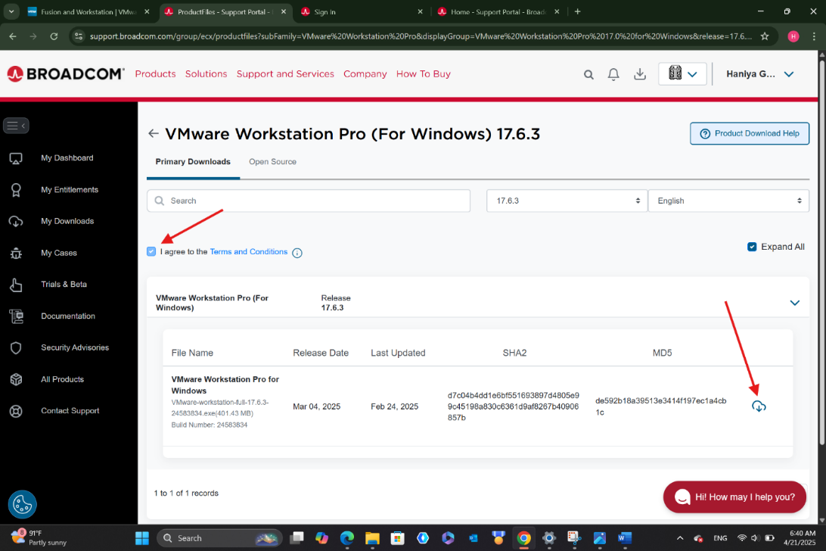

Step2: Getting an ISO for FreeBSD

* Browse [www.freebsd.org](http://www.freebsd.org) on your favorite browser
* press the download button and it will redirect to other page
* scroll down and under installer select “amd64”

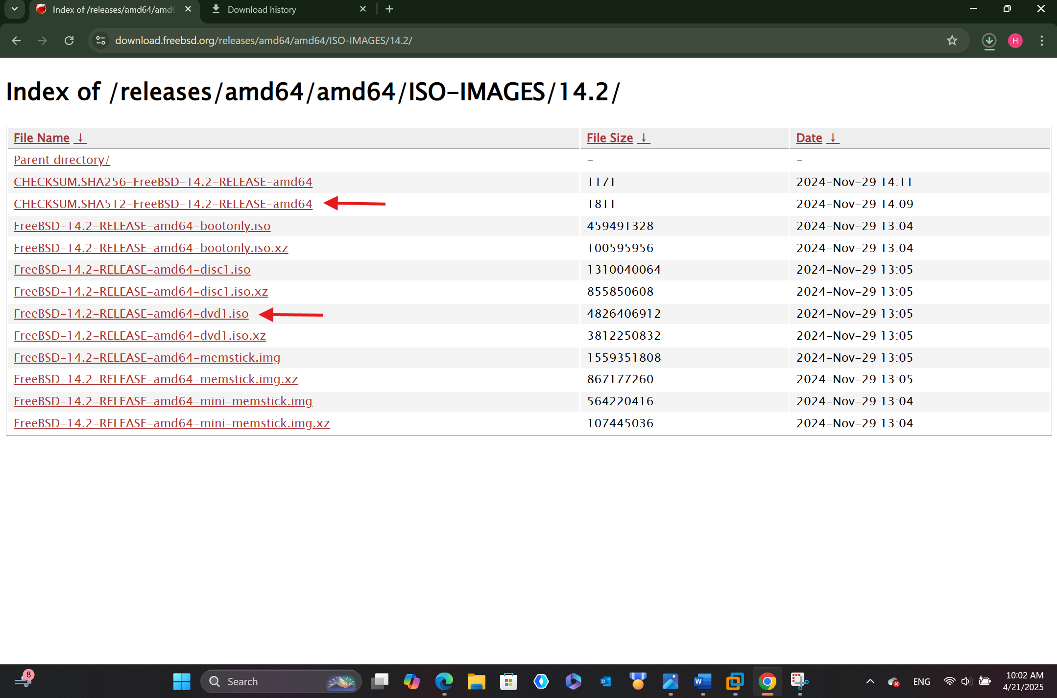

* meanwhile you downloading the Free BSD, open the CHECKSUM.SHA512 in the downloaded files.
* then copy the associated code for this SHA512 (FreeBSD-14.2-RELEASE-amd64-dvd1.iso)

## STEP 3: INSTALLING FREEBSD 14.1 INTO VMWARE WORKSTATION 17.6.3

* open a new file by just go to file ->new file or simply ctrl+N
* make it custom(advance) for special purpose we used later.
* set the guest operating system “other” and fil the version by “FreeBSD 14 64-bit”
* set the number of processer 2 and number of core processer 2, total 4 processors
* set the memory for the virtual machine 16384MB(16GB)
* make the network type bridged to give the guest operating system direct access to an external Ethernet network. The guest can have its own IP address on the external network.
* Set the I/O controller type “Para virtualized SCSI” to optimize for virtual machine.
* Make the virtual disk type SCSI
* Make the maximum disk size 40GB
* Split virtual disk into multiple files. Splitting the disk makes it easier to move the virtual machine to another computer but may reduce performance with very large disks.
* Go to CD/DVD(IDE) and check “use ISO image file”. Then insert the ISO file what you have downloaded earlier.
* Go to “Options” and make the firmware UEFI in advanced.
* Play the virtual machine
* Choose the optional system component to install: check kernel-dbg, ltb32, ports and src
* In ZFS configuration check VMware, VMware Virtual System
* After setting the all the above correctly, it will verify checksums of selected distribution and you will see the overall progress at the bottom by archiving extraction
* It will ask you to Enter a New Password. (Notice: for security purpose your password will not be shown at the screen, be careful on writing your password.)
* In this process we do not need to configure IPv6 for the interface

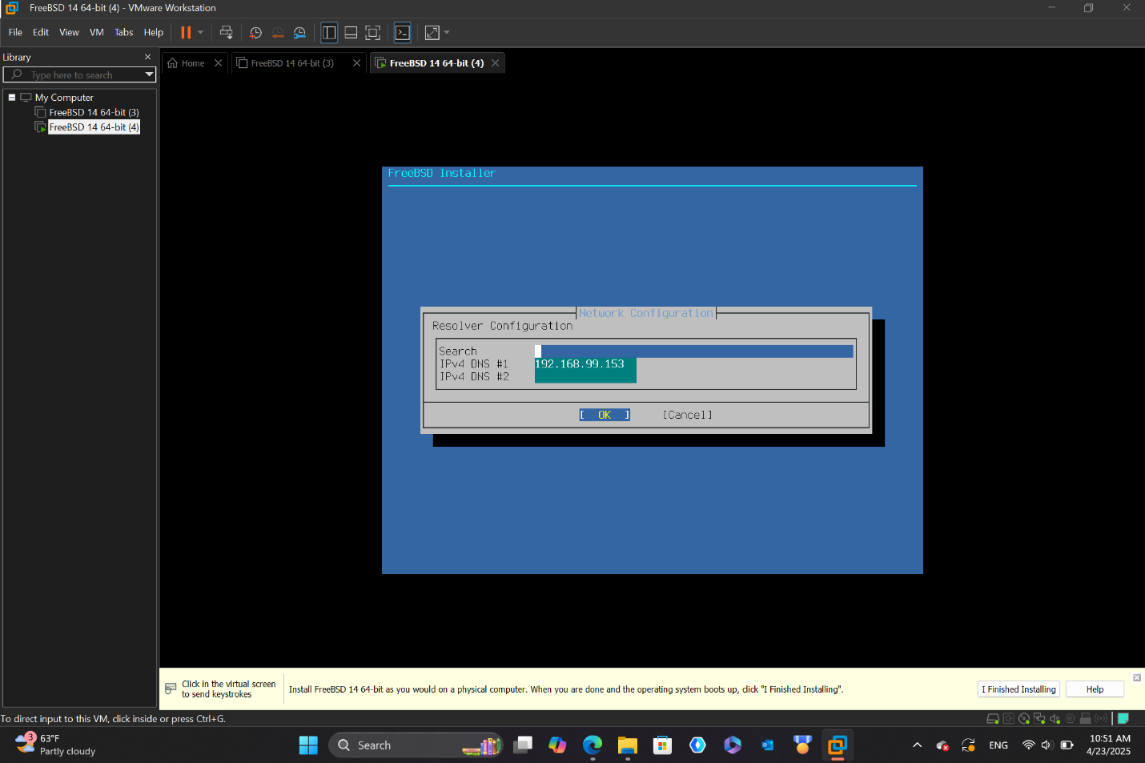

* Select your Continent and Country in Time Zone Selector
* You can set Time & Date at this stage or you can skip it for now.
* Check for ntpd, ntod_sync_on_start and dumpdev on System Configuration
* Enter your Username and Full name

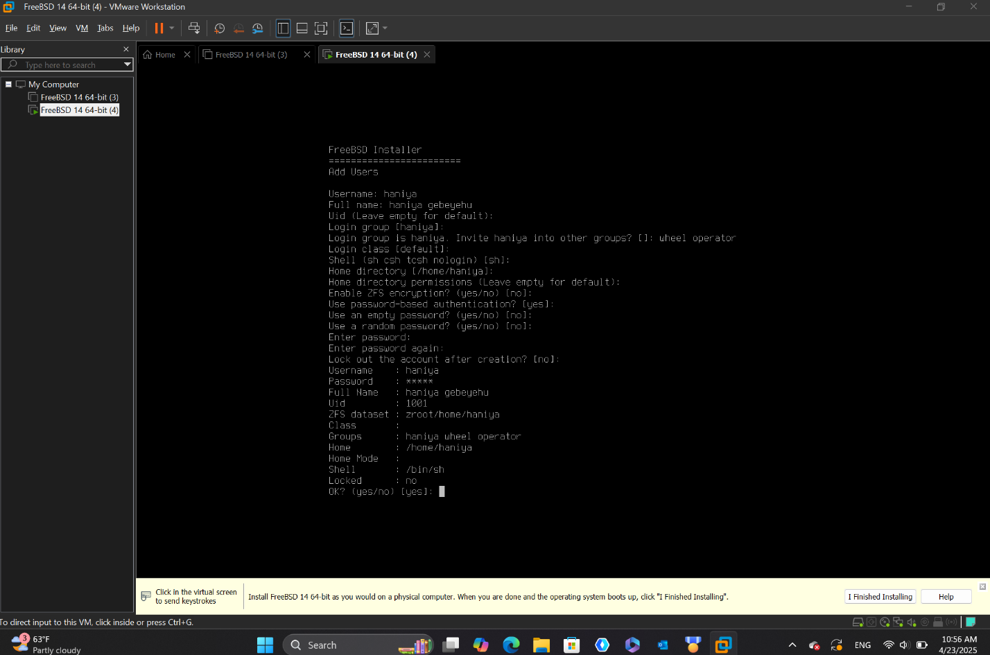

* Make FreeBSD Documentation Installation in English language which is recommended
* After setting correctly, it will asks you if you would like to reboot into installed system, choose “shutdown” from the alternatives.

## STEP 4: EJECT VIRTUAL DISK

* Go to the Setting and choose CD/DVD(SCSI) then Uncheck “connect at power on” option under Device states.

## STEP 5: FIRST BOOT

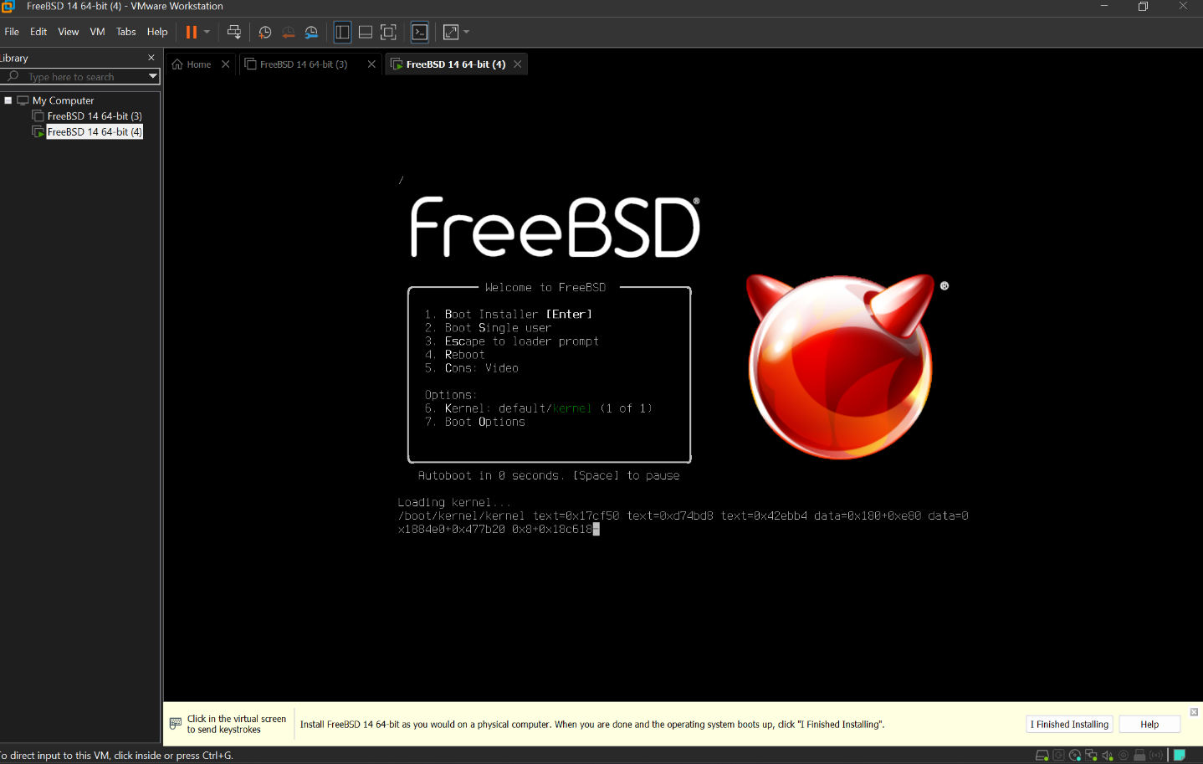

* Play the Guest Virtual Machine
* Login by your username
* Enter your Password
* Type this: example@freebsdpc: ~$ su - (Notice: “exmaple” is not the correct name, you have to replace it by your username, for example. haniya@freebsdpc: ~$ su
* “~” represents your home directory
* “$ “means you are not root, just a regural user.
* “su -” means switch to the root user and give me root’s full environment.

Therefore, it means you are using a regular user shell, not root.

## STEP 6: BECOME ROOT USER

* Enter your password
* Type root@freebsd: ~# pkg update
* We are commanding the system to fetch the latest list of available packages from FreeBSD package repository
* Type root@freebsd: ~# install xf86-video-vmware xf86-input-vmmouse open-vm-tools
* We are making our graphics, mouse and VM features work smoothly in FreeBSD running on VMware Workstation Pro
* Type root@freebsdpc: ~# pkg install nano
* Used to install the Nano text editor in your FreeBSD system running on the VMware virtual machine.

## STEP 7: INSTALL XORG PACKAGE

* Type root@freebsdpc: ~# pkg install xorg
* Used to install X. Org Server, which is the graphical system like the foundation for GUIs in FreeBSD

## STEP 8: ADD USER TO VIDEO GROUP

* Type root@freebasdpc: ~# pw groupmod video -m example (“example” is not the correct word, you have to write your username. E.g. Haniya)
* Adding username to the video group

* Type root@freebsdpc: ~# nano /boot/loader .conf
* We are using the Nano text editor to open and edit the file located at “/boot/loader.conf”

## STEP 9: INSTALL VMWARE KERNEL MODULE

* Type root@freebsdpc: ~ # sysrc kld_list+=vmwgfx

We are enablimg the “vmwgfx” kernel module to the list

* Type root@freebsdpc: ~ # pkg install xfce

We are using the pkg package manager to install the “xfce”

* Type root@freebsdpc: ~#nano /etc/fsta

This file contains information about the system’s file system such as hard drives and partitions.

## STEP 10: INSTALLING LIGHTDM LOGIN MANAGER

* Type root@freebsdpc: ~# pkg install lightdm lightdm-gtk-greeter
* Here, we are installing two packages. “lightdm” and “lightdm-gtk-greeter”. The “lightdm” is a displaying manager and “lightdm-gtk-greeter ” gives graphical interface for the login screen
* Type root@freebsdpc: ~ # sysrc lightdm_enable=”YES”
* This command tells the system’s startup sctipts to enable and start the “lightdm” authomatically when everytime the computer boots up.
* Type root@freebsdpc: ~# shutdown -r now
* We are shutting down by using shutdown command and -r, which means reboot happens authomatically and immediately after shutting down.

## STEP 11: FIRST BOOT INTO LIGHTDM AND XFCE

* In this stage, the log in page will appear. Enter your username and password.

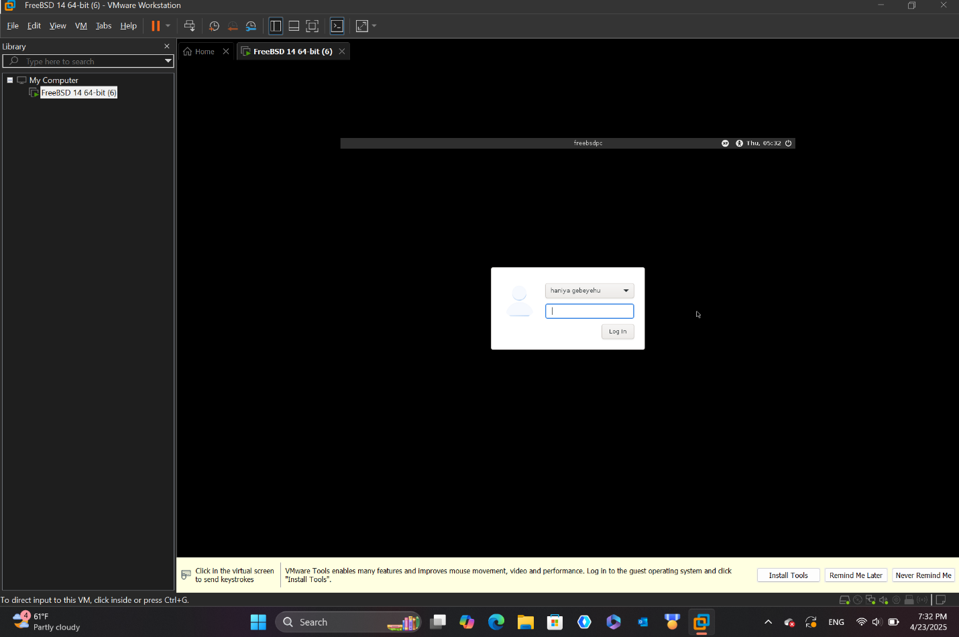

* After the login page you will get into your virtual FreeBSD OS

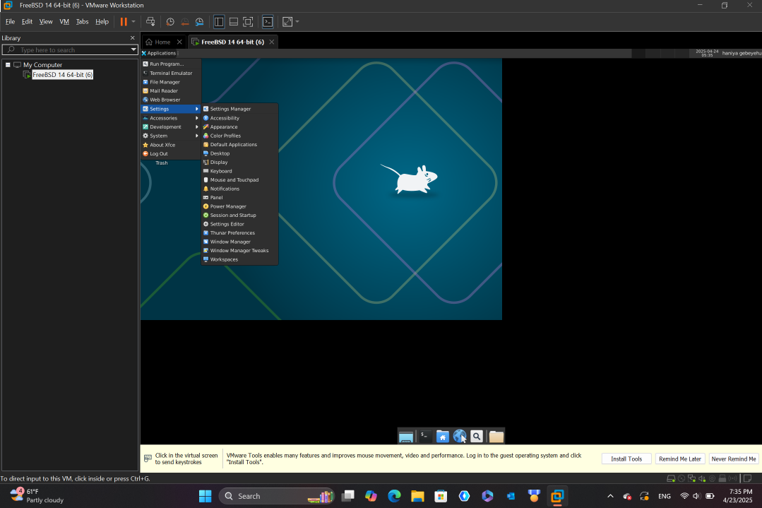

# STEP 12: DISPLAY RESLUTION CHANGE

* As we all see, the page is not fit to our screen. To resolve this, go to Setting -> Display -> set the resolution1920 x 1080

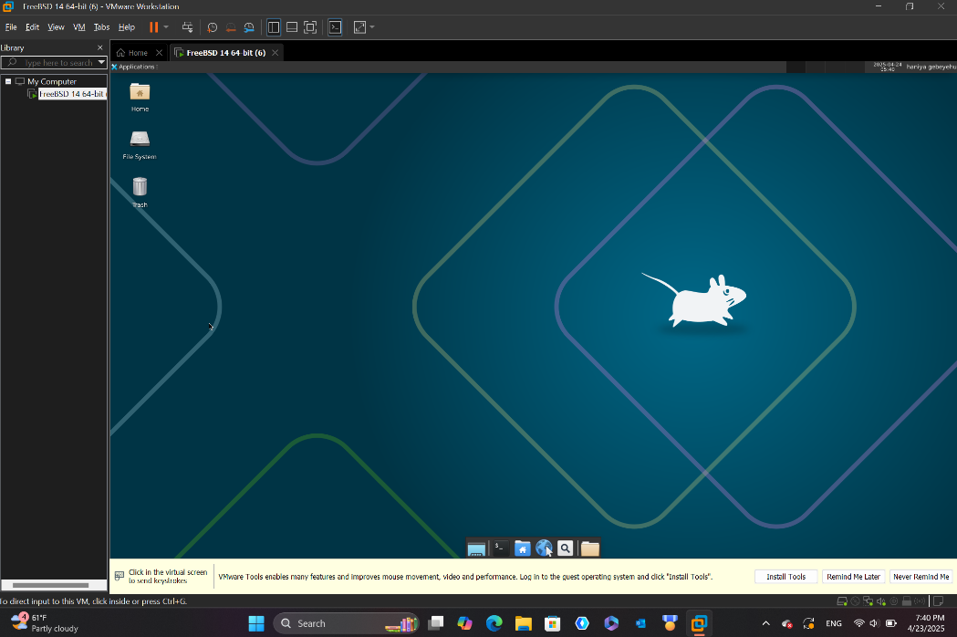

# ISSUES(PROBLEM) FACED

When I am installing and booting FreeBSD OS on VMware workstation pro I have face a problem of not displaying the log in page. it was very critical and I could not pass to the virtual machine environment.

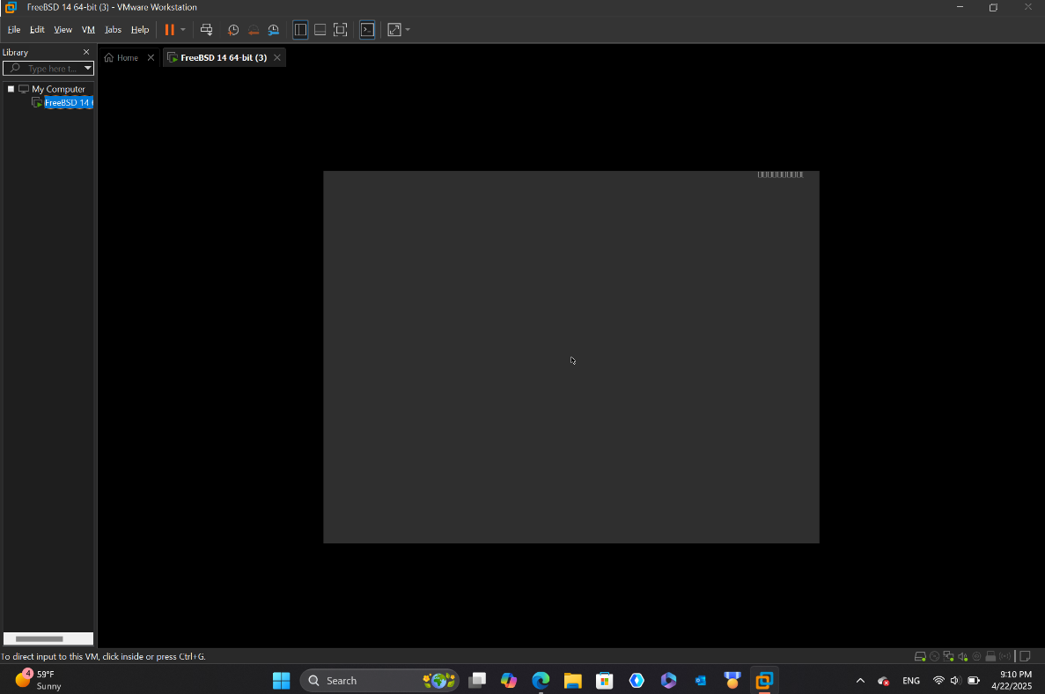

# SOLUTIONS

I solve the problem by correcting the I/O controller type into Para Virtualized SCSI. I researched a lot about it and I get Para Virtualized SCSI is very beneficial for FreeBSD. Here is why:

* It has faster Disk performance: higher throughput and lower latency compared to others.
* Lower CPU overhead: other virtual hardware use more CPU but it is not
* Better for Scalability: it supports more virtual disks and better performance under load and useful in servers or development environment

# FILESYSTEM SUPPORT

Which file system does FreeBSD support?

|  |  |  |  |  |
| --- | --- | --- | --- | --- |
| File system | FreeBSD support | Read | Write | Why/Notes |
| UFS(FFS) | Yes | yes | yes | FreeBSD’s native file |
| ZFS | yes | yes | yes | Fully supported also FreeBSD is major supporter of ZFS |
| NTFS | Partial | yes | partial | Via ntfs or fusefsntfs: which can read but write is not always safe |
| FAT32 | yes | yes | yes | Fully supported |
| exFAT | yes | yes | yes | Supported via fusefs-exfat |
| EXT2/EXT3/EXT4 | partial | yes | yes | Ext2fs can read and write, Ext2 partial and Ext4 no |
| Btrfs | No | no | no | Not supported |
| HFS+ | Read-only | yes | no | Read only |
| APFS | no | no | no | Not suppotred |

## WHY?

* FreeBSD originally supported UFS and ZFS because they are desig=ned for BSD/UNIX systems
* FAT32 and exFAT are supported because they are simple and more common
* NTFS and EXT4 supported partially because they belongs to windows and Linux
* HFS+ and APFS are not supported because they are not well deocumented which is in the way suitable for FreeBSD

# ADVANTAGE AND DISADVANTAGE

**Advantages:**

* Resource Efficiency: it enables up to run multiple operating systems without changing our original operating g system just in virtual.
* Easy testing and development: we can test new operating systems without incorporating it to our native OS
* Isolation: each virtual machine OS can run in their own ecosystem. Without crushing one to another.
* Backup: we can take snapshot before making any changes. And then we can eaily revert if there is wrong.
* Flexibility: it enables us using one computer for everything

**Disadvantages:**

* **Performance overhead:** virtual machines are slower in running compared to the real hardware
* **Needs more RAM and CPU:** we should have a powerful computer to run multiple virtual machines side by side.
* **Hardware access is limited:** some hardware systems may not work properly as needed.
* **Complex for Beginners:** setting networks, shared folder and drivers may be confusing at the first

# CONCLUSION

In conclusion, the process of installing and exploring FreeBSD within VMware workstation pro gives a practical benefit of virtualization. Throughout the process we addressed the key hardware and software requirements from downloading the ISO image to setting up the VM using para-virtualized SCSI for improved disk I/O. we have identified the supported and unsupported filesystems. Additionally, we explore the advantage and disadvantage of virtualization.

Despite the problem faced as a beginner, this journey gives valuable understanding of operating system installation, virtualization and file systems.

# FUTURE OUTLOOK/RECOMMENDATION

As virtualization technologies continues to grow and enhance, FreeBSD’s role in virtual ecosystem is expected to grow especially in server deployment, security research and operating system development.

* The further benefits from FreeBSD in a virtualized ecosystem:
* Deepen understanding of system calls
* Explore virtual networking
* Practice filesystem management
* Use snapshots for experimentation
* Stay updated with FreeBSD community
* Use lightweight Desktop Environments

# **Briefly explain the what, why and how virtualization in modern operating system**

**What is virtualization?**

Virtualization is the process of creating virtual versions of physical components, such as operating system, servers, storage devices and networks. It enables one computer to run multiple operating systems at the same time simply by virtualization without incorporating to the original operating system.

**Why Virtualization?**

* **Resource efficiency :** it maximizes the use of RAM, CPU and storage
* **Cost saving:** Reduces the use of physical machine. One computer for everything.
* **Testing and development:** we can test new system without damaging our main Operating System
* **Isolation:**  one operating system will not crush and interfere with others.
* **Flexibility:** run operating system in single machine

**How does virtualization work?**

here is brief way of explanation:

* a hypervisor (VMware, VirtualBox, oracle…) are bridge between hardware and the virtual machine
* the hypervisor allocated resources like RAM, CPU, storage and so on.
* Each virtual machine independently run neither interfering with the main operating system nor crushing with other virtual machines.

# **IMPLEMENT SYSTEMCALLS**

## Tools Used

-- GCC or Clang compiler (comes with FreeBSD)  
- Terminal (Shell) for compiling and executing the program

## Code Summary

The program starts by printing the parent process ID. It then creates three child processes using the fork () system call. For the first and third children, it explicitly sets their process group IDs using setpgid() to make them group leaders. It prints out the PID, PPID and the process group ID of each child and parent to demonstrate how they are related. The parent process waits for the second and third process to finish execution using waitpid (). Each child process exits after a sleep delay to simulate some processing time.

## Key System Calls

* The following system calls are demonstrated:
* fork(): Creates a new child process.
* getpid(): Retrieves the current process ID.
* getppid(): Retrieves the parent process ID.
* setpgid(): Sets the process group ID.
* getpgrp(): Gets the current process group ID.
* waitpid(): Waits for a specific child to terminate.
* perror(): Outputs error messages when system calls fail.
* sleep(): Pauses execution temporarily.
* exit(): Terminates the process cleanly.

## How to Compile and Run

To compile and run the program on FreeBSD, use the following terminal commands:  
  
cc -o syscall syscall.c  
./syscall

## Sample Output

Parent process PID: 1234  
First child PID: 1235, Parent PID: 1234  
First child’s process group ID: 1235  
Third child PID: 1237, Parent PID: 1234  
Third child’s process group ID: 1237  
  
Parent process group ID: 1234  
All child processes have completed.