Supplementary Material

Comprehensive investigation of pathway enrichment methods for functional interpretation of LC-MS global metabolomics data

¹Yao Lu, ²Zhiqiang Pang, and ^{1,2*}Jianguo Xia

¹Department of Microbiology and Immunology, McGill University, Quebec, Canada
²Institute of Parasitology, McGill University, Quebec, Canada.

*To whom correspondence should be addressed:
Tel: 1-514-398-8668
Email: jeff.xia@mcgill.ca

Table S1: Review of the enrichment tools

Software | Version | Year | Key method | Platform | Peak annotation | Input | Output | Website | Ref
IMPaLA | 13 | 2021 | Fisher’s exact test;Wilcoxon test | web | N | Metabolite list | Table of Enriched pathways ranked by significance | http://impala.molgen.mpg.de/ | [1]
MBRole | 2 | 2016 | Fisher’s exact test | web | N | Metabolite list |  | https://csbg.cnb.csic.es/mbrole2/analysis.php | [2]
MetaboAnalyst | 5 | 2021 | Fisher’s exact test; | web;R package | N | Ranking peak list/Peak abundance table |  | https://www.metaboanalyst.ca/ | [3]
 |  |  | GSEA |  | Y
 |  |  | Mummichog |  | Y
Metabox |  | 2017 | Hypergeometric test | R-based web applications | N | Metabolite abundance table |  | http://kwanjeeraw.github.io/metabox/ | [4]
MetExplore | 2.13.0 | 2018 | Fisher’s exact test; | web | N | Metabolite list |  | https://metexplore.toulouse.inrae.fr/index.html/ | [5]
PathVisio | 3 | 2015 | Z-score | web | N | Ranking metabolite list |  | https://pathvisio.org/ | [6]
XCMS | 3.5.1 | 2016 | Mummichog | web | Y | Ranking peak list |  | https://xcmsonline.scripps.edu/landing_page.php?pgcontent=institute | [7]
ConsensusPathDB | 35 | 2022 | Fisher’s exact test | web | N | Metabolite list |  | http://cpdb.molgen.mpg.de/CPDB | [8]
PAPi | 1.22.1. | 2019 | AS score | R package | N | Metabolite abundance table |  | https://rdrr.io/bioc/PAPi/ | [9]
PALS |  | 2021 | PLAGE | Python | N | Metabolite abundance table |  | https://pals.glasgowcompbio.org/ | [10]
PUMA |  | 2021 | Inference and approximates posteriors using Gibbs Sampling | Python | Y | Peak list with putative annotated information; Pathway sets |  | https://github.com/HassounLab/PUMA | [11]
metPath | 0.0.1 | 2020 | Fisher’s exact test; | R package | N | Metabolite list |  | https://metpath.tidymass.org/ | [12]
FELLA |  | 2018 | Hypergeometric test;Heat diffusion scores;PageRank score | Web;R package | N | Metabolite list |  | https://github.com/b2slab/FELLA | [13]
RaMP | 2 | 2022 | Fisher’s exact test | R package | N | Metabolite list |  | https://rampdb.nih.gov/ | [14]
Lilikoi | 2 | 2022 | Pathifier algorithm | R package | N | Metabolite abundance table |  | https://github.com/lanagarmire/lilikoi | [15]
tmod | 0.46.2 | 2020 | Hypergeometric test;Mann-Whitney test;CERNO test |  | N | Metabolite abundance table |  | https://github.com/january3/tmod/ | [16]
MetENP | 0.0.0.9000 | 2020 | Hypergeometric test; | R package | N | Metabolite abundance table |  | https://github.com/metabolomicsworkbench/MetENP | [17]
OmicsNet | 2 | 2022 | Fisher’s exact test | web;R package | Y | Peak list |  | https://www.omicsnet.ca/OmicsNet/home.xhtml | [18]
* Most of the tools also provide network-based visualization in different formats, which is not the focus in our study.

Table S2: Tested scenarios in simulation study

Scenario | Variable | Condition changed in evaluation
 |  | Magnitude of change | Direction of change | Percentage of change | ppm | Annotation percentage | Significant feature selection | Ranking metric | Annotation method
1 | Magnitude of change | 0.5 | up | 80% | 3 | depending on annotation | 10% | p.value | AMRT-based annotation
2 |  | 1
3 |  | 2
4 |  | 5
5 |  | 10
6 | Direction of change | 2 | up
7 |  |  | down
8 |  |  | both
9 | Percentage of change |  | up | 30%
10 |  |  |  | 50%
11 |  |  |  | 80%
12 |  |  |  | 100%
13 | ppm |  |  | 80% | 1
14 |  |  |  |  | 3
15 |  |  |  |  | 5
16 |  |  |  |  | 10
17 |  |  |  |  | 12
21 | Annotation percentage |  |  |  | 3 | 10%
22 |  |  |  |  |  | 20%
23 |  |  |  |  |  | 40%
24 |  |  |  |  |  | 60%
25 |  |  |  |  |  | 80%
26 |  |  |  |  |  | 100%
27 | Significant feature selection |  |  |  |  | depending on annotation | 15%
28 |  |  |  |  |  |  | 10%
29 |  |  |  |  |  |  | 15%
30 | Ranking metric |  |  |  |  |  | 10% | p.value
31 |  |  |  |  |  |  |  | t.score
32 |  |  |  |  |  |  |  | fold change
33 |  |  |  |  |  |  |  | |t.score|
34 |  |  |  |  |  |  |  | |fold change|
35 | Annotation method | N/A |  |  |  |  |  | p.value | AM-based annotation
36 |  |  |  |  |  |  |  |  | AMRT-based annotation
37 |  |  |  |  |  |  |  |  | prior annotation by NetID

Table S3: Three initial datasets for simulation

Datasets | Study type | Chromatogram | MS Platform | Sample Size | Feature size | Ref
1 | Immune cell | UPLC | Orbitrap-Velos mass spectrometer | 18 | 6318 | [19]
2 | Malaria | UPLC- HILIC | High Field Q-Exactive mass spectrometer | 12 | 5113 | [20]
3 | COVID-19 | UPLC- HILIC | Quadrupole time-of flight mass spectrometer | 59 | 9671 | [21]

Table S4: Eleven COVID-19 datasets

Datasets | Chromatogram | MS Platform | Sample Types | Sample Size | Feature size | REF
BR | UPLC | Q-TOF | Serum | 28 | 1043 | [22]
CN | UPLC-C18 | Triple TOF | Serum | 76 | 1358 | [23]
UK1 | UPLC-HILIC | Q-TOF | Serum | 312 | 9391 | [24]
UK2 | UPLC-C18 | Q-TOF | Serum | 132 | 12261 | [24]
US1 | HPLC | TSQ Quantiva Triple Quadrupole | Plasma | 144 | 8468 | [25]
US2 | UPLC-pHILIC | Q-TOF | Plasma | 700 | 2659 | [26]
US3 | HPLC- C18 | CyTOF | Plasma | 102 | 2311 | [27]
US4 | UPLC-HILIC | Q-Exactive HF-X | Plasma | 80 | 7696 | [28]
US5 | UPLC | Q-Exactive | Plasma | 49 | 2266 | [29]
US6 | UPLC-HILIC | Q-TOF | Plasma | 59 | 3488 | [21]
US7 | UPLC-C18 | Q-TOF | Plasma | 59 | 9671 | [21]

Table S5: Eight IBD datasets

Datasets | Chromatogram | MS Platform | Sample Types | Sample Size | Feature size | REF
POS1 | LC-RP | Exactive Plus Orbitrap | Stool | 42 | 2177 | [30]
POS2 | LC-HILIC | Q Exactive Orbitrap | Stool | 42 | 1856 | [30]
POS3 | LC-RP | Exactive Plus Orbitrap | Stool | 42 | 2439 | [30]
POS4 | LC-HILIC | Q Exactive Orbitrap | Stool | 42 | 2376 | [30]
NEG1 | LC-RP | Q Exactive Orbitrap | Stool | 102 | 2177 | [30]
NEG2 | LC-HILIC | Q Exactive Orbitrap | Stool | 102 | 1856 | [30]
NEG3 | LC-RP | Q Exactive Orbitrap | Stool | 102 | 2439 | [30]
NEG4 | LC-HILIC | Q Exactive Orbitrap | Stool | 102 | 2376 | [30]

Supplementary Figure

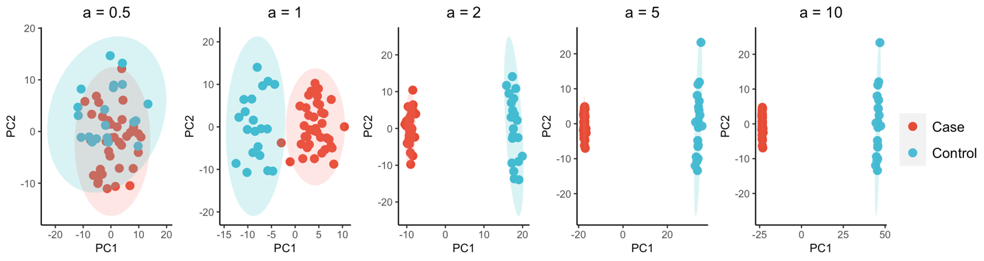

Figure S1: PCA plots indicate the differences between the case and control groups in simulated datasets increasing along with the magnitude of changes at the compound level, representing by the index a;

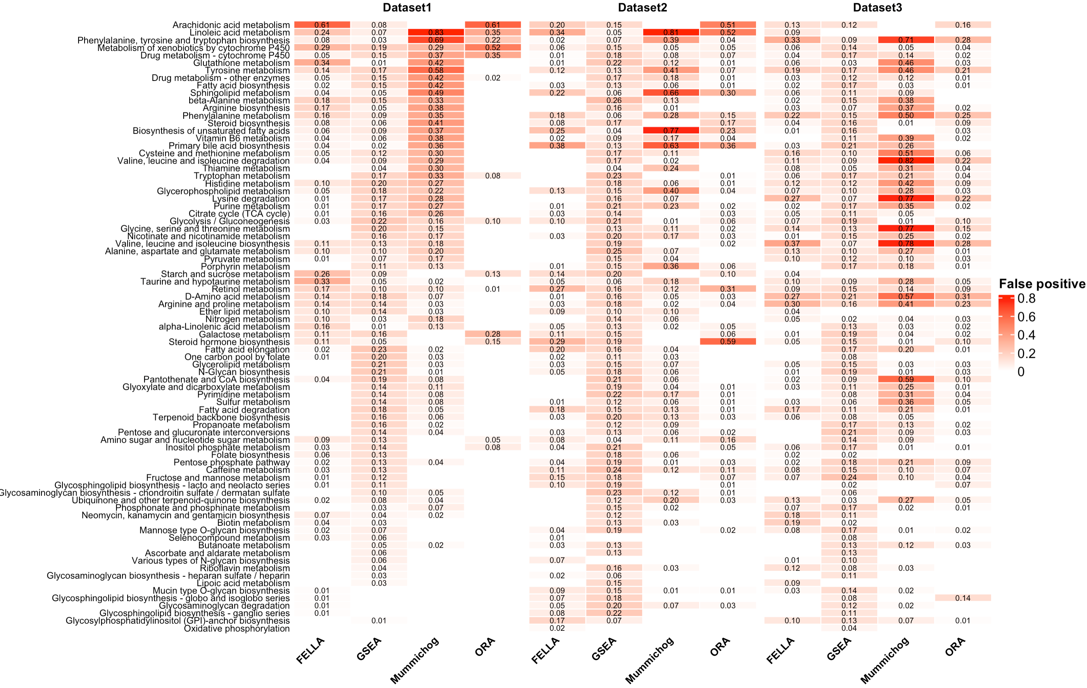

Figure S2: Potential distribution of false positive pathways in real datasets.
A

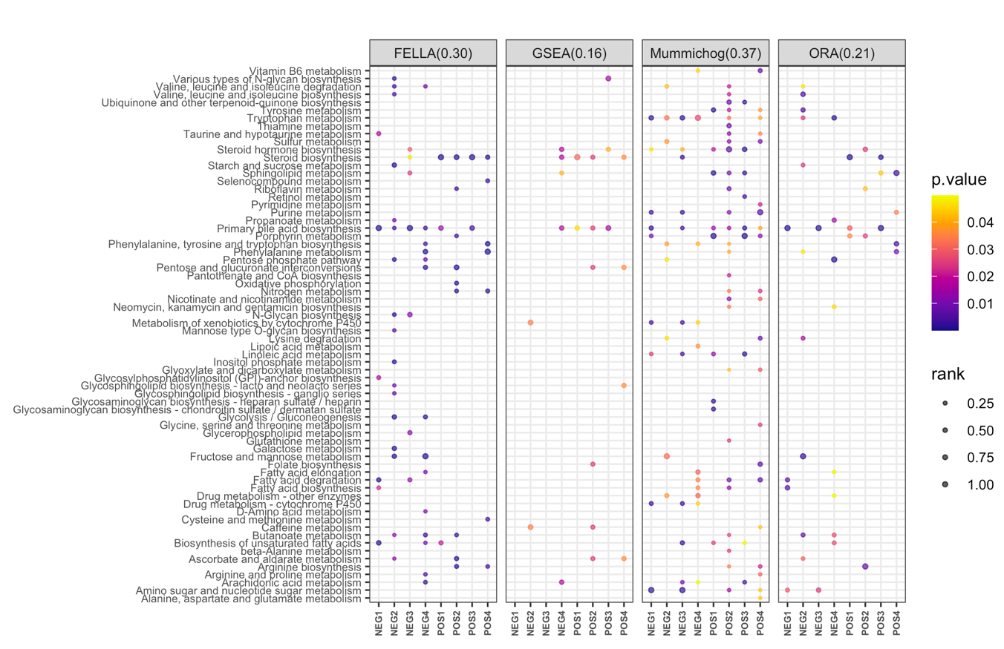
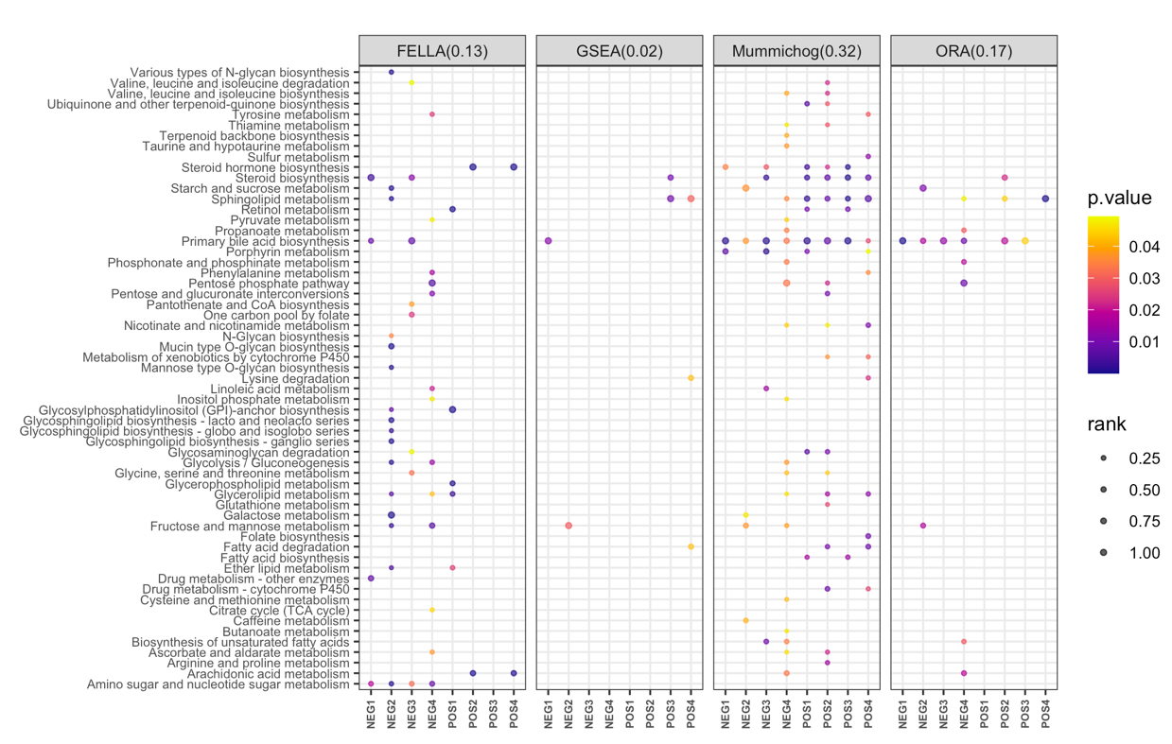
A
B
Figure S3: Consistency of enrichment results obtained using different enrichment methods from eight IBD datasets. For each method, its consistency score is indicated at the top inside the round brackets. (A) Results generated using peak list as input; (B) Results generated using the semi-annotated metabolite/peak list as input.

Text S1: Enrichment methods

In this section, we briefly describe the equations for p-value assessment of the evaluated methods listed in Table 1. More detail on the algorithms can be found in the original paper.

ORA

ORA methods, also known as 2x2 table methods[31], divide the metabolites based on whether they belong to differential metabolites (DE) and whether they are members of a particular pathway M containing x metabolites m₁, m₂, …, m_{x}. The main idea is to determine if there was a higher overlap between DE and M than expected by chance. The classical way to calculate the p-value for pathway M is using the Hypergeometric test (same as the right-tailed Fisher’s exact test based on the hypergeometric distribution). Thus, the probability that at least k metabolites in DE belong to pathway M is observed by chance is defined by (1):

$P\left(X≥k \right)=1-\sum_{i=1}^{k-1}{\left(\frac{\left({x \atop i}\right)\left({N \atop n-i}\right) }{\left({N \atop n}\right)}\right)}$ (1)

where N denotes the size of the background set, and n gives the number of DE.

Mummichog

Mummichog enhances the p-value assessment of ORA by employing the NULL model by Berriz et al.[32], which estimates an adjusted p-value from the results of 1000 simulated null hypothesis queries. Instead of using empirical p-value, mummichog models the p-values from null distribution as a Gamma distribution based on the maximum likelihood estimation and calculates the cumulative distribution function (CDF). In addition, EASE[33], a more conservative version of ORA, was applied to increase the accuracy, which can penalize pathways with fewer hits by taking out one hit from each pathway. The final pathway significance is accessed by both the EASE score ($S_{EASE}$) and CDF given by (2).

$P_{adj}=1- G(x,a)=1- \frac{1}{Γ(a)}\int_{0}^{x}{t^{a-1}}e^{-t}dt$ (2)

where x indicates the influence of the raw p-value calculated by ($1-S_{EASE}$). $a$ is defined by $P_{perm }\sim gamma(α,θ)$, where $P_{perm }$gives the empirical p-value in each permutation.

GSEA
GSEA is a typical implementation of functional class scoring (FCS) methods that widely used in multiple fields. It can be achieved in three steps. First, values from all the measurements are used to form a decreasing ranked list, $L= \left\{m_{1}, …, m_{l}\right\}$, based on the differential statistics of the individual features de(i) between different experimental conditions. The enrichment score for each pathway is calculated as the largest difference in a running-sum statistic corresponding to a weighted Kolmogorov–Smirnov-like statistic given by:

${ES}_{M}= \max_{1≤r≤T}{(F_{m_{k}}\left(r\right)-F_{{\hat{m}}_{k}}\left(r\right))}$ (3)

Where index r represents the position of the metabolite in the metabolites rank list. Metabolites in or out of the pathway M are signified as m and $\hat{m}$. F is the empirical cumulative distribution functions defined as:

$F_{m_{k}}\left(r\right)= \sum_{\begin{aligned}i ∈ M \\ r\left(i\right)<r\end{aligned}}{\frac{|de(i)|^{p}}{\sum_{ ϵ M}{|de(i)|^{p}}}}$(4)
$F_{{\hat{m}}_{k}}\left(r\right)= \sum_{\begin{aligned}i ∉ M \\ r\left(i\right)<r\end{aligned}}{\frac{1}{l-K}}$ (5)

where de(i) represents the feature level statistic (e.g. t-score, fold change) and p gives the weight. Generally, we assign p = 0 (original K-S statistic) or p = 1(choice in original paper). Pathway significance is generated by permuting either the sample labels or metabolite labels. Different from the original paper, in our study, we use the metabolite permutation as it is faster and more widely used currently. The empirical p-value is then calculated as:

$P_{M}= \frac{1}{N_{perm}} \sum_{ρ=1}^{N_{perm}}{I\left\{{ES}_{ρ} ≥ {ES}_{M}\right\}}$ (6)

where $N_{perm}$ is the total number of permutations which is usually 1000.

FELLA
FELLA is a topology-based method which employs a subnetwork optimization strategy to determine the most infected subgraph based on the input significant metabolites. It builds a unique network that encompasses all the pathways from KEGG as a graph object and calculates scores for all the nodes using PageRank algorithm and heat diffusion model. A permutation step was conducted to estimate the null distribution of scores for each node. Then the node scores are normalized and ranked using their null distributions to extract the most infected subgraph relative to the input metabolites. The p-value can be estimated by (7):

$P_{M}= \frac{r_{S_{perm≥}S_{M}}+ 1}{N_{perm}+1}$ (7)

where r gives the number of permutations in which the null scores is greater than or equal to the raw scores of the given nodes. FELLA provide other p-value assessment by normalized score(z-score) or gamma distribution as well.

Reference:

1. Kamburov A, Cavill R, Ebbels TM et al. Integrated pathway-level analysis of transcriptomics and metabolomics data with IMPaLA, Bioinformatics 2011;27:2917-2918.
2. Lopez-Ibanez J, Pazos F, Chagoyen M. MBROLE 2.0-functional enrichment of chemical compounds, Nucleic Acids Res 2016;44:W201-204.
3. Pang Z, Chong J, Zhou G et al. MetaboAnalyst 5.0: narrowing the gap between raw spectra and functional insights, Nucleic Acids Res 2021;49:W388-W396.
4. Wanichthanarak K, Fan S, Grapov D et al. Metabox: A Toolbox for Metabolomic Data Analysis, Interpretation and Integrative Exploration, PLoS One 2017;12:e0171046.
5. Cottret L, Frainay C, Chazalviel M et al. MetExplore: collaborative edition and exploration of metabolic networks, Nucleic Acids Res 2018;46:W495-W502.
6. Kutmon M, van Iersel MP, Bohler A et al. PathVisio 3: an extendable pathway analysis toolbox, PLoS Comput Biol 2015;11:e1004085.
7. Tautenhahn R, Patti GJ, Rinehart D et al. XCMS Online: a web-based platform to process untargeted metabolomic data, Anal Chem 2012;84:5035-5039.
8. Kamburov A, Herwig R. ConsensusPathDB 2022: molecular interactions update as a resource for network biology, Nucleic Acids Res 2022;50:D587-D595.
9. Aggio RB. Pathway Activity Profiling (PAPi): a tool for metabolic pathway analysis, Methods Mol Biol 2014;1152:233-250.
10. McLuskey K, Wandy J, Vincent I et al. Ranking Metabolite Sets by Their Activity Levels, Metabolites 2021;11.
11. Hosseini R, Hassanpour N, Liu LP et al. Pathway-Activity Likelihood Analysis and Metabolite Annotation for Untargeted Metabolomics Using Probabilistic Modeling, Metabolites 2020;10.
12. Shen X, Yan H, Wang C et al. TidyMass an object-oriented reproducible analysis framework for LC-MS data, Nat Commun 2022;13:4365.
13. Picart-Armada S, Fernandez-Albert F, Vinaixa M et al. Null diffusion-based enrichment for metabolomics data, PLoS One 2017;12:e0189012.
14. Zhang B, Hu S, Baskin E et al. RaMP: A Comprehensive Relational Database of Metabolomics Pathways for Pathway Enrichment Analysis of Genes and Metabolites, Metabolites 2018;8.
15. Fang X, Liu Y, Ren Z et al. Lilikoi V2.0: a deep learning-enabled, personalized pathway-based R package for diagnosis and prognosis predictions using metabolomics data, Gigascience 2021;10.
16. Weiner J. tmod: Feature Set Enrichment Analysis for Metabolomics and Transcriptomics 2020.
17. Kumari Sonal Choudhary EF, Kevin Coakley, Manish Sud, Mano R Maurya, Shankar Subramaniam. MetENP/MetENPWeb: An R package and web application for metabolomics enrichment and pathway analysis in Metabolomics Workbench 2020.
18. Zhou G, Pang Z, Lu Y et al. OmicsNet 2.0: a web-based platform for multi-omics integration and network visual analytics, Nucleic Acids Res 2022.
19. Li S, Park Y, Duraisingham S et al. Predicting network activity from high throughput metabolomics, PLoS Comput Biol 2013;9:e1003123.
20. Gardinassi LG, Arevalo-Herrera M, Herrera S et al. Integrative metabolomics and transcriptomics signatures of clinical tolerance to Plasmodium vivax reveal activation of innate cell immunity and T cell signaling, Redox Biol 2018;17:158-170.
21. Cai Y, Kim DJ, Takahashi T et al. Kynurenic acid underlies sex-specific immune responses to COVID-19, medRxiv 2020.
22. Gauglitz JMB, W.; Williams, C.L.; Weldon, K.C.; Panitchpakdi, M.; Di Ottavio, F.; Aceves, C.M.; Brown, E.; Sikora, N.C.; Jarmusch, A.K.; et al. Reference data based insights expand understanding of human metabolomes, bioRxiv 2020.
23. Song JW, Lam SM, Fan X et al. Omics-Driven Systems Interrogation of Metabolic Dysregulation in COVID-19 Pathogenesis, Cell Metab 2020;32:188-202 e185.
24. Mehta R, Chekmeneva E, Jackson H et al. Antiviral metabolite 3'-deoxy-3',4'-didehydro-cytidine is detectable in serum and identifies acute viral infections including COVID-19, Med (N Y) 2022;3:204-215 e206.
25. Overmyer KA, Shishkova E, Miller IJ et al. Large-Scale Multi-omic Analysis of COVID-19 Severity, Cell Syst 2021;12:23-40 e27.
26. Sindelar M, Stancliffe E, Schwaiger-Haber M et al. Longitudinal metabolomics of human plasma reveals prognostic markers of COVID-19 disease severity, Cell Rep Med 2021;2:100369.
27. Sullivan KD, Galbraith MD, Kinning KT et al. The COVIDome Explorer researcher portal, Cell Rep 2021;36:109527.
28. Giron LB, Dweep H, Yin X et al. Plasma Markers of Disrupted Gut Permeability in Severe COVID-19 Patients, Front Immunol 2021;12:686240.
29. Thomas T, Stefanoni D, Reisz JA et al. COVID-19 infection alters kynurenine and fatty acid metabolism, correlating with IL-6 levels and renal status, JCI Insight 2020;5.
30. Franzosa EA, Sirota-Madi A, Avila-Pacheco J et al. Gut microbiome structure and metabolic activity in inflammatory bowel disease, Nat Microbiol 2019;4:293-305.
31. Goeman JJ, Buhlmann P. Analyzing gene expression data in terms of gene sets: methodological issues, Bioinformatics 2007;23:980-987.
32. Berriz GF, King OD, Bryant B et al. Characterizing gene sets with FuncAssociate, Bioinformatics 2003;19:2502-2504.
33. Hosack DA, Dennis G, Jr., Sherman BT et al. Identifying biological themes within lists of genes with EASE, Genome Biol 2003;4:R70.

