Web Scraping Project: www.habitaclia.com

Pol Ferrando & Wei Huang

May 23, 2017

Goal

The main goal of this project is to extract the important information about rental flats in Barcelona city:

district, neighborhood, price, square meters, number of rooms and price per square meter.

With this information, we are going to compute the average price of rental flats in Barcelona by district and neighborhood, which could be useful either to know the price range in each zone or to choose the neighborhood or district in which look for according to the user’s budget.

Data source

We will get the necessary data from Habitaclia’s website¹, which is a portal that puts estate agents and individuals in touch with people looking to buy or rent a property.

This webpage is based on HTML, so we will scrap it using rvest R package and, after that, we will use regular expressions to clean the downloaded information in order to obtain the data of our interest.

Web scraping

We will scrap the webpage in two steps: a first one to extract the main information of each rental flat and a second one to obtain the district which a neighborhood belongs to.

First, we will extract the information of all rental ads in Barcelona city. One can found a maximum of 15 ads in each page, so we will need to scrap several urls. To do so, we have found a pattern in all these pages: “http://www.habitaclia.com/alquiler-barcelona-i.htm”, where “i” is one of the search results pages (minus 1 because the first one does not match the pattern). Therefore, we can use a loop to scrap all these pages using the same code. However, there are some ads which do not include either the price or the description and we cannot use the same code to extract the same information, so we will treat them diﬀerently.² require(rvest)

# number of results pages

url <- 'http://www.habitaclia.com/alquiler-barcelona.htm'

parsedURL <- read_html(url)

num <- parsedURL %>%

html_nodes(".ultimo") %>%

html_text()

num <- as.numeric(num)-1

- rental flats information price <- NULL
info <- NULL zone <- NULL for(i in 0:num){

- url if(i==0){
url <- 'http://www.habitaclia.com/alquiler-barcelona.htm'

- www.habitaclia.com
²When this document was created, there were 339 search result pages for rental flats in Barcelona.

1

}else{

url <- paste0('http://www.habitaclia.com/alquiler-barcelona-',i,'.htm')

}

parsedURL <- read_html(url)

# prices
price.i <- parsedURL %>%

html_nodes("li div span") %>%

html_text()

price.i <- grep("\u20AC", price.i, value=T)

# info
info.i <- parsedURL %>%

html_nodes("div i") %>%

html_text()

# zone
zone.i <- parsedURL %>%

html_nodes("li div span div") %>%

html_text()

# if all ads of a page include all the information
if(length(price.i)==15&length(info.i)==15&length(zone.i)==15){ price <- c(price, price.i)

info <- c(info, info.i)

zone <- c(zone, zone.i)

}

- if any ad of a page does not include all the information else{

indx <- max(grep("Barcelona", zone.i))

# price
price.i <- parsedURL %>%

html_nodes(".opciones") %>%

html_text()

price.i <- price.i[grep("Avísame", price.i)]

price.i <- substr(price.i, 5, regexpr("\u20AC", price.i))

price <- c(price, price.i[1:indx])

# info
info2 <- parsedURL %>%

html_nodes(".datos") %>%

html_text()

info.i <- NULL

for(j in 1:length(info2)){

aux <- strsplit(info2[j], "\t\t\t\t")[[1]][6]

info.i <- c(info.i, ifelse(grepl("-", aux), aux, NA))

}

info <- c(info, info.i[1:indx])

# zone
zone <- c(zone, zone.i[1:indx])

}

}

head(price, 3)

- [1] "2.400 <U+0080>" "2.000 <U+0080>" "1.800 <U+0080>" head(info, 3)

- [1] "94m2 - 2 habitaciones - 25,53 <U+0080> /m2"

2

- [2] "105m2 - 3 habitaciones - 19,05 <U+0080> /m2"

- [3] "102m2 - 3 habitaciones - 17,65 <U+0080> /m2"

head(zone, 3)

- [1] "Barcelona Tres Torres\r\n""Barcelona Putget - Farró\r\n"

- [3] "Barcelona Sant Antoni\r\n"

Therefore, we need to clean these data, which can be done using regular expressions:

price2 <- as.numeric(gsub("\\s\u20AC|\\.", "", price))

m2 <- as.numeric(gsub("\\.","",substr(info,1,regexpr("m2",info)-1)))

rooms <- as.numeric(substr(info,regexpr("[0-9]+\\shabitaci",info),regexpr("\\shabitaci",info)-1)) pricem2 <- as.numeric(gsub(",",".",substr(info,regexpr("[0-9]+,[0-9]+\\s\u0080",info),

regexpr("\\s\u0080",info)-1)))

neighborhood <- gsub("\r\n", "", zone)

neighborhood <- gsub("Barcelona\\s", "", neighborhood)

bcn.data <- data.frame(neighborhood, price=price2, rooms, m2, pricem2)

head(bcn.data)

## | neighborhood price rooms |  |  | m2 | pricem2
## 1 | Tres Torres | 2400 | 2 | 94 | 25.53
## 2 | Putget - Farró | 2000 | 3 | 105 | 19.05
## 3 | Sant Antoni | 1800 | 3 | 102 | 17.65
## 4 St. Pere - Sta. Caterina - El Born |  | 850 | 1 | 50 | 17.00
## 5 | Sant Gervasi - Bonanova | 1590 | 3 | 90 | 17.67
## 6 | Poblenou | 1600 | 4 | 126 | 12.70

Second, we will extract the district of each neighborhood of Barcelona³:

url <- 'http://www.habitaclia.com/alquiler-vivienda-en-barcelona/provincia_barcelona-barcelones-area_6/b

parsedURL <- read_html(url)

district <- parsedURL %>%

html_nodes(".verticalul") %>%

html_text()

district <- strsplit(district, "\\s+[0-9]+\\.?[0-9]+(\r\n)+")[[1]]

#install.packages("stringi", dependencies=TRUE)
library(stringi)

district2 <- tolower(district)

district2 <- gsub("\\s", "_", district2)

district2 <- stri_trans_general(district2,"Latin-ASCII")

distr.nb <- NULL

for(i in 1:length(district2)){

url <- paste0("http://www.habitaclia.com/alquiler-vivienda-en-barcelona-distrito_",district2[i], "/provincia_barcelona-barcelones-area_6/seldistrito.htm")

parsedURL <- read_html(url)

aux <- parsedURL %>%

html_nodes(".verticalul") %>%

html_text()

aux <- strsplit(aux, "\\s*[0-9]*\\.?[0-9]*(\r\n)+")[[1]]

distr.nb <- rbind(distr.nb, data.frame(district=district[i], neighborhood=aux, stringsAsFactors=F))

}

head(distr.nb)

## district neighborhood

## 1 Ciutat Vella Barceloneta

- http://www.habitaclia.com/alquiler-vivienda-en-barcelona/provincia_barcelona-barcelones-area_6/buscardistrito.htm

3

## 2 Ciutat |  |  | Vella |  | Gòtic
## 3 |  | Ciutat | Vella |  | Raval
## 4 |  | Ciutat Vella St. Pere - Sta. Caterina - El Born
## | 5 | Eixample |  | Dreta de | l´Eixample
## | 6 | Eixample |  | Esquerra Alta de | l´Eixample

And merge this information with the previous data to obtain our dataset for the analysis:

bcn.data.final <- merge(distr.nb, bcn.data, by="neighborhood", all.y=T)

head(bcn.data.final)

## | neighborhood | district price rooms |  |  | m2 | pricem2
## 1 | Badal Sants Montjuïc |  | 1000 | 3 | 70 | 14.29
## 2 | Badal Sants Montjuïc |  | 1350 | 3 | 120 | 11.25
## 3 | Badal Sants Montjuïc |  | 885 | 3 | 52 | 17.02
## 4 | Badal Sants Montjuïc |  | 900 | 3 | 70 | 12.86
## 5 | Badal Sants Montjuïc |  | 1922 | 3 | 63 | 30.51
## 6 | Badal Sants Montjuïc |  | 1350 | 3 | 70 | 19.29

Analysis

The summary of the data is:

summary(bcn.data.final)

## | neighborhood |  |  | district |  |  | price |  |  | rooms
## | Length:5099 |  |  | Length:5099 |  | Min. | : | 370 | Min. | : 1.000
## | Class :character |  |  | Class :character |  | 1st Qu.: |  | 1100 | 1st Qu.: 2.000
## | Mode | :character |  | Mode | :character | Median : |  | 1500 | Median : 3.000
## |  |  |  |  |  | Mean | : | 2492 | Mean | : 2.637
## |  |  |  |  |  | 3rd Qu.: |  | 2200 | 3rd Qu.: 3.000
## |  |  |  |  |  | Max. | :2595000 |  | Max. | :20.000
## |  |  |  |  |  | NA's | :8 |  | NA's | :86
## |  | m2 |  | pricem2
## | Min. | : | 6.0 | Min. | : 1.00
## | 1st Qu.: |  | 65.0 | 1st Qu.: 14.19
## | Median : |  | 85.0 | Median : 17.27
## | Mean | : 107.4 |  | Mean | : 19.30
## | 3rd Qu.: 120.0 |  |  | 3rd Qu.: 21.73
- Max. :5309.0 Max. :228.41

## NA's :13 NA's :20

Note that there are some missing values and, also, some strange prices, square meters and prices per square meter (we have checked that they correspond to errors in the description). Therefore, we remove these observations from the data:

bcn.data.final <- with(bcn.data.final, bcn.data.final[!is.na(price)&!is.na(m2)&!is.na(pricem2)& price!=2595000&m2>10&pricem2>1,])

summary(bcn.data.final)

## | neighborhood | district | price |  | rooms
## | Length:5075 | Length:5075 | Min. : 370 | Min. | : 1.000
## | Class :character | Class :character | 1st Qu.: 1100 | 1st Qu.: 2.000
## | Mode :character | Mode :character | Median : 1500 | Median : 3.000
## |  |  | Mean : 1984 | Mean | : 2.634
## |  |  | 3rd Qu.: 2200 | 3rd Qu.: 3.000

4

## |  |  |  |  | Max. :45000 Max. | :20.000
## |  |  |  |  | NA's | :82
## |  | m2 |  | pricem2
## | Min. | : | 20.0 | Min. | : 5.17
## | 1st Qu.: |  | 65.0 | 1st Qu.: 14.19
## | Median : |  | 85.0 | Median : 17.27
## | Mean | : 105.8 |  | Mean | : 19.20
## | 3rd Qu.: 120.0 |  |  | 3rd Qu.: 21.71
- Max. :1577.0 Max. :137.78

Now, we can compute and plot both the average price and the average price per square meter by district:

distr.avg <- aggregate(cbind(price,pricem2) ~ district, data=bcn.data.final, mean)

(distr.avg <- distr.avg[order(distr.avg$price, decreasing=T),])

## | district | price | pricem2
## 5 | Les Corts | 2684.0451 17.33546
## 10 Sarrià Sant Gervasi |  | 2546.4509 | 18.39875
## 2 | Eixample | 2039.7262 | 20.36269
## 8 | Sant Martí | 2009.9759 | 20.33532
- 1Ciutat Vella 1711.0926 22.35184

- 7Sant Andreu 1511.9239 14.89902

## 3 Gràcia 1472.0868 17.58251

- 9Sants Montjuïc 1162.6681 16.49447

- 4Horta Guinardó 1048.7376 14.02807

- 6Nou Barris 853.1429 12.04467

par(mfrow=c(1,2), mar=c(9,4,4,2))

barplot(distr.avg$price, names.arg=distr.avg$district, las=2, cex.names=1, main="Average price by district")

distr.avg <- distr.avg[order(distr.avg$pricem2, decreasing=T),]

barplot(distr.avg$pricem2, names.arg=distr.avg$district, las=2, cex.names=1, main="Average price per square\n meter by district")

5

Average price per square
Average price by district
meter by district

2500

2000

1500

1000

500

0

20
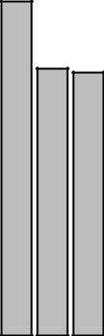
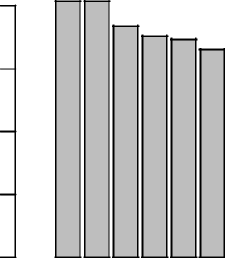

15
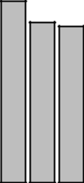
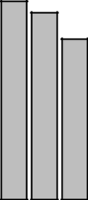

10
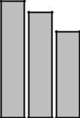

5

0

Les CortsSarriàSantGervasiEixampleSantMartíCiutatVellaSantAndreuGràciaSantsMontjuïcHortaGuinardóNouBarris | Ciutat VellaEixampleSantMartíSarriàSantGervasiGràciaLesCortsSantsMontjuïcSantAndreuHortaGuinardóNouBarris

On the left plot, we can see that the most expensive districts are Les Corts and Sarrià Sant Gervasi, with an average price approximately three times larger than the one of the cheapest districts (Horta Guinardó and Nou Barris). However, on the right plot we can see that Les Corts and Sarrià Sant Gervasi are not the most expensive districts, and they have medium prices per square meter. Instead, Ciutat Vella has the highest price per square meter, which is probably because there are many small flats with high prices.

Finally, we can compute and plot the average price by neighborhood:

nb.pr <- aggregate(cbind(price,pricem2) ~ neighborhood + district, data=bcn.data.final, mean) nb.pr <- nb.pr[order(nb.pr$price, decreasing=T),] head(nb.pr)

## |  | neighborhood | district | price
## | 27 | Pedralbes | Les Corts | 4716.692
## 68 Vallvidrera - Tibidabo - Les Planes Sarrià Sant Gervasi 4480.800

## 47 |  | Diagonal Mar - La Mar Bella | Sant Martí 3438.774
## 67 |  | Tres Torres Sarrià Sant Gervasi 2975.904
## | 64 | Sant Gervasi - Bonanova Sarrià Sant Gervasi |  | 2830.702
## | 65 | Sant Gervasi - Galvany | Sarrià Sant Gervasi | 2785.734
- pricem2

- 27 19.43135

- 68 12.85767

- 47 28.92365

- 67 17.61771

- 64 20.18836

- 65 18.58746

6

palette(rainbow(10))

par(mar=c(10,4,4,2))

barplot(nb.pr$price, names.arg=nb.pr$neighborhood, col=factor(nb.pr$district), las=2, cex.names=0.7, main="Average price by neighborhood")

legend("topright", levels(factor(nb.pr$district)),

col=1:length(levels(factor(nb.pr$district))), pch=16)

Average price by neighborhood
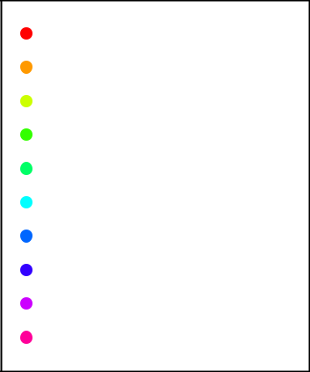

4000

3000

2000

1000

0

Ciutat Vella

Eixample

Gràcia

Horta Guinardó

Les Corts

Nou Barris

Sant Andreu

Sant Martí

Sants Montjuïc

Sarrià Sant Gervasi

Vallvidrera |  |  | Sant |  | Dretade |  |  |  |  | St.Pere |  |  |  | Esquerra |  |  |  | Glòries |  | Sagrada |  | Provençals |  |  |  | Campd´enGrassot | SantRamon−MaternitatLaMarina−MontjuïcBesòs |  |  |  |  | Fontde |  |  |  |  | Vilapicina−Torre |  | SantGenís |  | La |  | LaMarina−Port |  |  | TuródelaPeira−Can |  |  |  | Prosperitat |  |  | La |  |  | Vall |  | Ciutat
 | Mar − |  | Gervasi |  |  | Olímpica |  |  | Alta de l´Eixample |  | Font d´en |  | − |  |  |  | − |  |  |  | Sant |  | de |  | Guinardó |  |  |  |  | Can |  |  | SagreraLa |  |  | BadalLlobeta |  |  |  | − |  |  |  |  | Porta |  | Pastor |  |  |  |  | Vella |  | Montbau |  |  | Baró
−Tibidabo |  |  | Gervasi |  | l´Eixample |  | Sant |  |  | Sta.Caterina |  |  |  | Baixade |  | Vilade |  |  |  |  |  | del |  | Poble |  | −GràciaElClot |  |  | −Maresme |  |  | la |  | La |  |  |  |  | dels |  | Verneda− |  |  |  |  | Peguera |  | Carmel |  |  | Roquetes |  | Guineueta |  |  | d´Hebron |  | Meridiana
 | Bella |  |  | Sarrià |  |  | Andreu |  |  |  | Fargas |  |  |  | PiencGràcia |  |  |  |  | Família |  | Poblenou |  |  |  | N. |  |  |  |  | Coll |  |  | Bordeta | Sants |  |  |  | Agudells |  |  |  |  |  |  |  |  |  |  |  |  |  |  |  | Nova
Les |  | Tres |  |  |  |  |  |  |  | −El |  |  |  | l´Eixample |  |  |  | El |  |  |  |  |  |  |  | N. |  |  |  |  |  | Guatlla |  | Bordeta |  |  |  |  |  |  | La
Pedralbes | Mar |  | Bonanova |  |  |  |  | Gòtic |  |  |  |  | Penitents |  | Fort |  |  |  | Antoni |  | Martí |  | l´Arpa |  |  |  |  |  |  |  | El |  |  | Salut |  |  |  | Navas |  | Indians |  | Horta
 | Diagonal |  | Sant |  |  | Vila |  |  | Esquerra |  |  |  | Vallcarca |  |  | Corts |  | Parc |  |  |  |  | Camp |  | BaixBarceloneta |  |  | Raval | Hostafrancs | Baró |  |  | La |  |  |  | Guinardó |  |  | Congrés |  |  |  | Verdun |  |  | Bon |  | Taxonera |  |  | Trinitat |  |  | Trinitat |  | Torre
 |  |  |  |  |  |  |  |  |  |  |  |  |  |  |  | Corts | PutgetSant |  |  |  |  |  |  |  |  |  |  | Raval | Hostafrancs |  |  |  |  |  |  |  | Guinardó
Planes |  | Torres−Galvany |  |  |  |  |  |  |  | Born |  | Poblenou |  |  |  | Corts | Farró |  |  |  |  |  |  | Sec |  |  |  |  |  |  |  |  |  |  |  |  |  |  |  |  | Pau
 |  |  |  |  |  |  |  |  |  |  |  |  |  |  |  | Les
La−
−
−

Firstly, now it is clear that Les Corts district had the higher average prices because Pedralbes is the most expensive neighborhood in Barcelona, but the average prices in Les Corts and Sant Ramon - Maternitat (the other two neighborhoods that belong to Les Corts district) are quite standard. Secondly, note that all neighborhoods in Sarrià Sant Gervasi except Putget Farró are very expensive in average. Finally, we can see that the cheapest flats (in average) are located in neighborhoods of Nou Barris and Horta Guinardó, which explains why these two districts had the lowest average prices.

Also, we can compute and plot the average price per square meter by neighborhood:

par(mar=c(10,4,4,2))

nb.pr <- nb.pr[order(nb.pr$pricem2, decreasing=T),]

7

barplot(nb.pr$pricem2, names.arg=nb.pr$neighborhood, col=factor(nb.pr$district), las=2, cex.names=0.7, main="Average price per square meter by neighborhood")

legend("topright", levels(factor(nb.pr$district)),

col=1:length(levels(factor(nb.pr$district))), pch=16, cex=0.75)

Average price per square meter by neighborhood
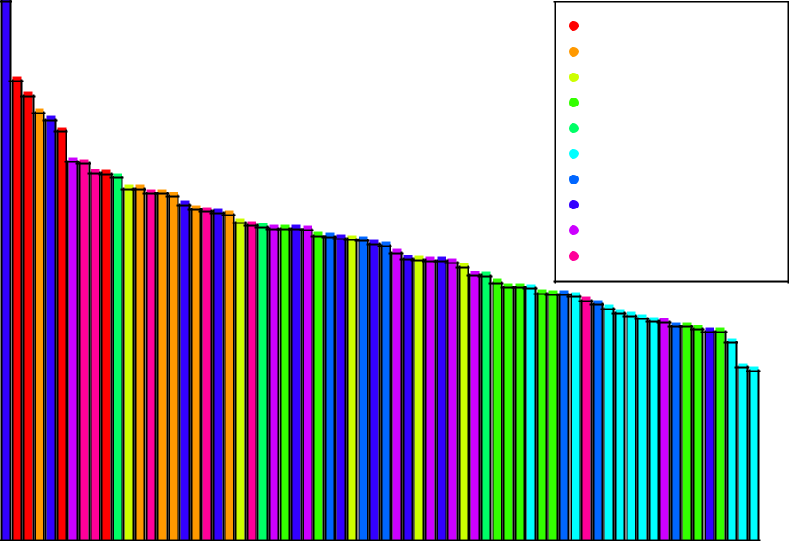

25

20

15

10

5

0

Ciutat Vella

Eixample

Gràcia

Horta Guinardó

Les Corts

Nou Barris

Sant Andreu

Sant Martí

Sants Montjuïc

Sarrià Sant Gervasi

MarBella |  | l´Eixample | − |  |  |  |  |  | Baixa |  | del´Eixample |  |  |  | Poblenou−Penitents |  |  |  | de |  | del |  |  |  | − |  | Andreu |  | El |  | La | Marina−Montjuïc |  |  |  | HortaPeguera |  |  |  |  |  | Tibidabo |  |  |  | Roquetes |  | Marina−Port |  |  | −LaPau |  | Meridiana
Barceloneta |  |  | El Born |  | Sarrià |  | Pedralbes |  | del´Eixample |  | del´Eixample | Camp |  | Tres |  | Sant | − Farró |  | la Guatlla |  | Poblenou |  | Navas |  | Gràcia |  |  | Hostafrancs |  |  | Bordeta |  | Badal |  | Guinardó |  | Can |  |  | Trinitat |  | −LesLaGuineueta |  |  |  |  | Trinitat |  | Montbau |  |  |  | Torre
 |  | Vila |  | Poble |  |  |  | deGràcia |  | Sant |  |  |  |  |  | Sant | Putget |  |  | Font |  |  |  | Martí |  | La |  |  |  |  | Besòs |  |  |  |  |  | Can |  | Agudells |  | Vilapicina |  | − | Porta |  |  |  |  |  | TaxoneraValld´Hebron |  |  | Torre
 |  |  |  | Sec |  | Raval |  |  |  | −GalvanyFort |  |  |  | Torres |  |  |  | Corts |  | FargasSants |  |  |  |  |  | Sagrera |  |  |  | El |  | Salut |  |  |  |  |  |  |  |  |  |  | − |  |  |  |  | Pastor
 | GòticOlímpica |  |  |  |  |  |  |  |  |  | Piencl´Arpa |  |  |  |  | Antoni |  | Les |  | d´en |  | BaixGuinardó |  | Sant |  |  | Sant |  | Glòries |  | −MaresmeLa |  |  | SantRamon−Maternitat |  |  | Baró |  |  | Vella |  |  |  |  | Prosperitat |  | NovaBon |  |  |  |  | VerdunBaró
DiagonalMar−La |  |  |  |  |  |  |  | Vila |  | Gervasi |  |  | Sagrada |  |  | Antoni |  |  |  |  |  |  |  |  |  |  |  |  |  |  |  |  |  |  |  |  | Baró |  | SantGenísdels |  | −Torre |  | Congrés |  |  |  |  |  |  |  | LaVerneda
DiagonalMar−La |  | Dretade | St.Pere−Sta.CaterinaSantGervasi−Bonanova |  |  |  |  |  | Esquerra |  | Esquerra |  |  |  |  | Vallcarca |  |  | Font |  | Provençals |  |  |  | Campd´enGrassot |  |  |  |  |  |  | La |  |  |  |  | TuródelaPeira−Can |  |  |  |  | Vallvidrera |  |  |  |  |  | La |  |  | LaVerneda |  | Ciutat
 |  |  |  |  |  |  |  |  |  |  |  | de |  |  |  |  |  |  |  |  |  |  |  |  | N.ElClot |  |  |  | Parc |  |  |  |  |  |  |  |  | Carmel |  |  |  | Planes
 |  |  |  |  |  |  |  |  |  |  |  |  | Família |  |  |  |  |  |  |  |  |  |  |  |  |  |  |  |  | Coll |  |  |  |  |  |  |  |  |  |  | Llobeta |  | Indians
 |  |  |  |  |  |  |  |  |  |  | Alta
 |  |  |  |  |  |  |  |  |  |  |  |  |  |  |  |  |  |  |  |  |  |  |  |  |  |  |  |  |  |  |  |  |  |  |  |  |  |  |  |  |  | −

Again, we can conclude that, in Ciutat Vella, the prices are too high in relation to the area of the flats, which leads to the highest prices per square meter. Also, note that Diagonal Mar - La Mar Bella (that belongs to Sant Martí) has the highest value, while the rest of neighborhoods of this district are quite low.

Conclusions

With this project, we have learned that a basic knowledge of HTML, regular expressions and the R package rvest is a powerful tool for data analysts to scrap the web and get the necessary data for analysis.

In our case, a limitation that we have found during the scraping process is that there were some pages containing ads which did not have all the required information for our analysis, so we had to change our scraping code in these cases in order to overcome this issue and get all the data we wanted.

8

In summary, scraping Habitaclia’s website has given us the chance to collect information about rental flats in Barcelona and we have used it to have a first idea of the average prices in every neighborhood and district of the city, but note that we could use the obtained dataset to do more sophisticated analysis. Moreover, for a complete analysis of all rental flats in Barcelona, we could have scraped more websites similar to Habitaclia’s (such as idealista or f otocasa) because with this project we only consider the ads posted in www.habitaclia.com.

9

