ASQ editor

Student: Marco Ravazzini

Advisor: Cesare Pautasso

email: [ravazm@usi.ch](mailto:ravazm@usi.ch)

# 1 Introduction & Motivation

ASQ is a Web application for creating and delivering interactive HTML5 presentations. It is designed to help teacher to make more powerful presentations ables to collect real time feedback or answers from students.

The power and the distribution of this platform is currently limited by the fact that the slides can only be made in html and javascript with all the possible errors and difficulties related to these languages.

The purpose of this bachelor project is to build an easy and powerful editor to simplify the interaction of the future ASQ users, moving from pure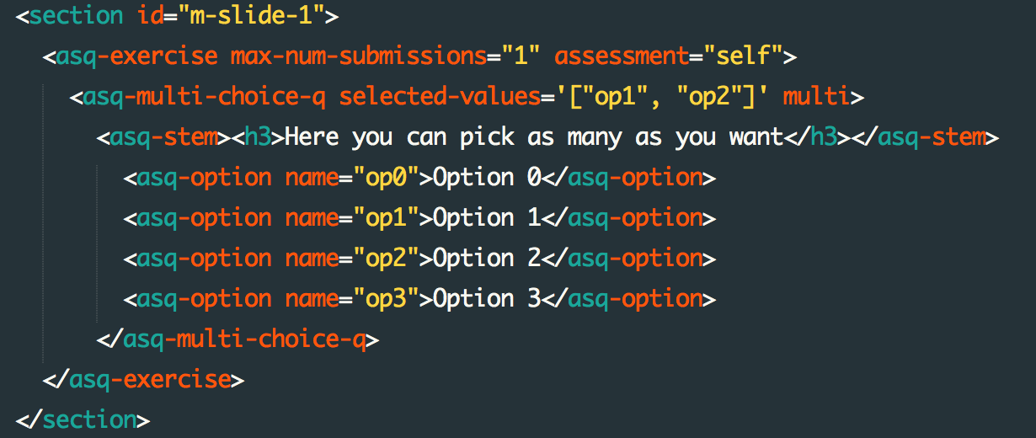 code editing

to an easy graphical interface similar to the figure below: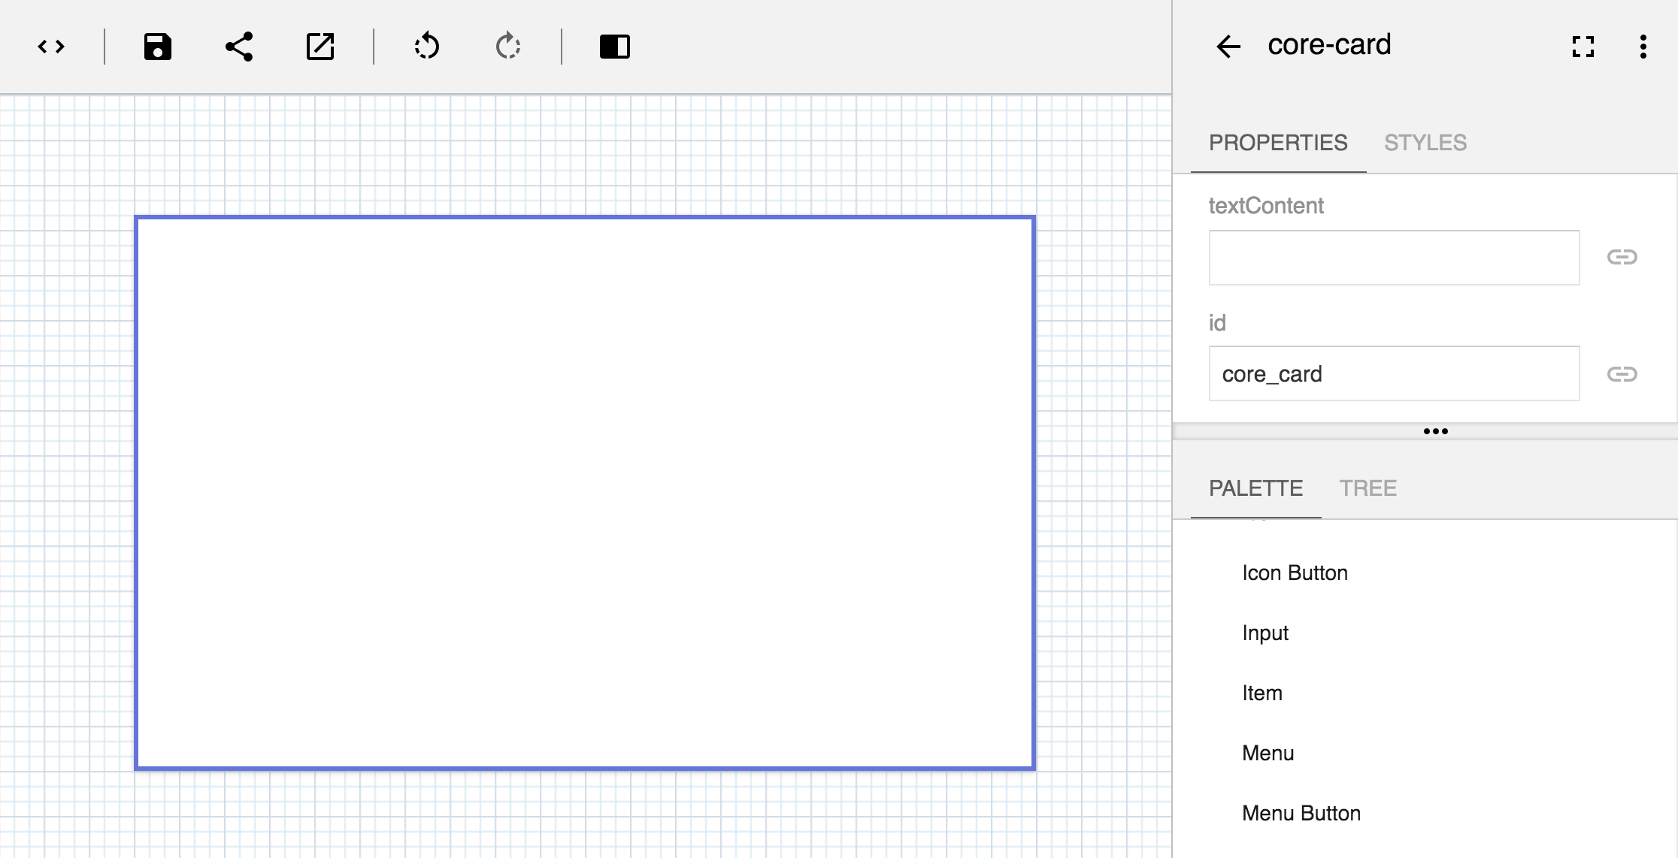

# 2 Project description

The ASQ editor will be made from scratch using all the functionalities offered by the latest web technologies, such as Polymer 1.0* for the front-end and Node.js and Express.js for the back-end

The editor is a key feature of the ASQ platform since it will be one of the most used components of this web application.

It needs to be easy to use but also rich of functionalities and possible customisations in order to satisfy every kind of user.

To accomplish all these requirements, the editor, will have a core structure beast on plug in that will increase the flexibility and the longevity of the editor and the entire platform.

Summary of functionalities

* Ability to visually create questions with a simple and user friendly interface
* Very flexible and extensible structure, able to support different question types in the form of   
  plug-in
* Ability to modify existing presentation

* Polymer is a software library used to define and style Web Components. The library is developed by Google. Modern design principles are implemented as a separate project using Google's Material Design design language.

# 3 Project Goal

The goal of this project is to have a full functional question editor, able to manage at leat 2 types of questions and to modify existing presentations

# 4 Project Milestones

The project can be divided in 5 different milestones

* **Milestone 1**: Analysis of some already existing technologies
* **Milestone 2**: Creation of a proof of concept in order to verify main ideas  
  Due to the extremely flexible nature of the editor, a lot of effort will be spent in designing and implementing the graphical user interface and the structure beneath, that is the reason why the second milestone is the biggest one.  
  In case of huge problems, part of milestone 2 will be postpone on milestone 3
* **Milestone 3**: Expansion of editor functionalities and possible changes
* **Milestone 4**: Implement the ability to modify existing presentations
* **Milestone 5**: Time dedicated to thesis report and poster

# 5 Project gantt chart