Design Document

# Who is the Site for?

The site is for students between the ages of 19 – 35 both male and female who live or school in Eindhoven who fall amongst the active internet user and are looking for student’s gossip, news, students discounts, entertainment gist, student jobs and other social events.

# Site Map

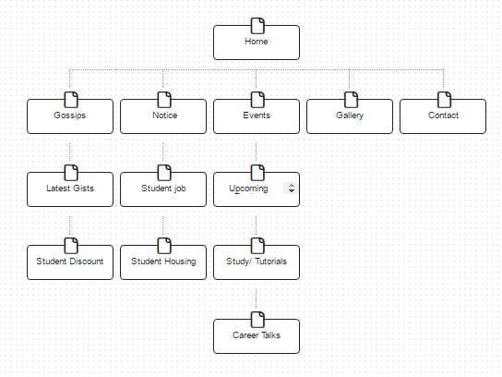

# Wire Frame

Home

Gossips

NoticeBoard

Events

Gallery

Contact

Headline news …………………………………………………………………………………………………………………………………………………………………………………………………………………………………………………………………………………………………………………………………………………………………………………….

Notice Board

Events

Calender

More Gossips/ News………………………

Social Media feeds

