A PROJECT REPORT ON
HACKAGON
A Web Platform for Hosting and Joining Online Coding Competitions
INDIVIDUAL CONTRIBUTION REPORT
Member 1: Accounts and Rooms
Submitted in partial fulfilment of the requirements for the degree of
Bachelor of Technology in Computer Science and Engineering
Submitted by
Hiten Sharma
(Member 1 of the HackAgon team: Hiten Sharma, Harsh Sharma, Hemanth Singh Tanwar, Arjun Suman, Akshat Rathore)
Under the guidance of
Er. Ram Babu Buri
Department of Computer Science and Engineering
Arya College of Engineering and IT, Jaipur
Session 2026-27

CERTIFICATE
This is to certify that the individual contribution report entitled “HackAgon: Individual Report of Member 1 (Accounts and Rooms)”, submitted by Hiten Sharma, a student of the third year of Bachelor of Technology in Computer Science and Engineering at Arya College of Engineering and IT, Jaipur, is a record of his own work carried out during the session 2026-27 as a member of the HackAgon project team, under my guidance and supervision.
The work embodied in this report has not been submitted elsewhere for the award of any degree or diploma. The report is, in my opinion, worthy of consideration as part of the project submission.

Er. Ram Babu Buri  Project Guide | Dr. Akhil Pandey  Head of Department

Date: ____________________
Place: Jaipur
DECLARATION
I, Hiten Sharma, hereby declare that the individual contribution report entitled “HackAgon: Individual Report of Member 1 (Accounts and Rooms)” is an original account of the work done by me as Member 1 of the HackAgon project team, under the guidance of the project guide named in the certificate.
The report is based on my own work, supported by the HackAgon Daily Work Log of the team (6 July 2026 to 6 October 2026) and the HackAgon Team Modules and 12-Week Plan. It has not been copied from any other source. Wherever the work of other team members is described, it is attributed to them by name or by member number.

Hiten Sharma

Date: ____________________
Place: Jaipur
ACKNOWLEDGEMENT
I would like to express my sincere gratitude to everyone who helped me complete my part of the HackAgon project. I thank our project guide for constant direction, patient review and helpful suggestions throughout the project. I am grateful to the Head of the Department of Computer Science and Engineering and to the faculty of Arya College of Engineering and IT, Jaipur, for the learning environment and the laboratory facilities.
I thank my teammates Harsh Sharma, Hemanth Singh Tanwar, Arjun Suman and Akshat Rathore. The accounts and rooms could only be useful because their modules, the judge and admin tools, the money and database core, the proctoring and host dashboard, and the design and learning screens, were built in the same weeks and fitted together with mine. Their reviews of my pull requests and my reviews of theirs taught me as much about collaboration as about code.
I also thank the open-source community. HackAgon stands on Node.js, Express, MySQL, Render, GitHub and many small libraries, all of which are free to use and well documented. Finally, I thank my friends and family for their encouragement.
Hiten Sharma
ABSTRACT
HackAgon is a web application for hosting and joining online coding competitions, with solo, duo, squad and duel rooms, paid tournaments with a funded prize pool, automatic judging, proctoring and an administrator back office. It is built by a team of five students. This report describes the contribution of Member 1, Hiten Sharma, who owned two modules: Module 1, Accounts and OTP, and Module 2, Rooms and matches.
For Module 1, the report covers the audit of the existing authentication code, email OTP with a 5 minute expiry, 5 attempts and a 60 second resend, SMS OTP through MSG91, forgot password, profile edit with re-verification and the age rule for paid tournaments. For Module 2, it covers the room data model, the room create API with editable defaults, the server timer for room status, joining and starting, the submission endpoint with the judge call and on-time check, ranks and tie-break, profile counters from real records, tournament mode with consent and lock refusal, elimination, result locking and organisation hosting. It then describes the hardening and launch work of weeks 10 to 14: the end-to-end test script, keyboard and screen-reader checks, the legal pages with the signup checkbox, launch-week monitoring and the fixes after the first real tournament.
A full chapter is devoted to collaboration. I worked with Member 2 on the submission path and disputes, with Member 3 on the data model, payouts, security and deployment, with Member 4 on locks and elimination, and with Member 5 on the pages and the match screen. In total I logged 194.0 hours over 67 working days, from 6 July to 6 October 2026. Every feature in the report is traced to a dated entry in the daily work log.
Keywords: accounts, one-time password, rooms, matches, tournament mode, result locking, accessibility, launch, collaboration, Node.js, Express, MySQL.
CONTENTS
1. INTRODUCTION 1
1.1 About the HackAgon Project 1
1.2 Purpose of This Report 1
1.3 Member 1 at a Glance 1
1.4 Sources and Method 2
1.5 Organisation of the Report 2
2. ROLE AND RESPONSIBILITIES 3
2.1 The Two Modules 3
2.2 Files, Pages and Responsibilities 3
2.3 Decisions Owned by Member 1 4
2.4 What Belonged to Other Members 4
2.5 Effort Summary 4
3. REQUIREMENTS AND DESIGN 7
3.1 Requirements Covered 7
3.2 Non-Functional Requirements That Shaped the Work 8
3.3 Position in the Architecture 8
3.4 Data Design 9
3.5 Design Principles 9
4. MODULE 1: ACCOUNTS AND OTP 10
4.1 Audit of Accounts (Week 1) 10
4.2 Email OTP (13 and 14 July) 10
4.3 SMS OTP with MSG91 (15 July) 11
4.4 Forgot Password (16 July) 12
4.5 Profile Edit with Re-verification (17 July) 12
4.6 The Age Rule (19 August) 12
4.7 Pages and Copy 12
5. MODULE 2: ROOMS AND MATCHES 13
5.1 Room and Match Data Model (9 and 10 July) 13
5.2 Room Create API (20 July) 13
5.3 Editable Defaults and the Create-room Page (21 and 22 July) 13
5.4 Room Status Timer (23 July) 13
5.5 Join and Start (27 and 28 July) 14
5.6 Submission Endpoint (29 and 30 July) 14
5.7 Testing a Full Solo Room (31 July) 14
5.8 Results, Ranks and Profile Counters (3 to 6 August) 14
5.9 Tournament Mode and Consent (10 to 14 August) 15
5.10 Elimination and the Paid-tournament Age Rule (17 to 20 August) 15
5.11 Result Locking (24 to 28 August) 15
5.12 Organisation Hosting (31 August to 4 September) 16
6. HARDENING, LEGAL PAGES AND LAUNCH 17
6.1 End-to-end Test Script (7 to 9 September) 17
6.2 Accessibility Checks (10 and 11 September) 17
6.3 Legal Pages and the Acceptance Checkbox (14 to 18 September) 17
6.4 Code Freeze and Launch Week (21 to 25 September) 17
6.5 After Launch (28 September to 2 October) 18
6.6 Final Report and Submission (5 and 6 October) 18
7. COLLABORATION WITH OTHER MEMBERS 19
7.1 Overview of Dependencies and Joint Functions 19
7.2 Collaboration with Member 2 (Harsh Sharma) 20
7.3 Collaboration with Member 3 (Hemanth Singh Tanwar) 20
7.4 Collaboration with Member 4 (Arjun Suman) 21
7.5 Collaboration with Member 5 (Akshat Rathore) 21
7.6 Team-Wide Activities 21
7.7 Summary of Collaboration 21
8. TESTING AND VERIFICATION 23
8.1 Test Strategy 23
8.2 Tests Recorded in the Work Log 23
8.3 Bug-fix Days 23
8.4 Verification by Other Members 24
8.5 Points to Note 24
9. WEEK-BY-WEEK SUMMARY 25
9.1 Weeks 1 and 2: Audit and Accounts 26
9.2 Weeks 3 to 5: Rooms, the First Playable Match and Results 26
9.3 Weeks 6 to 9: Tournament Mode, Host Controls, Result Locking and Organisations 27
9.4 Weeks 10 to 12: Hardening, Legal Pages and Launch 27
9.5 Weeks 13 and 14: After Launch and Handover 27
10. CHALLENGES, DECISIONS AND LIMITATIONS 28
10.1 Challenges and How They Were Met 28
10.2 Delivered Features 28
10.3 Notes on the Sources 29
10.4 Limitations 29
11. CONCLUSION AND FUTURE SCOPE 30
11.1 Conclusion 30
11.2 Lessons Learnt 30
11.3 Future Scope 30
REFERENCES 31
APPENDIX A: COMPLETE DAILY WORK LOG OF MEMBER 1 32
APPENDIX B: DATED JOINT WORK WITH OTHER MEMBERS 35
LIST OF FIGURES
Figure 2.1: Hours logged by Member 1 per kind of work 5
Figure 2.2: Timeline of Member 1’s work across the fourteen logged weeks 6
Figure 2.3: Share of logged hours by project stage 6
Figure 3.1: Layered architecture around Member 1’s modules 8
Figure 4.1: OTP request, delivery and verification with its limits 11
Figure 4.2: Sequence diagram of OTP request and verification 11
Figure 5.1: Room status, join, submission and result steps owned by Member 1 13
Figure 5.2: Sequence of a code submission through Member 1’s endpoint and Member 2’s judge 14
Figure 5.3: Result locking: confirmation, auto-confirmation, dispute and hand-over to payouts 16
Figure 7.1: Collaboration map of Member 1 with the other four members 19
Figure 7.2: Joint work items per partner (from Appendix B) 22
Figure 9.1: Cumulative hours logged by Member 1 week by week 26
Figure 9.2: Hours logged per day, 6 July to 6 October 2026 (one bar per weekday) 26
LIST OF TABLES
Table 1.1: Summary of Member 1 1
Table 2.1: Files and pages of Member 1 3
Table 2.2: Hours by area of work 4
Table 3.1: Requirements and Member 1’s contribution 7
Table 3.2: Data used by Member 1’s modules 9
Table 4.1: Week 1 activities of Member 1 10
Table 6.1: Work of weeks 10 to 14 18
Table 7.1: Matrix of joint functions 19
Table 8.1: Tests carried out by Member 1 23
Table 9.1: Weekly summary of Member 1’s work 25
Table 10.1: Challenges and responses 28
Table 10.2: Status of Member 1’s features 28
Table A.1: Daily work log of Member 1 32
Table B.1: Dated joint work 35

1. INTRODUCTION

1.1 About the HackAgon Project
HackAgon is a web platform for hosting and joining online coding competitions. A college club, a class or a group of friends can create a room in a few minutes, pick questions, invite players and, when they want stakes, run a paid tournament in which the host funds the prize pool in advance and the pool is paid out by a published split after a flat 1% platform fee. The application is built on Node.js and Express with a MySQL database, a set of plain HTML pages, and shared browser scripts and style files.
The project was carried out by a team of five students of Arya College of Engineering and IT, Jaipur. The work was divided into ten modules, and every member owns modules of equal total weight. This report is about Member 1, Hiten Sharma, whose area in the team plan is Accounts and Rooms.

1.2 Purpose of This Report
The team plan lists the modules and the weekly tasks of all five members. The daily work log records what each member actually did, day by day. Neither document describes one member’s contribution in full. This report collects in one place everything I did: what I built, in which week, how it was tested and how it connected to the work of the other four members.
HackAgon is a tightly connected system. An account created in my module is used by the payout details of Member 3, a room created in my module is judged by the code of Member 2, a lock set by Member 4 is enforced on my match page, and the final rank list produced by my module feeds the payouts of Member 3. Wherever I worked together with another member on a shared function, the report names the shared function, the interface between the two sides and the dates on which each side did its part.

1.3 Member 1 at a Glance
Table 1.1: Summary of Member 1
Item | Details
Name | Hiten Sharma (Member 1)
Role in the team plan | Accounts and Rooms
Modules owned | Module 1: Accounts and OTP; Module 2: Rooms and matches
Main files | routes/auth.js, lib/auth.js, lib/otp.js, lib/mail.js, routes/rooms.js, routes/play.js (shared), lib/domain.js
Main pages | login, signup, verify-otp, profile, create-room, arena, match (the match page is shared with Member 5)
Period covered by the log | 6 July 2026 to 6 October 2026 (weekdays), project weeks 1 to 14
Work logged | 67 weekdays, all marked Completed; 194.0 hours (2 to 4 hours a day; 14.5 hours in each of weeks 1 to 13 and 5.5 hours in the two-day week 14)
Collaborated with | Member 2 (Harsh Sharma), Member 3 (Hemanth Singh Tanwar), Member 4 (Arjun Suman), Member 5 (Akshat Rathore)

1.4 Sources and Method
This report is based on my own work, supported by two team documents: the HackAgon Team Modules and 12-Week Plan, and the HackAgon Daily Work Log. The plan supplies the module descriptions, the owners, the file names, the weekly tasks and the risks. The log supplies the day-by-day record of what each member did, including my 67 entries and the entries of the other four members that touch my work. Dates follow the day-month-year format of the log.
The plan is the authority on what each task was meant to deliver and who owned it. The log is the authority on what I actually did and on which date, so every date in this report comes from the log. The plan sets out twelve weeks of tasks; the log runs for fourteen project weeks from 6 July to 6 October 2026. Weeks 10 to 12 of the plan (the end-to-end test, accessibility checks, legal pages and launch monitoring) all appear in the log as completed, and weeks 13 and 14 cover the review after the first real tournament and the preparation of this report.

1.5 Organisation of the Report
Chapter 2 explains my role, the files and the effort. Chapter 3 lists the requirements and the design that the two modules follow. Chapter 4 describes Module 1, accounts and OTP, and Chapter 5 describes Module 2, rooms and matches. Chapter 6 covers the work of weeks 10 to 14: testing end to end, accessibility, legal pages, launch and the weeks after launch. Chapter 7 is devoted to collaboration with the other members. Chapter 8 reports testing, Chapter 9 gives a week-by-week account, and Chapter 10 discusses challenges, decisions and limitations. Chapter 11 concludes with lessons learnt and future scope. Appendix A reproduces my complete daily log and Appendix B lists the dated joint work with the other members.

2. ROLE AND RESPONSIBILITIES

2.1 The Two Modules
In the team plan each member owns two modules, one larger and one smaller, so that the load is shared evenly. I own the two modules that decide who can enter the platform and how a contest is created, joined and finished.

Module 1: Accounts and OTP (weight 2)
This module covers signup, login, JWT sessions, email and SMS one-time passwords, forgot password, profile details and the age check. Its files are routes/auth.js, lib/auth.js, lib/otp.js and lib/mail.js, together with the login, signup, verify-otp and profile pages.

Module 2: Rooms and Matches (weight 3)
This module covers the room creation form, the question side panel, the Arena list, joining, the live match page, scoring, the scoreboard and the results. Its files are routes/rooms.js, routes/play.js and lib/domain.js, together with the create-room, arena and match pages. The weights of 2 and 3 give me a load of 5 points, the same as every other member.

2.2 Files, Pages and Responsibilities
Table 2.1: Files and pages of Member 1
File or page | Responsibility
routes/auth.js | Signup, login, OTP request and verify, forgot password, profile update
lib/auth.js | Password hashing, JWT creation and checking, cookie settings
lib/otp.js | Creating, storing and checking one-time passwords, expiry, attempt count and resend timing
lib/mail.js | Sending email OTP. Mail first went through Gmail; Member 3 moved it to a transactional provider on 11 September
routes/rooms.js | Room create API with validation and defaults, room status, join, start, host actions such as eliminate and confirm results
routes/play.js (shared) | Submission endpoint written by me, which calls the judge of Member 2; the hook for saving wrong submissions was agreed with Member 5
lib/domain.js | Shared rules of the domain: ranks, tie-break, on-time check, counters
login, signup, verify-otp, profile | Account pages; styled by Member 5, wired to the API by me
create-room, arena, match | Room pages; designed by Member 5, connected to the room and play APIs by me

2.3 Decisions Owned by Member 1
- The server decides, not the browser. OTP expiry, attempt limits, resend timing, room status changes and the on-time check of a submission are all decided on the server.
- Real counters only. Profile counters such as rooms played and rooms won are calculated from real records, so a new account shows zero everywhere, as the product requirements demand.
- Verification on change. Changing the email or the mobile number on the profile asks for a new OTP before the change is saved.
- Age rule. Only users aged 18 or over may enter or host paid tournaments.
- No silent results. A result is confirmed by the host, or confirmed automatically after 24 hours if there is no dispute.

2.4 What Belonged to Other Members
Clear boundaries help the team avoid overlap. I did not own the code judge or the question bank (Member 2), the money tables, payouts, deployment and the database core (Member 3), the proctoring endpoints and the host dashboard (Member 4), or the design system and the learning screens (Member 5). My code calls or feeds these parts at agreed points, which are described in Chapter 7.

2.5 Effort Summary
I logged work on all 67 weekdays between 6 July and 6 October 2026, a total of 194.0 hours. Daily hours ranged from 2 to 4, every full week came to 14.5 hours, and the last week (5 and 6 October) came to 5.5 hours. All entries are marked Completed. Table 2.2 groups the hours by area of work; each of the first twelve areas is exactly one project week.
Table 2.2: Hours by area of work
Area of work | Weeks | Days | Hours | Share
Account audit and data model | 1 | 5 | 14.5 | 7.5%
Accounts and OTP | 2 | 5 | 14.5 | 7.5%
Room creation | 3 | 5 | 14.5 | 7.5%
Join, submit and play | 4 | 5 | 14.5 | 7.5%
Results and profile counters | 5 | 5 | 14.5 | 7.5%
Tournament mode and consent | 6 | 5 | 14.5 | 7.5%
Elimination and age rule | 7 | 5 | 14.5 | 7.5%
Result locking | 8 | 5 | 14.5 | 7.5%
Organization hosting | 9 | 5 | 14.5 | 7.5%
End-to-end test and accessibility | 10 | 5 | 14.5 | 7.5%
Legal pages | 11 | 5 | 14.5 | 7.5%
Launch and monitoring | 12 | 5 | 14.5 | 7.5%
Post-launch fixes and handover | 13 to 14 | 7 | 20.0 | 10.3%
Total | 1 to 14 | 67 | 194.0 | 100%

The work in the log falls into six kinds of activity. Building new features took more than half of the logged time. Testing (including the end-to-end script and the accessibility checks) took about a sixth, and documentation, bug fixing, monitoring and review share the rest. Figure 2.1 shows the split.
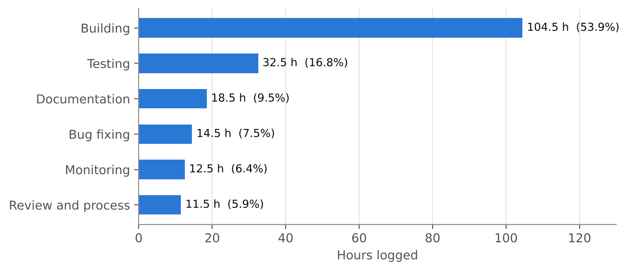
Figure 2.1: Hours logged by Member 1 per kind of work
Figure 2.2 shows when each area of work took place. The account audit and the OTP flows fill the first two weeks, rooms and the first playable match follow in weeks 3 to 5, and tournament mode, host controls, result locking and organisation hosting fill weeks 6 to 9. Weeks 10 to 12 are the hardening and launch weeks, and weeks 13 and 14 close the project.
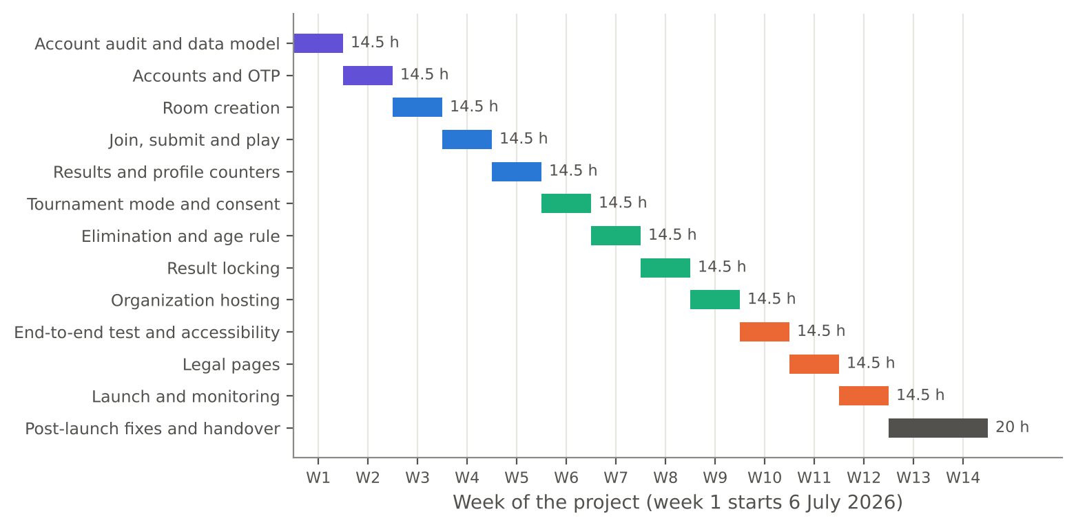
Figure 2.2: Timeline of Member 1’s work across the fourteen logged weeks
Figure 2.3 groups the same hours into five stages of the project. The largest stage is weeks 6 to 9, because tournament mode and elimination touch the match page, the consent page, the age rule and the host controls, and result locking connects the match to the payouts.
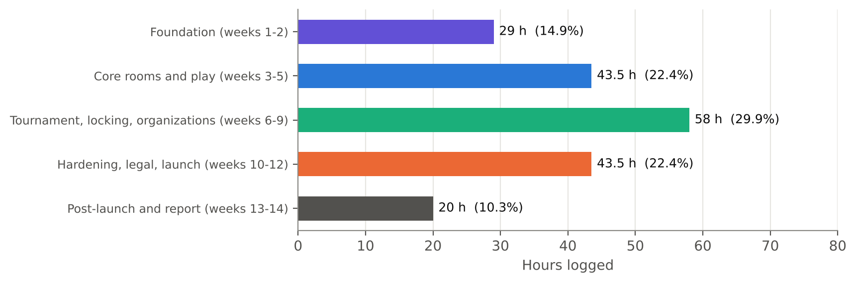
Figure 2.3: Share of logged hours by project stage

3. REQUIREMENTS AND DESIGN

3.1 Requirements Covered
The plan states what each module must do. Table 3.1 lists the requirements that my tasks address and the contribution made.
Table 3.1: Requirements and Member 1’s contribution
Requirement (from the plan) | Contribution and date
Email OTP with 5 minute expiry, 5 attempts and 60 second resend | Built in week 2 (13 and 14 July)
SMS OTP | Added using MSG91 (15 July)
Forgot password | Built with OTP (16 July)
Profile edit asks for a new OTP when email or mobile changes | Built (17 July)
Room create API with validation and the PRD’s editable defaults | Built and wired to create-room.html (20 to 22 July)
Room status open, live, finished run by a timer on the server | Added (23 July)
Join by Arena or invite code; start the match | Built (27 and 28 July)
Server decides whether a submission is on time | Added with the judge call (29 and 30 July)
Final ranks with tie-break; results page data | Built (3 and 4 August)
Profile counters from real records; new account shows zero | Calculated and tested (5 and 6 August)
Tournament mode, consent page, locked players refused on every request | Built and tested (10 to 13 August)
Host eliminates a player with a reason; no rejoin; removed from ranking | Built (17 and 18 August)
Only users aged 18 or over can enter or host paid tournaments | Added (19 August)
Host confirms results or they auto-confirm after 24 hours; rank list to money module | Built (24 to 26 August)
Organisation host application, admin approval, higher limits | Built (31 August to 3 September)
End-to-end script of signup, room creation, join, solve and results | Written, extended and run (7 to 9 September); re-run on 30 September
Keyboard and screen-reader check of auth and room pages | Done (10 and 11 September)
Terms of service, privacy policy, refund policy, webcam consent text, acceptance checkbox at signup | Written and added (14 to 18 September)
Launch-week monitoring of signups, OTP delivery, login errors and the first real tournament | Done (22 to 24 September)

3.2 Non-Functional Requirements That Shaped the Work
- Security of accounts. Passwords are hashed with bcryptjs, sessions use JWT with an expiry, and cookie flags are checked. Week 1 was spent auditing these settings.
- Server authority. Anything that affects fairness or money, such as time, locks, eliminations and results, is checked on the server for every request.
- Honest numbers. No demo users, scores or counters are placed in the app; counters start at zero and grow from real records.
- Clear messages. Every feature has hand-written empty and error messages, which is part of the team’s definition of done.
- Deployability. The main branch is always deployable. It went to a staging service on Render during the build and to a separate production service from 22 September.

3.3 Position in the Architecture
The application is a Node.js and Express server with a MySQL database through the mysql2 driver. The browser pages talk to the server through js/api.js. My routes sit in the server/routes folder (auth, rooms and play), and the shared logic sits in the lib folder (auth, otp, mail and domain). The libraries used by my modules are express, bcryptjs, jsonwebtoken, nodemailer and dotenv, with MSG91 for SMS. Figure 3.1 shows the layers and where my code sits.
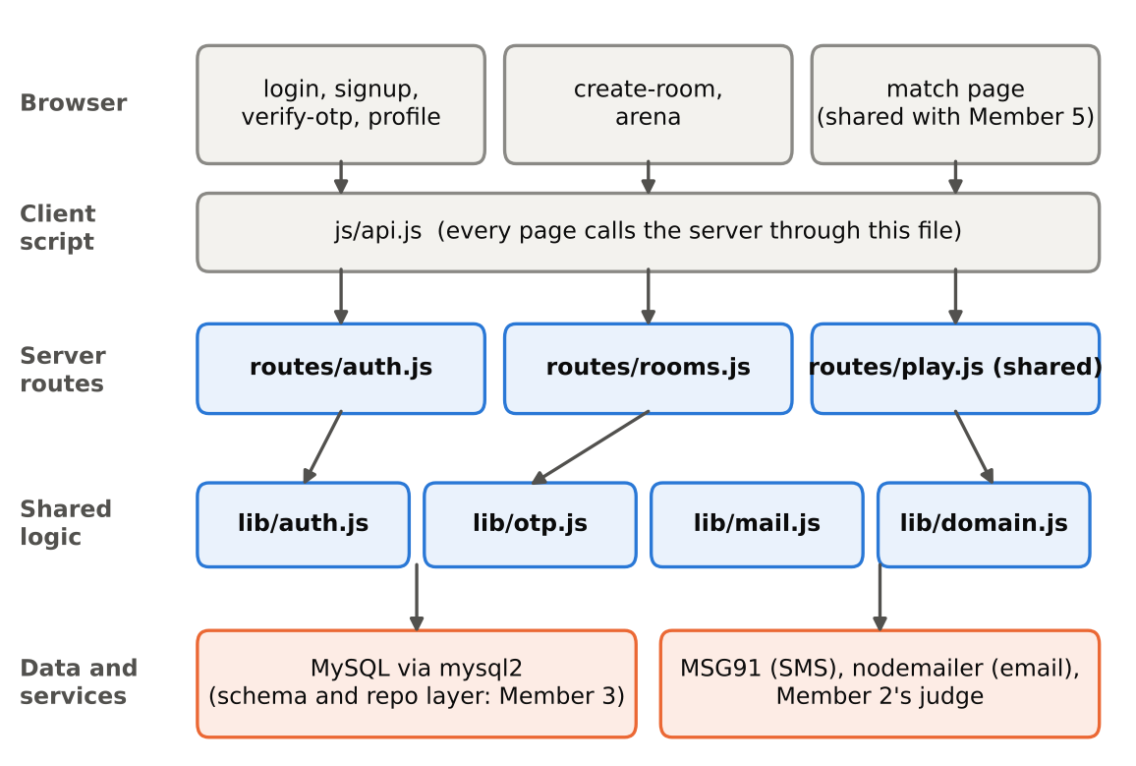
Figure 3.1: Layered architecture around Member 1’s modules

3.4 Data Design
In week 1 I drafted the room and match data model and reviewed it with Member 3, who owns schema.sql and the repository layer. The model describes the following ideas. The exact table and column names are those of schema.sql and are not repeated here.
Table 3.2: Data used by Member 1’s modules
Data | Purpose
Users | Name, email, mobile, password hash, date of birth for the age check, verification state
OTP records | Code, purpose, expiry time, attempts used, time of last send
Rooms | Settings from the creation form, mode (solo, duo, squad, duel, tournament), status, host, start and end times
Room players | Who joined which room, elimination flag and reason, lock state (written by Member 4’s endpoints)
Submissions | Language, question, verdict, time and memory (written with Member 2’s judge)
Results | Final ranks, confirmation state, auto-confirm deadline

3.5 Design Principles
- Small steps with a test each. Almost every building week in the log ends with a testing day and a bug-fix day.
- Contracts before connections. Where two modules meet, such as the money module, the owners agree the request and response first.
- Defaults that the host can edit. The room form starts from the PRD defaults and lets the host change them, which keeps room creation fast.
- Fail closed. A locked or eliminated player is refused on every request; an unverified contact change is not saved.

4. MODULE 1: ACCOUNTS AND OTP

4.1 Audit of Accounts (Week 1)
Week 1 was an audit. Instead of starting from nothing, I read the existing authentication code and compared it with the product requirements. The team plan notes that existing pages and routes count as a first skeleton, so the early weeks make it real.
Table 4.1: Week 1 activities of Member 1
Date | Hours | Activity
06-07-2026 | 3 | Read routes/auth.js and lib/auth.js to understand login flow
07-07-2026 | 2.5 | Checked password hashing and JWT expiry settings
08-07-2026 | 4 | Checked cookie flags and listed gaps against the PRD
09-07-2026 | 3 | Drafted room and match data model
10-07-2026 | 2 | Reviewed data model with Member 3 and noted changes

The result of the audit was a list of gaps against the PRD. That list became the task list of weeks 2 and 3: the missing OTP rules, SMS delivery, forgot password and re-verification on profile changes.

4.2 Email OTP (13 and 14 July)
I built the email one-time password with a 5 minute expiry on 13 July. On 14 July I added the attempt limit of 5 and the resend delay of 60 seconds. An attempt counter stops guessing, the expiry stops old codes from being used, and the resend delay stops a user from flooding an inbox. Mail is sent through lib/mail.js using nodemailer. During the build the mail went out through Gmail; Member 3 later moved it to a transactional provider on 11 September, which needed no change to the OTP rules.
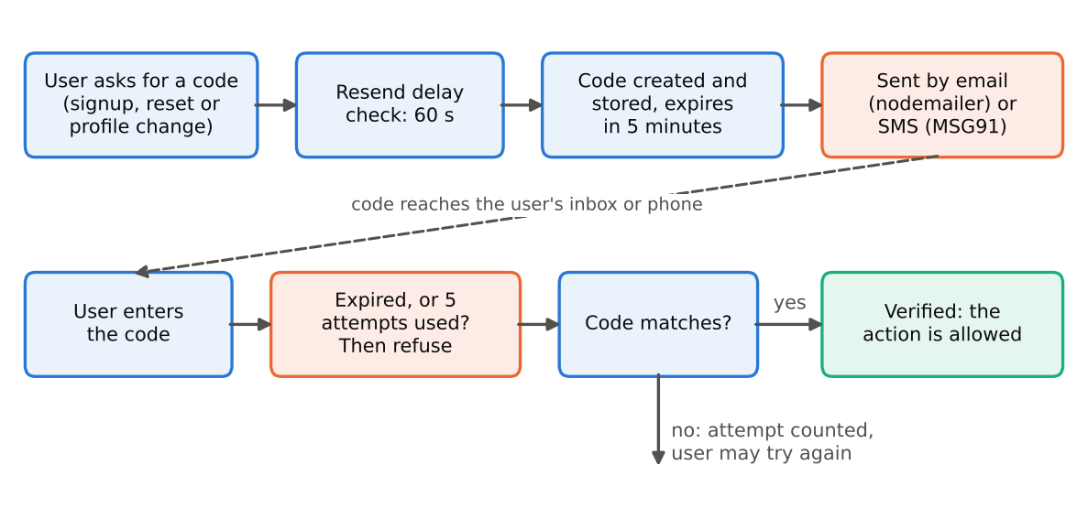
Figure 4.1: OTP request, delivery and verification with its limits
Figure 4.2 shows the same flow as a sequence between the user, the browser, the auth route, the OTP library and the delivery service.
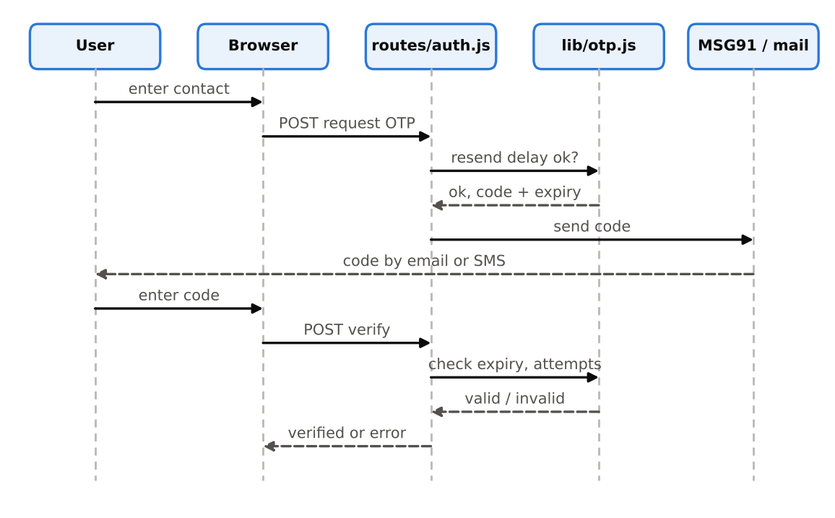
Figure 4.2: Sequence diagram of OTP request and verification

4.3 SMS OTP with MSG91 (15 July)
On 15 July I added an SMS OTP using MSG91. The same rules of expiry, attempts and resend apply, so email and SMS share one OTP library. Sharing the library means a rule is changed in one place and applies to both channels.

4.4 Forgot Password (16 July)
The forgot password flow uses the same OTP. A user asks for a reset, receives a code, proves control of the contact by entering it, and then sets a new password. Using one OTP library for signup, reset and profile change keeps the rules identical in every place.

4.5 Profile Edit with Re-verification (17 July)
A profile edit that changes the email address or the mobile number asks for a new OTP to the new contact before it is saved. This protects the account, and it also protects Member 3’s payout details, which send an OTP to the profile mobile number (24 August). If a mobile number could be changed without proof, that payout check would be weak.

4.6 The Age Rule (19 August)
On 19 August I added the rule that only users aged 18 or over may enter or host paid tournaments. The rule lives with the account because it depends on the date of birth in the profile, and it is checked on the server when a paid tournament is joined or created. It sits between Member 3’s entry fee checkout (17 August) and the join after payment (18 August) on one side and the refund work (19 and 20 August) on the other.

4.7 Pages and Copy
Member 5 styled the login, signup and verify-otp pages with hand-written copy on 17 July, the same day that I finished profile re-verification. I supplied the API behaviour and the error cases, and Member 5 wrote the messages and the layout. The acceptance checkbox for the terms and privacy policy was added to the signup page on 18 September (Section 6.3).

5. MODULE 2: ROOMS AND MATCHES

5.1 Room and Match Data Model (9 and 10 July)
I drafted the model on 9 July and reviewed it with Member 3 on 10 July. Member 3 fixed the version 1 tables on 13 July, finished the migration runner on 14 July and the repository layer on 15 July, so the model went into the schema without delay.

5.2 Room Create API (20 July)
The room create API validates every field before a room is stored. Validation keeps wrong values out of the database and returns clear messages to the form. Member 3’s input validation and error handler (21 and 23 July) work around the same routes.

5.3 Editable Defaults and the Create-room Page (21 and 22 July)
On 21 July I added the PRD default values to the room form, with each default editable by the host. On 22 July I connected create-room.html to the API. Member 5 had already designed the page and its question side panel on 20 July and the topic and difficulty filters on 21 July, so the page was ready to connect. The filter API that feeds the side panel was built by Member 2 on 24 July. Author to add: the PRD default values used in the room form.

5.4 Room Status Timer (23 July)
A server-side timer moves a room from open to live to finished. The browser does not decide when a room starts or ends. This makes every player see the same status and prevents a player from extending the contest by changing a local clock.
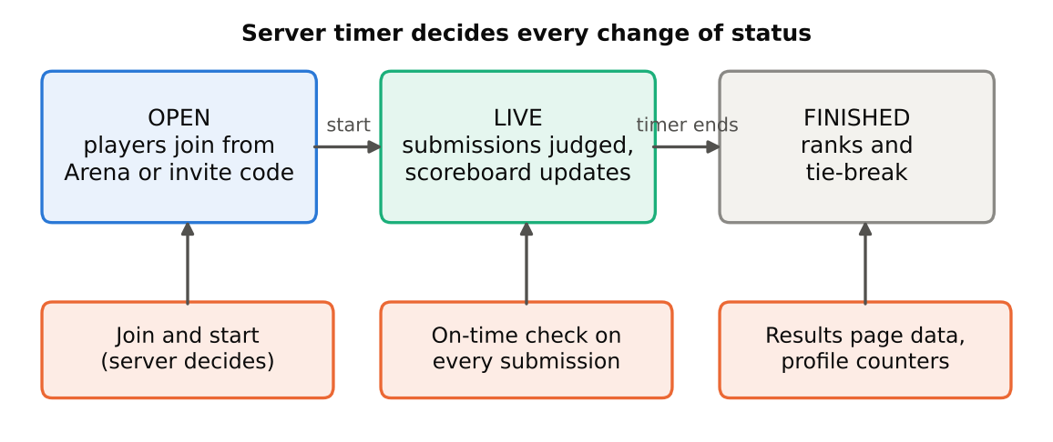
Figure 5.1: Room status, join, submission and result steps owned by Member 1

5.5 Join and Start (27 and 28 July)
Players join a room from the Arena list or with an invite code. On 28 July I added the start match logic. Joining and starting are decided on the server, not in the page. Member 5 had designed the Arena room cards on 22 July and built the match page in the same week: editor and question list on 27 July, timer on 28 July and the polling scoreboard on 29 July.

5.6 Submission Endpoint (29 and 30 July)
The submission endpoint in play.js receives the code, the language and the question, calls the judge, and records the result. The judge itself belongs to Member 2, who built the submit flow, the test-case run and the verdict storage on 13 to 15 July. My endpoint adds the server-side on-time check, so a submission that arrives after the deadline is not scored. Member 2 limited concurrent judge runs (27 July) and allowed one pending submission per player per question (28 July), which my endpoint relies on.
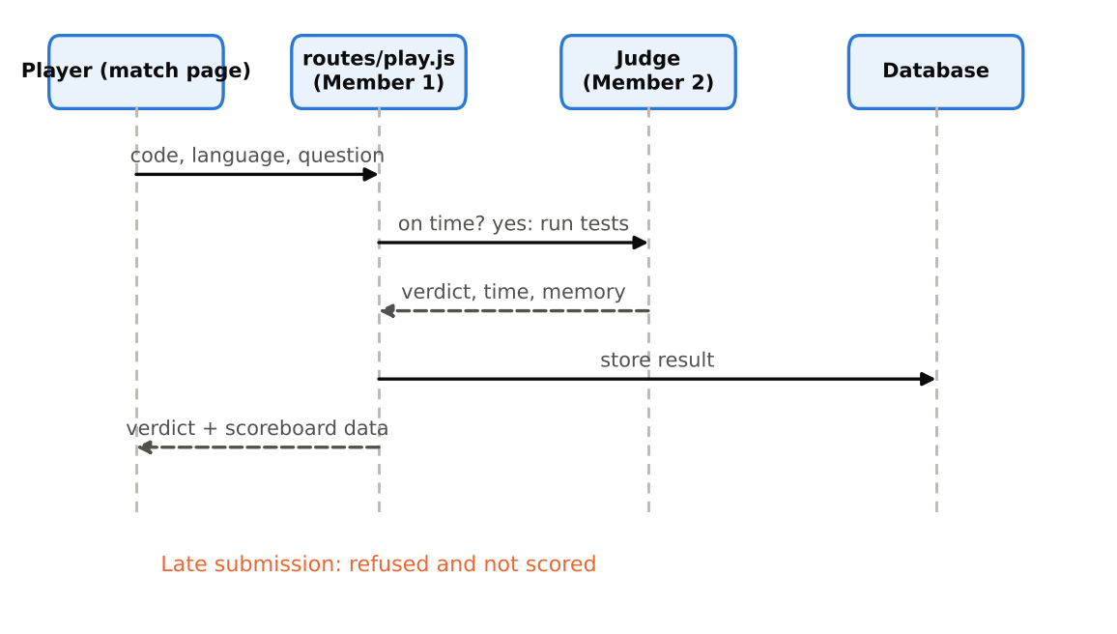
Figure 5.2: Sequence of a code submission through Member 1’s endpoint and Member 2’s judge

5.7 Testing a Full Solo Room (31 July)
On 31 July I tested a full solo room with two users. This was the test for Milestone 1 in the plan: two real users play a full solo room on staging. Member 3 deployed Milestone 1 to staging on 30 July and ran the test checklist on 31 July, and Member 5 fixed visual bugs on the match page the same day.

5.8 Results, Ranks and Profile Counters (3 to 6 August)
On 3 August I added the final rank rule and the tie-break. On 4 August I built the results page data, and on 5 August I calculated the profile counters, rooms played and rooms won, from real records. The test of 6 August checked that a new account shows zero everywhere, which is the product requirement for honest numbers. Member 5’s achievements (17 to 20 August) calculate their metrics from the same real counts. Author to add: the tie-break order used in lib/domain.js.

5.9 Tournament Mode and Consent (10 to 14 August)
On 10 August I added the tournament mode option to room creation. On 11 August I built the consent page before joining, because tournament mode uses the webcam and the tab lock. Member 5 designed the consent screen on 10 August, the camera check screen on 11 August and the lock screen on 12 August, so the screens were ready as the logic was built. On 12 August I made the match page refuse locked players, and on 13 August I tested the lock check on every request. The locks themselves are set by Member 4’s code: the lock-state endpoint (15 July), the camera permission and face check (10 August), snapshots (11 August), the server-side tab and minimize lock (12 August) and the 30 second network grace period (13 August).

5.10 Elimination and the Paid-tournament Age Rule (17 to 20 August)
A host can eliminate a player with a stated reason (17 August). An eliminated player cannot rejoin, and the score of that player is removed from the ranking (18 August). Member 4 built the live player list on 17 August and the eliminate button on 20 August, which calls this server logic. The 18+ rule was added on 19 August (Section 4.6), and both were tested on 20 August.

5.11 Result Locking (24 to 28 August)
The host confirms the results with a button (24 August), or the results confirm automatically after 24 hours if there is no dispute (25 August). A dispute raised by a player blocks the payout; Member 2 built the dispute form (17 August), the payout block (18 August), the admin review screen (19 August) and the decide and close actions (20 August). After confirmation, I sent the final rank list to the money module (26 August). On 27 August I tested result locking with Member 3, whose payout job deducts the 1% fee and splits the prize by rank.
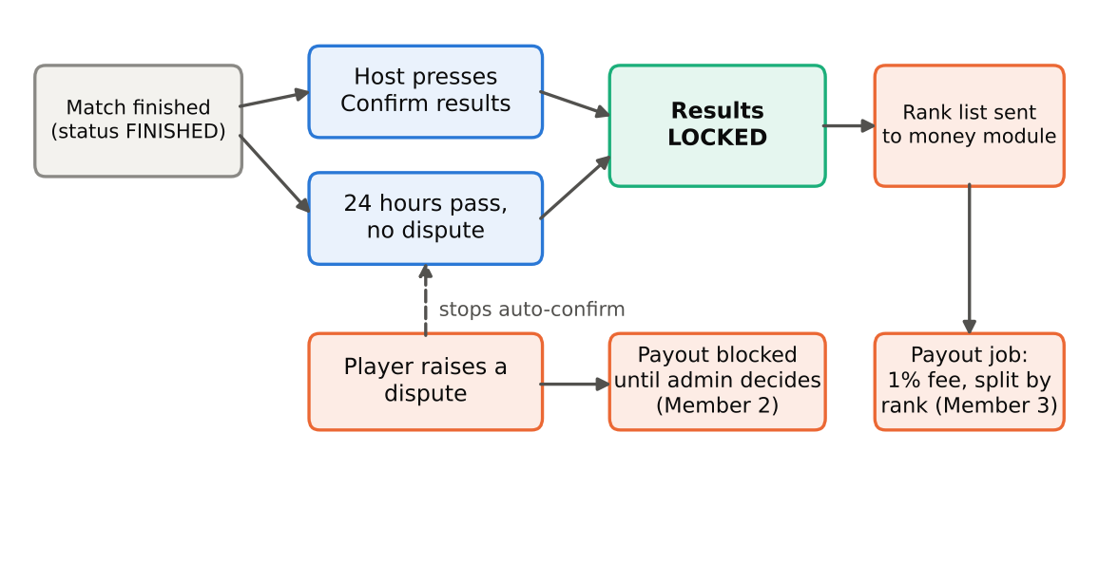
Figure 5.3: Result locking: confirmation, auto-confirmation, dispute and hand-over to payouts

5.12 Organisation Hosting (31 August to 4 September)
I built the organisation host application form (31 August), the admin approval flow (1 September), the higher limits for approved organisations (2 September) and the final profile page (3 September). The whole flow was tested end to end on 4 September. The approval screen sits in the admin area of Member 2, whose final admin dashboard layout was built on 31 August and whose panels were added on 1 and 2 September.

6. HARDENING, LEGAL PAGES AND LAUNCH
Weeks 10 to 14 turned the finished features into a launched product. This chapter covers the work of those five weeks, which the plan describes as testing, legal pages, launch and the weeks after launch.

6.1 End-to-end Test Script (7 to 9 September)
On 7 September I wrote a script that walks through signup, room creation and join. On 8 September I extended it to solve a question and show the results, so that it covers the whole path from a new account to a result. On 9 September I ran the script and fixed what broke. The script stands in for a user and can be run again after any change; I re-ran it on 30 September after the first tournament. In the same week Member 2 ran the judge load test (7 to 9 September) and Member 3 simulated 200 and then 500 players polling one room (7 and 8 September), and a few days later Member 2 tested the whole app as a stranger would, from signup to match (14 September).

6.2 Accessibility Checks (10 and 11 September)
On 10 September I did a keyboard check of the auth pages, and on 11 September a screen-reader check of the room pages. Member 5 worked on the same goal from the design side: colour contrast of at least 4.5:1 (7 and 8 September), clear focus states on buttons and inputs (9 September) and a final accessibility re-check on 5 October. The log records that the checks were done; it does not list the individual findings.

6.3 Legal Pages and the Acceptance Checkbox (14 to 18 September)
I wrote the terms of service on 14 September, the privacy policy on 15 September, the refund policy on 16 September and the webcam consent text on 17 September. On 18 September I added the acceptance checkbox at signup and tested it. The refund policy follows the refund work of Member 3 (19 and 20 August) and the live-mode checklist for paid contests that Member 3 wrote on 16 September, and the webcam consent text matches the consent page that I built on 11 August and the consent screen of Member 5. Member 3 filed the written confirmation about paid contests on 17 September.

6.4 Code Freeze and Launch Week (21 to 25 September)
The code freeze and final checks were on 21 September. Member 3 deployed to production on 22 September, the day I watched signups and OTP delivery. On 23 September I watched login errors, and on 24 September I monitored the first real tournament; Member 3’s log records that the small tournament with friends was run on 23 September and that the payouts were checked on 24 September. Member 4 monitored locks and snapshots during the event (22 and 23 September). On 25 September the whole team held its retro and I noted what to build next.

6.5 After Launch (28 September to 2 October)
On 28 September I reviewed the signup and login errors from the first tournament and on 29 September I fixed small account and room bugs. On 30 September I re-ran the end-to-end test script. On 1 October I updated api-contract.md for accounts and rooms, so that the contract matches the code as launched, and on 2 October I reviewed my teammates’ pull requests.

6.6 Final Report and Submission (5 and 6 October)
On 5 October I wrote the notes for the final project report, and on 6 October I did the final review and the submission preparation, which ended the logged work.
Table 6.1: Work of weeks 10 to 14
Week | Dates | Work of Member 1
10 | 07-09 to 11-09 | End-to-end script written, extended and run; keyboard and screen-reader checks
11 | 14-09 to 18-09 | Terms, privacy, refund and webcam consent text; acceptance checkbox at signup
12 | 21-09 to 25-09 | Code freeze; monitoring of signups, OTP, login errors and the first real tournament; retro
13 | 28-09 to 02-10 | Error review, small bug fixes, end-to-end script re-run, api-contract.md, pull request reviews
14 | 05-10 to 06-10 | Notes for the final report; final review and submission preparation

7. COLLABORATION WITH OTHER MEMBERS

7.1 Overview of Dependencies and Joint Functions
The plan names the pairs that depend on each other: rooms (Member 1) need the judge (Member 2), tournaments (Member 3) need accounts (Member 1) for payout details, and every page needs the design system (Member 5). The plan also asks module owners to write the request and response of a shared API into a contract file before connecting. Figure 7.1 shows my collaboration map.
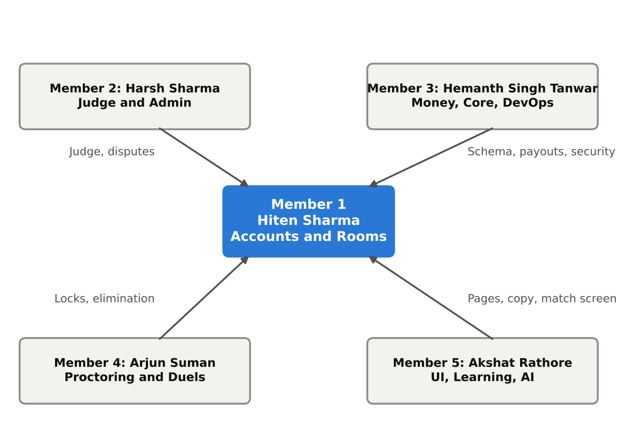
Figure 7.1: Collaboration map of Member 1 with the other four members
Table 7.1: Matrix of joint functions
Joint function | Member 1 side | Other side
Judging a submission | Submission endpoint and on-time check | Member 2: judge, verdicts, concurrency limits
Data model and schema | Room and match model | Member 3: schema V1, migrations, repo layer
Payout details | OTP to the profile mobile | Member 3: payout details and account validation
Final rank list and payouts | Sends the rank list after confirmation | Member 3: payout job, 1% fee, ledger
Tournament lock | Match page refuses locked players | Member 4: lock-state endpoint, snapshots, grace period
Elimination | Server logic with reason | Member 4: eliminate button on host dashboard
Disputes | Result locking waits on disputes | Member 2: dispute form and admin review
Email delivery | OTP mail through lib/mail.js | Member 3: move to a transactional provider (11 September)
Legal pages and paid contests | Refund policy, consent text | Member 3: refund logic, live-mode checklist, written confirmation
Launch | Monitoring of signups, OTP and login errors | Members 3 and 4: deploy, payouts, locks and snapshots
Pages and copy | API behaviour and error cases | Member 5: styling, layouts, empty states, consent and lock screens

7.2 Collaboration with Member 2 (Harsh Sharma)
The submission path is the main link. My endpoint calls Member 2’s judge and stores the result. Member 2 first built the submit flow, the test-case run and verdict storage (13 to 15 July), then I built the endpoint (29 and 30 July). Member 2 added a limit on concurrent runs (27 July), one pending submission per player per question (28 July) and stored the code for later similarity checks (31 July). Disputes are the second link: a dispute blocks payout until an administrator decides (17 to 20 August), which my result locking respects. The organisation approval screen of 1 September uses the admin area of Member 2. After launch, Member 2 tested the app as a stranger (14 September) and reviewed the disputes from the first event (24 September).

7.3 Collaboration with Member 3 (Hemanth Singh Tanwar)
Member 3 is the closest partner. We reviewed the room data model together on 10 July, and Member 3 fixed schema V1 on 13 July. Member 3’s rate limits on login and OTP (20 July), input validation (21 July), CORS rules (22 July), error handler and request logs (23 July) and tests for the auth routes (24 July) harden the routes that I wrote. Member 3 wrote the money API contract with Member 5 and me on 7 August. Payments follow the account rules: entry fee checkout (17 August), join after payment (18 August) and the age rule (19 August) fit together. The payout details of Member 3 use the OTP and the mobile number of my module (24 August). The rank list that I sent on 26 August feeds the payout job of 26 and 27 August, and we tested result locking together on 27 August. The security review of 31 August to 3 September, with tests for SQL injection, session fixation and token misuse, applied directly to my sessions. In week 10 Member 3 moved email from Gmail to a transactional provider (11 September), and in weeks 11 and 12 prepared the live-mode checklist, deployed to production and ran the first real tournament.

7.4 Collaboration with Member 4 (Arjun Suman)
Member 4 owns the proctoring endpoints: the contract (10 July), then snapshot, violation log and lock state (13 to 15 July). My match page refuses locked players on every request (12 August) and the lock check was tested on 13 August. Member 4 set the tab and minimize lock on the server on 12 August and added the 30 second grace period on 13 August. The host dashboard of Member 4 (17 to 20 August) shows the live player list and the eliminate button, which calls my elimination logic. In weeks 10 to 12 Member 4 tested refresh, two tabs, an unplugged camera and a slow network (7 to 11 September), ran three mock matches (14 to 16 September) and monitored the locks and snapshots during the first event (22 and 23 September).

7.5 Collaboration with Member 5 (Akshat Rathore)
Member 5 gave the pages their look and wording. The login, signup and verify-otp pages (17 July) show the OTP flows of week 2. Member 5 designed create-room and its filters (20 and 21 July) and the Arena cards (22 July), built the match page with the editor, timer, polling scoreboard and countdown (27 to 30 July), and agreed the hook in play.js for saving wrong submissions with me on 3 August, because play.js is shared. The consent, camera check and lock screens (10 to 12 August) match my consent page and lock refusal. The money screens of 24 to 28 August use the results that I lock. In weeks 10 to 14 Member 5 worked on contrast and focus states (7 to 9 September), the final index page (14 September) and the feedback of the first players (24 and 28 September).

7.6 Team-Wide Activities
All members follow the same working rhythm from the plan: a short Monday planning meeting, a Wednesday stand-up, a Friday demo and a retro. Main is always deployable, changes merge through a pull request that one other member reviews, and shared files such as schema.sql, index.js and api.js are changed through Member 3 and Member 5. The whole team held a retro on 25 September and reviewed each other’s pull requests on 2 October, and every member’s log ends with the final review and submission preparation on 6 October.

7.7 Summary of Collaboration
My modules sit at both ends of a contest. Accounts open the door and rooms run the match; everything in between is supplied by others: the judge by Member 2, the data and money by Member 3, the locks by Member 4 and the screens by Member 5. The dates in Appendix B show that each side delivered its part before the other side needed it. Figure 7.2 counts the dated joint work items of Appendix B for each partner, split between the build weeks and the hardening and launch weeks. Member 3 is the busiest partner, which matches the shared data model, security, payouts and deployment.
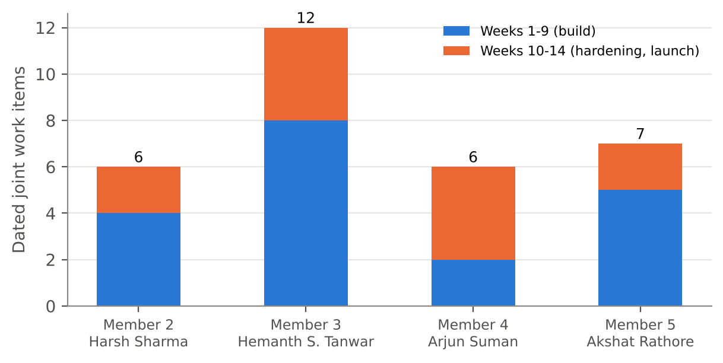
Figure 7.2: Joint work items per partner (from Appendix B)

8. TESTING AND VERIFICATION

8.1 Test Strategy
The plan’s definition of done says a feature must work in the browser, have a test or smoke check, show no fake numbers, have hand-written empty and error messages, and be merged to main. I followed this by pairing nearly every build week with a dedicated testing day and a bug-fix day.

8.2 Tests Recorded in the Work Log
Table 8.1: Tests carried out by Member 1
Date | Test | What it checked
24-07-2026 | Room creation test | Validation, defaults and form connection; bugs fixed the same day
31-07-2026 | Full solo room with two users | The Milestone 1 scenario on the join, submit, judge and scoreboard path
06-08-2026 | New account shows zero everywhere | Profile counters come from real records
13-08-2026 | Lock check on every request | Locked players are refused by the match page
20-08-2026 | Elimination and age rule | No rejoin, ranking removal, 18+ for paid tournaments
27-08-2026 | Result locking with Member 3 | Confirm, auto-confirm and delivery of the rank list to payouts
04-09-2026 | Organisation flow end to end | Application, approval, higher limits and profile
07-09 to 09-09-2026 | End-to-end script | Signup, room creation, join, solving a question and results; fixes on 09-09
10-09-2026 | Keyboard check | Auth pages can be used with the keyboard
11-09-2026 | Screen-reader check | Room pages work with a screen reader
18-09-2026 | Acceptance checkbox | Signup with the terms and privacy checkbox
30-09-2026 | End-to-end script re-run | The whole path still works after the first tournament

8.3 Bug-fix Days
Bug-fix entries appear on 7 August (bugs found in testing), 14 August (issues found in testing), 21 August (bugs fixed and code reviewed), 28 August (bugs from testing), 9 September (fixes after the first run of the end-to-end script) and 29 September (small account and room bugs after the first tournament). Room creation bugs were also fixed on the testing day of 24 July. The log does not list each bug, so this report does not either.

8.4 Verification by Other Members
Member 3’s tests for the auth routes (24 July), the test checklist before Milestone 1 (31 July) and the security tests (31 August to 3 September) covered code written by me. Member 2’s stranger test (14 September) went from signup to match, and Member 4’s mock matches (14 to 16 September) and the first real tournament (23 September) exercised my room, join and lock code under real use.

8.5 Points to Note
- The tie-break order and the full set of PRD defaults are in the code, but the log does not spell them out. Author to add both in Sections 5.3 and 5.8.
- The log records that the keyboard and screen-reader checks were done but not what they found.
- Email now goes through a transactional provider; OTP delivery was watched on launch day (22 September) and no change to the OTP rules was needed.

9. WEEK-BY-WEEK SUMMARY
Table 9.1 gives the week-by-week summary. Weeks 1 to 13 have 14.5 hours each and week 14 has 5.5 hours.
Table 9.1: Weekly summary of Member 1’s work
Week | Dates (log) | Work | Hours
1 | 06-07 to 10-07 | Audit of auth, cookie flags, gaps list; room and match data model reviewed with Member 3 | 14.5
2 | 13-07 to 17-07 | Email OTP, attempts and resend, SMS OTP, forgot password, profile re-verification | 14.5
3 | 20-07 to 24-07 | Room create API, PRD defaults, create-room page connected, status timer, testing | 14.5
4 | 27-07 to 31-07 | Join by Arena or code, start match, submission endpoint, judge call, on-time check, solo room test | 14.5
5 | 03-08 to 07-08 | Final ranks and tie-break, results data, profile counters, zero-account test, bug fixes | 14.5
6 | 10-08 to 14-08 | Tournament mode option, consent page, locked players refused, lock test, bug fixes | 14.5
7 | 17-08 to 21-08 | Host elimination, no rejoin, 18+ age rule, tests, bug fixes and review | 14.5
8 | 24-08 to 28-08 | Confirm results, 24 hour auto-confirm, rank list to money module, joint test, bug fixes | 14.5
9 | 31-08 to 04-09 | Organisation application, approval, limits, final profile page, end-to-end test | 14.5
10 | 07-09 to 11-09 | End-to-end script written, extended and run; keyboard and screen-reader checks | 14.5
11 | 14-09 to 18-09 | Terms of service, privacy, refund policy, webcam consent text, acceptance checkbox | 14.5
12 | 21-09 to 25-09 | Code freeze, monitoring of signups, OTP, login errors and the first real tournament, retro | 14.5
13 | 28-09 to 02-10 | Error review, small bug fixes, script re-run, api-contract.md, pull request reviews | 14.5
14 | 05-10 to 06-10 | Notes for the final report, final review and submission preparation | 5.5
 |  | Total | 194.0

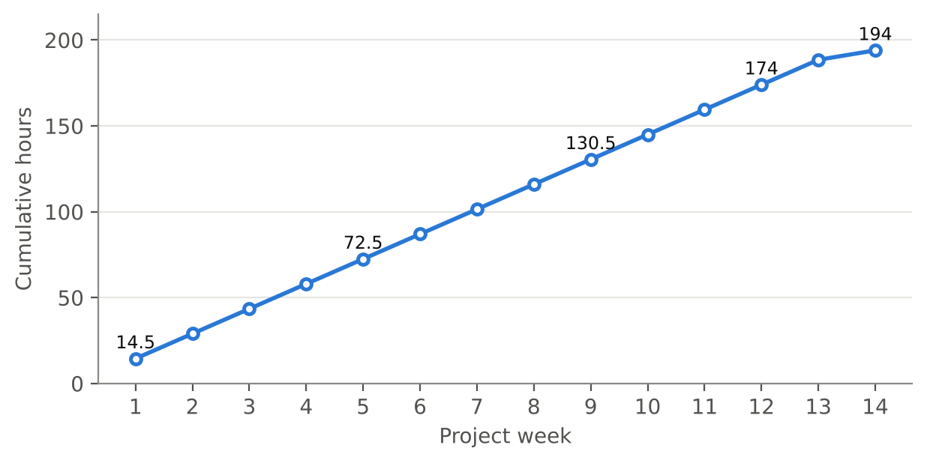
Figure 9.1: Cumulative hours logged by Member 1 week by week
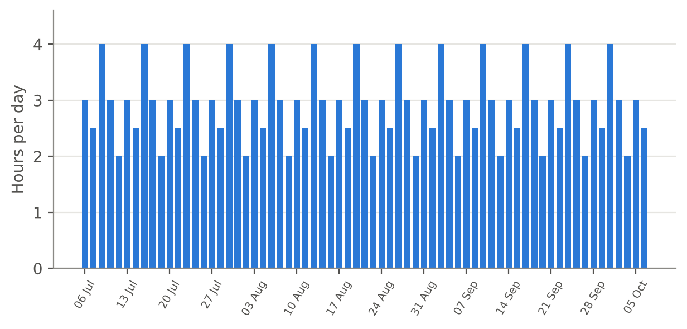
Figure 9.2: Hours logged per day, 6 July to 6 October 2026 (one bar per weekday)

9.1 Weeks 1 and 2: Audit and Accounts
The first week produced the audit and the data model. The second week produced the whole OTP family: email OTP, attempt limits, resend timing, SMS through MSG91, forgot password and profile re-verification.

9.2 Weeks 3 to 5: Rooms, the First Playable Match and Results
Week 3 delivered room creation. Week 4 delivered join, start, submission and judging, ending with the solo room test on 31 July, which is the first milestone of the plan. Week 5 gave the platform ranks, results and honest counters.

9.3 Weeks 6 to 9: Tournament Mode, Host Controls, Result Locking and Organisations
Week 6 added the tournament option and the rule that locked players are refused. Week 7 gave hosts the right to eliminate a player and enforced the age rule. Week 8 closed the loop between a finished match and a payout: confirmation, auto-confirmation and the rank list. Week 9 added organisation hosting and finished the profile page, with a full test of the flow.

9.4 Weeks 10 to 12: Hardening, Legal Pages and Launch
Week 10 gave the project its end-to-end script and the accessibility checks. Week 11 produced the legal pages and the signup checkbox. Week 12 began with the code freeze, followed by launch monitoring and the first real tournament.

9.5 Weeks 13 and 14: After Launch and Handover
Week 13 reviewed the errors of the first tournament, fixed small bugs, re-ran the end-to-end script and brought api-contract.md up to date. Week 14 prepared the notes for this report and the final submission.

10. CHALLENGES, DECISIONS AND LIMITATIONS

10.1 Challenges and How They Were Met
Table 10.1: Challenges and responses
Challenge | Response
Existing code did not match the PRD | Audited auth first and listed the gaps before building new features
OTP can be abused by guessing or flooding | 5 attempt limit, 5 minute expiry and 60 second resend
Players or hosts could try to change time or status from the browser | Status timer and on-time check run on the server
A paid tournament needs trustworthy age and contact details | 18+ rule and re-verification of email and mobile changes
Locks set by one module must be respected by another | Match page refuses locked players on every request, tested on 13 August
Results must not be changed after payouts begin | Host confirmation or 24 hour auto-confirm before the rank list is sent
Shared files can cause merge conflicts | Changes to play.js agreed with Member 5; schema changes go through Member 3
Users must accept legal terms before a paid contest | Terms, privacy, refund and webcam consent text, with an acceptance checkbox at signup (14 to 18 September)
The first real tournament could expose errors that tests miss | Monitored signups, OTP delivery and login errors; reviewed and fixed what appeared (22 to 29 September)

10.2 Delivered Features
Table 10.2: Status of Member 1’s features
Feature | Status
Email OTP, SMS OTP, forgot password, profile re-verification | Delivered (log, 13 to 17 July)
Room create, defaults, status timer | Delivered (log, 20 to 24 July)
Join, start, submission endpoint, on-time check | Delivered (log, 27 to 31 July)
Results, tie-break, profile counters | Delivered (log, 3 to 7 August)
Tournament mode, consent, lock refusal | Delivered (log, 10 to 14 August)
Elimination, age rule | Delivered (log, 17 to 21 August)
Result locking and rank list | Delivered (log, 24 to 28 August)
Organisation hosting | Delivered (log, 31 August to 4 September)
End-to-end script, keyboard and screen-reader check | Delivered (log, 7 to 11 September)
Legal pages and signup acceptance checkbox | Delivered (log, 14 to 18 September)
Launch monitoring and first tournament | Delivered (log, 21 to 25 September)
Post-launch fixes, API contract and report preparation | Delivered (log, 28 September to 6 October)

10.3 Notes on the Sources
- The log describes each task in one line. Details such as the tie-break order, the exact PRD default values and the OTP table design are not stated in either document, so they are not invented here.
- Dates and hours are those of the log. They are the only source for what was done on each day.
- The plan lists twelve weeks of tasks; the log covers fourteen project weeks, and the last two are the review after launch and the preparation of this report.

10.4 Limitations
The report relies on the plan and the log and does not contain test output or code listings. Hours are as recorded in the log. Before submission I should fill in the two highlighted points (the tie-break order and the PRD default values).

11. CONCLUSION AND FUTURE SCOPE

11.1 Conclusion
Over fourteen logged weeks and 194.0 hours, I delivered the accounts and OTP module and the rooms and matches module of HackAgon and took them through testing, legal pages and launch. A user can sign up and verify by email or SMS, recover a password, edit a profile with re-verification, accept the terms, create a room with sensible editable defaults, join by the Arena or an invite code, submit code that is judged and scored on time, see ranks and honest counters, and play in tournament mode under locks. Hosts can eliminate players and confirm results, and organisations can apply for higher limits. The first real tournament ran on 23 September, and the weeks after it were used to review the errors and fix small bugs. Each task is traced to a dated log entry and to the partner module it connects with.

11.2 Lessons Learnt
- Auditing before building saves time, because the existing skeleton already covered part of the work.
- Server-side rules for time, locks and results are the base of fairness in any contest platform.
- A shared OTP library keeps signup, reset and profile change consistent, and let the mail provider change without touching the rules.
- Early agreement on interfaces, such as the rank list for the money module, lets two members finish within days of each other.
- A testing day and a bug-fix day after each build week keep the main branch deployable.
- A scripted end-to-end test is cheap to write and was worth re-running after the first real event.

11.3 Future Scope
- Add rate-based monitoring of OTP delivery and login errors, since both were checked by hand in launch week.
- Run the end-to-end script automatically on every deploy.
- Record the findings of the keyboard and screen-reader checks and repeat them for new pages.
- Support more room formats and finer host controls once duos, squads and duels are used heavily.
- Have the terms of service, privacy policy and refund policy reviewed by a legal adviser before wider use.

REFERENCES
- HackAgon Team Modules and 12-Week Plan, HackAgon team, 2026.
- HackAgon Daily Work Log, 6 July 2026 to 6 October 2026, HackAgon team.
- Node.js documentation, nodejs.org.
- Express documentation, expressjs.com.
- MySQL Reference Manual, dev.mysql.com.
- MSG91 documentation, msg91.com.
- Nodemailer documentation, nodemailer.com.

APPENDIX A: COMPLETE DAILY WORK LOG OF MEMBER 1
The log below is reproduced from the HackAgon Daily Work Log, Member 1 (Accounts, Rooms), 6 July 2026 to 6 October 2026. Total: 67 days, 194.0 hours.
Table A.1: Daily work log of Member 1
Date | Hrs | Status | Work description
Week 1
06-07-2026 | 3 | Completed | Read routes/auth.js and lib/auth.js to understand login flow
07-07-2026 | 2.5 | Completed | Checked password hashing and JWT expiry settings
08-07-2026 | 4 | Completed | Checked cookie flags and listed gaps against the PRD
09-07-2026 | 3 | Completed | Drafted room and match data model
10-07-2026 | 2 | Completed | Reviewed data model with Member 3 and noted changes
Week 2
13-07-2026 | 3 | Completed | Built email OTP with 5 minute expiry
14-07-2026 | 2.5 | Completed | Added 5 attempt limit and 60 second resend
15-07-2026 | 4 | Completed | Added SMS OTP using MSG91
16-07-2026 | 3 | Completed | Built forgot password flow with OTP
17-07-2026 | 2 | Completed | Built profile edit that asks for new OTP on email or mobile change
Week 3
20-07-2026 | 3 | Completed | Built room create API with validation
21-07-2026 | 2.5 | Completed | Added editable PRD default values to room form
22-07-2026 | 4 | Completed | Connected create-room.html to the API
23-07-2026 | 3 | Completed | Added server timer for room status open, live, finished
24-07-2026 | 2 | Completed | Tested room creation and fixed bugs
Week 4
27-07-2026 | 3 | Completed | Built join room by Arena and invite code
28-07-2026 | 2.5 | Completed | Added start match logic
29-07-2026 | 4 | Completed | Built submission endpoint in play.js
30-07-2026 | 3 | Completed | Added judge call and server-side on-time check
31-07-2026 | 2 | Completed | Tested a full solo room with two users
Week 5
03-08-2026 | 3 | Completed | Added final ranks and tie-break rule
04-08-2026 | 2.5 | Completed | Built results page data
05-08-2026 | 4 | Completed | Calculated profile counters from real records
06-08-2026 | 3 | Completed | Tested that a new account shows zero everywhere
07-08-2026 | 2 | Completed | Fixed bugs found in testing
Week 6
10-08-2026 | 3 | Completed | Added tournament mode option to room creation
11-08-2026 | 2.5 | Completed | Built consent page before joining
12-08-2026 | 4 | Completed | Made match page refuse locked players
13-08-2026 | 3 | Completed | Tested lock check on every request
14-08-2026 | 2 | Completed | Fixed issues found in testing
Week 7
17-08-2026 | 3 | Completed | Built host eliminate player with reason
18-08-2026 | 2.5 | Completed | Blocked rejoin and removed eliminated score from ranking
19-08-2026 | 4 | Completed | Added 18+ age rule for paid tournaments
20-08-2026 | 3 | Completed | Tested elimination and age rule
21-08-2026 | 2 | Completed | Fixed bugs and reviewed code
Week 8
24-08-2026 | 3 | Completed | Built host confirm results button
25-08-2026 | 2.5 | Completed | Added 24 hour auto-confirm with no dispute
26-08-2026 | 4 | Completed | Sent final rank list to the money module
27-08-2026 | 3 | Completed | Tested result locking with Member 3
28-08-2026 | 2 | Completed | Fixed bugs from testing
Week 9
31-08-2026 | 3 | Completed | Built organization host application form
01-09-2026 | 2.5 | Completed | Built admin approval flow for organizations
02-09-2026 | 4 | Completed | Added higher limits for approved organizations
03-09-2026 | 3 | Completed | Finalised profile page
04-09-2026 | 2 | Completed | Tested organization flow end to end
Week 10
07-09-2026 | 3 | Completed | Wrote script for signup, room creation and join
08-09-2026 | 2.5 | Completed | Extended script to solve a question and show results
09-09-2026 | 4 | Completed | Ran the script and fixed what broke
10-09-2026 | 3 | Completed | Did keyboard check of auth pages
11-09-2026 | 2 | Completed | Did screen-reader check of room pages
Week 11
14-09-2026 | 3 | Completed | Wrote terms of service
15-09-2026 | 2.5 | Completed | Wrote privacy policy
16-09-2026 | 4 | Completed | Wrote refund policy
17-09-2026 | 3 | Completed | Wrote webcam consent text
18-09-2026 | 2 | Completed | Added acceptance checkbox at signup and tested
Week 12
21-09-2026 | 3 | Completed | Code freeze and final checks
22-09-2026 | 2.5 | Completed | Watched signups and OTP delivery
23-09-2026 | 4 | Completed | Watched login errors
24-09-2026 | 3 | Completed | Monitored the first real tournament
25-09-2026 | 2 | Completed | Held team retro and noted what to build next
Week 13
28-09-2026 | 3 | Completed | Reviewed signup and login errors from first tournament
29-09-2026 | 2.5 | Completed | Fixed small account and room bugs
30-09-2026 | 4 | Completed | Re-ran the end-to-end test script
01-10-2026 | 3 | Completed | Updated api-contract.md for accounts and rooms
02-10-2026 | 2 | Completed | Reviewed teammates' pull requests
Week 14
05-10-2026 | 3 | Completed | Wrote notes for the final project report
06-10-2026 | 2.5 | Completed | Final review and submission preparation

APPENDIX B: DATED JOINT WORK WITH OTHER MEMBERS
Each row pairs a task of Member 1 with the task of another member that it depends on or supports, as recorded in the daily log.
Table B.1: Dated joint work
Member 1 task | Other member task | With
09-07 and 10-07: room and match model drafted and reviewed | 07-07 schema reviewed against PRD; 13-07 schema V1 tables fixed | Member 3
13-07 to 17-07: OTP flows | 20-07 rate limits on login and OTP; 24-07 tests for auth routes | Member 3
13-07 to 17-07: OTP flows | 17-07 login, signup and verify-otp pages styled | Member 5
22-07: create-room.html connected | 24-07 filter API (Member 2); 20-07 and 21-07 create-room page and filters (Member 5) | Member 2, Member 5
29-07 and 30-07: submission endpoint and judge call | 13-07 to 15-07 submit, test cases, verdicts; 27-07 and 28-07 concurrency and pending limits; 31-07 code stored | Member 2
31-07: full solo room with two users | 30-07 Milestone 1 deployed; 31-07 test checklist | Member 3
04-08 to 06-08: results and counters | 27-07 to 31-07 match.html, scoreboard, countdown; 03-08 hook in play.js agreed | Member 5
07-08: money API contract | 07-08 contract written with Members 1 and 5 | Member 3
11-08: consent page | 10-08 to 12-08 consent, camera check and lock screens designed | Member 5
12-08 and 13-08: lock refusal and test | 15-07 lock-state endpoint; 12-08 tab and minimize lock; 13-08 grace period | Member 4
17-08 and 18-08: elimination logic | 17-08 live player list; 20-08 eliminate button | Member 4
19-08: age rule for paid tournaments | 17-08 entry fee checkout; 18-08 join after payment | Member 3
24-08 and 25-08: confirm and auto-confirm | 17-08 to 20-08 dispute form, payout block, admin review | Member 2
26-08 and 27-08: rank list sent and joint test | 26-08 payout job with 1% fee; 27-08 split by rank and leftover paise | Member 3
17-07 and 24-08: profile mobile change needs OTP | 24-08 payout details with OTP to profile mobile | Member 3
01-09: organization approval flow | 03-08 to 07-08 admin login protection and admin screens | Member 2
01-09 to 03-09: security review of sessions | 01-09 SQL injection test; 02-09 session fixation and token misuse; 03-09 fixes | Member 3
04-09: organization flow end to end | 24-08 to 28-08 money screens, winner screen | Member 5
07-09 to 09-09: end-to-end script | 14-09 Member 2 tested the app as a stranger, signup to match | Member 2
10-09 and 11-09: keyboard and screen-reader checks | 07-09 to 09-09 colour contrast and focus states | Member 5
10-09 to 11-09: auth emails | 11-09 email moved from Gmail to a transactional provider | Member 3
16-09: refund policy | 17-09 written confirmation about paid contests; 16-09 Razorpay live-mode checklist | Member 3
17-09: webcam consent text | 07-09 to 17-09 proctoring tests and mock matches; 18-09 host guide for tournament mode | Member 4
22-09 to 24-09: monitoring signups, OTP, login errors and the first tournament | 22-09 deploy to production; 23-09 first real tournament; 24-09 payouts checked | Member 3
22-09 to 24-09: monitoring | 22-09 and 23-09 locks and snapshots monitored during the event | Member 4
24-09: first tournament | 24-09 disputes from the first event reviewed | Member 2
28-09 to 29-09: account and room bugs | 29-09 lock rules tuned; 29-09 small UI issues fixed from feedback | Member 4, Member 5
01-10: api-contract.md updated for accounts and rooms | 07-08 money API contract (Member 3); 10-07 proctor API contract (Member 4) | Member 3, Member 4

