SYSTEM ARCHITECTURE DOCUMENT
AI Interview Monitoring and Detection System
AI Interview Integrity Platform
Document 3 | Version 1.0 | Derived from PRD v1.0
Architecture purpose
Define the logical components, services, communication paths, data flow, AI pipeline, real-time pipeline, security boundaries and deployment direction required to implement the product requirements established in PRD v1.0.

Field | Value
Baseline source | AI Interview Monitoring and Detection System — PRD v1.0
Architecture style | Modular application architecture; service boundaries are logical and may be deployed together initially
Primary clients | Candidate browser and recruiter browser
Application backend | Node.js + Express.js
AI service | Python + FastAPI
Database | MongoDB
Real-time direction | WebRTC for interview media where required; Socket.io / HTTPS for application events
Initial deployment direction | Local/containerized validation; cloud provider and production topology TBD
Architecture principle | Build only the complexity justified by current requirements; preserve future scalability

1. Architecture Scope and Traceability
This document translates the product requirements in PRD v1.0 into a logical system architecture. It defines how product capabilities are separated into components and how those components communicate. It does not claim that all components are already implemented.
PRD Reference | Architecture Responsibility
PRD-FR-001 | Authentication and role-aware access path
PRD-FR-002 | Interview management/application service
PRD-FR-003 | Candidate system-check flow
PRD-FR-004 | Interview room and real-time communication
PRD-FR-005 | Video capture/monitoring path and CV analysis
PRD-FR-006 | Suspicious-event generation and event normalization
PRD-FR-007 | Real-time alert delivery
PRD-FR-008 | Evidence/event persistence
PRD-FR-009 | Risk/integrity aggregation and presentation
PRD-FR-010 | Report generation and retrieval
PRD-FR-011 | Future audio analysis extension point
PRD-FR-012 | Future NLP analysis extension point
PRD-FR-013 | Proposed screen/activity event extension point
PRD-FR-014 | Evidence review interface

Traceability rule
The SRS should refine these architectural responsibilities into precise software requirements. Later AI/ML, database, UI/UX and testing documents should reference the same requirement IDs.

2. Architecture Goals
- Support the MVP interview workflow from authentication through interview completion.
- Separate application workflow logic from AI/ML inference so models can evolve independently.
- Provide a real-time path for interview events and recruiter alerts.
- Represent monitoring output as timestamped events and evidence references.
- Support future audio, NLP, screen/activity and advanced integrity modules without rewriting the entire application.
- Allow the initial implementation to remain modular and reasonably simple while retaining clear service boundaries.
- Protect candidate and interview data through role-based access, secure transport and controlled persistence.
- Keep deployment choices flexible until actual resource, concurrency and privacy requirements are measured.

3. Architecture Principles
Principle | Application
Modularity | Separate UI, application workflow, AI analysis, integrity/risk, persistence and notification responsibilities.
Single interview context | Interview Session is the central business context linking monitoring events, analysis, alerts and reports.
Event-based monitoring | Prefer normalized events with timestamps and evidence references rather than permanently storing every raw frame.
Evidence before verdict | Architecture must preserve the underlying event/context so a reviewer can inspect it.
Human-in-the-loop | Risk indicators and alerts support recruiter review; they do not automatically determine employment outcomes.
Graceful degradation | Failure of a non-critical analysis component should not unnecessarily terminate the interview.
Scalability by separation | Keep components separable, but do not deploy microservices merely for appearance.
Replaceable AI | AI detectors should be replaceable without redesigning the complete product.
Security by boundary | Client, application, AI and data access paths should have explicit trust boundaries.

4. High-Level Logical Architecture
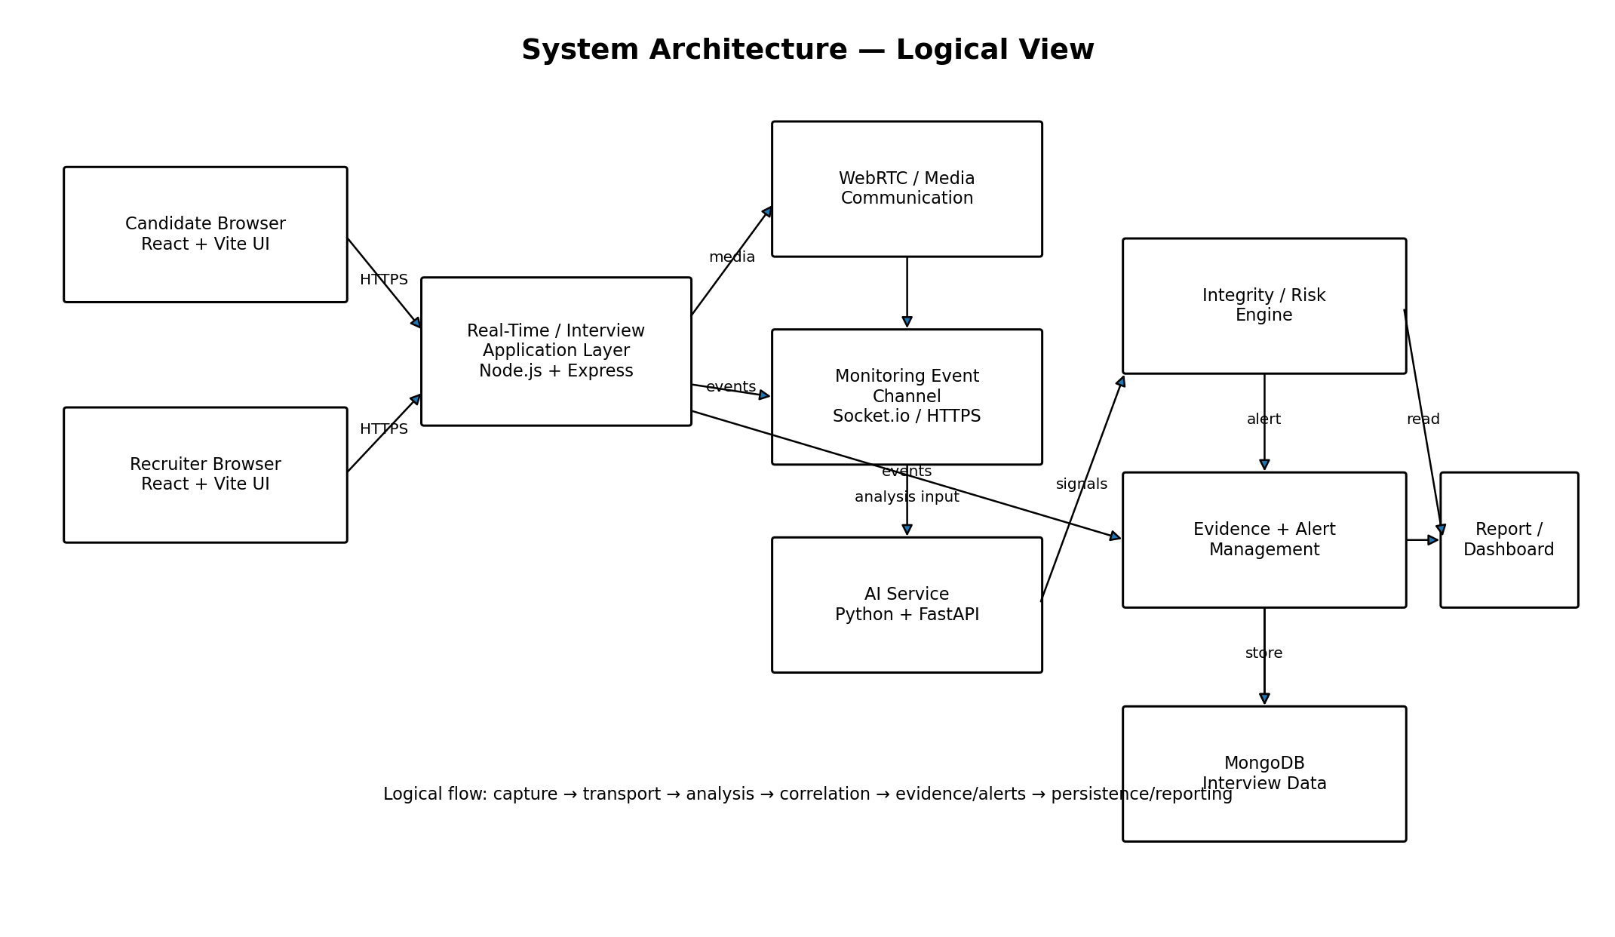
Figure 1. Logical system architecture. The diagram shows the intended separation of client, application, real-time communication, AI analysis, integrity/risk, evidence/alerts and persistence responsibilities.
The architecture is intentionally logical rather than a final cloud topology. Exact deployment placement, scaling strategy and media routing remain subject to later benchmarking and infrastructure decisions.

5. System Components
Component ID | Component | Responsibility | Primary Interfaces | Status
ARCH-C-001 | Candidate Web Client | Candidate login/invite flow, system check, interview room, monitoring permissions and completion. | HTTPS; WebRTC; Socket.io/HTTPS events | Baseline
ARCH-C-002 | Recruiter Web Client | Recruiter dashboard, interview creation, live monitoring, alerts, evidence review and reports. | HTTPS; Socket.io/HTTPS events | Baseline
ARCH-C-003 | Application/API Layer | Authentication, authorization, interview management, session state, API orchestration and report access. | HTTPS/REST; internal service calls | Baseline
ARCH-C-004 | Interview/Session Module | Creates and manages interview sessions, lifecycle state and participant association. | Application API; DB | Baseline
ARCH-C-005 | Real-Time Communication Module | Coordinates interview-room signaling and real-time event delivery. | WebRTC signaling path; Socket.io | Baseline direction
ARCH-C-006 | Monitoring Ingestion Module | Accepts selected monitoring events/data from clients and normalizes them for processing. | Socket.io/HTTPS | Proposed
ARCH-C-007 | AI Analysis Service | Runs selected CV/audio/NLP analysis and emits structured analysis results. | Internal HTTP/API | Baseline direction
ARCH-C-008 | Integrity/Risk Engine | Combines events and model outputs into interpretable risk indicators and alert candidates. | Internal service interface | Proposed
ARCH-C-009 | Evidence/Alert Module | Persists event metadata/evidence references and creates recruiter-facing alerts. | Application API; DB; real-time channel | Proposed
ARCH-C-010 | Persistence Layer | Stores users, interviews, events, analysis results, alerts and reports. | MongoDB driver/API | Baseline
ARCH-C-011 | Report Module | Builds and retrieves post-interview integrity summaries. | Application API; DB | P1

6. Logical Services / Modules
The following are logical service boundaries. During the MVP, several of them may run inside one Node.js application process rather than as independently deployed microservices.
Service/Module | Core Responsibilities | May Run Separately Later?
Auth & Access | Authentication, role checks, session/token validation. | Yes
Interview Management | Create interview, lifecycle state, candidate association. | Yes
Interview Room / Signaling | Room state and signaling required for real-time communication. | Yes
Monitoring Ingestion | Normalize incoming monitoring events/data. | Yes
CV Analysis | Process selected webcam frames/signals. | Yes
Audio Analysis | Future speech/audio analysis. | Yes
NLP Analysis | Future transcript/response analysis. | Yes
Integrity / Risk Engine | Correlate signals, apply defined rules/model outputs, create risk indicators. | Yes
Alert Service | Create and deliver recruiter-facing alerts. | Yes
Evidence Service | Manage event metadata and references to supporting evidence. | Yes
Reporting | Generate post-interview summaries. | Yes
Persistence | Database access and data models. | Usually shared through application/service boundaries; exact deployment TBD

7. End-to-End Data Flow
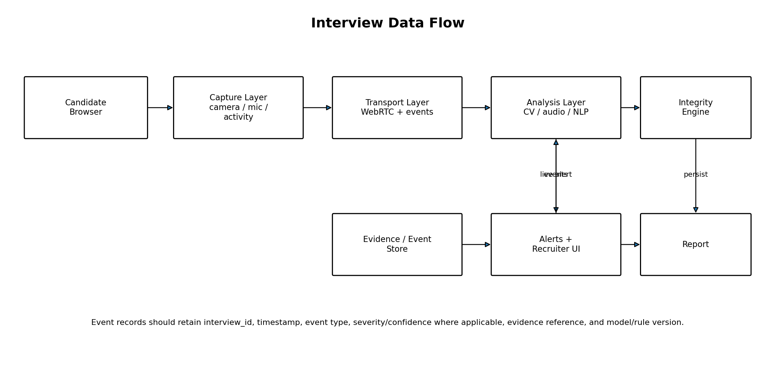
Figure 2. Logical interview data flow.
- Candidate enters the interview workflow through the browser client.
- Client performs the required pre-interview system checks.
- Interview session is established and associated with recruiter/candidate identities.
- Interview media and permitted monitoring inputs are captured according to the selected implementation.
- Real-time communication transports interview media/signaling and monitoring events through their respective paths.
- Monitoring ingestion normalizes relevant events into a common event representation.
- Selected inputs are sent to the applicable analysis component.
- Analysis components return structured signals with timestamps and confidence where applicable.
- Integrity/Risk Engine correlates relevant signals and determines whether an alert candidate or risk indicator should be generated.
- Evidence/Alert Module persists event metadata and sends configured alerts to the recruiter.
- After the interview, the reporting layer retrieves relevant events and produces the integrity summary.

8. Canonical Monitoring Event
The event model is derived from the PRD alert/evidence requirements. The exact MongoDB schema will be specified in Document 4 — Database Specification.
Field | Purpose | Requirement Link
event_id | Unique identifier for the event. | PRD-FR-006 / PRD alert requirements
interview_id | Associates event with central interview session. | PRD-FR-008
timestamp | Identifies when event occurred. | PRD-FR-008
event_type | Identifies observable event category. | PRD-FR-006
severity | Represents configured importance; exact levels/thresholds TBD. | PRD-FR-007
confidence | Separates model confidence from severity. | PRD-FR-006
evidence_reference | Points to supporting evidence/context where available. | PRD-FR-008
source | Identifies detector/rule/component producing the event. | Architecture traceability
model_or_rule_version | Supports reproducibility/version tracking where applicable. | PRD alert requirements
review_status | Supports later recruiter review workflow. | PRD-FR-014

Important distinction
Severity answers 'how important is this event for review?' Confidence answers 'how confident was the detector?' They must not be treated as the same value.

9. AI / Integrity Analysis Pipeline
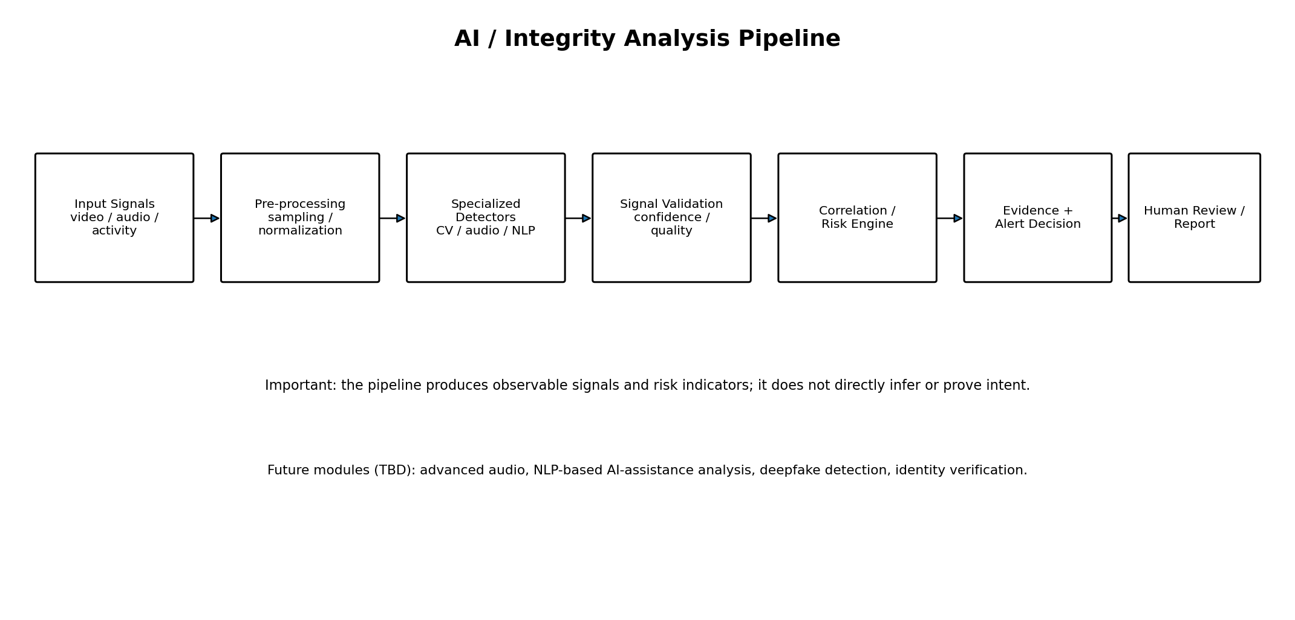
Figure 3. AI and integrity-analysis pipeline.

9.1 Pipeline Stages
Stage | Responsibility | Current Scope
Input | Receive selected video/audio/activity inputs. | Video is MVP; audio/NLP/activity are staged.
Pre-processing | Sampling, normalization, quality checks and conversion into model-ready inputs. | Required as applicable
Specialized Detection | Run the appropriate detector for the input type. | CV is MVP; audio/NLP future/proposed
Signal Validation | Attach confidence and verify basic input/model quality. | Required
Correlation / Risk | Combine relevant events/signals using explicit rules or models. | MVP/P1; exact method TBD
Evidence + Alert | Create event/alert records when configured criteria are met. | MVP
Human Review / Report | Present events and evidence for recruiter review. | MVP/P1

9.2 AI Module Boundaries
- Computer Vision: selected observable webcam signals such as face presence, multiple-person presence and selected head/gaze/movement signals.
- Audio/Speech: future extension for speech capture, transcription and selected audio features.
- NLP: future extension for transcript and response analysis, including potential AI-assistance indicators; model and evaluation protocol are TBD.
- Screen/Activity: proposed extension based on technically accessible browser/OS signals.
- Integrity/Risk Engine: combines signals and confidence values; it does not infer intent as a directly observed fact.
AI architecture constraint
No single detector is treated as a definitive cheating detector. The architecture must preserve the source event and detector confidence so that later evaluation can measure false positives, false negatives and limitations.

10. Real-Time Pipeline
Step | Component | Real-Time Action
RT-01 | Candidate Client | Captures permitted live inputs and produces interview-room events.
RT-02 | Communication Layer | Maintains interview-room signaling/media paths using the selected WebRTC architecture.
RT-03 | Event Channel | Transmits normalized application/monitoring events using Socket.io and/or HTTPS as appropriate.
RT-04 | Monitoring Ingestion | Validates and normalizes incoming monitoring events.
RT-05 | AI Service | Processes selected inputs and returns structured analysis results.
RT-06 | Integrity/Risk Engine | Correlates relevant signals and determines alert candidates.
RT-07 | Alert Module | Persists alert/event metadata and publishes recruiter-facing alert.
RT-08 | Recruiter Client | Displays the alert and associated context/evidence reference.

Latency requirement
PRD v1.0 does not define a numeric latency target. The system architecture therefore uses a low-latency event path, but the actual target must be established through benchmarking in testing.

11. Communication Architecture
Communication Path | Protocol / Direction | Purpose | Status
Browser → Application API | HTTPS / REST | Authentication, interview management, report retrieval and standard API operations. | Baseline
Candidate ↔ Interview Room | WebRTC (with signaling) | Real-time interview media where the selected implementation uses WebRTC. | Baseline direction
Client ↔ Real-Time Event Layer | Socket.io / HTTPS | Live monitoring events, session events and recruiter alerts. | Baseline direction
Application → AI Service | Internal HTTP API | Send selected analysis inputs/metadata and receive structured results. | Proposed
Application → MongoDB | MongoDB driver/API over secured connection | Persist application and monitoring data. | Baseline
Recruiter Client → Application | HTTPS | Dashboard queries, evidence/report retrieval and actions. | Baseline

11.1 API Communication Rule
The application API is the primary authorization boundary. Clients should not receive unrestricted direct access to internal AI services or database resources. Internal service access should be authenticated/controlled even when services run on the same host in the MVP.

12. Security Architecture
Security Area | Architecture Requirement
Identity | Authenticate users before access to protected workflows.
Authorization | Enforce role-aware access for recruiter and candidate resources.
Session security | Use secure session/token handling and expiration appropriate to the chosen authentication design; exact mechanism is SRS/TBD.
Transport security | Use HTTPS/TLS for protected network communication in deployed environments.
Service boundary | Keep AI and database interfaces behind controlled application/service access.
Data protection | Protect sensitive interview data and evidence at rest where applicable; exact encryption implementation is TBD.
Evidence access | Restrict evidence and reports to authorized users associated with the relevant organization/interview.
Secrets | Do not hard-code API keys, database credentials or signing secrets in source code.
Logging | Avoid placing unnecessary candidate media or sensitive content into ordinary application logs.
Auditability | Production implementation should log security-relevant access/actions where required.
Privacy | Collect only required monitoring data and define retention before production deployment.

12.1 Trust Boundaries
- Untrusted external browser environment: candidate/recruiter devices.
- Application boundary: validates identity, authorization and input.
- AI boundary: accepts only required inputs and returns structured results.
- Data boundary: database and evidence storage are accessible only through controlled application/service paths.
- External infrastructure boundary: cloud services, if used, must be evaluated for security, privacy, cost and terms before adoption.

13. Reliability and Failure Handling
The architecture should distinguish critical interview functions from non-critical analysis functions.
Failure | Expected Architectural Response
Camera unavailable | Candidate system check blocks or requests remediation before interview if camera is required.
Temporary event-channel interruption | Reconnect where possible and mark missing monitoring interval rather than silently fabricating events.
AI service unavailable | Interview workflow should not necessarily terminate; monitoring status should indicate analysis unavailable/degraded.
Single detector failure | Other available detectors continue; failed detector status is recorded.
Database write failure | Do not claim evidence was persisted; surface operational error and use controlled retry where safe.
WebRTC/media issue | Show clear connection state and allow supported recovery/reconnection flow.
Model timeout | Record timeout/error status; do not convert missing inference into a suspicious event.

Integrity rule
System failures must never be transformed into evidence of suspicious candidate behaviour. A missing signal is not a suspicious signal.

14. Deployment Architecture
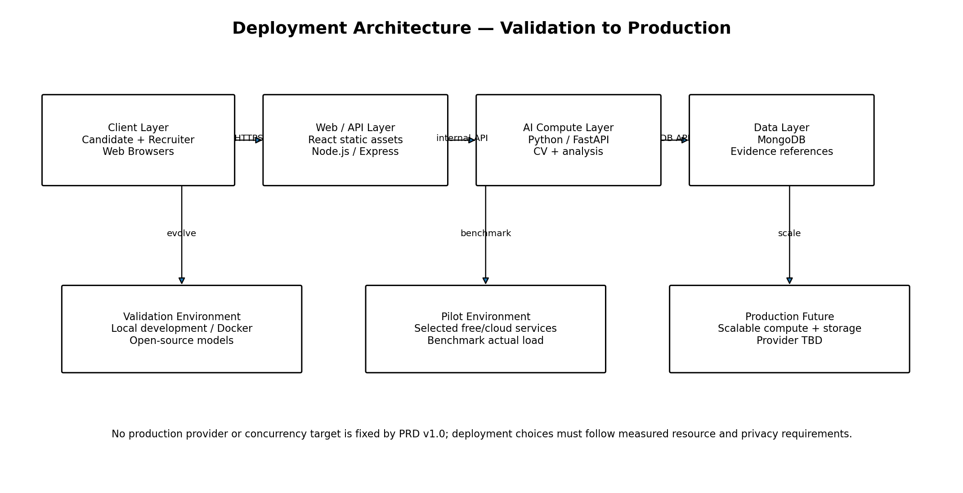
Figure 4. Deployment evolution from validation to future production.
Environment | Purpose | Expected Topology
Local Development | Build and debug core system. | Browser + Node/Express + Python/FastAPI + MongoDB, optionally containerized.
Prototype / Validation | Controlled testing and demonstration. | Frontend hosting + application/API + AI service + database; exact provider TBD.
Pilot | Evaluate real workflows with controlled users. | Separated application and AI resources as needed; benchmark resource use and concurrency.
Production Future | Multi-tenant SaaS and larger workloads. | Scalable web/API, AI compute, data/storage and observability; provider/topology TBD.

The PRD explicitly requires future scalability but does not fix a cloud provider or production concurrency target. Therefore, this document defines deployable logical boundaries without inventing a production infrastructure specification.

15. Scalability Strategy
Layer | Initial Approach | Future Scaling Direction
Frontend | Static web application. | CDN/static hosting and versioned assets.
Application API | Single modular Node.js application. | Horizontal replicas behind a load balancer when required.
AI Service | Python/FastAPI service, initially small-scale. | Separate compute workers/replicas by analysis workload.
Real-Time Layer | Socket.io/WebRTC-compatible architecture. | Dedicated real-time infrastructure if concurrency requires it.
Database | MongoDB. | Indexes, replica/scaling strategy and storage architecture based on measured workload.
Evidence | Event metadata + references; avoid unnecessary raw-frame retention. | Dedicated object storage/media service if validated and required.

Scalability principle
Future scaling should be triggered by measured bottlenecks—CPU/GPU usage, memory, network, database load, media storage and concurrent sessions—not by adopting infrastructure complexity in advance.

16. Observability and Operational Telemetry
- Application health status.
- AI service availability and inference errors.
- Monitoring-event ingestion errors.
- Real-time connection/reconnection status.
- Interview session state transitions.
- Database operation errors and latency.
- Alert delivery status.
- Resource usage during controlled benchmarks.
- Model/rule version associated with model-generated events.
Production observability requirements will be detailed later. Sensitive candidate content should not be indiscriminately written to logs.

17. Architecture-to-Data Relationship
Architecture Component | Primary Data Concepts
Auth & Access | User, role, authentication/session metadata
Interview Management | Interview Session, recruiter/candidate references, lifecycle state
Monitoring Ingestion | Monitoring Event
AI Analysis Service | AI Analysis Result, detector/model metadata
Integrity / Risk Engine | Risk indicator, correlated event references
Alert Module | Alert
Evidence Module | Evidence Reference
Report Module | Final Report

The exact collection structure, field types, indexes, validation rules and relationships belong to Document 4 — Database Specification.

18. Architecture-to-UI Relationship
UI Screen | Architecture Dependencies
Recruiter Dashboard | Application API + Interview Management + Alert Module
Create Interview | Interview Management + Persistence
Live Interview Monitoring | Real-Time Layer + Monitoring Ingestion + Integrity/Risk + Alert Module
Alert Details | Evidence Module + Application API
Interview Report | Report Module + Persistence + Evidence
Candidate System Check | Candidate Client + Application API + browser capability checks
Interview Room | Candidate Client + Real-Time Communication + session state
Completion | Interview Management + Persistence

This mapping will be expanded into screen-level interaction specifications in Document 6 — UI/UX Specification.

19. Technology-to-Component Mapping
Technology | Architecture Component | Reason / Scope
React + Vite | Candidate and recruiter web clients | PRD baseline frontend direction
Tailwind CSS | Web client UI layer | PRD baseline frontend direction
Node.js + Express.js | Application/API layer | PRD baseline backend direction
Python + FastAPI | AI analysis service | PRD baseline AI-service direction
MongoDB | Persistence layer | PRD baseline database direction
OpenCV + MediaPipe | CV analysis module | PRD baseline CV direction
Transformers / BERT-family tooling | Future/proposed NLP module | Model choice must be validated
Local speech-to-text + Librosa | Future/proposed audio module | Exact model and architecture TBD
WebRTC | Interview media/real-time communication | PRD baseline direction
Socket.io | Application/monitoring event channel | PRD baseline direction
Docker | Containerization | PRD baseline direction

Technology constraint
A technology appearing in this table is not evidence that it is already implemented. The implementation plan and repository state must be used to determine what is actually built.

20. Secure Request Flow
- Client initiates a protected operation over HTTPS.
- Application validates authentication/session information.
- Application checks role and resource authorization.
- Application validates request data.
- Application performs the requested operation or calls an internal service.
- Internal service returns a structured result without bypassing the application's authorization model.
- Application persists only required data/evidence references.
- Response is returned to the authorized client.
For monitoring events, the same principle applies: the server should validate interview association and authorized session context rather than trusting client-supplied interview identifiers blindly.

21. Privacy-Aware Data Architecture
- Candidate monitoring should be disclosed before relevant collection begins.
- Only data necessary for defined monitoring purposes should be collected.
- Raw media should not be retained indefinitely by default.
- Event metadata should be preferred where it can satisfy the review requirement.
- Evidence references should be separated from ordinary application logs.
- Retention periods must be explicitly defined before production deployment.
- Access to evidence should be restricted and auditable in production.
- Deletion/retention workflows must be designed before production launch.
These are architecture requirements derived from PRD privacy principles; legal/compliance obligations for a specific deployment are not determined by this document and require separate review.

22. Architecture Decisions and Status
ID | Decision | Status | Rationale / Constraint
ARCH-DEC-001 | Use a modular application architecture initially. | Confirmed direction | Avoid premature microservices while preserving logical boundaries.
ARCH-DEC-002 | Separate AI inference behind a Python/FastAPI boundary. | Confirmed direction | Allows AI components to evolve independently from application workflow.
ARCH-DEC-003 | Use MongoDB as the baseline persistence technology. | Confirmed direction | Matches PRD technology baseline.
ARCH-DEC-004 | Use WebRTC for real-time interview media where required. | Baseline direction | Matches PRD real-time communication direction.
ARCH-DEC-005 | Use Socket.io/HTTPS for real-time application/monitoring events. | Baseline direction | Supports live event/alert flow.
ARCH-DEC-006 | Use event-based evidence as the primary integrity record. | Confirmed principle | Reduces unnecessary retention and supports timestamped review.
ARCH-DEC-007 | Do not make AI risk output an automatic hiring decision. | Confirmed product constraint | Required by PRD responsible-AI requirements.
ARCH-DEC-008 | Production cloud provider and concurrency target remain TBD. | TBD | Must follow benchmarking, privacy, cost and scale requirements.

23. Architecture Open Decisions / TBD
ID | Open Decision | Why Needed | Owner Document
ARCH-TBD-001 | Exact WebRTC media routing/topology for AI access | Determines media server/stream duplication requirements if needed. | SRS + Infrastructure
ARCH-TBD-002 | Exact monitoring-frame/audio sampling strategy | Affects CPU/GPU/network load and detection latency. | AI/ML + Testing
ARCH-TBD-003 | Whether AI service receives raw media, sampled frames/chunks, or derived features | Major privacy/performance architecture choice. | AI/ML + Security
ARCH-TBD-004 | Exact real-time event schema | Required for implementation consistency. | Database + SRS
ARCH-TBD-005 | Alert threshold mechanism | Requires validated detection/risk logic. | AI/ML
ARCH-TBD-006 | Evidence storage technology | Depends on media retention and size. | Database + Infrastructure
ARCH-TBD-007 | Authentication mechanism | Exact protocol/library is not fixed in PRD. | SRS + Security
ARCH-TBD-008 | Production cloud provider | Depends on benchmark, budget, privacy and terms. | Infrastructure
ARCH-TBD-009 | Production concurrency target | Required for capacity planning. | Testing + Infrastructure
ARCH-TBD-010 | Queue/message broker requirement | May be unnecessary for MVP; depends on load and asynchronous processing needs. | Testing + Infrastructure

24. Architecture Test Implications
Test Area | What Must Be Validated
Component integration | Client, API, AI service and database communicate correctly.
Real-time behaviour | Events and alerts reach recruiter with measured latency.
Failure handling | AI/network/database failures do not create false suspicious events.
AI integration | Model outputs are correctly converted into structured events.
Persistence | Interview IDs, timestamps and evidence references remain consistent.
Authorization | Users cannot access unrelated interviews/evidence.
Load | Concurrent interview capacity is measured rather than assumed.
Privacy | Only intended data is collected/stored and logs do not leak sensitive content.

Document 9 — Testing & Evaluation Plan will convert these architectural implications into executable test cases and benchmark procedures.

25. Handoff to Document 4 — Database Specification
The database specification must derive its entities and relationships from this architecture and the PRD. At minimum it must cover the central Interview Session and its relationships to users, monitoring events, AI analysis results, alerts, evidence references and final reports.
Next-document dependency
Document 4 should not invent unrelated data entities. Where architecture has marked a data decision as TBD—especially evidence/media storage, retention or exact event fields—the database document should explicitly resolve or preserve that TBD.

