**EXPERIMENT_4_EXAM REGISTRATION**

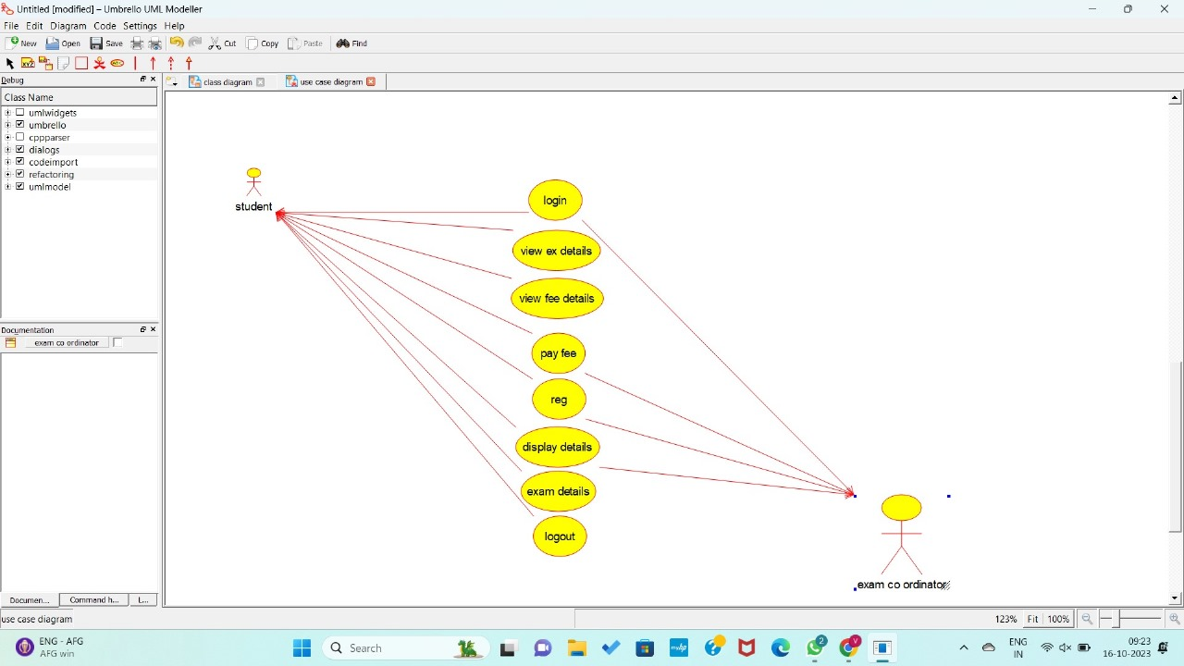USE CASE Diagram

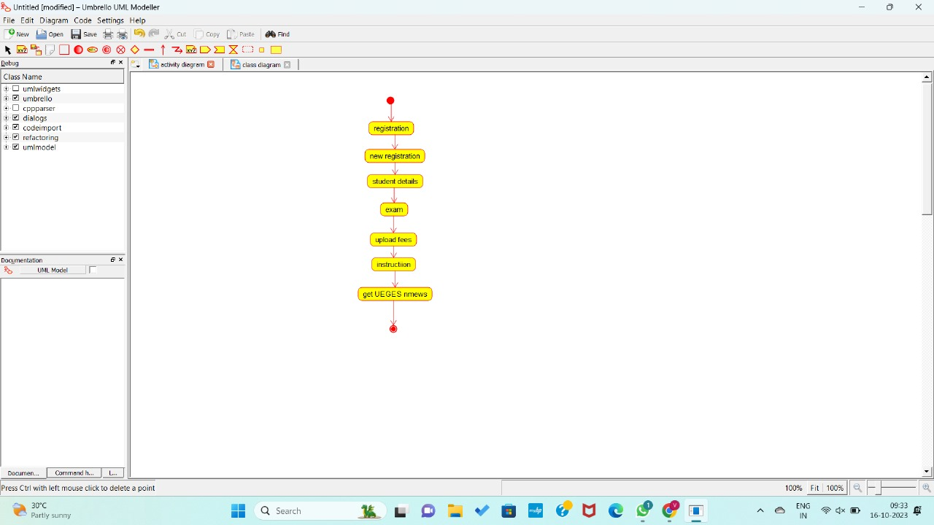

ACTIVITY Diagram

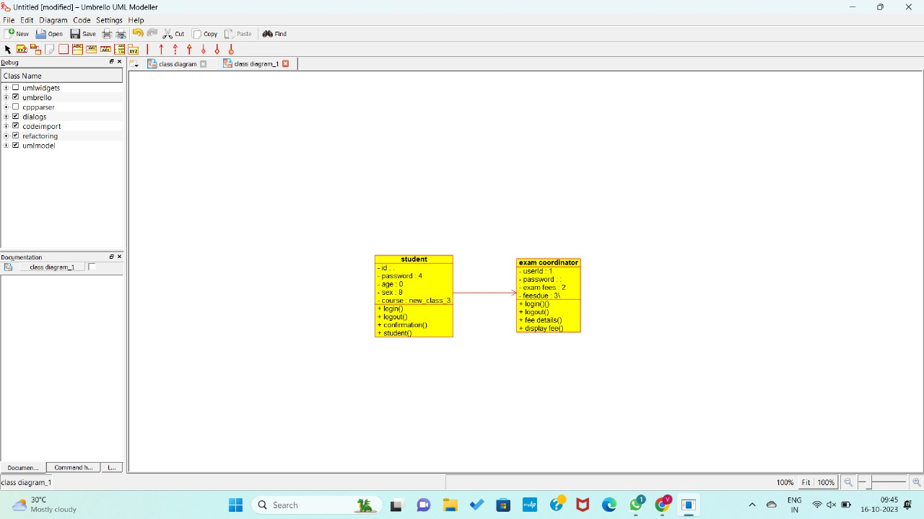

CLASS DIAGRAM

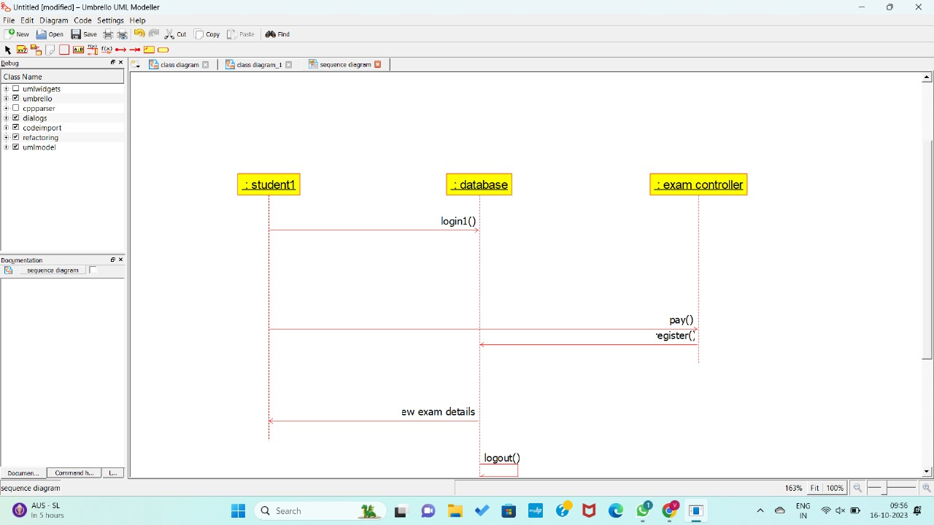

SEQUENCE DIAGRAM

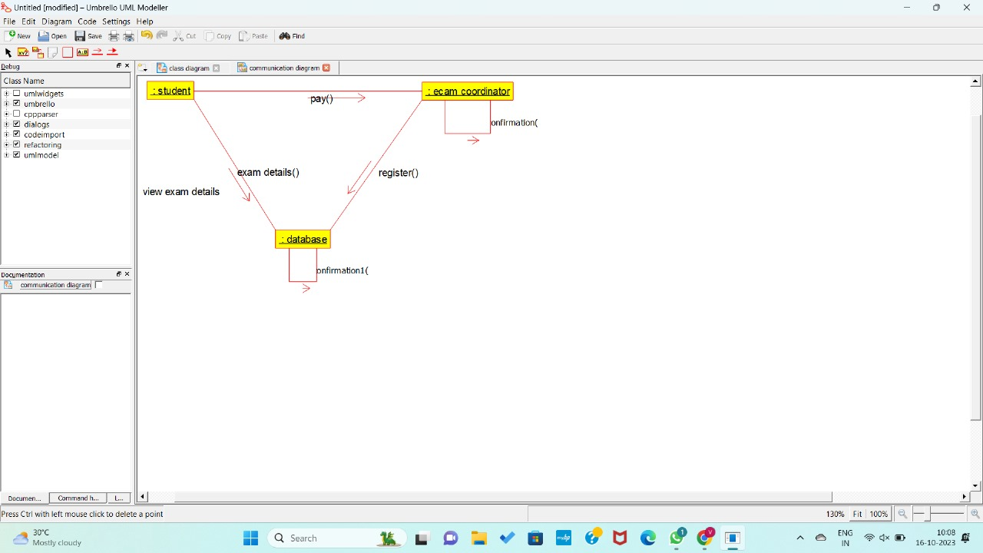

COLLABORATION DIAGRAM

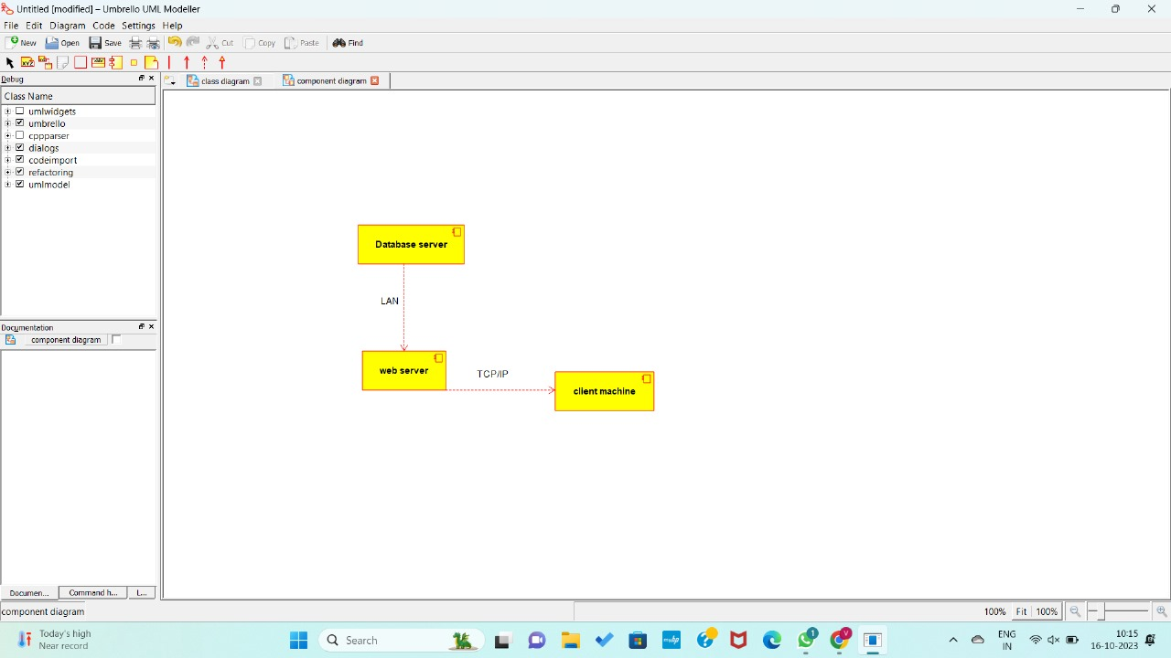

COMPONENT DIAGRAM