ASSMS

Sprint 1 API documentation
REST contracts and Swagger evidence
Field | Value
Sprint | Sprint 1
Status date | 7 September 2026
Primary owner | Developer
Audience | Project team and academic reviewers

Evidence basis Developer Markdown under the service docs folders, controllers, DTOs, SQL migrations, migration scripts, README files and recorded staging verification.

Document control
Field | Value
Document version | 1.0
Prepared on | 7 September 2026
Scope | Sprint 1 implemented interfaces and schemas
Change rule | Update when controller contracts, migrations or verified evidence changes

Evidence interpretation
Documented means the developer notes describe the behavior. Implemented means matching source or SQL exists. Verified means a recorded runtime or database check demonstrated the result. Deferred means the repository explicitly leaves the behavior for later work.

Contents

API documentation approach
The service source is the authoritative API contract. Each ASP.NET Core project enables XML documentation output, Swashbuckle imports controller and DTO comments, and response attributes provide the machine readable response schemas. This keeps Swagger aligned with compiled code.
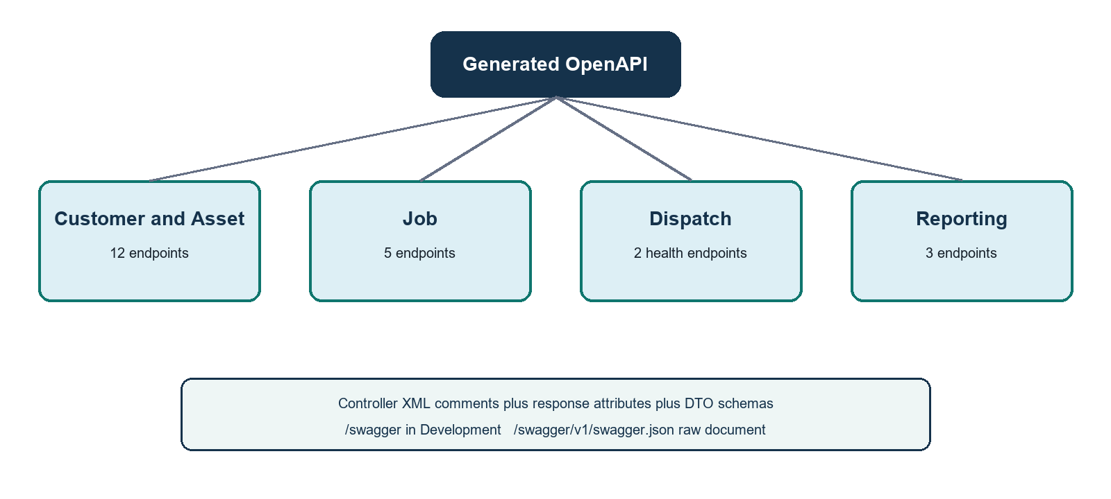
Figure 1 Swagger documentation flow
Implemented | All four service Program files configure Swagger generation and include XML comments when the documentation file exists.

Access | Swagger UI is available at /swagger in Development only. The raw contract is /swagger/v1/swagger.json.

Endpoint catalog

Customer and asset service
Method | Path | Success | Purpose
GET | /api/Health | 200 | Application liveness
GET | /api/Health/db | 200 or 503 | Database reachability
POST | /api/customers | 201 | Create an active customer
GET | /api/customers | 200 | List customers with optional status filter
GET | /api/customers/{id} | 200 or 404 | Get customer in any status
PUT | /api/customers/{id} | 200 | Update an active customer
POST | /api/customers/{id}/deactivate | 200 or 404 | Idempotent soft deactivation
GET | /api/customers/{customerId}/assets | 200 or 404 | List the customer assets
POST | /api/assets | 201 | Register an asset for an active customer
GET | /api/assets/{id} | 200 or 404 | Get asset in any status
PUT | /api/assets/{id} | 200 | Update editable asset fields
POST | /api/assets/{id}/deactivate | 200 or 404 | Idempotent soft deactivation

Job service
Method | Path | Success | Principal failures
GET | /api/Health | 200 | None expected
GET | /api/Health/db | 200 | 503 database unavailable
POST | /api/jobs | 201 and Location header | 400 validation, 409 customer or asset conflict, 503 validation dependency unavailable
GET | /api/jobs/{id} | 200 | 404 unknown job
GET | /api/jobs/reference/{jobReference} | 200 | 404 unknown reference

Reporting service
Method | Path | Result
GET | /api/Health | 200 liveness
GET | /api/Health/db | 200 or 503 database reachability
GET | /api/reports/jobs-by-status | 200 report; optional from and to; 400 invalid filter

Dispatch service
Method | Path | Sprint 1 scope
GET | /api/health | Application liveness
GET | /api/health/db | Database reachability only

Boundary | Technician and assignment endpoints were not part of Sprint 1. The Dispatch API surface contains health endpoints only.

Request models
Model | Client supplied fields | Main constraints
Create or update customer | name, phone, address, customerType, email | Required except email; lengths 100, 20, 255, 20 and 255; valid email; customer type INDIVIDUAL or BUSINESS
Create asset | customerId, assetType, model, serialNumber, installationDate, location, notes | Active customer; five asset types; serial normalized unique; required date; notes optional up to 1000
Update asset | assetType, model, serialNumber, installationDate, location, notes | Owner, status, id and created time are server controlled
Create job | customerId, assetId, serviceCategory, problemDescription, priority, region | Active matching customer and asset; five categories; four priorities; nine provinces; problem up to 1000

Response models
Model | Shape
CustomerResponse | id, submitted customer values, status, createdAt and updatedAt
AssetResponse | id, customerId, submitted asset values, status, createdAt and updatedAt
JobResponse | stored job including JOB reference, status, scheduledDate, createdBy and timestamps
JobsByStatusResponse | statuses array of status and count plus total jobs counted

HTTP and error conventions
Concern | Contract
Media type | JSON responses; camelCase properties and dictionary keys; UTC ISO 8601 timestamps
Created resources | 201 with Location header through CreatedAtAction
Validation | 400 ValidationProblemDetails keyed by input field
Business conflict | 409 keyed ValidationProblemDetails for a field or ProblemDetails for a whole request refusal
Unknown addressed resource | 404 problem response
Unavailable dependency | 503 for database health or Job validation dependency
Deactivation | POST state transition; repeated call returns 200 without moving updatedAt

Representative payloads
Operation | Example
Create customer | {"name":"Nimal Perera","phone":"0771234567","address":"Colombo","customerType":"INDIVIDUAL","email":"nimal@example.com"}
Create job | {"customerId":"<guid>","assetId":"<guid>","serviceCategory":"REPAIR","problemDescription":"Unit does not cool","priority":"HIGH","region":"WESTERN"}
Status report | {"statuses":[{"status":"CREATED","count":12}],"total":12}

Swagger evidence
Evidence | Finding | Assessment
Program configuration | AddSwaggerGen and IncludeXmlComments exist in Customer, Job, Dispatch and Reporting services | Implemented
Controller metadata | Routes, XML summaries and ProducesResponseType attributes describe success and failure schemas | Implemented
DTO metadata | Request and response properties carry XML descriptions and validation attributes | Implemented
Customer and asset runtime | CRUD, negative validation and health paths were exercised in staging | Verified by recorded staging evidence
Job runtime | Create and both retrieval routes plus negative cases were exercised in staging | Verified except Kafka publication
Reporting runtime | Schema, date filter and empty result behavior were exercised in staging | Verified endpoint behavior
Swagger UI in staging | UI is intentionally Development only | Not a staging deliverable

Known boundaries
- Authentication and authorization were not part of the Sprint 1 API contract.
- JobCreated publication and its Reporting consumer were not demonstrated end to end in Azure.
- Health route casing differs because three services use api/[controller] while Dispatch declares lowercase api/health. Clients should use the documented path exactly.
- Swagger carries one response schema per status code, so a 409 with two possible RFC 7807 shapes requires the prose convention as well as the generated schema.

Source register
- assms-customer-asset-service README and docs/api/conventions.md plus customer and asset story notes.
- assms-job-service docs/job-management/US-03-create-job.md.
- assms-reporting-service README and docs/read-model/job-projection.md.
- All four service Program files, controllers and DTO source files.
- Recorded customer, asset, job and reporting staging verification notes under service docs/deployment.

