ASSMS

Sprint 1 Azure deployment
Staging infrastructure network controls and operations
Sprint | Sprint 1
Status date | 7 September 2026
Primary owner | DevOps
Audience | Project team and academic reviewers

Evidence basis Live Sprint 1 Jira backlog plus the six repository workspaces, source code, tests, workflows, Terraform, and recorded staging verification. Planned or deferred work is labelled explicitly.

Document control
Field | Value
Document version | 1.0
Prepared on | 7 September 2026
Sprint state | Closed with documented follow up items
Classification | Project documentation
Change rule | Update this document when Jira acceptance criteria, repository implementation, or deployment evidence changes

How to read this document
Verified means the repository or recorded staging evidence demonstrates the stated result. Implemented means code or configuration exists but the full runtime path was not demonstrated. Planned or deferred means the item remains outside the verified Sprint 1 boundary.

Contents

Deployment scope
Sprint 1 established an Azure staging environment for the frontend, service virtual machines, MySQL and the Kafka host. The topology spans Southeast Asia and Central India because the Azure for Students Southeast Asia vCPU quota did not cover the required VM total.
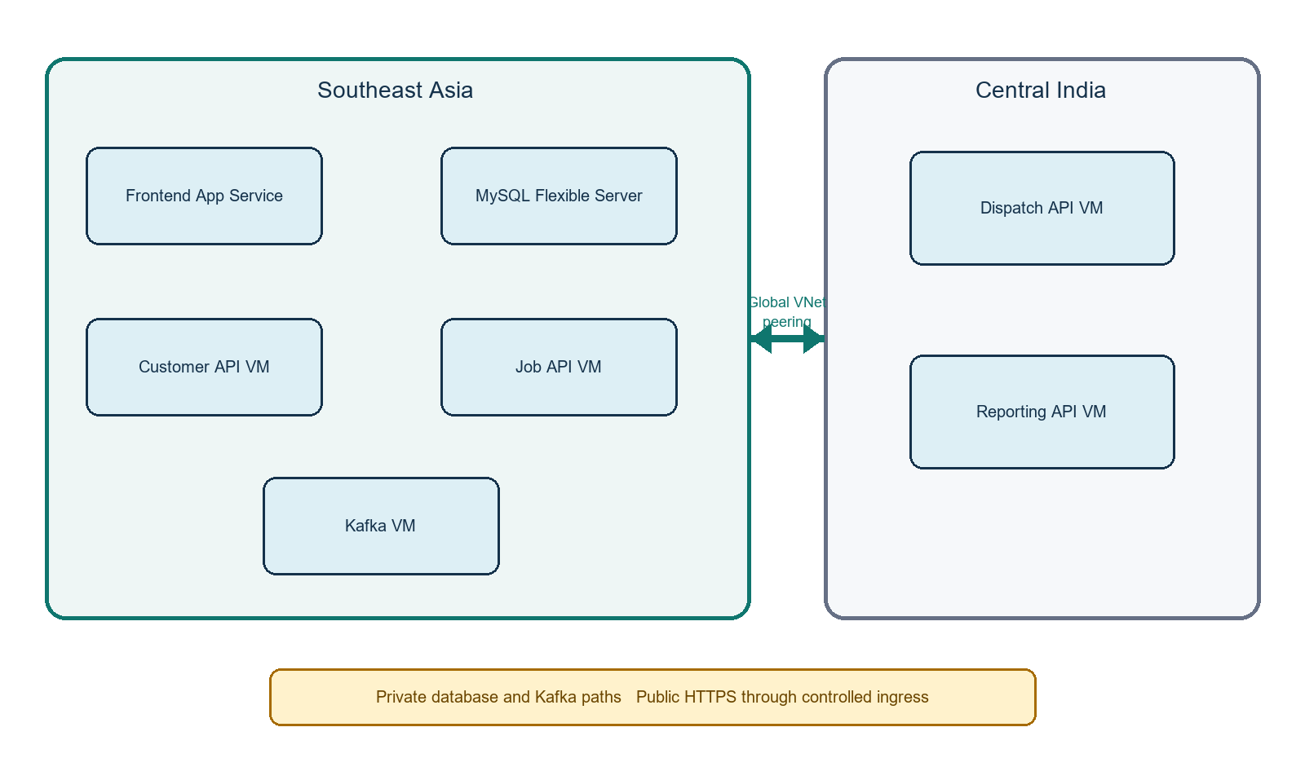
Figure 1 Azure staging topology

Resource inventory
Resource | Name or class | Region | Purpose
Resource group | rg-assms-staging | Multi region | Application staging resources
Primary VNet | vnet-assms-staging 10.20.0.0/16 | Southeast Asia | Service, platform and database subnets
Secondary VNet | vnet-assms-staging-secondary 10.30.0.0/16 | Central India | Dispatch and Reporting subnet
Service VMs | Ubuntu 22.04 Arm64 Standard B2pls v2 | Both | Customer, Job, Dispatch and Reporting hosts
Kafka VM | Ubuntu 22.04 Arm64 Standard B2pls v2 | Southeast Asia | Private Kafka host foundation
Database | MySQL Flexible Standard B1ms 20 GiB | Southeast Asia | Four service databases
App Service | Linux F1 plan and staging web app | Southeast Asia | React static SPA

Network design
Network | CIDR | Workloads or role
Primary VNet | 10.20.0.0/16 | Southeast Asia staging network
Services subnet | 10.20.1.0/24 | Customer 10.20.1.4 and Job 10.20.1.5
Platform subnet | 10.20.2.0/24 | Kafka 10.20.2.4
Database subnet | 10.20.3.0/24 | Delegated private MySQL access
Secondary VNet | 10.30.0.0/16 | Central India staging network
Secondary service subnet | 10.30.1.0/24 | Dispatch 10.30.1.4 and Reporting 10.30.1.5

- Bidirectional Global VNet peering connects both regions.
- The MySQL private DNS zone is linked to both VNets.
- MySQL has public network access disabled.
- Kafka port 9092 accepts traffic only from approved private subnets and has no public IP.
- Backend application port 8080 is loopback only; public users reach Nginx over HTTPS.
- Deployment SSH is opened only to the current GitHub runner address and is removed during cleanup.

Terraform state
Item | Value
State resource group | rg-assms-tfstate
Storage account | stassmstfstate45ff260826
Container | tfstate
Platform key | platform/staging.tfstate
Customer key | customer-asset-service/staging.tfstate
Job key | job-service/staging.tfstate
Dispatch key | dispatch-service/staging.tfstate
Reporting key | reporting-service/staging.tfstate
Frontend key | frontend/staging.tfstate

Security controls
Control | Implementation | Operational requirement
Cloud authentication | GitHub Actions uses OIDC with user assigned identity id-assms-github-staging-cd | Review federated subjects and role scopes when repositories or environments change
Least privilege | Frontend and service network roles are scoped to their required resources | Avoid subscription wide roles
Database isolation | Separate databases and users with grants limited to service ownership | Rotate credentials and keep them out of source and logs
Ingress | HTTPS, TLS 1.2 or later, HTTP 2 for frontend and Nginx for APIs | Renew certificates and verify external health
Administrative access | Strict known hosts and temporary runner IP rules | Remove rules in an always cleanup step
Publishing controls | Basic App Service publishing is disabled | Use approved workload identity deployment path

Deployment procedure
Phase | Action | Gate
Plan | Run Terraform formatting, initialization, validation and review the plan | No unreviewed apply
Provision | Apply approved platform and service stacks in dependency order | State stored in the correct remote key
Configure | Install Docker and Nginx, create protected environment files and configure certificates | No secrets printed or committed
Deploy | Promote the exact CI validated SHA through the repository CD workflow | OIDC success and temporary SSH access only
Verify | Check HTTPS, application health, database health and representative acceptance tests | Record result with SHA
Close | Remove temporary access and deallocate nonessential VMs when the exercise is complete | Confirm current power state before the next test

Operations and cost control
- Use Azure CLI identity checks before operator actions and select the intended subscription explicitly.
- Treat VM power state as operational data that can change between exercises; query it before making availability claims.
- Deallocate nonessential VMs outside demonstrations to control student subscription cost.
- Start dependencies before services, then verify health and database health before user testing.
- Database autogrow is disabled in the current low cost staging tier, so monitor free storage during extended testing.

Recovery and continuity
Scenario | Recovery action
Failed service release | Redeploy a known good exact SHA and confirm both health endpoints
Nginx or certificate failure | Restore the reviewed site configuration and certificate, then retest HTTPS
Database connectivity failure | Check private DNS, subnet delegation, credentials and service specific grants
Cross region service failure | Check both peerings, NSG paths and private DNS links
Terraform drift | Run a reviewed plan against the correct state key before changing resources
Kafka unavailable | Keep job data authoritative in Job Service, restore broker connectivity and replay only through an approved recovery design

Verified state and boundaries
Verified | Customer, asset, job and reporting HTTPS endpoints plus their database health were exercised in staging. The frontend production build and deployed route behavior were also checked.

Deferred | Azure Kafka software and the end to end JobCreated reporting projection were not demonstrated. Monitoring remains open under ASSMS-18.

Variable | VM power state changes for cost control and deployment exercises. Query Azure before reporting current availability.

Source register
- assms-platform-infrastructure Terraform for networking, database, Kafka host and cross region connectivity.
- Service repository Terraform for Customer, Job, Dispatch and Reporting virtual machines and network controls.
- assms-frontend Terraform for the Linux App Service plan and staging web application.
- Repository staging workflow files and recorded health and acceptance verification associated with ASSMS-17 and ASSMS-210.

