ASSMS

Sprint 1 CI CD workflow
Build validation staging promotion and recovery
Sprint | Sprint 1
Status date | 7 September 2026
Primary owner | DevOps
Audience | Project team and academic reviewers

Evidence basis Live Sprint 1 Jira backlog plus the six repository workspaces, source code, tests, workflows, Terraform, and recorded staging verification. Planned or deferred work is labelled explicitly.

Document control
Field | Value
Document version | 1.0
Prepared on | 7 September 2026
Sprint state | Closed with documented follow up items
Classification | Project documentation
Change rule | Update this document when Jira acceptance criteria, repository implementation, or deployment evidence changes

How to read this document
Verified means the repository or recorded staging evidence demonstrates the stated result. Implemented means code or configuration exists but the full runtime path was not demonstrated. Planned or deferred means the item remains outside the verified Sprint 1 boundary.

Contents

Delivery objective
Each ASSMS repository validates only the affected code, produces evidence before promotion and deploys a traceable source revision. The workflow uses GitHub Actions for automation and Azure workload identity federation for cloud access.
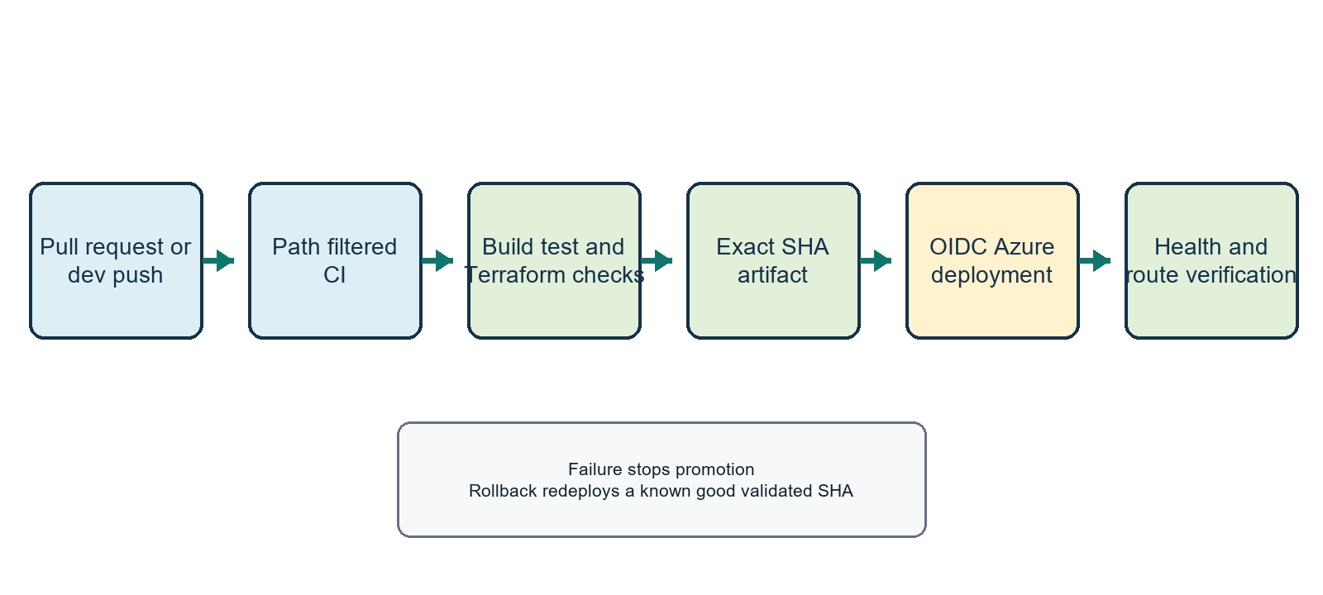
Figure 1 Delivery control flow

Repository workflow matrix
Repository | Continuous integration | Staging delivery | Sprint 1 evidence
Customer and Asset | Terraform checks, .NET restore, build, tests and coverage | Reusable staging CD after successful dev CI | Successful customer, asset and frontend deployment path recorded
Job | Terraform checks, .NET build, tests and coverage | Reusable staging CD after successful dev CI | Manual staging verification strong; final workflow run not confirmed
Dispatch | Terraform checks, .NET build, tests and coverage | No application CD in Sprint 1 | Appropriate for foundation only scope
Reporting | Terraform checks, .NET build, tests and coverage | Reusable staging CD after successful dev CI | Manual staging verification strong; final workflow run not confirmed
Frontend | Terraform checks, Node install, lint and production build | ZIP deployment to Azure App Service | Production build, routes, API URL and CORS verified
Platform infrastructure | Terraform formatting, initialization and validation | Operator controlled infrastructure apply | Foundation resources recorded

Continuous integration controls
- Pull requests and pushes to dev or main trigger path filtered workflows.
- Backend jobs install .NET 8, restore dependencies, build Release, run tests and collect XPlat coverage.
- Frontend jobs install Node 24 dependencies with npm ci, run lint and create a production build.
- Terraform jobs run format checks, initialize without a remote backend and validate staging and production configuration.
- Workflow artifacts are retained for 14 days to support review and diagnosis.

Backend staging deployment
Step | Control | Expected evidence
1 | Run only after successful CI on dev | Linked workflow run and exact source SHA
2 | Build a linux arm64 image from github.sha | Image label or archive associated with the commit
3 | Authenticate to Azure with OIDC | Federated identity login without a client secret
4 | Add the runner public IP as a temporary SSH rule | Time bounded NSG rule with configured priority
5 | Verify strict SSH known hosts and transfer the image archive | Host identity check and successful load on the VM
6 | Replace the service container using its protected environment file | Container bound to 127.0.0.1 port 8080
7 | Verify application and database health through HTTPS | HTTP 200 from health and database health
8 | Remove temporary network access in an always cleanup step | No residual runner SSH rule

Frontend staging deployment
- Build the exact commit with the configured Vite customer API URL.
- Package the dist directory as a ZIP and authenticate to Azure through OIDC.
- Deploy to the staging Web App and configure the PM2 static server with SPA fallback.
- Verify root HTTPS, application routes, embedded API configuration and cross origin API access.

Configuration ownership
Category | Examples | Handling
Azure identity | Client ID, tenant ID and subscription ID | GitHub environment variables; identity uses federated credentials
Deployment target | Resource group, VM host, NSG, App Service name and public API URL | Repository or environment variables
SSH trust | Deployment username and pinned known hosts | Variable or protected environment value; strict checking enabled
Private key | Service deployment SSH private key | GitHub environment secret
Application secrets | Database credentials and broker configuration | Protected VM environment file; never committed or printed

Branch and approval policy
- Develop changes on a story or task branch and open a pull request into dev.
- Require CI success and reviewer approval before merge.
- Promote dev to staging automatically only for repositories whose staging CD is enabled.
- Promote to main or production through a separate reviewed release process; Sprint 1 evidence covers staging only.
- Record Jira key, commit SHA, workflow run and verification result in the release note or task.

Failure handling and rollback
Failure point | Automatic response | Operator action
Build or test | Workflow stops before deployment | Fix on the source branch and rerun CI
Azure login or authorization | Deployment stops without changing the service | Correct federation or scoped role assignment
SSH or transfer | Deployment stops and cleanup removes the temporary rule | Correct host, key or known hosts data and rerun
Health verification | Workflow fails after replacement | Inspect service logs, database connectivity and Nginx; redeploy the last known good SHA
Frontend route check | Workflow fails | Restore the last known good ZIP or correct SPA startup and redeploy

Evidence checklist
Evidence | Required value
Source | Repository, branch and full commit SHA
Validation | CI run URL and successful jobs
Artifact | Exact SHA image or frontend ZIP
Deployment | CD run URL or operator command record
Runtime | Public HTTPS URL, health result and representative acceptance tests
Cleanup | Temporary SSH rule removed
Boundary | Any deferred Kafka, data projection, monitoring or migration verification

Current limitations
Confirmed | Customer and frontend continuous delivery was demonstrated. All repositories contain continuous integration definitions.

Open | A final successful GitHub Actions staging CD run for Job and Reporting was not confirmed in the reviewed evidence. Their manual staging deployments passed the documented API checks.

Source register
- GitHub Actions workflow files under each repository .github/workflows directory.
- Terraform configuration under each repository infrastructure directory.
- Recorded staging deployment and API smoke evidence associated with ASSMS-210, ASSMS-3 and ASSMS-4.
- Jira foundation task ASSMS-16 for CI and ASSMS-17 for Azure deployment.

