ASSMS

Sprint 1 database documentation
Schemas tables indexes and migrations
Field | Value
Sprint | Sprint 1
Status date | 7 September 2026
Primary owner | Developer
Audience | Project team and academic reviewers

Evidence basis Developer Markdown under the service docs folders, controllers, DTOs, SQL migrations, migration scripts, README files and recorded staging verification.

Document control
Field | Value
Document version | 1.0
Prepared on | 7 September 2026
Scope | Sprint 1 implemented interfaces and schemas
Change rule | Update when controller contracts, migrations or verified evidence changes

Evidence interpretation
Documented means the developer notes describe the behavior. Implemented means matching source or SQL exists. Verified means a recorded runtime or database check demonstrated the result. Deferred means the repository explicitly leaves the behavior for later work.

Contents

Database architecture
ASSMS applies database per service ownership. The platform creates four MySQL databases and four service users, each granted access only to its own database. Transactional services never join across service databases; HTTP and Kafka carry cross service facts.
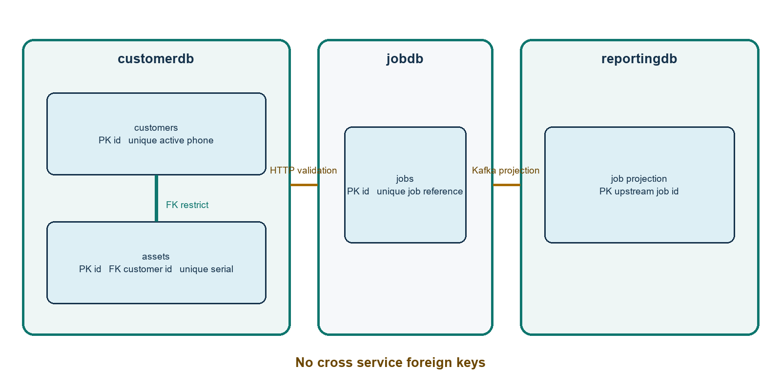
Figure 1 Database ownership and relationships

Database inventory
Database | Owner | Implemented tables | Sprint 1 state
customerdb | Customer and Asset Service | customers, assets, schema_migrations | Migrations V01 through V03 recorded and staging CRUD verified
jobdb | Job Service | jobs and migration tracking when runner is used | V01 applied in staging
dispatchdb | Dispatch Service | None in repository schema | Database exists; schema, indexes and seed files are placeholders
reportingdb | Reporting Service | job_projection and migration tracking when runner is used | V01 applied; query path verified

Boundary | Dispatch database documentation cannot list technician or assignment tables because the reviewed repository does not define them.

Customer table
Column | Type | Null or default | Purpose
id | CHAR(36) | Required | Primary key generated by the service
name | VARCHAR(100) | Required | Customer name
phone | VARCHAR(20) | Required | Original phone value
phone_normalized | VARCHAR(20) | Required | Normalized comparison value
phone_active_unique | VARCHAR(20) | Generated | Active only uniqueness expression
address | VARCHAR(255) | Required | Postal address
customer_type | VARCHAR(20) | Required | INDIVIDUAL or BUSINESS
email | VARCHAR(255) | Nullable | Optional email
status | VARCHAR(20) | ACTIVE | ACTIVE or INACTIVE
created_at | TIMESTAMP | Current time | Creation audit time
updated_at | TIMESTAMP | Auto update | Modification audit time

Customer controls
- Primary key on id.
- Unique key uq_customers_phone_active permits reuse after deactivation because the generated value becomes null for inactive rows.
- Index idx_customers_status supports lifecycle filtering.
- Check constraints restrict customer type and status.

Asset table
Column | Type | Null or default | Purpose
id | CHAR(36) | Required | Primary key
customer_id | CHAR(36) | Required | Owner and local foreign key
asset_type | VARCHAR(20) | Required | Controlled asset category
model | VARCHAR(100) | Required | Manufacturer model
serial_number | VARCHAR(100) | Required | Original serial
serial_normalized | VARCHAR(100) | Required | Unique normalized serial
installation_date | DATE | Required | Installation day
location | VARCHAR(255) | Required | Customer site location
notes | VARCHAR(1000) | Nullable | Optional notes
status | VARCHAR(20) | ACTIVE | Lifecycle from V03
created_at | TIMESTAMP | Current time | Creation audit time
updated_at | TIMESTAMP | Auto update | Modification audit time

Asset controls
- Foreign key customer_id references customers.id with ON DELETE RESTRICT.
- Unique key uq_assets_serial_normalized remains global even after deactivation.
- Indexes support customer lookup and lifecycle status filtering.
- Checks restrict asset type and status.

Job table
Column | Type | Default | Purpose
id | CHAR(36) | None | Primary key
job_reference | VARCHAR(20) | None | Unique JOB handle
customer_id | CHAR(36) | None | External customer reference without FK
asset_id | CHAR(36) | None | External asset reference without FK
service_category | VARCHAR(20) | None | Controlled work category
problem_description | VARCHAR(1000) | None | Reported problem
priority | VARCHAR(10) | None | LOW through URGENT
region | VARCHAR(20) | None | One of nine provinces
scheduled_date | DATE | Null | Future scheduling field
created_by | CHAR(36) | None | Agent id; zero GUID until authentication
status | VARCHAR(20) | CREATED | Lifecycle state
created_at | TIMESTAMP | Current time | Creation time
updated_at | TIMESTAMP | Auto update | Modification time

Job controls
- Unique job reference with collision retry in the service.
- Indexes on customer_id, asset_id and region.
- Checks restrict priority, service category and region.
- No customer or asset foreign keys because those records belong to customerdb; the Job Service validates them through HTTP.
- No status check because later sprints expand the lifecycle.

Reporting projection table
Column | Type | Default | Purpose
job_id | CHAR(36) | None | Primary key copied from Job Service
job_reference | VARCHAR(20) | None | Human readable handle
status | VARCHAR(20) | None | Upstream lifecycle value
region | VARCHAR(50) | None | Upstream region
priority | VARCHAR(20) | None | Upstream priority
service_category | VARCHAR(50) | None | Upstream category
job_created_at | TIMESTAMP | None | Business time used by filters
projected_at | TIMESTAMP | Current and auto update | Projection ingestion time

Projection controls
- Primary key job_id makes INSERT ON DUPLICATE KEY UPDATE idempotent for Kafka redelivery.
- Indexes on status and job_created_at serve the GROUP BY and date filter.
- No foreign keys or duplicated enum checks, allowing the projection to accept new upstream lifecycle values.
- job_created_at and projected_at represent different facts and must not be interchanged.

Migration catalog
Service | Version | File | Change | Rerun behavior
Customer | V01 | V01__create_customers.sql | Create customers with keys and checks | CREATE TABLE IF NOT EXISTS
Customer | V02 | V02__create_assets.sql | Create assets and customer FK | CREATE TABLE IF NOT EXISTS
Customer | V03 | V03__add_asset_status.sql | Add lifecycle status, check and index | Apply once through schema_migrations
Job | V01 | V01__create_jobs.sql | Create jobs, indexes and checks | CREATE TABLE IF NOT EXISTS
Reporting | V01 | V01__create_job_projection.sql | Create reporting read model and indexes | CREATE TABLE IF NOT EXISTS
Dispatch | None | schema.sql, indexes.sql and seed.sql | Placeholder comments only | No schema migration implemented

Migration runner behavior
- scripts/development/apply_migrations.ps1 discovers versioned V*.sql files and records successful filenames in schema_migrations.
- A migration is recorded only after it succeeds. Failed work remains eligible for a later retry.
- V01 and V02 customer migrations can safely meet a pre-existing database because they create tables conditionally.
- V03 is an ALTER TABLE and is not independently rerunnable; the tracking record and preflight guard prevent a duplicate column operation.
- Published migration files are append only. Schema changes require a new versioned file rather than editing an applied migration.

Platform initialization and access
Script | Creates | Grant boundary
01-init-customerdb.sql | customerdb and customer_svc | customerdb only
02-init-dispatchdb.sql | dispatchdb and dispatch_svc | dispatchdb only
03-init-jobdb.sql | jobdb and job_svc | jobdb only
04-init-reportingdb.sql | reportingdb and reporting_svc | reportingdb only

Credentials belong in protected runtime configuration. This document intentionally does not reproduce local sample passwords or staging secrets.

Verification evidence
Area | Recorded evidence | Assessment
Customer schema | Initial missing table caused HTTP 500; V01 was applied safely and subsequent CRUD and both health checks passed | Verified after remediation
Asset schema | V01, V02 and V03 records present; columns, primary key, unique serial, customer and status indexes verified; CRUD passed | Verified
Job schema | V01 migration reported PASS and create plus retrieval persisted expected values | Verified for database path
Reporting schema | V01 migration reported PASS and report schema, filtering and empty result behavior passed | Query verified; event population deferred
Dispatch schema | Repository SQL files contain Placeholder only | Not implemented in Sprint 1

Operational guidance
- Back up or snapshot data before a destructive future migration.
- Apply migrations with the owning service account through an approved operator controlled release step.
- Verify schema_migrations, SHOW CREATE TABLE, expected indexes and both application health endpoints after deployment.
- Do not add cross service foreign keys or grant one service access to another service database.
- Design a recovery procedure for the Job database write and Kafka publish gap before relying on event complete reporting.

Source register
- Customer migrations V01 through V03 and docs/customer-management, docs/asset-management and deployment verification notes.
- Job migration V01 and docs/job-management/US-03-create-job.md.
- Reporting migration V01 and docs/read-model/job-projection.md.
- Dispatch database schema, indexes and seed placeholder files.
- Platform database initialization scripts 01 through 04.

