ASSMS

Sprint 1 technical architecture
Service boundaries data design and runtime behavior
Sprint | Sprint 1
Status date | 7 September 2026
Primary owner | Developer and DevOps
Audience | Project team and academic reviewers

Evidence basis Live Sprint 1 Jira backlog plus the six repository workspaces, source code, tests, workflows, Terraform, and recorded staging verification. Planned or deferred work is labelled explicitly.

Document control
Field | Value
Document version | 1.0
Prepared on | 7 September 2026
Sprint state | Closed with documented follow up items
Classification | Project documentation
Change rule | Update this document when Jira acceptance criteria, repository implementation, or deployment evidence changes

How to read this document
Verified means the repository or recorded staging evidence demonstrates the stated result. Implemented means code or configuration exists but the full runtime path was not demonstrated. Planned or deferred means the item remains outside the verified Sprint 1 boundary.

Contents

Architecture overview
ASSMS uses a React single page application and four independently owned ASP.NET Core services. Each service owns its database. Kafka provides the intended asynchronous integration path, while HTTP APIs provide the Sprint 1 user facing transactions.
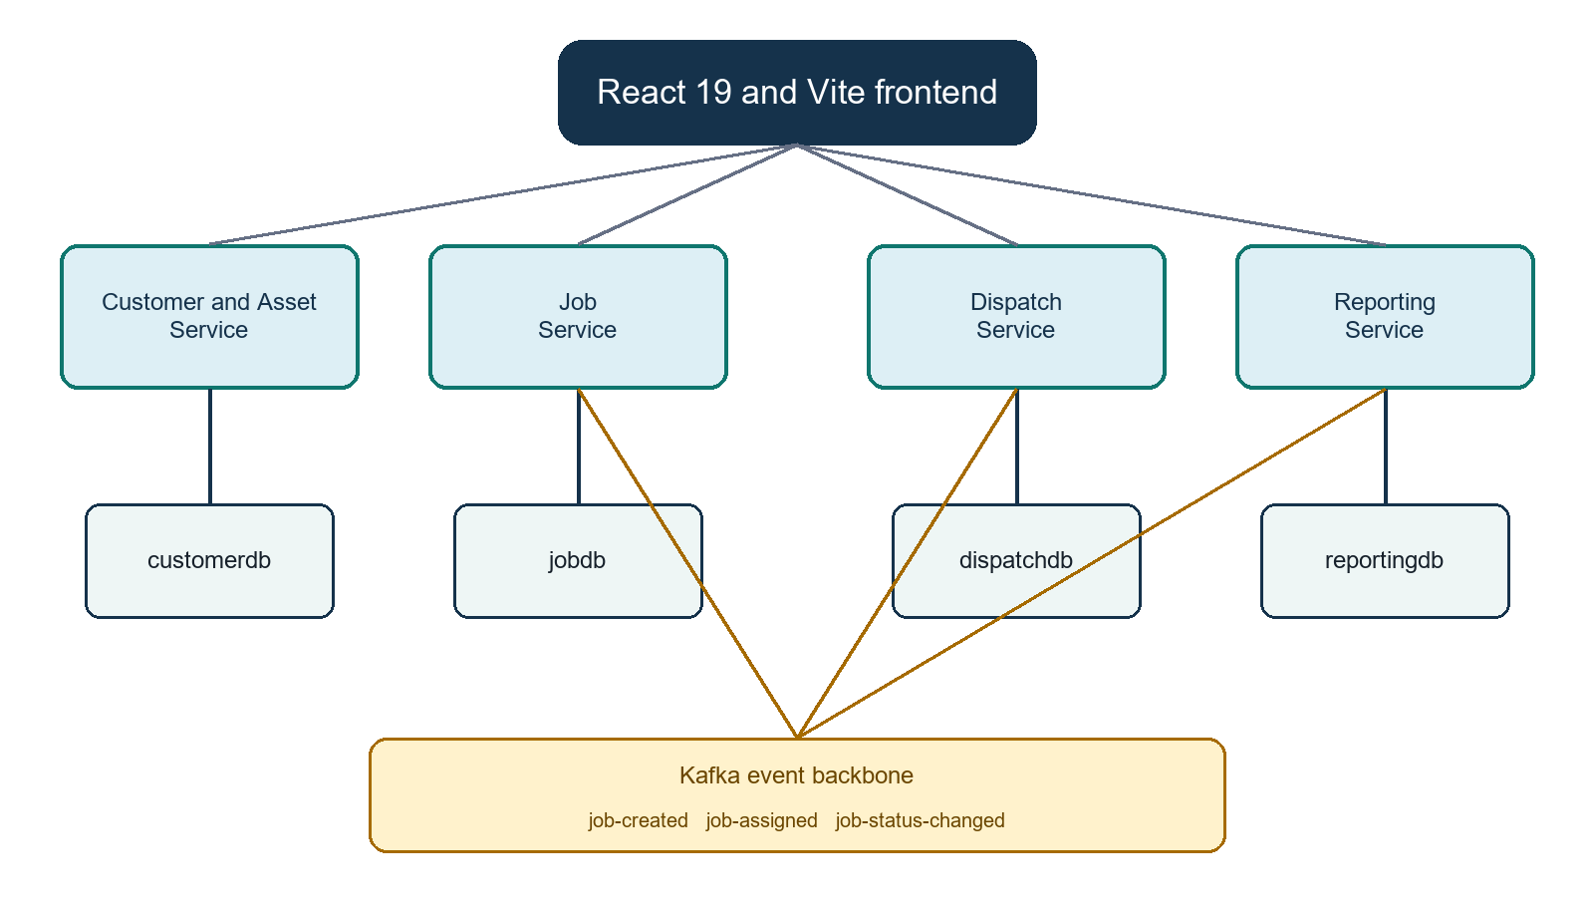
Figure 1 Logical service architecture

Technology baseline
Layer | Technology | Sprint 1 responsibility
Web client | React 19 and Vite | Customer, asset and job workflows plus reporting views
Services | ASP.NET Core on .NET 8 | HTTP APIs, validation, service rules and health endpoints
Data access | ADO.NET with MySqlConnector | Parameterized SQL and explicit repository behavior
Databases | Azure Database for MySQL and local MySQL | Independent customerdb, jobdb, dispatchdb and reportingdb schemas
Messaging | Apache Kafka | job-created, job-assigned and job-status-changed topics
Delivery | GitHub Actions, Terraform, Docker and Azure CLI | Build, validation, exact SHA artifacts and staging promotion

Service responsibilities
Service | Owns | Principal interfaces | Sprint 1 status
Customer and Asset | Customer and asset master data | Customer and asset REST APIs, health and database health | CRUD verified in staging
Job | Service request lifecycle | Create and retrieve job APIs, JobCreated producer path, health endpoints | HTTP flow verified; event publication deferred
Dispatch | Technician assignment | Dispatch schema and planned event consumers | Foundation only in Sprint 1
Reporting | Operational read models | Jobs by status query and job projection consumer | Query verified; event fed projection deferred

API surface

Customer and asset API
Method | Route | Purpose
GET | /api/Health | Application health
GET | /api/Health/db | Database connectivity
POST | /api/customers | Create customer
GET | /api/customers | List customers with optional status
GET | /api/customers/{id} | Get customer
PUT | /api/customers/{id} | Update customer
POST | /api/customers/{id}/deactivate | Deactivate customer
GET | /api/customers/{customerId}/assets | List customer assets
POST | /api/assets | Register asset
GET | /api/assets/{id} | Get asset
PUT | /api/assets/{id} | Update asset
POST | /api/assets/{id}/deactivate | Deactivate asset

Job and reporting API
Service | Interface | Purpose
Job | Create job | Validate customer and asset, generate reference and persist Created status
Job | Retrieve by identifier or reference | Support user confirmation and later workflow integration
Job | Health and database health | Separate process and dependency readiness
Reporting | GET /api/reports/jobs-by-status?from=&to= | Return status counts, totals and optional date filtered results
Reporting | Health and database health | Expose process and database readiness

Data design
Database | Core tables | Key controls
customerdb | customers and assets | Soft status, active phone uniqueness, normalized serial uniqueness, customer relationship and type checks
jobdb | jobs | Unique job reference, controlled priority, category and region values, Created lifecycle state
dispatchdb | Technician and assignment foundation | Reserved for Sprint 2 dispatch behavior
reportingdb | job_projection | Upstream job identifier as primary key and idempotent upsert behavior

Consistency and messaging
The intended flow writes the job in Job Service and publishes JobCreated so Reporting can update its local projection. The consumer stores by upstream job identifier, commits after the database write, skips malformed messages and retries a failed database write. These controls exist in the implementation design, but the full Azure producer to broker to consumer path was not demonstrated in Sprint 1.
Boundary | Do not describe the Reporting read model as event verified until a real JobCreated event produces a grouped report result in staging.

Runtime and security model
- Backend containers listen on 127.0.0.1 port 8080 and Nginx terminates public HTTPS.
- MySQL and Kafka accept private network traffic only; service database users are scoped to their own databases.
- SQL uses parameters and server side validation guards required fields, uniqueness and allowed values.
- Swagger UI is a development feature; the raw OpenAPI JSON remains the machine readable contract.
- Deployment uses workload identity federation rather than stored Azure client secrets.

Quality attributes
Attribute | Design response | Current evidence
Maintainability | Independent repositories and explicit service ownership | Builds and CI definitions present in all six repositories
Reliability | Health probes, idempotent deactivation and projection upsert | CRUD and health paths verified; messaging path incomplete
Security | Private data plane, HTTPS ingress, scoped identities and temporary SSH | Terraform and workflows define controls
Scalability | Independent service deployment and asynchronous read model | Architecture supports it; Sprint 1 scale testing not recorded
Observability | Health endpoints and planned monitoring stack | Health verified; ASSMS-18 monitoring deferred

Technical risks and decisions
Risk | Impact | Decision or action
Database commit succeeds but Kafka publish fails | Reporting can miss a job | Specify and implement a reliable publisher recovery approach such as a transactional outbox.
Event contract drift | Consumer failures or incorrect reports | Version contracts, test compatibility and retain representative event fixtures.
Two Azure regions | Latency and operational complexity | Keep Global VNet peering and private DNS explicit; monitor cross region traffic.
Manual schema changes | Release inconsistency | Keep migrations operator controlled until a safe automated migration policy is approved.
Missing metrics stack | Slow incident diagnosis | Complete ASSMS-18 and connect deployment verification to dashboards and alerts.

Source register
- assms-customer-asset-service source, SQL initialization, tests and workflow definitions.
- assms-job-service API, database schema, Kafka producer path and deployment workflow.
- assms-dispatch-service foundation schema and CI configuration.
- assms-reporting-service query API, job projection consumer, schema and deployment workflow.
- assms-frontend React application and assms-platform-infrastructure Terraform modules.

