|  |
| --- |
| Copyright Green Plus Inc. | A. Stambuli |



|  |  |
| --- | --- |
| Green Plus(+) Inc. | **Green Plus Sales Manager Technical Documentation.** |

Contents

1. Introduction 1

1.1 Purpose of this document 1

1.2 Intended Audience 1

1.3 Scope 1

2. General overview 1

2.1 Technologies used 1

2.2 General functioning 2

3. Technical requirement 2

3.1 Client requirement 2

3.2 Server side Requirements 2

3.3 Backend API 2

4. PATH Source structure 3

5. Architecture 4

# Introduction

## Purpose of this document

The purpose of this document is to give technical information about Green-plus Sales manager design and implementation.

## Intended Audience

The intended audiences are:

* Supervisors, to analyze the design and implementation of Green-plus Sales manager.
* Green-plus Sales manager Development team members.
* Future developers to extend or use some ideas of Green-plus Sales manager project.

## Scope

This document will describe the design and some technical issues of Green-plus Sales manager project.

# General overview

## Technologies used

Green-plus Sales manager is a front end web based application that depends on Backend REST API on a given jar file. I used the following technologies on the development process:-

1. Bootstrap
2. Less and Simpless Compiler.
3. Angular Js and Ui-Router.
4. J-Query.
5. Font Awesome.
6. Angular Chart js.
7. Apache web server.
8. Git hub.

## General functioning

The following are the major system functionalities:

* Sign in on login screen.
* View different graphs on the home page.

# Technical requirement

## Client requirement

As Green-plus Sales manager is a web application it could be run on most of custom operating systems via a web browser. Green-plus Sales manager work well with all the major browsers ie. Chrome 4.0+, Mozilla Firefox 2.0+, Safari 3.1+, Opera9.0+ and IE 9.0+.

## Server side Requirements

The following technologies are required for Green-plus Sales manager.

* Any web server.
* JDK 1.7.
* Backend API jar file.

## Backend API

The backend api allows the front end system to get data via http requests and the returned data are in JSON format. The response is processed by Angular js for the user to see the results.

# PATH Source structure

There are six main folders that contain the project files. The seventh folder (Documentation Folder) contains the documentation files. In this system each folder contains the corresponding system files as the folder name Implies. Example the css file contains all css files used on the system except font awesome css files.

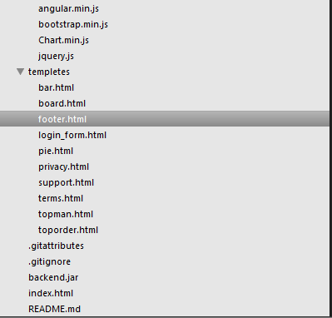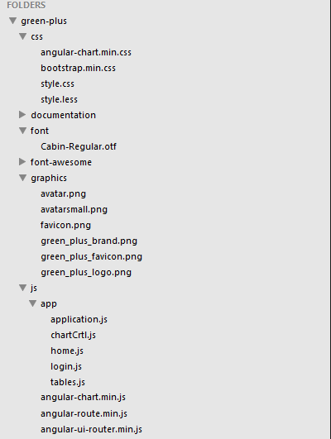

Figure 1: File structure of Green Plus Sales Manager.

# Architecture