Lab Experiment Proposal: Hardware Reverse Engineering of an Embedded System

Title
Reverse Engineering and Functional Characterization of an Unknown Embedded Device

Objective
The objective of this lab is to develop practical skills in hardware reverse engineering by analyzing an unknown embedded system. Students will identify system components, infer circuit functionality, and characterize communication protocols between subsystems without access to schematics or documentation.

Background
Embedded systems are often deployed in environments where documentation is incomplete or unavailable. Engineers must rely on observation, measurement, and inference to understand system behavior. Hardware reverse engineering is a valuable skill in areas such as debugging, system integration, security analysis, and legacy system maintenance.
This lab integrates concepts from:
- Microcontroller interfacing
- Digital communication protocols (UART, SPI, I2C)
- Analog and digital circuit analysis
- Signal measurement using lab instruments

Materials and Equipment
- *Unknown embedded device (e.g., consumer electronics module, development board, or simple PCB)
- Multimeter
- Datasheets for identified components

Note: If a larger board with many connections is used, a subsection focused on one or two chips is recommended for the sake of time.

Methodology
Section is broken into required and recommended optional modules.

Necessary:
The students will receive an embedded PCB and start by identifying all components starting with IC chips and working down to individual components such as resistors, capacitors, and test points. While identifying the components, the students should use component datasheets of ICs to see application of manufacturer recommended circuits, along with creating a bill of materials that includes the part description, part number, and component values*. As the student progresses through the sections of the PCB, they should hypothesize the function of the sections and explain their reasoning (These sections may be provided depending on the class level). Lastly, once the students have created their bill of materials, a high-level block diagram of their circuit should be made.
*Capacitor values may be ignored it is difficult to find values
Optional:
Trace probing and test point locations:
While students create their bill of materials, they should actively use a digital multimeter in continuity mode to map out the connections of a single, non-trivial, component such as a sensor or a memory module, to the microcontroller. While this is being performed, the connections should be recreated using a design software such as KiCad or PSpice.

Power analysis:
Students should provide power to the circuit and use a multimeter to probe key areas around the board, such as power lines and voltage regulators. While the board is on if there are any on-board inputs such as buttons, switches, or sensors, any responses due to interaction with these inputs should be measured and recorded.

Digital communication protocols:
While probing the board, students should try to identify common communication schemes such as I2C, SPI, and UART. If a logic analyzer is available, it should be used to confirm that the communication protocol is working as expected.

Expected Results
Students are expected to:
Required module
- Identify the primary microcontroller and supporting components
- Provide a full bill of materials of system
- Develop a high-level block diagram

Optional modules
- Correctly determine at least one communication protocol (provided one is present on the board)
- Provide a partial schematic of system
- Identify operating voltage levels and system power requirements

Deliverables
- Identified components with datasheet references
- Reconstructed schematic (partial or complete)
- Functional block diagram
- Lab report

Evaluation Criteria
- Accuracy of component identification
- Quality of circuit reconstruction
- Correct identification of communication protocols
- Depth of analysis and reasoning
- Clarity and organization of the report

Safety Considerations
- Ensure proper voltage levels to avoid damaging components
- Avoid short circuits during probing
- Use appropriate grounding when measuring signals

Educational Value
This experiment reinforces theoretical knowledge by requiring students to apply it in an open-ended, real-world scenario. It encourages problem-solving, critical thinking, and hands-on skills essential for embedded systems engineers.

Example Board:

HaHa SEP 3S board:
Below is an example of the deliverables outlined above, focusing on the, highlighted, microcontroller (red) and flash memory with SPI sections (blue).
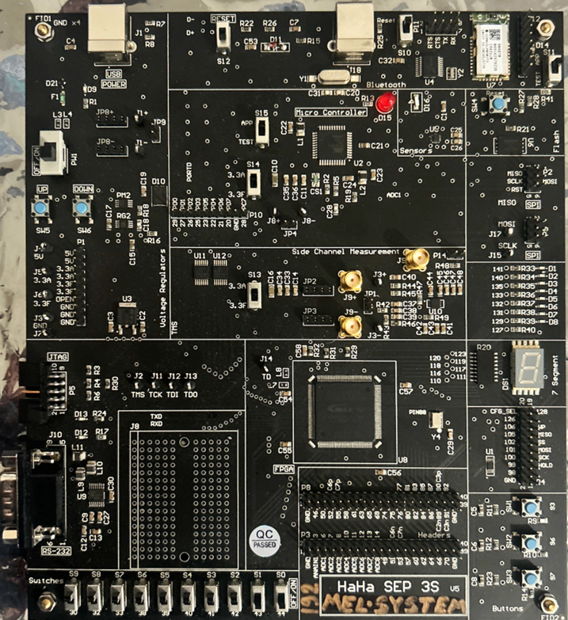
Figure 1. HaHa SEP 3s Board with areas of focus outlined

Below is an example of the bill of materials for the highlighted sections on the HaHa board, outlining a reference number, quantity, value (if possible), description, and part number.
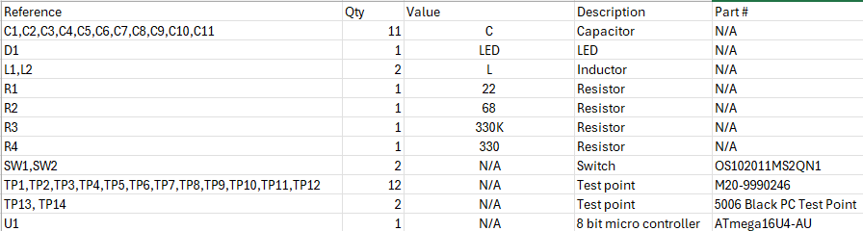Figure 2. Bill of Materials for the outlined microcontroller section

Figure 3. shows the high level block diagram depicting all connections to other sections of the board coming from the microcontroller using KiCAD.
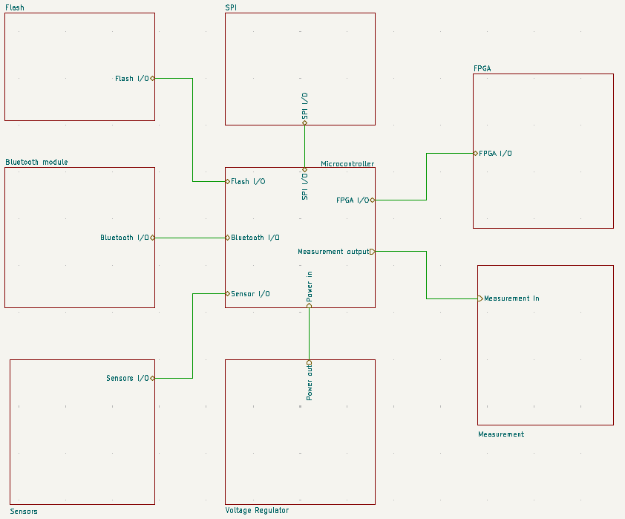
Figure 3. High level block diagram of microcontroller connections
The figure below shows the explicit trace connections between the microcontroller and the flash memory module.
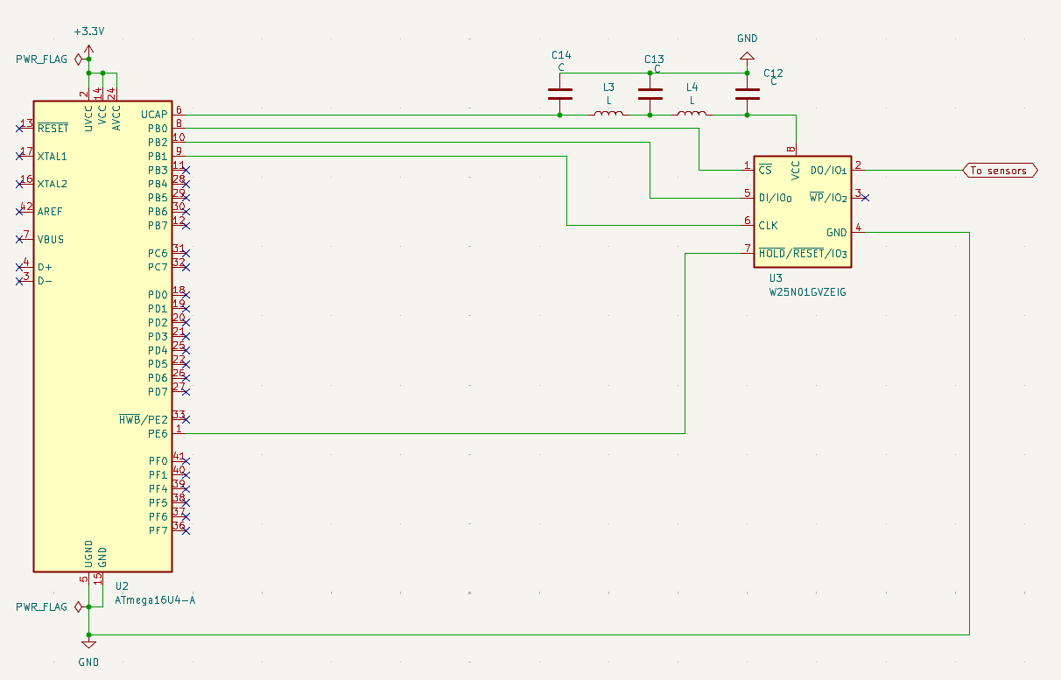Figure 4. Recreated circuit schematic of connections between flash memory and microcontroller

