Combinational Logic Locking of a 4-Bit Ripple Carry Adder

Objective
The objective of this experiment is to investigate the application of combinational logic locking to a 4-bit ripple carry adder implemented in VHDL. Students will analyze the operation of a standard ripple carry adder, construct the design hierarchically from a provided full adder component template, simulate its behavior, and modify the design to incorporate a combinational obfuscation mechanism using either XOR/XNOR gates or multiplexers.
Upon completion of this experiment, students should be able to:
- Explain the operation of a 4-bit ripple carry adder
- Describe the purpose of hardware obfuscation
- Distinguish between combinational and sequential locking techniques
- Implement combinational locking using XOR/XNOR gates
- Implement combinational locking using multiplexers
- Verify correct and incorrect key values through simulation
- Analyze the behavior of an obfuscated digital design

Case Study
Modern integrated circuit (IC) designs are commonly developed by fabless semiconductor companies and manufactured by third-party foundries. Throughout the design, verification, testing, fabrication, and assembly stages, intellectual property (IP) is exposed to potential threats such as reverse engineering, overproduction, unauthorized use, and malicious modification.
Hardware obfuscation is a technique used to protect hardware intellectual property by preventing a design from functioning correctly until a valid unlocking condition is met. By modifying the structure or behavior of a circuit, an attacker is unable to easily determine the intended functionality of the design.
In practical hardware security applications, the secret key used to unlock an obfuscated circuit must also be protected. Secure integrated circuits often employ tamper-proof memory to store the key, preventing unauthorized access through physical attacks such as probing, fault injection, or reverse engineering. Although the key in this laboratory is supplied manually for educational purposes, tamper-proof memory is commonly used in commercial designs to securely store and provide the correct unlocking key during device operation.

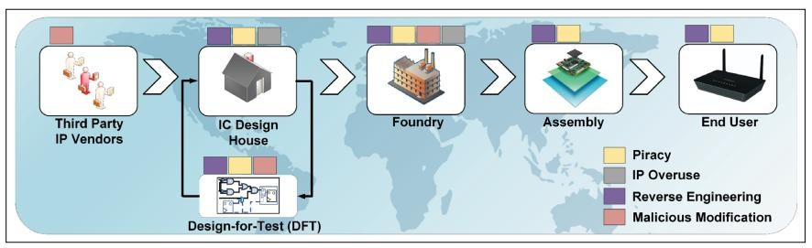

Figure 1. Threats to integrated circuit intellectual property throughout the semiconductor supply chain
In this experiment, a 4-bit ripple carry adder will serve as a case study for combinational logic locking. Students are provided only with a full adder component template. Using this template, they will first construct the original adder design and simulate its behavior. The design will then be modified by introducing key-controlled logic gates between carry signals. The resulting circuit will only function correctly when the proper key values are applied.

Theory Background

1. Ripple Carry Adder
A ripple carry adder is a digital circuit used to perform binary addition. It is constructed from multiple full adders connected in series.
Each full adder accepts:
- Input A
- Input B
- Carry-In (Cin) and produces:
- Sum
- Carry-Out (Cout)
The carry output from one stage becomes the carry input of the next stage. Because the carry signal propagates through each full adder stage, the structure is referred to as a ripple carry adder.
In this experiment, students will use the provided full adder component template as the building block for the 4-bit ripple carry adder.
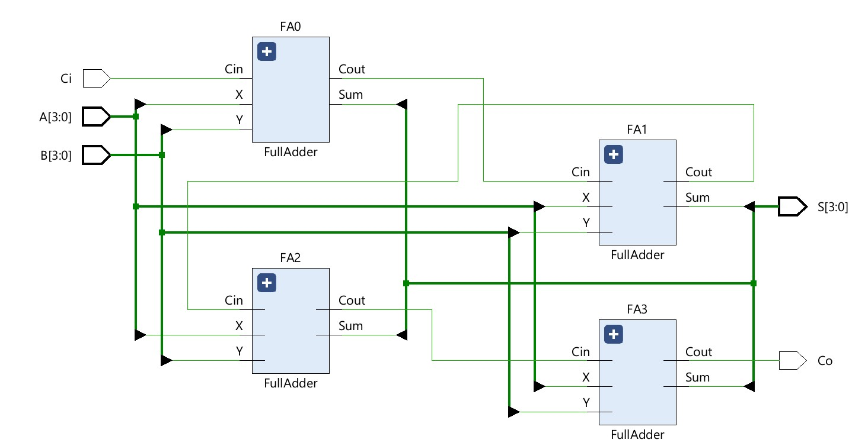

Figure 2. Structure of a 4-bit Ripple Carry Adder

2. Hardware Obfuscation
Hardware obfuscation is a technique used to protect digital intellectual property by modifying a design such that its intended functionality is hidden until a valid unlocking process is completed.
The primary objectives of hardware obfuscation include:
- Prevention of reverse engineering
- Protection against IP piracy
- Prevention of unauthorized manufacturing
- Increased resistance against malicious modification

2.1 Combinational Logic Locking
Combinational logic locking modifies the combinational logic of a design through the insertion of key-controlled gates such as XOR, XNOR, and multiplexers.
In a combinational locked design, the correct functionality depends on a secret key. When the proper key is applied, the circuit behaves normally. However, if an incorrect key is supplied, the output becomes corrupted and the circuit no longer performs its intended function.
Because the key is applied directly to combinational logic, the circuit’s behavior depends only on the current inputs and key values. No memory of previous inputs is required.
The primary advantage of combinational locking is its simplicity and relatively low hardware overhead.

2.2 XOR/XNOR Based Locking
One common method of combinational locking inserts XOR and XNOR gates into the circuit.
The behavior of XOR and XNOR gates makes them suitable for logic locking.
For XOR:
A XOR 0 = A
Therefore, a key bit of 0 allows the original signal to pass through unchanged.
For XNOR:
A XNOR 1 = A
Therefore, a key bit of 1 allows the original signal to pass through unchanged.
An incorrect key value in either case inverts the original signal and corrupts the circuit behavior.
In this laboratory, XOR and XNOR gates will be inserted between carry signals of adjacent full adders in the student-built ripple carry adder.

2.3 Multiplexer Based Locking
Another method of combinational locking uses multiplexers.
A multiplexer selects one of multiple inputs according to a select signal.
In this experiment, the select signal serves as the key bit.
When the correct key value is applied, the multiplexer forwards the original carry signal to the next full adder stage.
When an incorrect key value is applied, the multiplexer forwards an alternate signal instead, causing incorrect carry propagation and corrupting the final result.

Obfuscated 4-Bit Ripple Carry Adder
The original ripple carry adder will be modified by inserting key-controlled logic between carry stages. The carry signals: C(1), C(2), and C(3) will be replaced by obfuscated carry signals:
masked_carry(1), masked_carry(2), and masked_carry(3)
The obfuscated carry signals will then be used as carry inputs to the subsequent full adder stages.
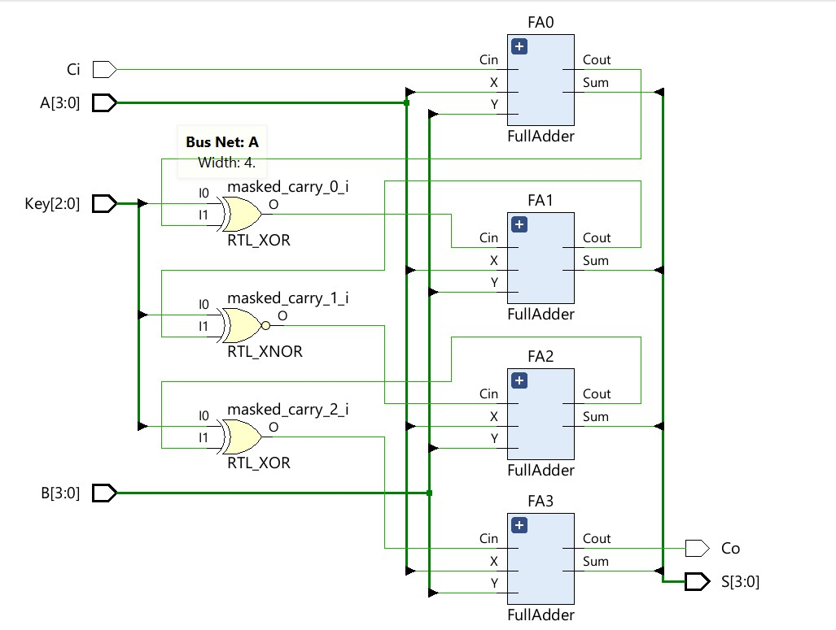

Figure 3. XOR/XNOR Obfuscated Ripple Carry Adder
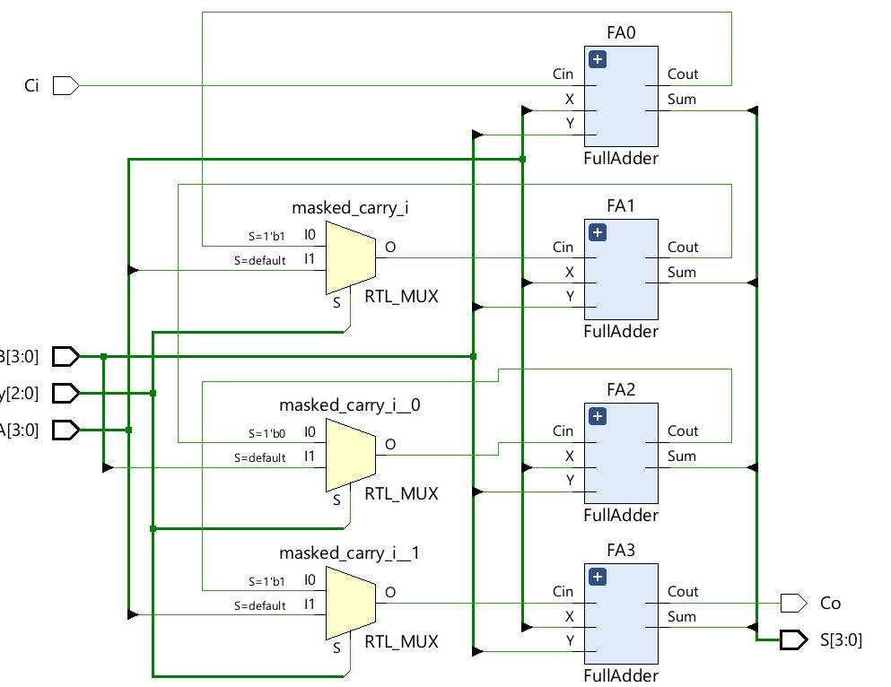
Figure 4. Multiplexer Obfuscated Ripple Carry Adder When the correct key is supplied, the adder behaves normally.
When an incorrect key is supplied, one or more carry signals become corrupted, resulting in incorrect sums.

Experiment Setup

Software Requirements
- Vivado Design Suite
- Full Adder Component Template
- Obfuscation Reference Diagrams

Knowledge Requirements
Students should be familiar with:
- VHDL
- Full Adders
- Ripple Carry Adders
- Component Instantiation
- Behavioral Simulation in Vivado
- Testbench Development

Instructions and Questions

Part I – Original Adder Analysis
Students are provided only with a full adder component template. Using this template, construct the original 4-bit ripple carry adder and create a testbench to verify its behavior.

Tasks
- Examine the provided full adder component template.
- Instantiate four full adders and connect the carry chain between stages.
- Create a testbench for the original ripple carry adder.
- Simulate the design and verify correct addition results.
- Observe carry propagation between stages.

Deliverables
- Ripple Carry Adder VHDL source code
- Ripple Carry Adder schematic
- Simulation waveform
- Brief explanation of ripple carry operation

Questions
- What is the purpose of the carry signal?
- Why is the structure called a ripple carry adder?
- How does carry propagation affect the final result?
- What would happen if a carry signal were modified?

Part II – Combinational Obfuscation
Modify your ripple carry adder to include combinational logic locking.

Requirements
- Insert locking circuitry between carry stages
- Use either XOR/XNOR gates or multiplexers
- Add a 3-bit key input
- Define a correct key value
- Ensure the adder operates correctly when the proper key is applied
- Ensure the adder produces incorrect outputs when an incorrect key is applied

Deliverables
- Modified VHDL source code
- Updated schematic
- Description of the locking mechanism

Part III – Verification
Extend your testbench to verify the operation of the obfuscated ripple carry adder.

Test Case A – Correct Key
Apply the correct key value.
Expected Result:
The adder should produce correct sums for all input combinations. Test Case B – Incorrect Key
Apply one or more incorrect key values.
Expected Result:
The adder should produce corrupted outputs.
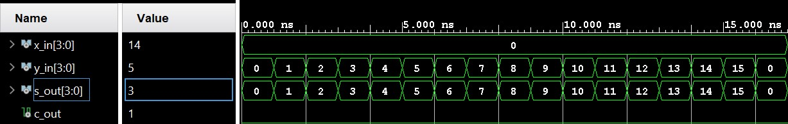

Figure 5. Example waveform showing correct key operation
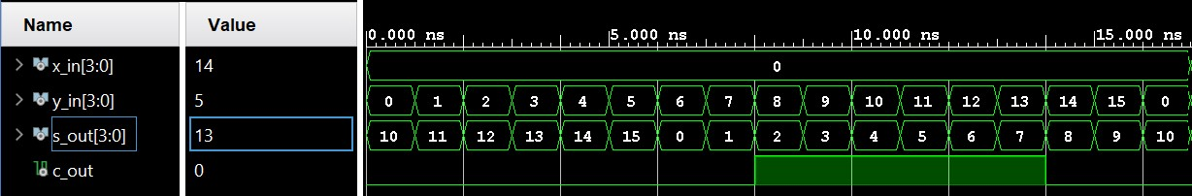

Figure 6. Example waveform showing incorrect key operation

Waveform Requirements
For each test case, capture simulation waveforms showing only:
- A
- B
- S
- Co
When the simulation is running in Vivado, right-click each signal name in the waveform window and change the radix to Unsigned Integer. Vivado defaults to Hexadecimal, so this step is required to display the values clearly.
Clearly indicate correct and incorrect operation.

Lab Report Guidelines

Part I
Include:
- Ripple Carry Adder VHDL source code
- Ripple Carry Adder schematic
- Simulation waveform
- Explanation of adder operation

Part II
Include:
- Obfuscated VHDL source code
- Obfuscated schematic
- Explanation of the locking mechanism

Part III
Include:
- Testbench source code
- Waveforms for:
  - Correct key
  - Incorrect key
- Discussion of simulation results
For the waveform figures, show only the first input, second input, sum, and carry out. Also make sure the waveform radix is changed to Unsigned Integer in Vivado before taking screenshots.

Discussion Questions
- Explain the purpose of hardware obfuscation.
- Compare XOR/XNOR locking and multiplexer locking.
- Why does an incorrect key produce incorrect outputs?
- Why are carry signals effective locations for inserting locking circuitry?
- What advantages does combinational locking provide?
- How could the key space be increased to improve security?
- Compare combinational locking and sequential locking.

