Sequential Obfuscation of a UART Transmitter

Objective
The objective of this experiment is to investigate the application of sequential logic locking to a Universal Asynchronous Receiver/Transmitter (UART) implemented in VHDL. Students will analyze the operation of a standard UART transmitter, simulate its behavior, and modify the finite state machine (FSM) to incorporate a sequential obfuscation mechanism.
Upon completion of this experiment, students should be able to:
- Explain the operation of a UART transmitter
- Describe the purpose of hardware obfuscation
- Distinguish between combinational and sequential locking techniques
- Implement a sequentially locked FSM
- Verify correct and incorrect key sequences through simulation
- Analyze the behavior of an obfuscated digital design

Case Study
Modern integrated circuit (IC) designs are commonly developed by fabless semiconductor companies and manufactured by third-party foundries. Throughout the design, verification, testing, fabrication, and assembly stages, intellectual property (IP) is exposed to potential threats such as reverse engineering, overproduction, unauthorized use, and malicious modification.
Hardware obfuscation is a technique used to protect hardware intellectual property by preventing a design from functioning correctly until a valid unlocking condition is met. By modifying the structure or behavior of a circuit, an attacker is unable to easily determine the intended functionality of the design.
In practical hardware security applications, the secret key used to unlock an obfuscated circuit must also be protected. Secure integrated circuits often employ tamper-proof memory to store the key, preventing unauthorized access through physical attacks such as probing, fault injection, or reverse engineering. Although the key in this laboratory is supplied manually for educational purposes, tamper-proof memory is commonly used in commercial designs to securely store and provide the correct unlocking key during device operation.

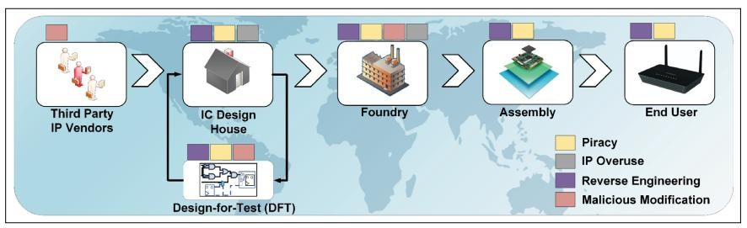

Figure 1. Threats to integrated circuit intellectual property throughout the semiconductor supply chain
In this experiment, a UART transmitter will serve as a case study for sequential logic locking. Students will first examine and simulate the original UART design. The design will then be modified by introducing an obfuscation FSM that requires a predefined sequence of key values before access to the original UART functionality is granted.

Theory Background

1. Universal Asynchronous Receiver/Transmitter (UART)
Universal Asynchronous Receiver/Transmitter (UART) is a serial communication protocol used to exchange data between two devices through a transmitter (TX) and receiver (RX). Unlike synchronous communication protocols, UART does not use a shared clock signal. Instead, both devices must operate at the same predetermined baud rate, which specifies the number of bits transmitted per second. Common baud rates include 4,800, 9,600, 19,200, 57,600, and 115,200 bps.
Data is transmitted in the form of frames consisting of a start bit, data bits, an optional parity bit, and one or more stop bits. For simplicity, the parity bit is omitted in this experiment. As shown in figure 2, the UART line remains at logic high during the idle state. Transmission begins with a start bit that drives the line low, followed by the data bits transmitted from Least Significant Bit (LSB) to Most Significant Bit (MSB).
In this laboratory, 8-bit data frames are used. After the final data bit is transmitted, a stop bit returns the line to logic high, indicating the end of the frame and a return to the idle state.
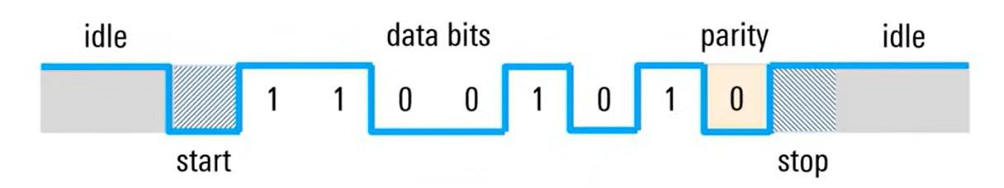

Figure 2. UART frame structure showing the idle state, start bit, 8 data bits, and stop bit

2. Hardware Obfuscation
Hardware obfuscation is a technique used to protect digital intellectual property by modifying a design such that its intended functionality is hidden until a valid unlocking process is completed.
The primary objectives of hardware obfuscation include:
- Prevention of reverse engineering
- Protection against IP piracy
- Prevention of unauthorized manufacturing
- Increased resistance against malicious modification

2.1 Combinational Obfuscation
Combinational obfuscation modifies the combinational logic of a design through the insertion of key-controlled gates, typically XOR, XNOR, and in special cases, multiplexers as shown in figure 3.
In a combinational locked design, the correct functionality depends on a secret key. When the proper key is applied, the circuit behaves normally. However, if an incorrect key is supplied, the output becomes corrupted and the circuit no longer performs its intended function.
Because the key is applied directly to the logic network, the circuit's behavior depends only on the current inputs and key values. No memory of previous inputs is required.
The primary advantage of combinational locking is its simplicity and relatively low hardware overhead. However, many combinational locking schemes have been shown to be vulnerable to attacks that attempt to recover the key through logical analysis of the circuit.
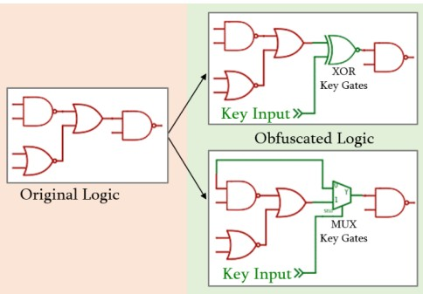
Figure 3. General Concept of using Combinational Obfuscation

2.2 Sequential Obfuscation
Sequential obfuscation protects a design by modifying its finite state machine rather than its combinational logic.
Instead of requiring a single key value, the design requires a specific sequence of inputs before normal operation is enabled. The key is therefore distributed across multiple clock cycles and becomes embedded within the state transitions of the FSM.
A common implementation technique is FSM augmentation, in which additional states are inserted before the original operational states of the design. The original functionality remains inaccessible until the correct sequence of inputs causes the FSM to traverse these added states.
For example, a design that originally begins in the IDLE state may be modified to begin in a sequence of key states:
S0 → S1 → S2 → IDLE
Only after the correct transitions occur is the original functionality enabled.
An incorrect input may instead force the FSM into a LOCKED state. The LOCKED state acts as a blackhole state, meaning that once entered, the FSM cannot return to normal operation without a reset.
Because an attacker must determine both the correct key values and the order in which they must be applied, sequential locking is generally more difficult to attack than combinational locking. The attacker must explore the behavior of the FSM over time rather than simply analyzing static logic connections.
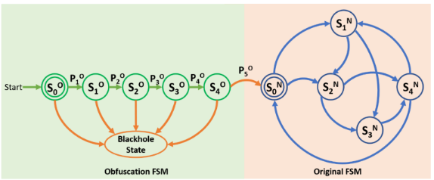

Figure 4. General Concept of using Sequential Obfuscation

3. Sequentially Obfuscated UART
The original UART FSM will be augmented with an obfuscation FSM consisting of three additional states.
The design begins operation in state S0 rather than the original IDLE state. A sequence of three 8-bit key values must be entered correctly before the FSM is allowed to enter the original UART state machine.
If an incorrect key value is entered at any point, the FSM transitions to a LOCKED state.
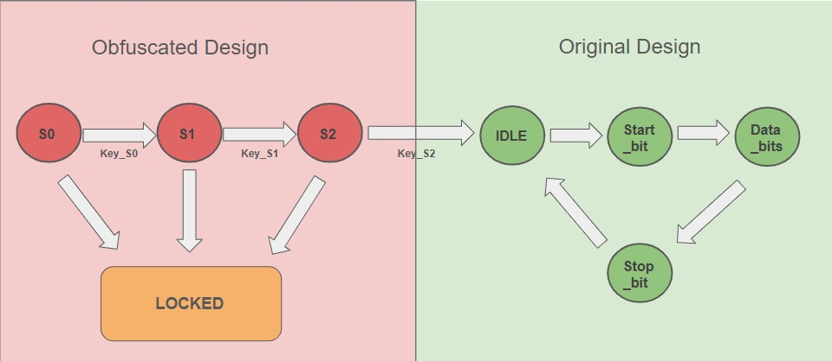
Figure 5. Obfuscated UART transmitter architecture
The obfuscation states include:
- S0
- S1
- S2
- LOCKED
The original UART states remain unchanged:
- IDLE
- START_BIT
- DATA_BITS
- STOP_BIT
Example key sequence:
- KEY_S0 = x”AA”
- KEY_S1 = x”BB”
- KEY_S2 = x”CC” Correct sequence:
S0 → S1 → S2 → IDLE
Any incorrect key value:
Current State → LOCKED

4. Locked State
The LOCKED state functions as a “blackhole” state.
Once entered:
- The UART transmitter is permanently disabled
- The tx output remains high
- No UART transmission can occur
- The FSM cannot leave the LOCKED state
- Recovery is only possible through reset The LOCKED state is implemented as:
This behavior ensures that any incorrect unlocking sequence permanently disables the design until reset.

Experiment Setup

Software Requirements
- Vivado Design Suite
- Original UART VHDL Source Code
- UART Testbench
- Obfuscated UART Reference Diagram

Knowledge Requirements
Students should be familiar with:
- VHDL
- Finite State Machines
- UART Communication Protocol
- Behavioral Simulation in Vivado

Instructions and Questions

Part I – Original UART Analysis
Students are provided with the original UART transmitter source code and testbench.

Tasks
- Examine the VHDL source code
- Identify the states within the FSM
- Simulate the design using the provided testbench
- Observe the transmission of the data byte
- Verify the sequence of state transitions

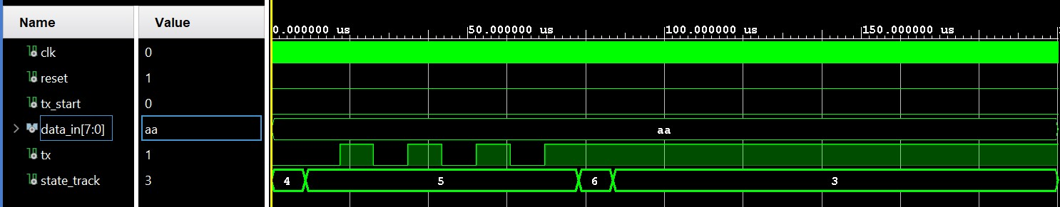
Figure 6. Example UART transmission waveform

Deliverables
- Original UART FSM diagram
- Timing diagram showing:
  - tx_start
  - tx
  - state_track
  - data_in
- Brief explanation of UART operation

Questions
- Why does the tx signal remain high during the IDLE state?
- Why is the start bit transmitted as logic 0?
- In what order are the data bits transmitted?
- What causes the FSM to leave the IDLE state?

Part II – Sequential Obfuscation
Modify the original UART transmitter to include an obfuscation FSM.

Requirements
- Add three key states:
  - S0
  - S1
  - S2
- Add one LOCKED state
- The design shall require three 8-bit key values to unlock
- Incorrect key values shall force the FSM into LOCKED
- The original UART FSM shall only be accessible after the correct key sequence has been entered
- Once the LOCKED state is entered, the FSM shall remain in LOCKED until reset

Deliverables
- Modified VHDL source code
- Updated FSM diagram
- Description of the implemented locking mechanism

Part III – Verification
Develop a testbench to verify the operation of the obfuscated UART transmitter.
The key sequence shall be applied using:
- key_valid
- key_seq
One key value should be applied per clock cycle. Test Case A – Correct Key Sequence
AA → BB → CC
Expected Result:
S0 → S1 → S2 → IDLE
The UART transmitter should operate normally.
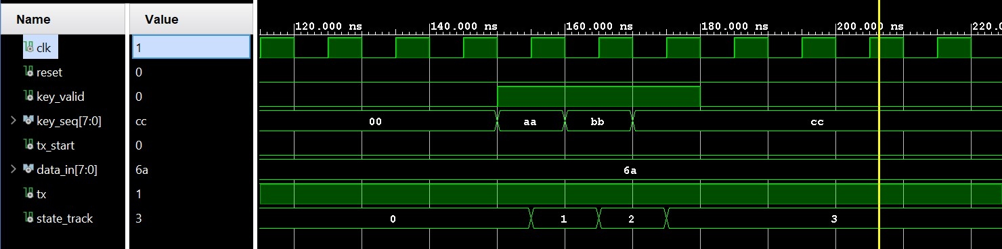
Figure 7. Example waveform showing successful unlock sequence
Design Note: The key_valid signal is used to indicate when a key value is being presented to the FSM. The key sequence should only be checked when key_valid = '1'. Without this condition, the FSM would continuously compare key_seq against the expected key values and could incorrectly transition to the LOCKED state when no key entry is intended. Using key_valid ensures that state transitions occur only during deliberate key-entry events.

Test Case B – Incorrect First Key
Expected Result:
S0 → LOCKED
The transmitter shall remain disabled.

Test Case C – Incorrect Second Key
Expected Result:
S0 → S1 → LOCKED
The transmitter shall remain disabled.

Test Case D – Incorrect Third Key
Expected Result:
S0 → S1 → S2 → LOCKED
The transmitter shall remain disabled.
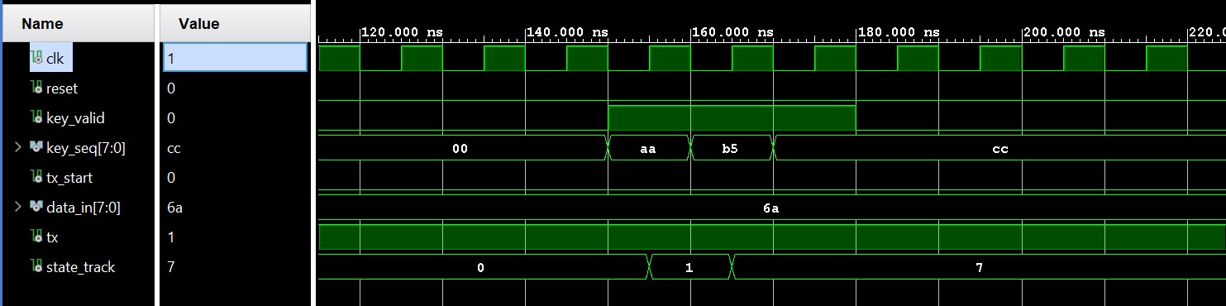
Figure 8. Example waveform showing transition of “state_track” signal into the LOCKED state.

Waveform Requirements
For each test case, capture simulation waveforms showing:
- key_valid
- key_seq
- state_track
- data_in
- tx_start
- tx
Clearly indicate all state transitions and identify the point at which the LOCKED state is entered.

Lab Report Guidelines

Part I
Include:
- Original UART FSM diagram
- Timing diagram of UART transmission
- Explanation of UART operation

Part II
Include:
- Obfuscated UART VHDL source code
- Obfuscated FSM diagram
- Explanation of the locking mechanism

Part III
Include:
- Testbench source code
- Waveforms for:
  - Correct key sequence
  - Incorrect first key
  - Incorrect second key
  - Incorrect third key
- Discussion of simulation results

Discussion Questions
- Explain the purpose of hardware obfuscation.
- Compare combinational and sequential obfuscation techniques.
- Why is the LOCKED state referred to as a blackhole state?
- Why does the UART transmitter remain disabled after an incorrect key sequence?
- How would increasing the number of key states affect the difficulty of a brute-force attack?
- What advantages does sequential locking provide over a traditional password protected system?
- How could the locking mechanism be extended to improve security further?

