Dynamics of the Solar System

Greg Smidt

Vishal Mehta

BACKGROUND

There are many celestial objects in the universe, all obeying Newton’s law of gravity. Many of those celestial bodies could be on their very way to disrupt the current motions of the planets in our solar system. It is possible such disruptions could have drastic effects on the orbits of the planets in our solar system. However, the most drastic effects will result from the disruptions of Jupiter since it is has the most mass compared to other planets in our solar system. The goal of project is to determine, through simulation, how the behavior of the planets, mostly their trajectories, will change if Jupiter collides with a celestial object of considerable size and mass while being governed by the gravitational law. The collision are treated as a perfectly inelastic collision.

Method

The base of the code was used from Project 2 where Velocity Verlet is used to set up the orbits. The base code also uses Newton’s Universal Law of Gravitation to calculate the positions and velocities at each time step. The collisions of the celestial object and Jupiter are modeled through perfectly inelastic collisions. The path of the celestial object is a straight line to Jupiter instead of a more realistic model where the path is more elliptical. This liberty was taken to simplify the model.

Each solar system object was created with initial conditions in VPython. Then, the position of each solar system object at each time step was turned into a vector and placed into a loop that updates the position of the VPython objects through time. The original goal was to simulate 20 Jovian years with the collision at 10 years. This proved to be more time than was necessary for many cases and caused simulations to take too long, so collision time was changed to appropriate values for the celestial object parameters.

Results

|  |  |  |  |  |
| --- | --- | --- | --- | --- |
| CO mass | 0.5*MJ |  | Collision time | 2*TJ |
| CO velocity | 1 AU/day |  | Simulation time | 6*TJ |

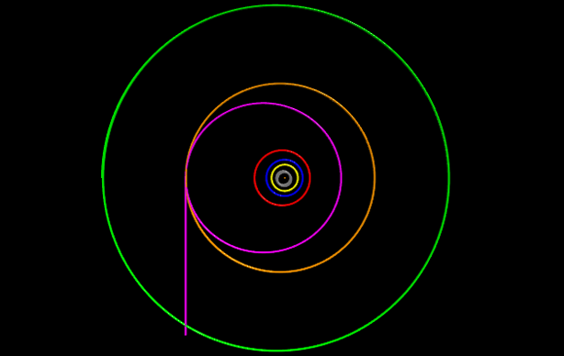

|  |  |  |  |  |
| --- | --- | --- | --- | --- |
| CO mass | 0.75*MJ |  | Collision time | 2*TJ |
| CO velocity | 2 AU/day |  | Simulation time | 6*TJ |

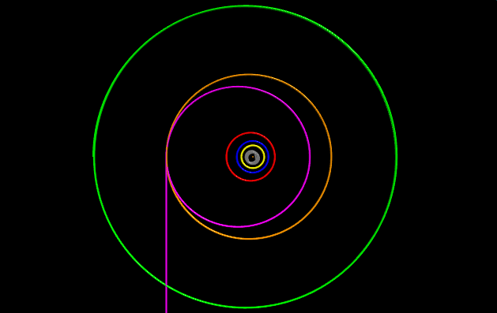

|  |  |  |  |  |
| --- | --- | --- | --- | --- |
| CO mass | 4*MJ |  | Collision time | 2*TJ |
| CO velocity | 2 AU/day |  | Simulation time | 6*TJ |

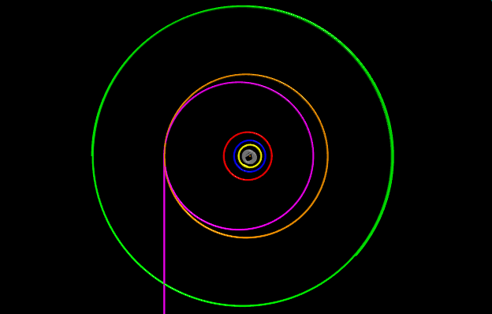

|  |  |  |  |  |
| --- | --- | --- | --- | --- |
| CO mass | 4*MJ |  | Collision time | 2*TJ |
| CO velocity | 0.1 AU/day |  | Simulation time | 6*TJ |

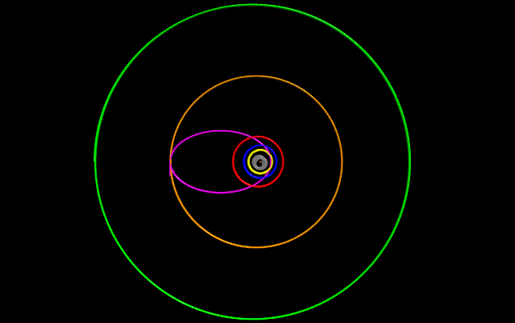

|  |  |  |  |  |
| --- | --- | --- | --- | --- |
| CO mass | 100*MJ |  | Collision time | 2*TJ |
| CO velocity | 1 AU/day |  | Simulation time | 20*TJ |

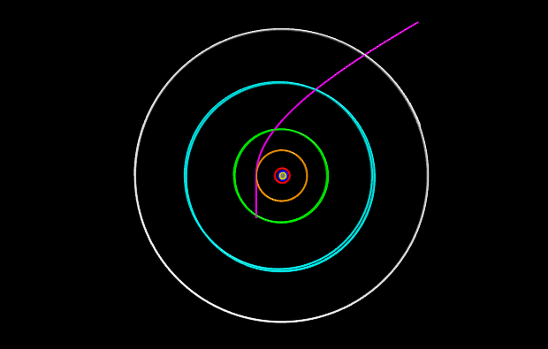

|  |  |  |  |  |
| --- | --- | --- | --- | --- |
| CO mass | 50*MJ |  | Collision time | 2*TJ |
| CO velocity | 1 AU/day |  | Simulation time | 20*TJ |

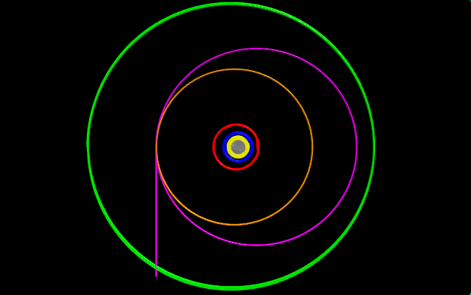

Summary

The primary goal of this report were to model the solar system in VPython, make a rogue celestial object collide with Jupiter, and monitor the changes in the orbits of both Jupiter and Earth. We successfully modeled the solar system and made the celestial object collide with Jupiter. After collision, the orbit of Jupiter changes dramatically. Due to the facts that the object is colliding with Jupiter when both of their velocities are entirely in the same direction and the collision is perfectly inelastic, the dependence of orbital radius on celestial object kinetic energy is directly proportional. In other words, lighter and slower celestial objects tend to produce orbits smaller than the original orbit of Jupiter, and larger and faster celestial objects tend to produce orbits larger than the original orbit of Jupiter. The results of these simulations also show no appreciable change in the orbit of Earth. This is due to the fact that the sun contains ~99.9% of the mass of the entire solar system, so Jupiter would need to either collide with Earth or come very close to it to affect its orbit noticeably.

Repository: <https://github.com/ASU-CompMethodsPhysics-PHY494/final-2017-uranus_coders>

Acknowledgements:

The VPython website, <http://www.vpython.org>, was used extensively in vptools.py.

VPython code was executed in a Jupyter Notebook.

Video was captured using Nvidia Shadowplay. Video was edited using Avidemux.