TEAM-8

Achal Shah - 1213294158
Aditi Sonik – 1211009433

REPORT

1) Task 2 Part 1

Kernelshark screenshot for signal generate
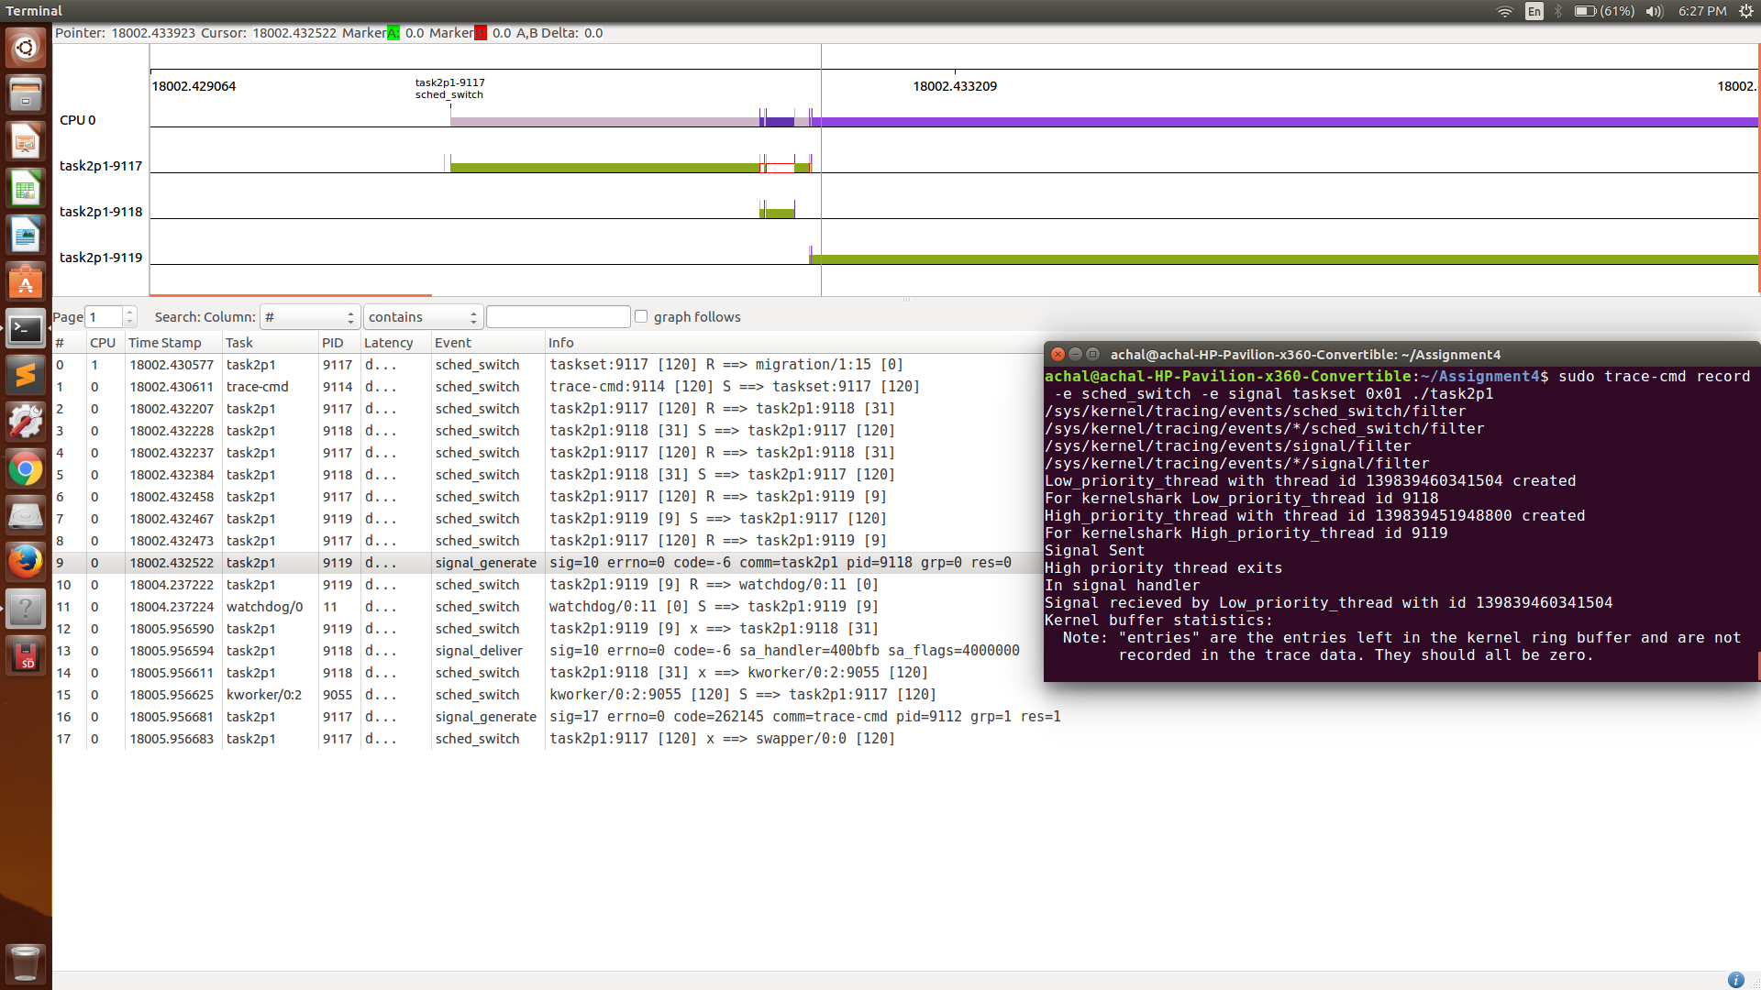

Kernelshark screenshot for signal delivered
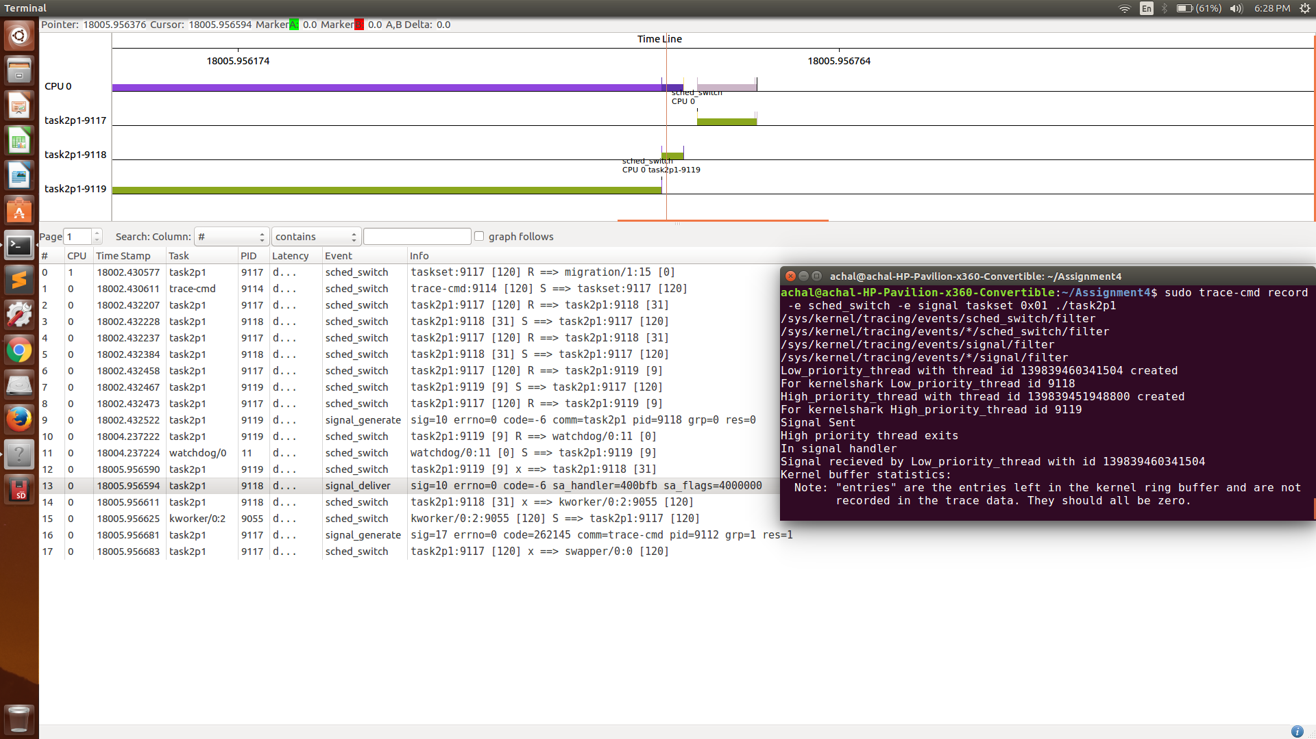
Explanation:

- As seen from the signal generation screenshot the thread with TID 9119 which is the high priority thread generates a signal (vertical thin red line) at the beginning of it’s function execution and the Time-Stamp can be observed in the kernel shark for the gray highlighted event which is the signal generation.
- As the thread to which the signal is sent is a low priority thread (TID 9118), it’s signal will have lower priority than the running high priority thread. And so the low priority would be in a runnable state as we are running it on a single CPU.
- After the execution of the high priority thread, it exits and than the shed-switch happens to the low priority thread and so the signal is delivered then. Thus the signal for a runnable (low priority) thread is delivered after the execution of the high priority thread.

2) Task 2 part 2

Kernelshark screenshot for signal generate

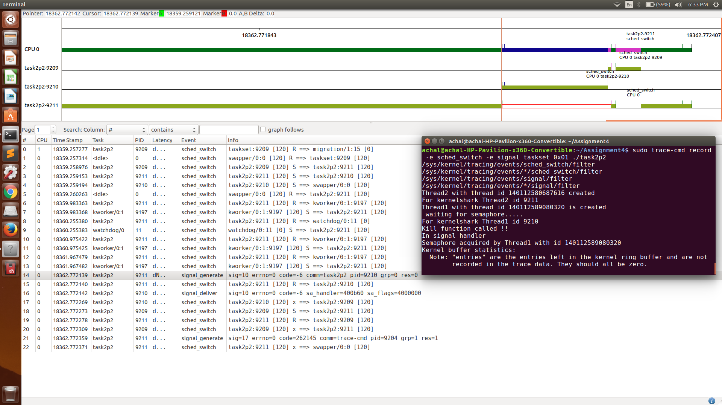

Kernelshark screenshot for signal delivered

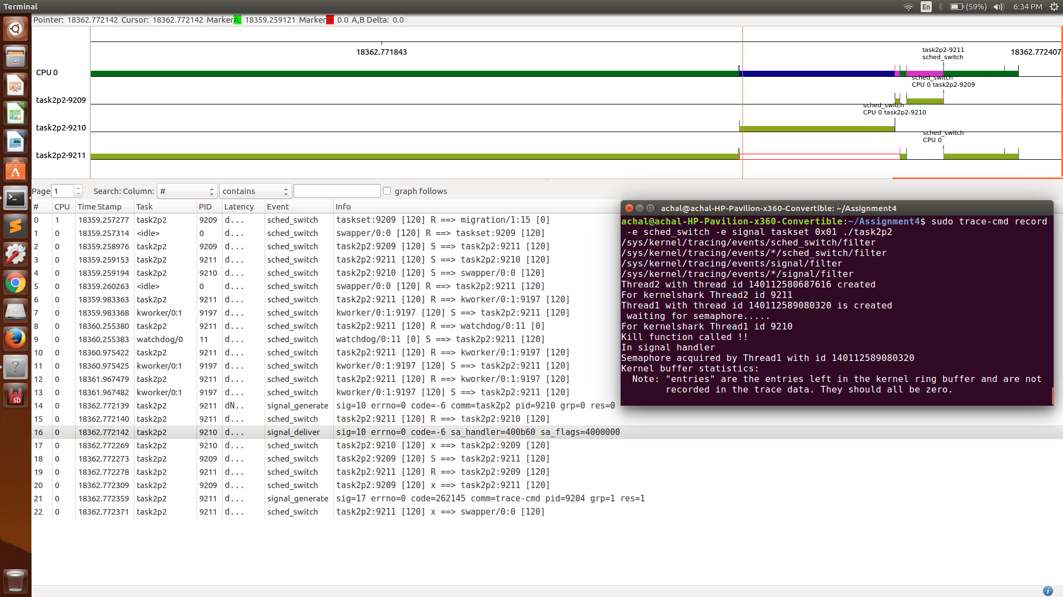

Explanation:

- In this part the Thread1 (TID 9210) is pended and waiting for the semaphore as sem_wait is called in the beginning of the thread function.
- After some computation in Thread2 (TID 9211), the thread2 calls the pthread_kill function to thread1 and so the signal is sent to the thread1.
- From the signal generate and signal delivered screenshots it can be seen that as soon as the signal is sent, even though the thread1 is pended, the handler runs before the semaphore is taken.
- We have done sem_post in the signal handler, so the handler will run and make the semaphore available for thread1 and so the thread1 is then executed.

3) Task 2 part 3

Kernelshark screenshot for signal generate
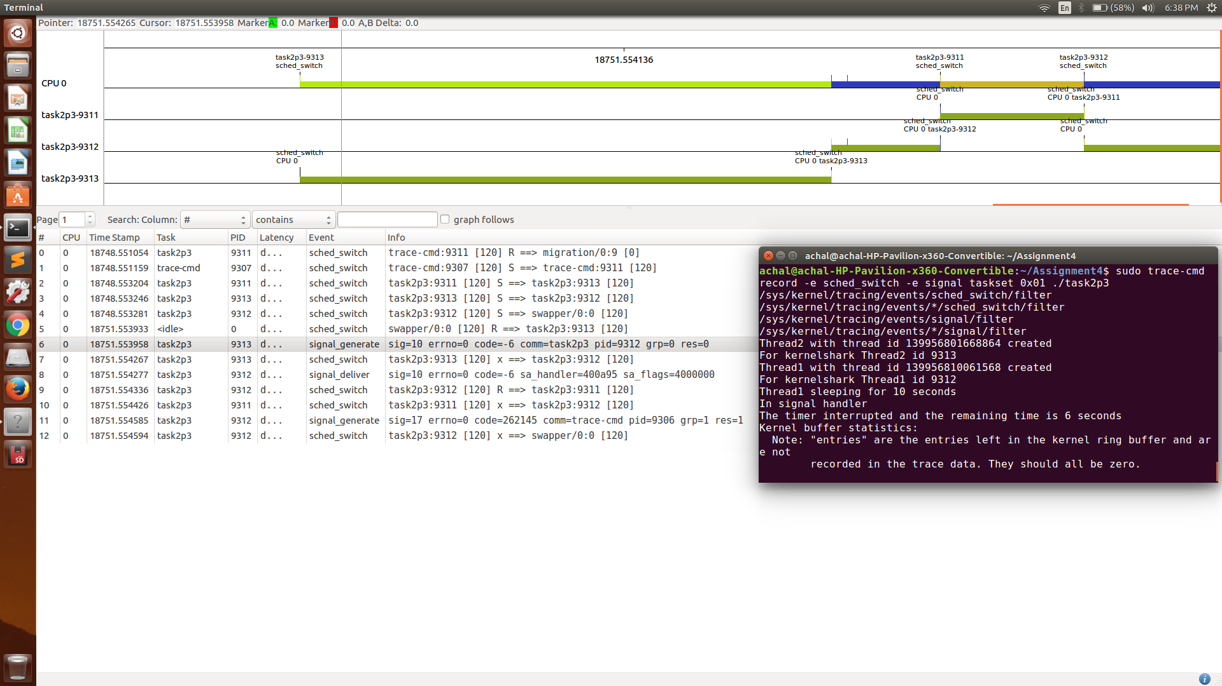
Kernelshark screenshot for signal delivered
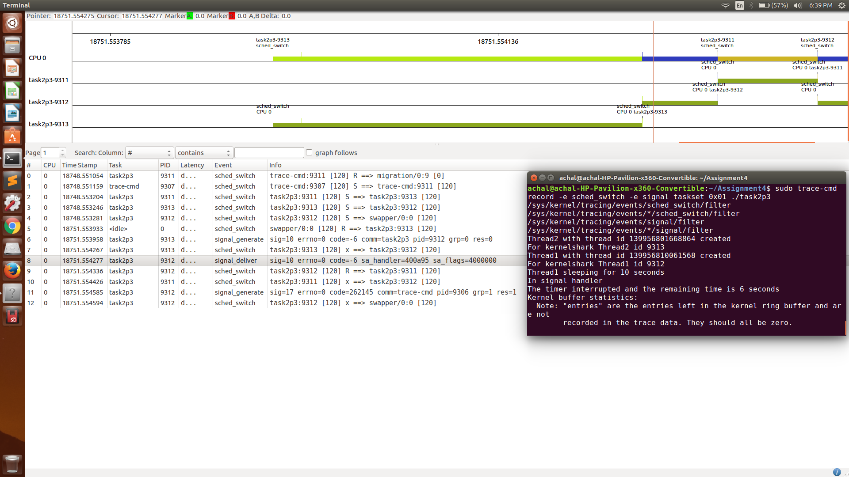

Explanation:

- In this part of the assignment, the thread1 (TID 9312) calls nanosleep for 10 seconds.
- The thread2 calls nanosleep for 3 seconds and then calls the pthread_kill and sends the signal to thread1.
- As seen from the screenshots, even though the thread1 is in sleep state, when the signal is sent, the sched-switch happens to the thread1 and the signal handler is executed and so the nanosleep does not return zero.
- The remaining time of the nanosleep for thread1 is stored in the struct timespec remain and it can be used to make the thread sleep for the remaining time.

