
ICS553 MACHINE LEARNING ESSENTIALS | PROSIT 2 | FINAL REPORT
Responsible credit scoring for NkwaPay
From Kenyan loans to Ghanaian borrowers
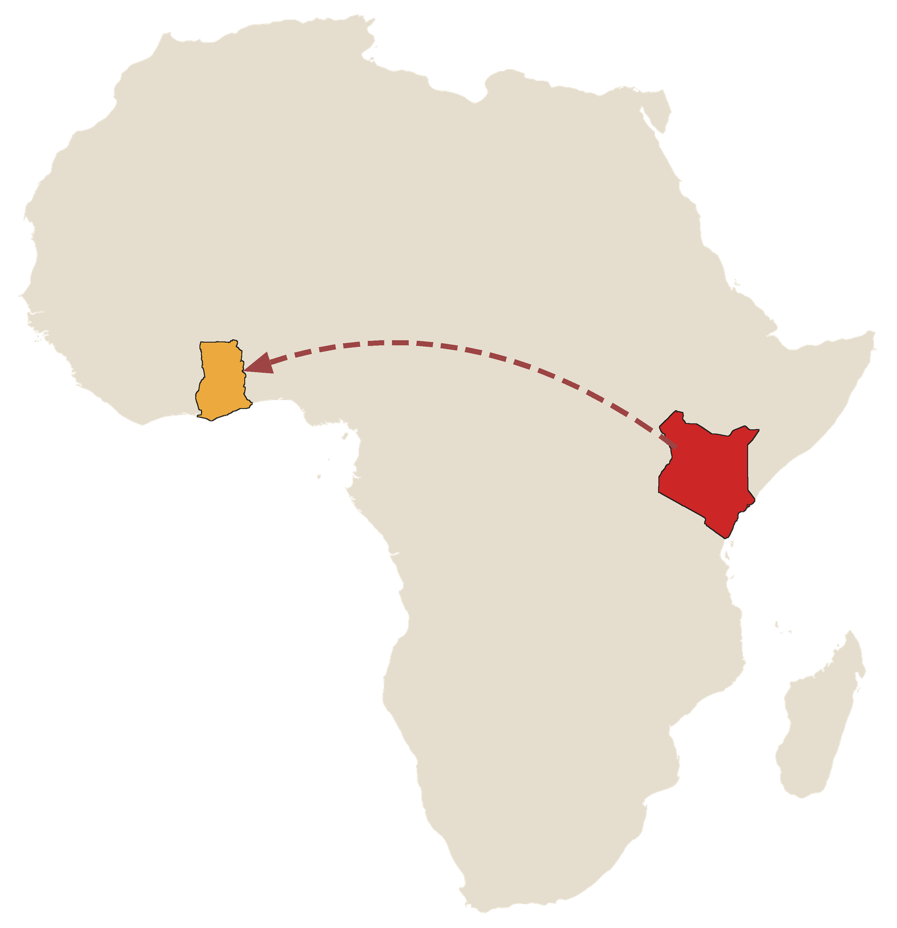
Trained on Kenyan loans. Asked to decide in Ghana.
Group | MLE Group 1
Members | Alice Iris Kare Acquah, Germain Emil Allotey-Pappoe, Joseph Delali Kodzo Etse, Liza Ekua Ndede Aikins
Institution | Ashesi University, November 2026
Code and results | github.com/ASU-MICS-2028/mle-group-1-prosit-2

Contents
Summary 3
1. Problem framing (Part A) 3
2. Data 4
3. Methods and derivations 4
4. Results: Task 2, default 5
5. Results: Task 1, loan amount 6
6. Kenya to Ghana (Part C) 7
7. Fairness and mitigation (Part D) 8
8. The scorer (Part E) 9
9. Limitations 9
10. Reproducibility 9
11. AI-use declaration 10

Our Project in Numbers
68,654  known Kenyan loans, and zero in Ghana | 0.128  PR-AUC on future loans, against a baseline of 0.018 | 47.9 KES  average cost per loan, down from 85 KES when approving everyone
53% → 4%  good first-time borrowers rejected, before and after our starter loan | 12.7%  of Ghanaian loans default, against 1.8% in Kenya | 729  Ghana policies tested. The best passed 4 of 6 stress tests

 | Summary

NkwaPay needs a single scoring tool to decide who to lend to and how much to offer. The challenge is that the tool must be trained on Kenyan loans with known outcomes and then used in Ghana, where no past outcomes are recorded. We built a calibrated logistic regression model to predict default risk (Task 2), a LightGBM model on log loan amounts to set safe credit limits (Task 1), and a live scoring tool that returns a risk score, a lending decision, a loan limit, and up to three plain-English reasons.
- Kenya: On future loans, our default model achieves a PR-AUC of 0.128 (95% CI: 0.110–0.154), compared with a 0.018 baseline. Because simple logistic regression beats more complex models on future loans, the committee's preference for an easy-to-explain model comes at no performance cost.
- Fairness: First-time borrowers faced the steepest barrier: 53% of first-timers who would have repaid were wrongly rejected, compared with just 8% of repeat borrowers. Offering a small, 10% starter loan cuts wrongful rejections to 4%. This costs about +0.9 KES per loan on first loans alone, and saves 3.4 KES per loan once repeat borrowing is counted.
- Ghana: The Kenyan model does not transfer safely to Ghana. Group-level totals from Zindi's scoring system show that about 12.7% of Ghanaian loans default, compared with 1.8% in Kenya. We recommend no full-size loans in Ghana yet: decline Type_2 and unfamiliar loan types, and offer Type_3 applicants a small 300 GHS starter loan in a capped pilot. Out of 729 policies tested, this rule tied for the highest score (passing 4 of 6 stress tests), though it remains unproven and loses money unless good borrowers return.
 | 1. Problem framing (Part A)

Decision point. A loan follows a clear timeline: application → decision → disbursement (disbursement_date) → due date → repaid or defaulted. Because NkwaPay makes its decision just before disbursement, our model can only use features known at that exact moment.
Label. Task 2 predicts target (1 = the loan defaulted). Task 1 predicts Total_Amount. The column names mentioned in the project brief (IsDefaulted and ProductCategory) do not appear in the dataset. We also excluded 190 loans whose due dates had not yet passed when the data was collected, since their final outcomes were not yet known.
Leakage audit. We audited all 16 columns for data leakage (learnings/03_feature_audit.md). Total_Amount_to_Repay and Lender_portion_to_be_repaid include penalty fees added only after a loan defaults. With them, PR-AUC jumps from 0.20 to 0.91—a false gain that would vanish in real-world lending. Meanwhile, lender_id adds no predictive value and simply reveals the borrower’s country, so we use it only for fairness checks.
Shared 13 features for both tasks (ADR 0012): loan_type, duration, New_versus_Repeat, and 10 borrower-history features (prior loan count, known outcomes, past defaults, time since last loan, recent borrowing frequency, and past loan amounts). To prevent leakage, a borrower’s history only counts past loans whose due dates had already passed before the new application. Calendar dates and macroeconomic indicators only helped when old and new loans were shuffled together, and hurt performance on future loans, so we removed them.
Cost matrix (calculated from platform fee rates; learnings/04_cost_matrix.md), for a typical 7-day loan:
 | Typical loan | Fee lost if good payer is rejected (FP cost) | Loss if approved loan defaults: 90% principal + collection (FN cost) | Decline above
Kenya | 5,000 KES | 2% = 100 KES | 4,500 + 200 = 4,700 KES | 2.1% = 100 / 4,800
Ghana | 3,000 GHS | 3% = 90 GHS | 2,700 + 16 = 2,716 GHS | 3.2% = 90 / 2,806

With a calibrated default probability p, rejecting an application is cheaper when p·FN > (1−p)·FP, which means we decline whenever p > FP / (FP + FN). Sensitivity: Changing debt recovery (0–30%) or doubling collection costs barely moves the cut-off, keeping it within 1.9–2.6% in Kenya and 2.9–4.1% in Ghana. Counting the future value of repeat customers moves it much more—to 9.6% in Kenya and 14.2% in Ghana. (The 10% recovery rate and collection costs are our working assumptions.) Business goal: We minimise expected financial cost per loan and report the resulting approval rate rather than forcing a fixed approval quota. Forcing an 80% approval target was slightly cheaper on immediate costs (47.2 vs. 49.0 KES), but far more expensive once repeat business is included (122 vs. 94 KES), and it fails to adapt when default rates shift over time (07_cost_sensitivity_verified.csv).
 | 2. Data

Train.csv contains 68,654 Kenyan loans with 1,258 defaults (1.83%). Test.csv contains 18,594 unlabelled loan applications: 15,069 from Kenya and 3,525 from Ghana (coming from just 446 unique Ghanaian customers). Because 4,306 Kenyan customers appear in both datasets, we group our validation splits by customer so the same person never appears in both training and validation. Loan amounts span a wide range (from 2 to 23 million), so we model them on a log scale. Time also matters: 92% of training loans come from July–December 2022 with a ~1% default rate, while later periods see default rates of 5–15%. Selection bias: Only 12% of borrowers who defaulted ever took another loan, meaning our history mostly reflects borrowers the lender chose to keep serving. World Bank Findex Ghana 2021 data (n = 1,000) is used strictly as survey-weighted summary totals. No raw loan records are stored in our code repository or shared with AI tools.
 | 3. Methods and derivations

Logistic regression. We model the log-odds of default as a linear combination of features: log(p/(1−p)) = xᵀβ, which gives p = σ(xᵀβ) = 1/(1+e^{−xᵀβ}). Assuming independent Bernoulli outcomes, the likelihood is L(β) = Π p_{i}^{y}_{i}(1−p_{i})^{1−y}_{i}. Taking the negative log-likelihood gives the cross-entropy loss: ℓ(β) = −Σ[y_{i} log p_{i} + (1−y_{i}) log(1−p_{i})]. Using the derivative σ′ = σ(1−σ), the gradient simplifies to ∇ℓ = Xᵀ(p−y). Because p depends non-linearly on β, there is no closed-form formula, but the loss function is convex, so Newton-style solvers reliably find the global minimum. Applying class weights multiplies the loss terms and distorts the output probabilities—which is why we use an unweighted model and calibrate its probabilities before applying our cost cut-off.
Linear regression. Assuming Gaussian noise y = Xβ + ε with ε ~ N(0, σ²I), the log-likelihood is −(n/2) log(2πσ²) − ‖y−Xβ‖²/(2σ²). Maximising this log-likelihood is equivalent to minimising squared error. Setting the gradient −2Xᵀ(y−Xβ) to zero yields the normal equations XᵀXβ̂ = Xᵀy, giving β̂ = (XᵀX)⁻¹Xᵀy when XᵀX is invertible. Ridge regression adds an L2 penalty λ‖β‖², giving β̂ = (XᵀX+λI)⁻¹Xᵀy, which is always invertible for λ > 0.
Gradient boosting. Boosting builds an ensemble step by step: F_{m}(x) = F_{m−1}(x) + ν·h_{m}(x), where each tree h_{m} fits the negative gradient of the loss at F_{m−1}. For squared-error loss, that negative gradient is simply the residual y−F; for log-loss, it is y−p. Full mathematical derivations are in knowledge/derivations.md.
Calibration and reasons. We calibrate probabilities using Platt scaling fitted on out-of-fold predictions across five customer-grouped folds. Because Platt scaling multiplies every feature's log-odds contribution by the same positive constant, it never changes the ranking of borrower reasons. Each reason is calculated as the feature group's weight multiplied by (borrower value − average value), and is shown if it raises log-odds by at least 0.2—matching linear SHAP values exactly (ADR 0017). All preprocessing runs inside a scikit-learn pipeline fitted strictly within each training fold.
Three validation schemes. We evaluated every model three ways: random shuffled folds (naive baseline), customer-grouped folds (testing on unseen borrowers), and rolling time blocks (training on older loans, testing on newer ones). We trust the time-block results most, because real lending always predicts future loans from past data. Using this setup, we compared seven classifiers and nine regressors.
 | 4. Results: Task 2, default

Model | PR-AUC shuffled | PR-AUC new customers | PR-AUC future loans | ROC-AUC future | F1 at 2.1%, future | Cost KES per loan, future
Majority baseline (approve all) | 0.018 | 0.018 | 0.018 | 0.500 | 0 | 85.3
Logistic regression | 0.221 | 0.216 | 0.108 | 0.738 | 0.129 | 51.1
Logistic, balanced weights | 0.217 | 0.210 | 0.105 | 0.742 | 0.133 | 59.3
Random forest | 0.223 | 0.208 | 0.068 | 0.692 | 0.059 | 52.8
k-NN | 0.181 | 0.169 | 0.064 | 0.627 | 0.039 | 61.1
LightGBM | 0.238 | 0.195 | 0.057 | 0.682 | 0.072 | 56.7
Pruned tree | 0.126 | 0.136 | 0.053 | 0.665 | 0.090 | 50.4

Averages across validation folds or time blocks (07_validation_comparison.csv) from Step 7. Although the pruned decision tree is 0.7 KES cheaper than logistic regression here, its PR-AUC is only half as high and its coarse step-function probabilities are poorly suited for a precise cost threshold.
- Shuffled testing gives a false winner: LightGBM looks best on randomly shuffled data (0.238 PR-AUC), but drops by 76% when tested on future loans (0.057). Logistic regression holds up much better, dropping by 51% to lead all models at 0.108.
- Noise floor (±0.0263): Looking at each of the four future time blocks separately, logistic regression beats random forest every time by an average of +0.039 PR-AUC (above our noise floor). However, when all future predictions are pooled together, the lead narrows to +0.015 (95% CI: +0.001 to +0.033), which sits inside the noise floor. Our honest conclusion is that logistic regression is at least as accurate as complex models, while being much simpler and clearly beating the baseline.
- Final model across all future loans (11_fairness_by_group.csv, 54,463 loans, 988 defaults, 2.1% cut-off): PR-AUC reaches 0.128 (95% CI: 0.110–0.154), ROC-AUC is 0.824, F1 is 0.160 (0.146–0.174), and lift is 7.1×. The model approves 89% of applications, catches 55% of defaults, and cuts the average cost per loan to 47.9 KES (down from 85.3 KES when approving everyone). Removing three borrowing-frequency features for fairness (Section 7) changes the cost by just −0.6 KES, well within normal noise.
- Calibration: An early version of our model was calibrated only on high-default 2024 loans, which caused it to overestimate risk on 2022-style loans by roughly 4× (ADR 0017). Calibrating across all time periods fixed this. On future loans, the model predicts an average risk of 1.3% compared with the actual 1.8% default rate, showing that it still needs regular recalibration as market conditions shift.
- Zindi (F1): On the Zindi leaderboard, our 2.1% cost-based threshold scored 0.210 public / 0.201 private F1, whereas thresholds tuned specifically to maximise F1 scored 0.376 / 0.393 (logistic regression) and 0.401 / 0.396 (LightGBM—a gap within our noise floor). We prioritise real financial cost over F1, because F1 treats false rejections and defaults as equally costly. (Top leaderboard scores reached ~0.84 / 0.78.)
Step 7 model, 4 future blocks, 2.1% | Repaid | Defaulted
Approved | 49,150 | 500
Declined | 4,325 | 488

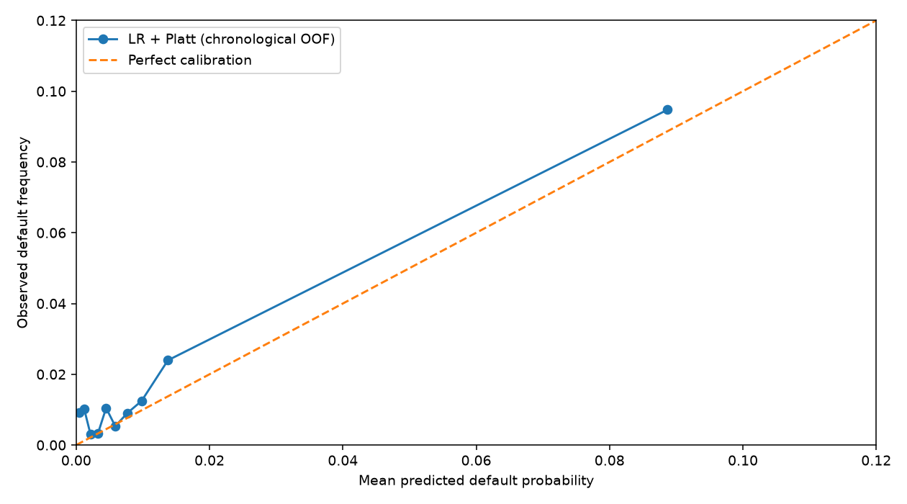 | 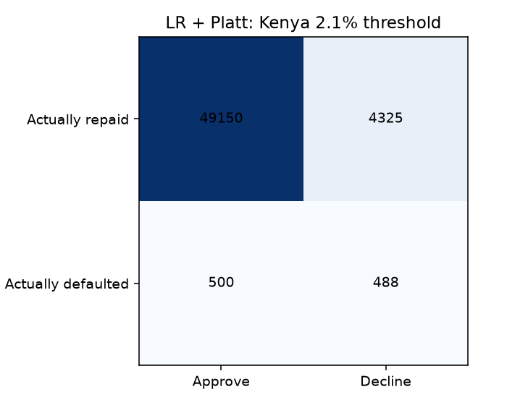
Figure 1. Left: reliability curve. Right: confusion matrix, from the step 7 run.
 | 5. Results: Task 1, loan amount

Model (future loans) | MAE log | RMSE log | MAE KES | RMSE KES | Within 2×
Guess the average | 0.972 | 1.262 | 12,149 | 110,139 | 44%
OLS | 0.630 | 0.822 | 13,834 | 167,858 | 64%
Ridge | 0.630 | 0.823 | 13,802 | 167,314 | 64%
Lasso | 0.628 | 0.820 | 12,860 | 152,290 | 65%
SVR | 0.592 | 0.860 | 9,112 | 106,291 | 71%
Random forest | 0.583 | 0.795 | 8,393 | 103,648 | 70%
LightGBM | 0.581 | 0.796 | 8,463 | 103,474 | 70%

For predicting loan amounts, LightGBM beats Ridge regression by a clear margin of −0.049 log MAE (95% CI: −0.054 to −0.045) and performs on par with random forest. A borrower's past loan amounts drive most of the prediction. Limit rule: We set each borrower’s credit limit at the 75th percentile of loans taken by similar recent borrowers. Under this cap, 74% of borrowers receive the full amount they request (compared with 53% under a "same as last loan" rule), while the share of lent money lost to defaults drops from 15% (with no cap) to 5.9%. When forecasting total cash reserves, we apply Duan’s smearing adjustment to convert from log scale back to shillings—recovering 98% of the true total, whereas unadjusted median predictions capture only 69%. Note that first-time loan amounts are still overestimated by about 1.4×.
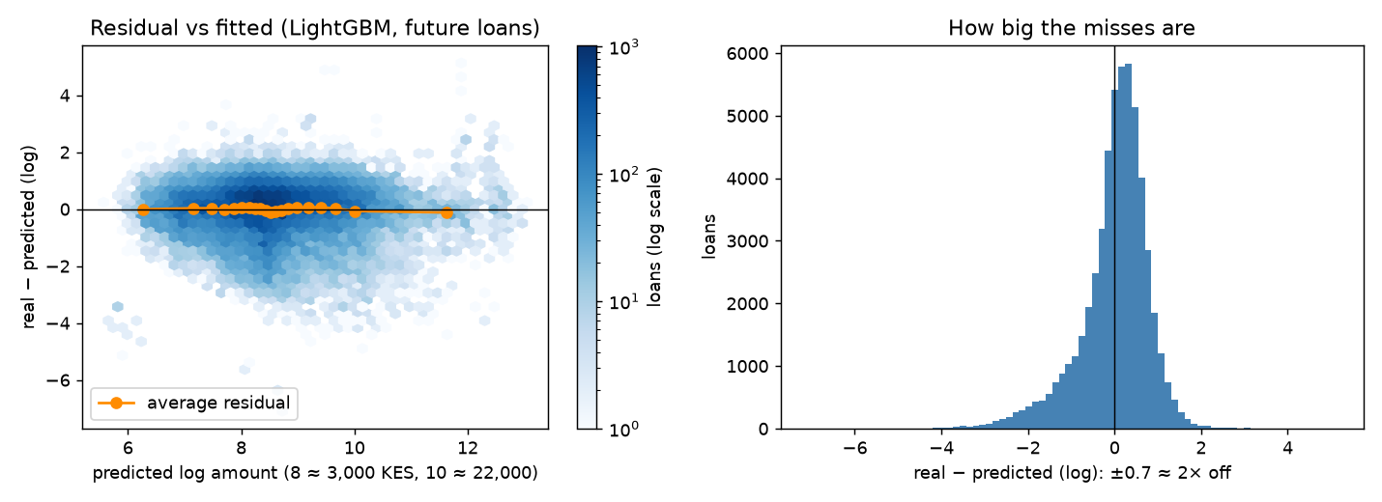
Figure 2. Residuals against fitted values, LightGBM on log amount.
 | 6. Kenya to Ghana (Part C)

Figure 3. The model is trained on Kenyan loans (red) and asked to decide in Ghana (gold).
Severe market shift. A domain classifier separates Ghanaian applications from Kenyan ones with a ROC-AUC of 1.00 (compared with 0.50 between Kenyan train and test sets), and still reaches 0.90–0.94 even after removing loan_type and past-outcome features. In the test set, 87% of Ghanaian applications are for loan types never seen in Kenya, 97% use unfamiliar lenders, no Ghanaian applicant has a recorded repayment outcome, and loan sizes are roughly 8× larger in US dollar terms. Importance weights fail: Re-weighting the 68,464 Kenyan loans to match Ghana shrinks the effective sample size to between 19 and 2,757 loans, making every re-weighted model perform worse. Amounts: Because loan amounts are visible in the test set, we could test our Task 1 regressor directly on Ghana: it achieves a log MAE of 0.45 in raw cedis (vs. 0.51 after converting currencies), but systematically over-predicts first-time loans (3.4×), loans over 90 days (3.1×), and Type_2 loans (2.8×).
Group evidence from Zindi. Although we have no outcome labels for Ghana, Zindi scores every test submission using F1. If a submission flags a single group of size k containing d defaults (out of P total defaults), its score is F1 = 2·d / (k + P). Using 20 group-level submissions (checked against Zindi's rules), we recovered totals per group, never per person. Because the F1 formula forms an exact fraction of whole numbers, we could solve for exact group default counts across the 4,649 public and 13,945 private test loans. Two sanity checks confirm the math: every subgroup adds up to its exact total size, and the Kenyan test set comes out at 275 defaults out of 15,069 loans (1.8%), matching our training data. Because these group counts come from the test set, any policy built on them cannot claim a clean Zindi leaderboard rank; our three Zindi scores in Section 4 were submitted before this step.
Ghana group | Loans | Defaults | Rate | Cautious range (customers, not loans)
All | 3,525 | 447 | 12.7% | 9.9–16.1%
Type_2 (median loan 76,970 GHS) | 449 | 226 | 50.3% | 43.8–56.8%
Type_3 | 3,039 | 213 | 7.0% | 4.2–11.4%
Type_3 first loans | 296 | 29 | 9.8% | 6.4–14.6%
Type_3, safest 60% by model score | 1,823 | 88 | 4.8% | bands reach about 2% to 11–13%
Type_3, riskiest 40% | 1,216 | 125 | 10.3% | band 4: 6.2–16.8%

These group rates overturned our initial plan to ignore loan_type in Ghana. At the 3.2% threshold, average cost per Ghanaian applicant is: approve everyone = 344 GHS; treat unseen types as Type_1 = 170 GHS; final model without loan type = 156 GHS; drop borrowing-frequency features = 147 GHS; drop loan_type only = 142 GHS; keep all 13 features = 105 GHS; decline everyone = 79 GHS.
Every policy tested. We divided Ghanaian applicants into six groups and tested all 729 ways of assigning each group a full loan, a 300 GHS starter loan, or a rejection across four repeat-customer values (0, 16, 180, and 360 GHS—2,916 scenarios in total). Not a single cheapest policy included full-size loans. Our recommended rule (give Type_3 a 300 GHS starter loan, and decline Type_2 and unknown types) costs 89, 90, 102, and 114 GHS per applicant across those four repeat values, compared with 79, 93, 236, and 393 GHS when declining everyone. It beats declining everyone as soon as a returning good borrower is worth at least 13 GHS.
Stress test (rules set in advance) | Result | Pass?
Beats full-size policies on both data parts and in 95%+ of rate draws | Both parts yes; only 77–87% of draws | No
Beats them in 90%+ of 2,880 assumption combinations | 78% | No
Against decline-all: at most +15 GHS with no repeat value; wins 50%+ at 16, 95%+ at 180, 360 | +10; 63%; 100%; 100% | Yes
Beats full-size on real loan amounts | Yes | Yes
Beats full-size if starters default twice as often | Yes, narrowly at no repeat value (101 vs 102) | Yes
Within 15 GHS of the cheapest, including out-of-part | At most 10.1 | Yes

Out of all 729 policies, none passed either of the first two stress tests, and none passed more than 4 tests overall. It loses money without repeat business: On first-loan fees alone, per 1,000 applicants our rule lends 258,638 GHS, earns 7,215 GHS in fees, and loses 17,282 GHS to defaults (a net loss of ~10,000 GHS). We therefore recommend it strictly as a capped starter pilot—the most affordable way to collect local data, not a proven profit-maker. Requirements before scaling: Collect roughly 5,000 completed Ghanaian loans (~90 defaults even at Kenya's low rate), recalibrate Platt scaling on local outcomes, run monthly drift checks (investigating any feature with PSI > 0.25), and verify pilot default rates against our group estimates.
 | 7. Fairness and mitigation (Part D)

Our complete fairness audit, Model Card, dataset documentation, and legal compliance map are provided in the companion audit document. Fairness priority: First, sufficiency (a given risk score should mean the same true default probability for every group); second, reducing disparities in false rejections of good borrowers. Because true default rates differ sharply across groups—first-time loans default 8× as often as repeat loans (10.9% vs. 1.3%)—it is mathematically impossible to equalise calibration, false rejections, and approval rates all at once.
Group (future Kenyan loans) | Approved | Good payers wrongly declined | Actual default | PR-AUC
First loans | 45% | 53% | 10.9% | 0.274
Earlier loans, known outcomes | 92% | 8% | 1.3% | 0.075
Smallest quarter of loans | 93% | 7% | 1.4% | 0.034
Largest quarter of loans | 84% | 15% | 3.0% | 0.200
Lender A (95% of loans) | 93% | 6% | 1.4% | 0.083
Lender B | 19% | 80% | 8.4% | 0.120

In our unadjusted model, the false-rejection gap between first-time and repeat borrowers is 45 percentage points (95% CI: 43–48). (Note that PR-AUC cannot be compared directly across groups with different base default rates.) Meanwhile, the loan-limit model offers the smallest-loan quartile up to 2.8× their usual loan size—meaning it is generous rather than restrictive, which carries its own risk of over-indebtedness.
Why hiding features fails: Remaining history features reveal whether an applicant is a first-time borrower with 100% accuracy (AUC 1.00), and nearly reveal lender and country as well. As a result, simply hiding the first-timer column backfires and lowers first-timer approval from 45% to 41%. Mitigations tested: We evaluated 1,224 combinations of starter-loan caps (10–50%), group-specific thresholds, sample re-weighting, and feature removal. Chosen for Kenya: We drop the three borrowing-frequency features (which costs nothing and stops telling 31% of declined Kenyans that they were rejected for "not borrowing recently"), and we offer first-timers between 2.1% and 24% risk a 10% starter loan. This cuts wrongful rejections of good first-time borrowers from 53% down to 4%. It costs just +0.9 KES per loan (95% CI: −0.5 to +2.4) on immediate loan outcomes, and saves 3.4 KES per loan (−4.9 to −1.9) once the ~200 KES repeat-borrower value on small first loans is included. (In our customer-grouped test, the immediate cost is +1.7 KES, slightly above our +1.0 KES target; we also note that repeat value across large first loans is negative.)
Financial inclusion context (Findex 2021). In Ghana, 68% of adults have a financial account, 60% use mobile money, and roughly 93% have never borrowed from a bank or mobile-money provider. Account ownership also shows clear gaps: 63% of women vs. 74% of men, and 55% of the poorest 40% of households vs. 77% of the richest 60%. While the unadjusted Kenyan model would reject every Ghanaian first-timer, our starter-pilot rule opens access for Type_3 applicants—though 55% of Ghanaian first-timers in the test set still get declined because they apply for high-default Type_2 loans. And because NkwaPay operates via mobile money, it cannot reach the 40% of adults without a mobile-money account. Finally, our dataset has no gender column, so we cannot audit gender disparities directly.
Legal and regulatory gaps. Our clearest legal gap in Ghana is Section 26(4) of the Credit Reporting Act (Act 726), which requires a credit-bureau check before every loan decision—a data feed NkwaPay does not yet have. Other requirements before launch include automated decision logging, a digital appeals channel (Bank of Ghana Directive 2.3(1) prohibits manual approvals from a physical office), Data Protection Commission registration and a DPIA under Act 843, and formal affordability caps. (Note: we are students, not legal counsel.)

8. The scorer (Part E)

score(application) in src/scorer.py accepts exactly 14 required application fields and rejects any unexpected fields (such as gender) so sensitive attributes can never enter the model. It returns a calibrated default probability, its source (model vs. group prior), a decision (approve / starter / decline), a credit limit, up to three plain-English borrower reasons, and audit notes. All 18 automated unit tests pass, and all 18,594 test applications score cleanly (Kenya: 82.1% approve, 8.8% starter, 9.1% decline; Ghana: 86.2% starter, 13.8% decline). Latency across 1,000 calls: 29 ms median in Kenya (95% under 37 ms), under 0.1 ms in Ghana, and 1.6 s to load models from disk. Testing found a real flaw: Stress-testing uncovered a genuine edge case: a fictional applicant who had defaulted on all 3 prior loans was approved at 1.9% risk, because the training set contains only 122 loans after a prior default and the linear model gave that feature too little weight. Adding a hard safety rule to decline anyone with 2+ past defaults (or a ≥50% past default rate) fixes the flaw without changing a single historical decision. Simulating unseen loan types in Kenya also confirmed that declining unfamiliar loan types is the safest default policy (90.7 KES per loan vs. 94.1 KES for the model and 141.9 KES for a starter loan).
 | 9. Limitations

- Ghana's rule is unproven. Our Ghanaian pilot rule relies on assumed starter-loan default rates and repeat-customer values, our group default rates come from just 446 unique customers, and Kenyan repeat-borrowing behaviour may not hold in Ghana.
- Cost assumptions are simplified: Our thresholds use median loan sizes, a 10% debt-recovery assumption, and estimated collection costs. We also assume amounts are recorded in local currency (KES and GHS), as the raw files do not specify units.
- Selection bias: We only observe outcomes for applicants whom lenders previously approved, and very few borrowers ever receive another loan after defaulting.
- Default rates drift from ~1% in late 2022 to 9–12% in 2023–2024, meaning probability calibration grows stale quickly without regular updates.
- Simple approval reasons: Because most approved borrowers look similar to the average good borrower, they typically receive one general explanation rather than three specific ones.
- Items to verify before launch: We omitted Findex rural and education breakdowns pending codebook verification, and the exact Bank of Ghana per-customer borrowing limit is not specified in the public Directive.
 | 10. Reproducibility

To reproduce all results from a fresh clone, run uv venv --python 3.12 && uv pip install -r requirements.txt, place the raw files in data/zindi/ and data/worldbank/, build features with .venv/bin/python src/features.py, run the notebooks in order, and then execute src/scorer.py --fit, tests/test_scorer.py, src/fairness_scenarios.py, src/zindi_submissions.py --read-exact and src/ghana_rule_tests.py. All random seeds are fixed. When we reran Steps 9–10 from a clean clone, 27 of 31 output tables matched identically and 4 differed only at the third decimal place. Every number in this report is indexed in learnings/results_index.md, design decisions are logged in docs/adr/ (22 ADRs), and step-by-step progress is in docs/log.md.

11. AI-use declaration

We used Claude Code throughout this project, with every prompt and output logged in docs/ai_use.md. Starting in Week 1, AI assisted with drafting our project plan, study notes, and data checks. At team members' direction, it also wrote or drafted much of the code, notebooks, decision records, and documentation—including Steps 8–12, this report, the fairness audit, and the presentation slides—using our saved summary tables. We never shared raw loan records with AI, only summary statistics and synthetic test cases. Team members set the methodology, reviewed and approved all decisions, and manually ran the Zindi submissions.
Design credits. Adinkra symbols, recoloured, from Wikimedia Commons: Boa me na me boa wo and Kuntinkantan by Pablo Busatto (public domain); Ani bere, Kontire ne akwamu, Nkyinkyim, Nea onnim no sua a ohu, Akoma ntoso and Mmere dane by Pablo Busatto (CC BY-SA 4.0); Nteasee by GeorgesMbakop (CC0). Kente-style and Maasai-style bands were drawn for this report and are inspired by those traditions. Map data: Natural Earth (public domain). Template: Ashesi University.

