|  |  |  |
| --- | --- | --- |
|  | **CMPS 350 Project Phase 2 – Conference Management System (ConfPlus)**  **(15% of the course grade)** | |
| **Group Id:** | | No group IDs are assigned |
| **Group Members:** | | Ahmed Mansoor Ali Al-Surmi (201901562)  Khaled saad Abdelnabi Mohamed (201805078)  Ziad Abdelazim Sabry Abdelazim (201905466)   Emails:  aa1901562@qu.edu.qa  km1805078@qu.edu.qa;  za1905466@qu.edu.qa; |

**Grading Rubric - In the Functionality column please specify either: *Working (completed x%)*, *Not Working (completed x%)* or *Not done or Not Applicable*.**

|  |  |  |  |  |
| --- | --- | --- | --- | --- |
| **Criteria** | **Weight** | **Functionality**\* | **Quality of the implementation** | **Grade** |
| **Improvement over the first phase:**  *Depending on the implantation status of the previous phase, the following might apply:*   * *Completing missing functionalities;* * *Improving the design and implementation of paper submission: paper status, etc.* * *Improving the design and implementation of paper review: distinction between reviewed papers and papers to review, etc.* * *Various filtering possibilities for the conf schedule* * *Correct interpretation of session* * *Clarity of the various UIs.*   *By default, if no improvement is made, the student will have the same grade of previous phase for this category.*  *Everything you improve will add up to your previous grade that will be used as a baseline.* | 25 | Completed 100% |  |  |
| Design and implement the Data Model.  Clarity of data entities, their attributes and relations (in Prisma and the conceptual model (the diagram)) | 10 | Completed 100% |  |  |
| Init DB: populate the database with the data from the json files. | 5 | Completed 100% |  |  |
| Repository Implementation to read/write data from the database | 10 | Completed 100% |  |  |
| Database:   * The design and implementation of the statistics page * All other use-cases use the database, not JSON files or local storage. * All queries function correctly. | 40 | Completed 100% |  |  |
| **Design and Testing Documentation**  **\* Design documentation:**  - 3 key lessons learned from Phase 1.  - Data Model diagram.  - UI Design table  - Data caching table  **\* Testing documentation:** with evidence of working implementation using snapshots illustrating the results of your solution testing (you must use the provided template).  * **Discussion of the project contribution** of each team member [-10pts if not done] | 10 | Completed 100% |  |  |
| **Total** | 100 |  |  |  |
| Bonus - successful deployment of the app and the Database to a cloud hosting service such as <https://vercel.com/> - successful implementation of use authentication. | 5 |  |  |  |
| Bonus- authentication through another service provider e.g. Google, Github, etc. | 5 |  |  |  |
| Copying and/or plagiarism or not being able to explain or answer questions about the implementation. | 0 |  |  |  |

# Application Design

# Improvement over the first phase

|  |  |
| --- | --- |
| REMARK 1: | Adding previous submitted papers to the author |
| REMARK 2: | Change the Card to have Headings notifying the reviewer each part of the card |
| REMARK 3: | Fixing upload and download of file |

### Remark 1:

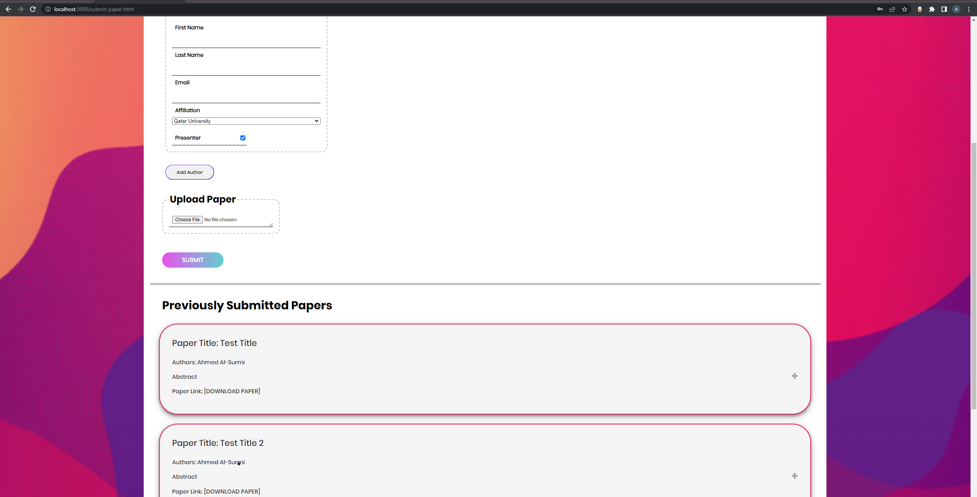

### Remark 2:

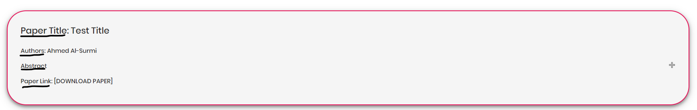

### Remark 3:

Uploading (Lorem_ipsum.pdf):

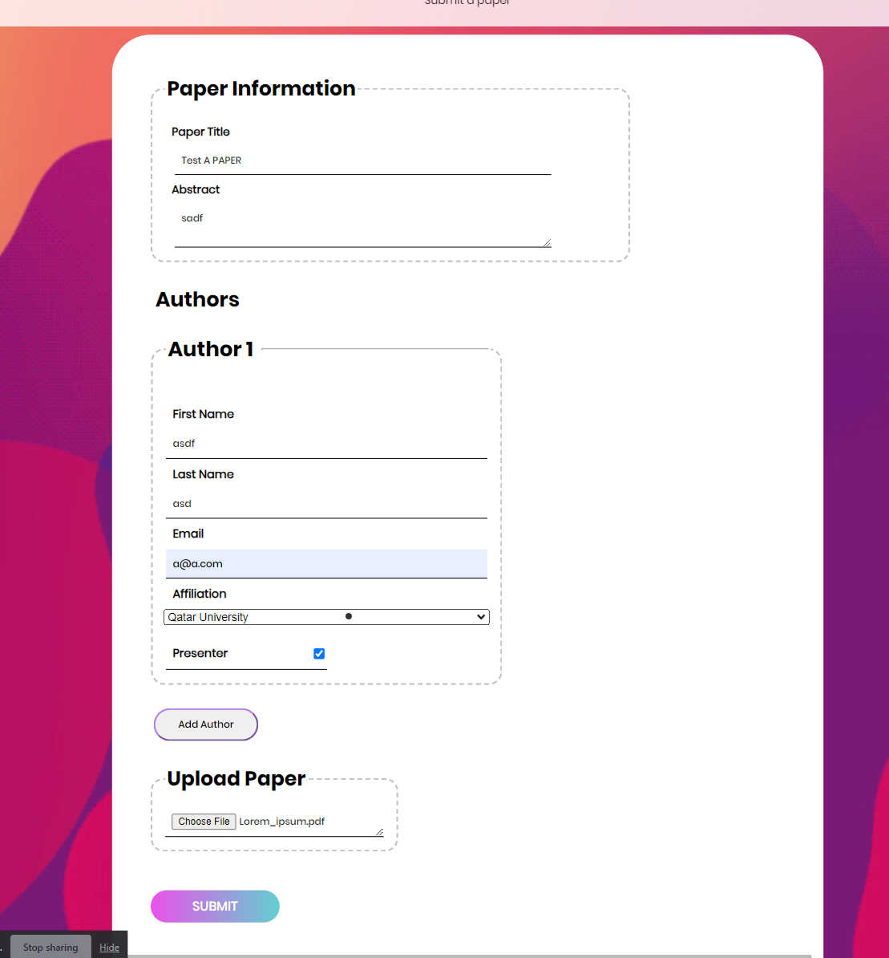

Uploaded into server:

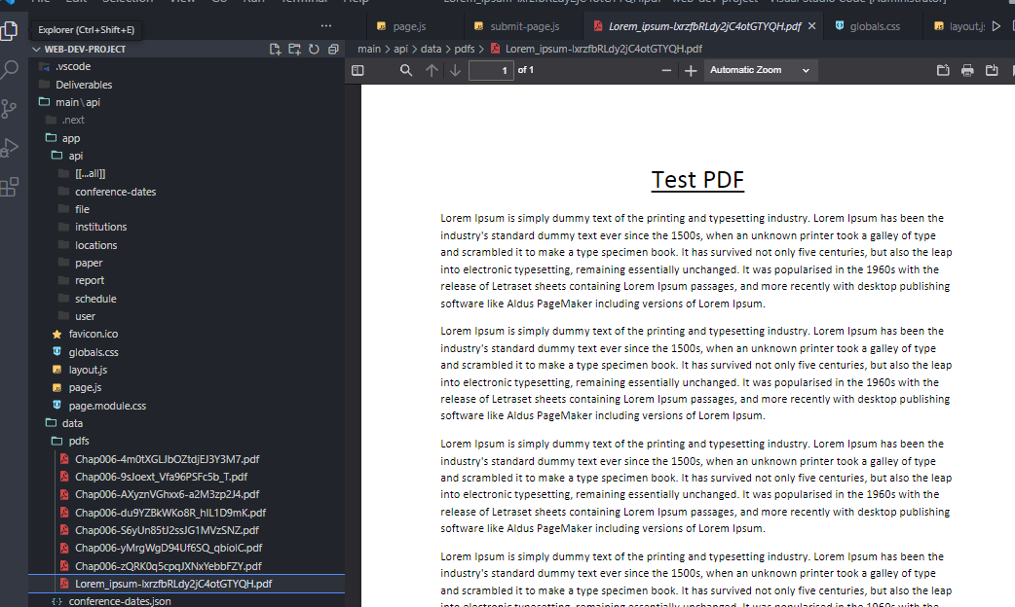

Downloading using previous papers reviewed:

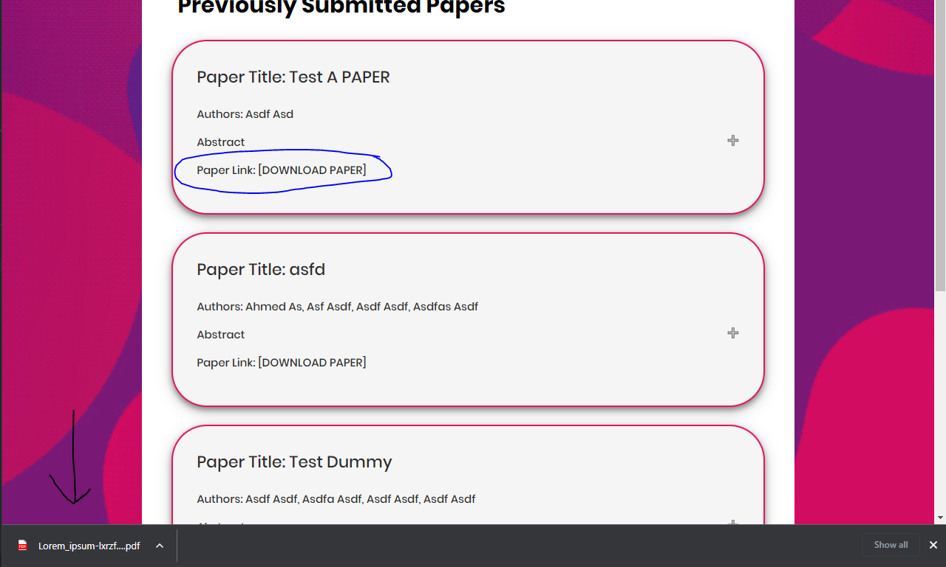

Downloaded File:

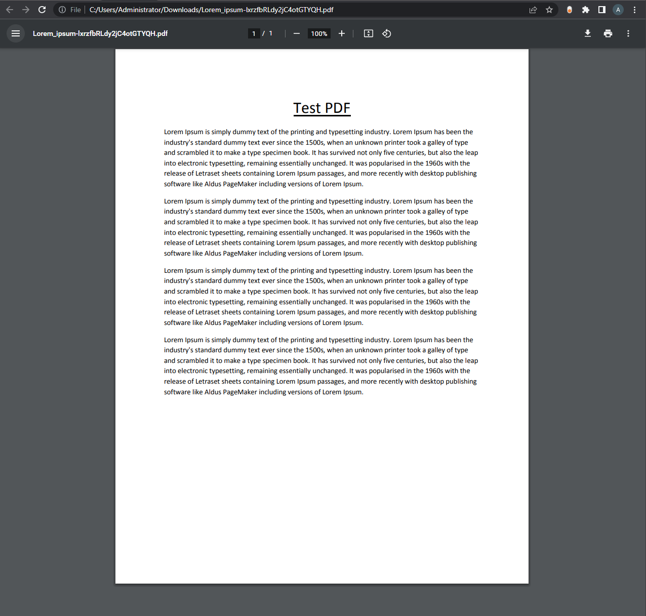

# Data Model diagram

### Prima Model:

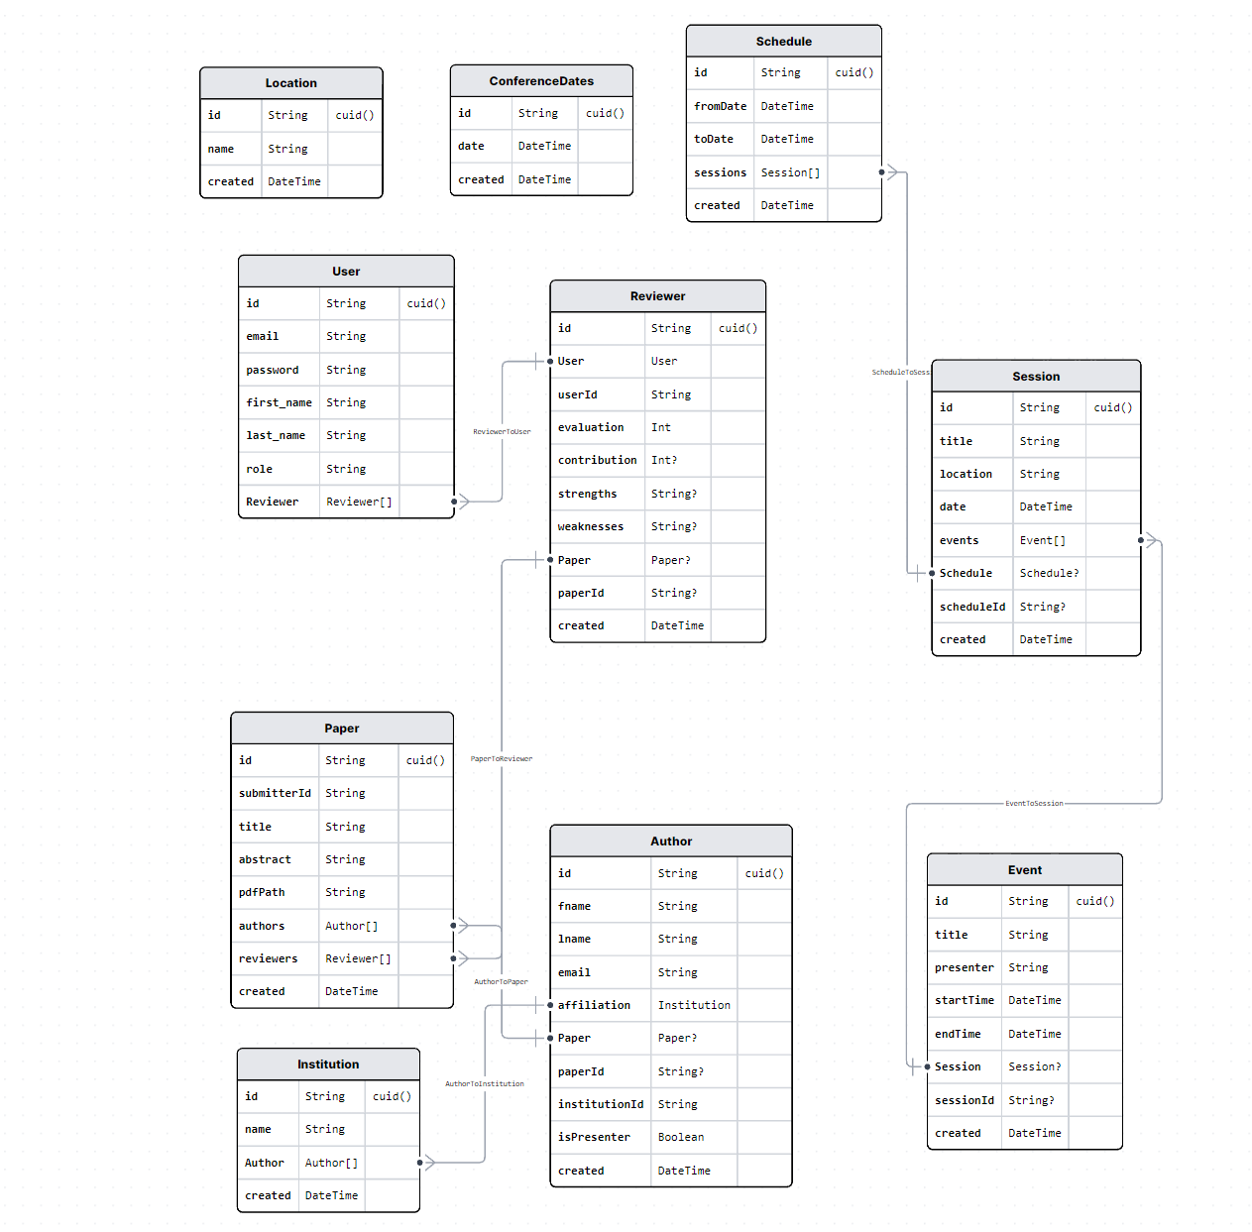

### Cached Items:

We only cashed the login data of user.

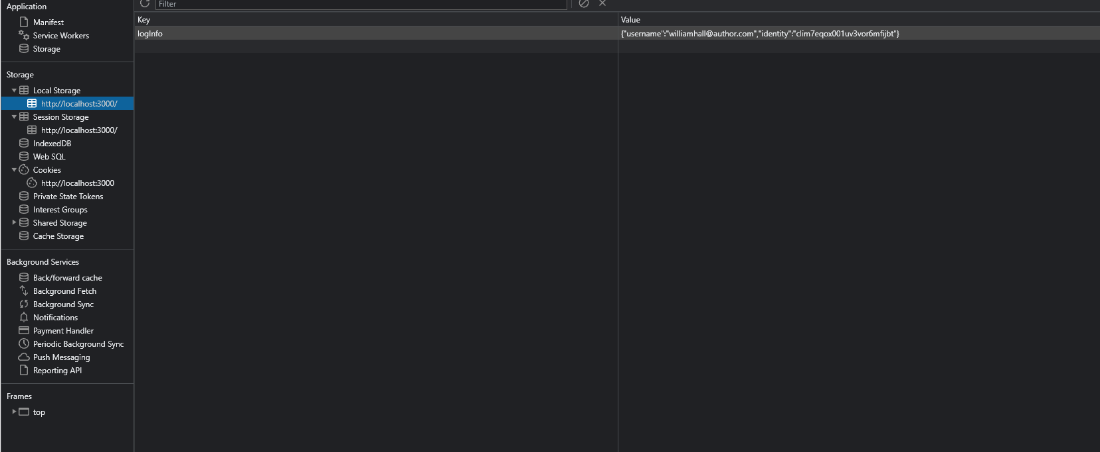

# Database population

### Seed.js

We used seed.js to populate the migration into the database:

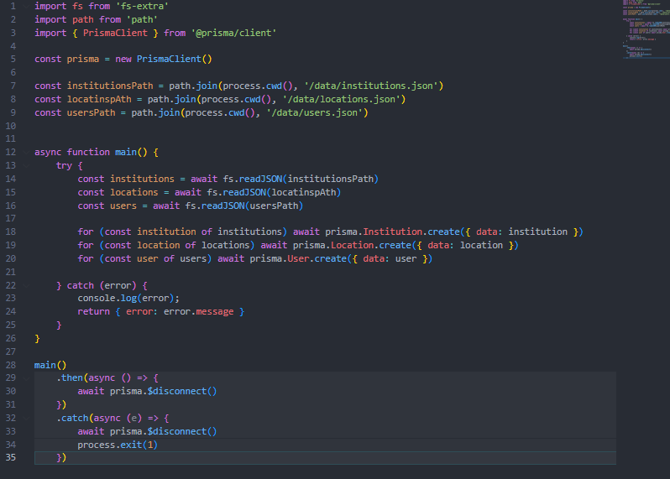

In Action:

Step 1 setting type to module and adding seed to Prisma in package.json:

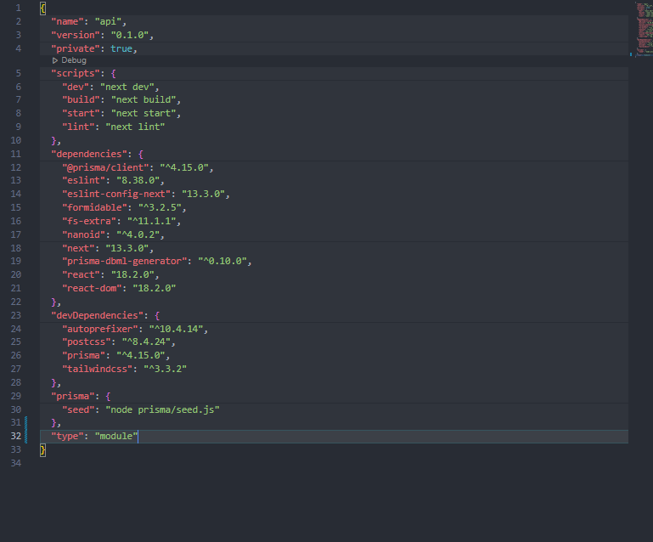

Step 2 running the migration command:

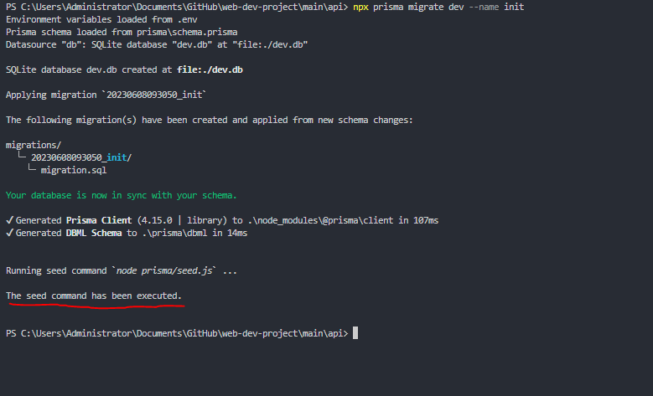

Step 3 Checking Database for Institution, Users, and Locations to be Populated:

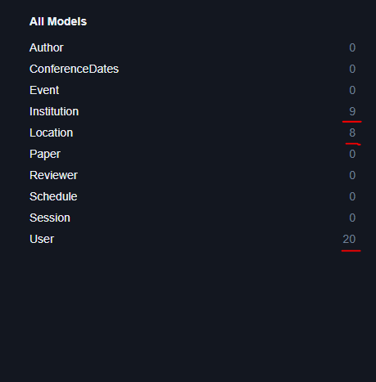

# Database

Give details and proofs about how you have updated your application to use database. This applies to all use-cases.

Detail your statistics page

Give the list of your Prisma queries

# 3 technical lessons learned from your submitted solution vs. the model solution

# Testing

# Custom Login

# Login using 2 Authentication Providers

# Submit paper

# Review paper

# Get conference schedule

# Edit conference schedule

# Conference Statistics Report

# Discussion of the project contribution of each team member