Exercise No: 2

Date: 10/10/2020

**Aim:**

To write a python program to count the number of occurrence of a number in a list.

**Program:**

def countX(lst,x):

count=0

for i in range(0,len(lst)):

if(x==lst[i]):

count=count+1

return count

lst1=[]

n=int(input())

for i in range(0,n):

inp=int(input())

lst1.append(inp)

x1=int(input())

y=countX(lst1,x1)

print(y)

**Link:**

http://103.53.53.18/mod/vpl/forms/submissionview.php?id=230&userid=1669

**Output:**

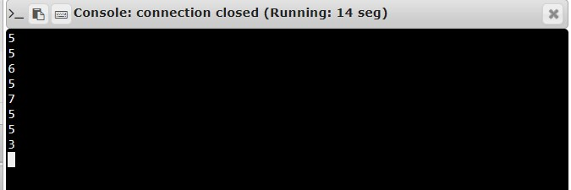

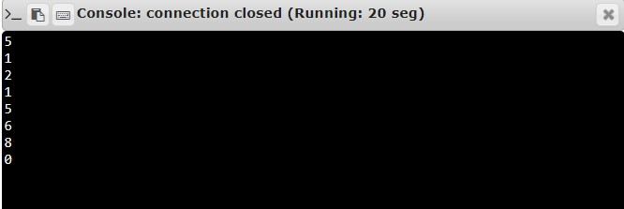

**Result:**

Thus, the program is executed and output of occurrence count Is obtained.