JIRASPRKLAERS
Autonomous Self-Healing Java Code Pipeline
Built on LangGraph · OPENAI LLM · Flask · Maven · JIRA · Jenkins

1. Executive Summary
agentService is an autonomous, agent-based pipeline that generates a Java 17 service together with its JUnit 5 tests, builds and tests it with Maven, and — when failures occur — automatically diagnoses the root cause, repairs the code with an LLM, and re-runs the build. The pipeline integrates with JIRA (ticketing), Git and Jenkins (CI), and a sibling Spring service (health checks). It is orchestrated as a LangGraph StateGraph in which 14 specialized nodes (referred to as ~15 nodes including the terminal END state) exchange a single typed AgentState dictionary, enabling granular context propagation and deterministic, router-driven decisioning.

2. Agent Catalogue (AI vs Non-AI)
The system distinguishes AI agents (which are called OpenAI LLM) from non-AI agents (deterministic, rule-based, or integration components). All LLM agents gpt-4o

2.1 AI Agents (LLM-backed via OpenAI)
Agent | File | Purpose
llm_code_generator | agents/llm_code_generator_agent.py | Generates a self-contained Java 17 service class with one public method. Can intentionally inject runtime bugs (NullPointer, ArrayIndexOutOfBounds, ClassCast, etc.) when trigger_bug_generation=True.
llm_test_generator | agents/llm_test_generator_agent.py | Generates the JUnit 5 test class for the service. Reflection-based fallback if the LLM call fails.
llm_fix_agent | agents/llm_fix_agent.py | Two-stage repair: Stage 1 (retry 0) source-only minimal fix; Stage 2 (retry 1+) source + test escalation. Generates the RCA comment. Falls back to a deterministic patch if the LLM fails.

2.2 Non-AI Agents (deterministic / integration)
Agent | File | Purpose
project_generator | agents/project_generator_agent.py | Picks project name/domain and loads the OpenAPI schema summary. Workflow entry point.
llm_file_writer | agents/llm_file_writer_agent.py | Writes pom.xml, Maven wrapper, and Java source/test files to disk (pure file I/O — no LLM).
build_agent | agents/build_agent.py | Runs mvn clean test-compile + mvn test; regex-parses output for exception type and failing test class/method/line.
source_ticket_in_progress_agent | agents/jira_agent.py | Marks the external JIRA source ticket 'In Progress'.
jira_failure_capture_agent | workflows/langgraph_workflow_llm.py | Wrapper node that creates/updates a JIRA failure ticket on build failure.
jira_agent | agents/jira_agent.py | Creates failure ticket (label ai-fix), attaches source/test files, writes WHAT/WHERE/HOW-TO-REPRODUCE description.
git_commit_agent | agents/git_ci_agent.py | git add + commit of repaired code.
jenkins_check_agent | agents/git_ci_agent.py | Triggers and polls a Jenkins CI job (SKIPPED_NO_CONFIG if not configured).
spring_smoke_agent | agents/spring_smoke_agent.py | Non-destructive GET health checks against the sibling Spring service.
jira_close_agent | agents/jira_agent.py | Marks the JIRA ticket 'Done' after successful build + CI.
source_ticket_finalize_agent | agents/jira_agent.py | Posts RCA, closes or keeps In Progress, and on exhausted retries hands off to a human (ai-fix -> developer-fix label).
ticket_poller_agent | agents/ticket_poller_agent.py | Background daemon (not a graph node) polling JIRA every 30s for open ai-fix tickets and auto-launching workflows.

3. System Architecture
The Flask application hosts the LangGraph engine, the runtime configuration (agent_runtime), and a WorkflowRunStore for live run tracking. Workflows are triggered manually (REST), by the background ticket poller, or via the web dashboard. The engine communicates with external systems — the OpenAI LLM API, Maven/JDK, JIRA, Git/Jenkins, and sibling Spring service.
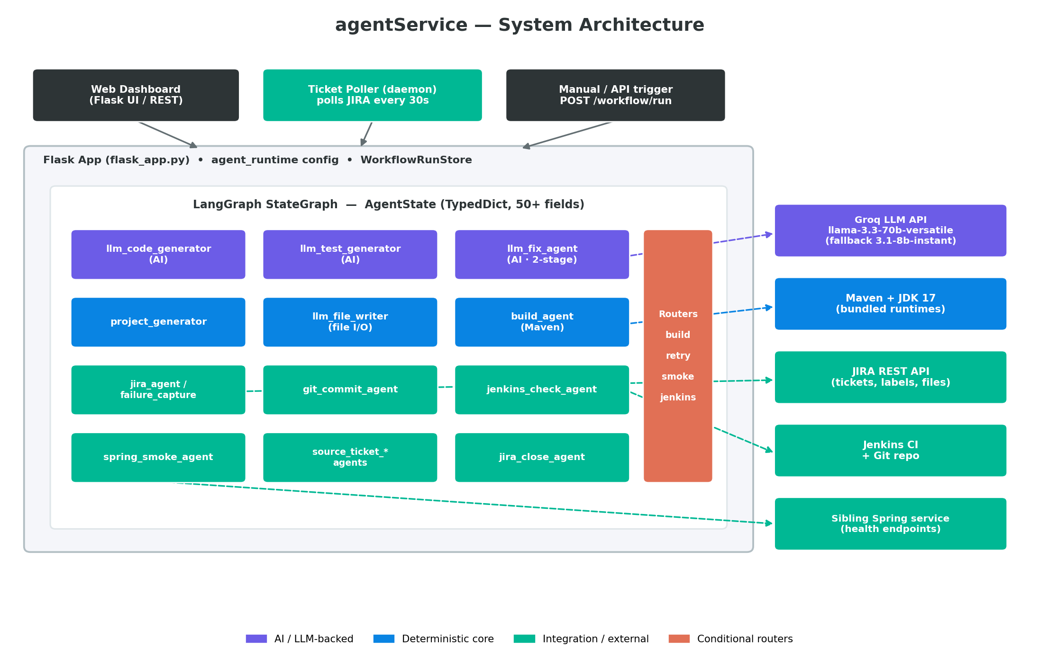
Figure 1 — agentService system architecture

4. Workflow & Control Flow
The pipeline is a LangGraph StateGraph. Each node is wrapped with a _tracked() helper that emits RUNNING/COMPLETED events to workflow_events via a contextvars-bound progress callback, which the dashboard polls for live status.
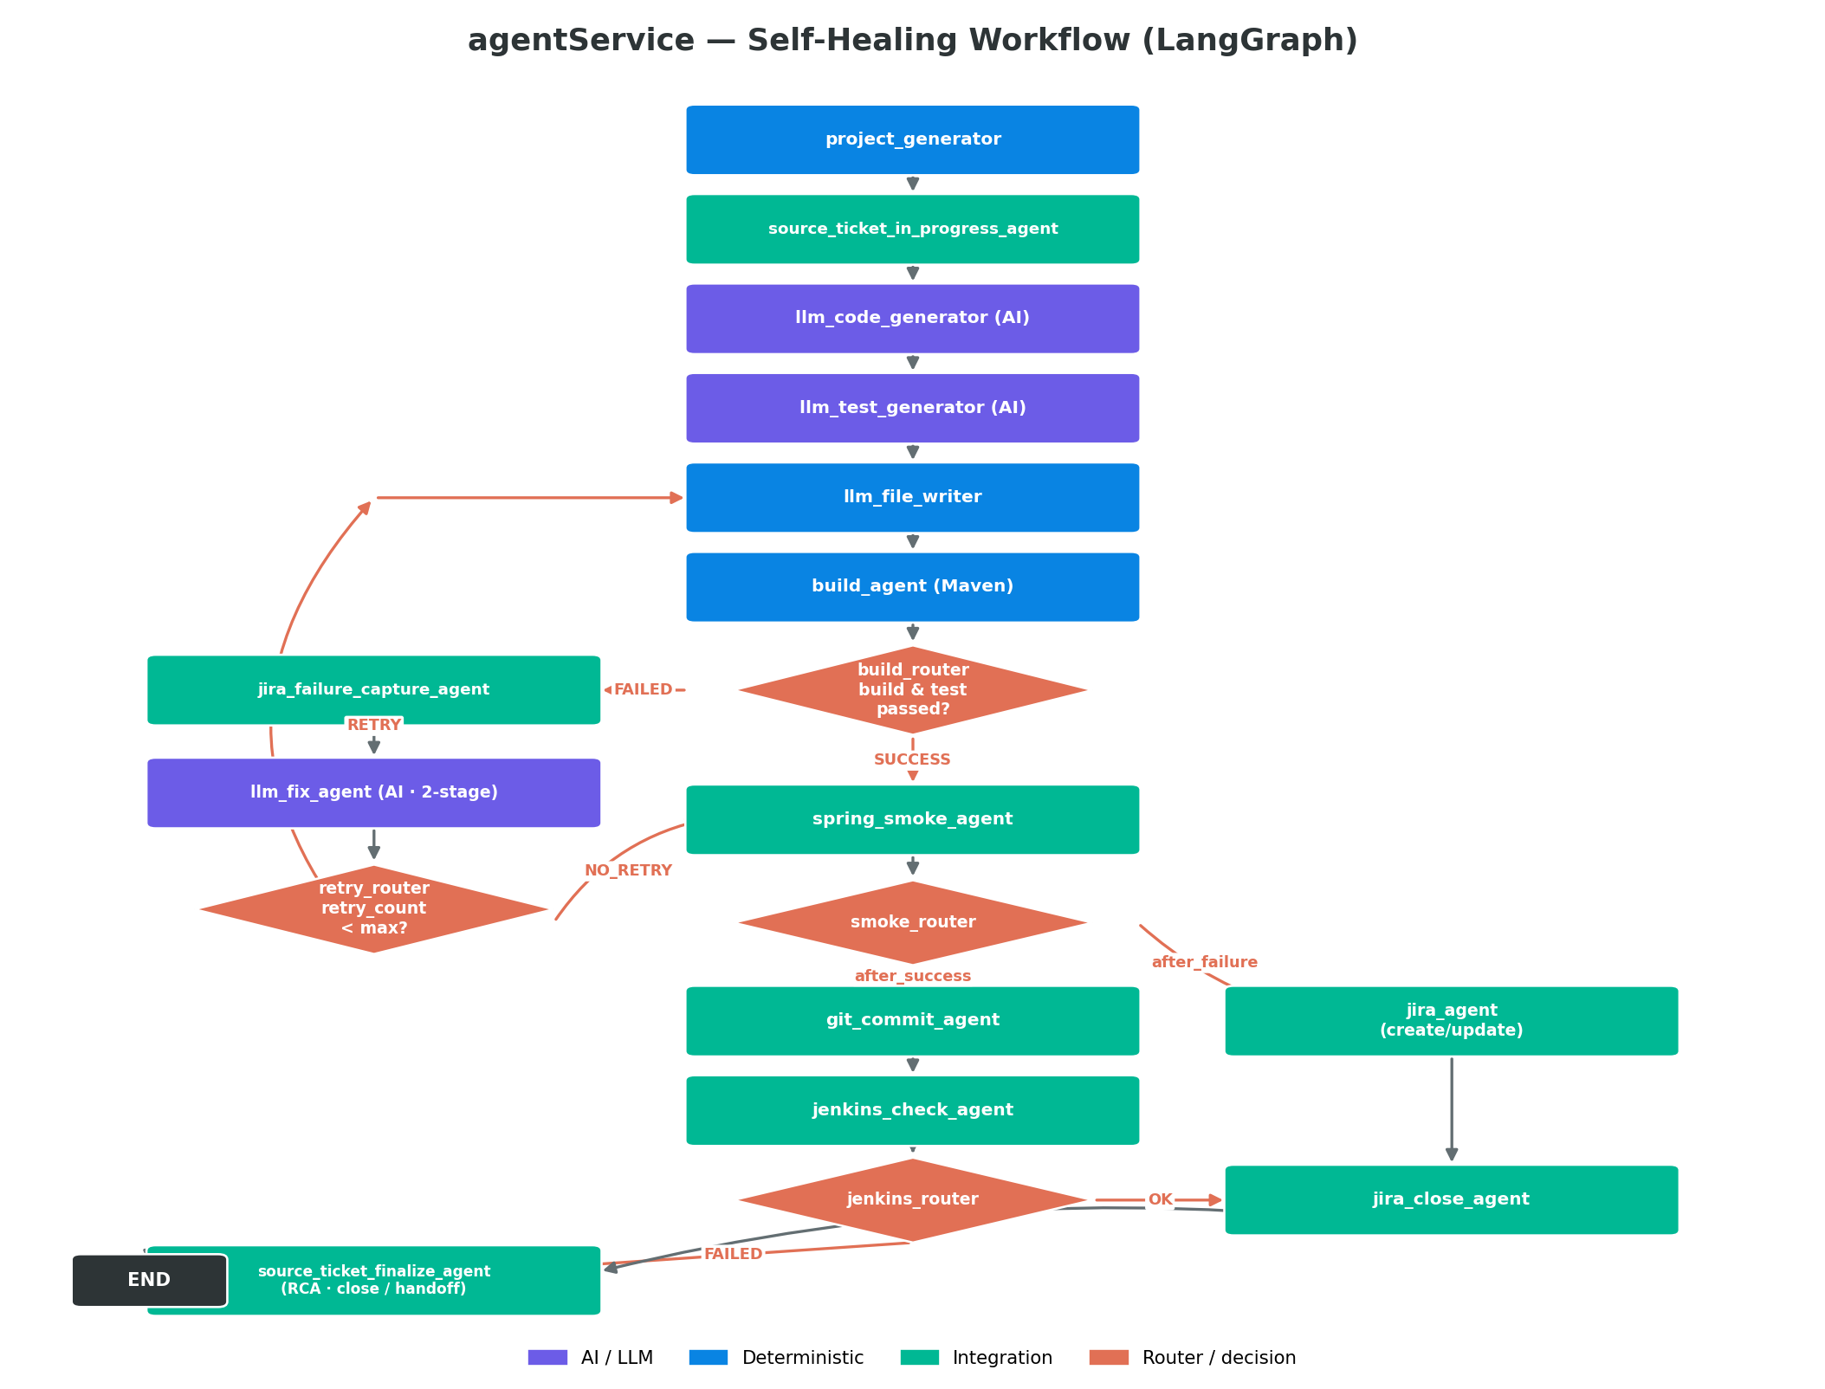
Figure 2 — Self-healing workflow flowchart

4.1 Node Sequence (14 nodes + END)
# | Node | Type | Responsibility
1 | project_generator | Deterministic | Entry; choose project, load schema
2 | source_ticket_in_progress_agent | Integration | Mark source ticket In Progress
3 | llm_code_generator | AI | Generate Java service
4 | llm_test_generator | AI | Generate JUnit tests
5 | llm_file_writer | Deterministic | Write files (retry-loop target)
6 | build_agent | Deterministic | Maven compile + test, parse failures
7 | jira_failure_capture_agent | Integration | Create failure ticket (failure branch)
8 | llm_fix_agent | AI | Repair code (2-stage)
9 | spring_smoke_agent | Integration | Service health checks
10 | git_commit_agent | Integration | Commit repaired code
11 | jenkins_check_agent | Integration | Trigger/poll CI
12 | jira_agent | Integration | Create/update ticket on CI/smoke failure
13 | jira_close_agent | Integration | Close ticket on success
14 | source_ticket_finalize_agent | Integration | RCA + close or developer handoff -> END

4.2 Routers (conditional decisioning)
Router | Decision | Routes
build_router | build_status==SUCCESS and test_status==PASSED | success -> spring_smoke_agent | failed -> jira_failure_capture_agent
retry_router | retry_count < max_retries | retry -> llm_file_writer (loop) | no_retry -> spring_smoke_agent
smoke_router | build & test passed | after_success -> git_commit_agent | after_failure -> jira_agent
jenkins_router | jenkins_status in (SUCCESS, SKIPPED_NO_CONFIG) | ok -> jira_close_agent | failed -> jira_agent

5. State Model — AgentState (TypedDict)
LangGraph passes one typed AgentState dictionary between every node. Each node reads what it needs via .get() and writes its results back, enabling granular context propagation. Routers make deterministic decisions purely by reading these fields (e.g., build_status, retry_count, jenkins_status), so the same typed contract that propagates context also drives the branching logic. Defined in state/agent_state.py.
Group | Fields
Input / control | project_name, domain, trigger_bug_generation, source_ticket_id, source_ticket_details, max_retries, retry_count
Code generation | generated_code, generated_test, java_project_path
Build / test | build_status, test_status, compile_status, baseline_test_status, edge_case_test_status, build_stdout, build_stderr, detected_exception_type, detected_exception_message
Failure diagnostics | source_class, source_method, source_file_path, failing_test_class, failing_test_method, failing_test_line, failing_test_file_path
Fix / repair | fix_strategy (LLM_SOURCE_FIX / DETERMINISTIC_SOURCE_FIX / LLM_SOURCE_AND_TEST_FIX), fix_rca_comment, fix_solution_summary, fix_test_modified, fix_llm_error
JIRA | jira_ticket_id, jira_ticket_status, jira_summary, jira_description, jira_attachment_status, developer_handoff_status, source_ticket_comment_status, source_ticket_status_update
External / CI | jenkins_status, jenkins_build_url, git_commit_message, git_commit_result, spring_smoke_status, spring_smoke_results, api_schema_summary, injected_exception_type, injected_exception_scenario
Tracking | workflow_run_id, workflow_status, workflow_current_step, workflow_events

6. Technology Stack & External Integrations
Component | Technology | Used by
LLM | Gpt-4o via langchain-openAI | llm_code_generator, llm_test_generator, llm_fix_agent
Orchestration | LangGraph StateGraph | Entire workflow
API / UI | Flask (flask_app.py) + dashboard | Triggering & live tracking
Build | Maven 3.9.x + JDK 17 (bundled) | build_agent
Ticketing | JIRA REST API | jira_agent and source_ticket_* agents
CI / VCS | Jenkins + Git | git_commit_agent, jenkins_check_agent
Service health | Sibling Spring service | spring_smoke_agent
Run store | WorkflowRunStore (max 20 runs, FIFO, thread-safe) | Dashboard polling

7. Build & Run
One-time setup (with internet): ./setup-portable.ps1 downloads JDK, Maven, Python, builds the offline wheelhouse, and warms the local Maven repo.
Start (any machine): ./start.ps1 prefers bundled runtimes, creates agentService/.venv, installs deps offline from wheelhouse/, and launches the Java service (:8080) and the Flask agent (:5000).
Tests: pytest test_agent.py -v covers initial state defaults/overrides, /health, and /config/active.

