FULL-STACK DEVELOPMENT

ASVS KRISHNA RAJESH

221710405003

ECE-A5

This website named full stack development is for informing about the internship and pre-placement offered by Dhyanahitha in this COVID-19 Lockdown period.

This webpage consists of 6 different pages:

1. Home
2. About Us
3. Contact Us
4. Login
5. Feedback
6. Registration

HOME:

This home shows a basic information about the topics covered in full-stack development and also a broacher which shows the topics covered during the course period in a detailed manner.

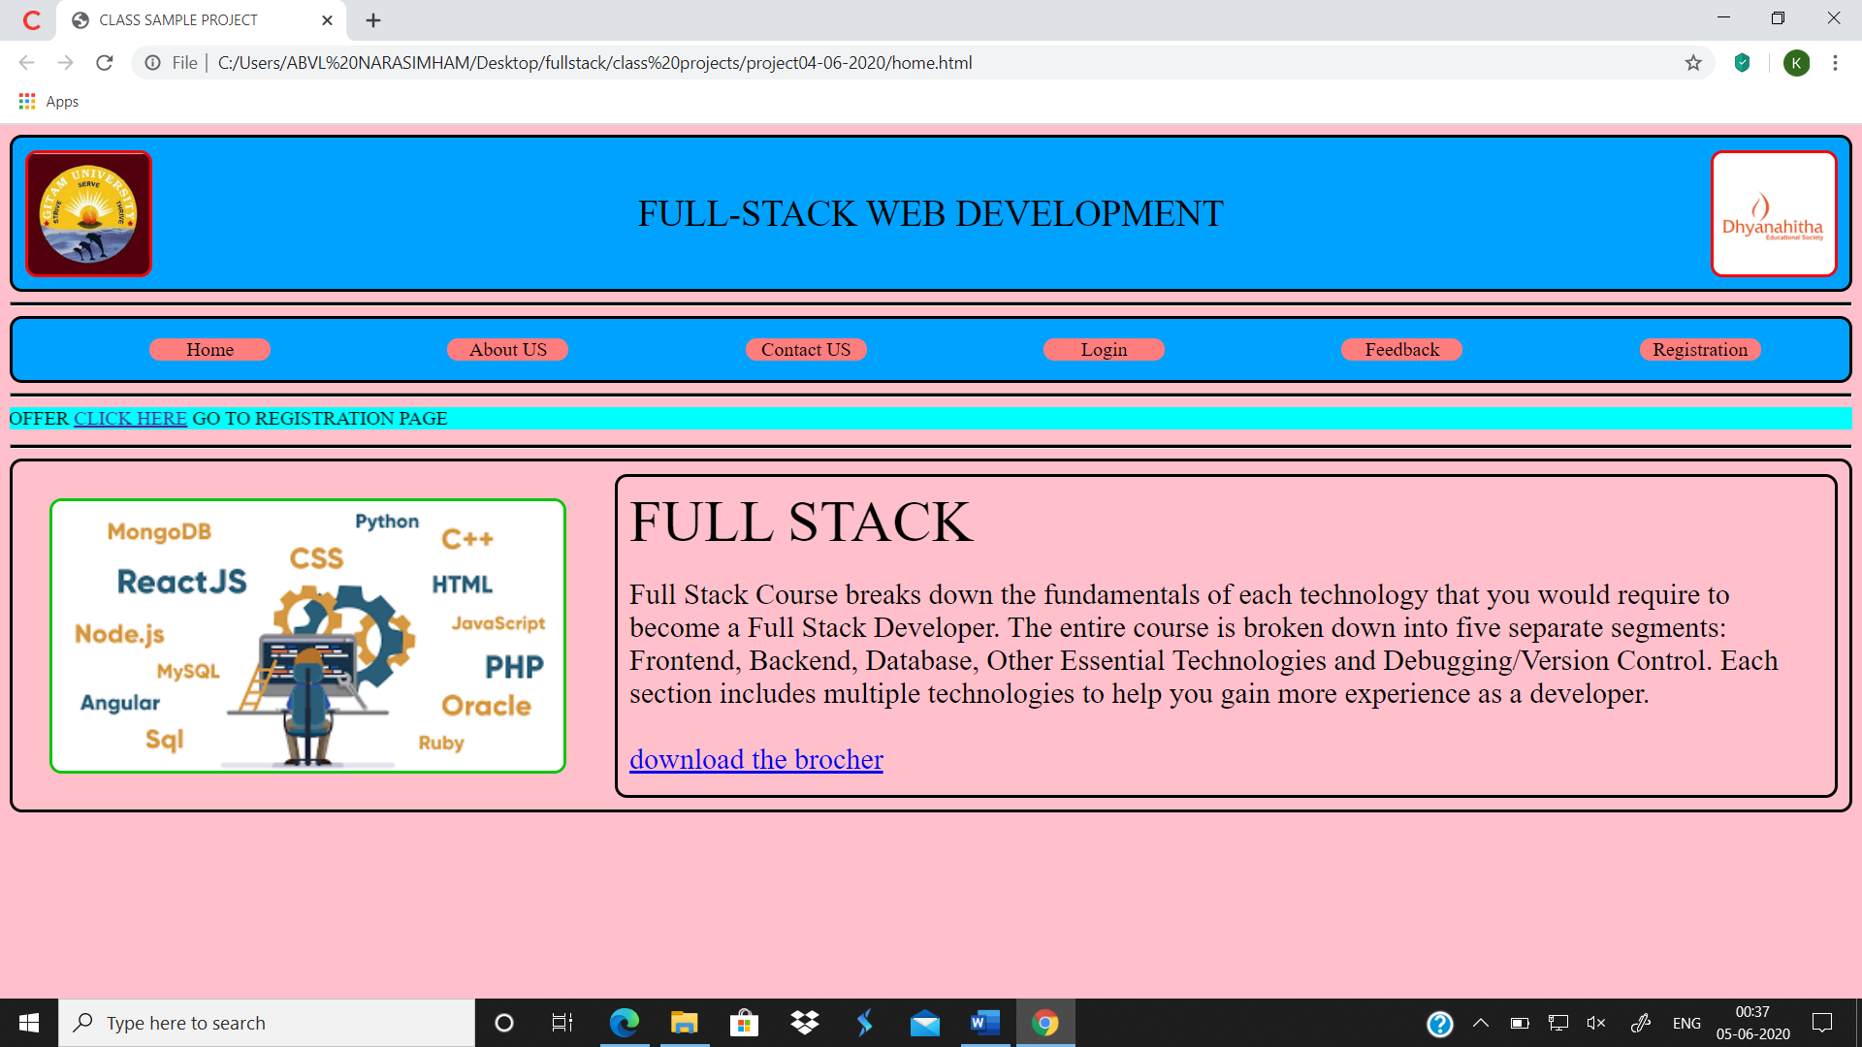

Fig 1.1

ABOUT US:

About us page mainly consists of the aim and also the agenda of Dhyanahitha.

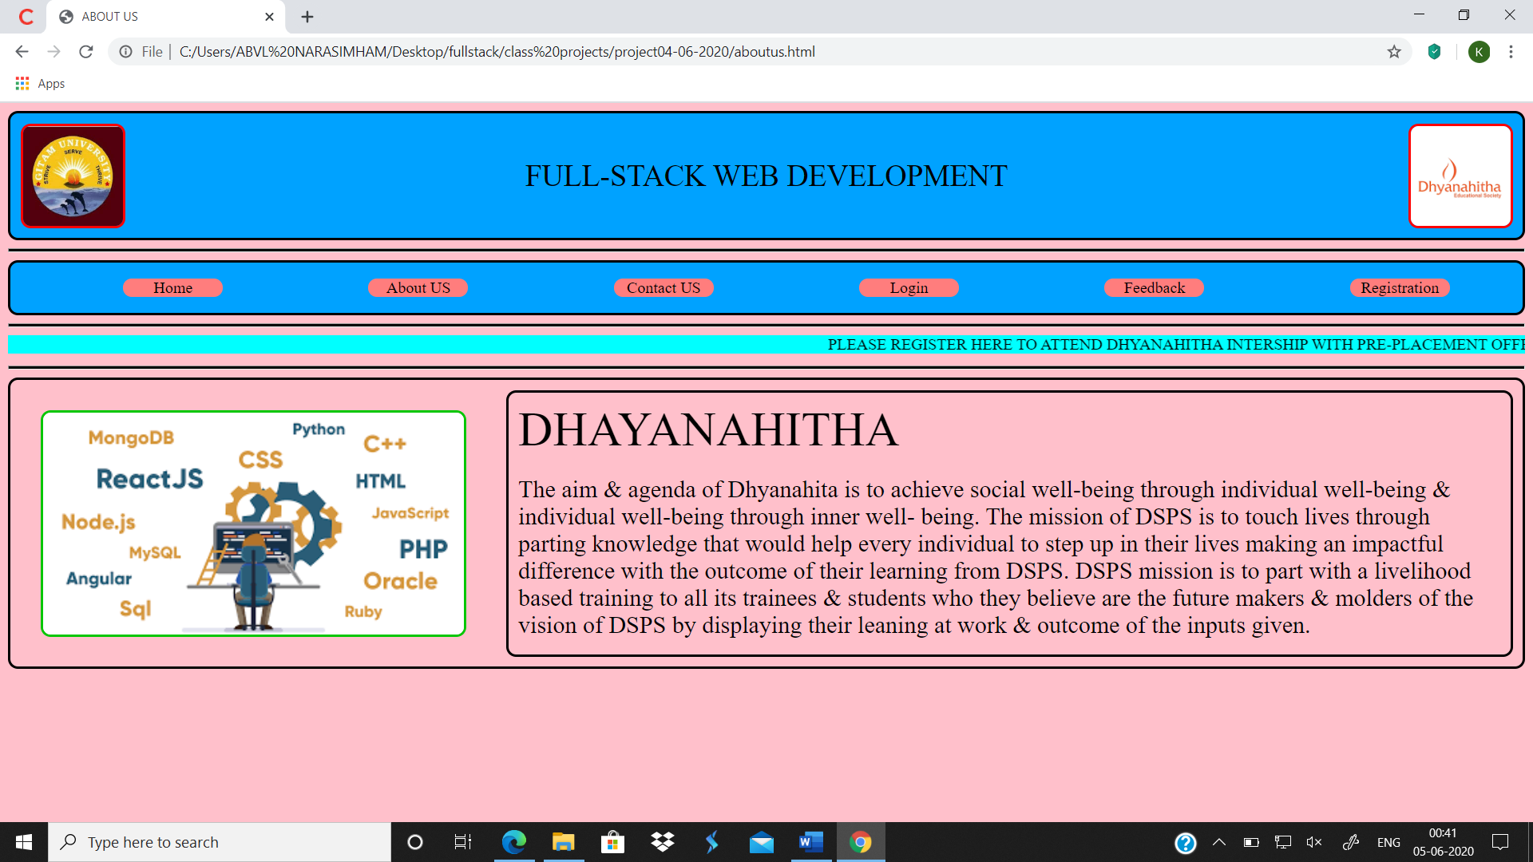

Fig 1.2

CONTACT US:

This page show the details such as name, phone number, email id and other different means to contact and clarify your doubts with Dhyanahitha.



Fig 1.3

LOGIN:

This page is mainly for the staff or the members who already have an account in Dhyanahitha. Here java script is used to validate username and password. Username is a 12digit pin number which is validated using a regular expression and password is “gitam123” (without quotes).

Username: 221710405003

Password: gitam123

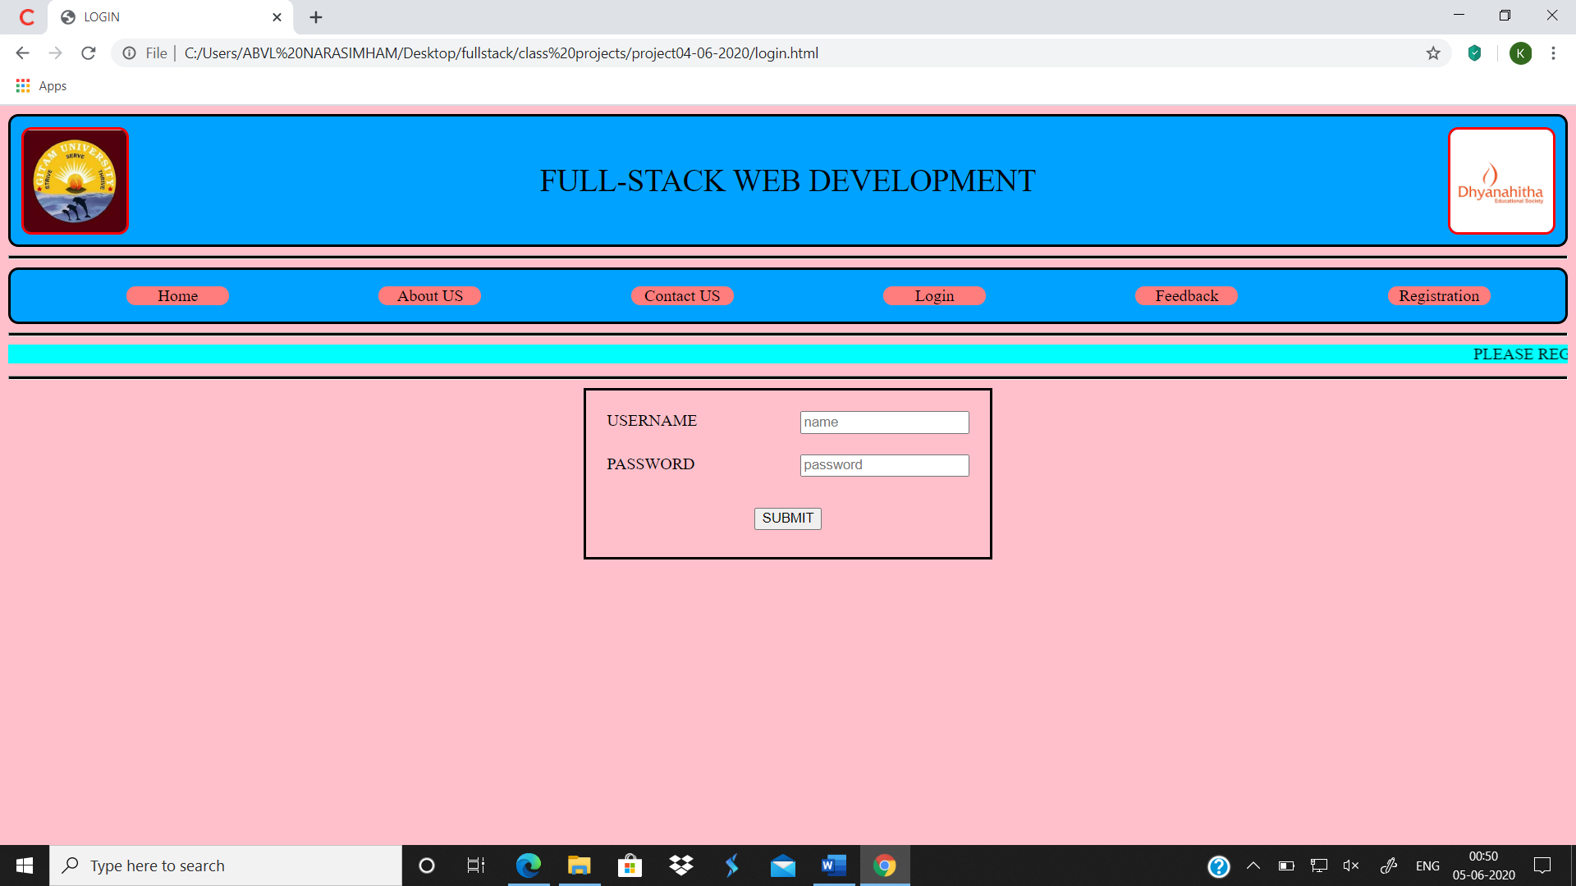

Fig 1.4

FEEDBACK:

After providing or at the time of providing the course each and every individual are encouraged to give feedback on the quality of service provided by us to them.

In this page email id, pin number and phone number are validated using java script and regex and there will be successful completion of feedback if the form is filled accurately as asked without any errors. And on clicking the submit button it shows a green colour tab which displays weather the feedback submission is successful or not.

This feedback helps to rate our self and also improve the standard of services provided by us.

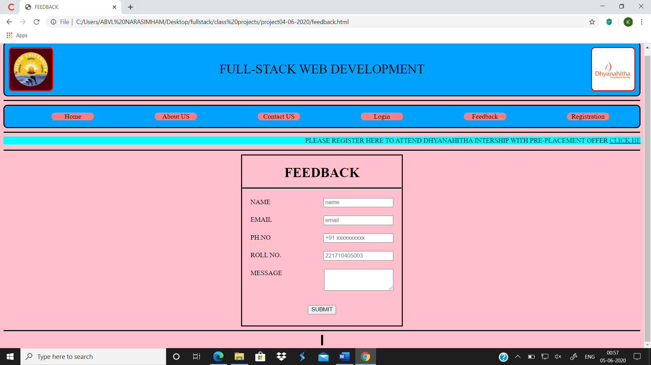

Fig 1.5

REGISTERATION:

This page is used to collect the details of the candidates who are willing to join the course and build a good resume and register here by filling all the necessary details which are asked in a particular way without having any errors. 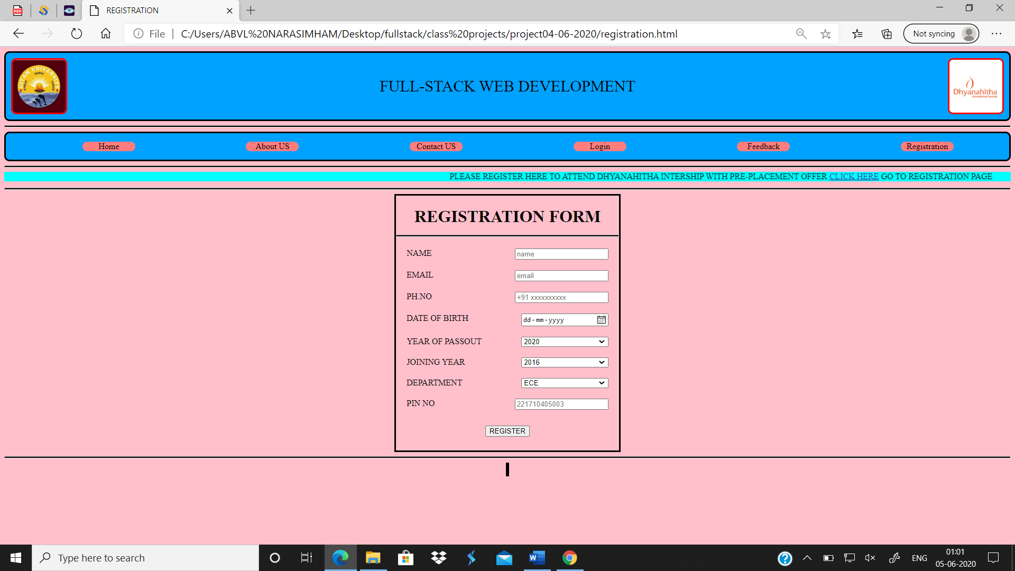

Fig 1.6

CONCLUSION:

This web is mainly to attract people to learn full-stack development.

**THANK YOU**