VSB ENGINEERING COLLEGE
VSB Skill Vault — Activity 3
MINI WEB APPLICATION
Course Management System
A CRUD-Based Web Application

Name | Aswath
Register No. | 922525205015
College | VSB Engineering College
Programme | B.Tech — Information Technology
Year | 2nd Year

Table of Contents
1. Project Overview
2. Problem Statement
3. Objectives
4. Technology Stack
5. System Architecture
6. Database Design
7. REST API Endpoint Documentation
8. CRUD Implementation Details
9. Validation Rules
10. User Interface — Screenshots
11. Testing Results
12. Installation & Execution Steps
13. Challenges and Solutions
14. Future Enhancements
15. Conclusion

1. Project Overview
This project is a Course Management System developed as part of the VSB Skill Vault Activity 3 — a mini web application implementing complete CRUD (Create, Read, Update, Delete) functionality. The application allows a college to maintain a digital register of the courses it offers each term, including course code, name, department, assigned instructor, credit value, semester, and seat availability.
The application is built as a self-contained frontend using HTML, CSS, and JavaScript, with a dedicated data-access layer designed to mirror REST API conventions so that it can be extended to a full client-server architecture (e.g. Django REST Framework or Spring Boot) with minimal changes to the interface code.

2. Problem Statement
Course catalogs in many academic departments are still tracked through spreadsheets or paper records, which makes searching, updating, and checking seat availability slow and error-prone. Staff need a lightweight tool to add new courses, update details such as instructor or seat count, remove discontinued courses, and quickly search or filter the list by department or semester — without requiring complex software installation.

3. Objectives
- Implement full CRUD operations — Create, Read, Update, and Delete — for course records.
- Design a clean, responsive user interface usable on both desktop and mobile screens.
- Apply client-side validation with clear, field-level error feedback.
- Provide search and multi-criteria filtering (by name, code, instructor, department, and semester).
- Structure the code so the data layer mirrors REST semantics and can be swapped for a real backend.
- Demonstrate the CRUD workflow end-to-end with functional testing.

4. Technology Stack
Layer | Technology | Purpose
Frontend | HTML5, CSS3 | Structure and styling of the user interface
Frontend Logic | JavaScript (ES6, vanilla) | CRUD logic, validation, search/filter, rendering
Data Persistence | Browser localStorage | Acts as the application's data store
Fonts | Google Fonts (Fraunces, IBM Plex Sans/Mono) | Typography
Version Control | Git / GitHub (recommended) | Source code management

5. System Architecture
The application follows a layered architecture. The presentation layer (HTML/CSS/JS) never touches storage directly — every read or write passes through a single data-access module, courseStore, which exposes the same four operations a REST backend would expose.
User → HTML / CSS / JavaScript Frontend → courseStore Data-Access Module → Browser localStorage
Because the UI layer only calls courseStore.list(), .create(), .update(), and .remove(), the localStorage-backed implementation of these four functions can be replaced with fetch() calls to a real backend (e.g. Django REST Framework or Spring Boot over MySQL/PostgreSQL) without changing any UI code — directly satisfying the layered separation recommended in the SOP.

6. Database Design
The system manages a single entity, Course, described below. In a production deployment this maps directly to one relational table with the fields as columns.
Field | Type | Constraint | Description
id | String (PK) | Auto-generated, unique | Primary key identifying each course record
code | String | Required, unique, pattern-validated | Course code, e.g. IT301
name | String | Required | Full course title
department | String | Required | Offering department
instructor | String | Required | Name of the assigned instructor
credits | Number | Required, 1–6 | Credit hours for the course
semester | Number | Required, 1–8 | Semester the course is offered in
seats | Number | Required, ≥ 0 | Number of open seats
description | String | Optional | Short description of course content

7. REST API Endpoint Documentation
The data-access layer is designed around the following REST conventions. In the current build these are implemented as local JavaScript functions operating on localStorage; the endpoint column shows the equivalent backend route each function is designed to be replaced by.
Operation | HTTP Method | Endpoint | Function | Result
Create | POST | /api/courses/ | courseStore.create() | New course record created
Read All | GET | /api/courses/ | courseStore.list() | List of all course records returned
Update | PUT | /api/courses/{id}/ | courseStore.update() | Existing record updated
Delete | DELETE | /api/courses/{id}/ | courseStore.remove() | Record removed

8. CRUD Implementation Details

Create
The "Add course" button opens a modal form. On submission, the entered data is validated; if valid, it is passed to courseStore.create(), assigned a unique ID, and appended to the stored course list. The table and summary statistics refresh immediately.

Read
courseStore.list() is called on page load and after every change. Results pass through the active search term and filters before being rendered into the table, with live counters for total courses, total credit hours, departments, and open seats.

Update
Clicking "Edit" on a row opens the same modal, pre-filled with that course's data. On submission, courseStore.update(id, data) replaces the record's fields while preserving its original ID.

Delete
Clicking "Delete" prompts for confirmation before courseStore.remove(id) permanently removes the record from storage and the table.

9. Validation Rules
Field | Validation Rule
Course code | Required; must match pattern of 2–5 letters followed by 2–4 digits; must be unique
Course name | Required, non-empty
Department | Required, non-empty
Semester | Required, must be selected from 1–8
Instructor | Required, non-empty
Credits | Required, numeric, between 1 and 6
Seats | Required, numeric, zero or positive
Invalid fields are outlined in red with an inline error message, and the form cannot be submitted until every rule is satisfied — satisfying both client-side validation and duplicate-value handling requirements.

10. User Interface — Screenshots

10.1 Main Dashboard — Course Register with live statistics
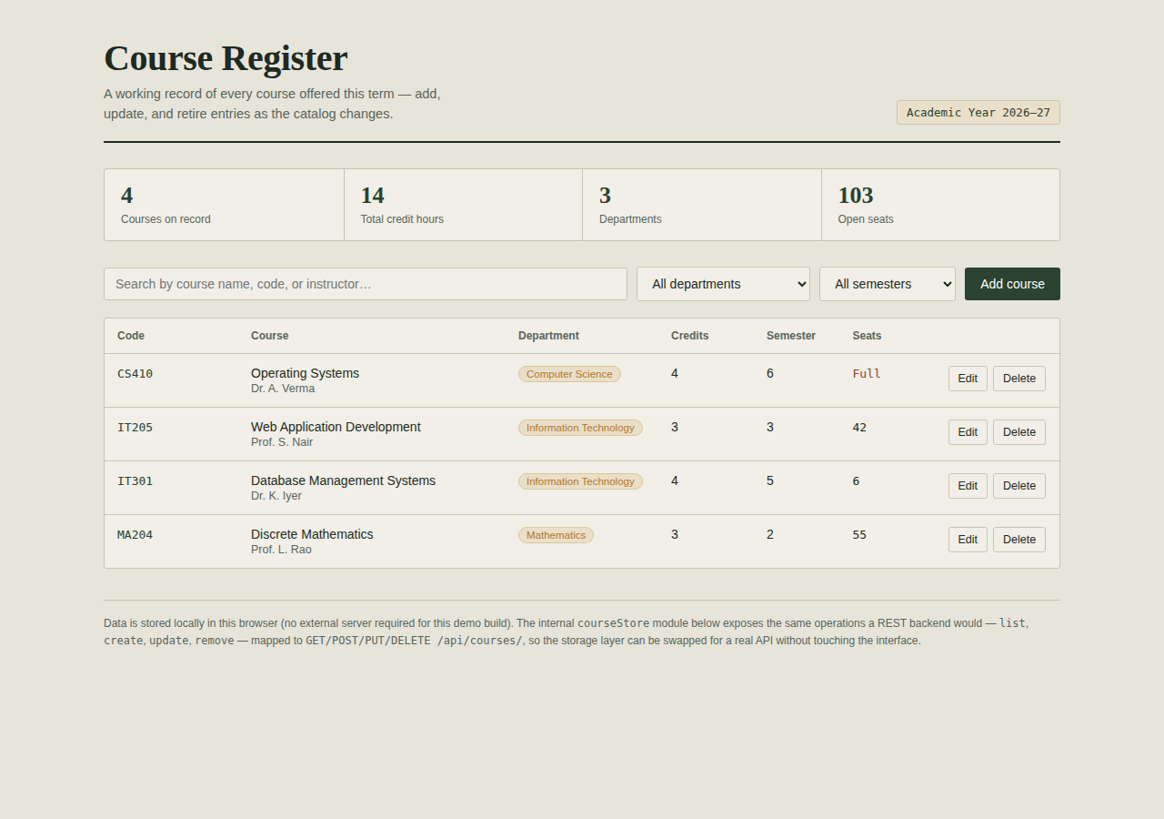
Figure 1: Main dashboard showing the course table, summary statistics, and toolbar.

10.2 Add / Edit Course Form
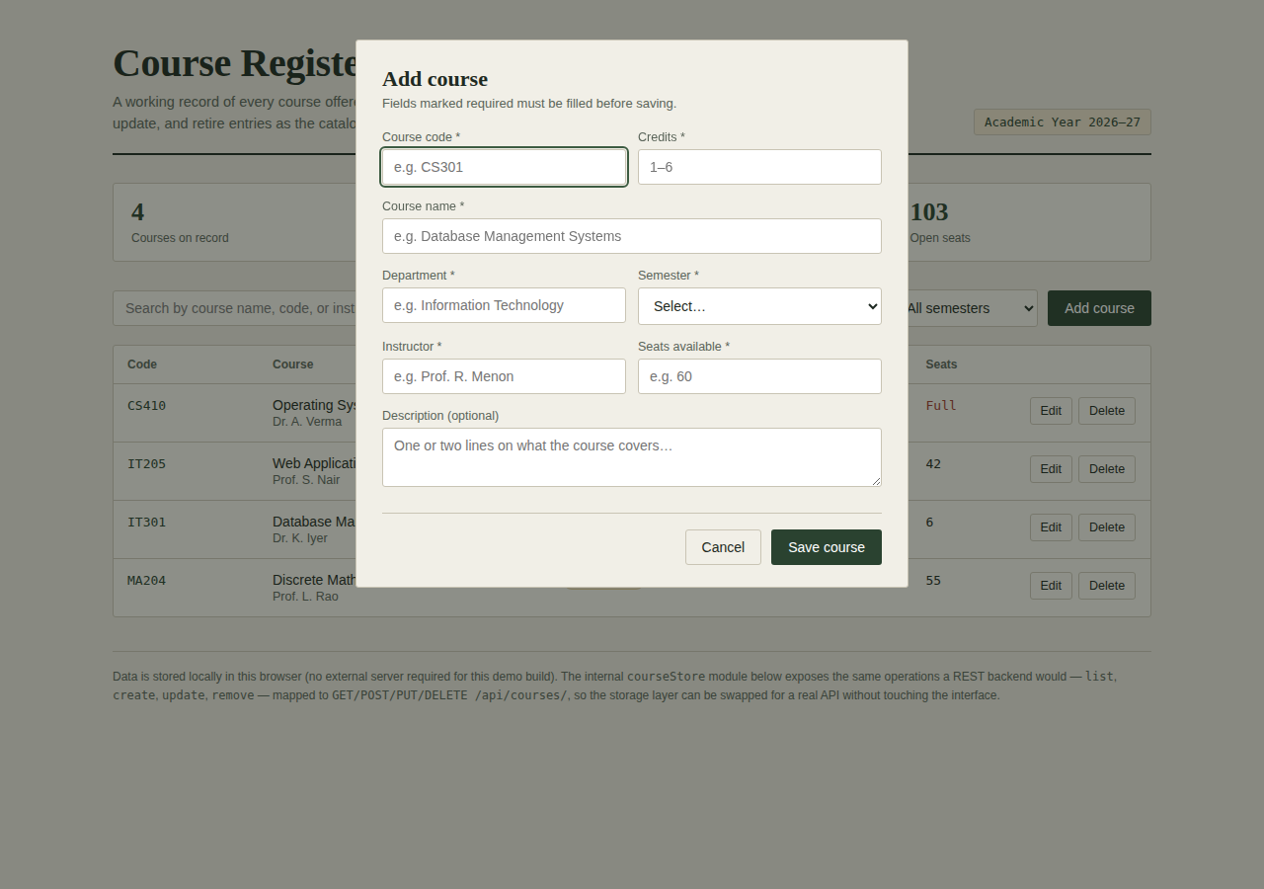
Figure 2: Modal form used for both creating and editing a course record.

10.3 Search Functionality
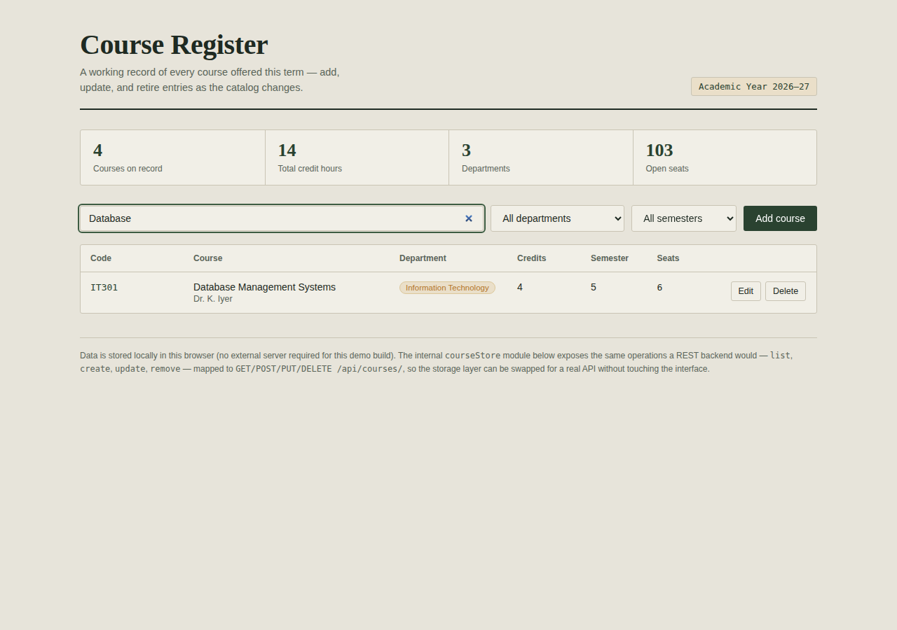
Figure 3: Live search filtering the course list by keyword ("Database").

10.4 Responsive Mobile Layout
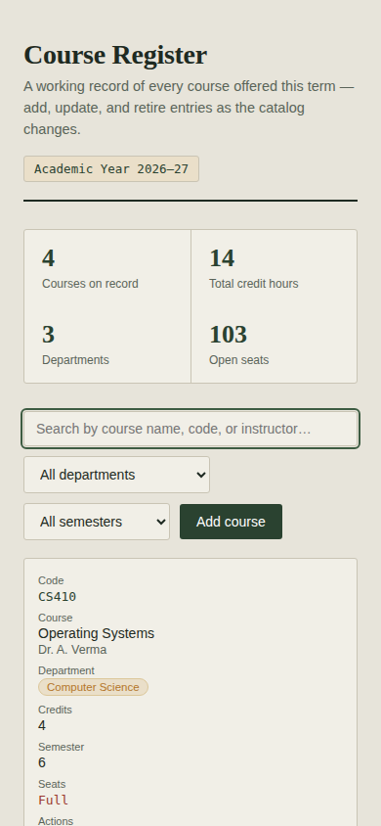
Figure 4: Table collapses into stacked cards on mobile screen widths.

11. Testing Results
Test Case | Steps | Expected Result | Status
Create — valid data | Fill all required fields correctly and save | Record appears in table, statistics update | Pass
Create — missing fields | Submit with empty required fields | Fields highlighted, submission blocked | Pass
Create — duplicate code | Add a course with a code already in use | Code field flagged, submission blocked | Pass
Create — invalid credits/seats | Enter credits outside 1–6 or negative seats | Field flagged, submission blocked | Pass
Read — search | Type keyword into search box | Table filters live by name/code/instructor | Pass
Read — filters | Select a department or semester | Table filters accordingly | Pass
Read — empty result | Search for a non-existent course | "No courses match yet" message shown | Pass
Update | Edit an existing course, change values, save | Table reflects updated values, ID unchanged | Pass
Delete | Delete a course and confirm | Record removed from table and statistics | Pass
Delete — cancel | Delete a course, cancel the prompt | Record remains unchanged | Pass
Responsiveness | Resize browser to mobile width | Table collapses into stacked card layout | Pass

12. Installation & Execution Steps
- No installation or server setup is required.
- Download the file course-management-system.html.
- Open it directly in any modern browser (Chrome, Edge, or Firefox).
- The app loads with sample course data pre-filled so the table is not empty on first run.
- All additions, edits, and deletions persist in that browser via localStorage.

13. Challenges and Solutions
Challenge | Solution
Keeping the app fully self-contained without a backend server | Built a courseStore module backed by localStorage, structured to mirror REST endpoints for easy future migration
Preventing duplicate or malformed course codes | Added a regex pattern check plus a uniqueness check against existing records before saving
Making the table usable on small screens | Used a responsive CSS layout that converts table rows into stacked cards below 640px width

14. Future Enhancements
- Replace the localStorage-backed courseStore with real REST API calls to a Django REST Framework or Spring Boot backend.
- Add user authentication with role-based access (administrator vs. student view).
- Add pagination for large course catalogs.
- Add CSV/PDF export of the course list.

15. Conclusion
The Course Management System successfully demonstrates a complete CRUD-based web application with a responsive interface, client-side validation, search and filtering, and a REST-oriented data-access architecture. All planned functional requirements — Create, Read, Update, and Delete — were implemented and verified through manual testing, meeting the objectives set out for this mini web application activity.

