INSTALLING VIRTUAL BOX FOR WINDOWS 7

STEPS:

1. Download Virtual Box Oracle from the developer's website of 32 bit operating system.

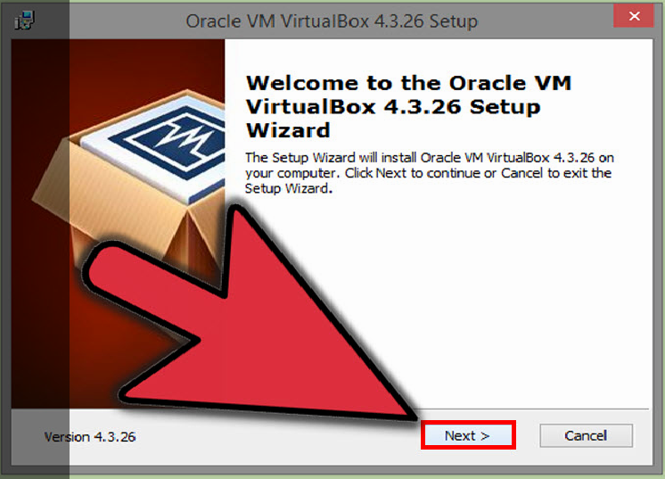

1. Install the Virtual Box program then double-click the setup file and follow the prompts to install. During the Windows installation, keep all of the options set to their default.
2. Start the program. Virtual Box allows you to manage your run Virtual Box directly from the installation program, or you can start it from the desktop icon.



1. Install the operating system as on a regular computer; install it directly from the ISO file.
2. Click the "New" button. This will open the wizard that will guide you through the process to create your first virtual machine.

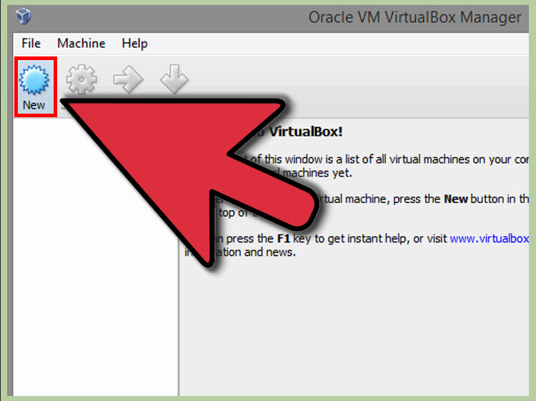

1. Identify the operating system. On the first screen of the wizard, give the new virtual machine a name as well as choose what operating system you will be installing.
2. Choose the type of operating system from the Type menu, and then choose which version you are installing from the Version menu.

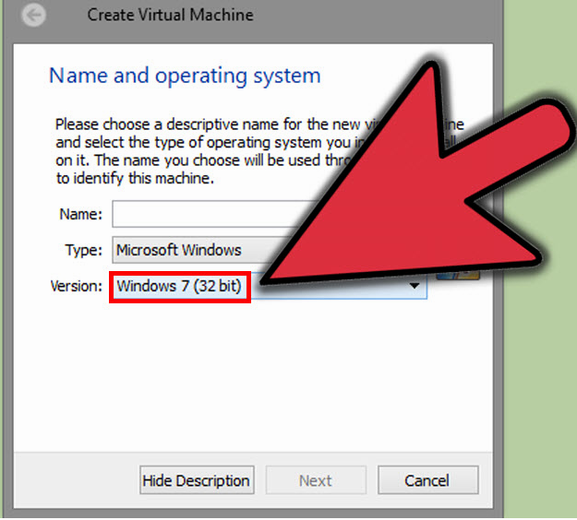

1. Set the amount of RAM. You will need to designate how much of your computer's RAM will be allocated to your virtual machine. Virtual Box will automatically choose the recommended minimum amount for the operating system you selected, but you can increase or decrease this if you'd like.

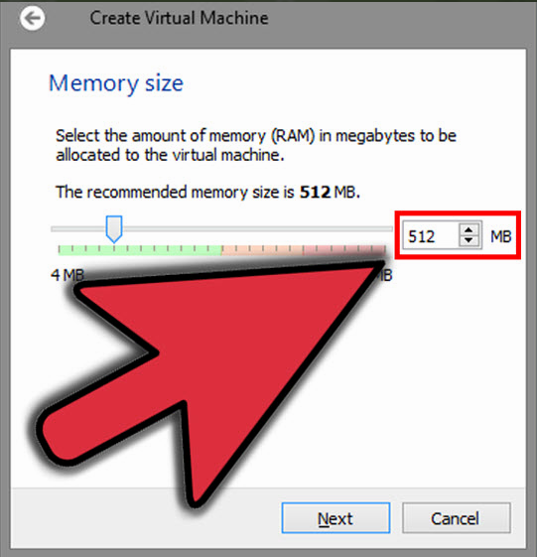

1. Create a virtual hard drive in order to install the operating system and any programs. Any programs you install will also take up space on your virtual hard drive, so plan accordingly.

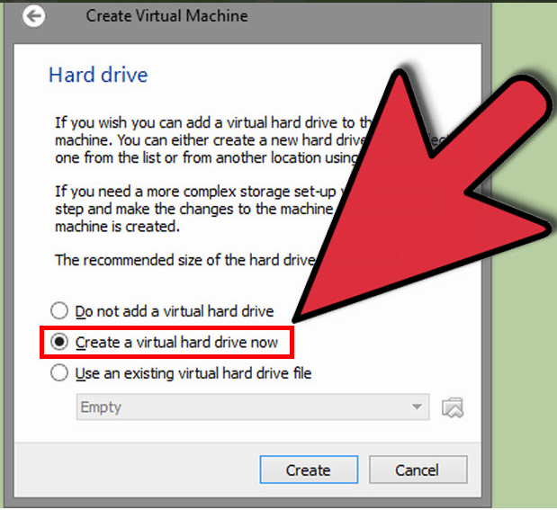

1. Start the operating system installation. Once the virtual machine has been configured, the wizard will close and you will be taken back to the Virtual Box main window. Double-click your new machine in the left menu to start it up for the first time.A new wizard will appear to help start the operating system installation.

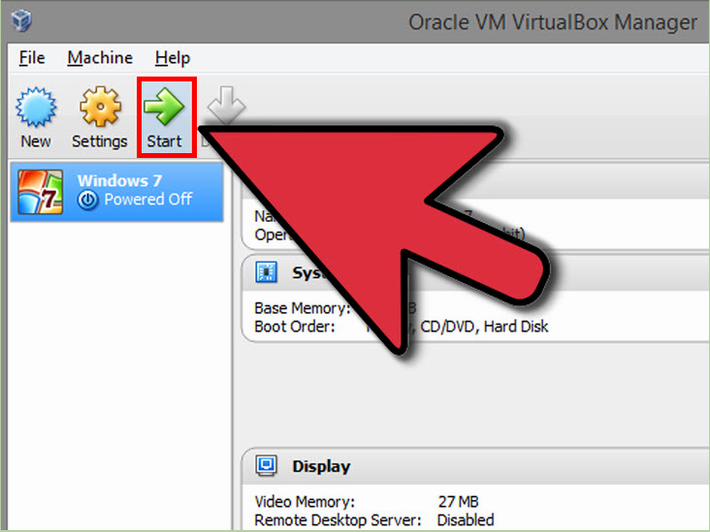

**INSTALLING LINUX IN VIRTUAL BOX**

1. Choose the system type: from the Type menu, and then choose which version you are installing from the Version menu.

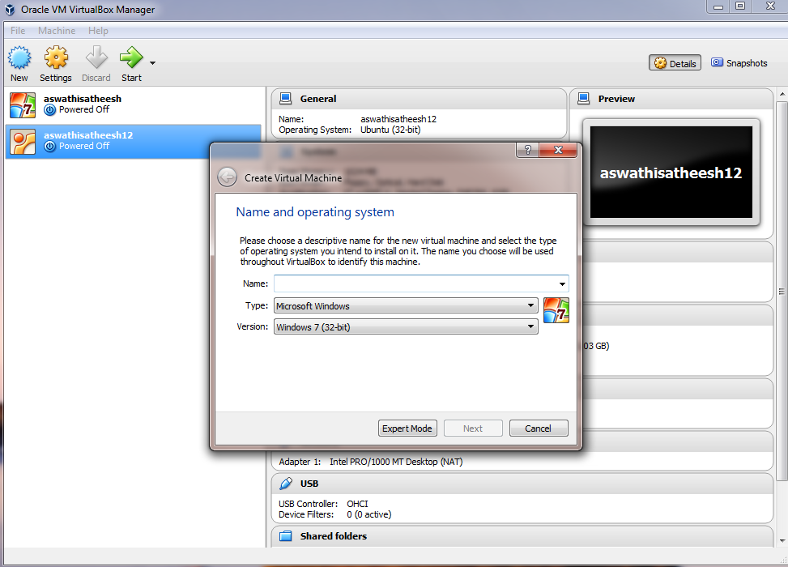

1. Select The Amount of RAM: You will need to designate how much of your computer's RAM will be allocated to your virtual machine. Virtual Box will automatically choose the recommended minimum amount for the operating system you selected, but you can increase or decrease this if you'd like.

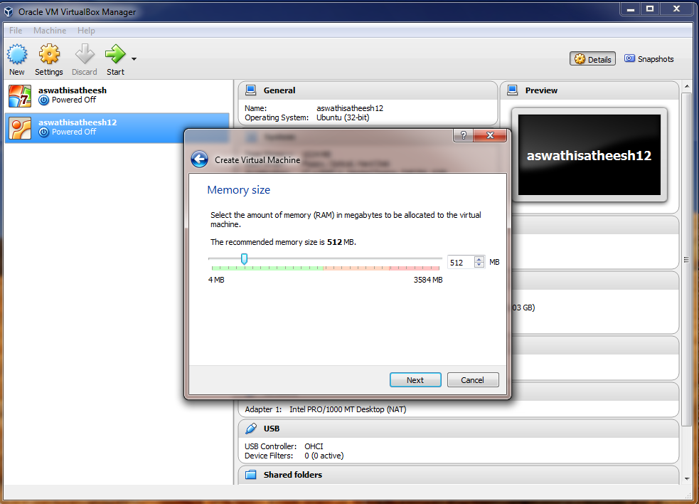

1. Hard Disk Setting: in order to install the operating system and any programs. Any programs you install will also take up space on your virtual hard drive, so plan accordingly.

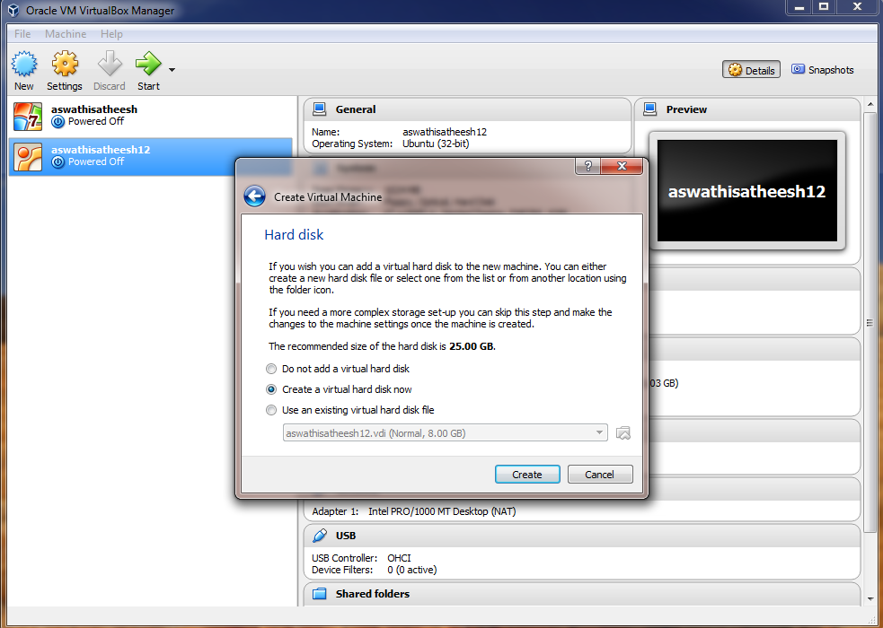

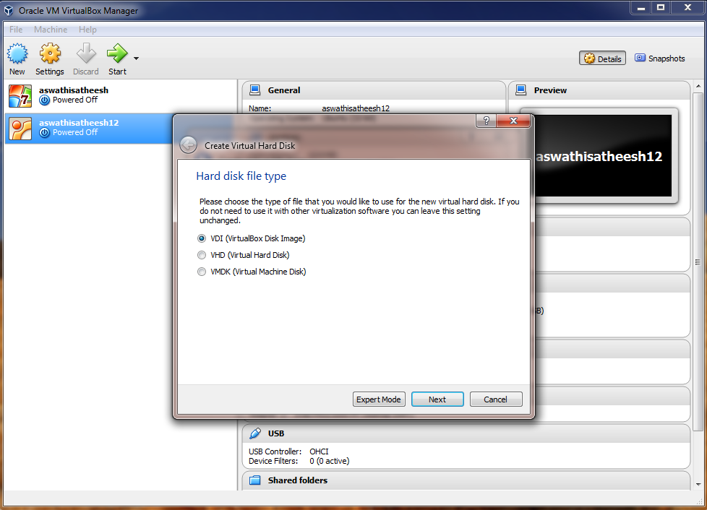

1. Choose Linux ISO file

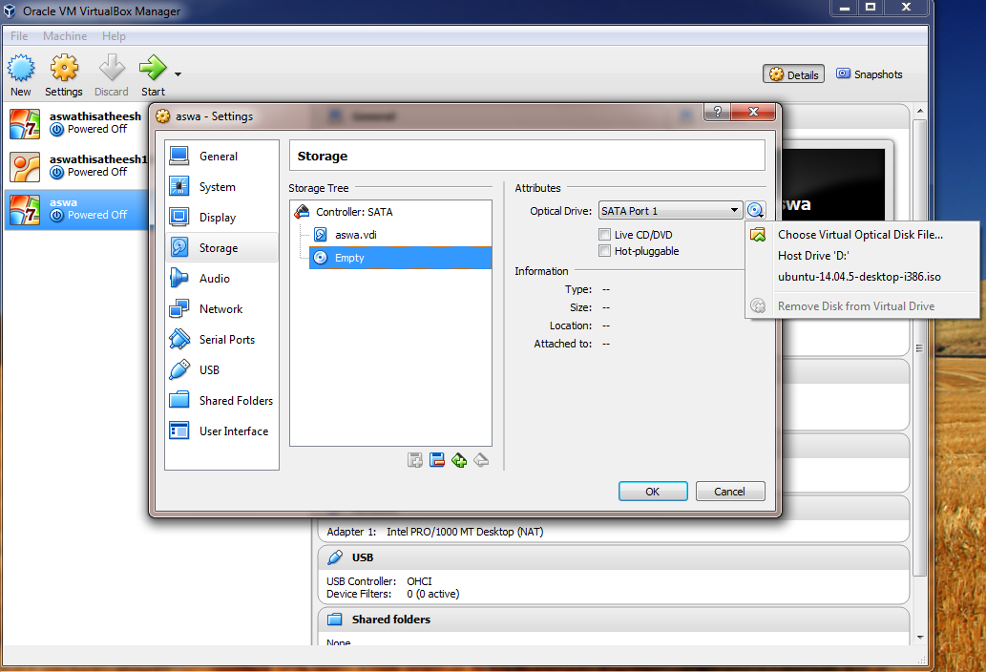

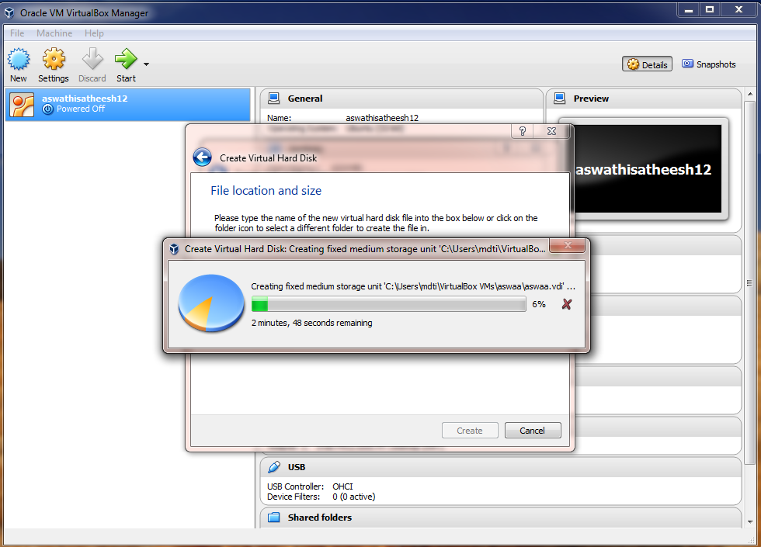

1. Start execution

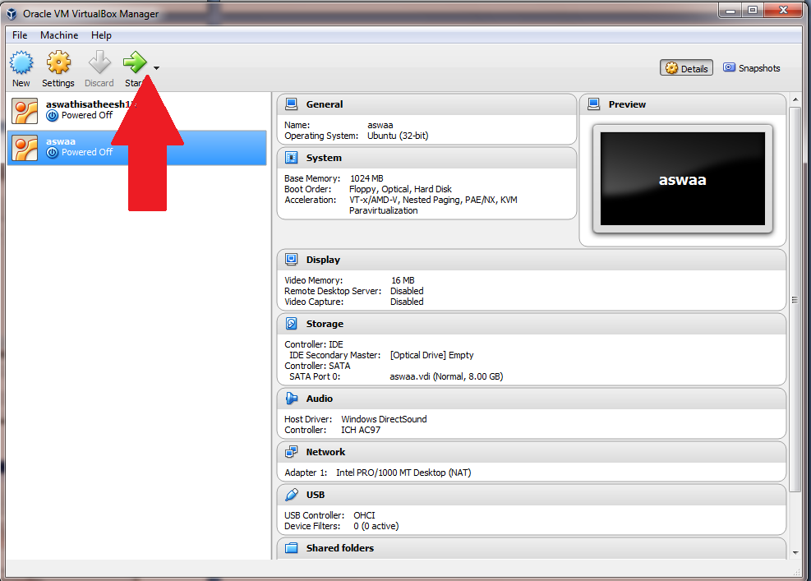

1. Installing has been complete and now we can use Ubuntu.

