Ex. No. 5 | Implementation of Navigation and Routing
Date of Exercise | 31 October 2026
GitHub Code Link (Keep as public) | https://github.com/ASWIN2006SK/Flutter-lab/tree/main/Experiment_05
Aim
To understand and implement navigation and routing mechanisms in a Flutter application, enabling users to move between multiple screens and pass data between them using named routes.
Description
Navigation and routing allow users to move from one screen to another in a Flutter application. Flutter provides the Navigator class to manage the stack of routes. Named routes identify screens using route names and make navigation easier to organize.
This experiment implements a product navigation application named “ShopEase”. The application contains three screens: Home Screen, Product Details Screen and Shopping Cart Screen. The Home Screen displays a predefined list of products. Selecting a product opens its details screen, where the product name, description, image representation and price are displayed. The user can then navigate to the Cart Screen and view the selected product.
The main widgets and navigation concepts used are:
• MaterialApp: Configures the application, theme, initial route and named route table.
• routes: Maps route names such as '/', '/details' and '/cart' to their corresponding screen widgets.
• initialRoute: Specifies the first screen displayed when the application starts.
• Navigator.pushNamed(): Opens a new screen using its route name and can pass data through the arguments parameter.
• Navigator.pop(): Removes the current route and returns to the previous screen.
• ModalRoute.of(context): Retrieves the current route information and its arguments in the destination screen.
• Navigator.pushNamedAndRemoveUntil(): Navigates to a named route while removing previous routes that match the supplied condition.
• Product model: Holds the product name, description, emoji, price and background colour that are passed between screens.
• Reusable ProductCard: Displays a product in the Home Screen and handles the tap action.
The named routes are registered in MaterialApp. When a user selects a product on the Home Screen, Navigator.pushNamed() opens the '/details' route and passes the selected Product object through arguments. The Details Screen retrieves this object using ModalRoute.of(context)!.settings.arguments and displays its information. When the user selects Add to Cart, the application opens the '/cart' route and passes the same product object. The Cart Screen displays the selected product. The Go Back button uses Navigator.pop(), while Continue Shopping navigates to the Home Screen and removes the previous routes.
The application was executed in Google Chrome. The output screenshots demonstrate the Home Screen containing five products, the Product Details Screen showing the selected Wireless Headphones product, and the Shopping Cart Screen displaying the same product with a success message. The cart in this experiment is a navigation demonstration that displays the single product passed through route arguments; it does not maintain a persistent multi-product cart.

Program
File: lib/main.dart
import 'package:flutter/material.dart';

void main() {
runApp(const ShopEaseApp());
}

// PRODUCT MODEL
class Product {
final String name;
final String description;
final String emoji;
final double price;
final Color color;

const Product({
required this.name,
required this.description,
required this.emoji,
required this.price,
required this.color,
});
}

// MAIN APPLICATION
class ShopEaseApp extends StatelessWidget {
const ShopEaseApp({super.key});

@override
Widget build(BuildContext context) {
return MaterialApp(
debugShowCheckedModeBanner: false,
title: 'ShopEase Navigation',
theme: ThemeData(
colorSchemeSeed: Colors.deepPurple,
useMaterial3: true,
),

// NAMED ROUTES
initialRoute: '/',
routes: {
'/': (context) => const HomeScreen(),
'/details': (context) => const DetailsScreen(),
'/cart': (context) => const CartScreen(),
},
);
}
}

// HOME SCREEN
class HomeScreen extends StatelessWidget {
const HomeScreen({super.key});

// PREDEFINED PRODUCTS
static const List<Product> products = [
Product(
name: 'Wireless Headphones',
description:
'High-quality wireless headphones with clear sound '
'and comfortable ear cushions.',
emoji: '🎧',
price: 1499,
color: Color(0xFFEDE7F6),
),
Product(
name: 'Smart Watch',
description:
'A stylish smartwatch with fitness tracking and '
'smart notifications.',
emoji: '⌚',
price: 2499,
color: Color(0xFFE3F2FD),
),
Product(
name: 'Running Shoes',
description:
'Comfortable and lightweight running shoes '
'designed for everyday activities.',
emoji: '👟',
price: 1999,
color: Color(0xFFFFF3E0),
),
Product(
name: 'Backpack',
description:
'A spacious and durable backpack suitable '
'for college and travel.',
emoji: '🎒',
price: 999,
color: Color(0xFFE8F5E9),
),
Product(
name: 'Camera',
description:
'Capture memorable moments with this '
'high-quality digital camera.',
emoji: '📷',
price: 5999,
color: Color(0xFFFCE4EC),
),
];

@override
Widget build(BuildContext context) {
return Scaffold(
backgroundColor: const Color(0xFFF7F7FB),
appBar: AppBar(
backgroundColor: Colors.deepPurple,
foregroundColor: Colors.white,
title: const Text(
'ShopEase',
style: TextStyle(fontWeight: FontWeight.bold),
),
actions: [
IconButton(
icon: const Icon(Icons.shopping_cart),
onPressed: () {
Navigator.pushNamed(context, '/cart');
},
),
const SizedBox(width: 10),
],
),

body: Column(
crossAxisAlignment: CrossAxisAlignment.start,
children: [
// WELCOME SECTION
Container(
width: double.infinity,
padding: const EdgeInsets.all(20),
color: Colors.deepPurple.shade50,
child: const Column(
crossAxisAlignment: CrossAxisAlignment.start,
children: [
Text(
'Welcome to ShopEase!',
style: TextStyle(
fontSize: 22,
fontWeight: FontWeight.bold,
color: Colors.deepPurple,
),
),
SizedBox(height: 5),
Text('Explore our latest products.'),
],
),
),

const Padding(
padding: EdgeInsets.all(16),
child: Text(
'Available Products',
style: TextStyle(
fontSize: 20,
fontWeight: FontWeight.bold,
),
),
),

// PRODUCT LIST
Expanded(
child: ListView.builder(
padding: const EdgeInsets.symmetric(horizontal: 14),
itemCount: products.length,
itemBuilder: (context, index) {
final product = products[index];

return ProductCard(
product: product,
onTap: () {
// NAVIGATE AND PASS DATA
Navigator.pushNamed(
context,
'/details',
arguments: product,
);
},
);
},
),
),
],
),
);
}
}

// REUSABLE PRODUCT CARD
class ProductCard extends StatelessWidget {
final Product product;
final VoidCallback onTap;

const ProductCard({
super.key,
required this.product,
required this.onTap,
});

@override
Widget build(BuildContext context) {
return Card(
margin: const EdgeInsets.only(bottom: 14),
elevation: 3,
color: Colors.white,
shape: RoundedRectangleBorder(
borderRadius: BorderRadius.circular(15),
),
child: ListTile(
contentPadding: const EdgeInsets.all(12),
leading: Container(
width: 65,
height: 65,
decoration: BoxDecoration(
color: product.color,
borderRadius: BorderRadius.circular(12),
),
child: Center(
child: Text(
product.emoji,
style: const TextStyle(fontSize: 35),
),
),
),
title: Text(
product.name,
style: const TextStyle(fontWeight: FontWeight.bold),
),
subtitle: Padding(
padding: const EdgeInsets.only(top: 6),
child: Text(
'₹${product.price.toStringAsFixed(0)}',
style: const TextStyle(
color: Colors.deepPurple,
fontWeight: FontWeight.bold,
),
),
),
trailing: const Icon(
Icons.arrow_forward_ios,
size: 18,
),
onTap: onTap,
),
);
}
}

// DETAILS SCREEN
class DetailsScreen extends StatelessWidget {
const DetailsScreen({super.key});

@override
Widget build(BuildContext context) {
// RECEIVE DATA FROM HOME SCREEN
final product =
ModalRoute.of(context)!.settings.arguments as Product;

return Scaffold(
backgroundColor: const Color(0xFFF7F7FB),
appBar: AppBar(
title: const Text('Product Details'),
backgroundColor: Colors.deepPurple,
foregroundColor: Colors.white,
),
body: Center(
child: Padding(
padding: const EdgeInsets.all(20),
child: Card(
color: Colors.white,
elevation: 4,
shape: RoundedRectangleBorder(
borderRadius: BorderRadius.circular(20),
),
child: Padding(
padding: const EdgeInsets.all(24),
child: Column(
mainAxisSize: MainAxisSize.min,
crossAxisAlignment: CrossAxisAlignment.stretch,
children: [
// PRODUCT IMAGE
Container(
height: 200,
decoration: BoxDecoration(
color: product.color,
borderRadius: BorderRadius.circular(15),
),
child: Center(
child: Text(
product.emoji,
style: const TextStyle(fontSize: 100),
),
),
),

const SizedBox(height: 20),

// PRODUCT NAME
Text(
product.name,
textAlign: TextAlign.center,
style: const TextStyle(
fontSize: 24,
fontWeight: FontWeight.bold,
),
),

const SizedBox(height: 12),

// DESCRIPTION
Text(
product.description,
textAlign: TextAlign.center,
style: const TextStyle(
fontSize: 15,
color: Colors.grey,
),
),

const SizedBox(height: 20),

// PRICE
Text(
'₹${product.price.toStringAsFixed(0)}',
textAlign: TextAlign.center,
style: const TextStyle(
fontSize: 28,
color: Colors.deepPurple,
fontWeight: FontWeight.bold,
),
),

const SizedBox(height: 25),

// ADD TO CART
ElevatedButton.icon(
onPressed: () {
Navigator.pushNamed(
context,
'/cart',
arguments: product,
);
},
icon: const Icon(Icons.shopping_cart),
label: const Text('Add to Cart'),
style: ElevatedButton.styleFrom(
backgroundColor: Colors.deepPurple,
foregroundColor: Colors.white,
padding: const EdgeInsets.all(15),
),
),

const SizedBox(height: 10),

// BACK BUTTON
OutlinedButton(
onPressed: () {
Navigator.pop(context);
},
child: const Text('Go Back'),
),
],
),
),
),
),
),
);
}
}

// CART SCREEN
class CartScreen extends StatelessWidget {
const CartScreen({super.key});

@override
Widget build(BuildContext context) {
// RECEIVE PRODUCT DATA
final product =
ModalRoute.of(context)!.settings.arguments as Product?;

return Scaffold(
backgroundColor: const Color(0xFFF7F7FB),
appBar: AppBar(
title: const Text('Shopping Cart'),
backgroundColor: Colors.deepPurple,
foregroundColor: Colors.white,
),
body: Center(
child: product == null
? const Text(
'Your cart is empty!',
style: TextStyle(fontSize: 20),
)
: Padding(
padding: const EdgeInsets.all(20),
child: Card(
color: Colors.white,
child: Padding(
padding: const EdgeInsets.all(25),
child: Column(
mainAxisSize: MainAxisSize.min,
children: [
const Icon(
Icons.check_circle,
color: Colors.green,
size: 60,
),

const SizedBox(height: 15),

const Text(
'Product Added Successfully!',
textAlign: TextAlign.center,
style: TextStyle(
fontSize: 20,
fontWeight: FontWeight.bold,
),
),

const SizedBox(height: 20),

Text(
product.emoji,
style: const TextStyle(fontSize: 65),
),

const SizedBox(height: 10),

Text(
product.name,
style: const TextStyle(
fontSize: 20,
fontWeight: FontWeight.bold,
),
),

const SizedBox(height: 8),

Text(
'₹${product.price.toStringAsFixed(0)}',
style: const TextStyle(
fontSize: 22,
color: Colors.deepPurple,
fontWeight: FontWeight.bold,
),
),

const SizedBox(height: 25),

ElevatedButton(
onPressed: () {
Navigator.pushNamedAndRemoveUntil(
context,
'/',
(route) => false,
);
},
style: ElevatedButton.styleFrom(
backgroundColor: Colors.deepPurple,
foregroundColor: Colors.white,
),
child: const Text('Continue Shopping'),
),
],
),
),
),
),
),
);
}
}

Output Screenshots
The following screenshots show the three screens of the ShopEase Navigation application running in Google Chrome. Figure 1 shows the Home Screen with the available products. Figure 2 shows the Product Details Screen displaying the selected Wireless Headphones product and its details. Figure 3 shows the Shopping Cart Screen displaying the same product after the Add to Cart action.
Figure 1: Home Screen displaying available products
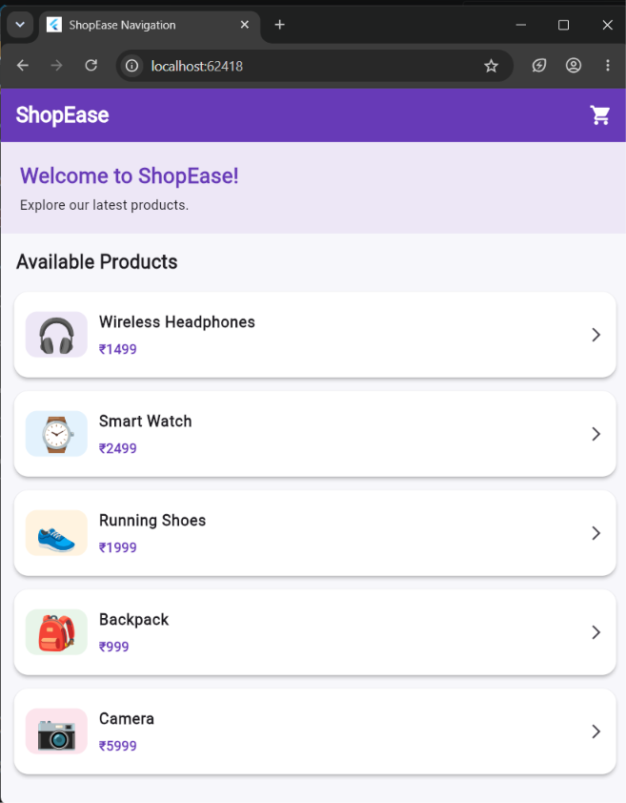
Figure 2: Product Details Screen showing the selected product
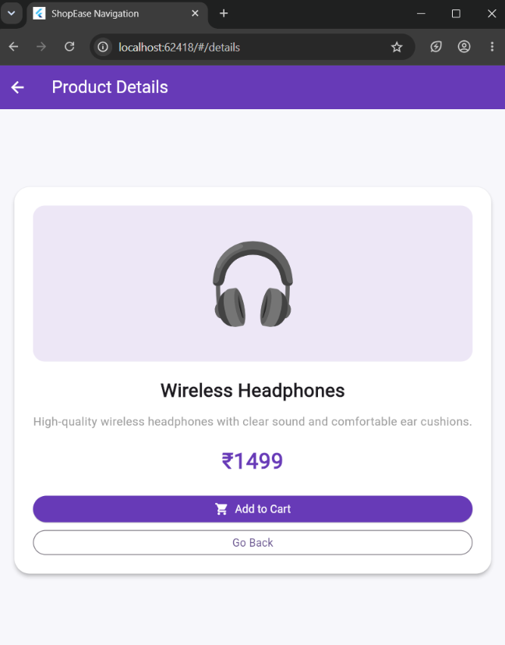
Figure 3: Shopping Cart Screen showing the added product
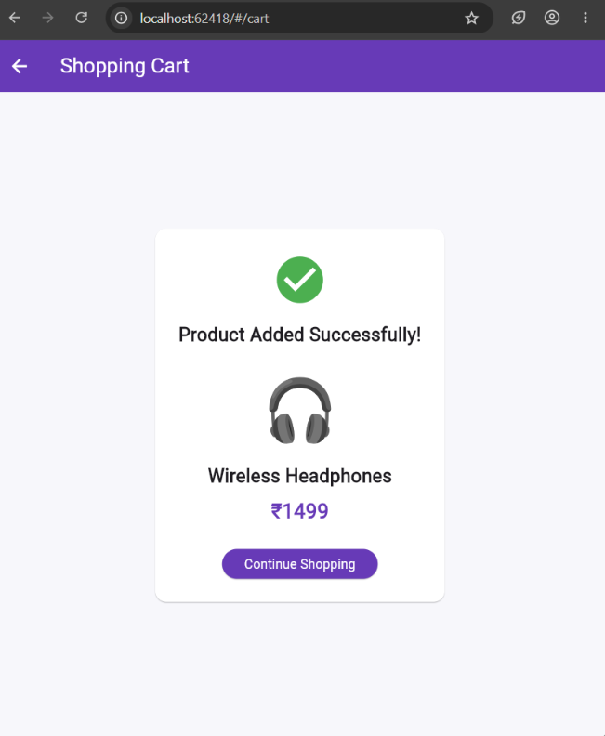
Result
Thus, navigation and routing were successfully implemented in the Flutter ShopEase application using named routes. The user can navigate from the Home Screen to the Product Details Screen and then to the Shopping Cart Screen. Product information was passed between screens using route arguments and retrieved using ModalRoute.of(context). The application was executed successfully in Google Chrome.

